**Walter George Waldron**, born November 1895, Middle Creek (Beaufort). Single, farmer, CoE.

Next of Kin, father, Mrs Sarah Waldron (Father Mr G Waldron) (20 years, 3 months)

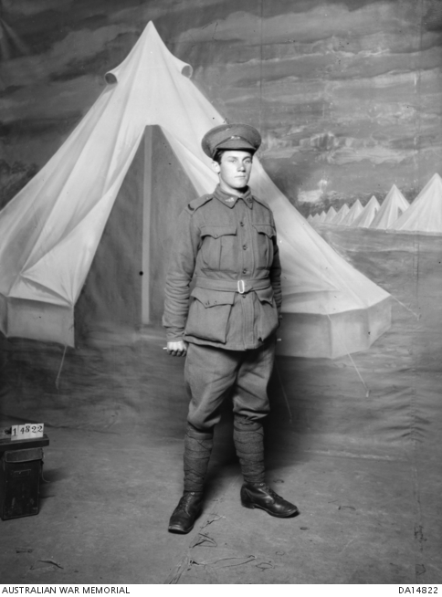

**1916**

14 Feb Enlisted Ararat, posted to Beaufort Camp

16 Mar 39th Battalion, Ballarat

25 Mar 14th Depot Bn, Ballarat

3 Apr Allocated as 1786 to 2nd Reinf, 57th Bn

4 Apr Embarked Melbourne, HMAT Euripides

8 May Disembarked Alexandria

24 May Allocated to 60th Bn, Tel-el-Kebir

13 Jun Embarked Alexandria, HMT Aragon

23 Jun Disembarked Plymouth, England

23 Jun Admitted hospital, Lark Hill, sick

10 Sep Embarked for overseas, Folkestone

11 Sep Marched In 5th Div Base Depot, Etaples

24 Oct Marched Out to join unit

26 Oct Taken on Strength 58th Bn,

11 Dec To 5th Aust Field Ambulance, diarrhoea. Transferred to ANZAC Corps Rest Station

27 Dec Transferred to 36th Cas Clearing Stn, Laryngitis

28 Dec Transferred to Ambulance Train

29 Dec Admitted No. 9 General Hospital, Rouen

**1917**

3 Jan Transferred to England, embarked for England Hosp Ship St David

4 Jan Admitted Boscombe Military Hospital

1 Feb Transferred to 1st Auxiliary Hosp, Harefield

6 Feb Granted Furlough & to report to Perham Downs

21 Feb Marched In to No. 1 Command Depot, Perham Downs, Classified B1A

2 Mar Admitted to Military Hospital, Parkhouse, VD, total period 78 days

18 May Discharged to Duty

19 May Marched In to No. 1 Comd Depot, Classified B1A

17 Sep Proceeded Overseas via Southampton

18 Sep Marched In to 5 ADBD, Havre

25 Sep Marched Out to unit

2 Oct Rejoined Bn, ex hospital

15 Oct Westhoek Ridge: Enemy shelling overnight and again at mid-day

Killed in Action, buried in Vicinity of Zonnebeke, Belgium

Awarded:

British War Medal 36941 Sent 14 Nov 1924

Victory Medal 36648 Sent 28 Feb 1923 Rec’d 12 Mar 1923

Memorial Scroll Sent 25 Jan 1922 Rec’d 8 Feb 1922

Memorial Plaque 335174 Sent 29 Sep 1922 Rec’d 10 Oct 1922

**Virtual War Memorial** - need to amend: Involvement - 4 Apr 1916 - 57th Inf Bn, Third Ypres

**Honour Board of The Boys of the Shirley School** (via Beaufort, Victoria) who fought in the Great War 1914-1919. Identified top to bottom row, left to right:

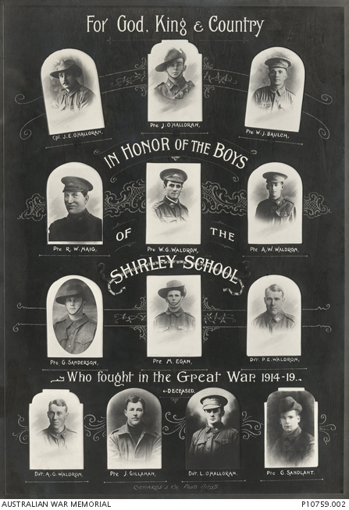

Top Row: 3209 Corporal (Cpl) **James Edward O’Halloran**, killed in action at Pozieres, France on 5 Aug 1916; Private (Pte) J O’Halloran, probably 2537 Driver (Dvr) **Eugene John O’Halloran**, died of dysentery and cerebellum tumor at Malta on 10 Oct 1915; 2566 Pte **William John Baulch**, wounded in action at the Somme, France and died of wounds on 1 Dec 1916.

Second Row: 1806 Pte **Robert William Haig**, killed in action at Bullecourt, France on 3 May 1917; 1786 Pte **Walter George Waldron**, killed in action near Westhoek Ridge, Belgium on 15 October 1917; 1418 Pte **Arthur William Waldron**, returned to Australia on 11 Jan 1918.

Third Row: Pte G. Sanderson, probably V58605 Pte **Gilbert Sanderson**; 6996 Pte **Michael Egan**, returned to Australia 23 Jul 1919; Dvr P.E. Waldron, probably 6926 Sapper (Spr) **Edward Percival Waldron**, returned to Australia 12 May 1919.

Bottom Row: 6927 Spr **Albert George Waldron,** returned to Australia 9 Feb 1919; Pte J Gillahan, either 1452 Pte **Joseph Simon Gillahan**, returned to Australia 14 Dec 1918 or 1913 Pte **Leo Gillahan**, wounded in action at Bullecourt, France and died of wounds on 13 May 1917; Dvr L O’Halloran, probably 6919A Pte **Lawrence O’Halloran**, returned to Australia 10 Dec 1918; Pte G Sandlant, probably 434 Pte **George Albert Sandlant**, returned to Australia 24 Sep 1918.

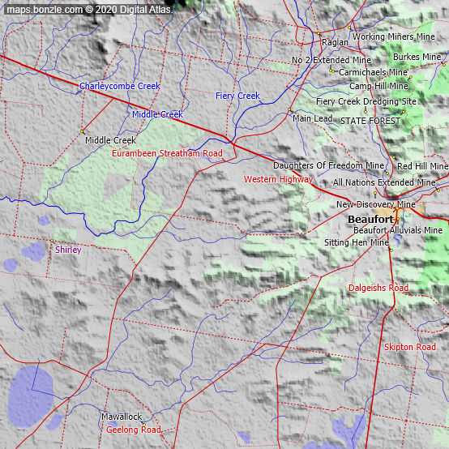

You'll find the locality of Shirley just off the [Fiery Creek](http://bonzle.com/c/a?a=p&p=212249&cmd=sp&s=The%20Three%20Sisters&pg=4&m=6&c=1&x=143%2E298165&y=%2D37%2E43635&w=19627&mpsec=0) in Victoria about 160km west-northwest of [Melbourne](http://bonzle.com/c/a?a=p&p=854&cmd=sp&s=The%20Three%20Sisters&pg=4&m=6&c=1&x=143%2E298165&y=%2D37%2E43635&w=19627&mpsec=0). Shirley is at an altitude of about 340m above sea level.

The nearest ocean is the Southern Ocean about 120km south-southwest of Shirley.

The nearest more populous place is the village of [Beaufort](http://bonzle.com/c/a?a=p&p=39&cmd=sp&s=The%20Three%20Sisters&pg=4&m=6&c=1&x=143%2E298165&y=%2D37%2E43635&w=19627&mpsec=0) which is (ENE) 15km away with a population of around 990

<https://honouringveterans.org/search-veterans-born-in/beaufort-VIC> All WW2

Allan George Waldron, b 5 May 1919, Beaufort, Enl 3 Jun 41, Coleraine, disch 5 Feb 44, Pte Army

NoK Samuel Waldron

Frank Waldron, b 12 Apr 21, Beaufort, Enl 4 Feb 43, Roweville, disch 9 Nov 45, Dvr Army

NoK Samuel Waldron

Ralph Edward Waldron, b 8 Jul 1912, Beaufort, Enl 7 Jul 41, Coleraine, Disch 30 Oct 45, Pte, Army

NoK Samuel Waldron

Walter Esmond Waldron, b 24 Nov 18, Beaufort, Enl 24 Jul 42, Roweville, Disch 24 Jun 46, Cpl Army

NoK William Waldron

William Arthur Waldron, b 9 Oct 20, Beaufort, Enl 2 Nov 42, Melbourne, Disch 27 Dec 43, LAC RAAF,

NoK George Waldron

William Ernest Vernon Waldron, b 2 Feb 15, Beaufort, Enl 16 Jul 41, Westmere, Disch 24 Sep 45, Pte Army,

NoK William Waldron

**Walter George Waldron** was not listed!

<https://firstworldwaronthisday.blogspot.com/2017/10/747-died-on-this-day-mon-15101917>

[First World War - On this day: 747 died on this day: Mon 15/10/1917](https://firstworldwaronthisday.blogspot.com/2017/10/747-died-on-this-day-mon-15101917.html)

Belgium: West-Vlaanderen MENIN ROAD SOUTH MILITARY CEMETERY

2937 Private ROBERT EDWARD McSULLEA 58th Bn. Australian Infantry, A.I.F.

Belgium: West-Vlaanderen YPRES (MENIN GATE) MEMORIAL (53)

1868 Private EDGAR WILLIAM ABLEY 58th Bn. Australian Infantry, A.I.F.

1669 Private ARCHIBALD CHARLES **BROWN** (M M) 58th Bn. Australian Infantry, A.I.F.

1683 Sergeant ARTHUR **CRICK** 58th Bn. Australian Infantry, A.I.F.

3091 Private PATRICK HUGHES 58th Bn. Australian Infantry, A.I.F.

1786 Private **WALTER GEORGE WALDRON** 58th Bn. Australian Infantry, A.I.F.

Note, Brown, Crick and Waldron all sailed with 2nd Reinf, 57th Bn.

AIF Project: Walter George WALDRON

|  |  |
| --- | --- |
| Regimental number | 1786 |
| Place of birth | Middle Creek, Victoria |
| School | Middle Creek State School No. 1045, Victoria |
| Religion | Church of England |
| Occupation | Farmer |
| Address | Middle Creek, Victoria |
| Marital status | Single |
| Age at embarkation | 20 |
| Next of kin | Mother, Mrs T Waldron, Middle Creek, Victoria |
| Enlistment date | 14 February 1916 |
| Rank on enlistment | Private |
| Unit name | [57th Battalion, 2nd Reinforcement](https://www.aif.adfa.edu.au/showUnit?unitCode=INF57REIN2) |
| AWM Embarkation Roll number | 23/74/3 |
| Embarkation details | Unit embarked from Melbourne, Victoria, on board HMAT A14 *Euripides* on 4 April 1916 |
| Rank from Nominal Roll | Private |
| Unit from Nominal Roll | 58th Battalion |
| Fate | Killed in Action 15 October 1917 |
| Age at death | 22 |
| Place of burial | No known grave |
| Commemoration details | The Ypres (Menin Gate) Memorial (Panel 29), Belgium  The Menin Gate Memorial (so named because the road led to the town of Menin) was constructed on the site of a gateway in the eastern walls of the old Flemish town of Ypres, Belgium, where hundreds of thousands of allied troops passed on their way to the front, the Ypres salient, the site from April 1915 to the end of the war of some of the fiercest fighting of the war.  The Memorial was conceived as a monument to the 350,000 men of the British Empire who fought in the campaign. Inside the arch, on tablets of Portland stone, are inscribed the names of 56,000 men, including 6,178 Australians, who served in the Ypres campaign and who have no known grave.  The opening of the Menin Gate Memorial on 24 July 1927 so moved the Australian artist Will Longstaff that he painted 'The Menin Gate at Midnight', which portrays a ghostly army of the dead marching past the Menin Gate. The painting now hangs in the Australian War Memorial, Canberra, at the entrance of which are two medieval stone lions presented to the Memorial by the City of Ypres in 1936.  Since the 1930s, with the brief interval of the German occupation in the Second World War, the City of Ypres has conducted a ceremony at the Memorial at dusk each evening to commemorate those who died in the Ypres campaign. |
| Panel number, Roll of Honour, | 166 Australian War Memorial |
| Miscellaneous information from   cemetery records | Son of George and Sarah Amelia Waldron, Middle Creek, Victoria |
| Family/military connections | Two cousins killed in action.  Possibly Leonard Waldron 149 8th Bn, KiA 25 Apr 1915, Gallipoli  and William Waldron 7340 5th Bn KiA 19 Apr 18, France |
| Other details | War service: Western Front  Medals: British War Medal, Victory Medal |