MAJOR ALEXANDER SANDERSON
Commanding Officer - 3rd Australian Tunnelling Company

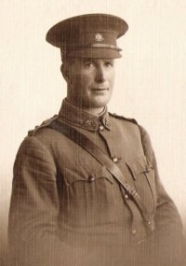
Born on 3 Dec 1881 at Oamaru, Otago, New Zealand, the son of William James Alexander and Augusta Sanderson, Alexander Sanderson was appointed to Commission rank, 2nd Lieutenant, on 11 December 1915.
Captain Alexander Sanderson - 1916

A single Civil & Mining Engineer and Licensed Surveyor, he completed the Attestation Paper of Persons Enlisted for Service Abroad on 1 February 1916, underwent a medical examination at Casula, New South Wales on 14 February, which found him to be fit for active service, and signed the Attestation Paper the same day. He stated that he had been in the Engineer Officers Training Corps for a period of two months.

Alex was 34 years and 2 months of age in February 1916. He was 5ft 9in tall, weighed 169lbs, had a fair complexion, grey eyes and light brown hair.

He gave as his Postal address ‘The Gables’, Stirling Road, Claremont, Western Australia and named his mother, Augusta Sanderson of the same address as his Next of Kin, his father being deceased.

He was promoted to Captain on 16 February 1916 and allotted to the Technical Staff of the Australian Mining Corps as the Surveyor.

The Australian Mining Corps left Sydney, N.S.W. on HMAT A38 S.S. Ulysses on February 20, 1916. Their voyage sailed via Melbourne, Victoria, and Fremantle, Western Australia where additional members of the Corps were embarked. After a delay of about a month due to Ulysses requiring repairs following a collision with an uncharted rock when leaving Fremantle. The men on board nicknamed her ‘Useless’. Captain Alex Sanderson personally supervised the filling of the gash in the ship with concrete (he was later a pioneer of reinforced concrete) so it could sail to Europe.

In his memoirs, Alex wrote:

“When the ship hit a reef going into Fremantle harbour, the plates were stripped for 40 feet and, although there was a gap in the outside plate, the inner bilge plates were not punctured. I personally went down in a diving suit. I suggested that 250 tons of reinforced concrete were pumped into the ship, lying on its side in the harbour covered in tarpaulins and timber. They gave it 3 weeks to harden.”

The Captain of the ship was reluctant to take Ulysses out of the Suez Canal because he felt the weight of the ship made it impossible to manoeuvre in the situation of a submarine attack.

Alex again wrote:

“It was just as well all cargo etc was transferred into a new ship before leaving Alexandria, Egypt, as just outside the port two submarines had a go at us and torpedoes fired at us, they missed us by a few yards.”

The troops were transhipped to HM Transport B.1 Ansonia, which docked at Marseilles, France on May 5, 1916, where the Corps disembarked. As a unit they entrained at Marseilles on 7 May and detrained on 11 May at Hazebrouk.

The Australian Mining Corps was disbanded and redesignated into three tunnelling companies and a technical unit named the Australian Electrical and Mechanical Mining and Boring Company. Alex was apparently attached to the 3rd Australian Tunnelling Company, which immediately went to work, relieving the 255th Tunnelling Company, Royal Engineers, in several sectors along the First Army Front.

On 3 June, the unit fired its first ‘push-pipe’ mine, a method of making communication trenches very quickly during an attack. The unit became well known for its work with push-pipes at the Boars Head, and was specifically requested by General Haking during his planning for the Fromelles offensive.

“Near PICANTIN on the night of the 18/19th July 1916, he worked under heavy shell fire in a forward sap, which gave little or no cover in pushing and exploding loaded pipes to form a communication trench. The leads for exploding were several times cut by shell fire, and it was therefore necessary to go out in front of the trenches to light the fuse. The first attempt was stopped by shell fire, which caused six casualties including the O.C. the Company. He succeeded however in a second attempt to fire the charge, which was entirely successful. He showed great pluck and determination throughout.”

Captain Sanderson was officially transferred from Headquarters, Mining Corps to 3rd Tunnelling Company on 30 July 1916, the same date his Next of Kin were advised that he had been wounded on 20 July, but had remained on duty.

The Commanding Officer of the Company, Major Jack Coulter, was also wounded on 20 July, his wounds being more serious, he was hospitalised and Alex Sanderson was, on 26 July, given ‘Temporary Command of the 3rd Tunnelling Company during the absence of Major Coulter L.J. DSO, from 30 July 1916 to 12 September 1916’.

Captain Alex Sanderson was awarded the Military Cross for his actions on 18/19 July, the award appearing in the London Gazette of 26 September 1916. He was taken on strength of the 3rd Tunnelling Company on 1 October 1916, and continued to work with the unit.
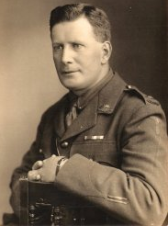
Major Alexander Sanderson DSO MC+Bar - 1918
“During a raid carried out against enemy trench East of LOOS by two Infantry Battalions on the evening of the 28th June 1917, Capt. Sanderson entered the enemy trench with some men of his Coy. This Officer did excellent work reconnoitring the enemy’s mining system behind the point of entry, and cutting the leads. The party successfully destroyed three enemy mine shafts and blew in two dugouts.”

On 29 June 1917 he was wounded in action (2nd occasion), again remaining on duty. Major Jack Coulter was killed during this action, and 1 July 1917 Alex was ‘Promoted to Major - to Command 3rd Tunnelling Company’.

His mother was advised of his wounding on 7 July, and the London Gazette of 17 September 1917 recorded the awarding of a Bar to his Military Cross for his actions on 28 June.

On 28 September 1918, the Royal Engineers Controller of Mines, First Army, recommended Alex for a Distinguished Service Order:

“This Officer has done consistent good work in mine fighting and subway construction under trying conditions during past two years on the Loos – Hill 70 front. He has Commanded the 3rd Australian Tunnelling Company since 1.7.17 with exceptional ability and has always inspired his officers and men by his gallantry and coolness when under heavy shell fire.”

The Major General, Chief Engineer, First Army, wrote in the margin of the recommendation “a very gallant Officer”.

Alex was Mentioned in the Despatches of Sir Douglas Haig’s Despatch of 8 November 1918, the award appearing in the London Gazette of 27 December 1918.

Major Alex Sanderson left France on 14 March 1919 returning to the United Kingdom where he was granted leave with pay and subsistence from 2 April to 30 November 1919 to pursue non-military employment (N.M.E.) in Engineering with Parry Black & Parry of 82 Victoria Street, London.
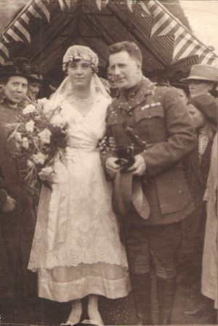
On 19 November 1919, the 36-year-old Alex married 18-year-old Gladys Royle Burden of Otford, near Seven Oaks, the daughter of Henry John Burden, Managing Director of Company.

When his N.M.E. expired, he was granted leave from 3 December to 18 December 1919, departing London with his wife on 20 December, on board Runic on Duty (O.C. Troops). The ship arrived in Australia on 21 February 1920 and Alex was granted leave in Melbourne from 21 February to 21 April 1920 – his address recorded as: Menzies Hotel, Melbourne.

The Appointment of Major Alexander Sanderson DSO MC+Bar MiD was terminated on 21 April 1920 in the 3rd Military District (Victoria).

The Register of Tunnelling Company Officers – February 1925 records that in 1925 Alex was living at Allahabad, India and Claremont, WA.

Alexander Sanderson died on 9 August 1971 in Beckenham, Kent, aged 90. His ashes were interred in St Bartholomews Church in Sydenham, London.

His brother William Lauchlan Sanderson (known as Lauchlan) was born in Oamaru, New Zealand on 23 October 1890 and was a Surveyor and Drainage Engineer by profession when he enlisted in October 1914. 219 Sergeant Sanderson embarked from Australia on 8 February 1915 with the 10th Light Horse, and embarked for Gallipoli on 16 May with the same unit. He was promoted temporary 2nd Lieutenant on 15 August and suffered a gun shot wound to the back on 29 August, which required his evacuation to hospital in Malta. He embarked for hospital in England in September, and after recovering was placed on the supernumery list, before being re-assigned to the 4th Divisional Artillery in the Middle East theatre.

In June he proceeded to join the British Expeditionary Force in France and was promoted to Lieutenant in August 1916. He was promoted to Captain in January 1918 and taken on strength of the 11th Field Artillery Brigade on 11 April 1918.

In May 1918, Lauchlan took part in the fighting around Villers-Bretonneux as the Special Liaison Officer with the Moroccan and 37th French Divisional Artillery, French army Corps, and was recommended for the Military Cross. The award was upgraded and he was made an Officer of the Military Division of the Most Excellent Order of the British Empire (OBE).

He was awarded the Military Cross for directing artillery during the forcing of the Oise-Sambre Canal on 4 November 1918. Lauchlan was also awarded the Croix de Guerre Avec Etoile, and was Mentioned in the Despatches of Sir Douglas Haig’s Despatch of 8 November 1918.

He led the Australian contingent on a white horse in the Victory parade in London, and later was a founding member of the Flying Doctor Service in Australia.

Lauchlan enlisted 15 August 1940 at Cottesloe, Western Australia, for service in World War 2 and served as a Lieutenant with the 16th Battalion until discharged on 27 July 1945.

British Biographical Index: Burkes OBEs (1921)

SANDERSON, Capt. William Lauchlin, O.B.E., M.C. b. 23 Oct 1890; son of W.J.A. SANDERSON, of New Zealand and India. Educ.: Scotch Coll., Western Australia. Irrigation and Drainage Engineer; at present engaged in pastoral pursuits. War Work: Embarked from Western Australia with the Australian Light Horse, and served on Gallipoli, and after the evacuation, transferred to the 4th Australian Divisional Artillery, and served with them in France and Flanders from June, 1916, till the termination of the war; French Croix de Guerre; mentioned in despatches. Addresses: Claremont, Western Australia: Kooline Station, via Onslow, W.A.
Club: Naval And Military (Western Australia)

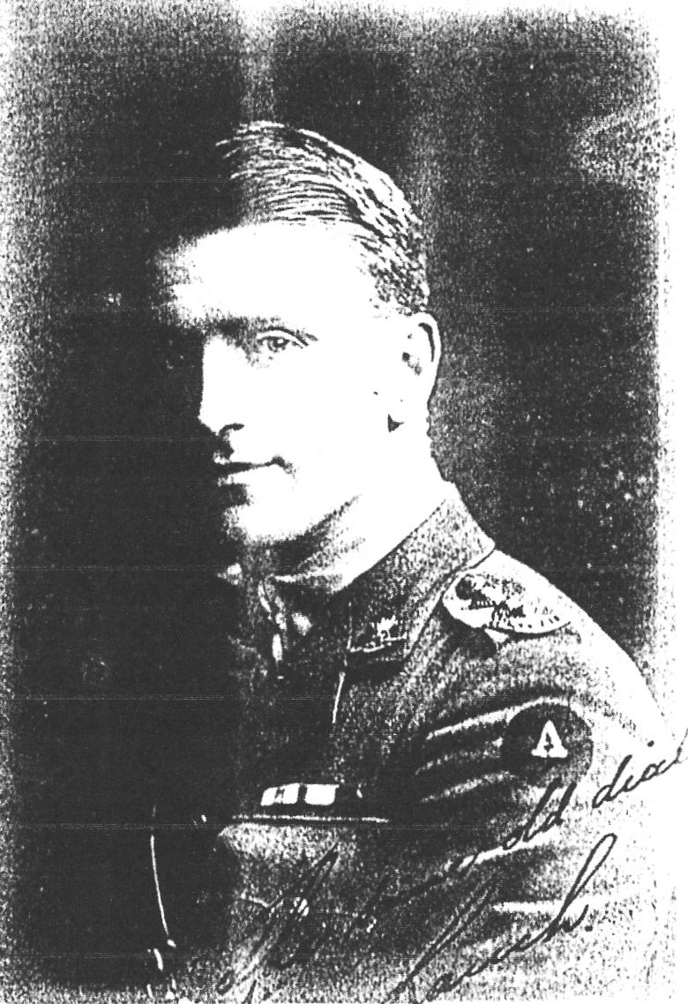

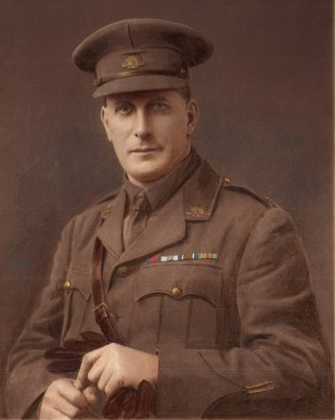
Major Alexander Sanderson DSO MC+Bar MiD - 1919
© Donna Baldey 2008 www.tunnellers.net
Compiled from records held by National Archives and information kindly provided by Robin Sanderson, Paris, France,
grandson of Major Alexander Sanderson. All photos provided by, & Copyrighted to, Robin Sanderson.

