Flight Sergeant Raey Hilton CHEATLE

Service No: 432755
Born: Bankstown NSW, 11 July 1924
Family: Son of Noel Rodney and Mabel Ruth Cheatle, Twin brother of Flight Sergeant
Allen Leonard Cheatle (432305)
Trade/calling: Clerk
Enlisted in the RAAF: 30 January 1943
Unit: No. 97 Squadron (RAF), RAF Station Coningsby
Died: Air Operations (No. 97 Squadron Lancaster aircraft ND961), Netherlands, 8
February 1945
Buried: Eindhoven (Woensel) CWGC Cemetery RR30, Noord-Brabant, Netherlands
At 21:05 hours on the night of 7 February 1945 Lancaster ND961 took off from Coningsby to bomb the Dortmund-Ems canal at Ladbergen, Germany. Raey was the wireless operator and air gunner. Nothing was heard from the aircraft after take-off and it failed to return to base. It seemed that on the way back from the mission the ND961 collided with Lancaster aircraft PB181 and crashed above the villages of Son and Best in then already liberated Holland. All but one of the crew members (the pilot of PB181) on both aircraft were killed.
The two Lancasters were part of a fleet of 177 Lancasters and 10 Mosquitoes from Group No 5. Target was the destruction of the aqueducts near Ladbergen, in particular the reclamation of the Dortmund-Ems canal banks —an important transport route for the German war industry. Previous air raids on Ladbergen had already led to the loss of dozens of Lancaster bombers.
Ladbergen is a place northeast of Münster and was an important target area because of the junction of the waterways. The German army used this important nodal point for the supply of raw materials for the war industry and the transport of war equipment . Between 1944 and 1945, several attacks on the Ladbergen aqueducts took place.
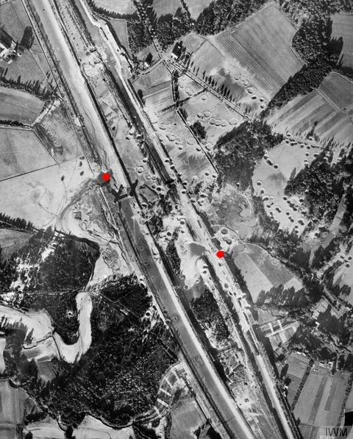 Ladbergen waterway junction 1944
After every successful attack, the Germans deployed thousands of forced laborers from the Todt Organisation to repair the damage. This led to new air raids on the aqueducts every few months, also in February 1945.
After departure, all radio communication between the Bomber Command and the Lancasters was broken.
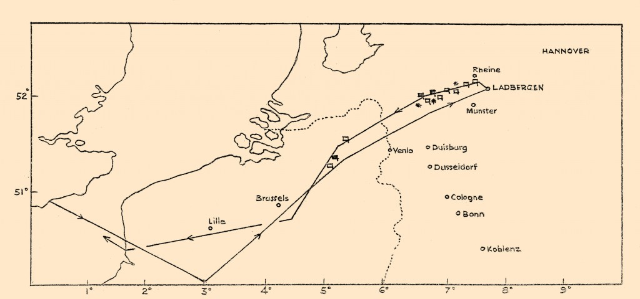
Approach route and back flight route from the Lancasters to Ladbergen.
On the way back the weather conditions were bad, poor visibility possibly was at the root of the high-level collision, which caused the pilots to crash near Best. Because both aircraft collided in midair, the damage was considerable and the aircraft were no longer controllable. When an aircraft goes into a dive, enormous aerodynamic forces are released on the aircraft. A Lancaster has an empty weight of 17 ton with a wing surface of 120 square metres and usually flies at an altitude of approximately 8 km.
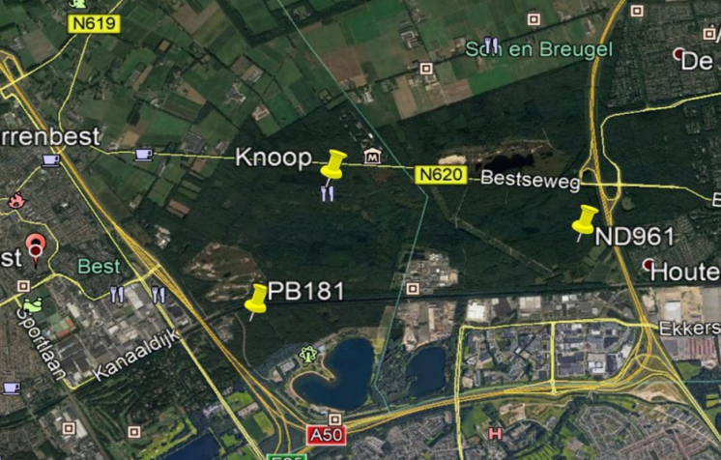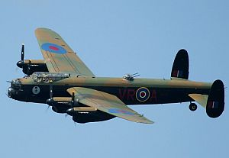
PB181- Lancaster crashed near the Lisseven in Best. ND961- Lancaster crashed near the Zandstraat in Son.
The crew members of ND961 were:
Flight Sergeant Percival George Cannon (1801327) (RAFVR) (Mid Upper Gunner)
Flight Sergeant Raey Hilton Cheatle (432755) (Wireless Air Gunner)
Flight Lieutenant Gerald Stansfield Johnson DFC & Bar (50002) (RAF) (flying as visual Air Bomber)
Sergeant David Strang Lennie (1824951) (RAFVR) (Rear Gunner)
Lieutenant Charles William McGregor (31794V) (SAAF) (Pilot)
Flying Officer Arthur Joseph Norton (154646) (RAFVR) (Navigator)
Sergeant Jonathon Shield (177165) (RAFVR) (Flight Engineer)
Flight Lieutenant Robert Cecil Smalley (J/25766) (RCAF) (Air Bomber)
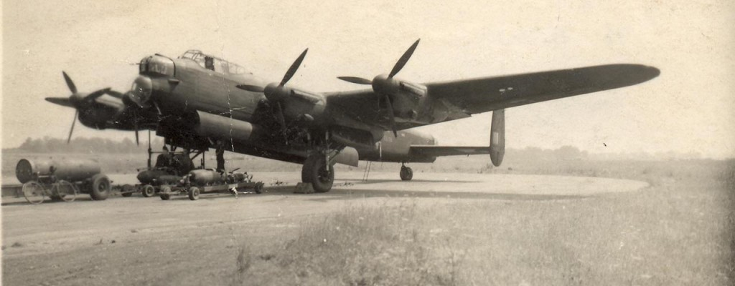
Lancaster of 97 Squadron before take-off when loading the bombs
Raey is burried in Woensel (Eindhoven) cemetery at plot RR30. His Twin brother Flight Sergeant Allen Leonard Cheatle died on 25 July 1944, when his Halifax EB190 bomber crashed during a non-operational practice just inside the border with Yorkshire, and about 5 miles north east from Doncaster.

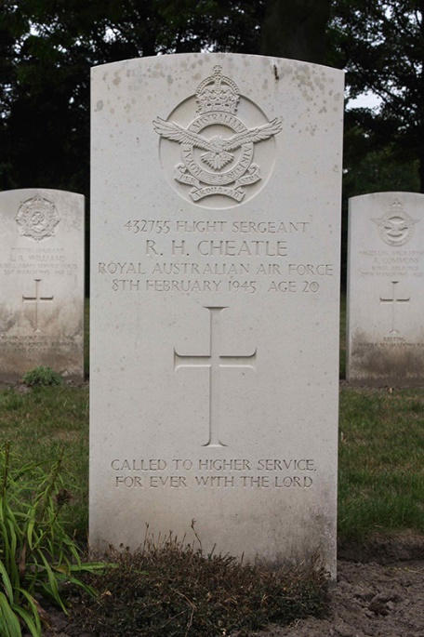 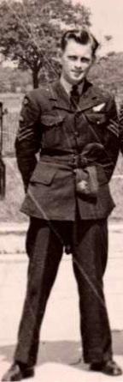 Allen Cheatle
