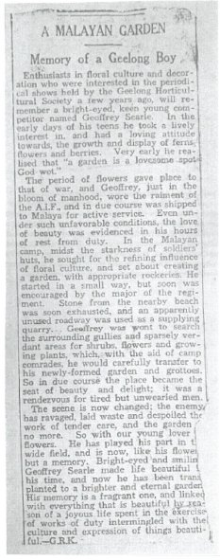

The Geelong Advertiser, circa February 1942

‘A Malaysian Garden -memory of a Geelong Boy’