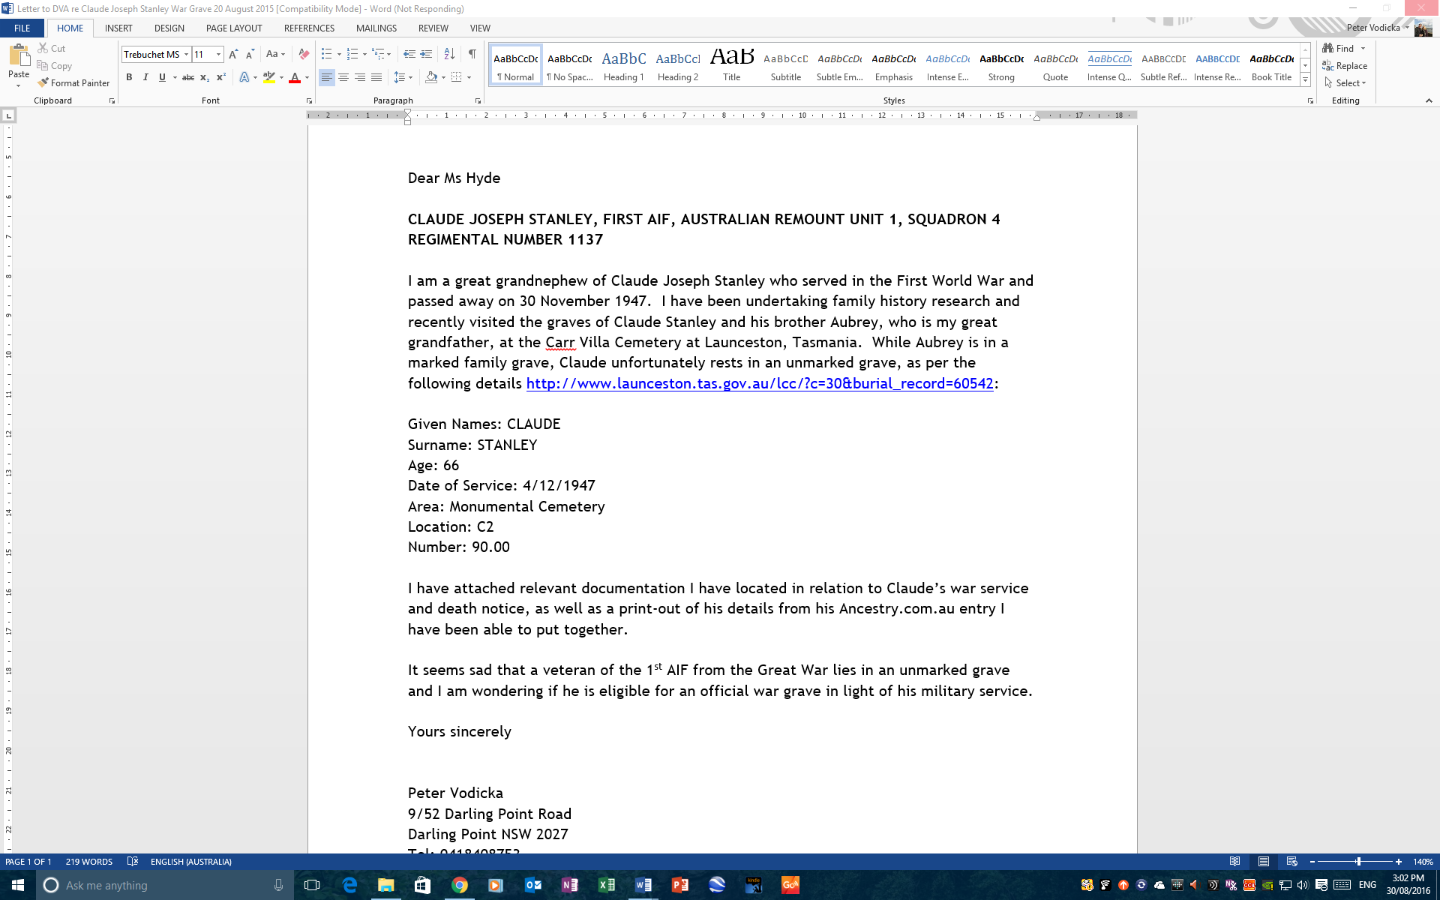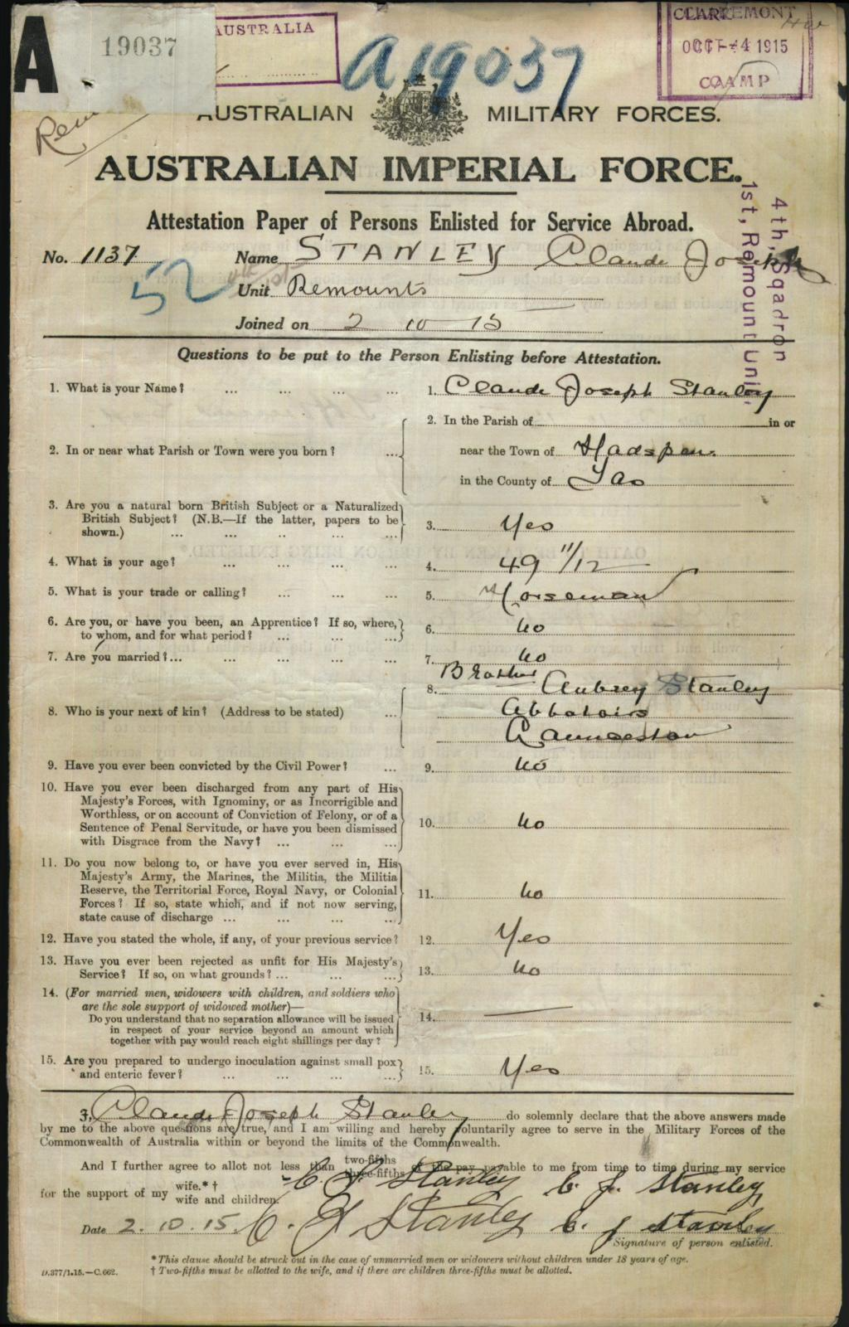

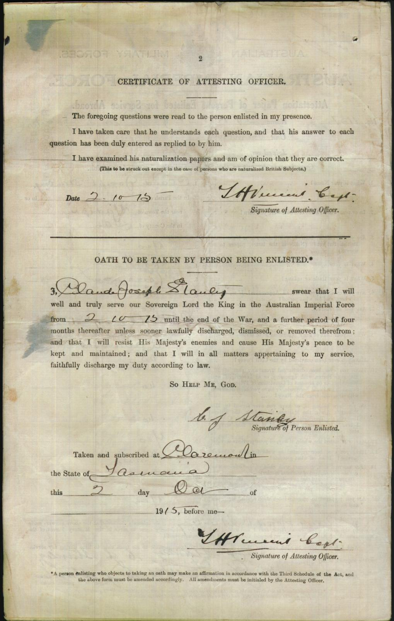

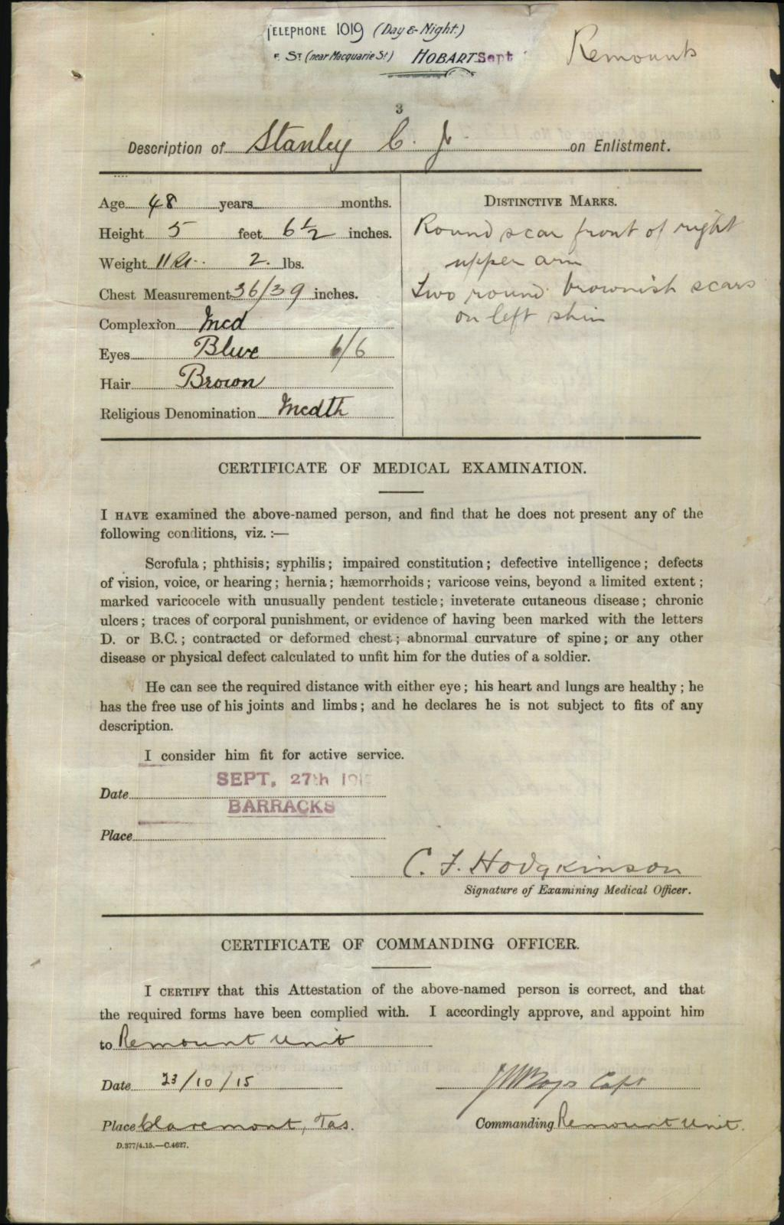

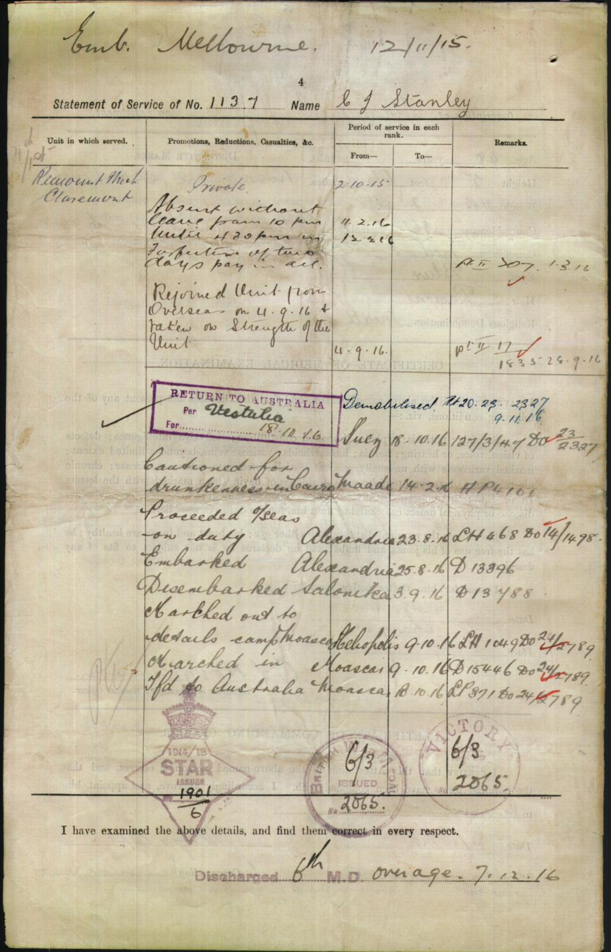

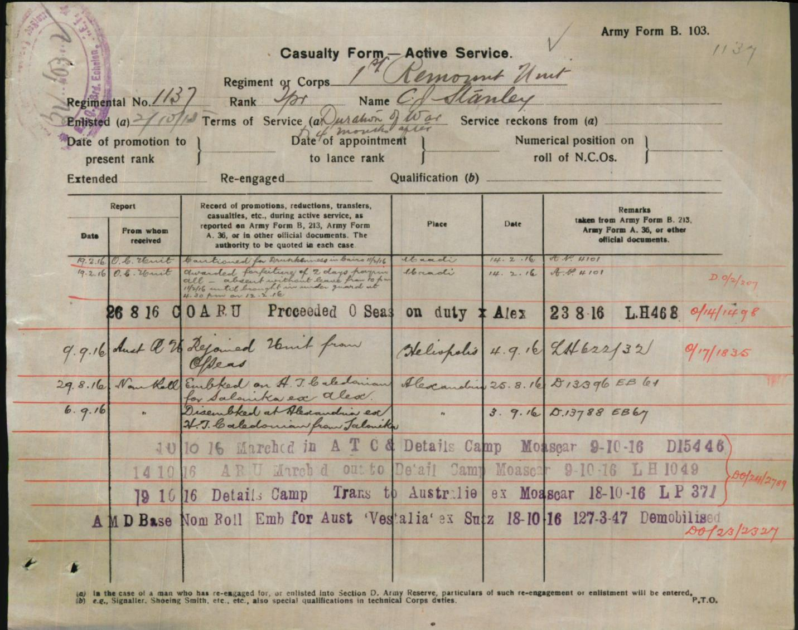

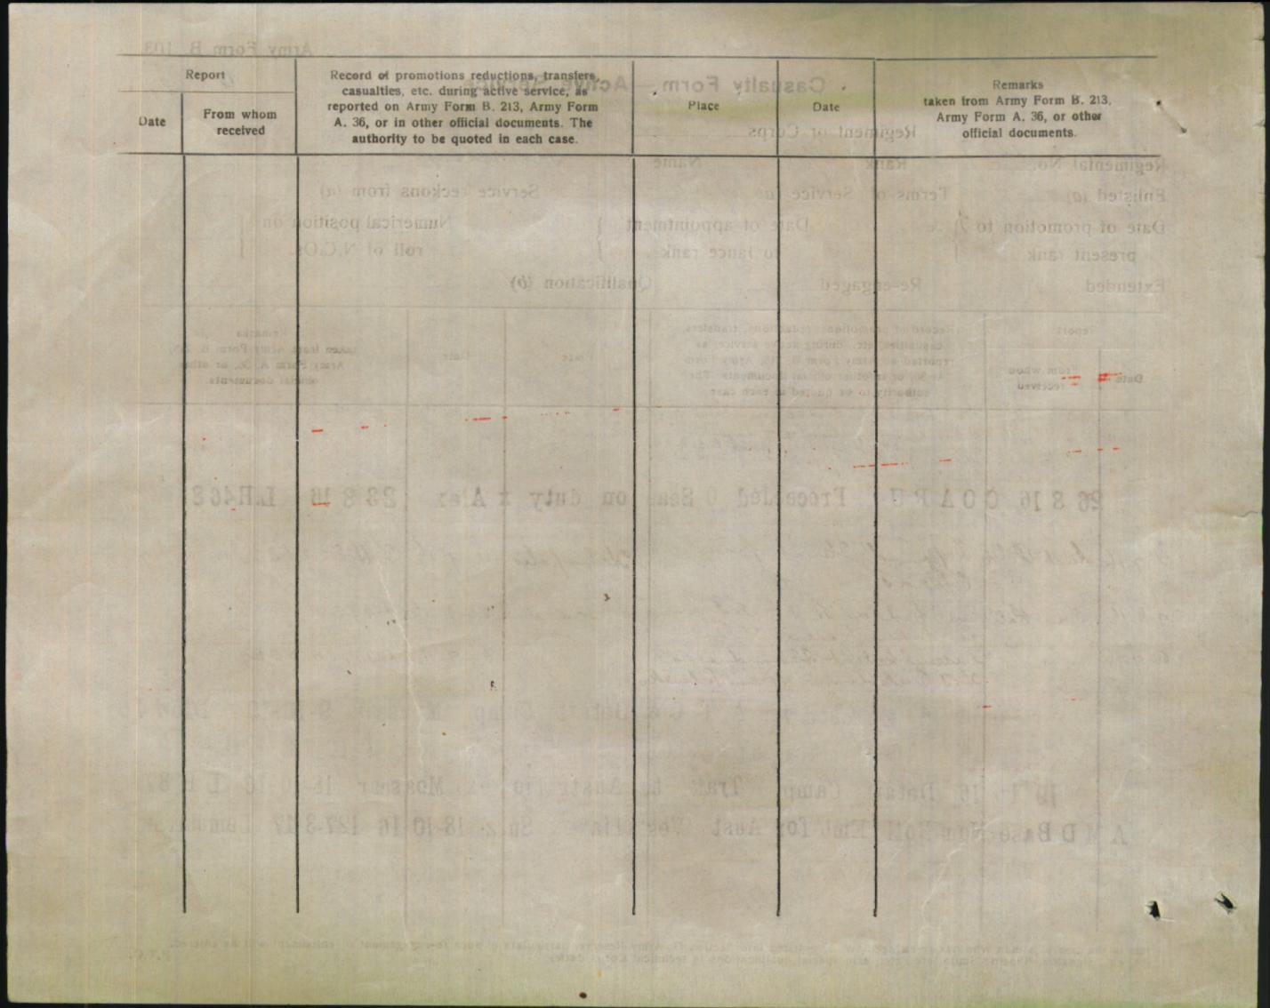

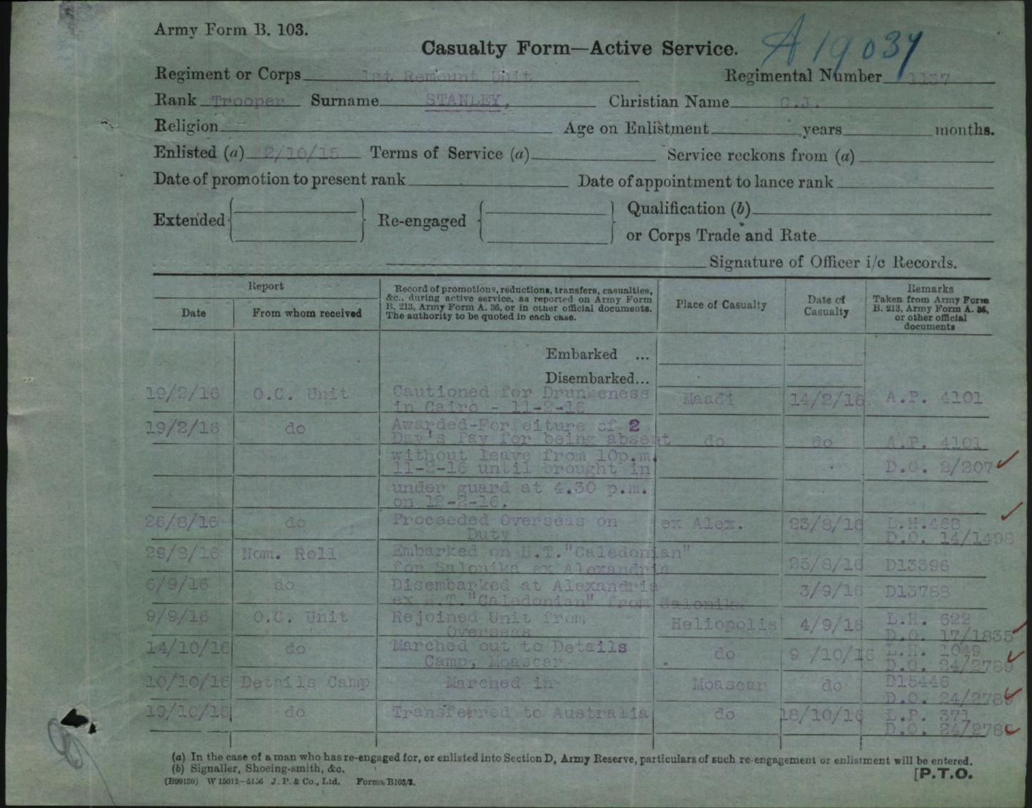

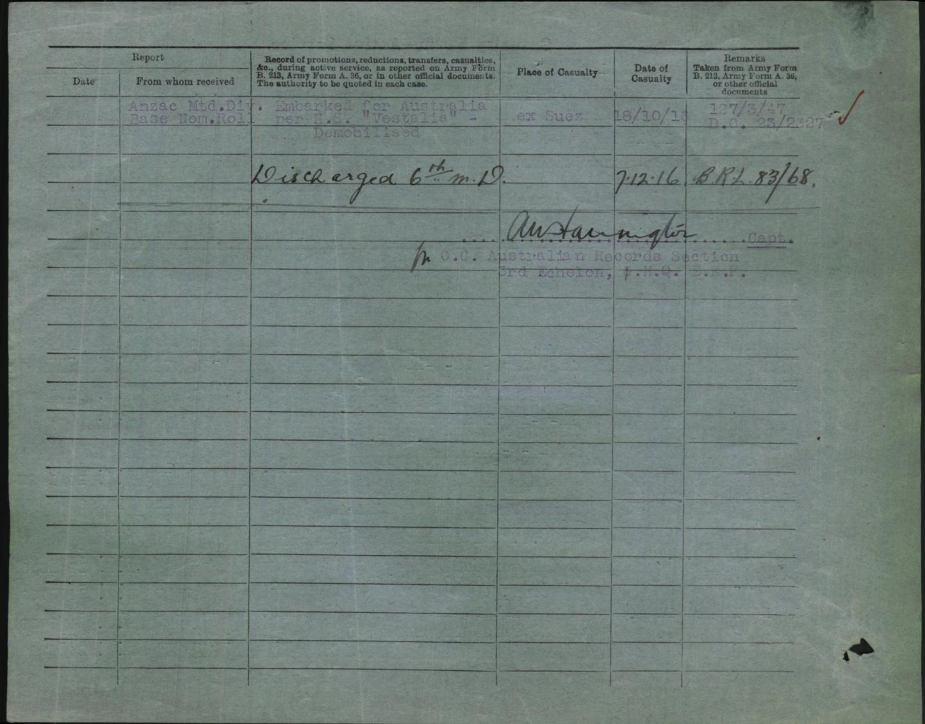

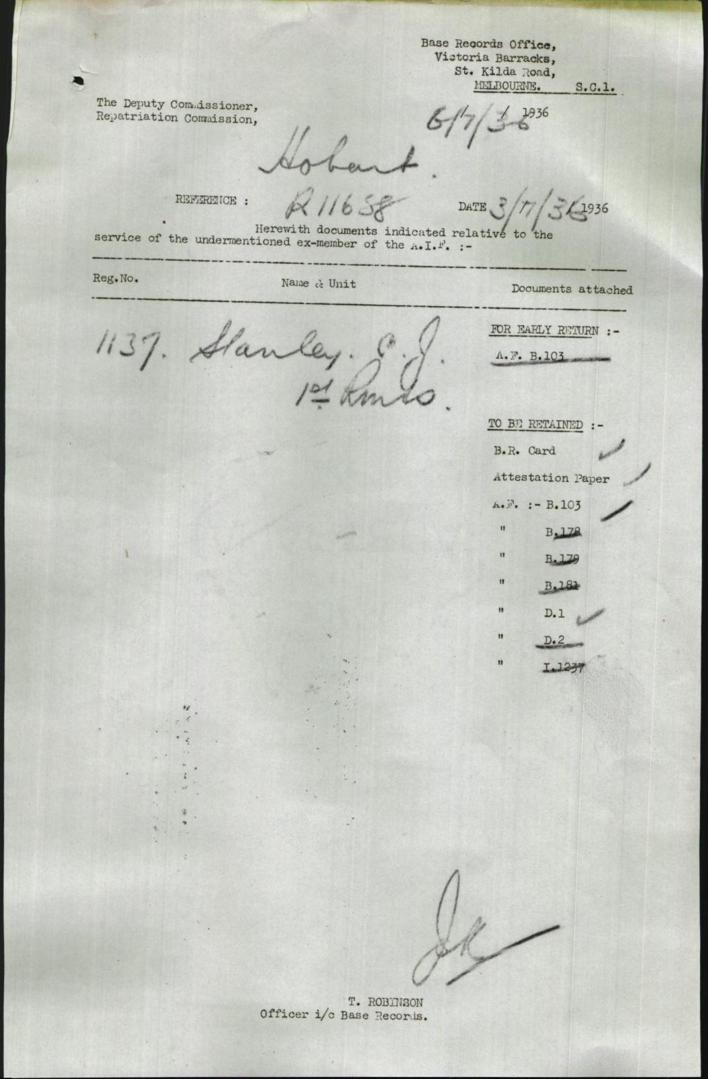

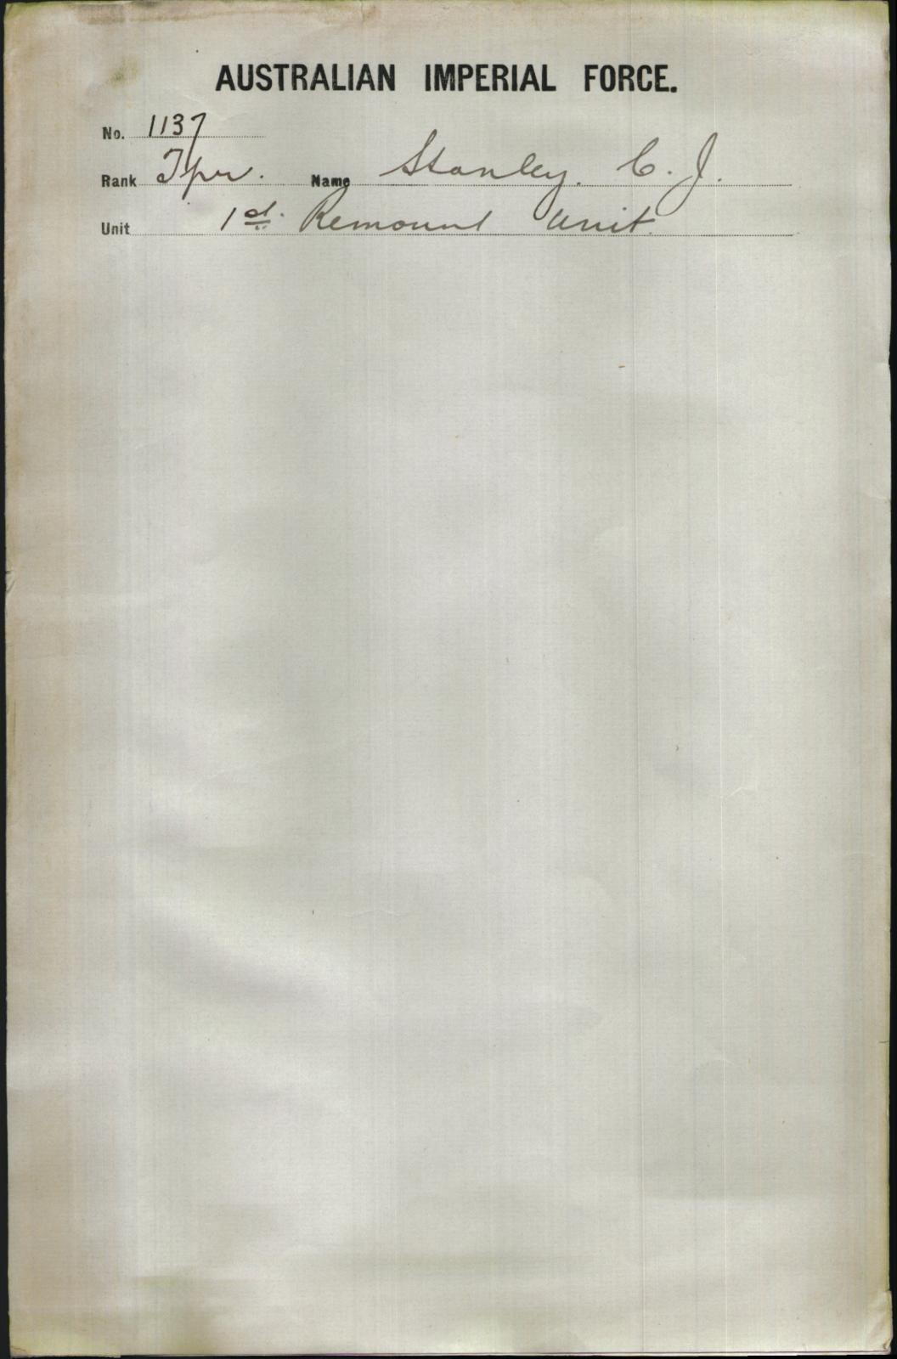

|  |  |
| --- | --- |
| **Item details for: B2455, STANLEY CLAUDE JOSEPH** | [View digital copy](javascript:void(openImageWin('/scripts/Imagine.asp?B=8090654',%20'imageWin'))) [http://recordsearch.naa.gov.au/NameSearch/images/View-record.png](javascript:void(openImageWin('/scripts/Imagine.asp?B=8090654',%20'imageWin')))    [Request copy](javascript:__doPostBack('ucItemDetails$lbtnRequestCopy','')) |
| |  |  | | --- | --- | | Title | STANLEY Claude Joseph : Service Number - 1137 : Place of Birth - Hadspen TAS : Place of Enlistment - Claremont TAS : Next of Kin - (Brother) STANLEY Aubrey | | Contents date range | 1914 - 1920 | | Series number | [B2455](http://recordsearch.naa.gov.au/scripts/SessionManagement/SessionManager.asp?Module=SearchNRetrieve&Location=SNRSeriesDetail2&SeriesNo=B2455) Click to see which government agency or person created this item. | | Control symbol | STANLEY CLAUDE JOSEPH | | Item barcode | 8090654 | | Location | Canberra | | Access status | Open | | Date of decision | 25 Apr 2006 | | Physical format | PAPER FILES AND DOCUMENTS (allocated at series level) | | Records authority class number | 1023540 | | Date registered | 12 Apr 2005 | | |