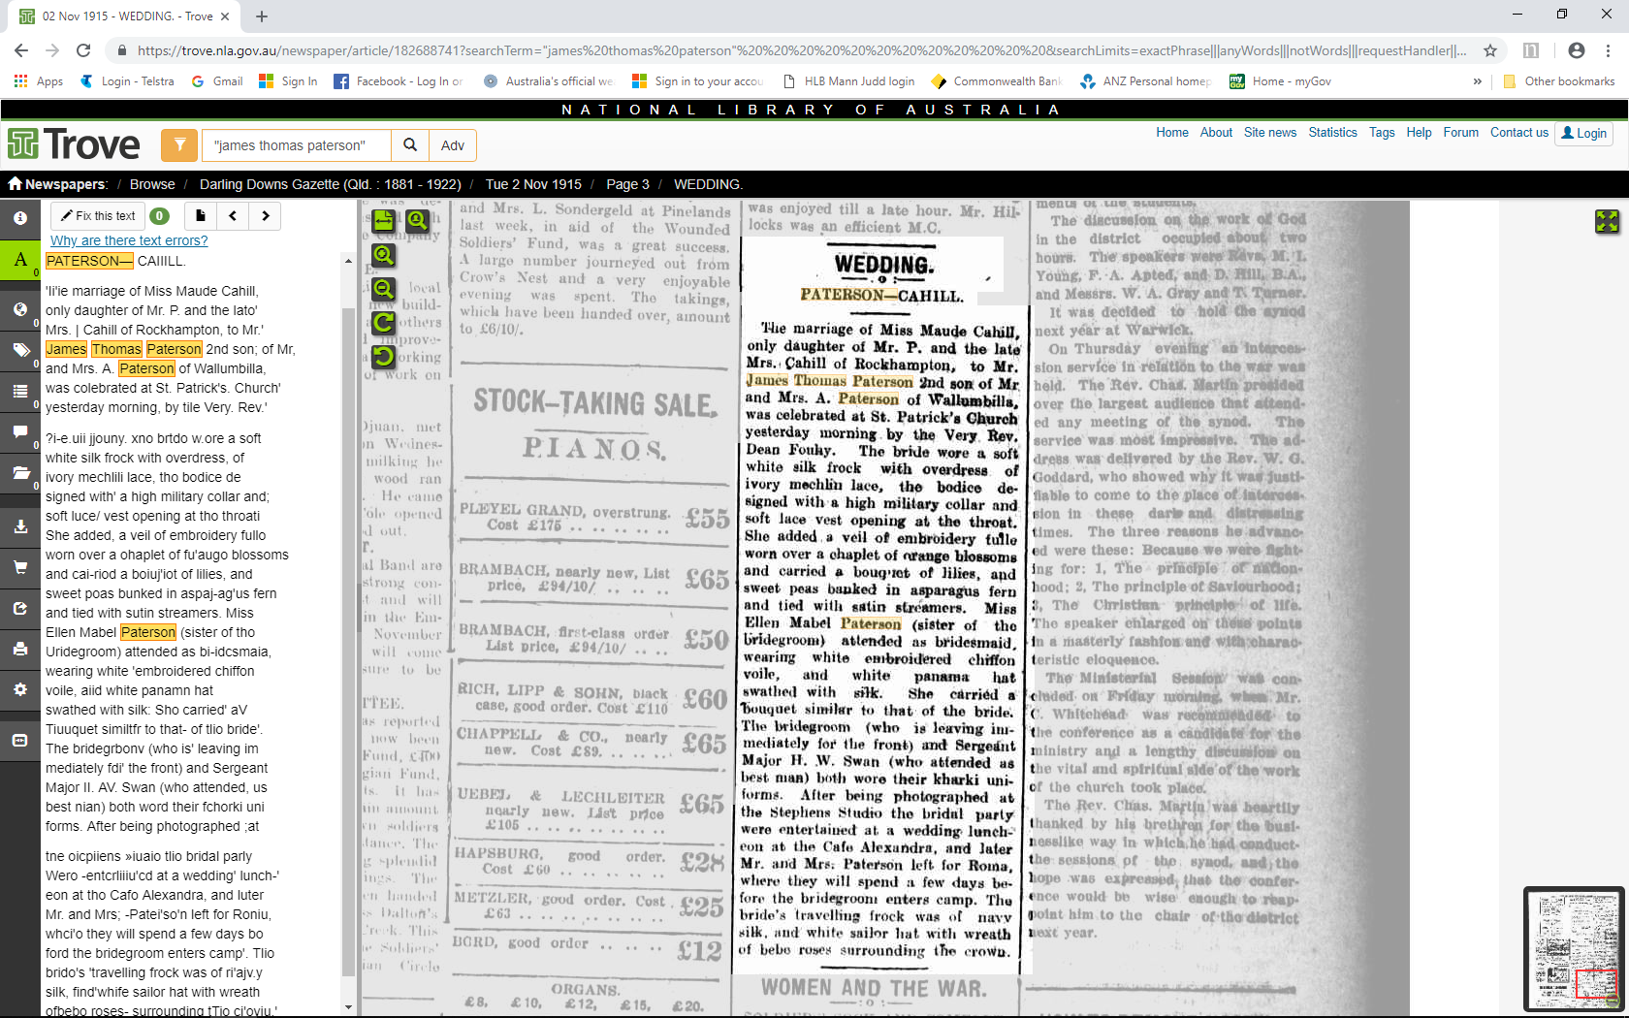
Darling Downs Gazette, Tuesday 2 November 1915, p. 3

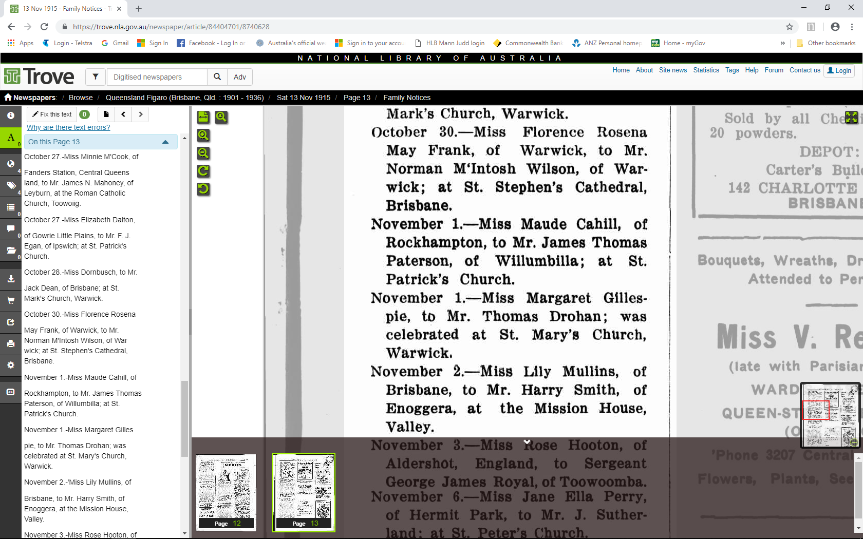
Queensland Figaro, Saturday 13 November 1915, p. 13 Family Notices – Marriages

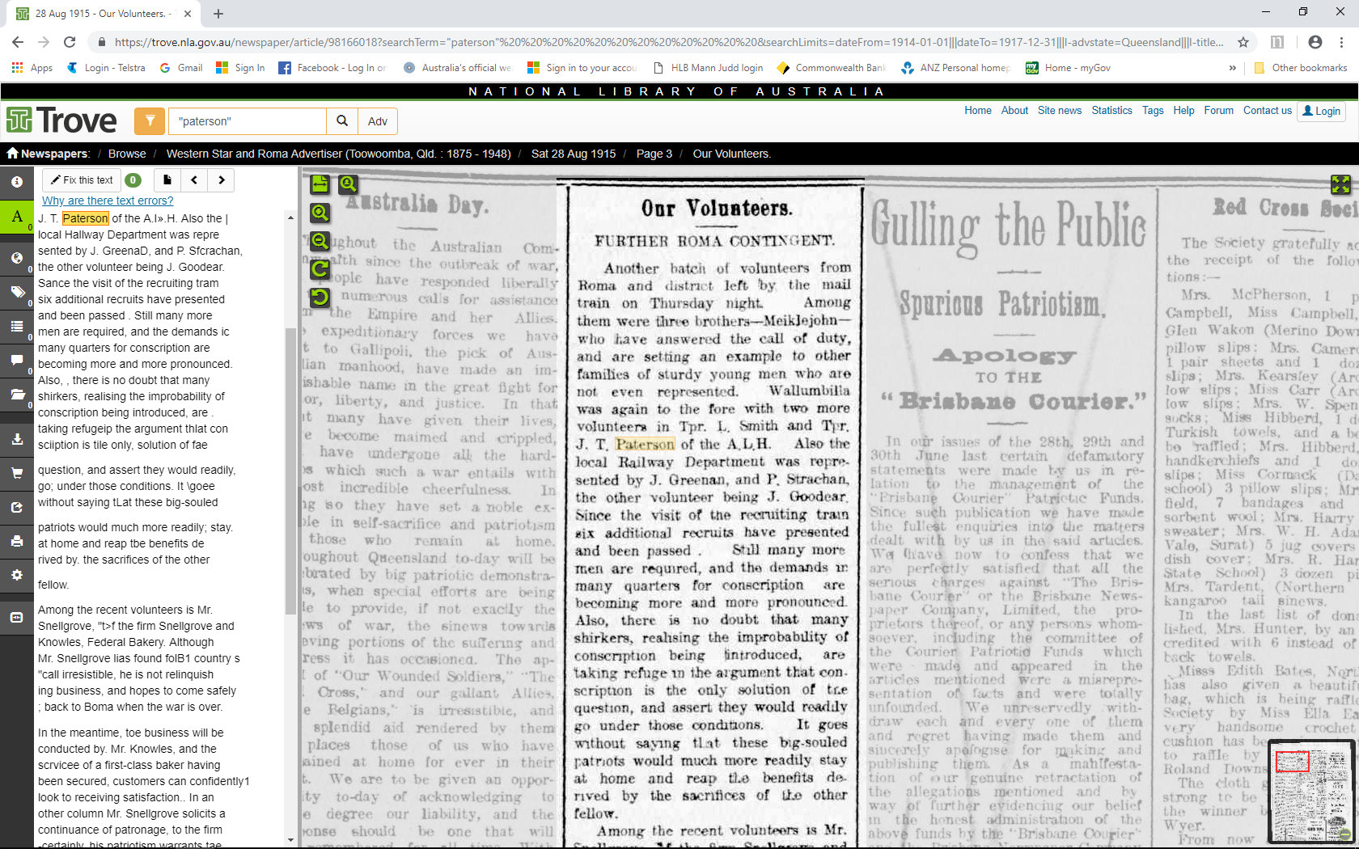
Western Star and Roma Advertiser, Saturday 28 August 1915, p. 3

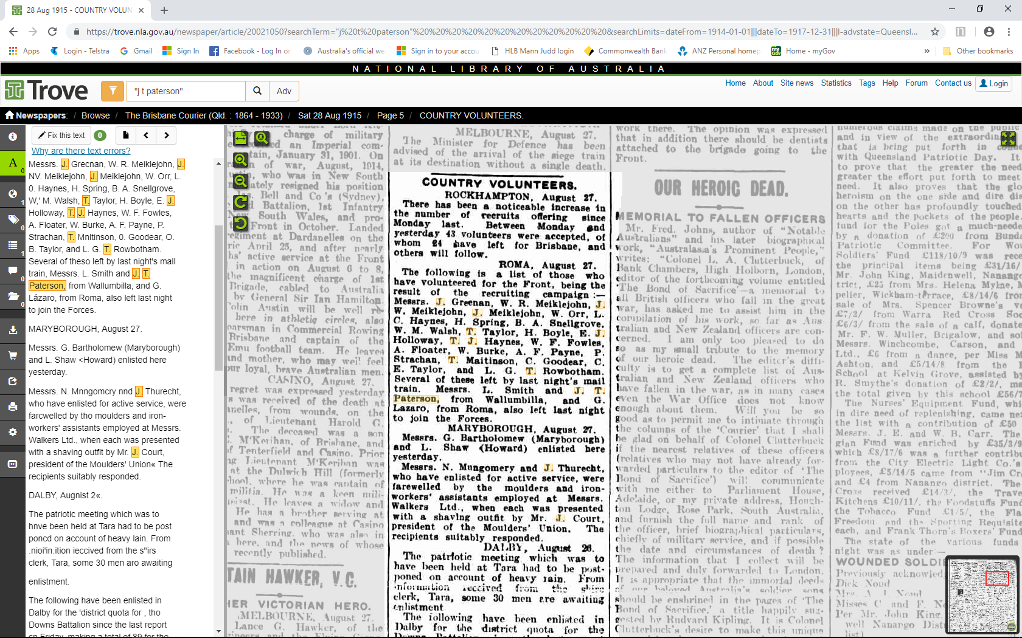
The Brisbane Courier, Saturday 28 August 1915, p. 5

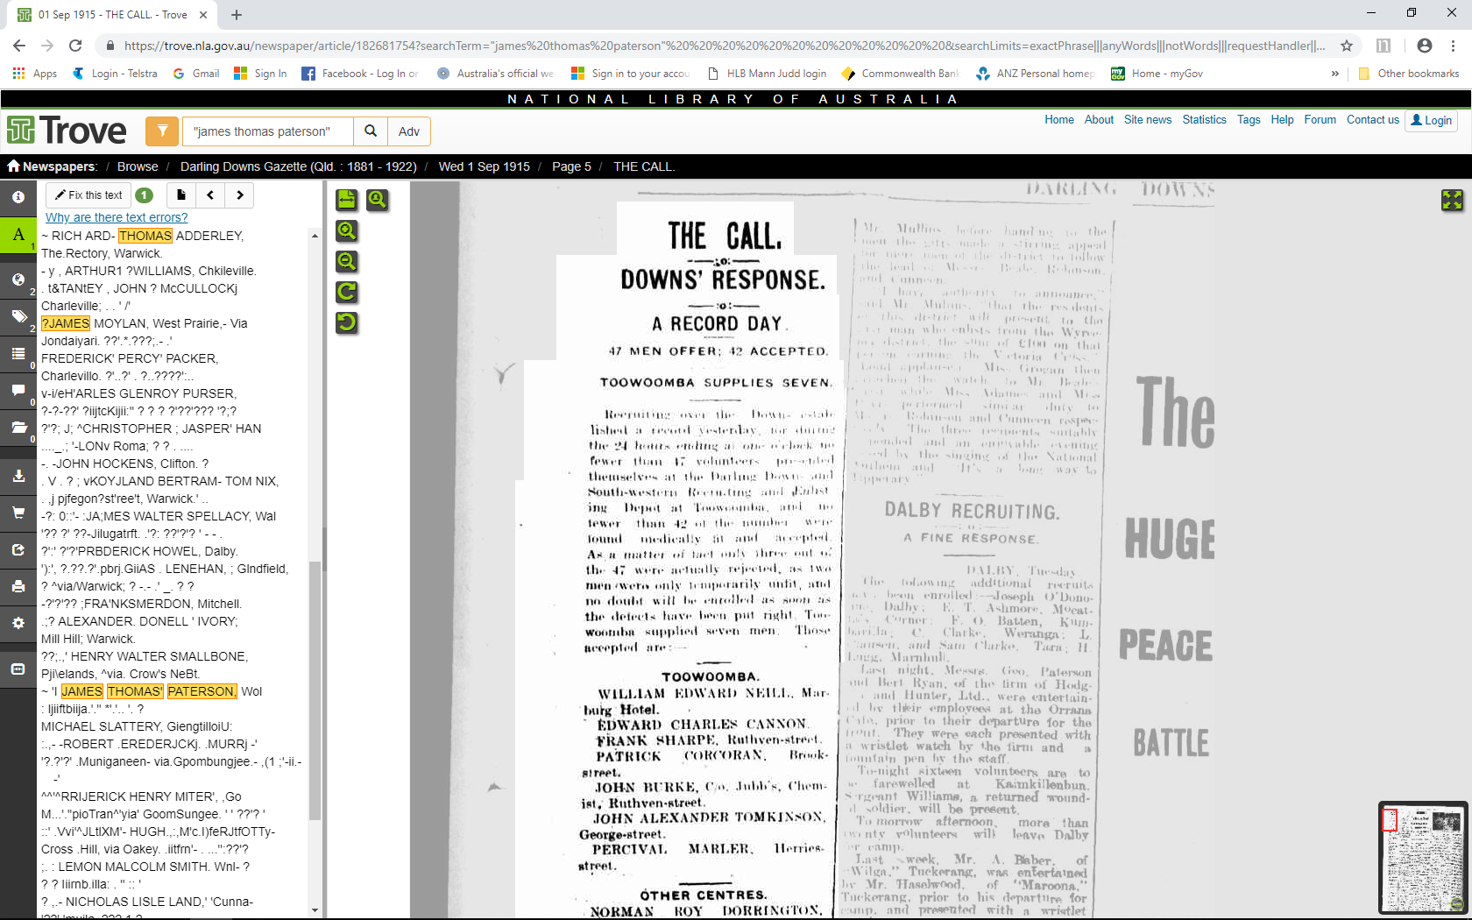
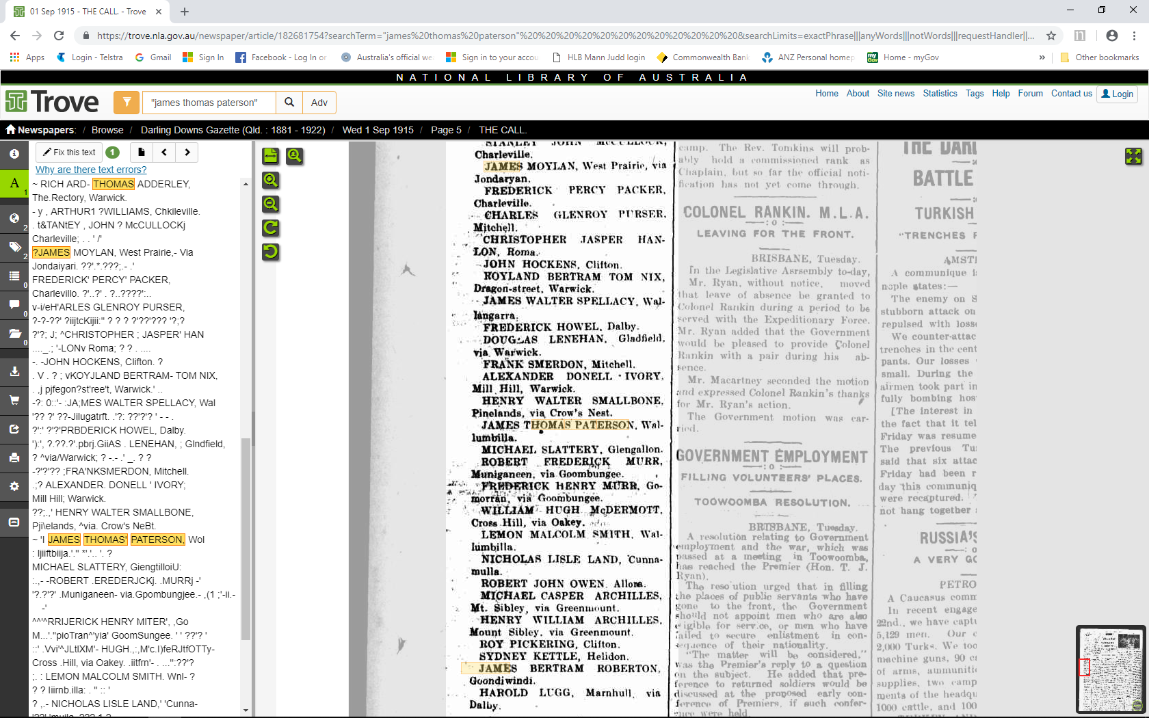
Darling Downs Gazette, Wednesday 1 September 1915, p. 5

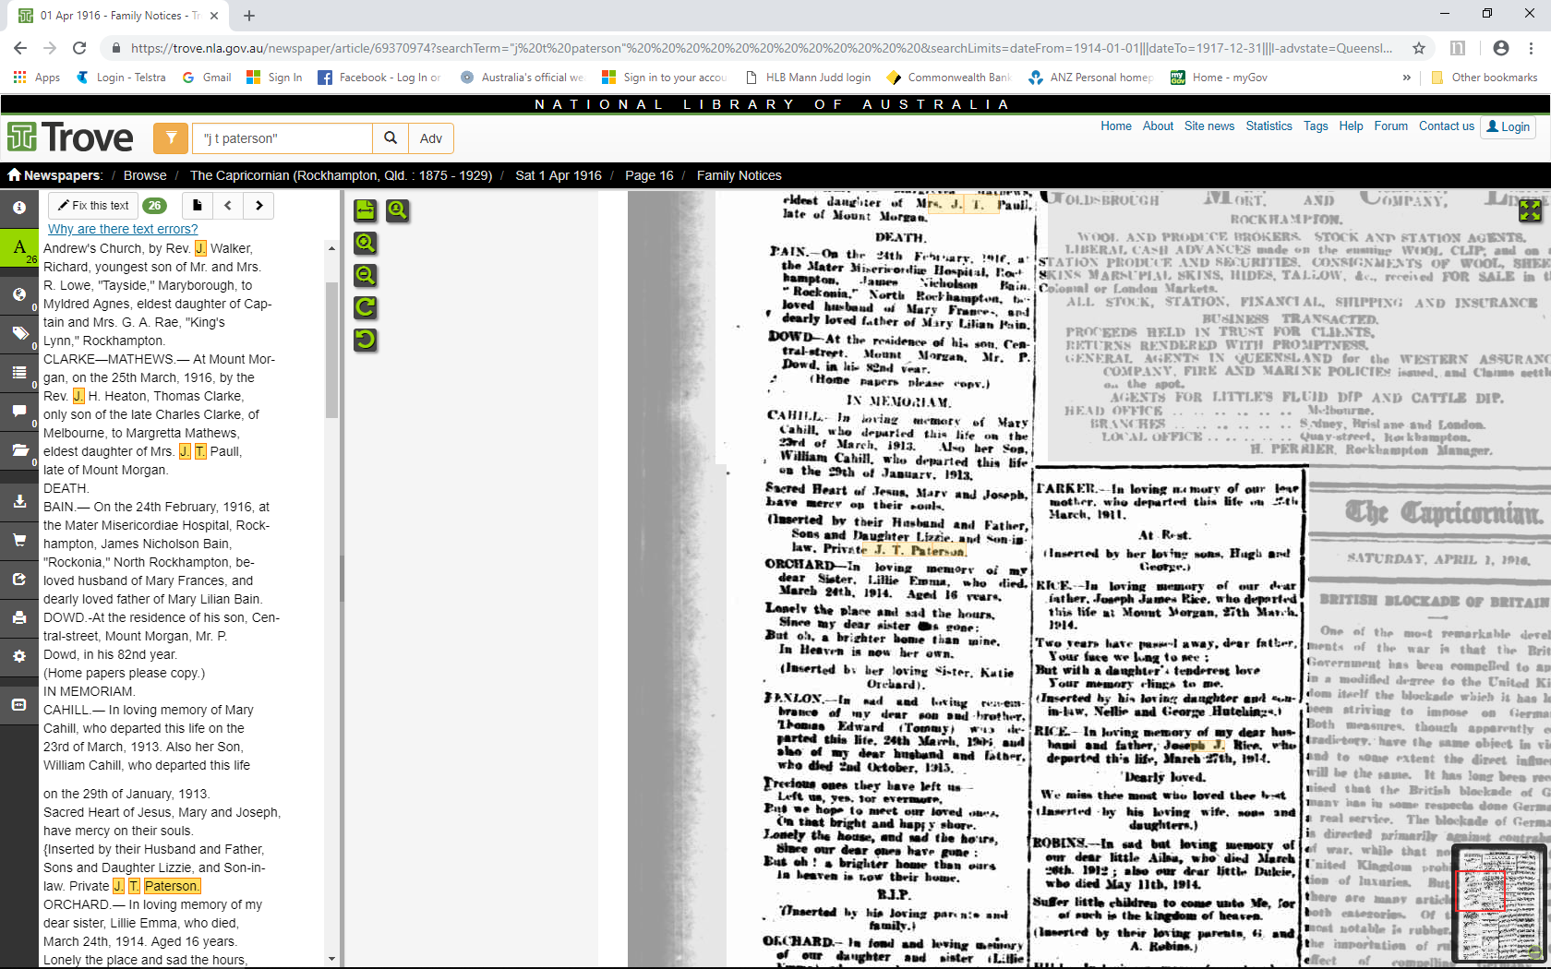
The Capricornian (Rockhampton), Saturday 1 April 1916, p. 16 – Family notices

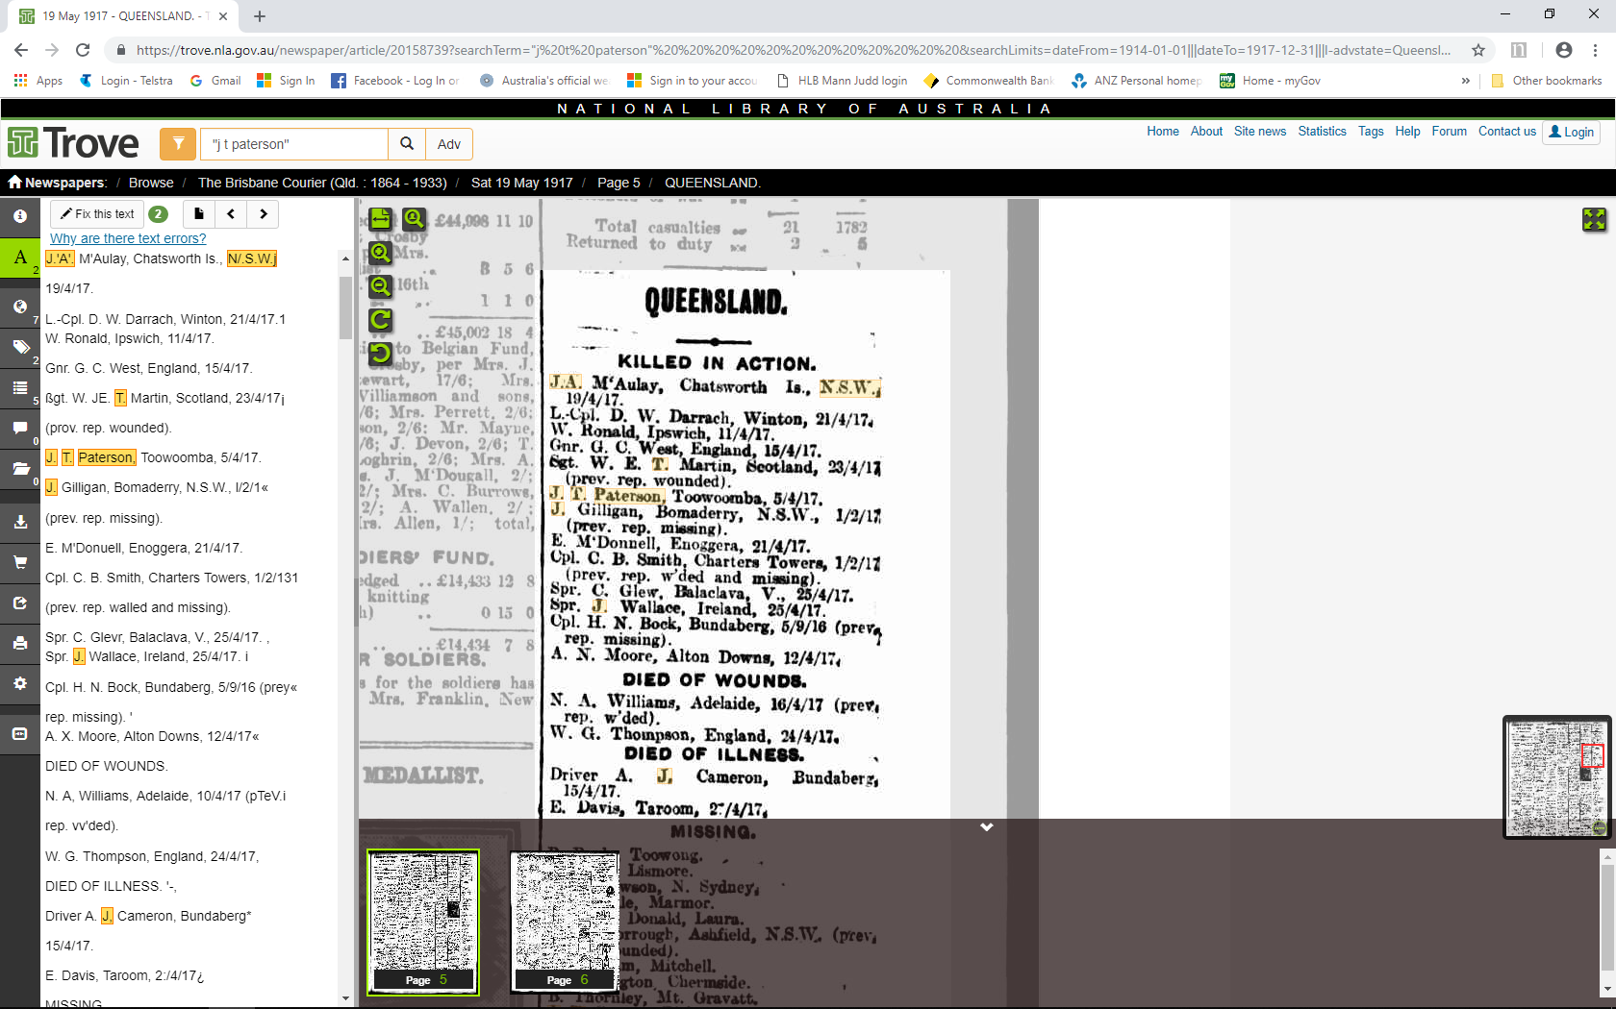
The Brisbane Courier, Saturday 19 May 1917, p. 5

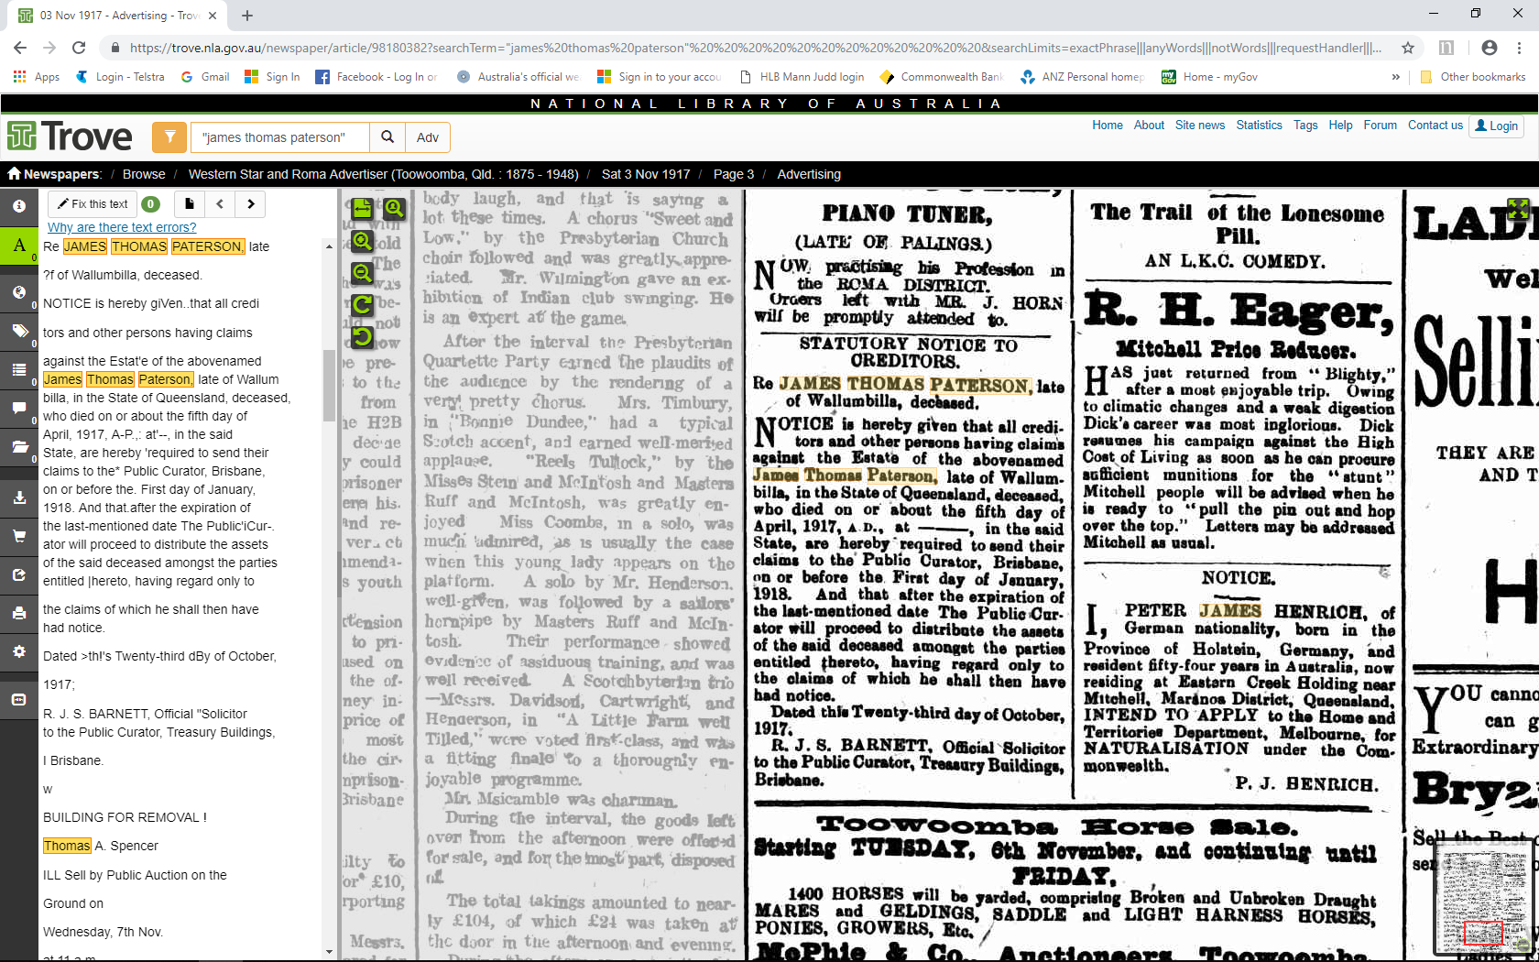
Western Star and Roma Advertiser, Saturday 3 November 1917, p. 3

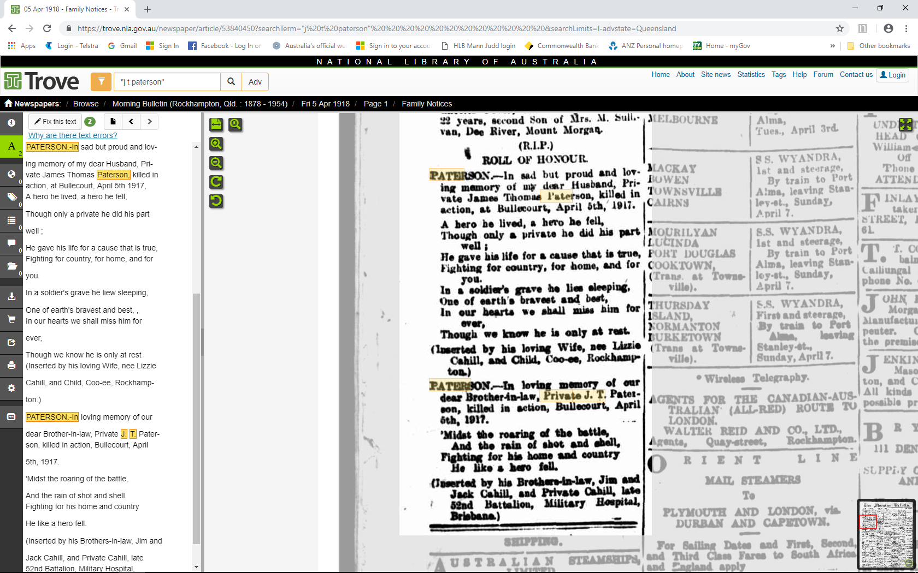
Morning Bulletin (Rockhampton), Friday 5 April 1918, p. 1 – Family notices

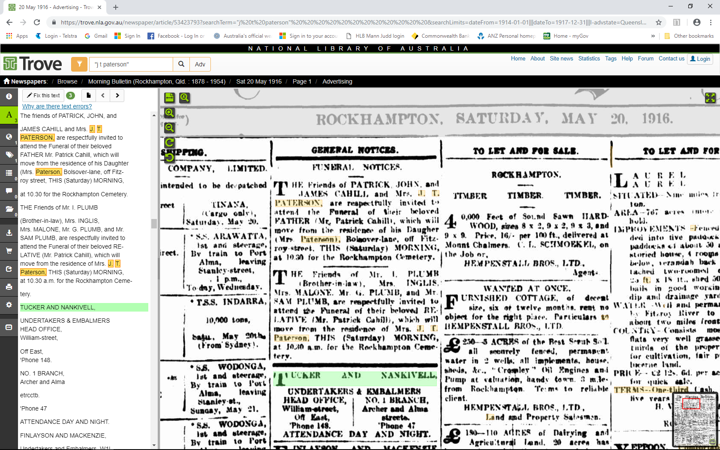
Morning Bulletin (Rockhampton), Saturday 20 May 1916, p. 1

