SAPPER ALBERT EDWARD REILLY
683 – 2nd Tunnelling Company

Born at Naracoorte, South Australia, on 24 May 1875, Edward Albert Reilly was the son of Edward and Ann (nee Wines) Reilly.

The 1903 Electoral Roll records Albert Edward Reilly, grocer, living at Hopetoun, Victoria.

On 26 April 1905 Edward Albert Reilly married Elizabeth Stanley at Glen Osmond, South Australia. Elizabeth was the daughter of Phillip Stanley.

The 1909 Electoral Roll records Albert Edward Reilly, salesman, and Elizabeth Reilly, home duties, living at Warracknabeal, Victoria. In the 1912 Roll Albert Edward Reilly is a grocer and is living with Elizabeth at Jeparit, Victoria. The 1912 Roll also records Albert Edward Reilly, grocer, and Elizabeth Reilly, home duties, living at Rainbow, Victoria.

In the 1914 Electoral Roll Albert Edward Reilly is recorded as a draper, and with Elizabeth Reilly, home duties, is living at Dimboola, Victoria. John Joseph Reilly, engine driver, is living at Lloyd, Street, Dimboola.

At Broken Hill on 17 August 1915, Albert completed and Application to Enlist in the Australian Imperial Force. An initial medical examination found him to be ‘fit for active service’ and his application was accepted.

At Adelaide on 20 August 1915, Albert signed the ‘Attestation Paper of Persons Enlisted for Service Abroad’ as A. E. Reilly, recording that he was a Salesman by trade and that he had been a member of the Hopetoun Rifle Club for 6 years.

A medical examination the same day recorded that he was 40 years and 3 months of age. He was 5ft 7ins tall and weighed 130 lbs. He had a fair complexion, blue eyes and brown hair and was of the Roman Catholic faith. 4 vaccination marks were recorded as distinguishing marks.

He recorded as his Next-of-Kin his wife Mrs. Elizabeth Reilly of 41 Bromide Street, Broken Hill, New South Wales, and allotted three-fifths of his pay for the support of his wife and 3 children.

He signed the Oath to ‘well and truly serve’ at Adelaide on 21 August 1915 and his training began at ‘G’ Company, 2nd Depot Battalion, Adelaide, on 21 August 1915. On 31 August he was transferred to ‘Z’ Group and on 15 September he was transferred again to ‘F’ Company, 2nd Depot Battalion. On 15 October he was again transferred to ‘Z’ Group.

On 31 October he was appointed to No.2 Company of the Miners Corps with the rank of Sapper. He had Final Leave from 19 to 24 November 1915 and was issued with a rail warrant for travel from Adelaide to Broken Hill and return.

Albert was transferred to Sydney, New South Wales where the Mining Corps was in training at their Casula camp. He was promoted to Corporal on 10 February 1916 and embarked at Sydney on board Ulysses with No.1 Mining Corps - No.2 Company.

At a civic parade in the Domain, Sydney on Saturday February 19, 1916, a large crowd of relations and friends of the departing Miners lined the four sides of the parade ground. Sixty police and 100 Garrison Military Police were on hand to keep the crowds within bounds. The scene was an inspiriting one. On the extreme right flank, facing the saluting base, were companies of the Rifle Club School; next came a detachment of the 4th King’s Shropshire Light Infantry, then the bands of the Light Horse, Liverpool Depot, and the Miners’ on the left, rank upon rank, the Miners’ Battalion.
Following the farewell parade in the Domain, Sydney, the Australian Mining Corps embarked from Sydney, New South Wales on 20 February 1916 on board HMAT A38 Ulysses.

The Mining Corps comprised 1303 members at the time they embarked with a Headquarters of 40; No.1 Company – 390; No.2 Company – 380; No.3 Company – 392, and 101 members of the 1st Reinforcements.

Ulysses arrived in Melbourne, Victoria on 22 February and the Miners were camped at Broadmeadows while additional stores and equipment were loaded onto Ulysses. Another parade was held at the Broadmeadows camp on March 1, the Miners’ Corps being inspected by the Governor-General, as Commander-in-Chief of the Commonwealth military forces.

Departing Melbourne on 1 March, Ulysses sailed to Fremantle, Western Australia where a further 53 members of the Corps were embarked. The ship hit a reef when leaving Fremantle harbour, stripping the plates for 40 feet and, although there was a gap in the outside plate, the inner bilge plates were not punctured. The men on board nicknamed her ‘Useless’. The Miners were off-loaded and sent to the Blackboy Hill Camp where further training was conducted. After a delay of about a month for repairs, The Mining Corps sailed for the European Theatre on 1 April 1916.

The ship arrived at Suez, Egypt on 22 April, departing for Port Said the next day; then on to Alexandria.
‘On the arrival of our troop ship in Alexandria in April 16, a party of some 120 out of our 1200 miners, with the wanderlust strong upon them, broke loose suddenly from our troop ship (Ulysses) as she lay at the wharf, rushed the sentries, and went careering like a lot of released school boys up the main street of Alexandria, making for the heart of the city.
Some bad sport, perhaps one should rather say, one sound disciplinarian, telephoned to the military police. And in due course the sappers were met by some charabancs driven by genial gentlemen, who offered them a lift.
The offer was of course accepted, and presently the vehicle swung into a courtyard, the gates of which were promptly closed, and the sappers then realised that they were prisoners. One hundred and twenty of them were locked up in a building designed for a maximum of 60. The sappers called it the ‘boob”. The night was very hot and the “boob” threatened to become a veritable Black Hole of Calcutta.
In the early dawn, an agonized SOS came from the military police to our ship to say that the sappers were tunnelling under the walls of the boob, and that it was tottering to its foundations, and would we send up a strong-armed party at once to hold and remove the prisoners.’
Major T.W. Edgeworth David

The Captain of the ship was reluctant to take Ulysses out of the Suez Canal because he felt the weight of the ship made it impossible to manoeuvre in the situation of a submarine attack. The Mining Corps was transhipped to B1 Ansonia for the final legs to Marseilles, France via Valetta, Malta. Arriving at Marseilles on 5 May, most of the men entrained for Hazebrouck where they arrived to set up their first camp on 8 May 1916.

A ‘Mining Corps’ did not fit in the British Expeditionary Force, and the Corps was disbanded and three Australian Tunnelling Companies were formed. The Technical Staff of the Corps Headquarters, plus some technically qualified men from the individual companies, was formed into the entirely new Australian Electrical and Mechanical Mining and Boring Company (AEMMBC), better known as the ‘Alphabetical Company’.

On 29 December 1916 Albert was officially transferred to the 2nd Australian Tunnelling Company (2ATC).

On 23 February 1917 the address of his Next-of-Kin was changed to Albert Street, Parkside, South Australia.

On 2 October 1917, while in London, he was remanded in custody at Warwick Square pending a District Court Martial. He was charged with: ‘W.O.A.S. (whilst on active service) absenting himself without leave in that he at London at 6 a.m. on 23 September 1917 failed to report to the R.T.O at Victoria Station, and remained absent until apprehended in London by Civil Power on 28 September 1917.’

Albert pled not guilty. He was found guilty and was sentenced on 10 October to be reduced to the ranks. He had spent 12 days in custody and in total forfeited 18 days pay.
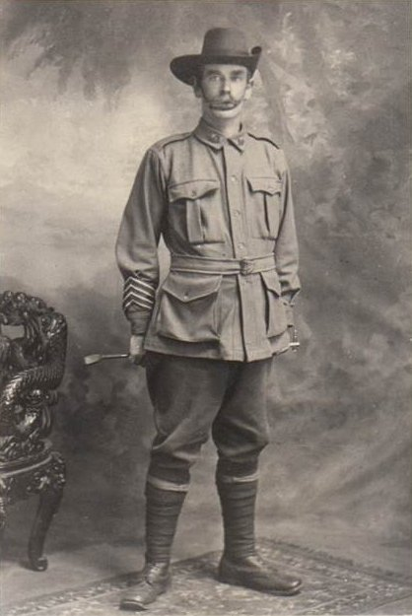
Albert Edward Reilly c. 1917
with Blue Chevrons on his right arm
Photo courtesy Sharon Watkins
After returning to France, he reported sick on 14 October and was admitted to the 1/1 East Lancashire Field Ambulance with an accidental wound to the head. He was discharged to duty on 20 October and rejoined his unit the same day.

He was due his Blue Chevrons. Each blue Service Chevron denoted one year’s service from 1 January 1915. A red Chevron denoted service before 31 December 1914.

On 14 February 1918 he was admitted to the 57th Field Ambulance with an accidental injury to his right leg. He was transferred to the 21st Casualty Clearing Station the same day and then transferred by Ambulance train 34 to the 3rd Australian General Hospital at Abbeville where he was admitted on 17 February.

On 19 March he was transferred by Ambulance Train 16 to the coast and embarked for England on 20 March. On 21 March he was admitted to the Graylingwell War Hospital at Chichester with a fractured fibula. He was transferred to the 3rd Auxiliary Hospital at Dartford on 28 March.

Albert was discharged to the Training Depot on 8 April for return to Australia by Hospital Ship. The medical report of that date recorded: “Fell off duckboards & twisted left foot. Simple fracture left fibula in lower third. United now – Position not very good. Ankle movement poor.”

During Alberts’ time with 2ATC they had relieved the 172nd Tunnelling Company, R.E. in May 1916 in the Neuville St Vaast/Vimy area. They supported the Australian 5th Division at Fromelles in July 1916 and relieved the Canadians at the Bluff in January 1917.

The Company moved to Nieuport in the same month, to construct subways for Operation Hush and was involved in an enemy attack – the German ‘Operation Strandfest’ - in this coastal sector in July 1917, recorded in the official histories as ‘The Affair at Nieuport Bains’. In April 1918, troops of the Company fought a large fire in Peronne.

Following the Armistice, members of the company were involved in the clearance of mines and delayed-action booby-traps and in the re-construction of civilian infrastructure until the Company was recalled to Base on May 23, 1919 to organize their departure from France.

Albert left London 8 April 1918 on board Hospital Ship Dunlace Castle for return to Australia. He was transferred to the Karoola which departed Suez on 27 April 1918 and disembarked at Melbourne on 26 May 1918, for travel to Adelaide.

Discharged from the A.I.F. as medically unfit at Adelaide on 5 July 1918, Albert was entitled to wear the British War Medal and the Victory Medal. He had served for 2 years and 320 days; 2 years, 96 days of that abroad.

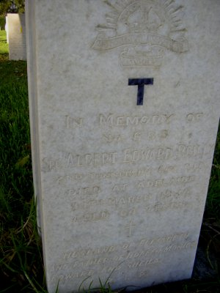
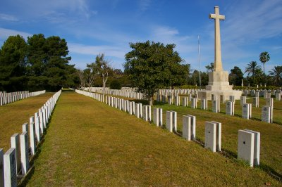
Chronicle, Adelaide – Thursday 21 March 1940:
DEATHS

REILLY.— On the 14th of March, Albert Edward Reilly (late of M.T.T., and 2nd Tunnelling Coy, AI.F.), of 53 Stanley street, Woodville Park, beloved husband of Elizabeth Reilly and father of Doreen, Monica, Edward and Sheila. Aged 64 years. Requiescat in pace.

Photo of headstone and Adelaide War Cemetery courtesy Heather Pearce

The Advertiser, Adelaide – Saturday 30 March 1940:

RETURN THANKS

THE WIDOW, SON and DAUGHTERS of the late ALBERT E. REILLY wish to THANK Relatives and Friends for floral tributes, cards, letters and personal expressions of sympathy in their recent sad bereavement.

At least one of Alberts’ brothers also served in WW1:

CORPORAL JAMES GAIUS REILLY
2279 – 24th Infantry Battalion

James enlisted on 19 March 1915 at age 36 years and 11 months. A Stud Groom by occupation, he named his mother Mrs A. Reilly of Main Street, Minyip, Victoria as his Next-of-Kin. He embarked at Melbourne for active service abroad on 27 September 1915 on board HMAT A20 Hororata.

He was taken on strength of 24th Battalion at Tel-el-Kebir on 10 January 1916. He proceeded from Alexandria to join the British Expeditionary Force on 20 March, disembarking at Marseilles, France on 26 March 1916.

On 7 April 1917 he was seconded for duty with the 6th Training Battalion, Larkhill, England. He proceeded overseas to France on 30 August 1917 and marched in to the 2nd Australian Divisional base Depot, Havre on 31 August, rejoining his unit in the field on 8 September.

James was wounded in action on 4 October 1917 and was admitted to the 64th Field Ambulance with a gun shot wound to his right arm. On 5 October he was transferred to the 3rd Australian General Hospital at Abbeville, France. He was transferred to England on 18 October and admitted to the Beaufort War Hospital, Bristol on 19 October.
He was transferred to 3rd Australian Auxiliary Hospital, Harefield on 24 January 1918. On 31 January he was discharged to furlough, reporting to No.4 Command Depot, Hurdcott on 14 February.

On 19 March he marched in to Overseas Training Brigade at Longbridge-Deverill, proceeding overseas to France 9 April and rejoining his unit in the field on 15 April 1918.

On 18 September James was admitted to the 6th Field Ambulance due to complications with his old wound as his forearm was wasting. He was transferred to the 12th General Hospital at Rouen on 25 September and discharged to the Base Depot on 26 September.

Evacuated to England, he marched in to No.2 Command Depot, Weymouth, England on 1 November and left England on 4 December 1918 for return to Australia on board Somerset.

Disembarking at Melbourne on 15 January 1919, he was discharged in from the A.I.F. as medically unfit on 1 March 1919, entitled to wear the 1914/15 Star, the British War Medal and the Victory Medal.

The 1919 Electoral Roll records James working as a blacksmith at Yanac North, Victoria. The 1921 Electoral Roll records James working as a blacksmith at Yanac North, Victoria with his mother Ann Reilly also living at Yanac.

James married Louisa Jane Baker in 1921.

The 1924 Electoral Roll records James working as a blacksmith at Yanac North, Victoria, with Louisa Jane and his mother Ann. His mother Ann Reilly, nee Wines, died in September 1926.

The 1936 and 1942 Electoral Rolls record James working as a blacksmith and living with Louisa Jane at Yanac North, Victoria. In the 1949 Electoral Roll, James is recorded as working as a blacksmith and living at Queen Street, Nhill, Victoria with Louisa Jane.

His medical and military records were provided to the Repatriation Commission, Melbourne, in March 1952

James Gaius Reilly died at Nhill, Victoria on 11 June 1960, aged 83 years and was buried in the Nhill Cemetery.

His medical and military records were again provided to the Repatriation Commission, Melbourne, in August 1960

Louisa Jane Reilly died at Nhill on 8 May 1966 and was also buried in the Nhill Cemetery.

© Donna Baldey 2016
www.tunnellers.net
with the assistance of Sharon Watkins (nee Lee), great granddaughter of Albert Edward Reilly.

