A World War One Soldiers story – Folio

**Source one – AIF project (**[**https://www.aif.adfa.edu.au/search**](https://www.aif.adfa.edu.au/search)**)**

This source gave information involving details about my soldier

before, during and after the war.

1. Why is this source useful?

This source is useful because it gives me lots of important information about my soldier during the war, such as his unit details and events in chronological order. The secondary source is also good because it will help me piece other bits of information together that I have found from other websites. For example, the dates of my soldier evacuating Gallipoli coincide with images on the Trove website.

1. What key details do I need to explore further?

I need to see if I can find any other connections between this source and other ones that I have researched into. These will help me discover other key details about certain events that are listed in this website. It will also let me know that this is a reliable source.

1. How will this further research give me a clearer picture of my soldiers life?

This source gives core and important information about my soldier, and without it I wouldn't have enough details to help me find other sources on websites. By using the AIF project, I have gotten a clearer view on the basic events and details about my soldier in the war, which have helped me understand what his life was like before, during and after the war.

|  |  |
| --- | --- |
| Regimental number | 1462 |
| Place of birth | Adelaide, South Australia |
| Religion | Roman Catholic |
| Occupation | Labourer |
| Address | Mrs Johnson, Moonee Ponds, Victoria |
| Marital status | Single |
| Age at embarkation | 27 |
| Height | 5' 5" |
| Weight | 144 lbs |
| Next of kin | Mrs Johnson, Moonee Ponds, Victoria |
| Previous military service | Nil |
|  |  |
|  |  |
|  |  |
|  |  |
|  |  |
|  |  |
|  |  |
|  |  |
|  |  |
|  |  |
|  |  |
|  |  |
|  |  |
|  |  |

Service number

The service number is what I need to enter into many websites to get information about my soldier. With this number, I can access many other useful sources to help me get more details on my soldiers life in the war.

There is general information given again, which helps me understand details about my soldier.

General information

These are the details about my soldiers enlistment, such as where he enlisted, and what date. I can then find out about himself when he joined the war, in terms of his age.

My soldiers given rank is shown in the war. I can see from this what his roles were in the battles and his battalion. Since he was a private, I know he was one of the least important people in his battalion.

The unit name tells me of his battalion. From this I can do further research into what his battalion did during the war, and I can find out if he was involved in any particularly interesting battles and jobs. The second unit name informs me which battalion he was moved to once the 10th started to break up into newer battalions.

These give me useful details into my soldiers death. Despite him not dying during the war, I can get an understanding of his life after he fought, and I can also research into the cemetery that is listed.

These details are useful and insightful into what happened to my soldier during his service time. They are placed in chronological order, which will be helpful for when I am doing my bibliography in the next section of this task. I can also gain general knowledge of who he was as a person, in terms of the crimes that he committed. Again, the dates and places listed can help me to research into events that happened during those times in the war, which could lead me to explanations of how he came to do some of these things listed.

His rank in the war

Enlistment details

|  |  |
| --- | --- |
| Enlistment date | 15 December 1914 |
| Place of enlistment | Oaklands, South Australia |
| Rank on enlistment | Private |
| Unit name | [10th Battalion, 3rd Reinforcement](https://www.aif.adfa.edu.au/showUnit?unitCode=INF10REIN3) |
| AWM Embarkation Roll number | 23/27/2 |
| Embarkation details | Unit embarked from Melbourne, Victoria, on board HMAT A54 *Runic* on 19 February 1915 |
| Rank from Nominal Roll | Private |
| Unit from Nominal Roll | 50th Battalion |
| Fate | Returned to Australia 10 July 1916 |
| Discharge date | 26 September 1916 |
|  |  |
| Date of death | 3 July 1952 |
| Age at death | 67 |
| Place of burial    Other details | AIF Cemetery (Row 16, Grave 39), West Terrace, Adelaide, South Australia  War service: Egypt, Gallipoli  Wounded in action, Gallipoli, 7 August 1915 (gun shot wound, face), and admitted to 3rd Field Ambulance, and transferred to 1st Casualty Clearing Station; transferred to Mudros, 7 August 1915, and thence to Alexandria, 11 August 1915, and admitted to 1st Australian General Hospital, Heliopolis, 12 August 1915; transferred to 4th Auxiliary Hospital, Heliopolis, 12 August 1915; to 1st Australian General Hospital, 21 August 1915; to Overseas Base, 13 September 1915.  Found guilty, 15 September 1915, of being absent without leave, 9pm-10.15 pm: awarded 7 days' confined to barracks.  Found guilty, 18 September 1915, of being absent from Defaulters' Parade: awarded 7 days' confined to barracks.  Embarked Alexandria to rejoin Mediterranean Expeditionary Force, 27 September 1915; rejoined Bn, Gallipoli, 4 October 1915.  Admitted to 2nd Light Horse Field Ambulance, 22 October 1915 (gastritis); rejoined Bn, 25 October 1915.  Admitted to 2nd Field Ambulance, Mudros, 11 December 1915 (pyrexia); transferred to 3rd Australian General Hospital, Musdros, 11 December 1915 (mumps); discharged to duty, 23 December 1915; rejoined Bn, Gallipoli, 23 December 1915.  Disembarked Alexandria, 29 December 1915 (general Gallipoli evacuation).  Found guilty, Tel el Kebir, 7 January 1916: awarded 14 days' detention, and forfeited 3 days' pay.  Found guilty, 24 March 1916, of overstaying leave; being absent without leave from 2400, 19 March, until giving himself up to the Piquet,2100, 21 March 1916: awarded 168 hours' detention, and forfeited 2 days' pay under Royal Warrant. |

Unit name

His rank in the war

Unit name

Death details

Other events with dates/places that occurred in during the war

This information tells me about when and why my soldier returned to Australia when he did. I can do further research into the ship details to see what the journey was like home.

The war service tells me how long my soldier was involved in the war.

Admitted to 2nd Australian Stationary Hospital, Tel el Kebir, 19 May 1916 (Aortic V); discharged, 19 May 1916; admitted to Hospital Train, 22 May 1916, and transferred to 3rd Auxiliary Hospital, Cairo; transferred to 1st Auxiliary Hospital, 10 June 1916 (valvular disease of the heart).

Commenced return to Australia on board HT 'Clan McGillivray', 10 July 1916; disembarked Melbourne, 15 august 1916; discharged (medically unfit: valvular disease of the heart), Adelaide, 26 September 1916.

War service: 1 year 287 days (of which 1 year 174 days was abroad)

|  |  |
| --- | --- |
| Date of death | 3 July 1952 |
| Age at death | 67 |
| Place of burial | AIF Cemetery (Row 16, Grave 39), West Terrace, Adelaide, South Australia |

Return details

War service

Death details

**Source two – Australian War Memorial (**[**https://www.awm.gov.au/people/roll-search**](https://www.awm.gov.au/people/roll-search)**)**

1. Why is this source useful?

This source gives me information into the embarkation details of my soldier during the war. It is a reliable secondary source as it is used and run by many well-respected historians. There are many details that I can also learn from this site about my soldier that can come in useful for the next part of this task, such as detailed information about the battalions that my soldier was involved in.

1. What key details do I need to explore further?

I believe that I need to research more into the ship that my soldier embarked on, which is listed in the website. Once I have done this, I can learn where he stopped off on his way to the battles he went to fight in, and also who else might have been on that ship. These details can help me write up my biography. I can also see if I can find any other information about either my soldier, or his battalion, on different parts of the website.

1. How will this further research give me a clearer picture of my soldiers life?

This research, as mentioned earlier, can be helpful with the second part of this assignment. It gives me more details into a different aspect of my soldier, which hasn't been mentioned properly in other sources. This means that I can use the information to research further into my soldier and his battalion and explain his journey during the war better.

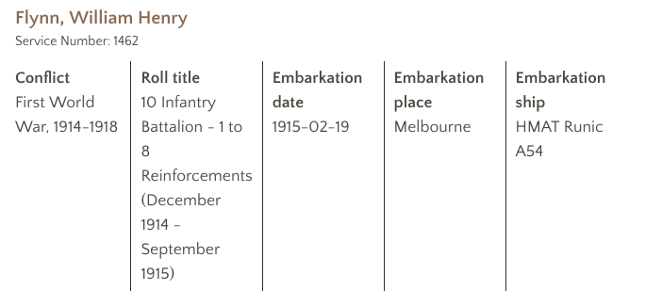

The name and service number of my soldier is given at the top. This means I can be sure that I am looking into the right soldier, and not a different on with the same name.

The conflict details tell me what time period the war happened in.

This tells me his role in the war, and his unit name. As mentioned earlier, these can help me research other aspects of himself and his battalion in his service time.

The source gives me my soldiers embarkation details. I can use these to learn about my soldiers journey to Gallipoli. By researching further into the ship listed, I can learn some more details about the conditions aboard and other people who were travelling with him.

Embarkation details

His role in the war/unit name

Conflict details

Name and service number

The 10th Battalion was among the first infantry units raised for the AIF during the First World War. The battalion was recruited in South Australia, and together with the 9th, 11th and 12th Battalions, formed the 3rd Brigade.   
  
The battalion was raised within weeks of the declaration of war in August 1914 and embarked for overseas just two months later. After a brief stop in Albany, Western Australia, the battalion proceeded to Egypt, arriving in early December.   
  
The 3rd Brigade was the covering force for the ANZAC landing on 25 April 1915 and so was the first ashore at around 4:30 am.

The following texts on the left give information about the two battalions that my soldier fought in. These let me know the general details about the battalions were, and what they were for. From this information, I can get background details about the two battalions that my soldier was involved in, and I can involve this information in the biography in the next section of this assignment.

The 50th Battalion was raised in Egypt on 26 February 1916 as part of the "doubling" of the AIF. Approximately half of its recruits were veterans from the 10th Battalion, and the other half, fresh reinforcements from Australia. Reflecting the composition of the 10th, the 50th was predominantly composed of men from South Australia. The battalion became part of the 13th Brigade of the 4th Australian Division and was dubbed "Hurcombe's Hungry Half Hundred", after its first CO, Lieutenant Colonel Frederick Hurcombe.

**Source three – The Commonwealth War Graves Commission (**[**https://www.cwgc.org/find-war-dead.aspx**](https://www.cwgc.org/find-war-dead.aspx)**)**

Due to the fact that my soldier did not die during the war, there is no information about a grave of his on the website.

**Source four – The National Archives of Australia (**[**https://recordsearch.naa.gov.au**](https://recordsearch.naa.gov.au)**)**

1. Why is this source useful?

This source is useful as it has lots of historical documents that give information about my soldier. Some of these include the attestation papers that William Henry Flynn filled out when he was enlisting in the war. The answers to the questions in the forms give details about his general life, such as his hometown, cultural background, job and emergency contacts. Some of these documents also give details about his embarkment to war, what happened to him while he was in the war, and medical records of the illnesses he caught whilst fighting. I also know they are all reliable, as they are primary sources from the time of the war.

1. What key details do I need to explore further?

I can further my research into my soldier for the second part of this assignment by looking into key dates, places and conflicts that are listed in these documents. By doing so, I can receive more information as to what was happening to my soldiers battalion during the times he was involved in certain events. These can give me clearer understandings of the things that happened during his service time in the war.

1. How will this further research give me a clearer picture of my soldiers life?

This research will help me to find out more information about my soldier, in terms of his life before and during the war. The information that is within the records and letters from this website help give a clearer perspective of major events that happened to my soldier during the war in chronological orders.

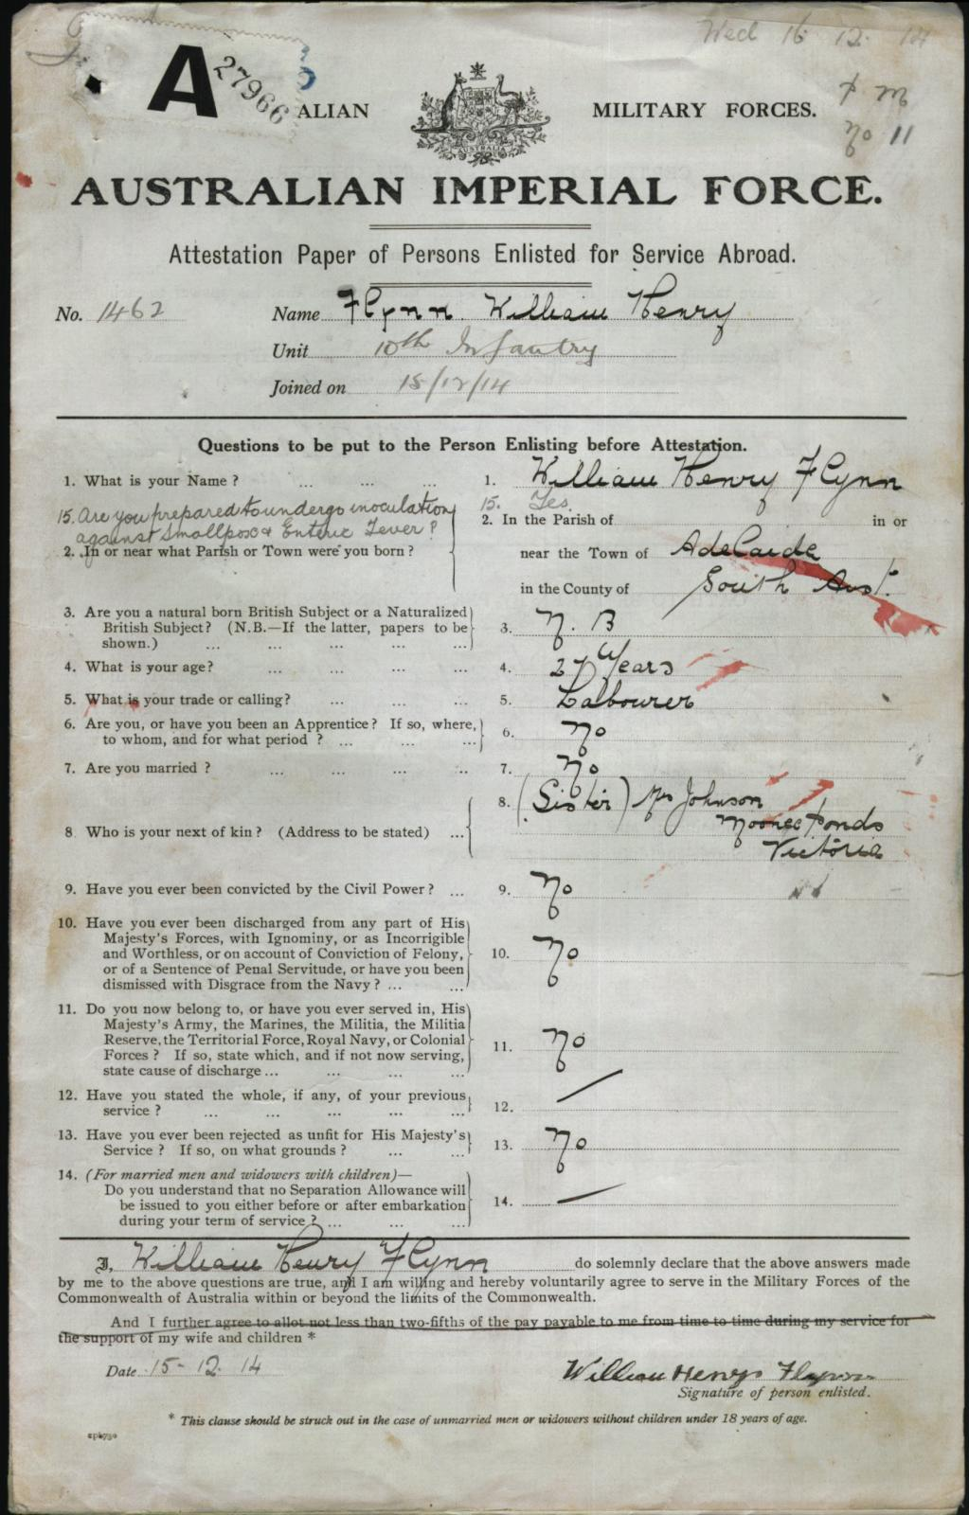

Tells me my soldiers name and helps for my research into his details.

Shows where he was born and now lives, and his nationality.

Tells me what job he has, which gives detail into what his life was like before the war.

Gives the name of his emergency contact.

Shows the date that this attestation paper was filled out.

Date

Next of kin

Job

Birthplace

Name

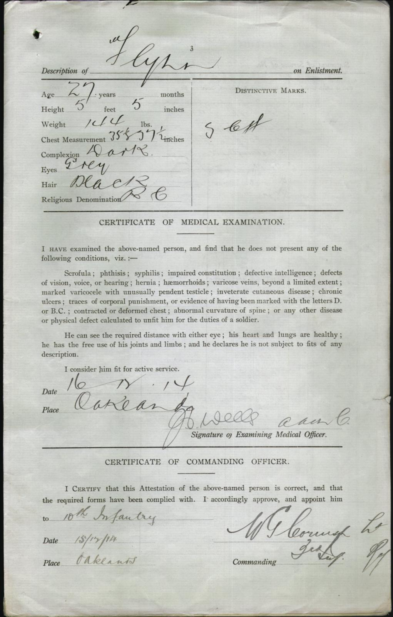

Date/Place

Battalion

Physical attributes information

This information gives detail to what my soldier looked like when he signed up for war. It can help me get an understanding of his looks and build, which can be useful information when researching into his general life. It also tells me his age at the time of him signing up.

This tells me what battalion my soldier was first placed in. I can further my research on his life in the war by looking into the battalion itself, and which battles they fought in.

The date and place where my soldier filled out this form is listed. It lets me know where and when he went to sign up for the war. The date and his age above also can help me work out what year he was born in.

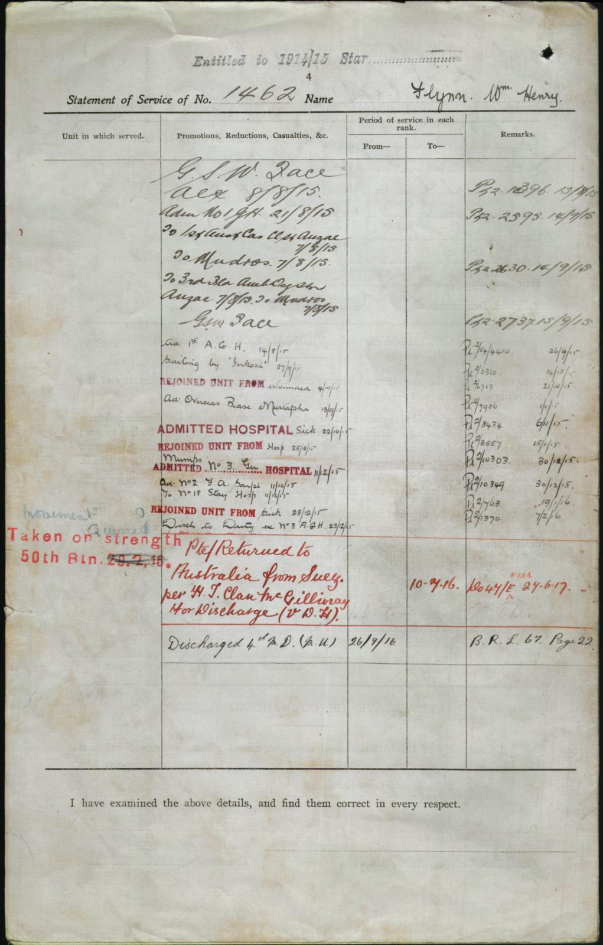

Discharge

Taken on strength

Dates

Injury/illness details

Service number

This can be helpful as it gives me his service number, which I can use to access his information on other sites.

Details of his injuries and illnesses that he got during the war are listed on here. These tell me some of the key events that happened during the time he served.

These dates that are shown tell me when each event happened. I can get a chronological explanation of his time in the war.

The information of being ‘taken on strength’ shows that my soldiers battalion got defeated, and which one he was then moved to.

This gives me the date and details of when my soldier went back to Australia. It proves that he went home and survived the war.

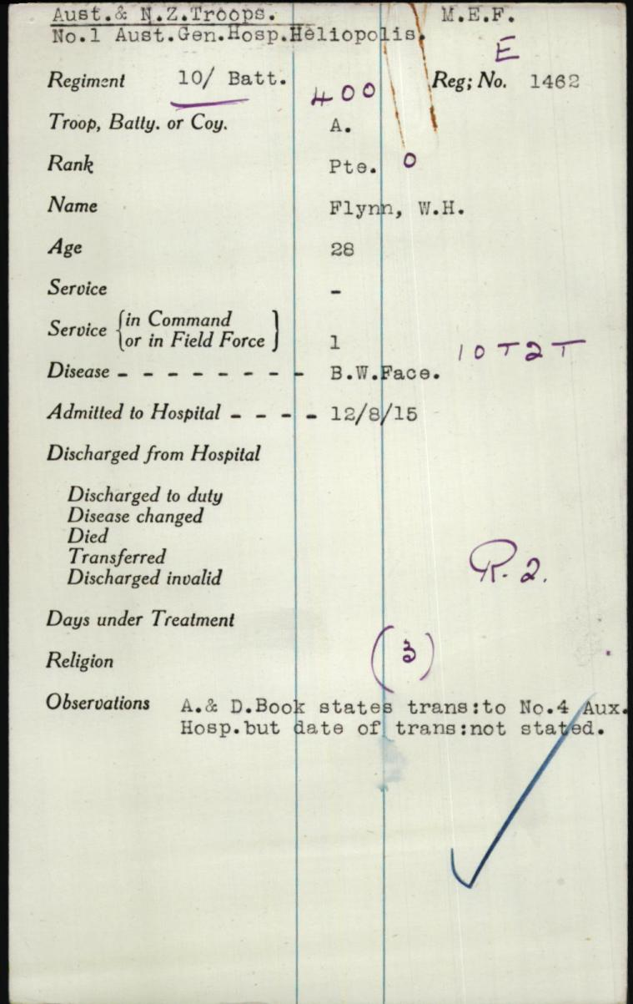

Illness/wounds/hospital details

General information

Rank details

These show what rank he was in the army. This can give me an understanding of his importance and position in his battalion, and what roles he might have played during his service time.

There is general given that can give me an understanding of what he was like during the war.

The information here gives me descriptions and dates of what injuries he got and when he went to hospital. I can use this date to check what his battalion was doing during the time of the war. This could further my knowledge on what might have caused his injuries.

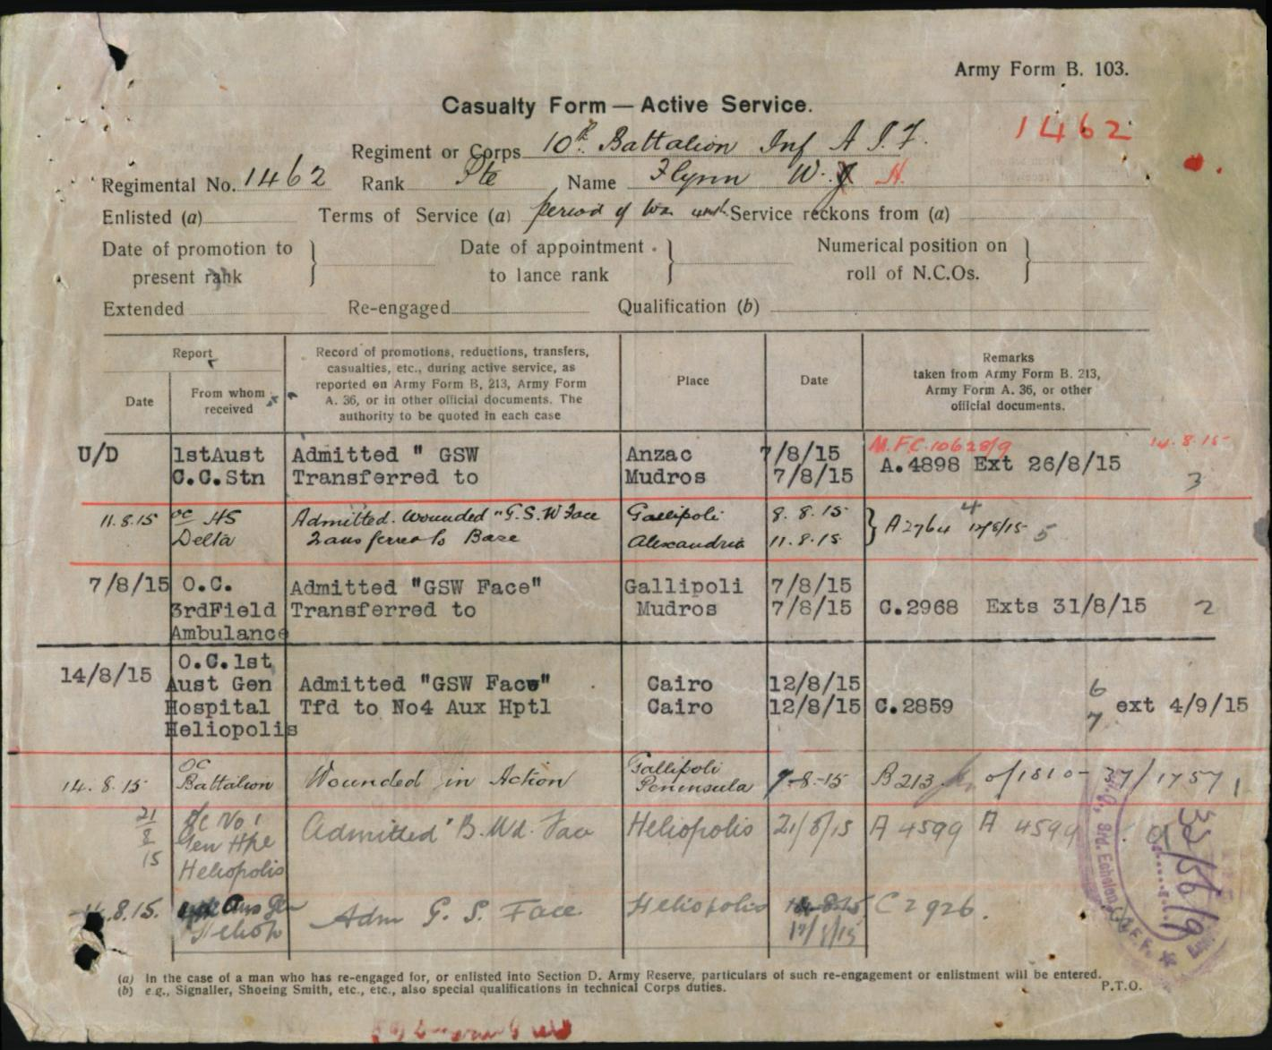

Date

Place

Details of injuries

These tell me what wounds and injuries he got during the time he served.

The places listed let me know where he got injured. From these I can piece together information about where he was and what he was doing in those places.

Dates are given to inform me about when these events occurred. I can then see what he was doing during different times of the war.

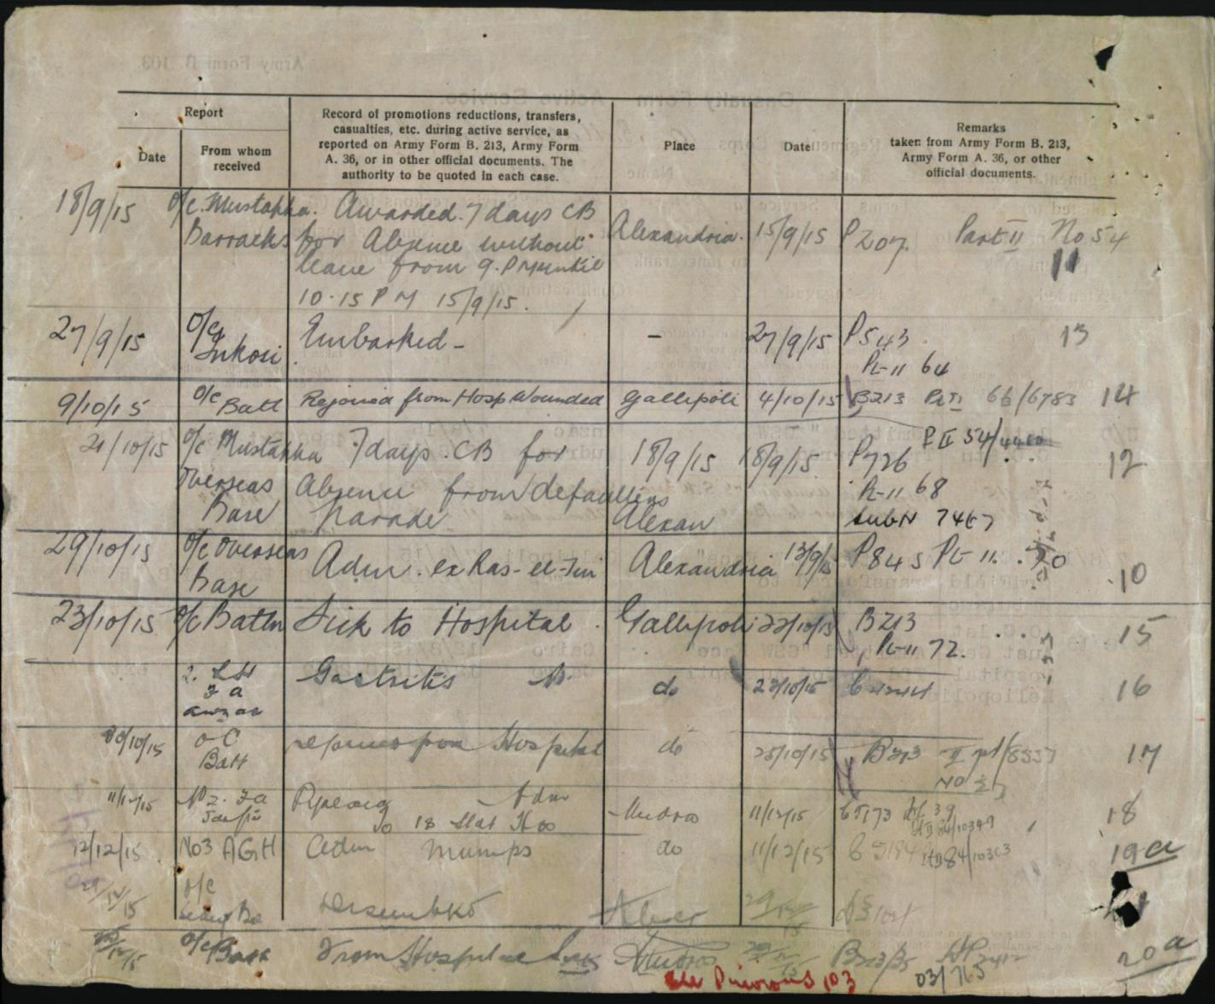

Date

Crimes and other events

Place

These tell me about what crimes my soldier committed during the war. It shows that he decided to leave the war many times and got caught each time. It also tells me about what type of person he was when he was faced with difficulties. For example, the fact that he kept deciding to go absent without leave shows me that he was very insistent upon not getting into too much danger whilst fighting.

The places given show me where he committed his crimes, an also where he was admitted to hospital.

The date tells me when these things happened. I can research into what his battalion was doing at these times, to give me an understanding about why he might have done these things.

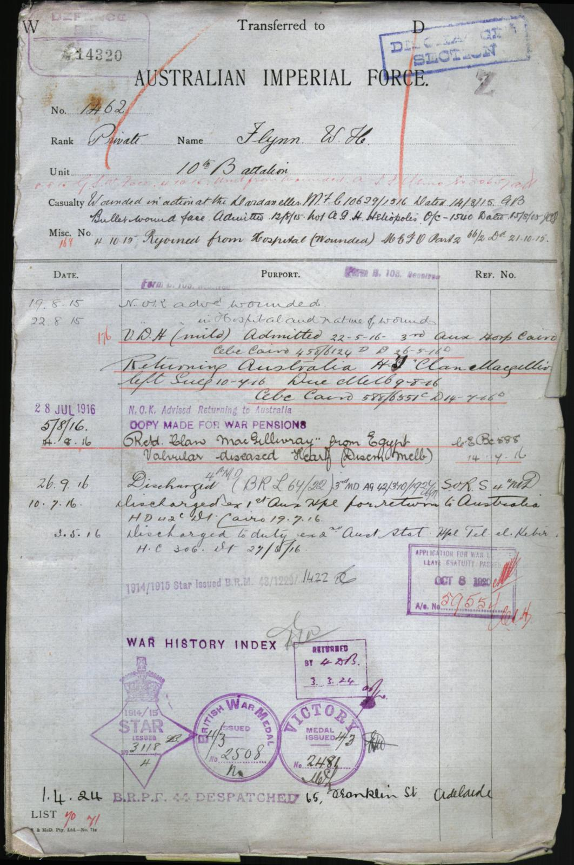

Medals received

Injuries/discharges/re-join details

Date of events

Information about his injury

General information

Again, there are general details about my soldier.

This gives information about the injuries that the form is mentioning. Again, it gives me an idea as to what happened to my soldier during the war.

The dates of these events are given. I can look up what was happening in my soldiers battalion during the times given here, and these can help me understand why he got injured.

These give the details about what happened to my soldier. They can help me put things in order as to when certain events happened to him.

The medals that he received after the war are given at the bottom. I can see that as he only got the participation medals, he didn’t do anything particularly helpful during his service time.

**Source five – Trove Australia (**[**https://trove.nla.gov.au/?q&adv=y**](https://trove.nla.gov.au/?q&adv=y)**)**

1. Why is this source useful?

This source is useful as it has many primary documents from the war, such as newspaper articles and photos. Although I haven't found any sources that are specifically about my soldier alone, there are many that involve his battalion, and people who fought in it.

1. What key details do I need to explore further?

I need to look into more of the articles that I have learned are on the Trove website, such as ones written from the perspectives of soldiers in the 10th battalion after landing in Gallipoli. This way I will be able to get a better understanding of the conditions and experiences that my soldier would have most likely gone through.

1. How will this further research give me a clearer picture of my soldiers life?

This source will help me learn what my soldier went through when he first landed in Gallipoli, due to the many articles written by his fellow soldiers about the time. By reading these, I can get a picture of what they would have been through in just those first few days, and how he might have been feeling. It can connect me with the events that went on during his service, instead of the standard details that other sources usually give me.

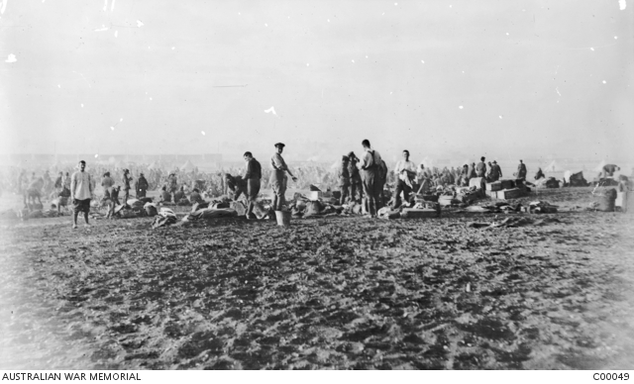

*The 10th Battalion bivouac west of the Suez Canal in Egypt after their evacuation from Gallipoli in December 1915.*

This image shows different aspects of the battalion that my soldier was first in, when they were evacuated from Gallipoli. Through other sources, I know that my soldier was involved in this event. The conditions of the evacuation are displayed in the picture, and from this I can see just what it would have been like for my soldier during this time. The area looks very cramped, dirty and unpleasant, which gives me a description of what almost everything would have been like during the war. From this picture, I can assume what my soldier must have been feeling like during his time in Gallipoli, by the looks of the soldiers and the environment in the image.

Fighting in the Dardanelles.

A Burra Boy's Experience.

Private Hartley Harris, of the famous

10th, writes home as follows :—

Hospital, Alexandria. May 23rd 1915.

(Snippet of text)

Our boys were dropping

everywhere but nobody hesitated in that

charge. We went up one hill, down it

and up the next in no time. And then

their reinforcements came to light and

made a counter attack, there were thou-

sands of them, but our boys never gave

way an inch, and when night came we

were still at it, and wasn't it cold that

night no overcoats or covering. To

make matters worse it rained and we got

soaked through and had to lie there wet.

They kept us at it all night, next day

and we were relieved on Wednesday for

a day's rest. Everybody was dead tired

Four days and nights without sleep and

only one bottle of water with two days

rations knock you out a bit, but nobody

complained. The worst and saddest

part in our battalion was on Thursday morning

when they called the roll.

Less than 400 answered their names.

Next day we had to go into the trenches

again.

Information about the text

This tells me what the text is about and confirms that it is useful information about what was happening to my soldiers battalion whilst he was fighting with him, due to the dates listed. The piece is written in the viewpoint of a 10th battalion private soldier, which is what my soldier was, so it would be very much like what my soldier would have experienced.

These details about the conditions and events that were happening to the soldiers in the 10th battalion give me a perspective on what my soldier would have had to go through in the war, and some of the things that happened to him over a couple of days. The information is very useful and reliable in this sense, and I can use it to explain my soldiers experiences in Gallipoli.

The text from the event

**Source six – AWM Unit Diaries (**[**https://www.awm.gov.au/collection/AWM4/**](https://www.awm.gov.au/collection/AWM4/)**)**

1. Why is this source useful?

This source is useful as it gives day by day updates of what was happening in my soldiers battalion, in chronological order. These show us each event that the soldiers went through each day, and the impacts that these had on the battalions. They are also primary sources, which means they were from the time of the battles that my soldiers battalion fought it and are from the perspectives of people who were experiencing the war.

1. What key details do I need to explore further?

I think that I need to analyse the handwriting of the diary entry more, as I am still confused about some of the words that have been written. Once I am more confident with what is being said, I can look up details on the events listed in the diaries, to further my knowledge on the conflicts listed with my soldiers battalion. However, there is only one-unit diary that I can find which is listed from during the times that my solder was actually fighting with his battalion (other times he was either not enlisted yet or in hospital), so further research into this source could be limited.

1. How will this further research give me a clearer picture of my soldiers life?

This research can help me get an understanding of some of the things that happened each day in my soldiers battalion. I can learn about the movement of his battalion, and what his life might have been like living under those conditions. The dates and places listed can also be good for me to look into, as I can then see what else might have been happening in other parts of the war during those times.

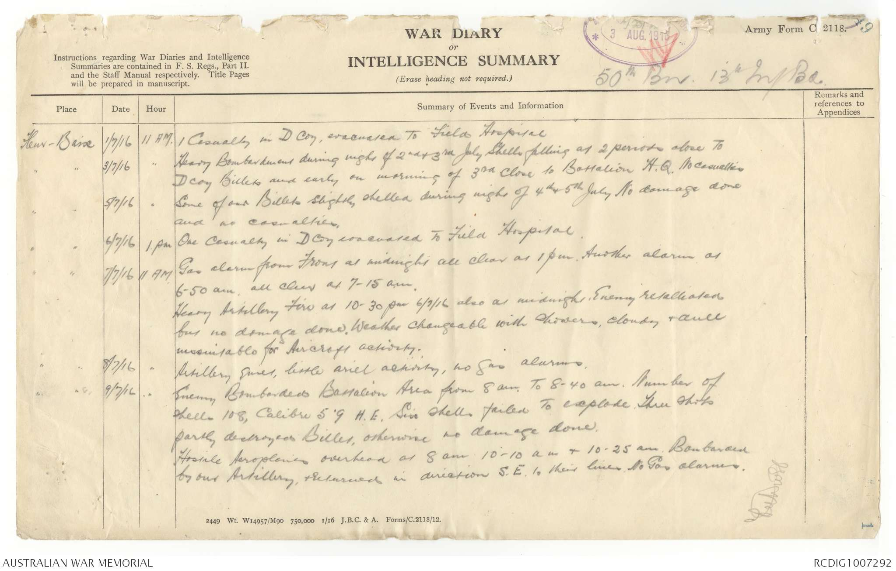

Information about events

Date/time

Place

The place that the events mentioned in the diary occurred is listed on the page. From this I can research further into this location, and get an understanding of the particular battles that my soldier and his battalion fought in.

The date and time of these events is also listed. These could help me get more specific details on the battle that I am researching from this unit diary.

This unit diary was written by a soldier in the 50th battalion, during July 1916, a few days before my soldier went home. From this I can get details into what was happening to the soldiers in that particular group, from their perspectives. It is reliable due to the fact that it is a primary resource. I can also get an understanding of the conditions during the war, and all of the bombings and fights that went on. I can see how my soldier would have had to have lived, in terms of constantly checking up on weaponry, being prepared for attacks, and dealing with numerous casualties over just a couple of days. All this will be extremely helpful for me in the second part of this task, and I can note down information about each of these days in the unit diary to help me talk about my soldier and his experiences during his service time.

**Source 7 - AWM Collections (**[**https://www.awm.gov.au/collection/AWM4/**](https://www.awm.gov.au/collection/AWM4/)**)**

I have not been able to find collections of information about my soldier or his battalion on the AWM website.

**Source 8 – State Library of South Australia (**[**https://www.catalog.slsa.sa.gov.au/search/X**](https://www.catalog.slsa.sa.gov.au/search/X)**)**

I have not found any details about my soldier or his battalion that I can access on this website.