William Charles Butler

# BIRTH

Mother – Elizabeth Butler nee Cashin

Father – William Butler

Born – 1887

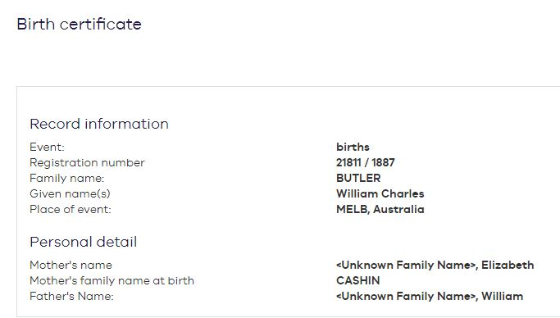

# SERVICE

He was a Clerk who lived in Carnegie VIC. He went to war aged 28. His mother Mrs E Butler of Nerrim road, Carnegie VIC, saw him onto the ship. He survived, came home and was a station master. He was married and his wife outlived him.

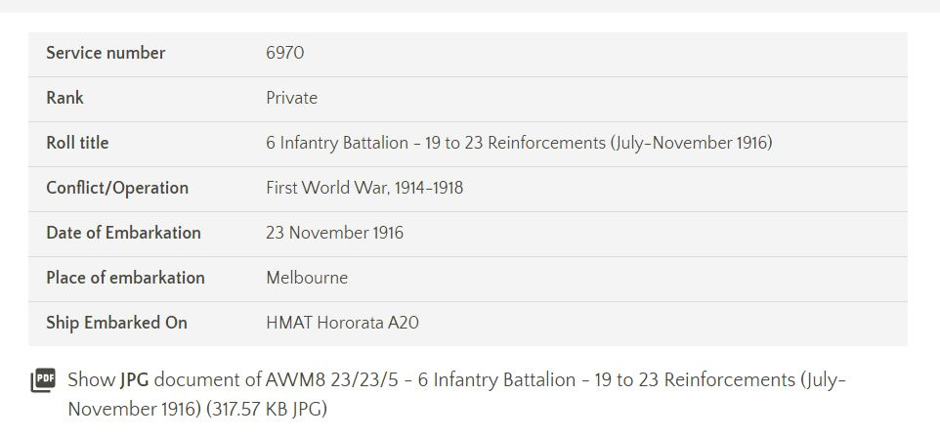

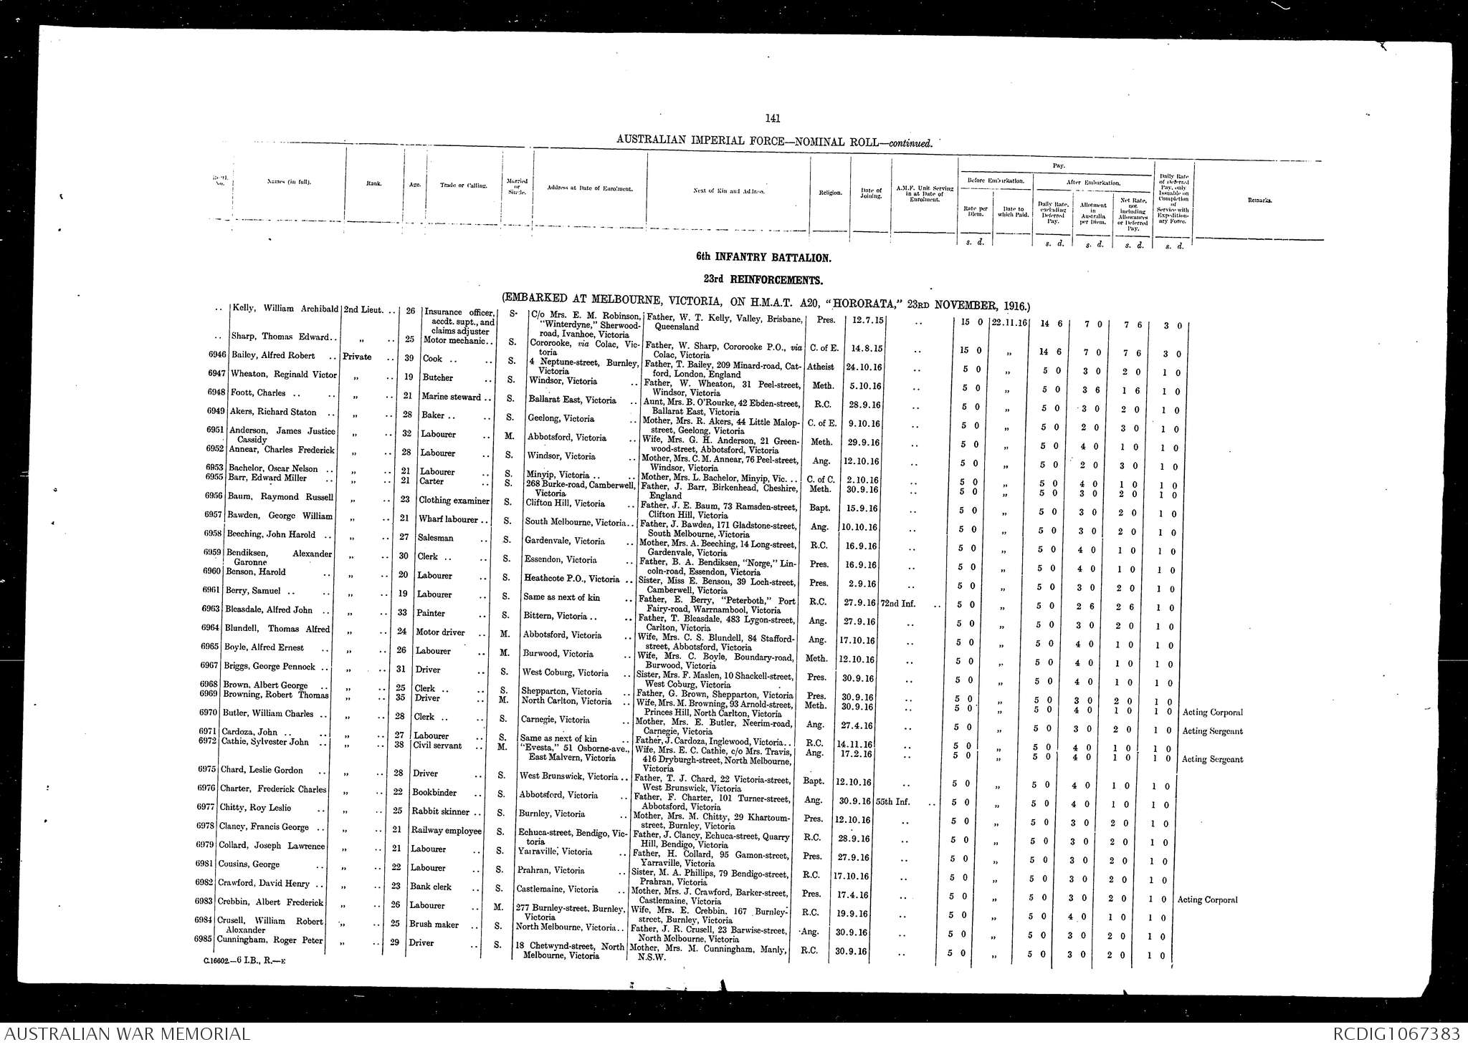

# DIED

April 1947, aged 60, at his home 29 Foster St Dandenong VIC Australia.