**CLEWS L.J., PA4064, Royal Australian Navy**

The following is an extract from my father’s memoir. The extract deals with his life during World War 2.

The war was not going well for us. Our troops in North Africa were doing it the hard way after being kicked out of Greece and Crete, but held their own magnificently in the defence of Tobruk. We had occupied Syria, but only after a grim struggle with the Foreign Legion, who were fighting with the Vichy French. In the Mediterranean, we had lost several of our destroyers with worse to come when the cruiser “Sydney” was lost with all hands – about 600 – off the coast of W.A. Casualties in the R.A.A.F. were quite severe in the U.K. and over Europe, and all in all the mood at home was quite sombre. Conscription into the Army became law at age 18, but the A.M.F. (Australian Military Forces) was not for overseas service, but for the defence of Australia and Territories, which included New Guinea. At this time, when the whole picture was fairly bleak, Japan hit Pearl Harbor and rolled apparently inexorably south, including the capture of the Philippines, Hong Kong and Singapore, where our 8th Division A.I.F. was stationed and where we lost about 12,000 troops as P.0.W.’s.

With the continual advance south of the Japanese and the bombing of Darwin, Broome and Townsville, Australians realised that they were at war. Petrol, meat, butter and clothing were rationed and could only be bought with the necessary ration tickets, which were issued from government offices and post offices. Bomb shelters and slit trenches were dug in most back yards, while the A.M.F. Militia placed barbed wire entanglements along some of our beaches, dug trenches and manned machine gun emplacements. Regular air raid exercises were carried out when the sirens sounded, while the few cars on the road at night had their lights dimmed with black paint, leaving only a horizontal strip about 2cms wide for visible light. All homes had to have black-out curtains, and during the exercises air raid wardens would patrol the streets looking for light escaping from windows. Due to the lack of petrol, many cars converted to gas from charcoal which, as it was produced, was stored in a huge rubber bag carried on the roof of the vehicle.

The Home Guard was formed, consisting of old soldiers from W.W.I and other men and boys who were either physically unfit for the Services or were in essential industries and thus barred from joining up. Naturally, Dad joined the Guard very promptly, and used to come home from the drill hall grumbling that, with a few exceptions, they wouldn’t know how to fight their way out of a wet paper bag. They were armed with old Lee Enfield 303 rifles left over from W.W.I. We young blokes – 15 and 16-year-olds – were undergoing a fairly frustrating time as we were not quite old enough to join up. My friends and I all owned .22 rifles and used to ride our bikes some 60 kilometres to Mannum on the River Murray on weekends, camping out, and shooting rabbits. We all agreed that should the Japanese ever get to South Australia, we would “go bush” with our rifles and give them a hard time. Romantic thinking, I suppose, but we were all fairly good shots and that was the mood of the times.

I was now 17 and the time had come to start working on my Mum to get her consent for me to apply to join the Navy. Parental consent was necessary if you were under 21-years-of-age. I knew there would be no problem with Dad, but with Mum it was a different matter. She had lost a brother, my uncle Les, in France and several close friends at Gallipoli. The one thing I had going for me was that I had decided on the Navy. I would not have made first base had I chosen the A.I.F. Dad had said that if I was determined to join up, the Navy was the way to go, as “You always have something to eat and somewhere to sleep”. Having done his time in the trenches in France, he knew what he was talking about. When I was about 17-and-a-half, I eventually wore Mum down with the argument that if I delayed much longer I would be “called up” (conscripted) into the A.M.F., and she grudgingly signed the papers. With these in my hot little hand, I dashed down to the Naval Depot H.M.A.S. Torrens at Birkenhead, lodged same and waited to be summoned for my medical. Much to my mother’s dismay, and as I had anticipated, this happened within a week or so. (I had convinced her that it would take months, when coaxing her to sign my application). Being extremely fit, I had no fears regarding the medical examination and with my application to join as a Signalman, I was full of confidence. Then came the first of many surprises that I was to experience in the Navy. The doctor confirmed what I had been told years before, during a school medical, that I was hopelessly colour blind and would never make a Signalman.

I don’t remember why I wanted to become a Signalman -probably some romantic notion – but when I was classified as completely unsuitable, since I couldn’t tell the difference between red and green, they offered me some alternatives. I could join as a Cook, Stoker, or, as I had an Intermediate Certificate, a Supply Assistant. Further, and they must have been short of S.A.’s, if I joined this branch I would be sent to Sydney to H.M.A.S, Penguin for training in two weeks’ time. I couldn’t sign quickly enough. So, on the 5th June 1943, CLEWS L.J. Official Number PA4064, Probationary Supply Assistant, 2nd Class (the latter because I was 17-years-old), classified by some as the “lowest form of marine life”, mustered on the Adelaide railway station with a mixed group of about 15 other characters, aged from 17 to others in their 30s, boarded the Melbourne Express and waved farewell to my tearful mother and rather proud looking father and sister.

On arrival at Sydney, two days later, we were bundled into the back of a truck, which deposited us at H.M.A.S. Penguin for two month’s training. This depot was a converted hospital overlooking Balmoral Beach and my main memory of it was the all-pervading smell of boiled cabbage. We were issued with uniforms and hammocks, introduced into the mysteries of lashing and hanging a hammock, subjected to a series of vaccinations, inoculations, etc., and worst of all, introduced to the Petty Officer, who had the unenviable task of drilling and marching us. I am sure he hated the job, because he gave us hell, which I think made him feel better. We had rifle drill, bayonet drill and I couldn’t really believe we would be using bayonets a lot at sea. Everything was done at the double. For example, following P.T, in shorts and singlets, we would be allowed seven minutes to race up three storeys to our dormitory, change into full uniform and be back on the parade ground for more drill. We did some target shooting where my days at Mannum chasing rabbits paid off. I finished second in the class of 30 to an ex-A.I.F, Infantryman who had transferred to the Navy. Our class was made up of all sorts, with past occupations ranging from farmers, clerks, tradesmen, a bank manager, lawyers (Frank Galbally), etc. I felt sorry for a couple of the 30 plus year-olds who had come from sedentary jobs. The pace at which we were pushed must have nearly killed them. We also went back to school, with theory on how to keep supplies up to a ship and the necessary paperwork involved. Some sailing was included in our training and this I enjoyed.

After about three weeks of this, I decided to go down with dry pleurisy which put me in the sick bay for ten days or so, and as a result I completed my training with the class that started a month later than the one I had commenced with. (A new batch of recruits started monthly). For the first month of training no leave was allowed, after which we could “go ashore” after 4 o’clock, but for we under-18s leave expired at 10pm. It was known as “boys’ leave”. Our pay as “boys” was 3/6 (35 cents) per day. This rose to 6/6 (65 cents) per day on reaching 18. On one of these “runs ashore” I met all of Dad’s five sisters, who had gathered to look me over, and who I had last seen in 1936 on our big caravan trip.

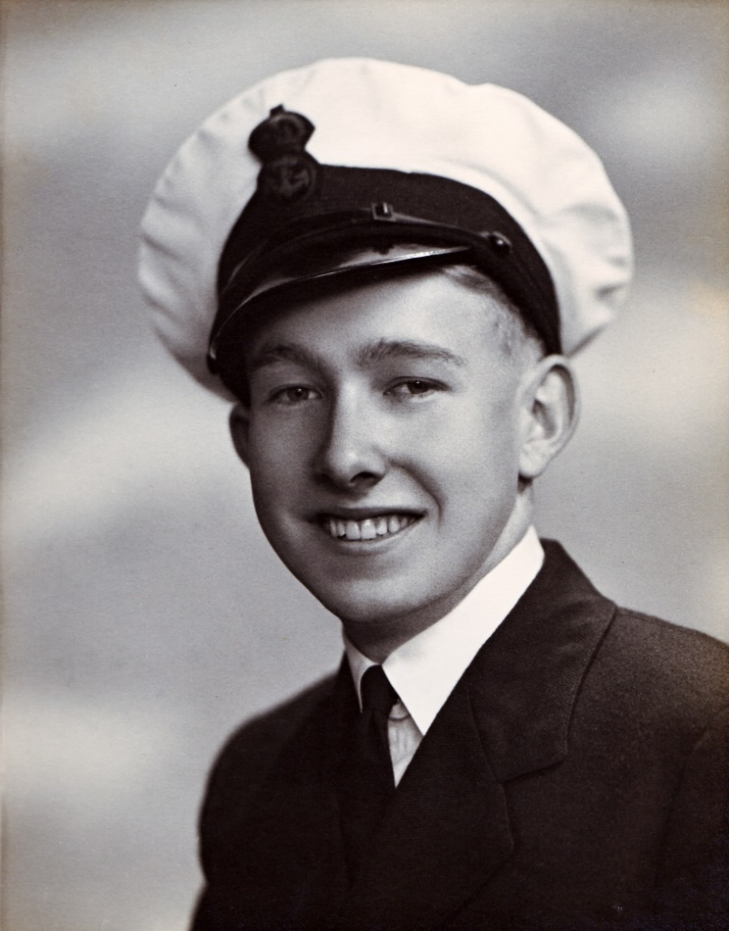Anyhow, towards the end of August our training was complete and we were given a few days final leave. As far as the South Australians were concerned, this consisted of two nights on the train to Adelaide, and for me, one night sleeping in my old bed (not a hammock) and then two more nights on the train back to Sydney. Some “leave” indeed. The Western Australian’s and Tasmanians missed out as they lived too far away, and in those days, there was no thought of air travel. On arrival back at Sydney, to my surprise I was singled out by the R.T.O. (Rail Transport Officer) who had with him all my gear (hammock and sea-bag). This was handed over to me, together with instructions to get back on the train, as I was to carry on to Cairns to join H.M.A.S. Wagga, which I knew to be one of about sixty corvettes in service with the R.A.N.

Needless to say, this 17-year-old was delighted to be given a sea-going draft, as probably about a third of our class was posted to shore bases around Australia, and that was the last thing I wanted. So I was back on the troop train with about 500 other soldiers, sailors and airmen heading north. Now these troop trains were hardly luxurious. They were what were commonly called “dog boxes”, with eight troops to a compartment, four facing forward and four facing aft, with overhead luggage racks. There was always intense competition to see who slept in the two luggage racks; personally, I preferred the floor which was shared with one or two others, while the rest tried to sleep sitting up. There were two toilets and hand basins per carriage, serving probably 80 personnel. Hygiene was obviously not a priority. We were issued with army type mess gear i.e. knife and fork, tin plate and mug, and were fed from army kitchens on railway stations along the way. The menu was the same each day – sandwiches, usually beef or cheese for breakfast and lunch, and stew each night for dinner with a mug of tea. The Army blokes considered this to be normal, but we Navy types were not impressed and realised how well we were looked after. Now this sort of living was not too bad for a couple of days, but in my case I had spent four out of the last five nights going to and from Adelaide on a train, and did not realise that for the next week I would be doing the same thing. Two nights to reach Brisbane and, would you believe, four more nights to Townsville and another day to reach Cairns. After about Nine days without a shower I was not nice to be with.

Our troop train must have had a very low priority, as we were shunted on to sidings time and time again to let other, faster trains through, thus the ridiculous time taken for the trip. When we stopped it would take about one minute for the troops, mainly Army, to jump off the train and start a two-up game (Swy). As we took off again there would be one helluva panic, troops gathering money and chasing the train, some just making it. It was always good to watch, very entertaining, and we didn’t lose a single soldier.

Our flotilla of escort vessels – mainly corvettes with the occasional assistance of some sloops or a destroyer when extra-large convoys needed to be escorted – were served by our “Mother Ship” the H.M.A.S. Platypus, which was permanently tied up to the Cairns wharf. She supplied us with our stores — victuals, mechanical, ammunition etc. – and on our return from a convoy we berthed alongside her. Having survived the train journey, I was picked up from the station, deposited on the wharf with my gear (hammock, kit bag, tin hat and gas mask) and directed to the second ship outboard from the Platypus. The Wagga – all corvettes were named after country towns – looked fairly good to me after the train trip, so with my gear I stumbled across the Platypus and another corvette and reported aboard my first ship. The coxswain knew that I was due and took a few details, then directed me to the Miscellaneous Mess (Supply Assistants, Cooks, Stewards) to which I headed, completely bemused but trying to look quite nonchalant, where I quickly discovered that no one had time to talk to me as all hands were involved in taking stores aboard. All was hustle and bustle as we were due to sail in three or four hours’ time; this situation, I was to find, was very much the norm between convoys. Successfully keeping out of everyone’s way during this organised chaos, I managed to find the showers, after which I felt that life might just be worth living.

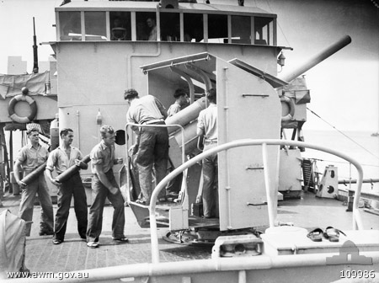Now a little about corvettes. They were a 900-odd ton vessel with complement (crew) of 95-100 sailors. They were designed not only for escort duties but most of them were also fitted with mine sweeping equipment. The Wagga was not thus equipped, which meant that we were never involved in this tedious and somewhat dangerous task. Our flotilla’s job was to meet the convoys of ships travelling north inside the Barrier Reef, which was submarine proof, and take them out through the Grafton Passage just outside Cairns and escort them across the Coral Sea to New Guinea, which generally took about 48-50 hours, depending on weather, the size and speed of the convoy (a convoy’s speed is the speed of the slowest ship), and whether our destination was Port Moresby, Milne Bay or Oro Bay. These convoys of troop ships, tankers and general cargo vessels usually numbered about ten or a dozen. This number could be handled usually by four corvettes, whose job was to patrol in zig-zag fashion around the convoy using ASDIC (anti-submarine detection equipment – echo sounding) in order to protect the convoy from Japanese subs, which were fairly busy in the Coral Sea. Our ship (J315) was armed with one 4-inch dual purpose gun on the fo’c’s’le, an Oerliken quick firing 1-inch gun aft on Y deck, with two machine guns on the wings of the bridge. Our main “teeth”, however, were about eighty 400-pound depth charges, which could be despatched from four throwers (two starboard, two port) or rolled off the stern from two sets of rails. This is what corvettes were designed for, to protect shipping from submarine attack. They could cruise for about ten days without re-fuelling, and were quite slow (18 knots, max.) but could manoeuvre in a very agile manner when under air attack. There is a painting in the War Memorial, which I stumbled across, showing the Wagga’s Oerliken gun and gunner in action during an air raid in Milne Bay. This raid happened just prior to my joining her, but when I did, she still sported a few shrapnel holes around the bridge area from near misses.

Corvettes were renowned for their behaviour – or lack of it – at sea. It was claimed that they could “roll on wet grass” and they did not only roll but could pitch at the same time. Now to me, who had no previous sea-time to my credit, this behaviour was, to say the least, quite disconcerting, and just to prove it, for the first six weeks I was sea-sick from the time we left the shelter of the Barrier Reef for two days until we reached Port Moresby or Milne Bay, and of course it was repeated on the return trip. After the first six weeks the sea-sickness stopped and to this day, while I have sailed on many different ships, I have never been sea-sick again. This problem did not preclude sufferers from carrying out normal duties. I used to work below decks in Central Stores, with the ever-present smell of fuel oil, and a jam tin by my side, which needed emptying quite often. Stokers who also had this problem took their jam tins with them while on watch in the engine or boiler rooms. I had quite a few mates.

At this time, it seemed that the war tide was turning in our favour. Most of our seasoned A.I.F. troops had returned from the Middle East and with the assistance of some militia units had stopped the Japanese, for the first time, on the Kokoda Trail just beyond Moresby. This win was quickly followed by a battle for the air-strip at Milne Bay and once again, while it was a very near thing, the Japanese were forced to retreat back up the south-east coast of New Guinea.

Needless to say, there was an enormous amount of shipping heading north at this time, which kept us extremely busy. During October, for example, we spent 28 of the 31 days at sea. It was quite common to sail into Cairns, head straight alongside the fuel lighter moored in the middle of the river, re­fuel then head once more for Grafton Passage for another convoy, without going alongside the Platypus to re-victual, collect mail or step ashore. These long periods at sea were not too bad as long as the weather was reasonable. A corvette’s mess deck is not a pretty sight during rough weather. A “mess deck” is the living area for the sailors, that is, a place to eat and sleep, and during heavy weather with the ship more often than not sailing through waves rather than over them, everything became wet. Water would find its way through the deck head (ceiling), wetting clothes and bedding and this, combined with spilt food, smashed cutlery, etc., made life a little tedious. While the cooks did a marvellous job, there were times when it became impossible to prepare hot food in the galley and this did not improve morale at all. Rough weather is very tiring as you are continuously bracing yourself against the rolling and pitching of the deck, and I found that I could drop off to sleep sitting at a mess deck table or wherever. We did not have much time for sleep at sea. The Supply Assistant’s routine was normal work in the stores – either victualling or central store (tools, nuts, bolts, machine spares, etc.) – from 6am to 4pm, into the hammock by 9 or 10pm, wakened at midnight for the middle watch as lookout on the wing of the bridge until 4am, back into the hammock until about 5.30am when all hands were called to close up for down action stations, after which it was time to think of breakfast and another day. With only four or five hours in the hammock a day, it was no wonder we could drop off to sleep while sitting at a table. It was also a good thing that we were young.

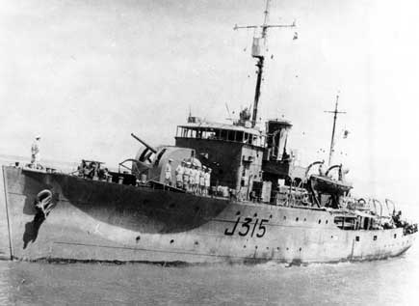My little black book (log) in which I recorded our activities reveals that I crossed the Coral Sea in the Wagga on 22 occasions, and there were times when we sailed in idyllic conditions with the tropical sea like glass. These were the “nervy” convoys when the situation was ideal for submarines, and while keeping lookout watch on the wing of the bridge, peering through night field glasses for periscopes from 12 to four in the morning, there was no need for the Officer of the Watch to remind us to keep a sharp lookout. Rough weather, therefore, had its good points, as it made the chance of submarine attack less likely.

When a “contact” was made by one of the escorting ships with the aid of the echo sounding equipment, all hell would break loose. If you were in your hammock, you grabbed your anti-flash gear, “Mae West” (inflatable life jacket), a helmet (we slept in overalls) and raced like a mad thing midst the strident ringing of the alarm bells to your designated action station. (Predictably, the first such alarm found me seated comfortably in the “heads” [dunny]). My station was on the after starb’d depth charge thrower where we manhandled the charges on to the thrower, ready to fire when the ASDIC operators signalled that we were over the “contact”. Some false alarms resulted from signals being received from objects other than submarines, for example a very compact school of fish or a sunken ship, but an experienced ASDIC operator could generally tell the difference between a false echo and the real thing.

On one memorable occasion when we were about 100 miles out of Cairns with a convoy heading south, a “contact” was made at about 11 o’clock at night. The convoy with three corvettes took off flat out for Cairns, while we were given the job of keeping the submarine involved. Now we knew that the Japanese long-range submarines sported, apart from torpedoes, a 6-inch gun and as our heavy armament consisted of a 4-inch gun, the last thing we wanted was for him to surface. The hunt went on all night, and as dawn was breaking our ASDIC operators reported noises of a submarine breaking up, and we knew that we had won this one. With only six or eight depth charges remaining it had not happened too soon, and we were all very thankful when we stopped circling and headed for Cairns. There was no exuberance, so beloved by Hollywood on such an occasion, among the crew. We were all very wet and tired, and when we secured action stations the mood was rather sombre and I believe all members of ship’s company, with at least half a brain, were thinking of the 60 or so Japanese sailors that died a very nasty death, several hundred feet below us. That night we had leave ashore in Cairns until midnight (I had turned 18 by this time) and I was, incongruously it now seems to me, in view of our activities of only a few hours earlier, at a dance. I was dancing with a civilian lass – a rare breed in Cairns at this time – when she posed the usual question, “What ship?” I replied “Wagga”, and to my amazement she said, “Oh, you sank that submarine last night”. So much for war time security! The full details of this particular action became known to me as it turned out that I was the only member of ship’s company who could use a typewriter, and on our way back to Cairns I was employed in typing out the Captain’s report. My commercial high school studies had come in useful at last.

At the end of ‘43 we headed south for a much-needed refit, arriving in Melbourne three days before Christmas Day, and from there home for two weeks’ leave. During this leave, much to my embarrassment, I became sick with a schoolboy’s disease – scarlet fever – and was bundled off to the Northfield Infectious Diseases Hospital, at that time run by the Army and known as the 121st A.G.H. There I developed acute sinusitis and spent a few very uncomfortable weeks. On being discharged, I found, much to my disgust, that the Wagga had sailed north without me and I was drafted to the local shore depot, H.M.A.S. Torrens. I was most uncomfortable while working in the clothing store at Torrens, and missed being at sea very much. I just could not wear being in the Navy and going home to the family two nights out of three, and felt very unsettled. Of course the family, particularly Mum, thought it was great and dragged me off to the Methodist church every Sunday to show me off to her friends. Fortunately, this purgatory only lasted for seven weeks, when to my delight I was told to pack my gear and get on a troop train for Sydney to join H.M.A.S. Whang Pu, which I did on 21st April 1944.

The Whang Pu, a vessel of 3,200 tons, operated pre-war along the China coast and was requisitioned by the Royal Navy when Japan entered the war. She sailed to Singapore and was being fitted out as a submarine depot ship. As the Japanese took over the Malay Peninsula and then Singapore, she sailed for the Dutch East Indies (Indonesia) laden with evacuees. Surviving several air attacks, she eventually made it to Fremantle, where she was taken over by the R.A.N. When I joined her in Sydney, she was being loaded with all the necessary equipment to build a naval depot on an island in Madang Harbour on the north-east coast of New Guinea, to service light patrol vessels known as “Fairmiles”. The equipment to build this depot included trucks, jeeps and a bulldozer, as well as building materials. Halfway through loading, the good old wharf labourers went on strike. The war effort meant little to those safe, stay at home sods. Anyhow, we were due to sail in three days, so the Captain told us that if we could load the ship within the three days allocated to the wharfies we could have a night’s shore leave. We achieved this in less 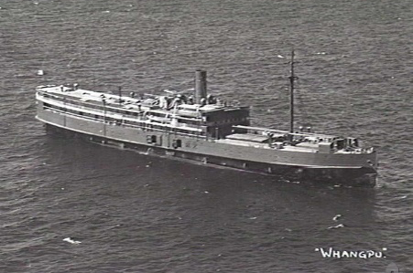than two days, had our night’s leave ashore and sailed on time.

Our trip north as I recall was fairly uneventful, with the exception of the Coral Sea crossing when heading for Milne Bay. We ran into a cyclone and to avoid foundering we had to head south-east when we should have been sailing north-east. These Chinese coastal and river ships were quite flat-bottomed and were not designed for heavy seas, so we had to head into the storm to stay afloat. I remember feeling very superior at this time as about half the crew were violently sea-sick, and as I had overcome that problem on the Wagga, I quite enjoyed the wild weather and the ample supply of food at meal times.

We eventually arrived at Madang after stops at Brisbane, Townsville and Milne Bay, six weeks after leaving Sydney. Madang had not long been captured by the Army and while a few Japanese snipers were still operating and being hunted down, there, under canvas, was the Salvation Army offering mugs of tea and coffee. We were very impressed. The little island in Madang Harbour at which we berthed and on which we were to build the depot was covered with 2-metre-high kunai grass, and it was decided that it was necessary to burn it off before work could start. That decision turned out to be only half smart, for as soon as the fire got under way we came under fire. It turned out that the island had housed a Japanese 3-inch anti-aircraft battery and when they had departed, they left a lot of unexploded shells in the grass. These did not remain unexploded once the fire hit them and as a result we experienced a very lively night, keeping out of the way of shrapnel. I suppose the Japanese had the last laugh.

Life at Madang was fairly dull. We built the depot, serviced Fairmiles, and sat in the rain at the pictures on 10 litre drums – it rained every night at 8pm in Madang – with our ground sheets around our shoulders, our army slouch hats pulled down over our ears and our feet covered by very serviceable army boots. We played some water polo by the ship’s side, with a sailor each end of the field armed with a Thompson sub-machine gun to frighten away the sharks. According to my discharge papers, I sat and passed an exam in December ‘44 to become a Leading Supply Assistant, probably the equivalent of a corporal in the Army. My pay was increased from 6/6 (65 cents) per day to 7/6 (75 cents).

After about 12 months in Madang I was given leave to go home for ten days. The problem was, of course, how to get home. I managed to organise a flight on an R.A.A.F. Dakota (D.C.3) with about 20 other chaps from the three services. We sat facing each other on a wooden bench, no seat belts or anything like that, as it was designed for delivering parachutists. It had taken part in Australia’s first parachute drop of the war over the Ramu Valley, in central New Guinea. The co-pilot conversationally told us that they had a somewhat dicey starboard engine. He may have been right, but it was the port engine that stopped dead, soon after take-off. We limped back to Madang airstrip and were told to reappear, same time, tomorrow morning. Not wholly convinced that this was a good idea we nevertheless fronted up again next morning. There were no problems in becoming airborne and while I knew our route to the first stop at Higgins Field was over the Owen Stanley Ranges (10,000 ft plus), it soon became apparent to us all that D.C.3’s lacked the ability to fly that high. This problem was simply overcome by flying through the mountains via the valleys, and I can assure you that looking out of a plane, when on both sides all that can be seen is the precipitous side of a mountain just a little beyond the wing tips, is an experience you could well do without.

On landing at Higgins Field, an airstrip built on the very tip of Cape York Peninsula, we were met by ladies of the American Red Cross, who plied us with fresh milk and doughnuts. Having always been a milk lover, this was something special as it was the first fresh milk I had tasted for a year or so. These ladies were the first white women I had seen for the same period of time. While up north our food, while far better than army food, was not the greatest. Apart from tinned food, we used dehydrated potatoes, onions, eggs and milk. Fresh fruit was just a memory as was fresh meat. We consumed large quantities of lime juice, which helped slow down prickly heat and probably helped with vitamin C deficiency. It was compulsory to take Atebrin tablets every day to prevent malaria, which they didn’t, but apparently helped. We all developed a pleasant shade of jaundiced yellow due to these tablets, which was a small price to pay if they kept malaria at bay. The most effective propaganda put out by the Japanese came from a lady called Tokyo Rose, who we used to enjoy listening to on the radio. She broadcast in a sexy American drawl and assured us, among other things, that there was no better way of becoming sterile than by taking Atebrin. Now while it was a punishable offence not to take Atebrin, it was hard to police, and a certain proportion of servicemen of the thick-wit variety who had definite ideas and plans of busily propagating the species when they got home, avoided the medication. As a result, they went down like flies with malaria and Tokyo Rose’s propaganda had served. I suspect that a proportion of the “Baby Boomers” generation may have been the result of returning ex-servicemen who had religiously taken their Atebrin, mistakenly believing Tokyo Rose’s garbage. Who knows?

Due to the unattractive food, we gradually ate less and less and in no time had trimmed down considerably, which with the continual heat and humidity was not a bad thing. About 90% of ship’s company smoked and at 2/6 (25 cents) for a carton of 200 cigarettes, or two-and-a-half cents for a packet of 20, why not? There was never any suggestion that smoking was a health hazard and in fact in the Royal Navy there was a free issue of cigarettes. Of course, the Royal Navy also had an issue of rum each day, but we in the R.A.N. had to get by on lime juice. At the end of the war when supplies were available, the R.A.N., when in port, issued a bottle of beer twice weekly. The idea of course was to cultivate a friendship with a non-drinker, but they were fairly scarce.

We flew from Higgins to Brisbane and I then travelled on to Adelaide by troop train to be with the family for 10 days or so. I don’t remember many details of this particular leave, but I do recall that I upset Mum by not being able to cope with what appeared to be huge meals. My stomach had shrunk, I had lost about 12 kilos and had not been overweight to start with. I was very yellow from the Atebrin, but I was quite fit. She was worried by my appearance and was quite sure that large meals would put things right. With time on my hands I looked up some of my ex-school friends who, for one reason or another, were still civilians. This proved to be a mistake, as I quickly established that we no longer had anything in common. We just did not speak the same language. My three close friends, Woods, Forrest and Hawson, were all away in the Navy and Air Force and I just felt that I was not in the “real world”. This was ridiculous of course, for “civvy street”, as we called normal life, was the “real world” and I had been, and was going back, to “elsewhere”, where I felt at home. Being in this unsettled state, it was not difficult to kiss my parents and sister goodbye and head off by troop train for Sydney. Looking back now, I realise I really was a mixed up 19-year-old, but having discussed my leave experience with other sailors I discovered I was not unique.

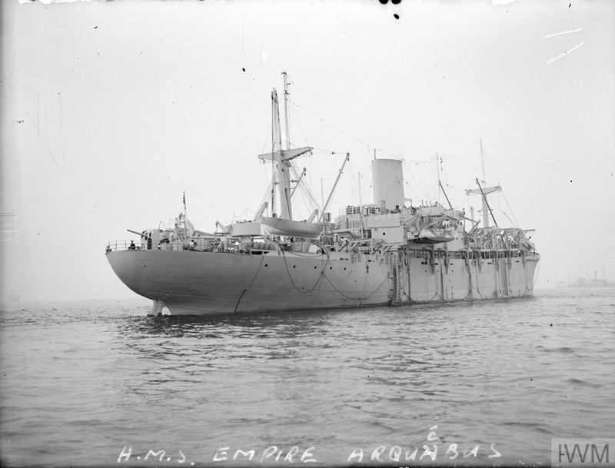In Sydney I took passage in a large Royal Navy assault vessel, the 10,000-ton H.M.S. Empire Arquebus, with about 2,000 Royal Navy sailors. This ship was equipped with landing barges for beach landings and the accommodation for the troops was basic to say the least, being designed for short stay purposes – probably across the English Channel for the invasion of Europe. We were crammed like sardines in the sleeping quarters, in three-tier bunks well below the water line, and with typical English lack of ventilation – they never envisaged that these ships may at some time operate in the tropics – the atmosphere during the night was putrid. We were not in convoy and with one corvette escorting us, the H.M.A.S. Glenelg, we took off for Manus in the Admiralty Islands. I don’t remember enjoying the trip over much, especially on one night when the Glenelg made a contact and went about chucking depth charges around. Below the water line, as we were, depth charges make a lot of noise and vibration, and the thought of an “unfriendly” out there, while being cramped in with 2,000 other sailors, just did not appeal. I must admit, however, that I did enjoy the 11am “up spirits” (rum issue) which we had in true R.N. style for the week that the trip took.

On arrival at Manus, which incidentally is the largest harbour in the world, I was victualled into H.M.S. Lament, the R.N. naval depot, for a few days while the Glenelg refuelled and then I took passage in the Glenelg for Madang and the Whang Pu. I was very happy to go aboard the Glenelg after the Empire Arquebus, and because of my ex-Wagga days I felt very much at home in a corvette. It turned out that one of the ship’s company had been a year ahead of me at high school and I had known him quite well as a kid – “Flip” Fuller by name – so we did a bit of catching up during the trip back to Madang.

Back on the Whang Pu nothing much had changed. We were servicing a flotilla of Fairmiles as well as being a store ship for other small ships. Don Woods, probably my best friend as a kid, showed up on one of the Fairmiles, on which he was a Signalman. Don, a few years later, was our groomsman at our wedding. He was turned in to our sick bay with a bad dose of tropical ear, a very painful infection caught from swimming. Most of us who swam suffered from it from time to time. I was fairly fit except for the normal malarial attacks, prickly heat and dermatitis, but nearly everyone enjoyed these problems. I played a bit of water polo, tried my hand at boxing and generally kept fit. I had three inter-ship bouts; lost the first, drew the second and won the third. At that point I discovered that to win, one had to take a fair amount of punishment, so I wisely retired while in front, deciding to devote my sporting ability to more peaceful pursuits such as lacrosse.

Early in ‘45, out of the blue, I was drafted to another ex-Chinese river boat, the H.M.A.S. Ping Wo, also sometimes known as the Winged Po or Flying Piss Pot. She was at the time undergoing a refit in Melbourne so, with my gear, I was bundled on to a Martin Mariner flying boat of the U.S. Air Force, which flew me down to Townsville and thence by rail to Melbourne. We flew over the Coral Sea all the way to Townsville, which was a far more comfortable experience than my previous flight south through the Owen Stanley’s in the old Dakota.

The Ping Wo, a ship of similar size to the Whang Pu, i.e. 3,000 odd tons, was fitted out as a supply vessel for smaller ships operating in the New Guinea region. Our departure was slightly delayed by yours truly, who, with perfect, timing, decided to go down with a heavy attack of malaria. I vaguely remember being carried ashore on a stretcher to a waiting ambulance, and regained consciousness to find myself in Heidelberg Military Hospital. My main memory of this episode concerned the daily inspections carried out by the colonel in charge of the hospital, who stalked down the ward following the redoubtable figure of the very large matron. He was always attired in full Light Horse uniform and carried a horse hair-switch, which he tapped with each step against his highly polished riding boots. As he entered the ward, the order would be given – “All patients, sit at attention!” – it didn’t matter how lousy you felt. At these times, I felt very pleased that I was in the Navy.

I caught up with the ship in Sydney and we headed north, but not without a further delay. We were refuelling in the Brisbane River when peace was declared – V.P. day, as it became known. Almost the whole of ship’s company headed for the city, where the celebrations were unbelievable. It was a very good day to be in uniform and we had a ball. Australia had had six years of war and the released emotions on this historic day had to be seen to be believed.

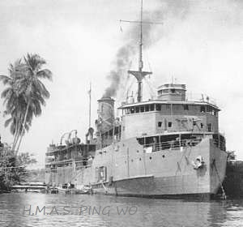From Brisbane, our cruise north was a pleasure. No blackout at nights, no dawn action stations and all in all a very relaxed atmosphere. Although the war was over there was still plenty for us to do. My log shows that we made about 20 voyages to and from Port Moresby, Milne Bay, Madang, Finschhaven, Alexishaven, Manus and Wewak, closing down shore depots, moving stores, etc. I recall one incident of stores being shipped – from Madang to Finschhaven and, in particular, cases of sacramental wine belonging to the Padre. Now it is a well-known fact among sailors who store ships that a wooden crate, when dropped on its corner, will split. It just so happened that one of the crates of wine was so damaged and a few bottles broken. While clearing up the mess with my mate Roy Noseda, somehow or other two or three unbroken bottles vanished, but were found later that night in a quiet corner of the “flight deck” where Roy and I discussed the meaning of life, etc. etc. until the early hours of the morning, as we steamed south to Finschhaven. Next morning when we reported for work, our Paymaster Lieutenant took one look at us and ordered us back into our bunks – a very understanding officer.

Early in ‘46 – about March, I think – we had finished our clearing up jobs around New Guinea and were ordered south to Sydney. All hands, with the exception of the permanent service sailors, were in a high state of excitement, anticipating their long-awaited discharge back to Civvy Street. The system for discharges was basically dependent on length of service and as I had only about three years to my credit, I knew that a lot of personnel would get their “ticket” before me. Some of my mates had served five or six years, so while I knew it would not be long, I was not over-excited, but wondered vaguely what I would be doing until the big day. I was soon to find out. Signals came aboard as soon as we docked, drafting, about 80% of the crew to their home shore depots to await discharge. The remaining 20%, of which I was one, were told to store ship for passage to Hong Kong to hand the ship back to its original owners, Jardine Matheson, a very large English shipping company. The bad news was that we had to store ship for an additional 200 personnel, R.N. (British) sailors who were taking passage to H.M.S. Tamar, the shore depot in Hong Kong.

Our six- or seven-week voyage to Hong Kong was a real “slow boat to China” job. We cruised via Brisbane, Townsville, Thursday Island, where we had engine problems and had to limp back to Darwin, Tarakan on the east coast of Borneo (now Indonesia), Manila and thence to Hong Kong, where we arrived on the 8th June ‘46, and unloaded with few regrets – very few, in fact – our 200 R.N. passengers. These people, in the main, were a very motley crew. They had no idea, as far as we (the Australian crew) were concerned, of basic hygiene as required at sea, and particularly in the tropics. At the end of the working day, the first thing our crew naturally did was to head for the showers, albeit salt water, but we did have salt water soap. Our R.N. passengers were obviously stunned by this behaviour and their ablutions consisted of washing hands, face and knees. Bathing the whole body was apparently restricted to Saturday nights. In no time they suffered from prickly heat and various forms of dermatitis and rashes, and the level of body odour on the mess deck was very high. We did our best to educate them, even to the point of pinning up a notice in the galley where food was served, with the subtle message - “No wash, no food”. I should stress that there were exceptions to the very ugly picture I have painted, but many came from some very tough areas of Scotland and England. Unlike the Australians, they were nearly all conscripts and hated the Navy. I have vivid memories of a couple of Scots from the docks of Glasgow, who used to spend their spare time beating their foreheads against the steel bulkhead in order to create the calluses necessary, apparently, to deliver the renowned “Liverpool Kiss”, which is a head butt into an opponent’s face. At Tarakan, where we spent 24 hours, the Surgeon Lt. Commander warned all hands that due to the Japanese occupation, the incidence of V.D, in various forms was estimated at 95% of the female population and for obvious reasons all shore leave ended at 6pm. That night we saw any number of these morons sneaking ashore with one thought in mind. A couple of weeks later, when I attended the sick bay at the shore depot in Hong Kong to get an insect removed from my eye, I met quite a few of these characters again, all being treated for various types of V.D., not in the slightest bit fazed by their condition, and in fact I gained the impression that they treated it almost as a badge of honour.

Soon after our arrival in Hong Kong, most of the Australians were sent home, as they had done their job of delivering the ship to the original owners. As I was now the senior Supply rating aboard, there was no way I would be sent home until the job of handing the ship over was complete. In fact, the job was totally mine, and for a 20-year-old Leading Supply Assistant this turned out to be quite a task. In theory it was quite straightforward, purely a matter of transferring all stores ashore to H.M.S. Tamar, getting a receipt from their Supply Officer and sending these receipts back to Navy Office in Melbourne. However, during our time in the New Guinea theatre, somehow or other we had acquired all sorts of items from the Army, U.S. Navy, the R.A. A.F., etc. and this material, because it was not “Pussa” (Navy) issue, would not be accepted by the R.N. types in Tamar. I took this problem to our Captain, one Lieutenant Commander Sam Smith, whose one aim in life was to get rid of the ship and get his discharge. He told me to get rid of the stuff and he wasn’t the slightest bit interested how I should do it. Rather than heave it over the side, I located some Chinese who would buy anything, and as a result for a couple of months I always had enough Hong Kong dollars in my pocket for a bottle or two of Carlsberg Danish beer.

During our stopover in Tarakan one of our officers, making a good fellow of himself to the Dutch residents, broke into my cold room and pinched two cases of butter for them. As I had to account for all stores I was quite cranky, and told him that unless he signed a statement I had prepared, saying that the butter had turned rancid and had been disposed of over the side at sea, he was in trouble. While balking at this idea initially, he was finally persuaded and signed on the dotted line. This snotty nosed Sub-Lieutenant hated the idea of being told what to do by a mere Leading Supply Assistant and was never very friendly towards me afterwards. I was devastated. I had been at sea for nearly three years, and was not prepared to take much nonsense from young Sub-Lieutenants who were overly excited about being an officer.

After the bulk of the Australian crew went home we were reduced to about ten, all key people in their particular branch, and it was at this time that Hong Kong was about to be hit by a particularly nasty typhoon. We had about six or eight hours’ warning of its approach and the routine for ships was to leave the wharf and moor to a storm buoy, in the centre of Victoria Harbour. We were attached to the buoy by two very heavy steel hawsers and to assist them in doing their job the ship’s engines were used to ease the strain on the steel hawsers. Unfortunately, we were in the throes of having a boiler clean, so only one propeller was in action when the typhoon struck; it could not provide full assistance to the lines, which snapped. We dropped both anchors and with our one engine steaming full ahead we drifted astern at about eight knots (15 kilometres per hour), swinging wildly on the end of our anchor cables. How we didn’t collide with any of the other ships during this performance was quite remarkable. The force of the wind was measured at 120 odd m.p.h. (200 kilometres per hour), which I became vividly aware of when Bob Adams our P.O. Shipwright made the mistake of opening the steel door of the P.O.’s mess and stepping outside ahead of me – and to my surprise, disappeared. Making sure that I didn’t repeat this act by grasping a steel handrail, we found Bob draped around a stanchion with, as it turned out later, his leg broken in about eighteen places. Soon after this episode, the wind dropped to about 100 kilometres and by sheer luck we slammed broadside on to a wharf, to which lines were quickly secured. There were quite a few lives lost as a result of the typhoon, both on the harbour and ashore. Our Captain, an old China coast hand from his merchant navy days who knew about these things, assured us that we were quite lucky to have survived, and to celebrate he entertained us all in the wardroom, where I surfaced next morning with a very sore head.

Political pressure to “bring our boys home” was being applied at this time and as a result our crew, with the notable exception of the Captain and I, was shipped home. Thus began an interesting, albeit lonely time, as I carried on the tedious job of paying the ship off in a necessarily, at times, somewhat unorthodox manner. The ship’s owners at this time brought a Chinese crew aboard and took over the victualling. I moved into what had been an officer’s cabin and enjoyed the best food in years. No one knew how to treat steak like our new Chinese cook. He was an absolute wizard. Sam Smith our Captain and I developed almost a father and son relationship. He was a very big Scotsman, red of hair and complexion. Before the war, he was one of an elite group of sailors known as Huangpu river pilots and had sailed the China coast for many years. I never heard him make mention of any family and at that time he must have been about 50-years-of-age. It was most unusual for a mere Leading Hand and a Lieutenant Commander to relate as we did. We had a Jeep attached to the ship for our use and at about four in the afternoon he would say, “Come on Clewsy, let’s go for a swim”, and we would drive around to the other side of the island to Cheko Beach. This, incidentally, is where I trod on a bit of barbed wire entanglement left by the Japanese, which caused me some problems at a later date. Quite often, he would take me to “Tiffin” – that is a few drinks followed by lunch with some of his old China coast mates at the China Fleet Club. There I met some very interesting characters. He tried to talk me into taking my discharge from the navy with him in Shanghai, where he was going to re-establish some sort of business which he owned pre-war, and apparently wanted me to be part of it. Fortunately, I suppose, at this time I was becoming a bit homesick, malaria was hitting me more and more often and the barbed wire scratch on my foot was developing into a tropical ulcer, which was being treated daily at the sick bay in H.M.S Tamar. Added to all this, I was sick of not hearing an Australian accent and the thought of civvy street was becoming quite attractive, the end result being that I did not take Sam up on his offer.

Early in September ‘46 I had completed paying-off the Ping Wo, which was now no longer an H.M.A.S. ship, bade farewell to Sam and took passage on an P.M. fleet tanker, first stop Brisbane. These ships had white officers and a Lascar crew, so I was treated as an officer with my own cabin and steward, which made it a very pleasant trip south. The only memory of this voyage that stays with me is that I turned 21 during the trip and I made the mistake of mentioning it to one of the officers. There were about ten of them, with everyone insisting that I should have a drink with them to celebrate gaining my majority. The 27th September 1946 was a long hard day for me.

On arrival at Brisbane naval depot it seemed that no one knew what to do with me. I suggested that, considering my length of time in the Navy I was due for discharge; however, they couldn’t find any recent demobilization signal concerning me. While beginning to feel somewhat unwanted, I insisted that they keep looking through their records, and then – jackpot – the missing signal, over six-months-old, was found. It was issued prior to our ship leaving Townsville, so it seemed that I should never have gone to Hong Kong and should have been a civilian six months ago. I was to find out later why the signal didn’t reach the Ping Wo before we left Australia. Anyhow, I was packed off down to Melbourne for “demob” where I was subjected to a medical examination, which I failed to pass because of the tropical ulcer on my foot, and as a result I was chucked into the sick bay at Flinders Naval Depot. The hospital was divided into four bed sections and I found myself sharing a section with three wild Western Australians, survivors of H.M.A.S. Perth which had been sunk in the battle of Sunda Strait. They had spent the rest of the war on the Burma railroad. They were very tough boys and a whole lot of fun. I think we gave the medical staff a very hard time. As part of our treatment to recover from our tropical related problems – dermatitis, malaria, ulcers, and in the case of the Burma railroad boys, beri-beri, dysentery, etc. – we were issued daily with a bottle (750 ml) of Coopers Stout to improve our appetites. These we would stash away in our lockers for three or four days and then after lights out we would have a party. I remember the appearance one night of the duty M.O., obviously called by the distraught sick bay attendant. He took one look at we four, sadly shook his head and walked away without saying a word. One good thing to come out of my time in F.N.D. sick bay resulted from a very heavy attack of malaria, which occurred while getting treatment for my foot. They tried what was then a new drug called Paludrine, and from that time on I never experienced a really bad bout again.

While laid up at F.N.D, I received an order to report, when fit, to a certain Paymaster Commander at Navy Office on St Kilda Road. Now, let it be said that during my three and a half years in the Navy, I had not ever so much as spoken to anyone as exalted as a Pay. Commander – they wear gold braid on their caps – and as for stepping foot in Navy Office, the Holy of Holies, the very thought concerned me no end. In fact, I wasn’t sure that it would be preferable never to be discharged from hospital! The reason for my anxiety was of course due to the albeit necessary, but nevertheless from time to time, unorthodox methods used to hand the ship over to its original owners, or as it is known in the Navy, “paying off” the ship. I had had an unblemished record in the Navy and I had been issued recently with a Good Conduct Badge (sometimes called “Undetected Crime Badge”) which, incidentally, was worth 3 pence (2½ cents) per day. While lying in bed with these thoughts running through my head, I was almost convinced that I may finish up on a charge of some sort, as I couldn’t imagine why such a personage would wish to speak to me.

Anyhow, putting on a brave face I headed for Navy Office and was shown in to the Commander. He proceeded to explain to me, in an apologetic manner, that it was never intended for a 20-year-old Leading Hand to be given the responsibility of paying off the ship, and in fact a Commissioned Warrant Officer had been on draft to the Ping Wo, but had somehow managed to miss the ship. He further went on to say, that he wanted to thank me personally for the good job I had done and wished me well in Civvy Street. I think I walked out of his office about two feet off the ground, not because of the praise, but because I wasn’t going to finish up in gaol.

So ended my naval career on the 19th December 1946. To coin a well-worn phrase, those three-and-a-half years were “the making of me”. I had changed from a callow 17-year-old into quite a mature person and had experienced things that a person who had not been in the Services would never encounter in a lifetime.

To coin yet another well-worn phrase – “I wouldn’t have missed it for the world”.