**Biography of WW1 Soldier – Harry Comery**

**Adwaith Abhilash**

* 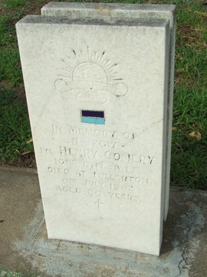NAME: Harry Comery
* SERVICE NUMBER: 2617
* RANK: Private Rank
* ADDRESS: 2 West Street, Torrensville, South Australia
* FAMILY: Mrs Elizabeth Comery (Wife)
* ENLISTMENT DATE: 2nd August
* EMBARKMENT: 27 Oct 1915, 27th infantry battalion, HMAT Benalla, Adelaide
* AGE OF EMBARKMENT: 40 Years Old
* INVOLVEMENT: 27 October 1915, 27th Infantry Battalion.
* INVOLVEMENT: 11 Nov 1918, 10th Infantry Battalion
* YEAR OF BIRTH: 1875 Approx.
* PLACE OF BIRTH: Nottingham England

This is an Image of the grave of Henry Comery which is most likely the same person as Harry Comery.

The Grave engraves the words: In Memory of No. 2617 Henry Comery, 10th BTN (Battalion) A.I.B (Australian Infantry Battalion). Died at Fullarton on July 19-2. Aged 80 Years.

At the top there is a logo of Australian Commonwealth Military forces. Underneath there is a blue flag which represents the 10th Infantry battalion and finally a cross which may mean he is Christian.

* RELIGION: Church Of England
* SERVICE OUTCOME: Returned

Harry Comery was a WW1 Veteran who worked as a labourer in a private rank. He worked for three years (from 1915 to 1918).

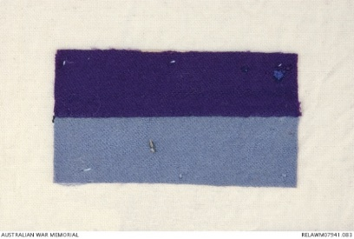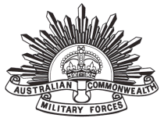He was married to Elizabeth Comery and lived in 2nd West Street, Torrensville, South Australia. He was enlisted on 2nd August 1915 and embarked on 27 Oct 1915, 27th infantry battalion, HMAT Benalla, Adelaide. He served in the 27th and 10th infantry battalion. He returned Home and died 80 years old.

Harry (Harry) COMERY 2019, Vwma.org.au, viewed 23 May 2019, <https://vwma.org.au/explore/people/201386?t=1558586378282&wizard-page-index=0>.,Harry Comery 2016, Awm.gov.au, viewed 23 May 2019, <https://www.awm.gov.au/collection/R1927768>.

‌Details 2016, Adfa.edu.au, viewed 23 May 2019, <https://www.aif.adfa.edu.au/showPerson?pid=59344>.