The Following are Letters from Will Baker to his Family during his service in World War I
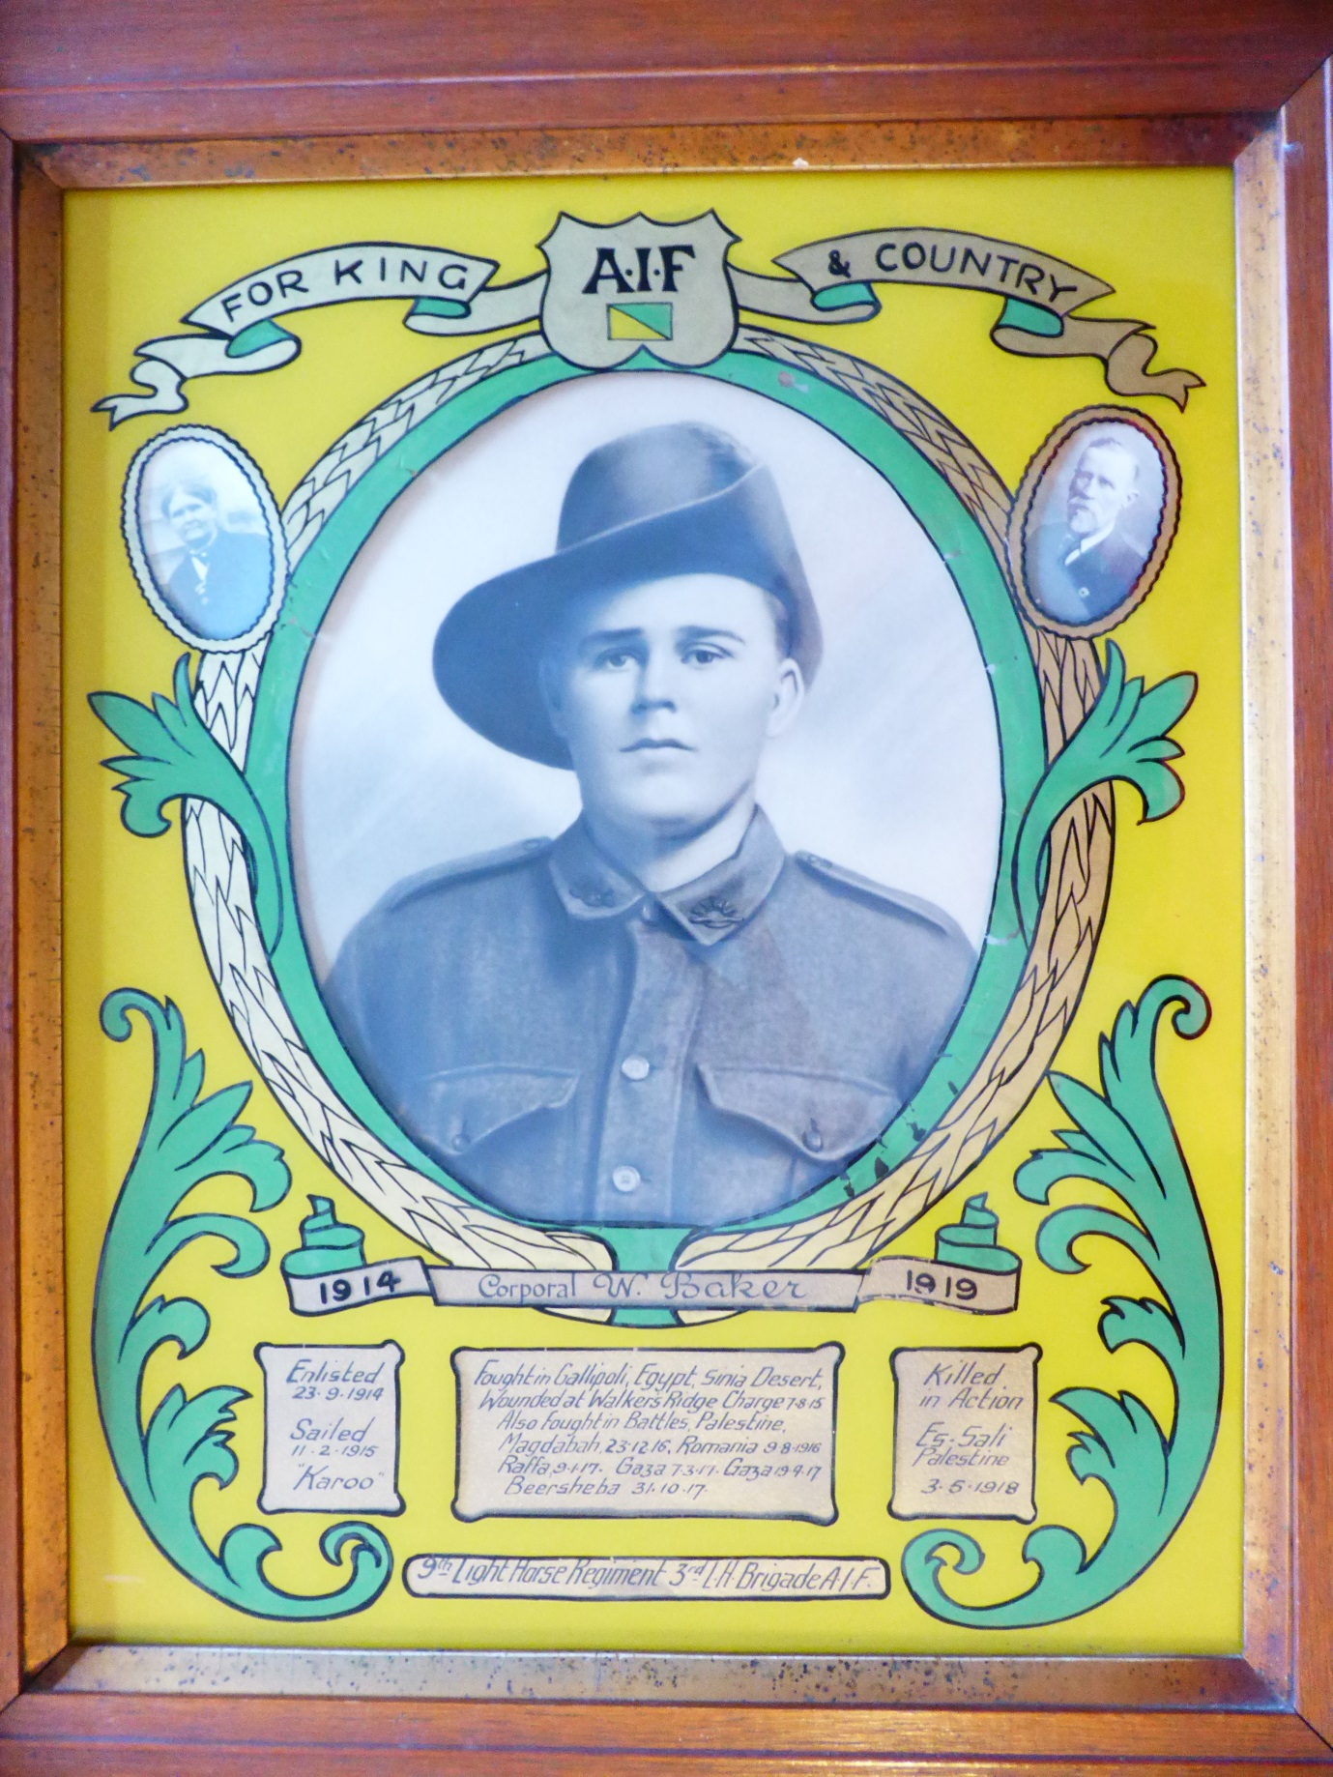

Enlisted 23rd Sept 1914 – C squadron 9th Light Horse Regiment--- Killed in Action 3rd May 1918
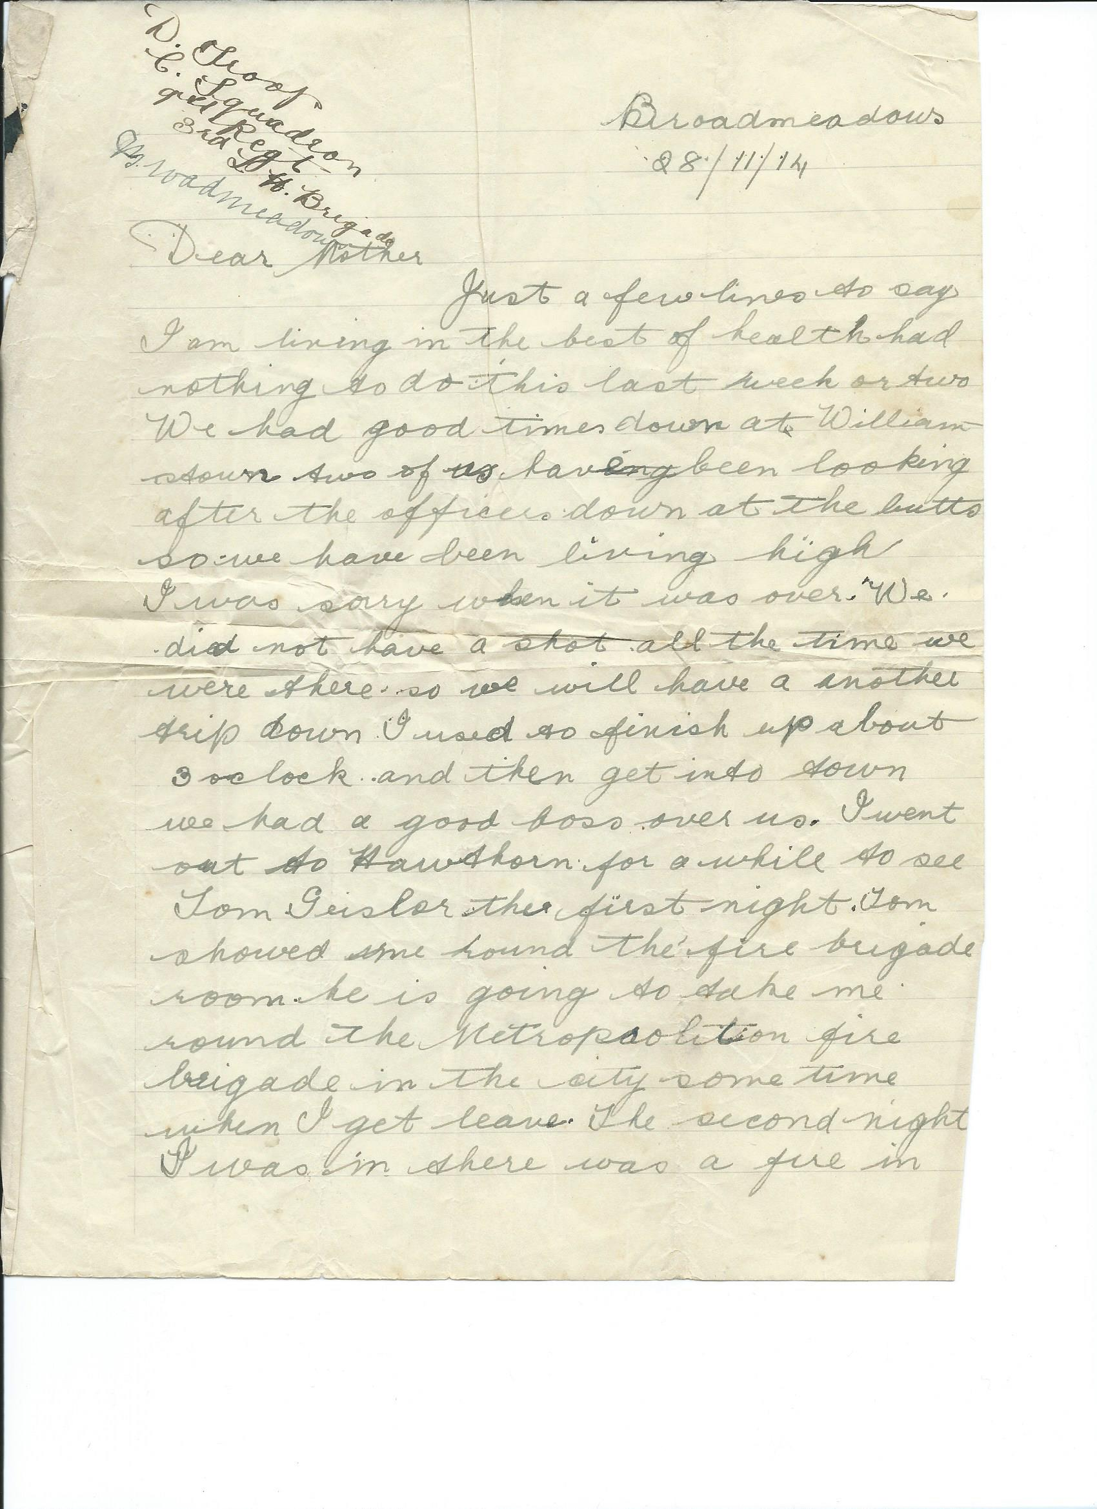
LETTER 1
BROADMEADOWS VICTORIA 28/11/1914
Dear Mother
Just a few lines to say I am living in the best of health. Had nothing to do this last week or two. We had good times down at Williamstown two of us having been looking after the officers down at the butts so we have been living high I was sorry when it was over. We did not have a shot all the time we were there so we will have another trip down. I used to finish up about 3 o’clock and then get into town , we had a good boss over us. I went out to Hawthorn for a while to see Tom Geisler . The first night Tom showed me round the fire brigade room, he is going to take me round the metropolitan fire brigade in the city some time when I get leave. The second night I was in there was a fire in the …….. ………

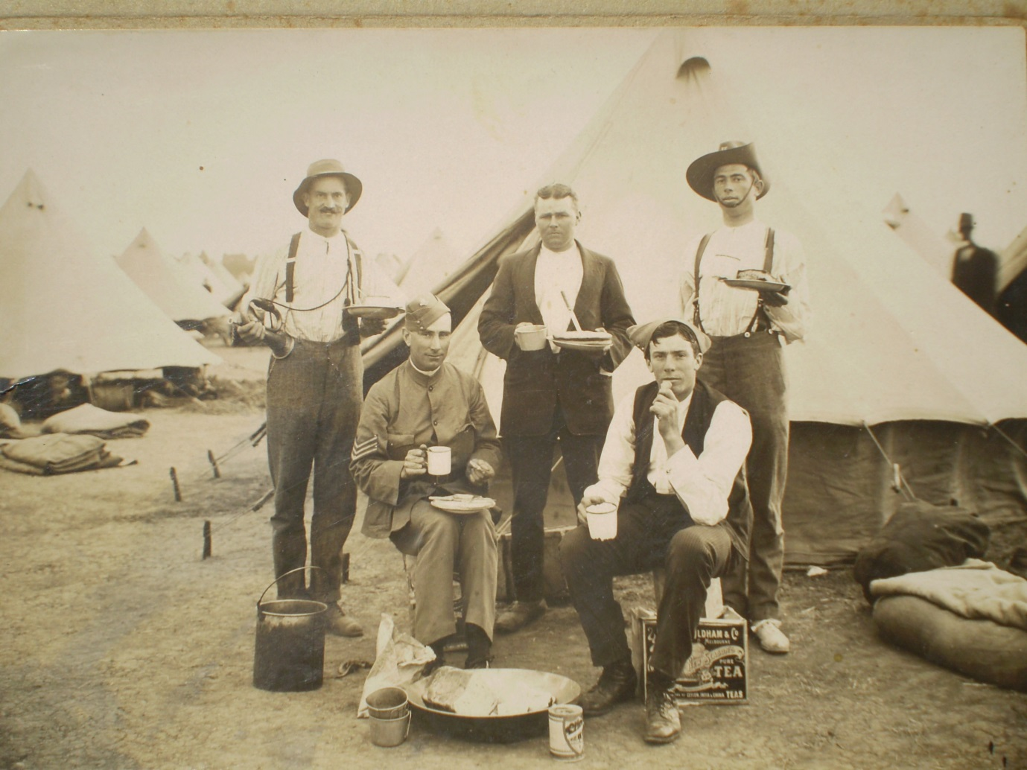
Bill Baker and Co at AIF training camp Broadmeadows unsure of others but could be from Colbinabbin /Rushworth Photo late 1914/early 1915 Update I have also Identified the 2 fellows sitting in the photo but can't lock in the other to either side of Bill Sitting to the right 492 Corporal Egbert Charles SMITH, a 22 year old Boot trader from Rushworth, Victoria. He enlisted on 23 September 1914; and at the conclusion of the war Returned to Australia, 23 December 1918. and sitting to the left 364 Farrier Sergeant William CAMERON, a 27 year old Agent from “Letterfinlay”, Rushworth, Victoria. He enlisted on 23 September 1914; and subsequently was Killed in Action, 4 September 1915.
Note they all enlisted on the same day

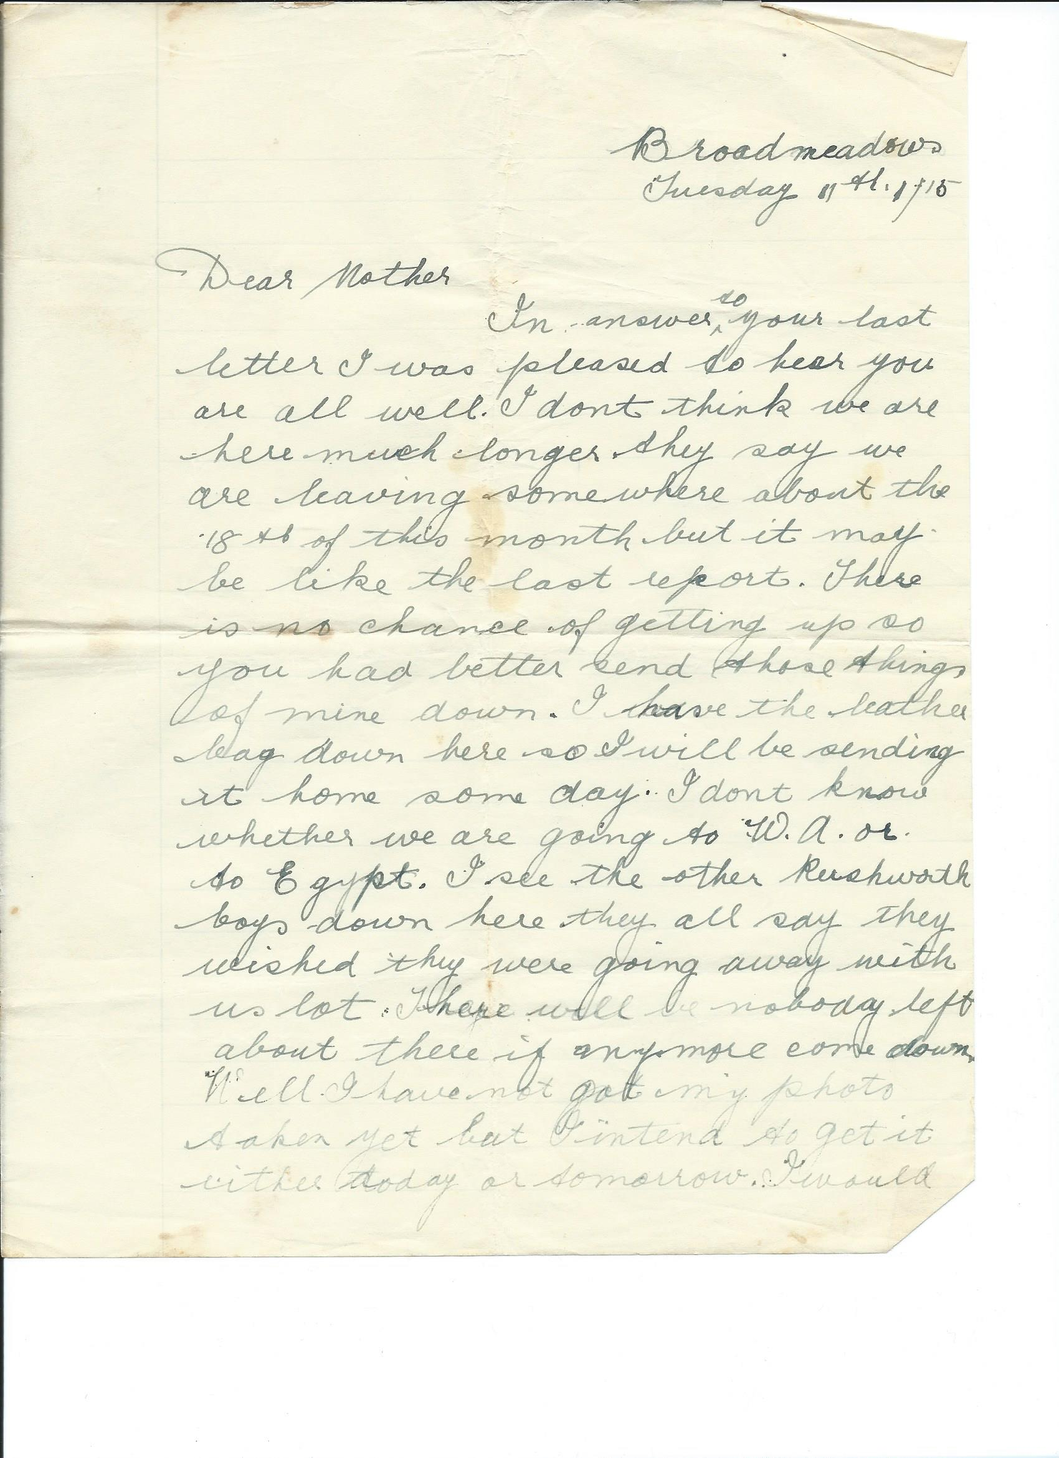
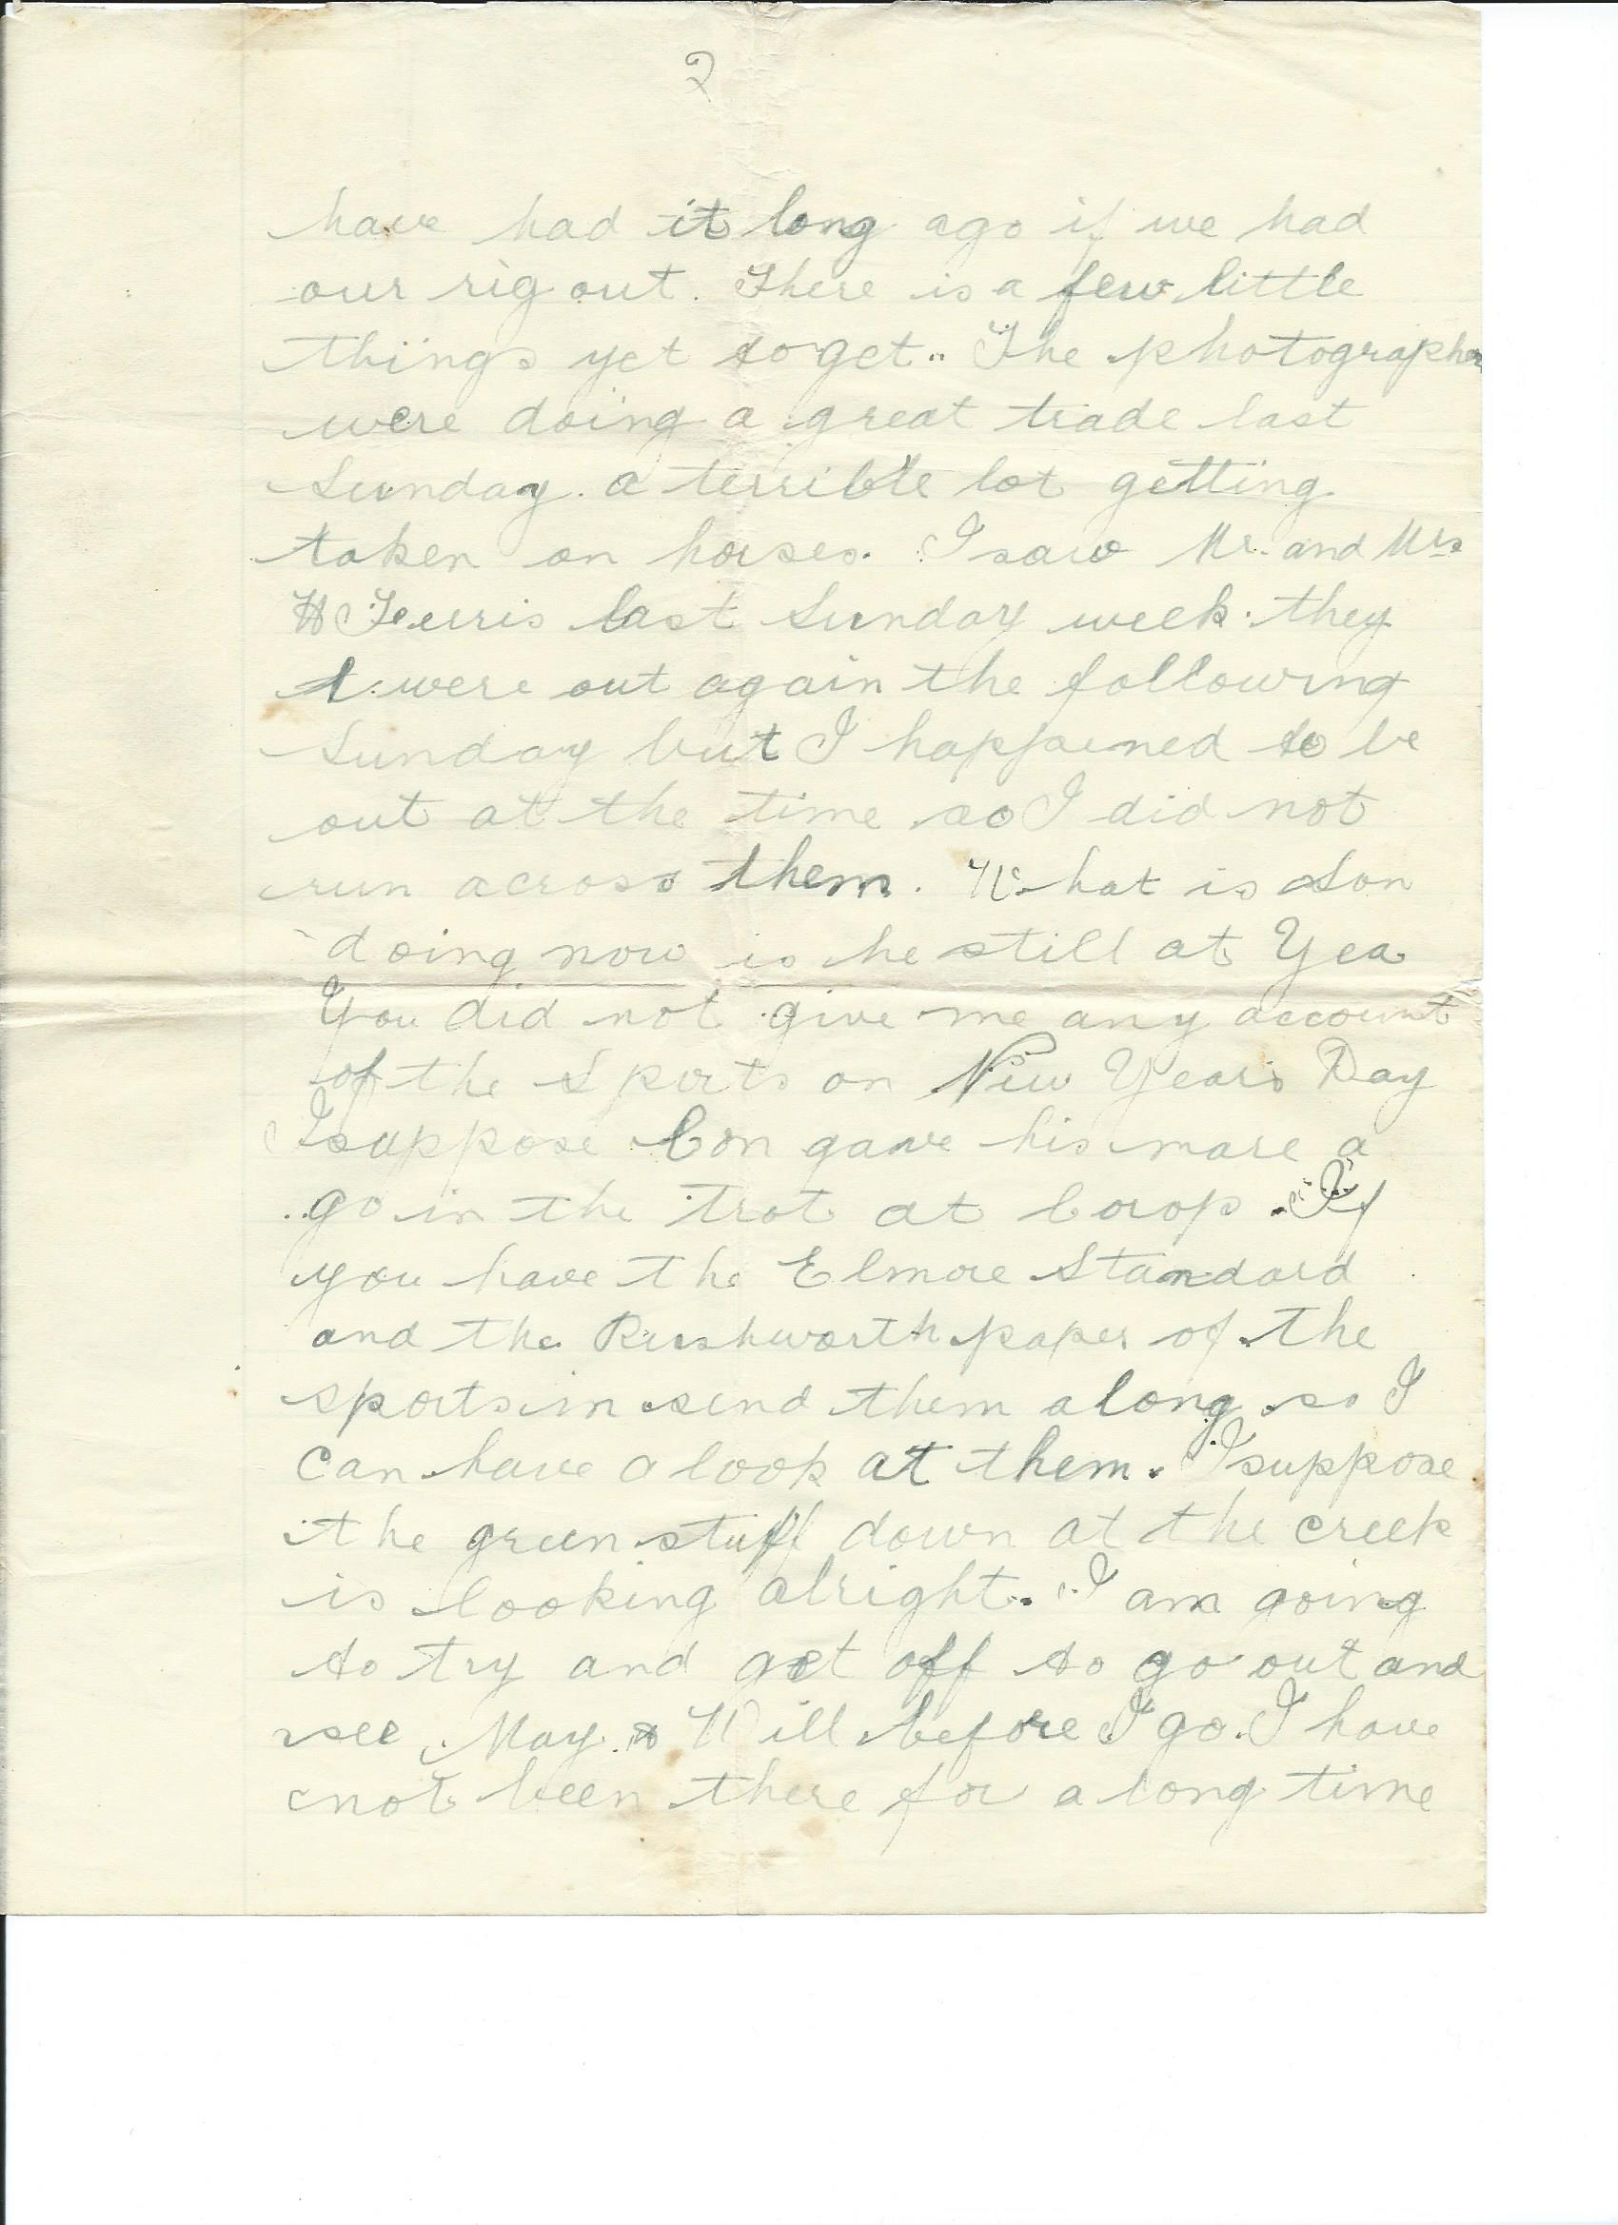
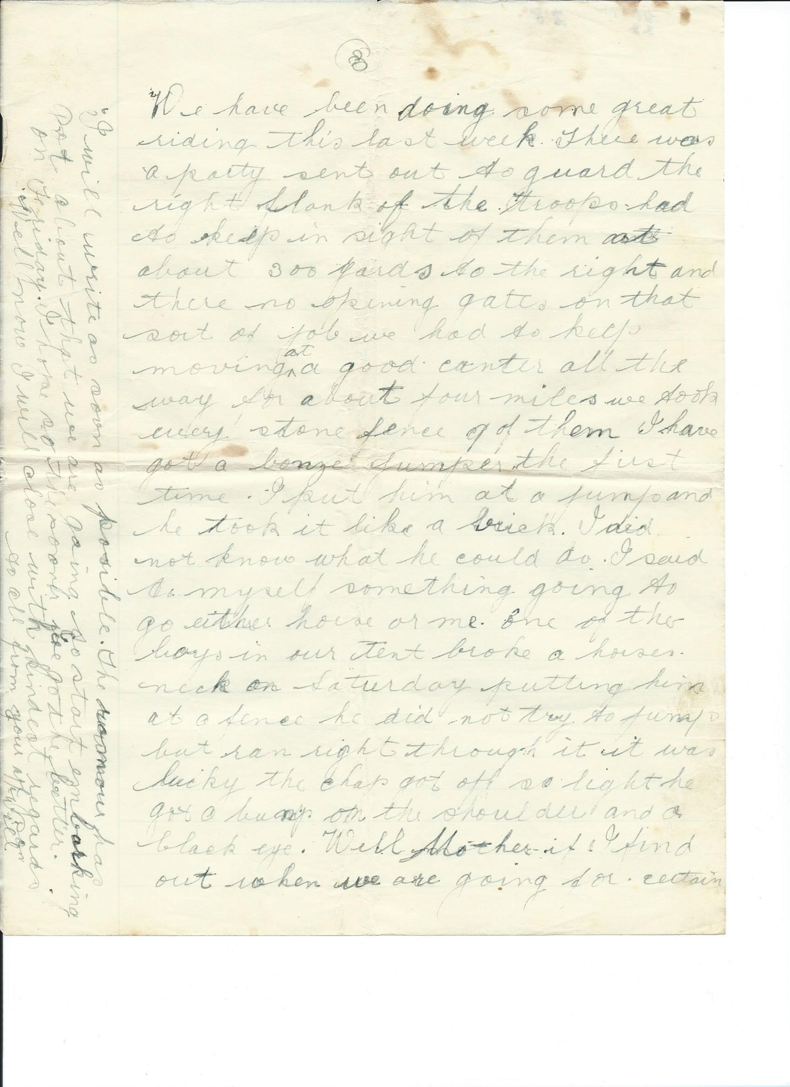
Letter 2
Broadmeadows Victoria Tuesday 11th Jan 1915
Dear Mother
In answer to your last letter I was pleased to hear you are all well. I don’t think we are here much longer they say we are leaving somewhere about the 18thof this month ,but it might be like the last report. There is a chance of oit getting up so you had better send those things of mine down. I have the leather bag down here so I will be sending it home someday. I don’t know whether we are going to W.A or Egypt I see the other Rushworth boys down here they all say they wish they were going away with us lot. There will be nobody left about there if anymore come down.
Well I haven’t got my photo taken yet but I intend to get it either today or tomorrow. I would have had it long ago if we had our rigout there is a few little things yet to get. The photographers were doing a great trade last Sunday. A terrible lot getting taken on horses. I saw Mr and Mrs H Ferris last Sunday week , they were out again the following Sunday but I happened to be out at the time so I did not come across them. What is Son doing now is he still at Yea. You did not give me any account of the sport on New Year’s Day I suppose Con gave his mare a go in the trot at Corop. If you have the Elmore Standard and the Rushworth paper of the sport in, send them along so I can have a look at them. I suppose the green stuff down at the creek is looking alright. I am going to try and get off to go out and see May and Will before I go . I have not been there for a long time.
We have been doing some great riding this last week. There was a party sent out to guard the right flank of the troops. Had to keep in sight of them at about 300 yards to the right and there no opening gates on that sort of job, we had to keep moving at a good canter all the way for about four miles we took every stone fence 9 of them. I have a bonzer jumper. The first time I put him at a jump and he took it like a brick. I did not know what he could do. I said to myself something going to go either horse or me. One of the boys in our tent broke a horse’s neck on Saturday putting him at a fence He did not try to jump but ran right through it. It was lucky the chap got off so light He got a bump on the shoulder and a black eye. Well Mother if I find out when we are going for certain I will write as soon as possible. The rumours has put about that we are going to start embarking on Friday. I hope so the sooner we go the better. Well now I will close with kindest regards to all
From your aff son Will.

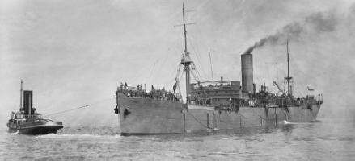
HMAT ship Karroo which William Baker embarked Melbourne on 15th Feb 1915
Letter found in Murchison Advertiser Friday 24th Sept 1915
Private W. Baker
Private W. Baker, who was recently reported wounded, writes to his mother
as follows from Heliopolis under date of 11th August:—
Dear Mother "No doubt you will think I have forgotten to write this last mail or two, 3
but the way things are I have not had the chance to do so. I had the misfortune to get a bullet.
through the left arm in an attack we made on the Turks on Saturday morning last.
I can't tell you anything about it but I was not going long before I was put out.
Bert Mason and Jack Considine were both wounded . I don't know how W. Cameron
and E Smith got on. Capt. Day is away sick and so is V Hicks so they both missed it
I have not had a mail for a good while as it will probably go from place to place before it reaches me
it is alright to get into a change of clothes, and I feel a different man. We arrived here about ten
o'clock last night after travelling from Alexandria in the Hospital train. It was a very pleasant ride
They look after one well and the orderlies cannot do enough for us. We had fowl for tea on the train.
The trip over on the boat was not too pleasant, though. I had no bed, only one blanket, and had to
lay on the upper deck on the boards, so was glad to get off it. The bullet went in the muscle of
my arm but did not strike the bone,"
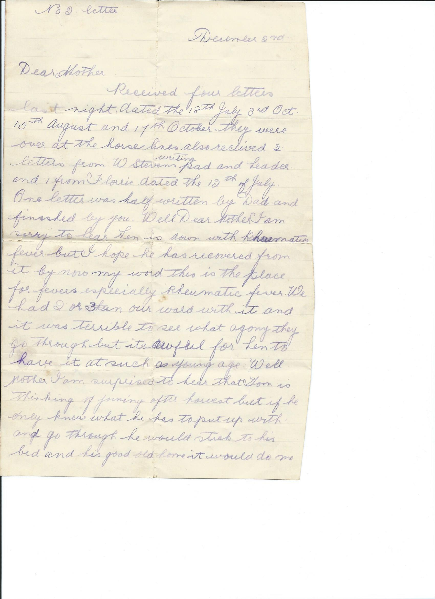
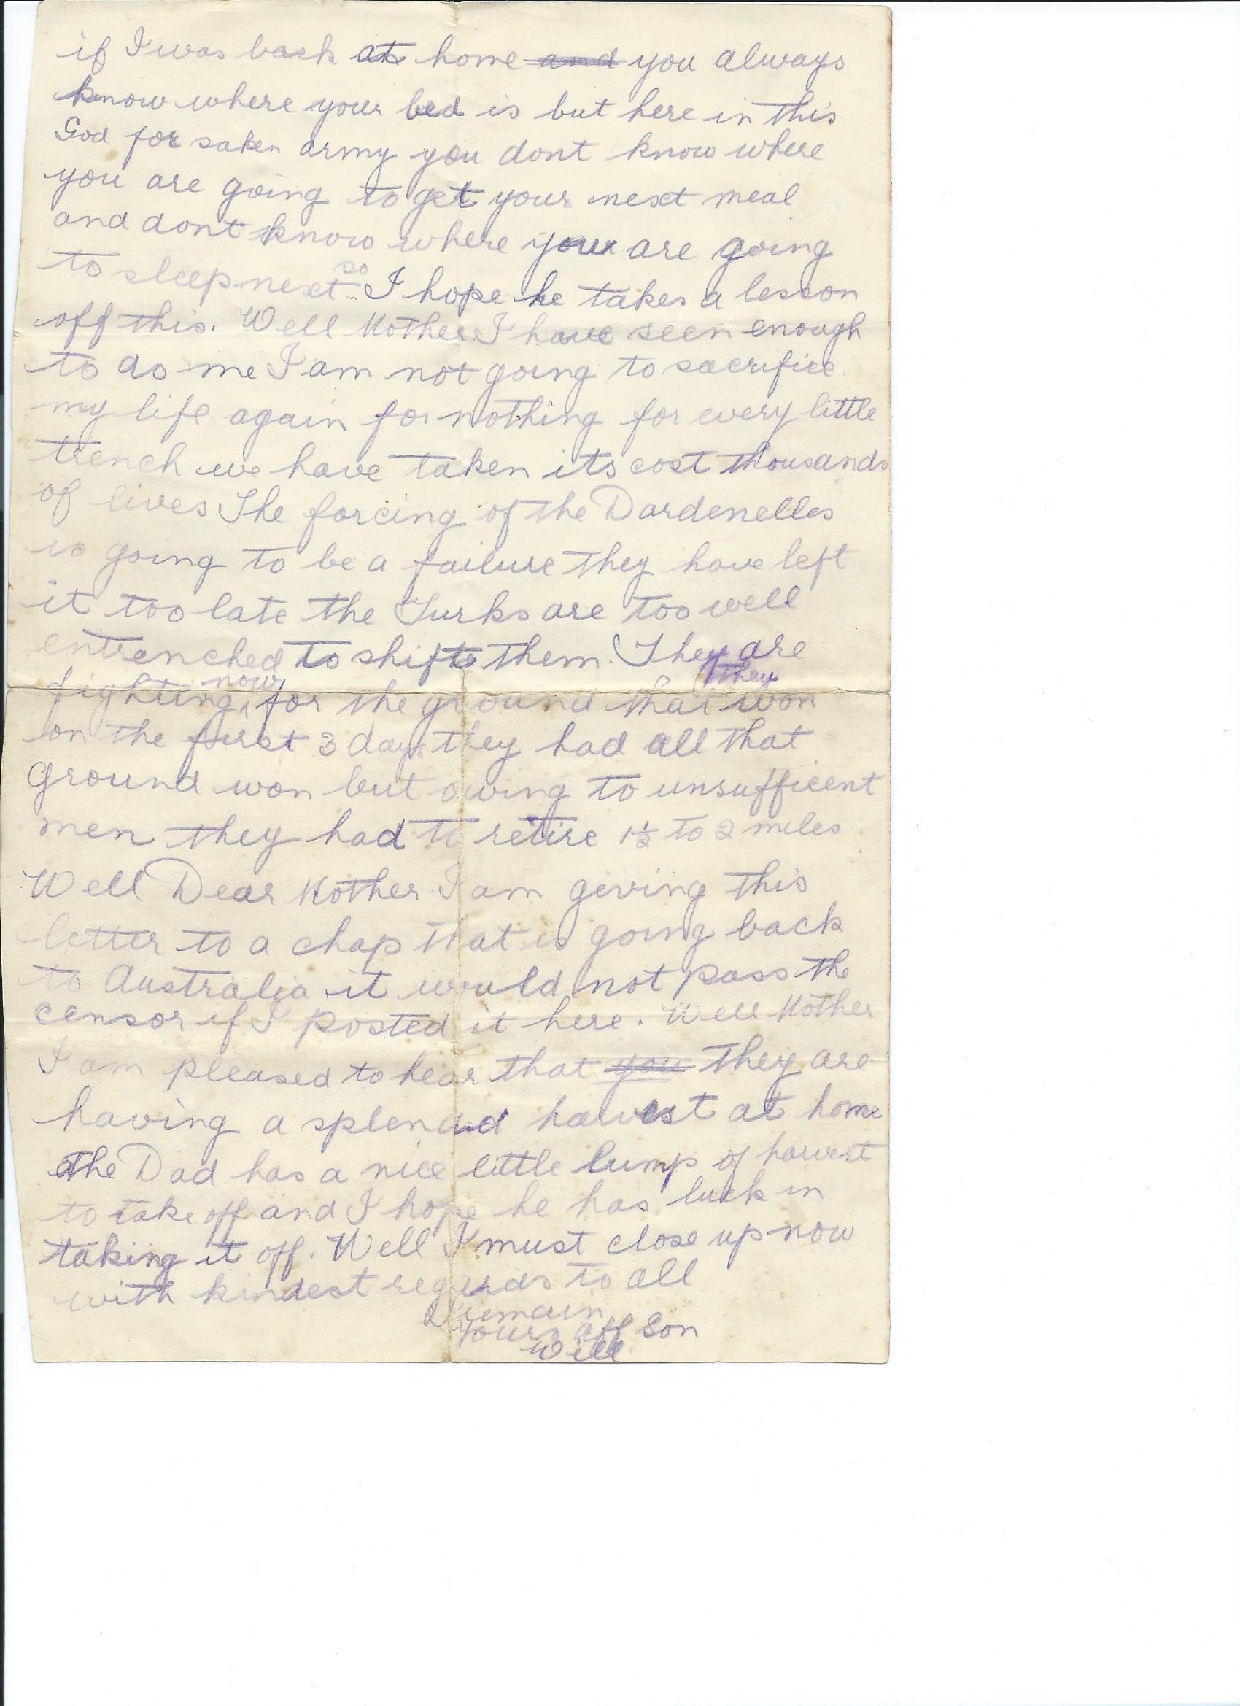

No 2 letter
December 2^{nd (1915)}
Dear Mother
Received four letters last night dated 18th July, 3rd Oct ,15th Aug and 17th Oct,
They were over at the horse lines also received 2 letters from W Stevens writing pad and header and 1 from Florrie dated 12th of July. One letter was half written by Dad and Finished by you. Well Dear Mother I am sorry to hear Len is down with rheumatic fever but hope he has recovered from it by now. My word this is the place for fevers especially rheumatic fever. We have 2 or 3 in our ward with it and it was terrible to see what agony they go through but it’s Awful for Len to have it as such a young age. Well Mother I am surprised to hear that Tom is thinking of joining after harvest but if he only knew what he has to put up with and go through he would stick to his own bed and his good old home it would do me if I was back at home, you always know where your bed is but here in this God forsaken army you don’t know where you are going to get your next meal and don’t know where you are going to sleep next so I hope he takes a lesson off this. Well Mother I have seen enough to do me I am not going to sacrifice my life again for nothing for every little trench we have taken it costs thousands of lives. The forcing of the Dardenelles is going to be a failure they have left it to late , the Turks are too well entrenched to shift them . they are fighting now for the ground that they won on the first 3 days, they had all that ground won but owing to insufficient men they had to retire 1 ½ to 2 miles
Well Dear Mother I am giving this letter to a chap that is going back to Australia , it would not pass the censor if I posted it here. Well Mother I am pleased to hear that they are having a splendid havest at home… Dad has a nice little lump of havest to take off and I hope he has luck in taking it off Well I must close now with kindest regards to all
I remain yours aff son
Will

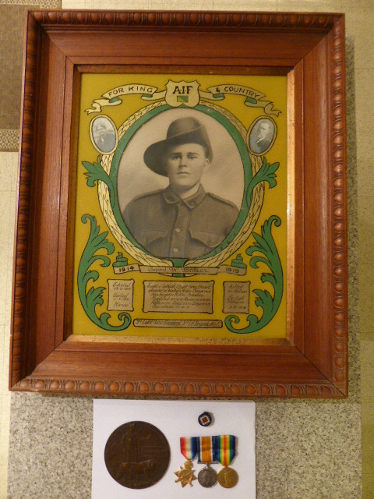

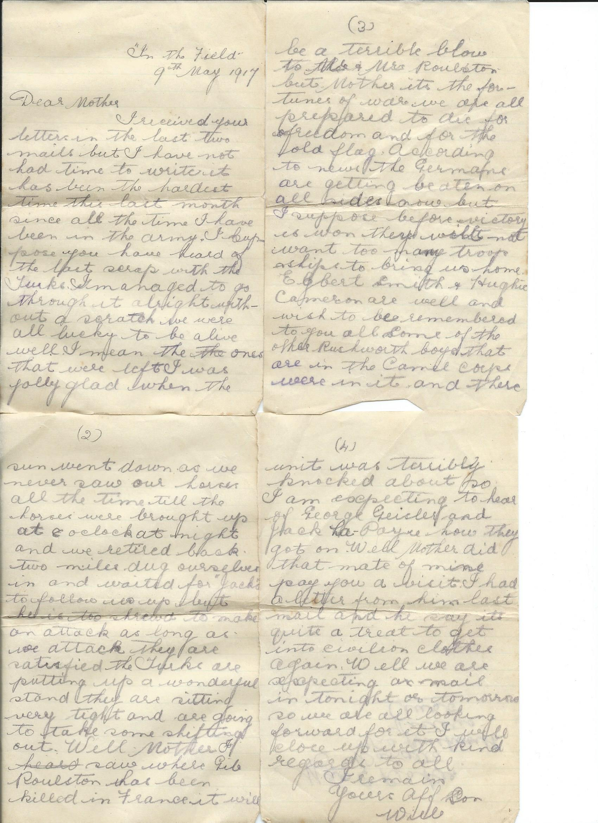

In the field
9th may 1917
Dear Mother
I received your letters in the last two mails but I have not had time to write, it has been the hardest times this last month since all the time I have been in the army. I suppose you have heard of the last scrap with the Turks. I managed to go through it alright without a scratch we were all lucky to be alive well I mean the ones that were left I was jolly glad when the sun went down as we never saw our horses all the time till the horses were brought up at 8 o’clock at night and we retired back two miles dug ourselves in and waited for “Jacks” to follow us up but he is too shrewd to make an attack as long as we attack they are satisfied. The Turks are putting up a wonderful stand they are sitting very tght and are going to take some shifting out. Well Mother I saw where Gib Roulston has been killed in France, it will be a terrible blow to Mr and Mrs Roulston but Mother it’s the fortunes of war we are all prepared to die for freedom and for the old flag. According to news the Germans are getting beaten on all sides now but I suppose before victory is won they will not want not want too many troop ships to bring us home Egbert Smith and Hughie Cameron are well and wish to be remembered to you all. Some of the other Rushworth boys that are in the Camel corps were in it and their unit was terribly knocked about so I am expecting to hear of George Geisler and Jack La Payne how they got on. Well Mother did that mate of mine pay you a visit. I had a letter from him last mail and he says it’s quite a treat to get into civilian clothes again. Well we are expecting a mail in tonight or tomorrow so we are all looking forward for it. I will close up with Kind regards to all
I remain yours aff son
Will

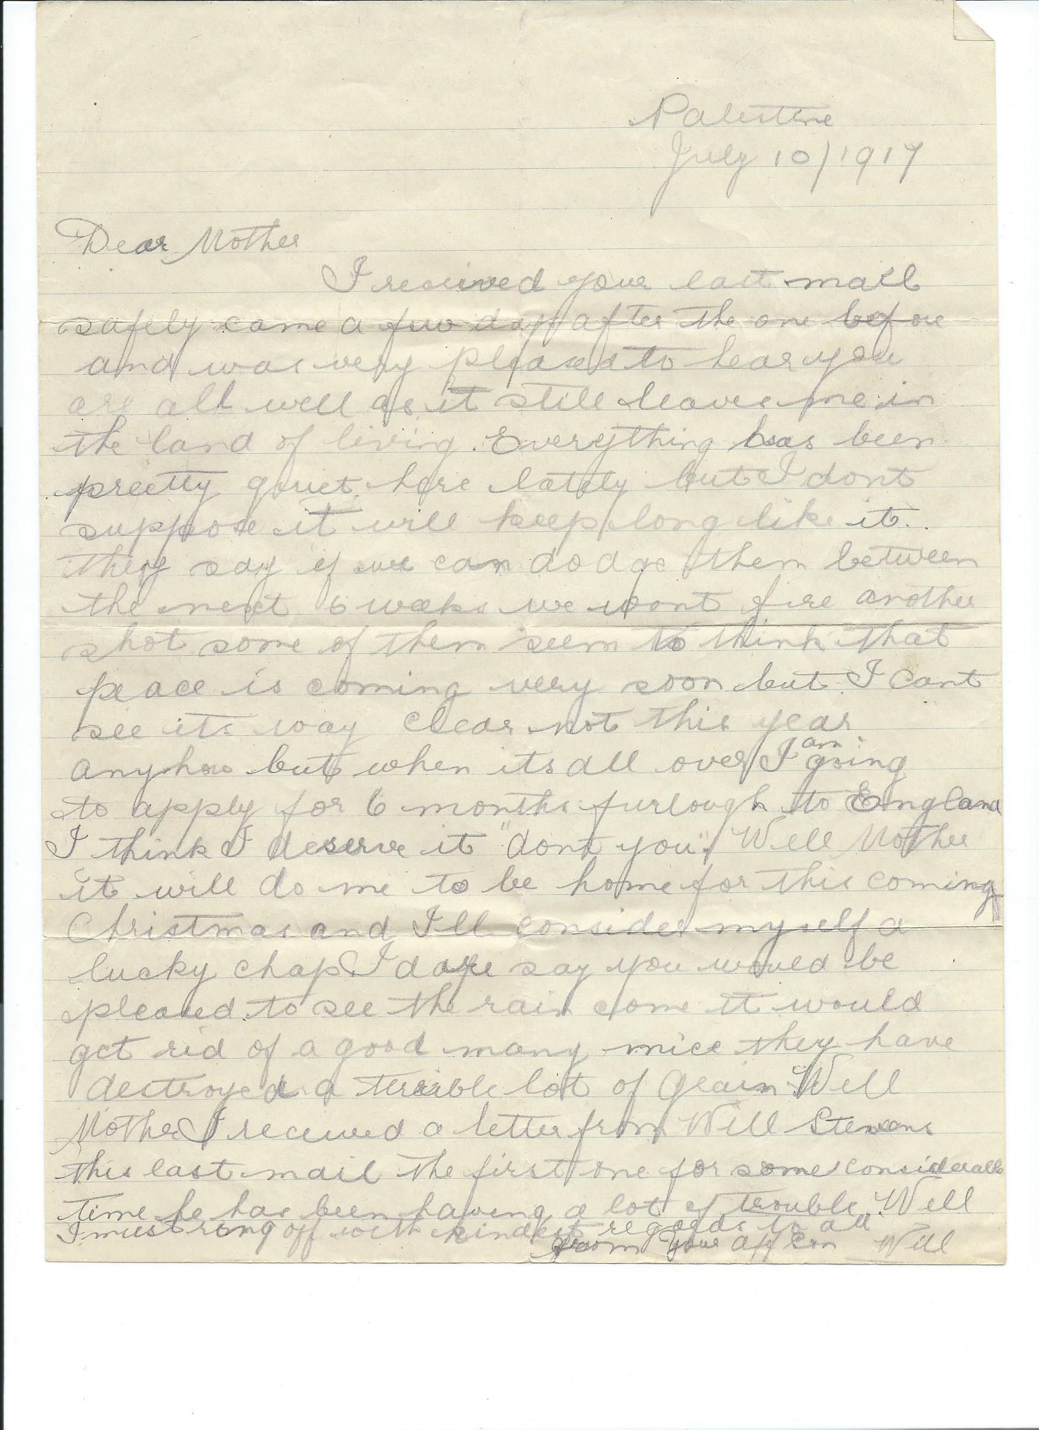

Palestine
July 10 1917
Dear Mother
I received your last mail safely , came a few days after the one before and was very pleased to hear you are all wall as it still leaves me in the land of the living. Everything has been pretty quiet here lately but I don’t suppose it will keep long like it. They say if we can dodge then between the next 6 weeks we won’t fire another shot some of them seem to think peace is coming very soon but I can’t see its way clear not this year anyhow but when it’s all over I am going to apply for 6 months furlough to England. I think I deserve it “ don’t you”. Well Mother it will do me to be home for this coming Christmas and I’ll consider myself a lucky chap. I dare say you would be pleased to see the rain. It would get rid of a good many mice they have destroyed a terrible lot of grain. Well Mother I received a letter from Will Stevens this last mail the first one for some considerable time he has been having a lot of trouble . Well I must ring off with kind regards to all
From yours aff son
Will

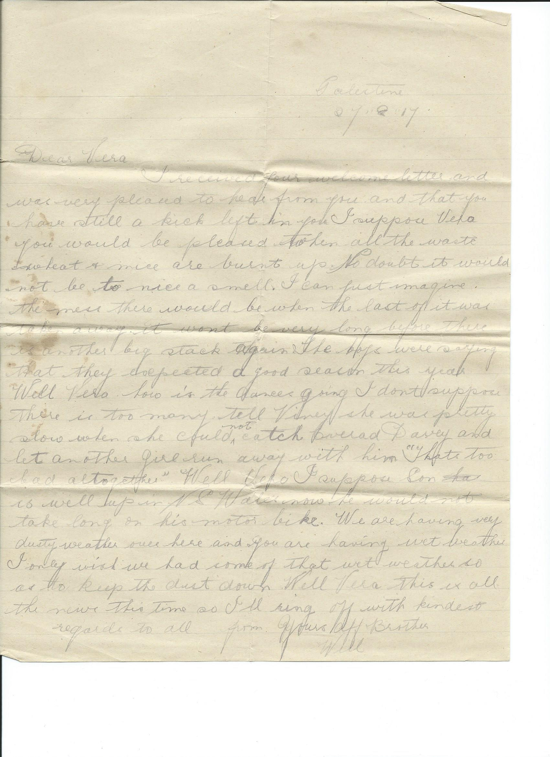

Palestine
27 8 1917
Dear Vera
I received your welcome letter and was very pleased to hear from you and that you have still a kick in you. I suppose Vera you would be pleased when all the waste grain and mice are burnt up no doubt it would not be to nice a smell. I can just imagine the mess there would be when the last of it was taken away. It won’t be long before there is a big stack again. The boys were saying that they expected a good season this year. Well Vera how is the dances going I don’t suppose there is too many. Tell Viney she was pretty slow when she could not catch …. Davey and let another girl run away with Him “ That’s too sad altogether”. Well Vera I suppose Son is well up in N S Wales now .he would not take long on his motorbike. We are having very dusty weather over here and you are having wet weather. I only wish we had some of that wet weather so as to keep the dust down. Well Vera this is all the news this time so I’ll ring off with kindest regards to all
From yours aff brother
Will

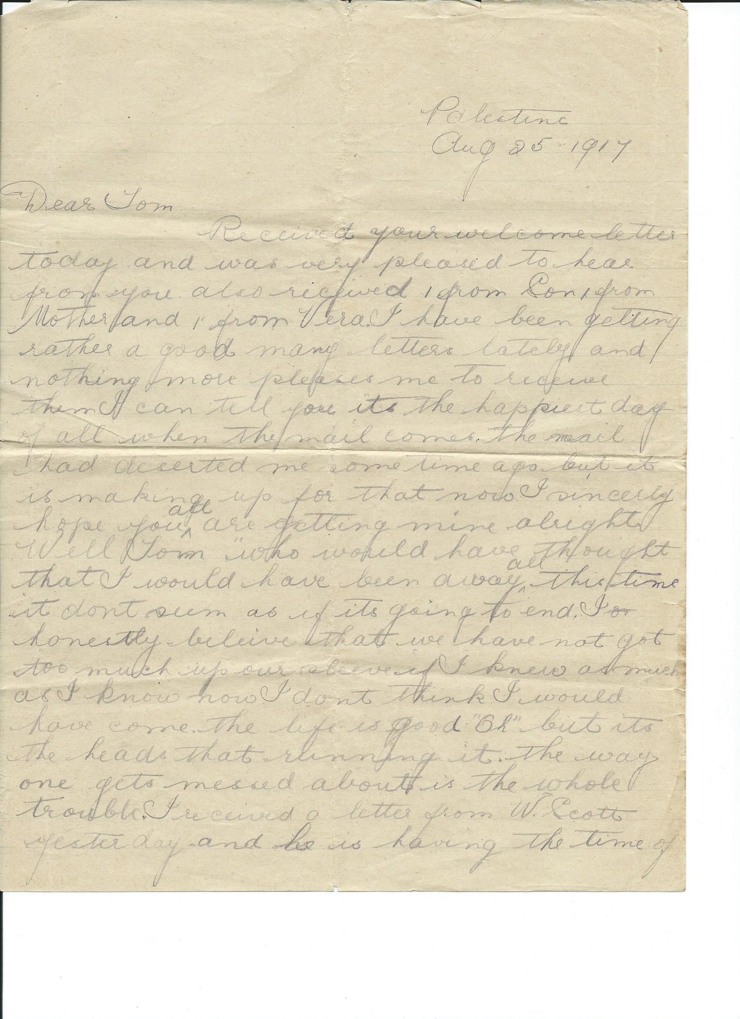
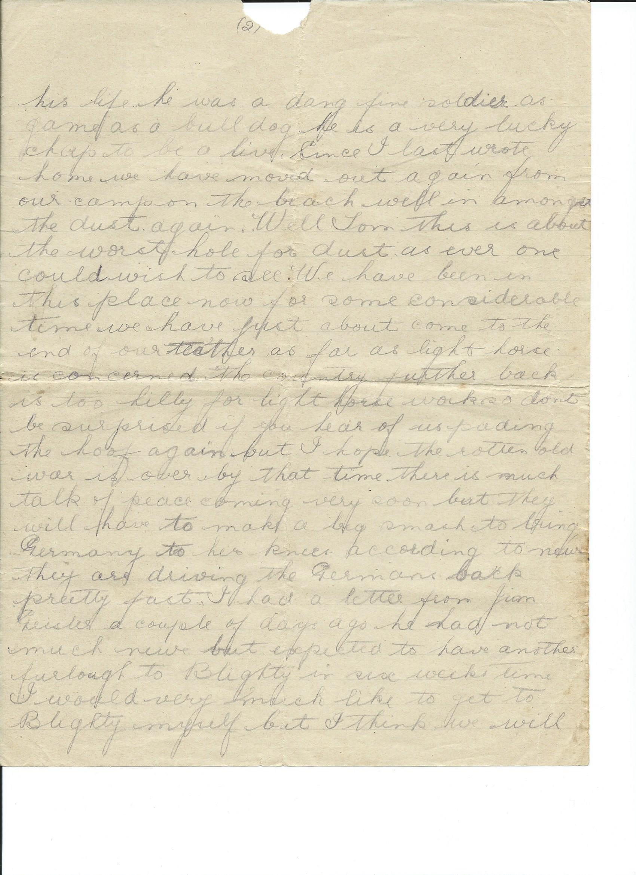
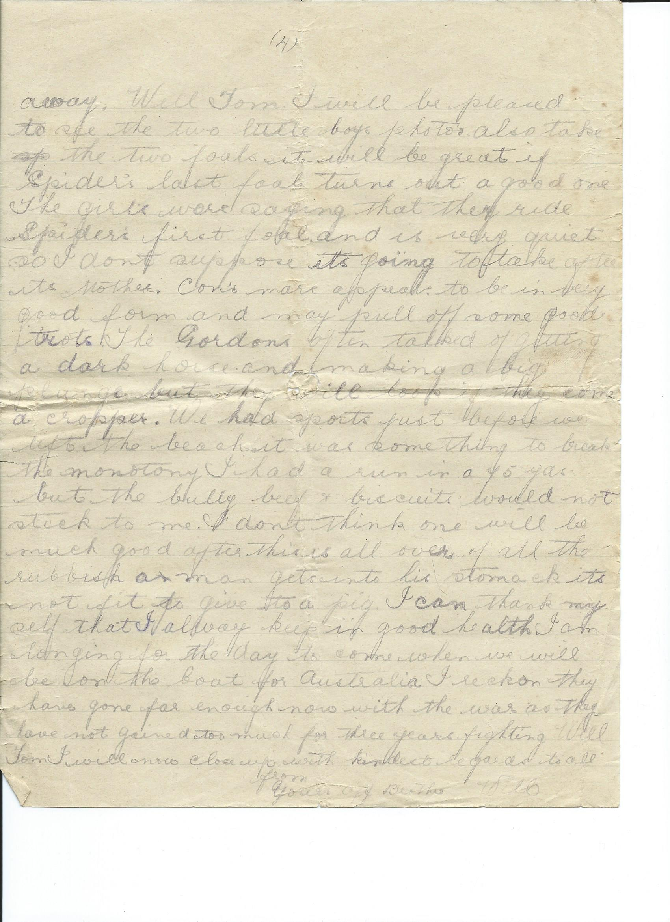

Palestine
Aug 25 1917
Dear Tom
Received your welcome letter today and was pleased to hear from you Also received 1 from Son 1 from Mother and 1 from Vera. I have been getting rather a good many letters lately and nothing more pleases me to receive them. I can tell you it’s the happiest day if all when the mail comes the mail had deserted me some time ago but it is making up for that now. I sincerely hope you all are getting mine alright.
Well Tom who would have thought that I would have been away all this time It don’t seem as if its going to end I honestly believe that we have not got too much up our sleeve if I knew as much as I know now I don’t think I would have come . The life is good “oh” but it’s the heads that running it. the way one gets messed about is the whole trouble. I received a letter from W Scott yesterday and he is having the time of his life he was a dang fine soldier as game as a bulldog he is a very lucky chap to be alive. Since I last wrote home we have moved out again from our camp on the beach well in among the dust again. Well tom this is about the worst hole for dust as ever one could wish to see. We have been in this place now for some considerable time we have just about come to the end of our teathers as far as light horse is concerned. The country further back is too hilly for light horse work so don’t be surprised if you hear of us …ding the hoof again but I hope the rotten old war is over by that time there is talk of peace coming very soon but they will have to make a big smack to bring Germany to her knees according to news they are driving the Germans back pretty fast. I had a letter from Jim Geisler a couple of days ago he had not much news but expected to have another furlough to Blighty in six weeks time I would very much like to get to Blighty myself but I think we will end (end page2) ………………………………………………..
(page 4 ) away . Well Tom I will be pleased to see the two little boys photos also take the two foals it will be great if spiders last foal turns out a good one the girls were saying that they ride spiders first foal and is very quiet so I don’t suppose it’s going to take after its mother. Con’s mare appears to be in very good form and may pull off some good trots. the Gordons often talked of getting a dark horse and making a big plunge but they will look if they come a cropper we had sport just before we left the beach it was something to break the monotony. I had a run in the 75yds but the bully beef and biscuits would not stick to me. I don’t think one will be much good after this is all over, of all the rubbish a man gets into his stomach its not fit to give to a pig. I can thank myself that I always keep in good health I am longing for the day to come when we will be on the boat for Australia I reckon they have gone far enough now with the war as they have not gained too much for three years fighting. Well Tom I will now close up with kindest regards to all
From your aff brother
Will

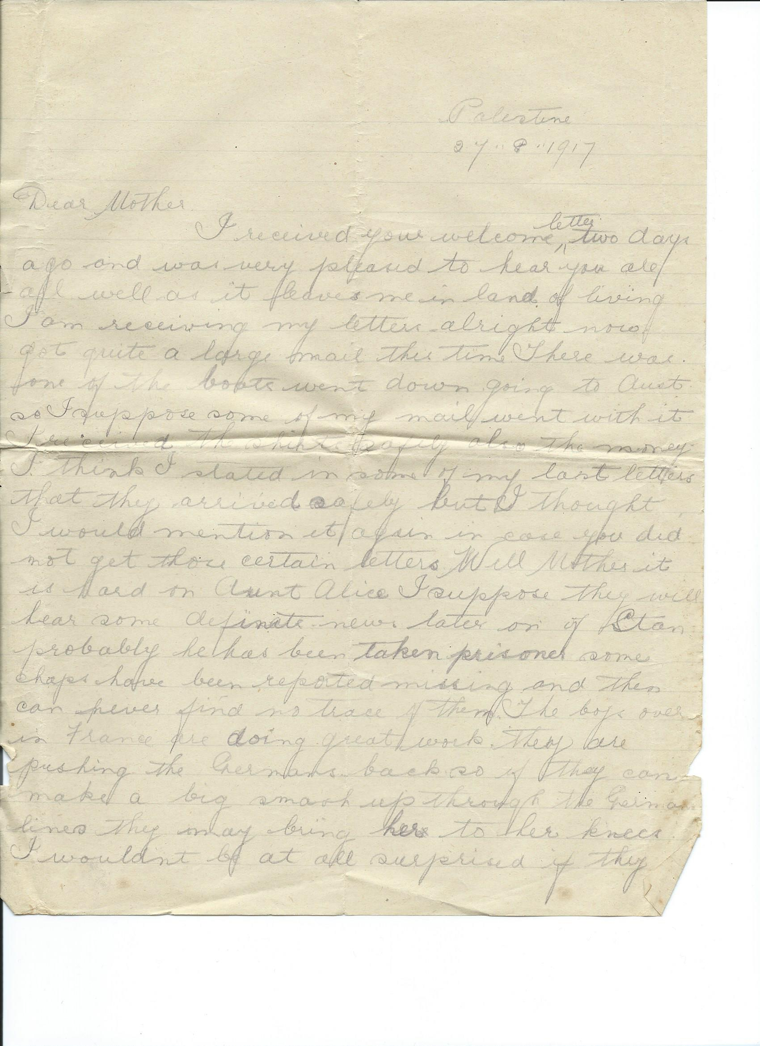
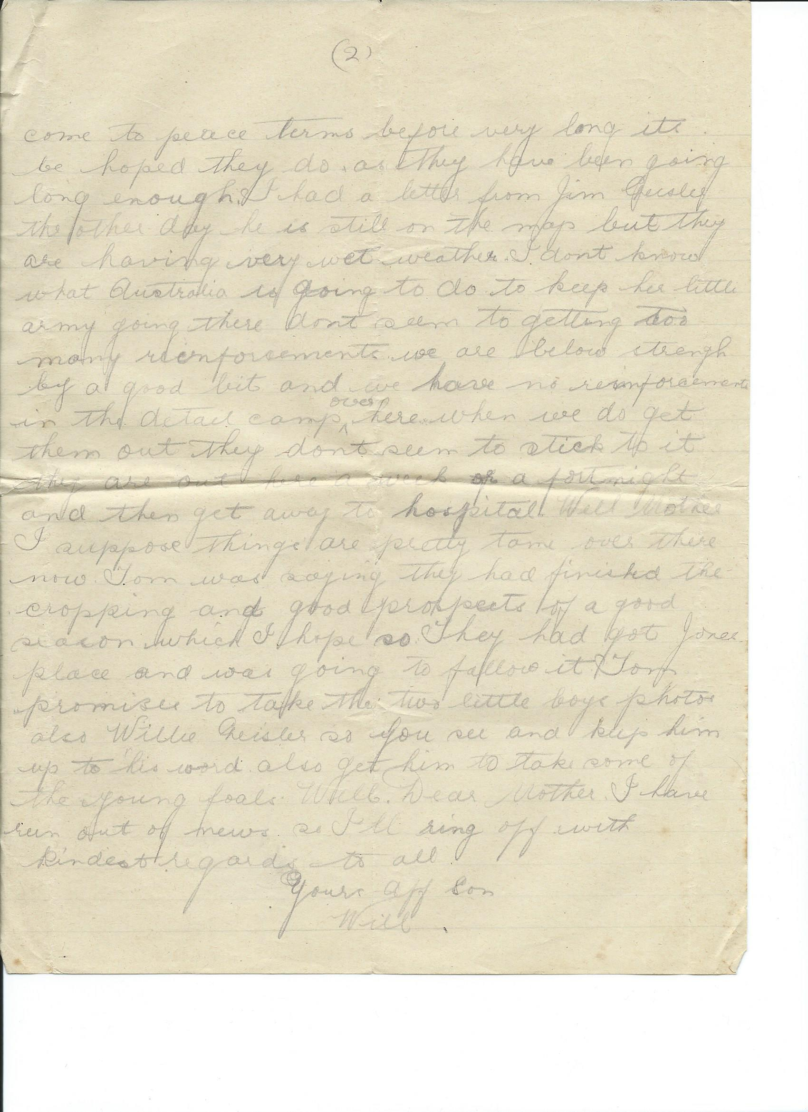

Palestine
27 8 1917
Dear Mother
I received your welcome letter two days ago and was very pleased to hear you are all well as it leaves me in the land of the living. I am receiving my letters alright now, got quite a large mail this time. There was one of the boats went down going to Aust. so I suppose some of my mail went with it. I received the shirts safely also the money. I think I stated in some of my last letters that they arrived safely But I thought I would mention it again in case you did not get those certain letters .Well Mother it is hard on Aunt Alice I suppose they will hear some definite news later on of Stan. Probably he has been taken prisoner. Some chaps have been reported missing and then can never find no trace of them. The boys over in France are doing great work they are pushing the Germans back so if they can make a big smack up through the German lines they may bring her to her knees I wouldn’t be at all surprised if they come to peace terms before very long have been going long enough. Its be hoped they do as they. I had a letter from Jim Geisler the other day he is still on the map but they are having very wet weather I don’t know what Australia is going to do to keep her little army going there don’t seem to getting too many reinforcements we are below strength by a good bit and we have no reinforcements in the detail camps over here, when we do get them out they don’t seem to stick to it. They are out here a week or a fortnight and then get away to hospital. Well Mother I suppose things are pretty tame over there now Tom was saying they had finished the cropping and good prospects of a good season which I hope so. They had got Jones place and was going to fallow it . Tom promises to take the two little boys photo also Willie Geisler so you see and keep him up to his word Also get him to take some of the young foals . Well Dear Mother I have run out of news so I’ll ring off with kindest regards to all

Yours aff son
Will

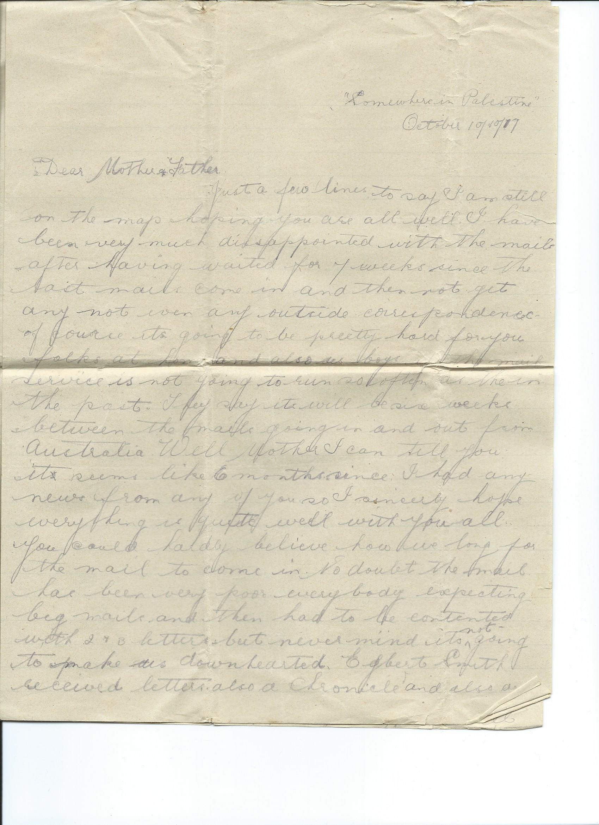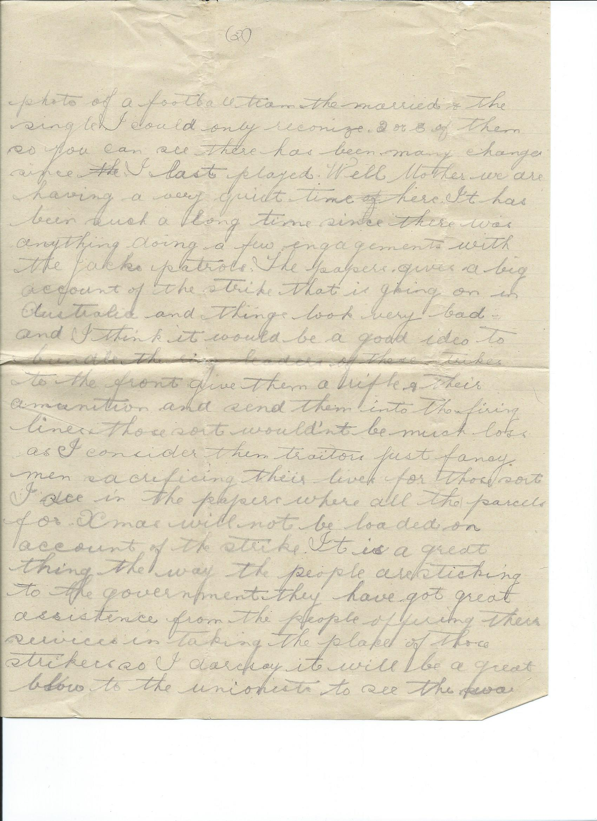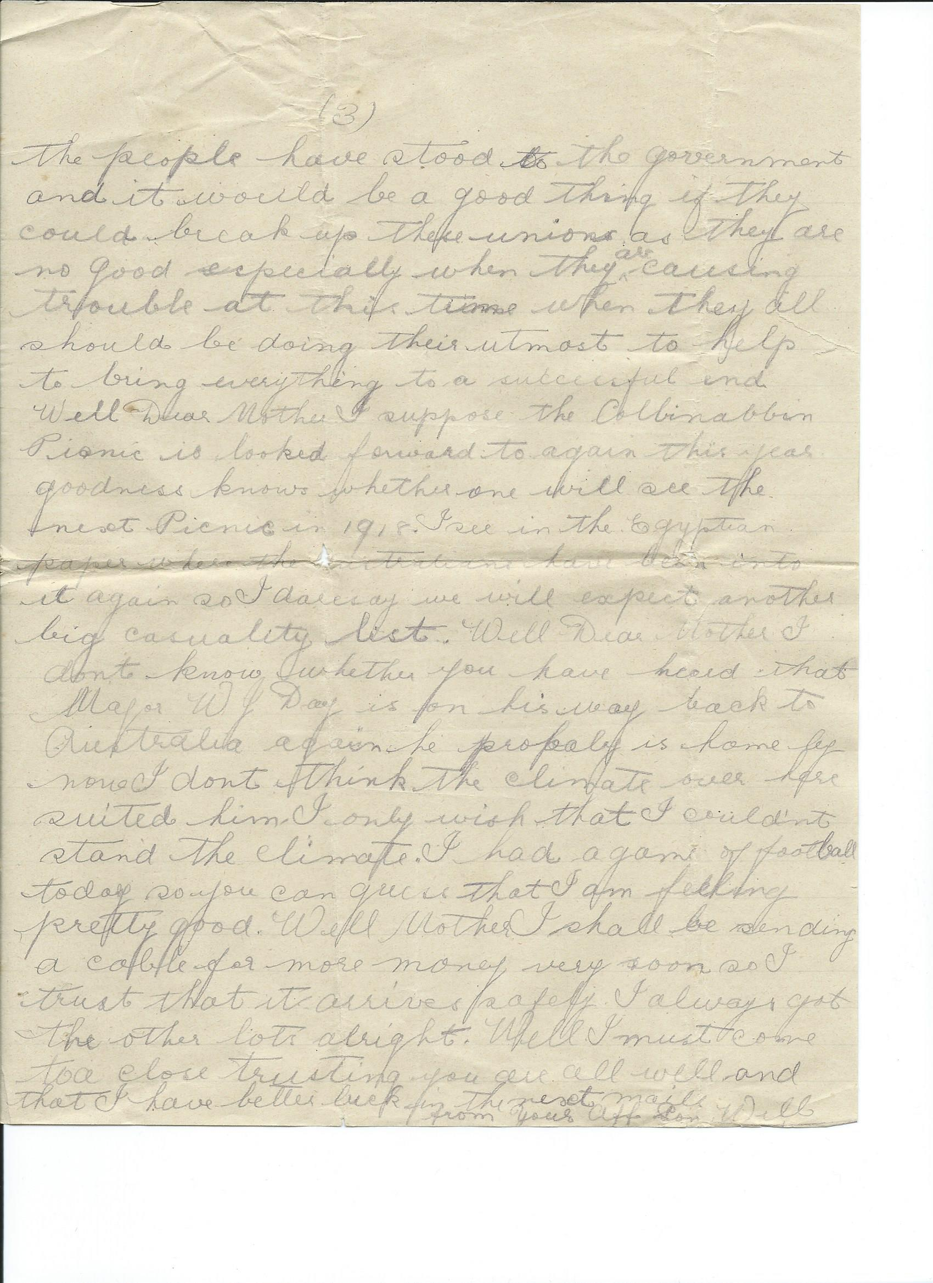

Somewhere in Palestine
October 19 1917
Dear Mother and Father
Just a few lines to say I am still on the map hoping you are all well
I have been very much disappointed with the mail after having waited for 7 weeks since the last mail come in and then not get any, not even outside correspondence. Of course it’s going to be pretty hard for you folks at home and also us boys if the mail service is not going to run so often as in the past. They say it will be six weeks between the mail going in and out from Australia. Well mother I can tell you it seems like 6 months since I had any news from any of you so I sincerely hope everything is quite well with you all you could hardly believe how we long for the mail to come in . No doubt the mail has been very poor everybody expecting big mail and then had to be content with 2 and 3 letters but never mind its not going to make us downhearted. Egbert Smith received letters also a chronicle and also a photo of a football team the married and the single . I could only recognise 2 or 3 of them so you can see there has been many changes since I last played. Well mother we are having a very quiet time here it has been such a long time since there was anything doing, a few engagements with the Jacks patrols . the papers give a big account of the strike that is going on in Australia and things look very bad and I think it would be a good idea to bundle the ringleaders of these strikes to the front give them a rifle and their ammunition and send them into the firing lines . those sort wouldn’t be much loss as I consider them traitors . Just fancy men sacrificing their lives for those sort . I see in the papers where all the parcels for xmas will not be loaded on account of the strike. It is a great thing the way the people are stiking to the government they have got great assistance from the people offering their services in taking the place of those striking I daresay it will be a great blow to the unionists to see the way the people have stood to the government and it would be a good thing if they could break up these unions as they are no good especially when they are causing trouble at this time when they all should be doing their utmost to help bring everything to a successful end. Well Dear mother I suppose the Colbinabbin picnic is looked forward to again this year Goodness knows whether one will see the next picnic in 1918. I see in the Egyptian paper where the Australians have been into it again so I dare say we will expect another big casualty list. Well Dear Mother I don’t know whether you have heard that Major W J Day is on his way back to Australia again he probably is home by now I don’t think the climate over here suited him. I only wish that I couldn’t stand the climate I had a game of football today so you can guess I’m feeling pretty good. Well Mother I shall be sending a cable for more money very soon so I trust that it arrives safely. I always got the other lots alright. Well I must come to a close trusting you are all well and that I have better luck in the next mail
From your aff son
Will
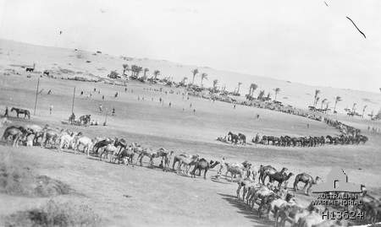
Football Match between 8th and 9th light horse Sinai desert 19th Oct 1917
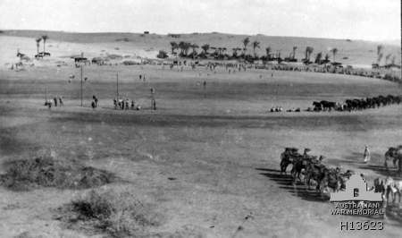
footy match between 8th & 9th Australian Light Horse Romani Sinai

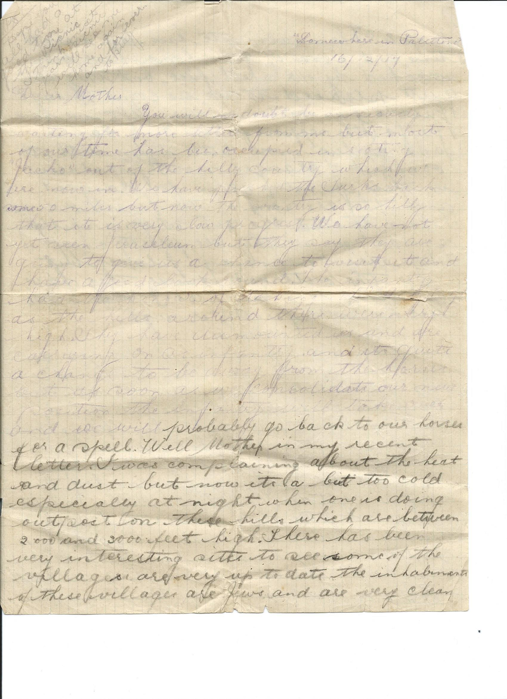
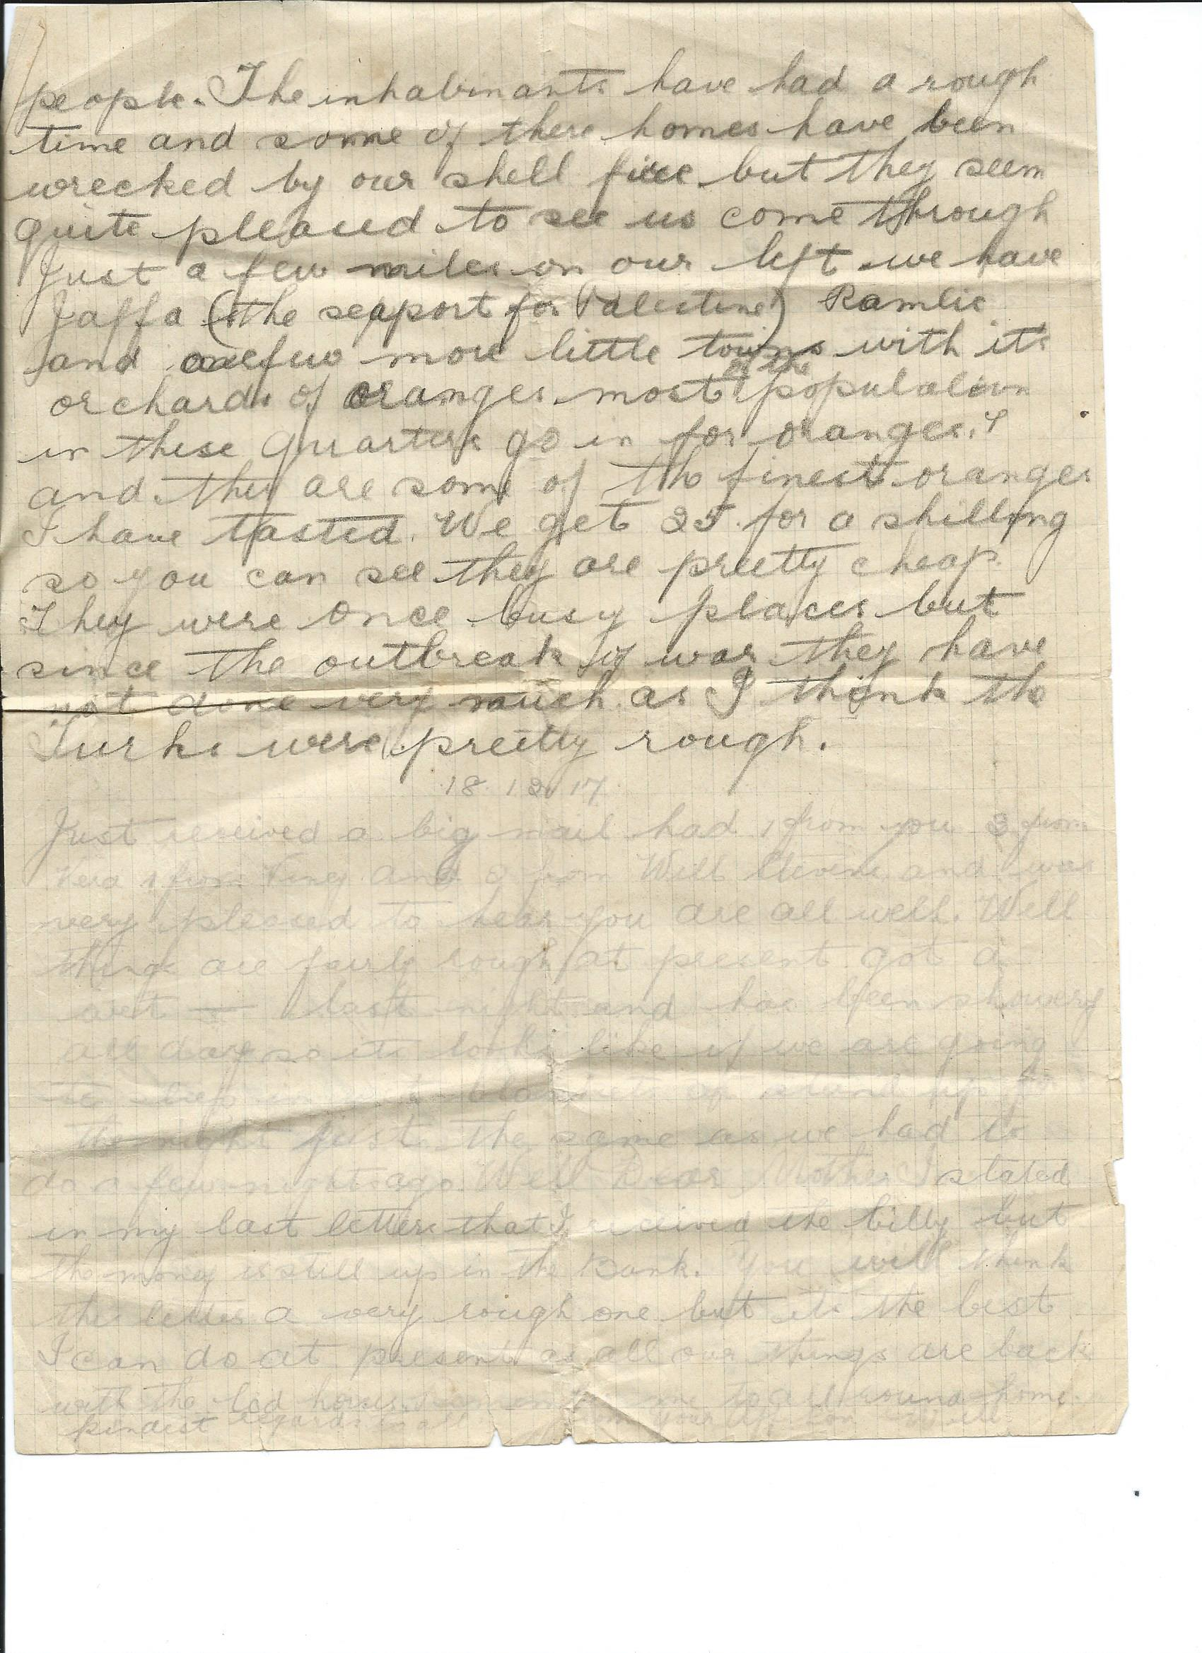

Somewhere in Palestine
16/12/17

Dear Mother
You will no doubt be anxiously waiting for more letters from me but most of our time has been occupied in fighting “Jacko” out of the Hill Country which we are now in. we have pushed the Turks back some 50 miles but now the country is so hilly that is very slow progress. We have not yet seen Jerusalem but they say they are going to give us a chance to visit it and have a good look around………and …… …… …hills around there are…… high…… they have demounted us and we are carrying on as an infantry and its quite a change to be away from the horses. But as soon as we consolidate our new position the infantry will take over and we will probably go back to our horses for a spell Well Mother in my recent letter I was complaining about the heat and dust but now it’s a bit too cold especially at night when one is doing outpost on these hills which are between 2000 and 3000 feet high. There has been very interesting sites to see some of the villages are very up to date the inhabitants of these villages are Jews and are very clean people. The inhabitants have had a rough time and some of these homes have been wrecked by our shell fire but they seem quite pleased to see us come through. Just a few miles on our left we have Jaffa the Support for Palestine ramlic and a few more little towns with its orchards of oranges .Most of the population in these quarters go in for oranges and they are some of the finest oranges I have tasted we get 25 for a shilling so you can see they are pretty cheap they were once busy places but since the outbreak of war they have not done very much as I think the Turks were pretty rough..
18.12.17
Just received a big mail had I from you 3 from Vera 1 from Viney and 2 from Will Stevens andwas very pleased to hear you are all well. Well things are fairly rough at present got a bit wet last night and has been showery all day so it looks like we are going to be in wet blankets or stand up all night just the same as we had to do a few nights ago. Well dear mother I stated in my last letter that I received the billy but the money is still up in the bank. You will think the letter a very rough one but it’s the best I can do at present as all our things are back at the Lod house remember me to all around home kindest regards to all from your aff son Will
Ps Hope you all had a good time at the picnic .I think next year’s picnic will see me home again and forever to stay
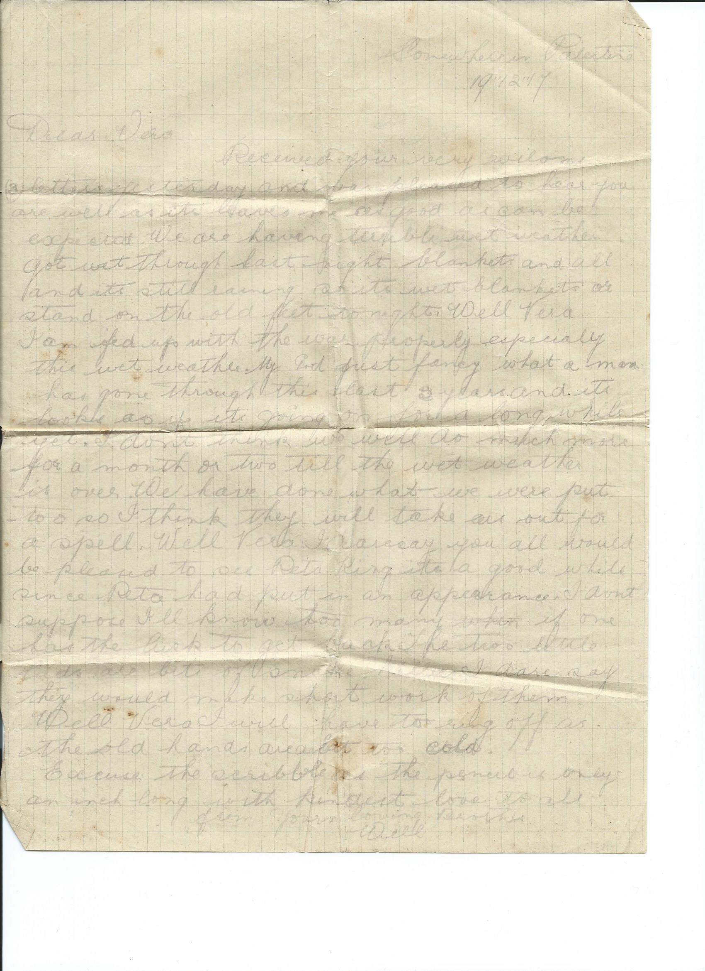

Somewhere in Palestine 19/12/17
Dear Vera received your welcome (3) letters yesterday and was pleased to hear you are well as it leaves me as good as can be expected. We are having terrible wet weather, got wet through last night blankets and all and it’s still raining, so it’s wet blankets or stand on the old feet tonight well Vera I’m fed up with the war properly. My god just fancy what a man has gone through this last 3 years and it looks as if its going on for a long while yet.I don’t think we will do much more for a month or two till the wet weather is over. We have done what we were put to do so I think they will take us out for a spell . Well Vera I daresay you all would be pleased to see Rita King, it’s a good while since Rita has put in an appearance. I don’t suppose I’ll know to many if one has the luck to get back. The two little lads are a bit of snake killers I daresay they would make short work of them ewell Vera I will have to ring off as the old hands are a bit too cold. Excuse the scribble as the pencil is only an inch long , with kindest love to all from your loving brother Will
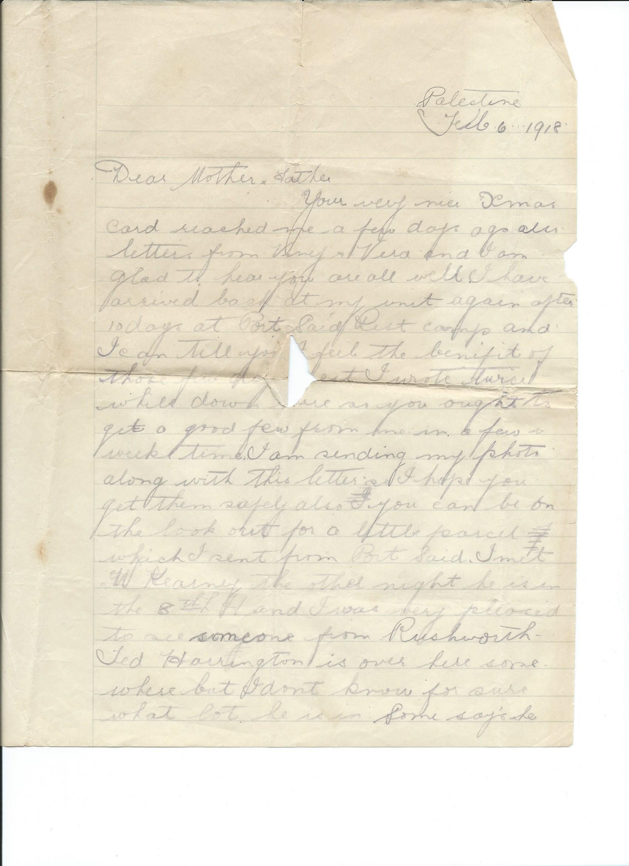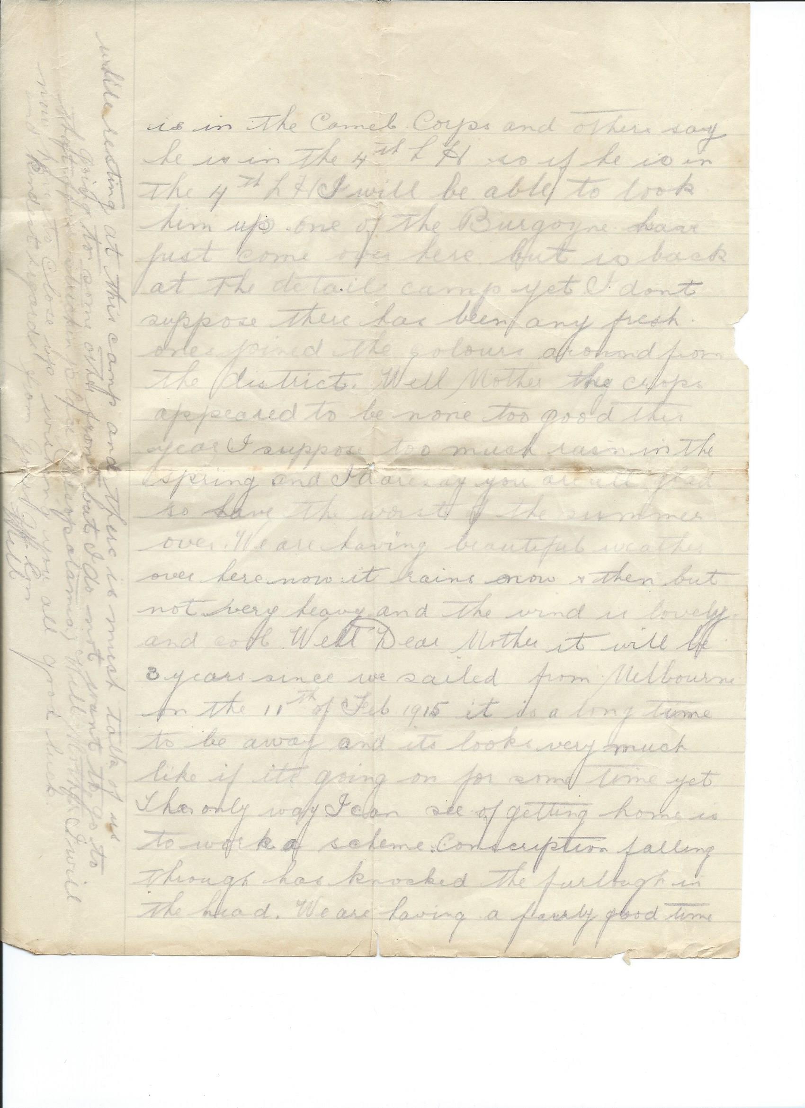

Palestine
Feb 6 1918
Dear Mother and Father
Your very nice xmas card reached me a few days ago also letter from Viney and Vera and I am glad to hear you are all well I have arrived back at my unit again after 10 days at Port Said rest camp and I can tell you I feel the benefit of those few days’ rest. I wrote twice while down there so you ought to get a good few from me in a few weeks’ time I am sending my photo along with letter. I hope you get them safely also you can be on the lookout for a little parcel which I sent from Port Said. I met W Kearney the other night he is in the 8th L H and I was very pleased to see someone from Rushworth Ted Harrington is over here somewhere but I don’t know for sure what lot he is in . Some says he is in the camel corp and others say he is in the 4th LH so if he is in the 4th LH Ill be able to look him up. One of the Burgoynes has just come over here but is back at the detail camp yet II don’t suppose there has been any fresh ones joined the colours around from the district. Well Mother the crops appeared to be none too good this year. Isuppose to much rainin the spring and I dare say you are glad to have the worst of the summer over . We are having beautiful weather over here now it rains now and then but not very heavy and the wind is lovely and cool
Well Dear mother it will be 3 years since we sailed from Melbourne on the 11th of Feb 1915. It is a long time to be away and it looks very much like if it’s going on for some time yet the only way I can see of getting home is to work a scheme. Conscription falling through has knocked the furlough in the head. We are having a fairly good time while resting at the camp and there is much talk of us going to some other front but I do not want to go to that flu stricken place (Mesopotamia ) Well mother I will now have to close up wishing you all good luck and kind regards from your aff. son Will

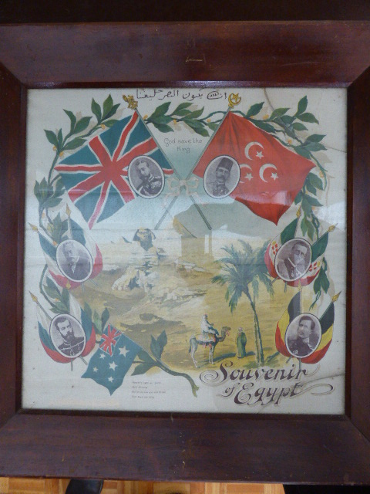
a silk scarf sent back by Will possibly mentioned as the little parcel in above letter. Perhaps for Viney as it is now held by Ron McTaggert

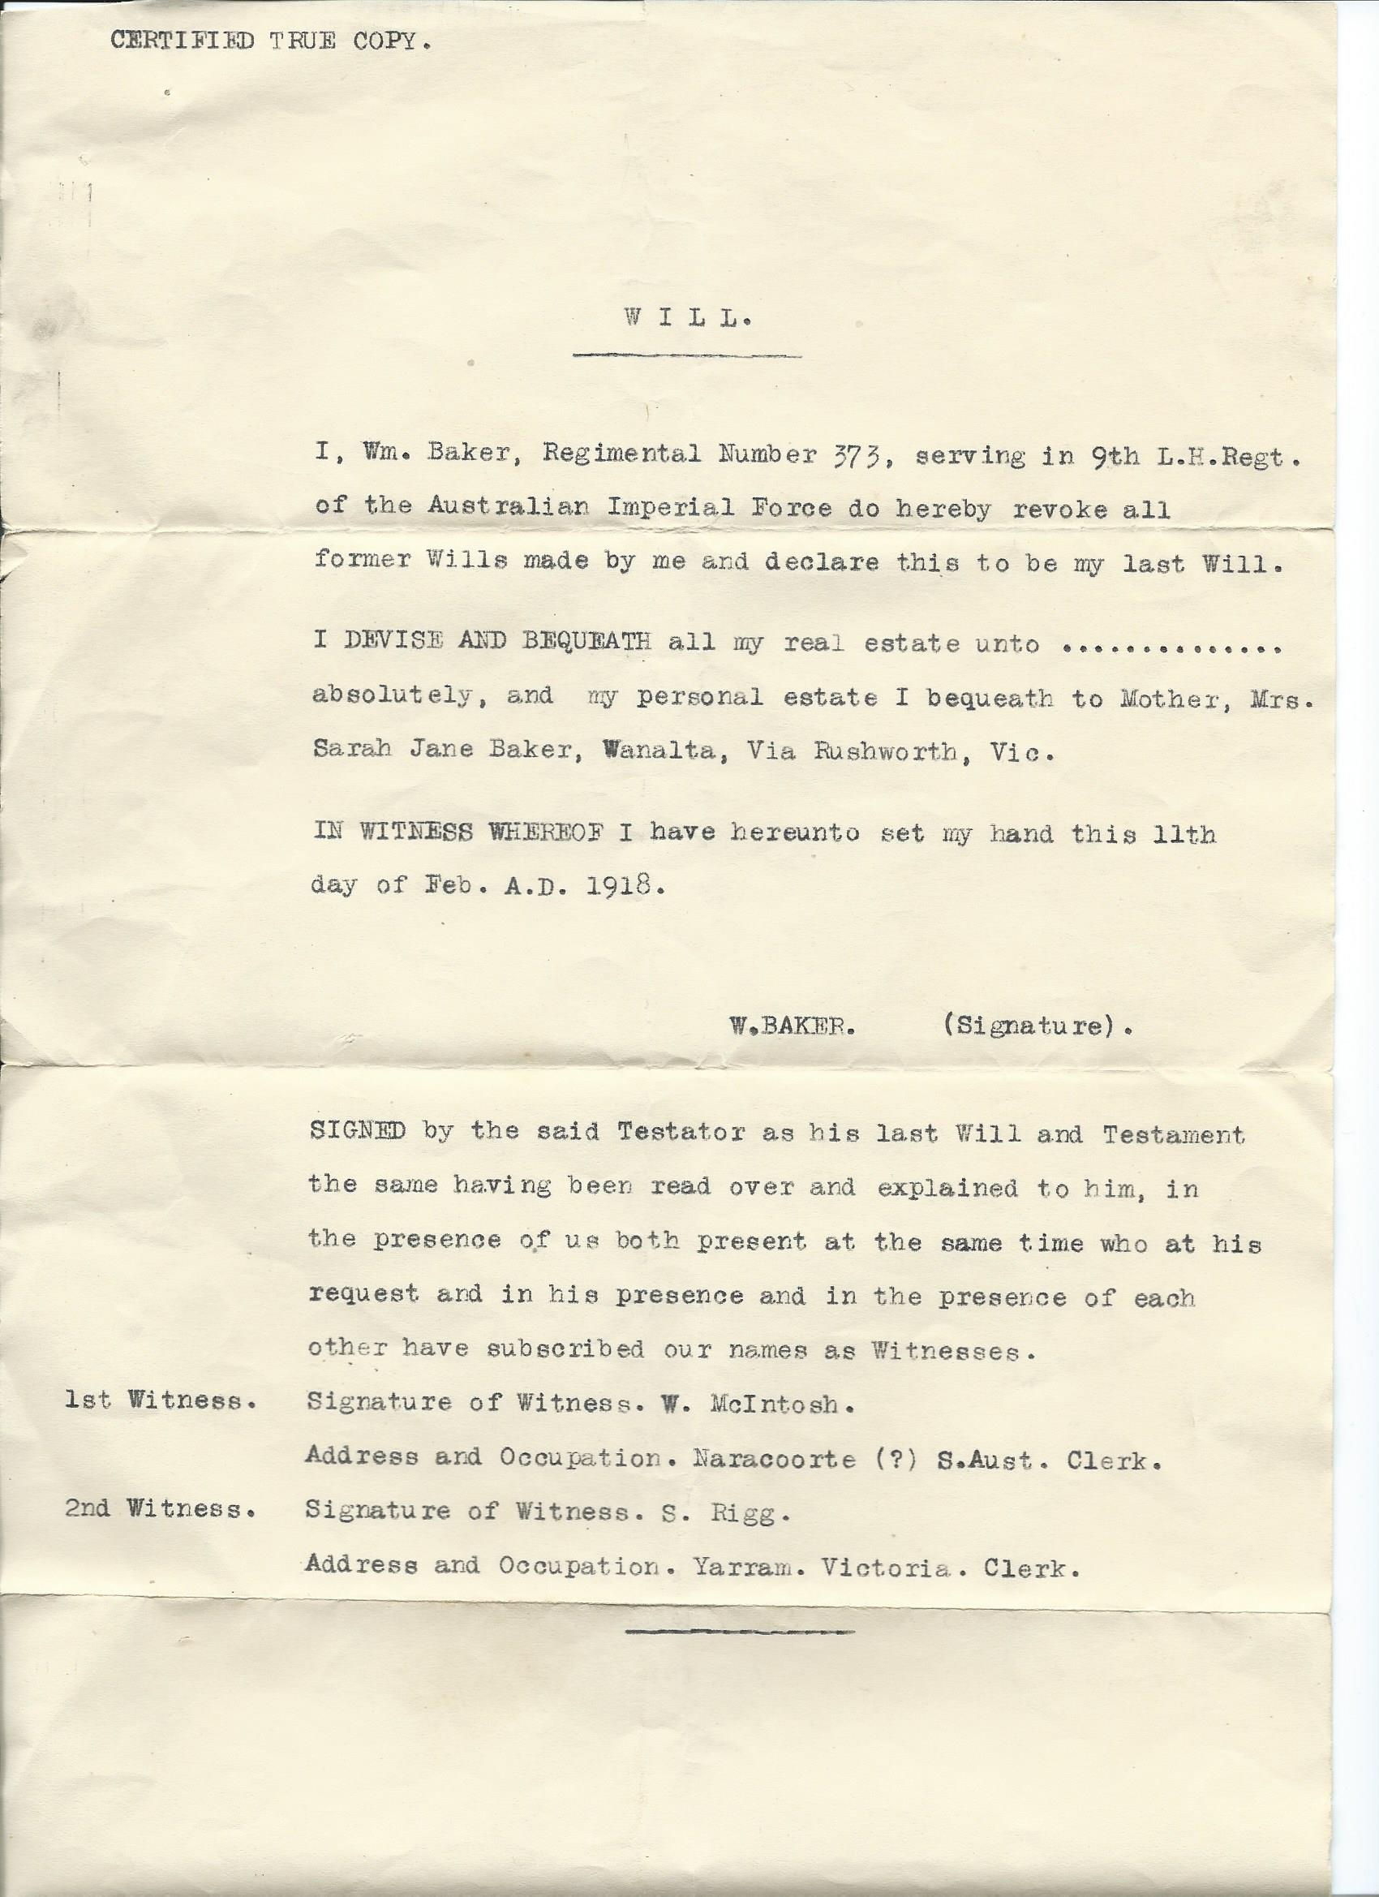

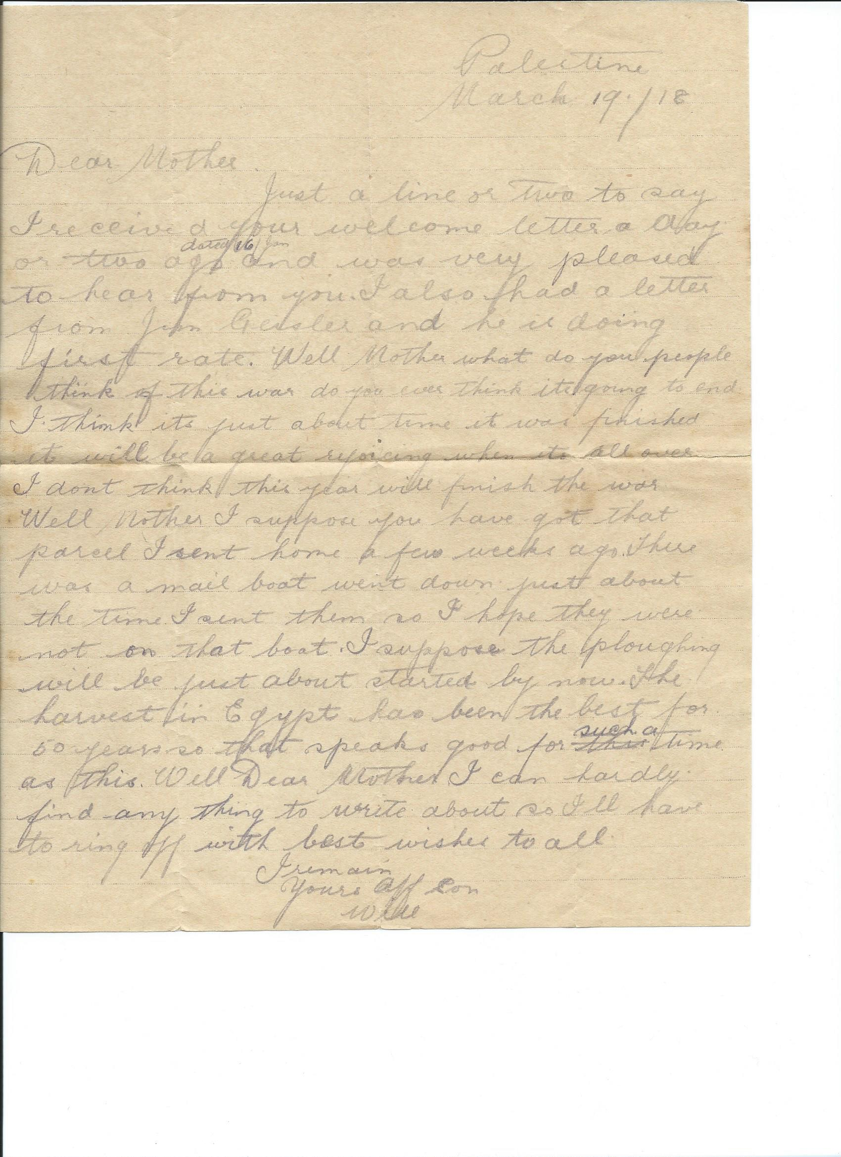

Palestine
March 19 1918
Dear Mother
Just a line or two to say I received your welcome letter a day or two ago (dated 16th Jan) and was very pleased to hear from you. I also had a letter from Jim Geisler and he is doing first rate. Well Mother what do you people think of this war do you ever think it’s going to end. I think it’s just about time it was finished it will be a great rejoicing when it’s all over I don’t think this year will finish the war
Well Mother I suppose you have got that parcel I sent home a few weeks ago. There was a mail boat went down just about the time I sent them so I hope they were not on that boat. I suppose the ploughing will be just about started by now . the harvest in Egypt has been the best for 50 years so that speaks good for such a time as this. Well Dear Mother I can hardly find anything to write about so Ill have to ring off with best wished to all
I remain yours aff son
Will

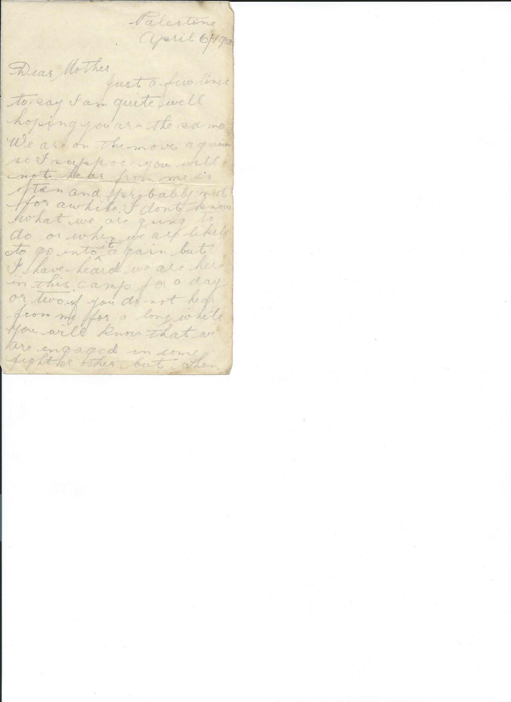
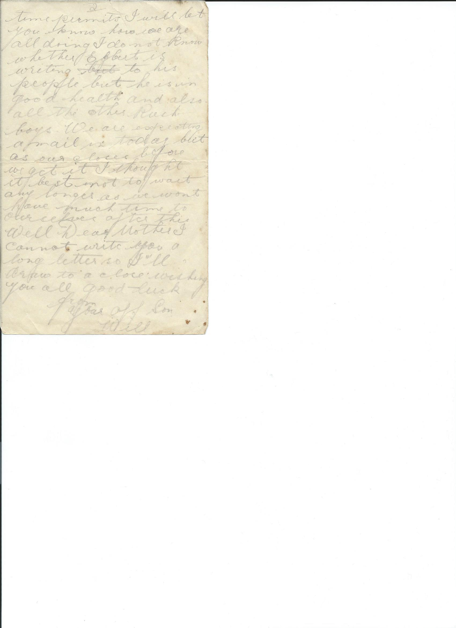

Palestine
April 6 1918
Dear Mother
Just a few lines to say I am quite well hoping you are the same. We are on the move again so I suppose you will not hear from me so often and probably not for a while. I don’t know what we are going to do or when we are likely to go into it again, but I have heard we are here in this camp for a day or two. If you don’t hear from me for a long while you will know that we are engaged in some fight or other but when time permits I will let you know how we are all doing. I don’t know whether Egbert is writing to his people but he is in good health and also all the other Rush. boys. We are expecting a mail in today but as ours closes before we get it I thought it bests not to wait any longer as we won’t have much time to ourselves after this . Well Dear Mother I can not write you a long letter so will draw to a close wishing you all good luck
From your aff son
Will

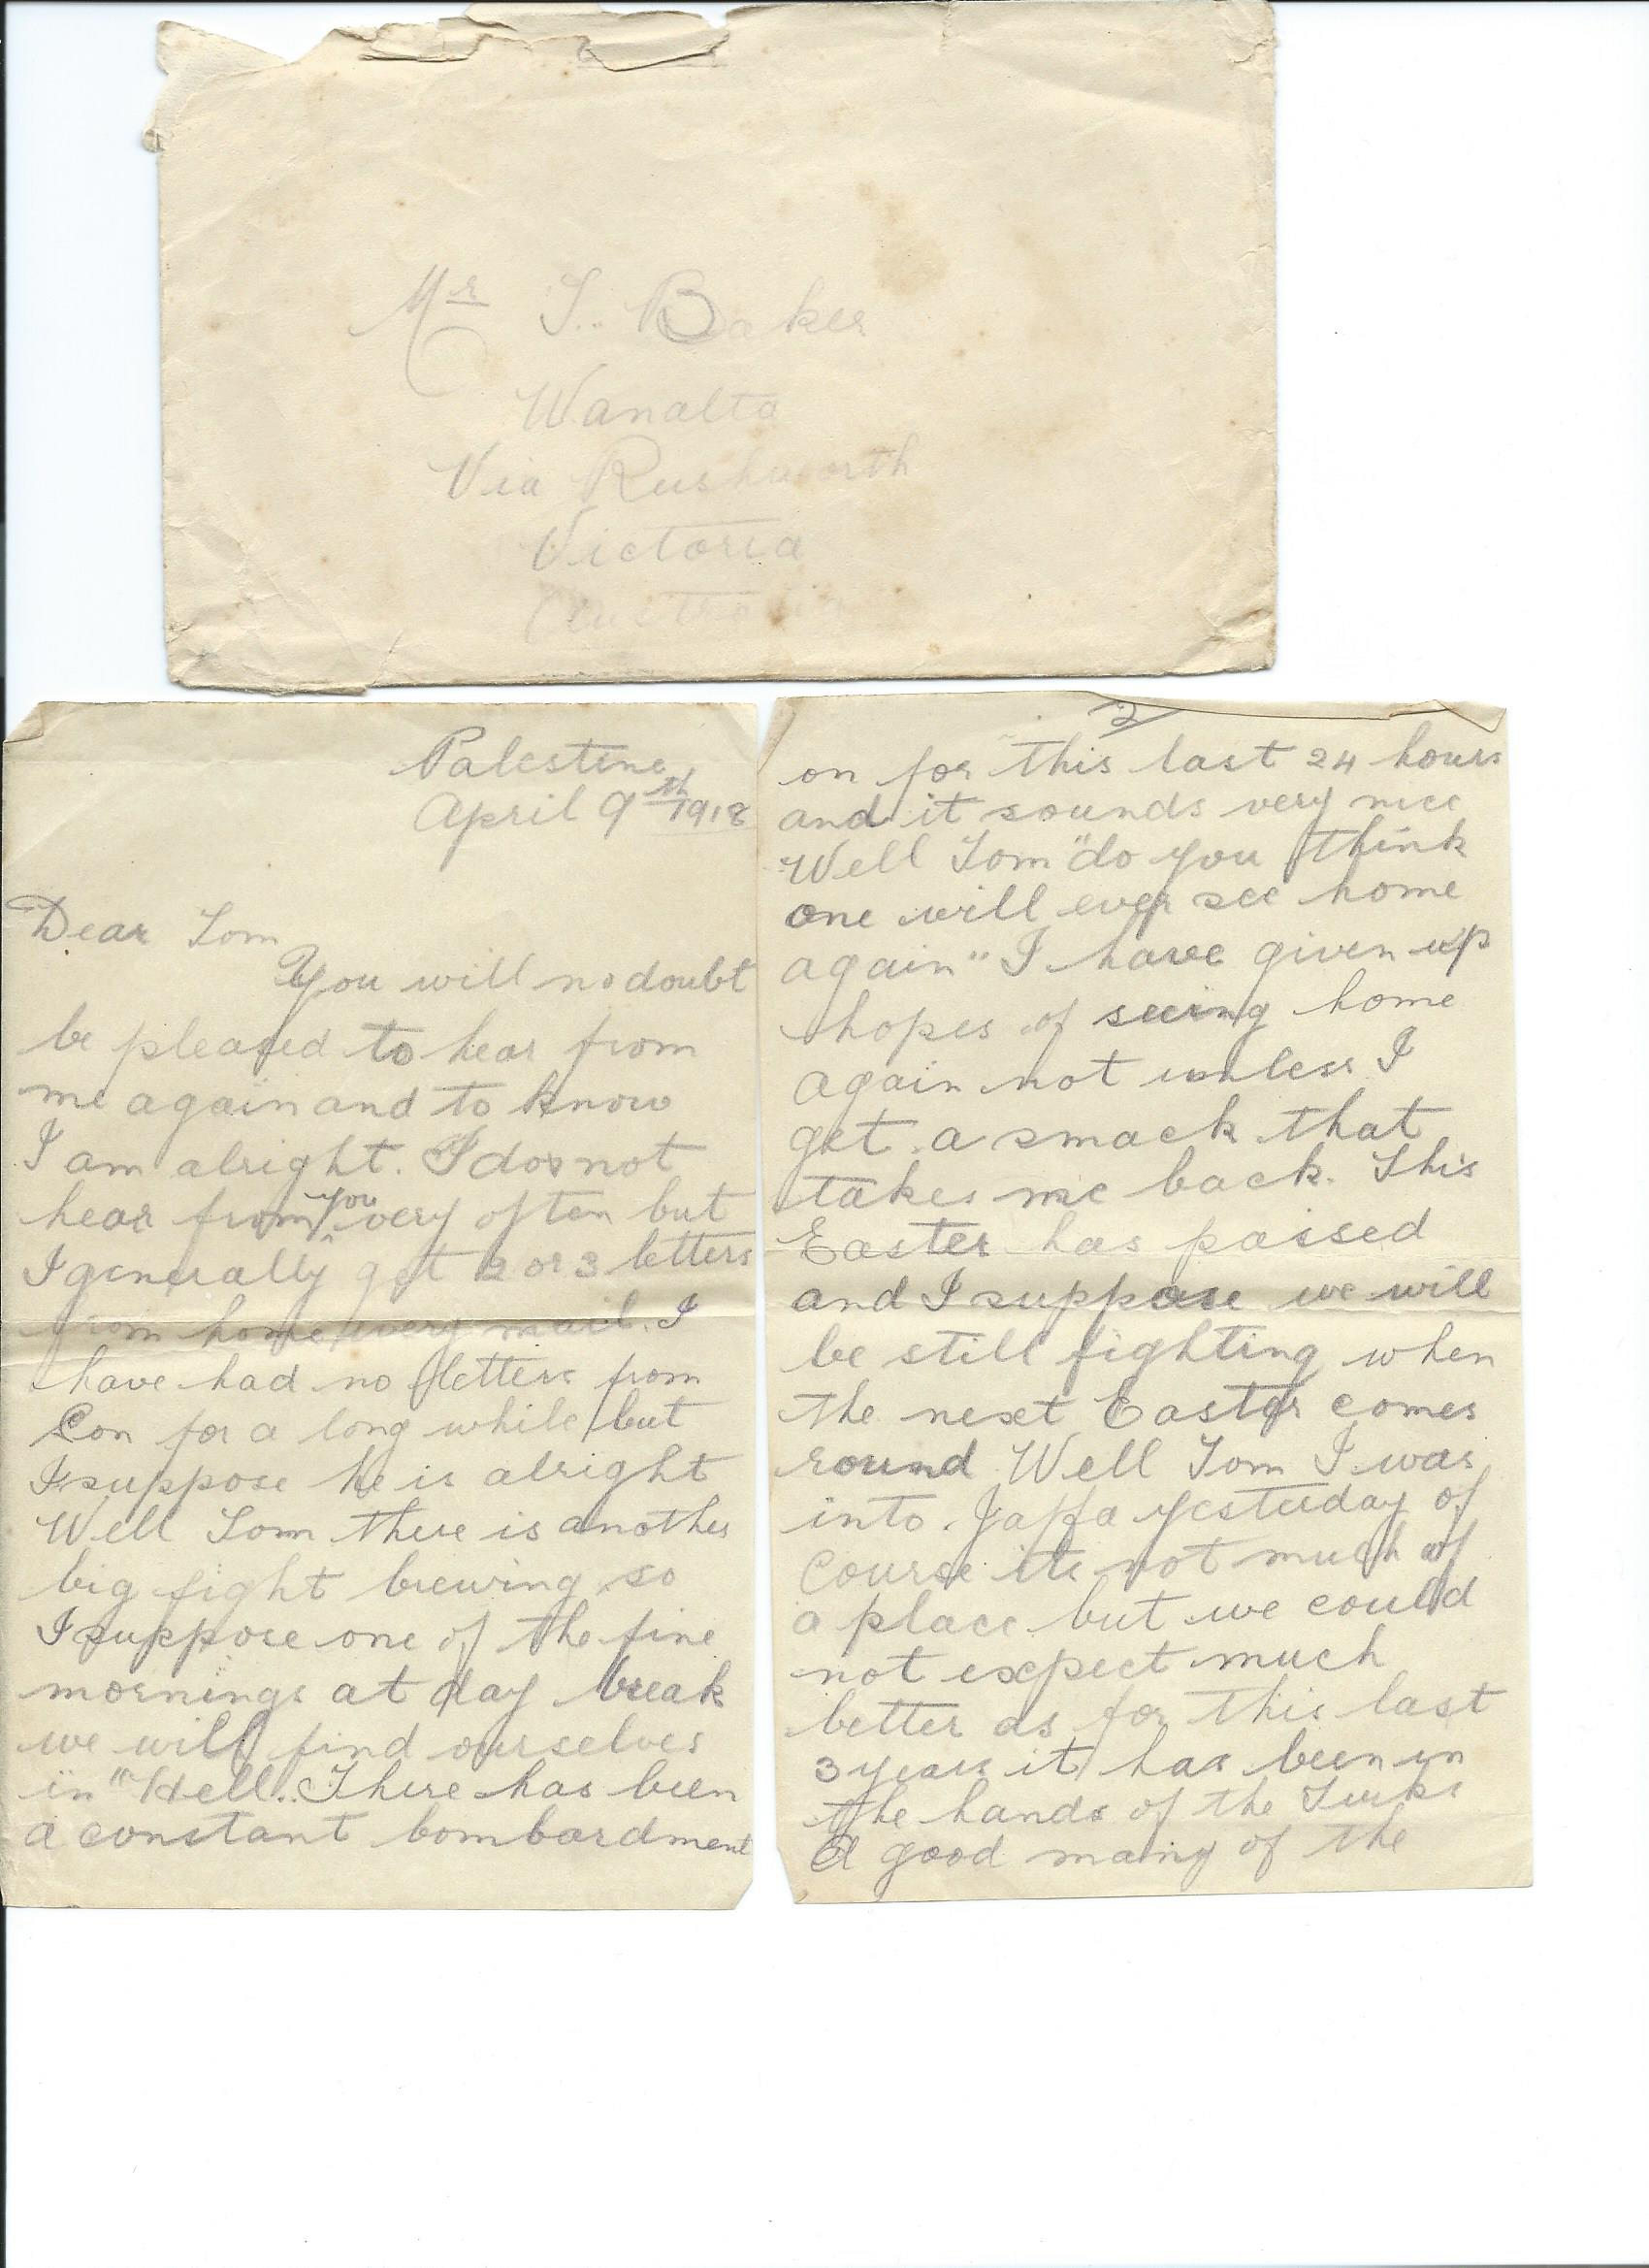
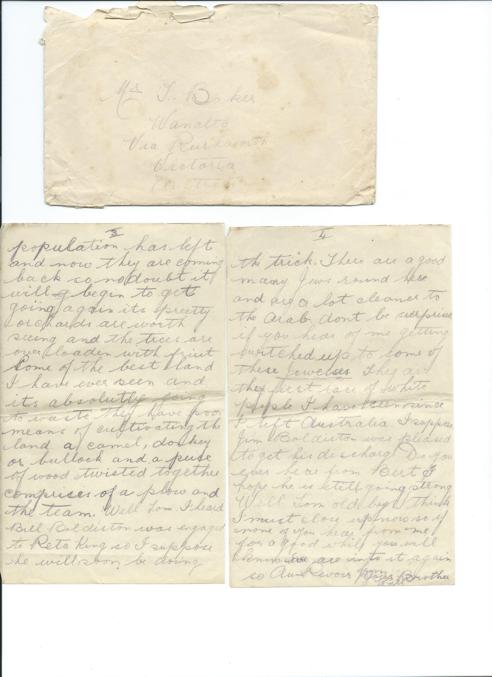

Palestine
April 9th 1918
Dear Tom
You will no doubt be pleased to hear from me again and to know I am alright I do not hear from you very often but I generally get 2 or 3 letters from home every mail. I have had no letters from Son for a long while but I suppose he is alright
Well Tom there is another big fight brewing so I suppose one of these fine mornings at day break we will find ourselves in ”Hell”. There has been a constant bombardment on for the last 24 hours and it sounds very nice. Well Tom ”do you think one will ever see home again”. I have given up hopes of seeing home again not unless I get a smack that takes me back. This Easter has past and I suppose we will be still fighting when the next Easter comes round. Well Tom I was into Jaffa yesterday, of course it’s not much of a place But we could not expect much better as for this last 3 years it has been in the hands of the Turks. A good many of the population has left and now they are coming back so no doubt it will begin to get going again .It’s pretty orchards are worth seeing and the trees are over loaden with fruit. Some of the best land I have ever seen and its absolutely going to waste they have poor means of cultivating the land, a camel, donkey or bullock and a piece of wood twisted together comprises of a plow and a team . Well Tom I heard Bill Boldiston was engaged to Rita King so I suppose she will soon be doing the trick. There are a good many Jews round here and are a lot cleaner to the Arab don’t be surprised if you hear of me getting switched up to some of these Jewesses . They are the first race of white people I have seen since l left Australia. I suppose Jim Boldiston was pleased to get his discharge. Do you ever hear from Bert I hope he is still going strong. I must close up now so if none of you hear from me for a good while you will know we are into it again
So Au Revior from your brother
Will

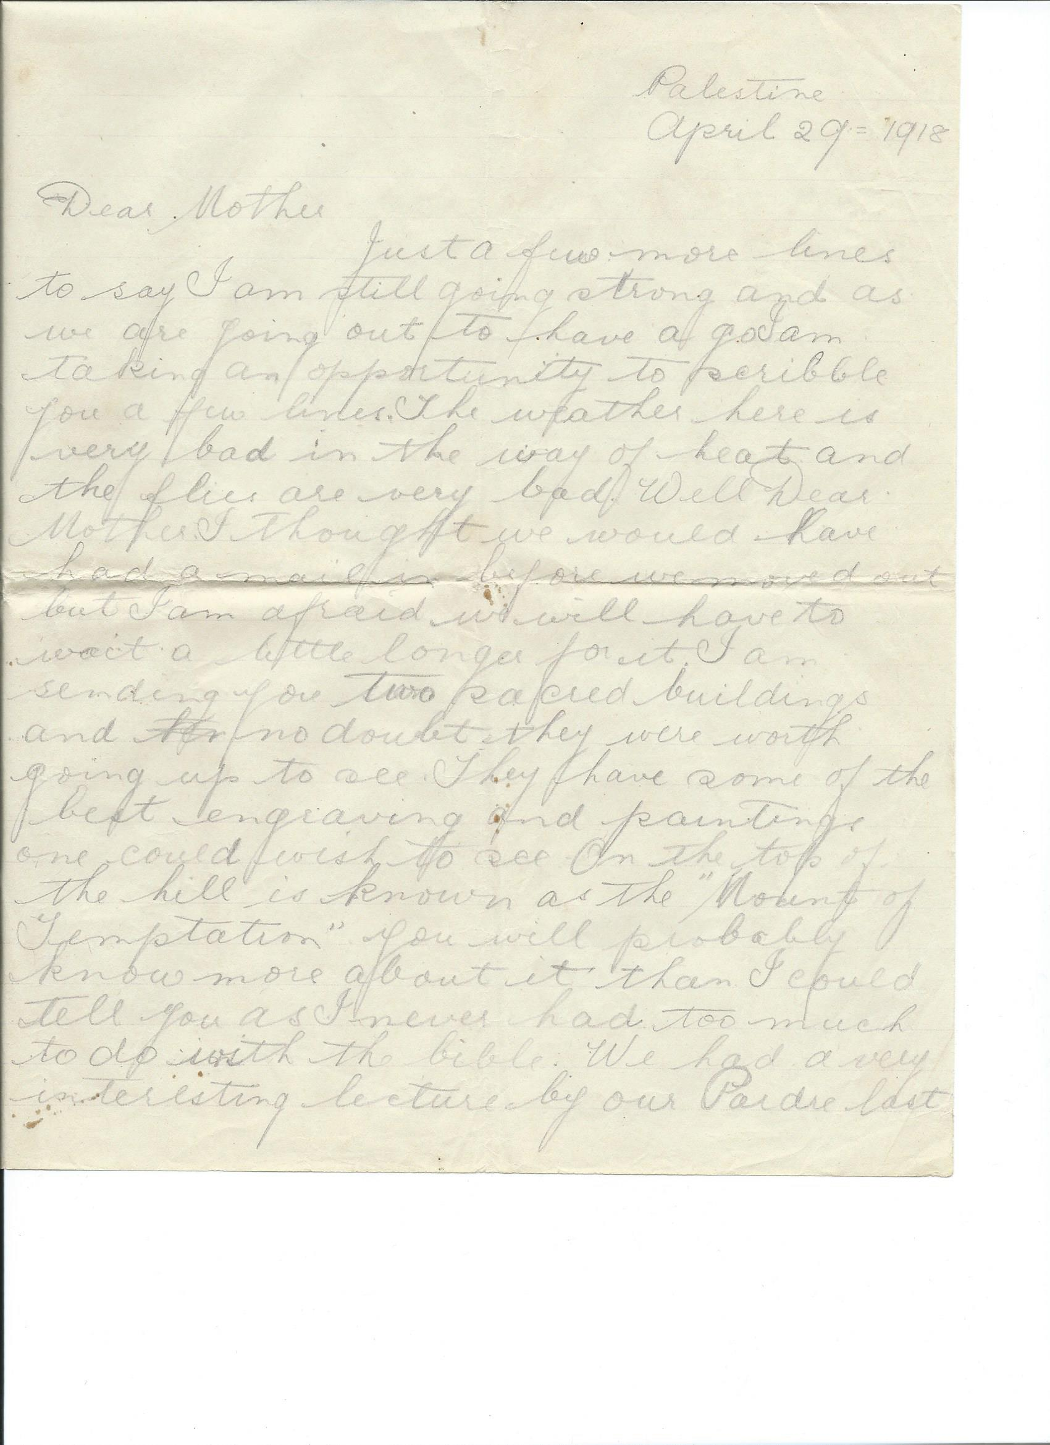
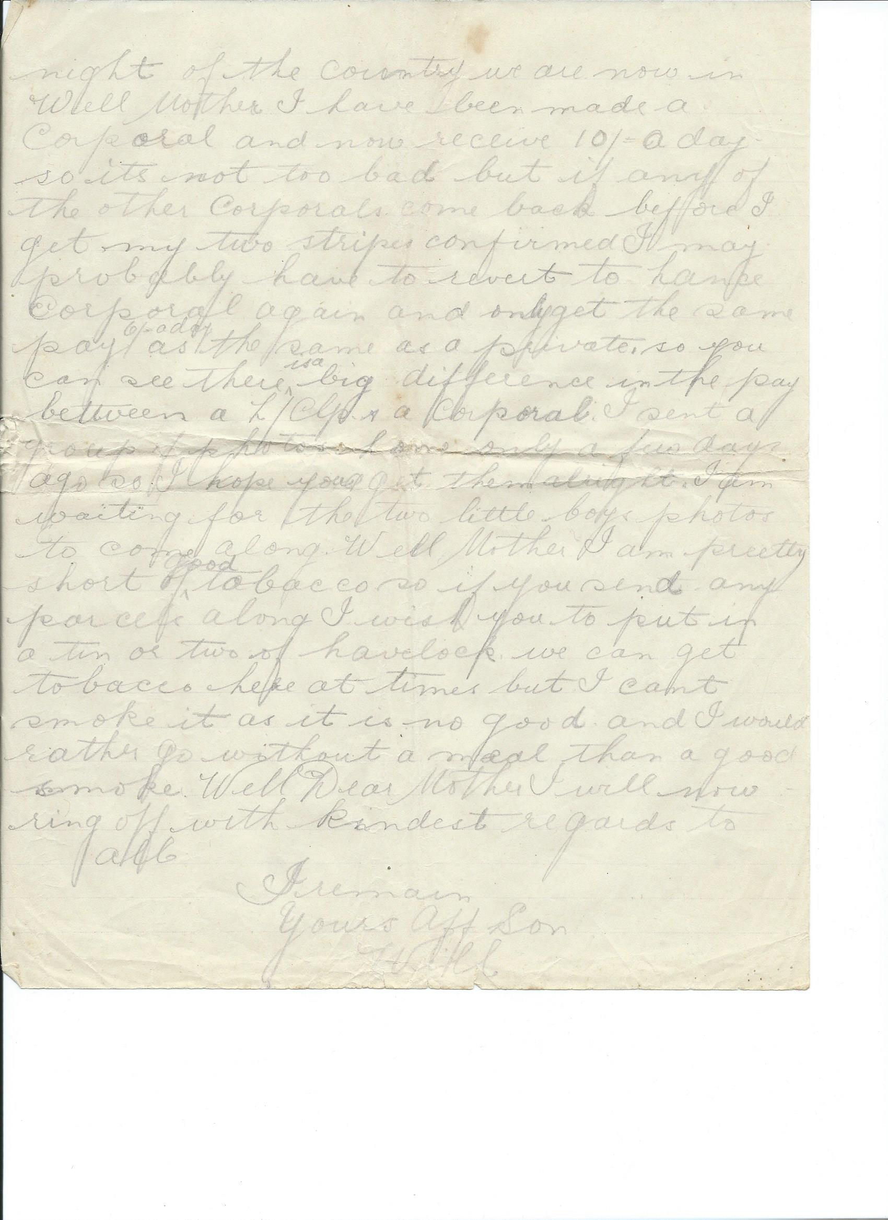

Palestine

April 29th 1918

Dear Mother

Just a few more lines to say I am still going strong and as we are going out to have a go,
I am taking this opportunity to scribble you a few lines. The weather here is very bad in the way of heat and the flies are very bad. Well Dear Mother I thought we would have had a mail in before we moved out but I am afraid we will have to wait a little longer for it .I am sending you two sacred buildings and no doubt they were worth going up to see. They have some of the best engraving and paintings one could wish to see. On the top of the hill is known as the "Mount of Temptation" you will probably know more about it than I could tell you as I never had too much to do with the bible. We had a very interesting lecture by our Parde last night of the country we are now in. Well Mother I have been made a Corporal and now receive 10/= a day so it’s not too bad, but if any of the other Corporals come back before I get my two stripes confirmed I may probably have to revert to Lance Corporal again and only get the same pay 6/= a day as the same as a private, so you can see there is a big difference in the pay between a Lance Corporal and a Corporal. I sent a group of photos home only a few days go so I hope you get them alright. I am waiting for the two little boys’ photos to come along. Well Mother I am pretty short of good tobacco so if you send any parcels along I wish you to put in a tin or two of havelock. We can get tobacco here at times but I can’t smoke it as it is no good and I would rather go without a meal than a good smoke. Well mother I will now ring off with kindest regards to all
I remain yours Aff Son
Will

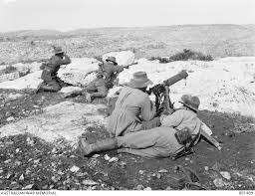
Four unidentified members of the 3rd Australian Light Horse Regiment machine gun in action at Khurbetha-Ibn
This action of using a Hotchkiss gun is what William Baker was engaging in ( 4 days after he wrote his last letter home on 29th April 1918 ) when he was Killed defending the retreat of the 9th light horse on 3rd May 1918

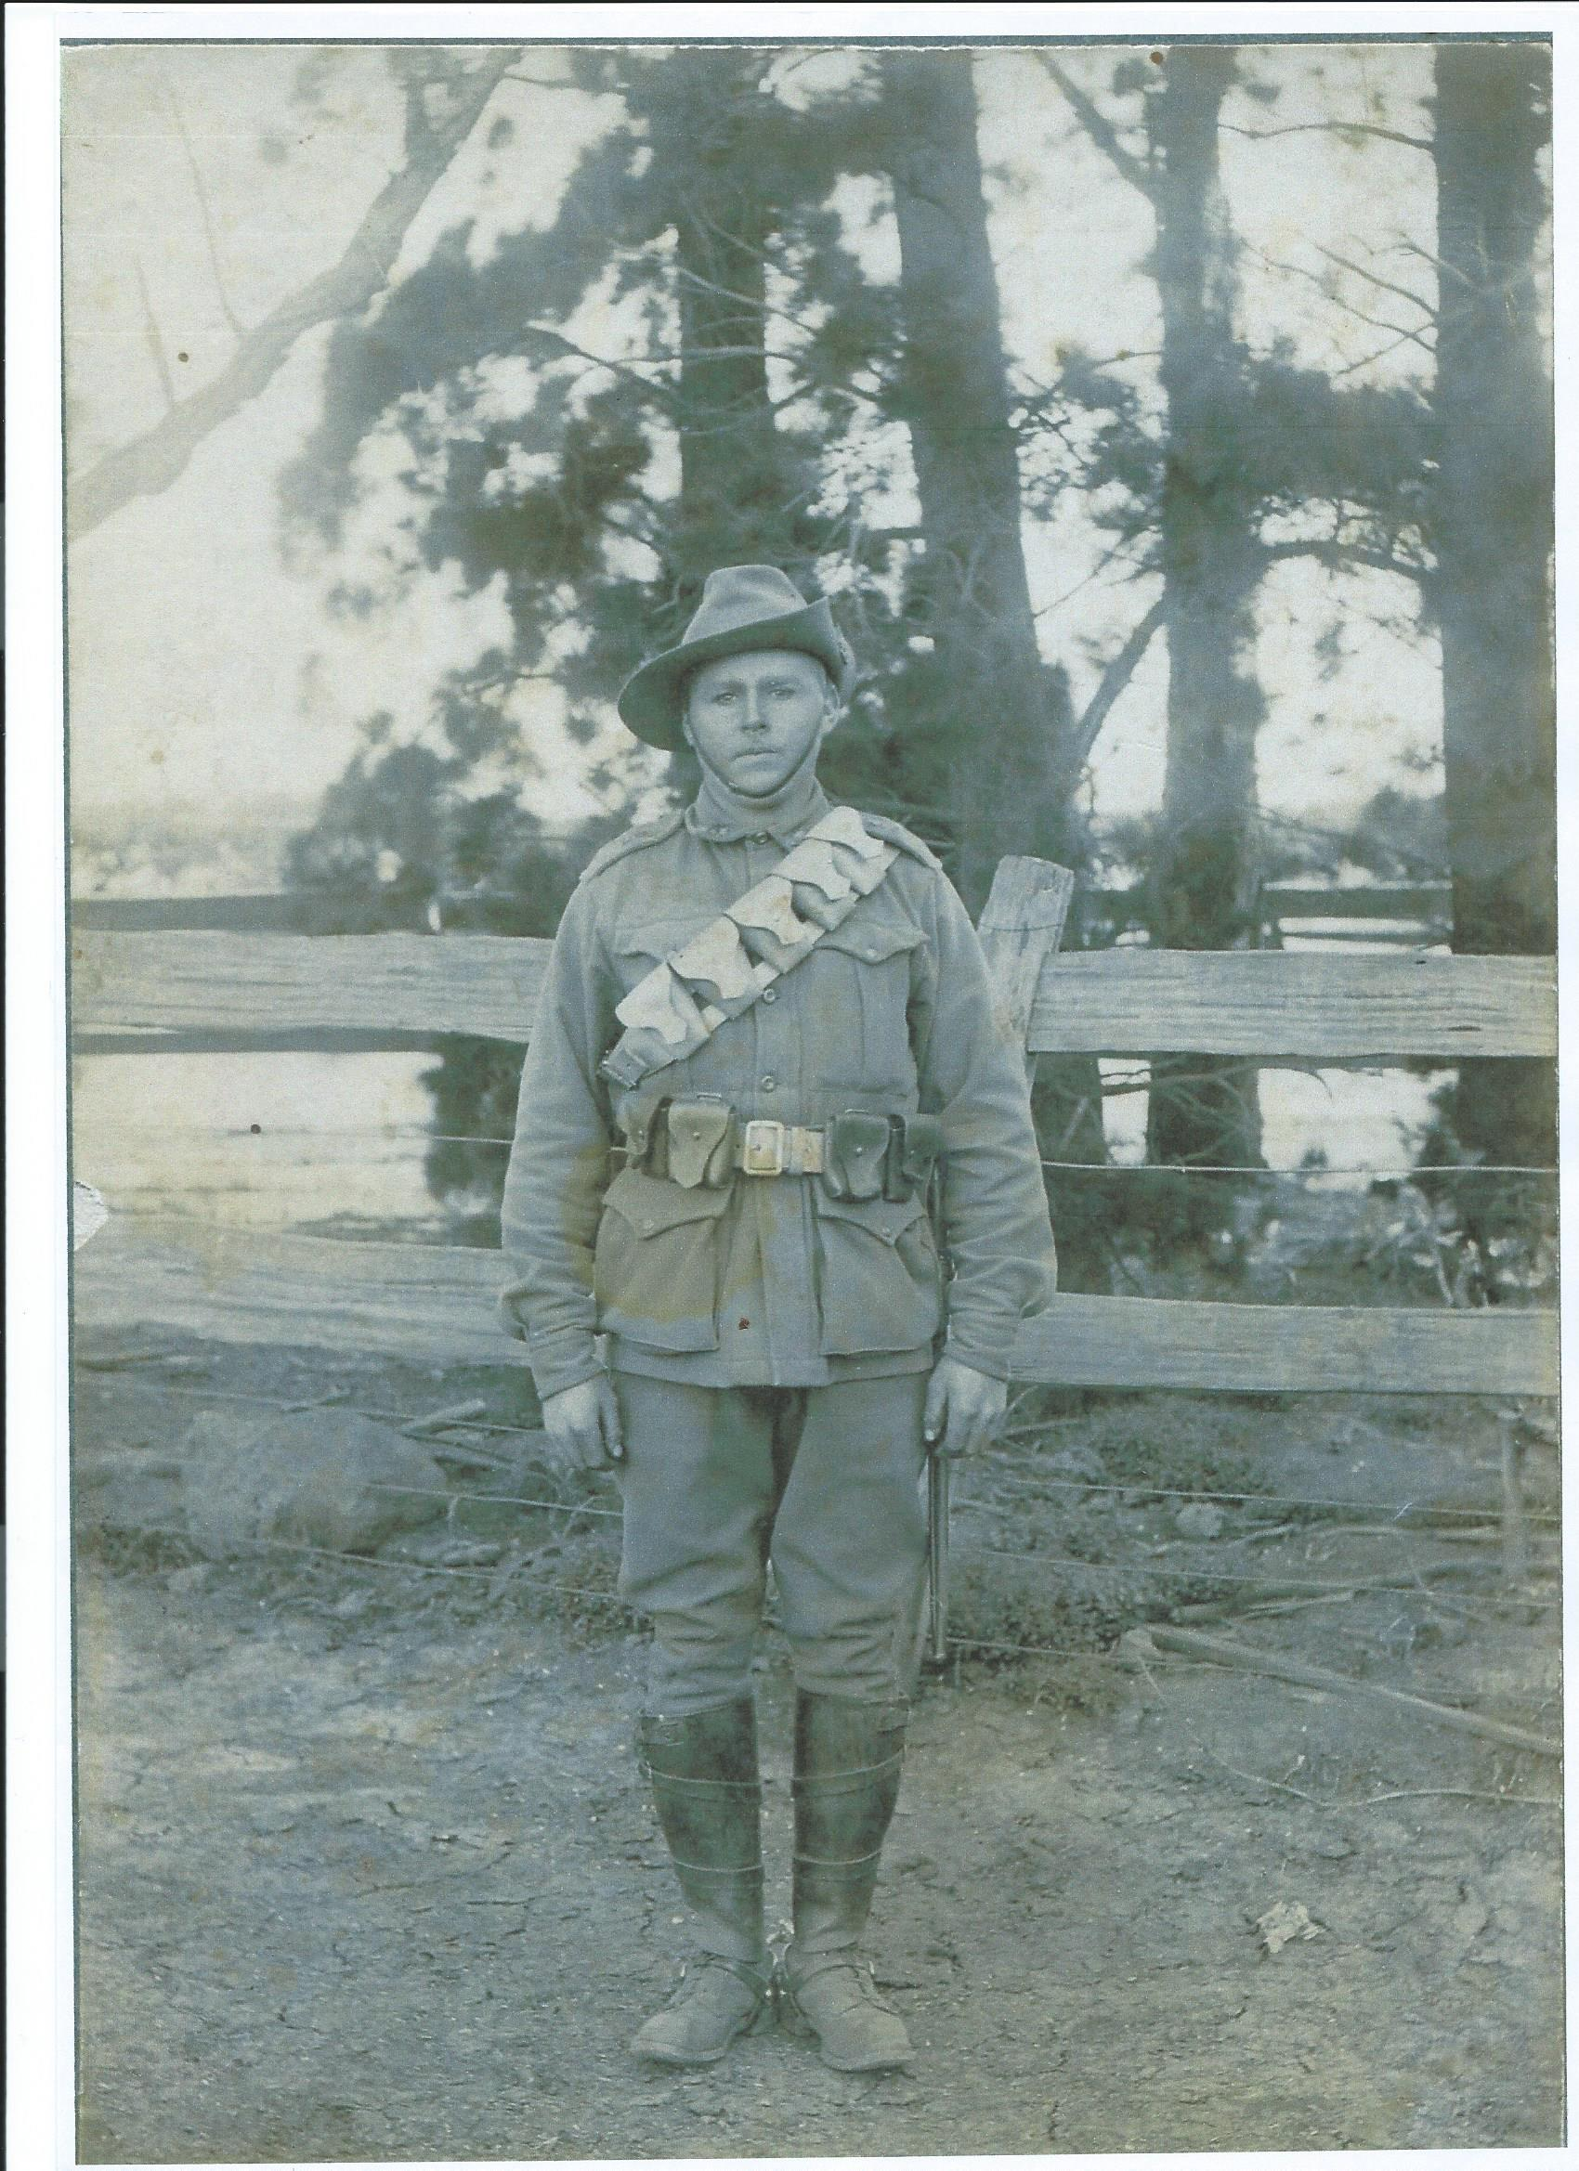

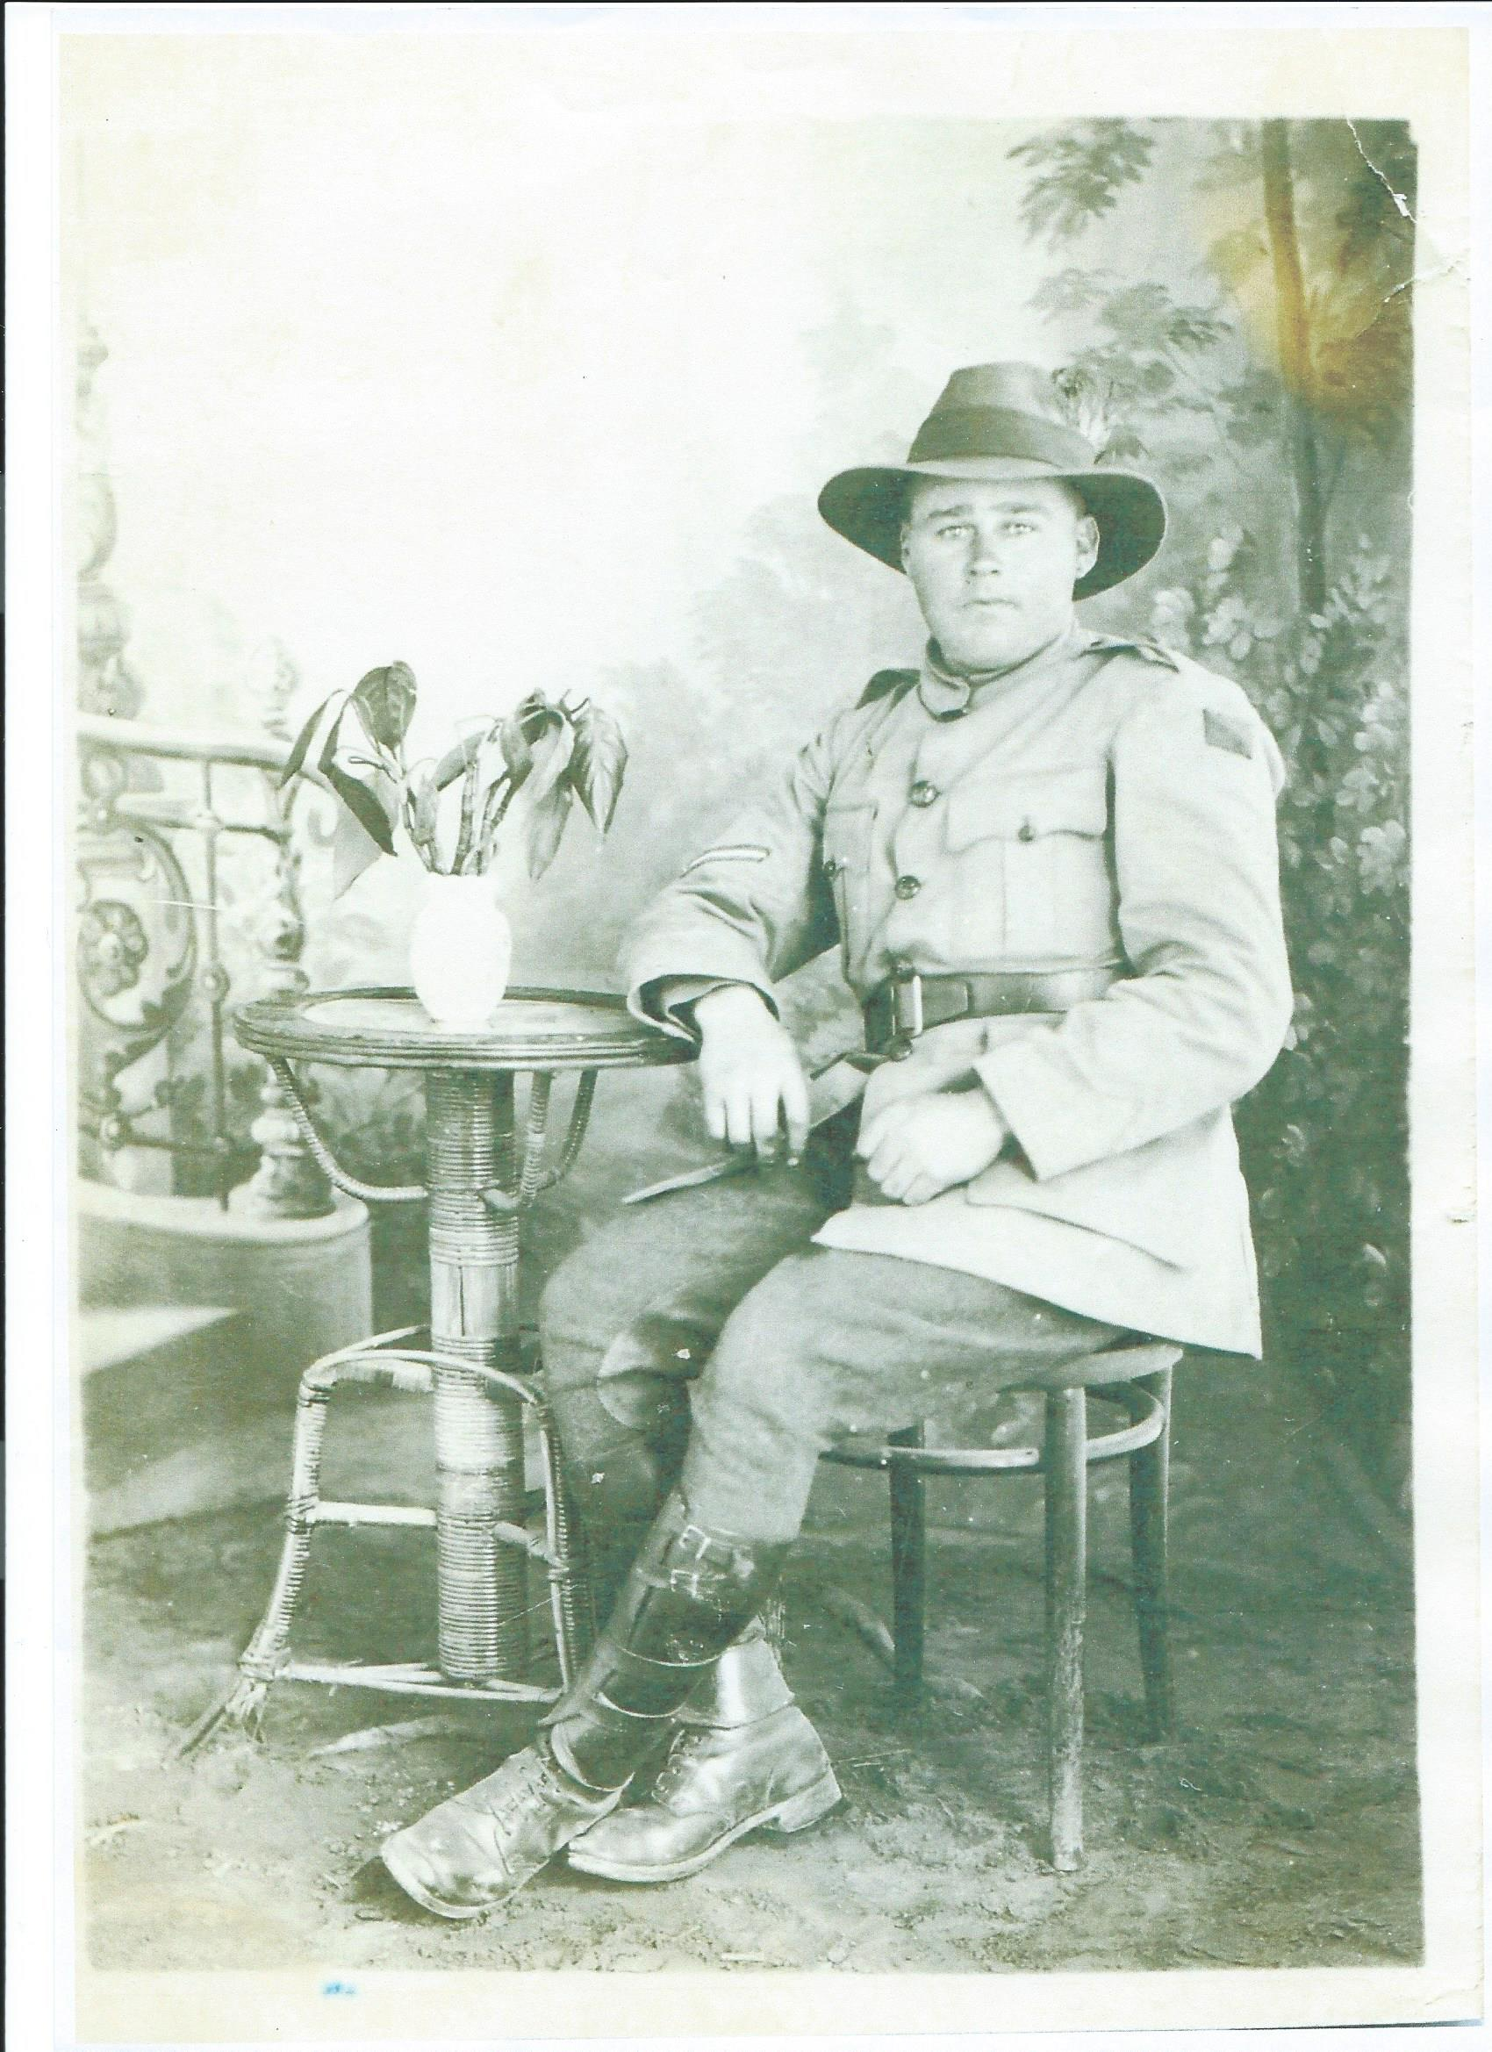

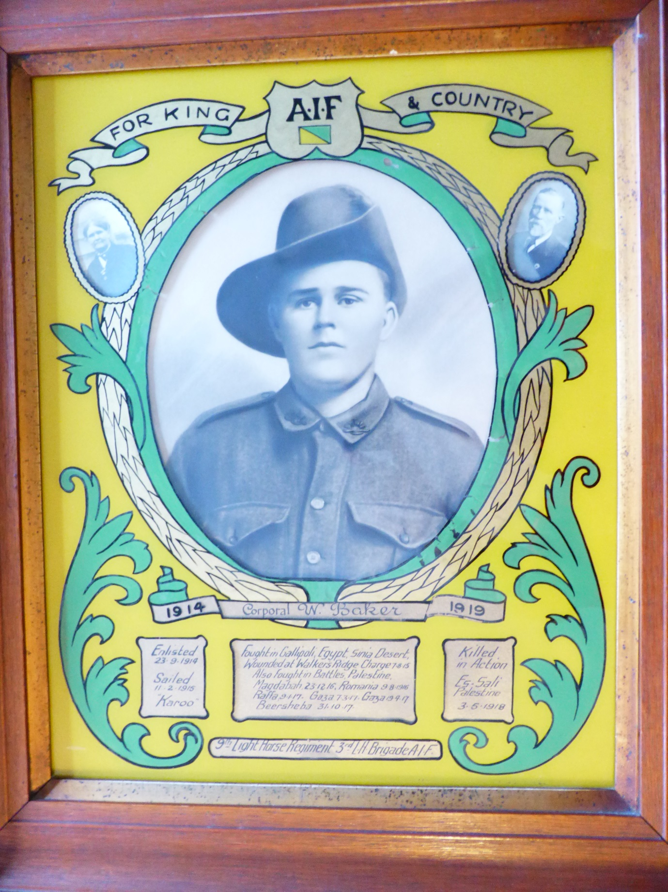
Below is detail for the above photo as written by Will’s father George Baker
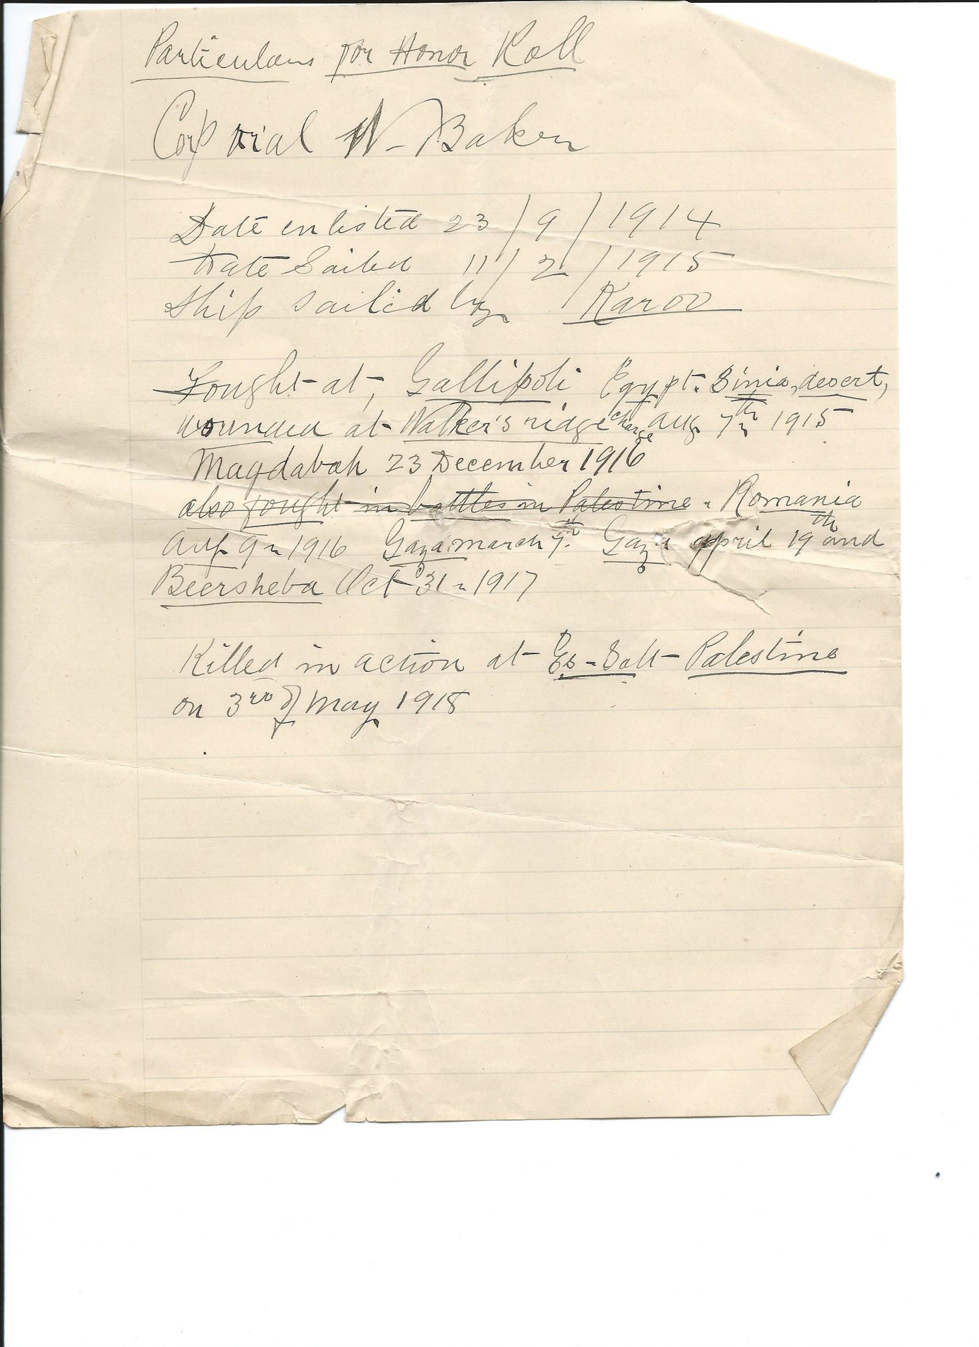
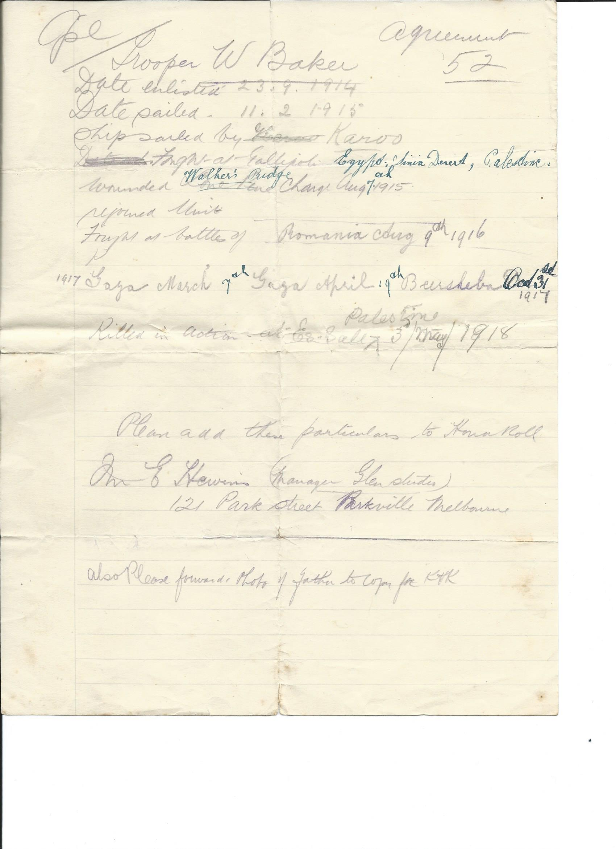

Letter found in Murchison Advertiser Friday 24th Sept 1915
Private W. Baker
Private W. Baker, who was recently reported wounded, writes to his mother
as follows from Heliopolis under date of 11th August:—
Dear Mother "No doubt you will think I have forgotten to write this last mail or two, 3
but the way things are I have not had the chance to do so. I had the misfortune to get a bullet.
through the left arm in an attack we made on the Turks on Saturday morning last.
I can't tell you anything about it but I was not going long before I was put out.
Bert Mason and Jack Considine were both wounded . I don't know how W. Cameron
and E Smith got on. Capt. Day is away sick and so is V Hicks so they both missed it
I have not had a mail for a good while as it will probably go from place to place before it reaches me
it is alright to get into a change of clothes, and I feel a different man. We arrived here about ten
o'clock last night after travelling from Alexandria in the Hospital train. It was a very pleasant ride
They look after one well and the orderlies cannot do enough for us. We had fowl for tea on the train.
The trip over on the boat was not too pleasant, though. I had no bed, only one blanket, and had to
lay on the upper deck on the boards, so was glad to get off it. The bullet went in the muscle of
my arm but did not strike the bone,"

Murchison Advertiser Friday 24th May 1918
Lance-Corporal William Baker
Killed.
During the week the sad news was received from the Defence Department that Lance-Corporal William Baker,son of Mr. and Mrs. Geo. Baker, Colbinabbin East, had been killed in action in Palestine on 3rd May. Lance-Corp.Baker was 25 years of age, and enlisted from Rushworth in September, 1914. He had seen three years and three months of active service up till the time of his death. He was a native of South
Murchison.

Murchison Adveriser Friday 19th July 1918

TheLate Corporal Baker.

The following letter has been received by Mrs Geo. Baker, Colbinabbin, from Major Charley, a squadron leader of the Aust. Light Horse, in Palestine,and tells how her son, Corporal Baker,met his death :

I thought you might like to get a note from someone who was there when your son met his death. I am his squadron leader. It all happened at 9;30 a.m. on tha morning of the 3rd inst. Your boy had charge of a Hotchkiss rifle and was in the front line doing his duty when a sudden rush of the enemy came. They threw a bomb, which caught him and wounded the other members of his team and smashed his gun. He suffered no pain. It was all so sudden. Corporal Baker was one of the best lads in my squadron, and was loved by everyone. His mates held him in great esteem. He was so attentive to his duties, so full of courage and ability, so keen, enthusiastic and zealous, and was such a gentleman. He was wafted away suddenly doing: his best in the execution of his duty. Please accept my sincere sympathy in your bereavement. Being his mother you will feel his loss so much. Try and take a little consolation in the fact that he died for his country; as so many thousands of others have
done in this terrible war.
Yours Sincerely
W. T. CHARLEY, Major,
9th L.H., A.I.F.

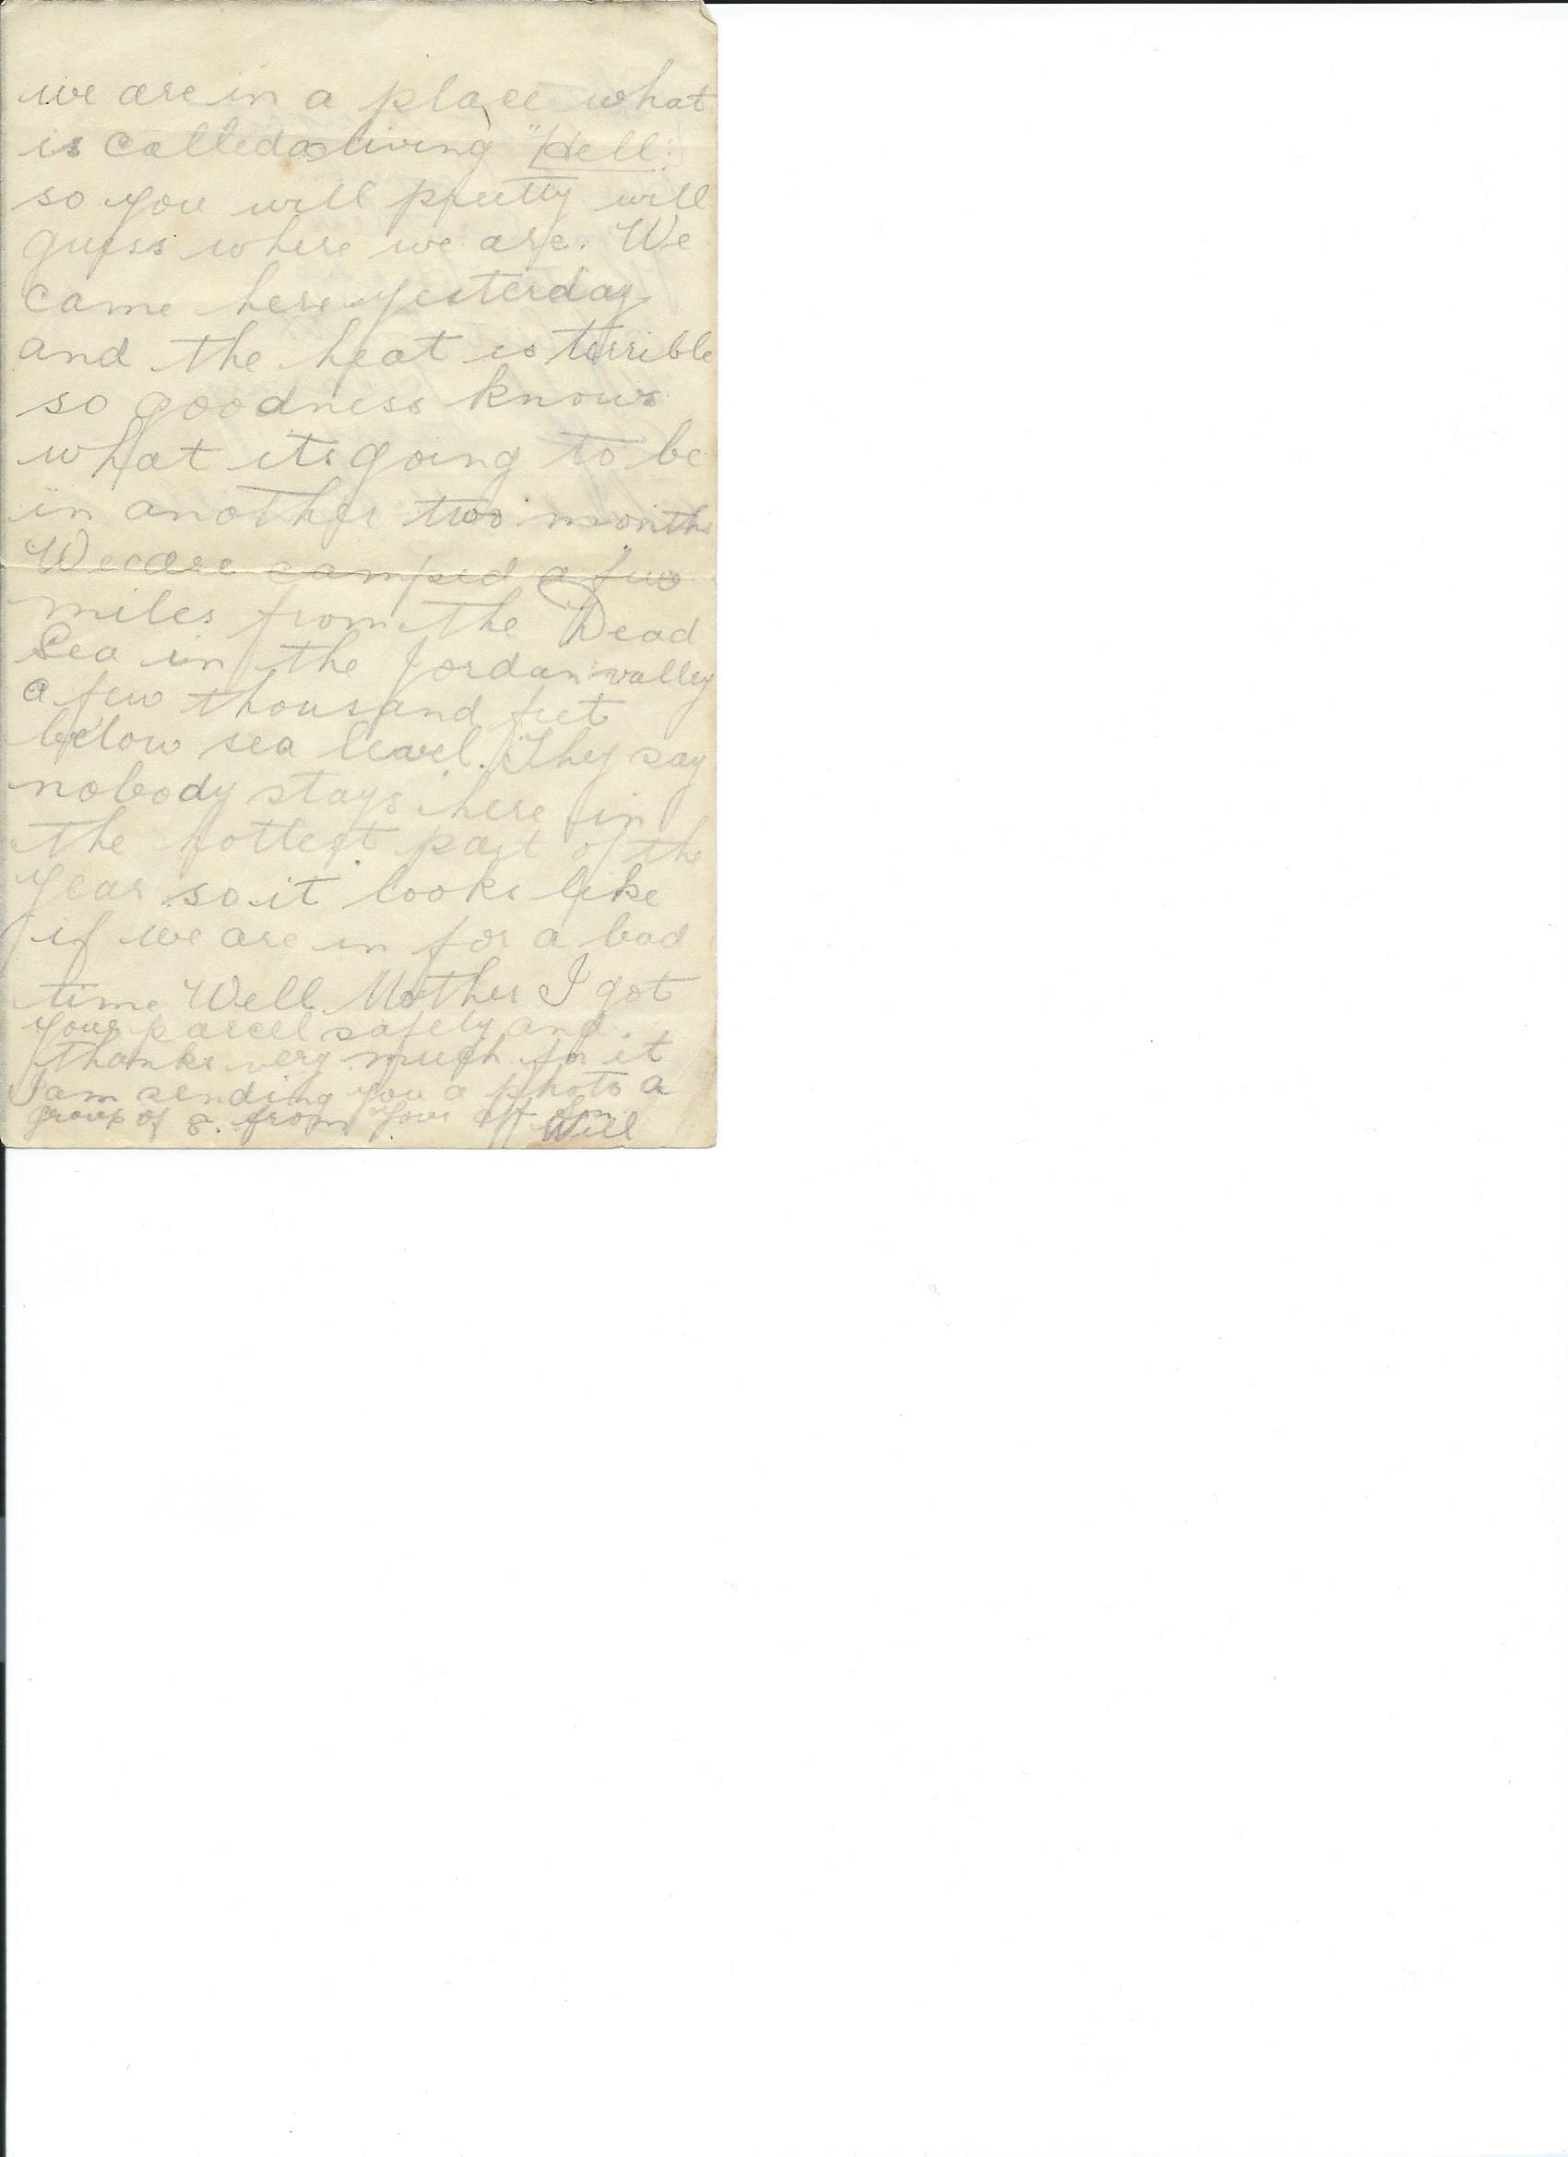

Partial letter.. second or last page
We are in a place what is called a living Hell so you will pretty well guess where we are. We came here yesterday and the heat is terrible, so goodness knows what it is going to be in another two months We are camped a few miles from the dead sea in the Jordon valley a few thousand feet below sea level. They say nobody stays here in the hottest part of the year so it looks like if we are in for a bad time Well mother I got your parcel safely and thanks very much for it I am sending you a photo a group of 8
from your aff son
Will

This is on the back of a partial letter

Photo ??
Left to right
Hughie Cameron
Jim Crothers
Victor Hicks
Egbert Smith
Will Kearney
Alf Perry
Charlie McConville
Perhaps Below is the photo in question only 7 in the group but there is an eighth person to the right partially visable in photo
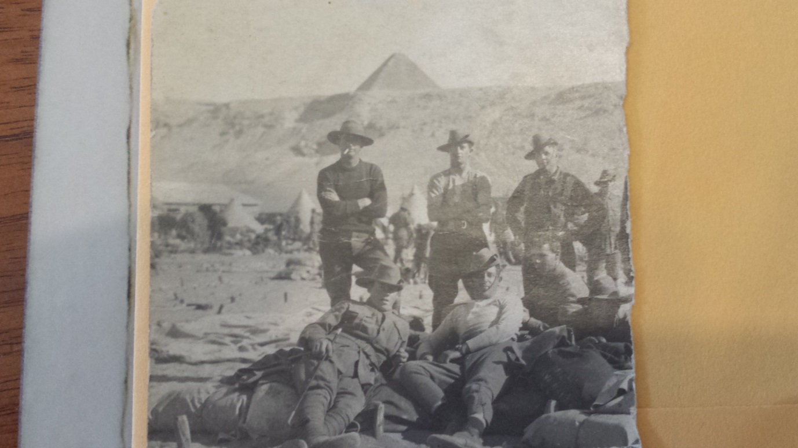
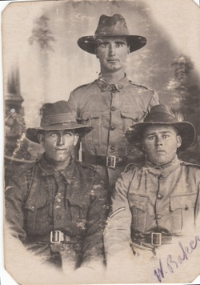

And now for something different A letter from John Baker
From military camp Castlemaine 7/11/1916

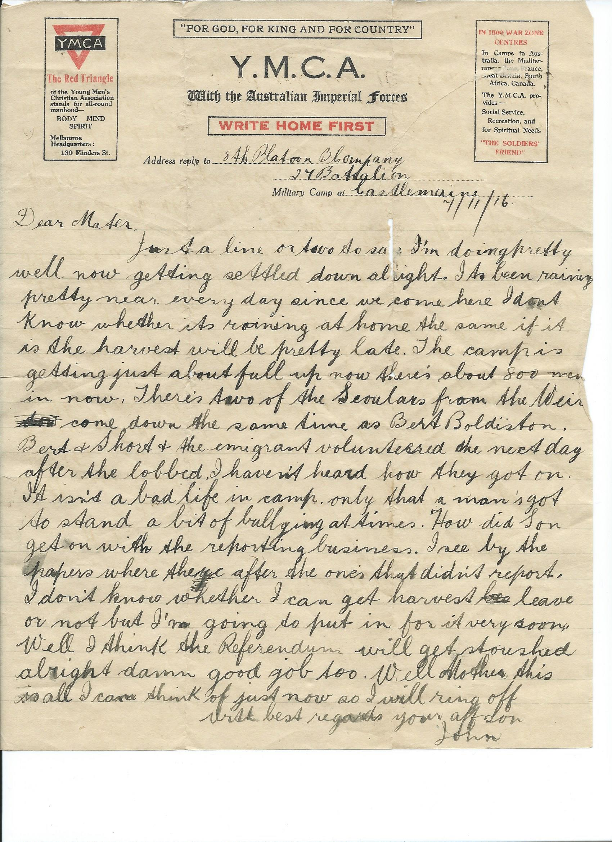

Address reply to 8th Platoon B company 27th Battalion Military Camp Castlemaine
7/11/16
Dear Mother
Just a line or two to say I’m doing pretty well now getting settled down alright. It’s been raining pretty near every day since we came here. I don’t know whether it’s raining at home the same if it is the harvest will be pretty late. The camp is getting just about full up now there’s about 800 men in now. There’s two of the Scoulars from the weir, came down same time as Bert Boldiston. Bert and Short and the emigrant volunteered the next day after they lobbed . I haven’t heard how they got on. It isn’t a bad life in camp only that a man’s got to stand a bit of bullying at times. How did Son get on with the reporting business. I see by the papers where they’re after the ones that didn’t report. I don’t know whether I can get harvest leave or not but I’m going to put in for it very soon. Well I think the referendum with get stoushed alright damn good job too. Well Mother this is all I can think of just now so I will ring off
with best regards your aff son John

