SAPPER LEWIS BRINLEY EDWARDS
1414 – 3rd Tunnelling Company

Hengoed, Glamorgan, Wales was stated to be the birthplace of Lewis Brinley Edwards on September 24, 1886 the son of Richard and Sarah Edwards. In 1891 the family were residing in Hengoed, Gelligaer, Glamorgan and consisted of Richard (39) colliery proprietor and his children Edith Margaret (10), Edward Stanley (8), Morgordon (7), Lewis Brinley (5), Sarah Lilian (3) and Elizabeth Nellie (1).

He received his education at the local Elementary School.

Ten years later in 1901 Lewis was a boarder with his widowed aunt at Hengoed, Gelligaer and Census particulars show they were living at 58 Bedwlowyn Road with details listed as Margaret Lewis (54) and Lewis B. Edwards (14) colliery clerk.

Lewis was employed two years later at sixteen years with the Great Western Railway Company as a clerk from August 5, 1902 with the Passenger Department and worked at Monmouth Trey Station until January 1903 then he was transferred to Rhymney Junction and was still there on October 20, 1904.

At twenty-six years of age Lewis was a passenger on the White Star Liner Medic which departed Liverpool, England on December 14, 1912 under Master of the Ship, Captain Hickson, docking at ports of Capetown on January 4, 1913, Albany, W.A. on January 21, Melbourne on January 29 arriving in Sydney, NSW at the Dalgety Wharf, Millers Point on January 29, 1913.

At the Recruiting Depot at Kiama, New South Wales on January 8, 1916 the twenty-nine year old single labourer applied to enlist for active service abroad. Passing the preliminary medical examination personal particulars taken reveal he was 163cms (5ft 4ins) tall, weighed 60.4kgs (133lbs) with a chest expansion 82-86cms (32-34ins) and had previously been rejected for active service ‘on account of a bad toe’. His complexion was fair with blue eyes and had brown hair. Baptist was his religious faith. Distinctive marks were noted ‘now as having a hammer toe on the left foot but it does not affect him in walking’ and the medical officer Captain Robert Beith noted ‘I am passing him on to Sydney’. Next-of-kin nominated was his father Richard Edwards of Hengoed, Wales, England. He was sworn in at Kiama the same day.

After re-Attestation at Victoria Barracks in Sydney, NSW on January 17, 1916 further information states his postal address was care of Mrs R.W. Jones, care of Mt Kembla Post Office, near Wollongong and was allotted for basic training with the Mining Corps at their Casula camp, near Liverpool, NSW. His rank was Sapper with the regimental number 1414 and assigned to the 1st Reinforcements of the Corps.

At a civic parade in the Domain, Sydney on Saturday February 19, 1916, a large crowd of relations and friends of the departing Miners lined the four sides of the parade ground. Sixty police and 100 Garrison Military Police were on hand to keep the crowds within bounds. The scene was an inspiriting one. On the extreme right flank, facing the saluting base, were companies of the Rifle Club School; next came a detachment of the 4th King’s Shropshire Light Infantry, then the bands of the Light Horse, Liverpool Depot, and the Miners’ on the left, rank upon rank, the Miners’ Battalion.

The Corps boarded HMAT A38 Ulysses in Sydney, NSW on February 20 and sailed for the European theatre. Arriving in Melbourne, Victoria on February 22 the Miners camped at Broadmeadows for a stay of 7 days while further cargo was loaded.

Another parade was held at the Broadmeadows camp on March 1, the Miners’ Corps being inspected by the Governor-General, as Commander-in-Chief of the Commonwealth military forces.

Leaving Melbourne on March 1, Ulysses arrived at Fremantle, Western Australia on March 7 where a further 53 members were taken on board.

On Wednesday March 8, 1916 the whole force, with their band and equipment, paraded at Fremantle prior to leaving Victoria Quay at 9.30 o’clock.

The ship hit a reef when leaving Fremantle harbour, stripping the plates for 40 feet and, although there was a gap in the outside plate, the inner bilge plates were not punctured. The men on board nicknamed her ‘Useless’. The Miners were off-loaded and sent to the Blackboy Hill Camp where further training was conducted.

The Mining Corps comprised 1303 members at the time they embarked with a Headquarters of 40; No.1 Company – 390; No.2 Company – 380; No.3 Company – 392, and 101 members of the 1st Reinforcements.

Finally departing Fremantle on April 1, Ulysses voyaged via Suez, Port Said and Alexandria in Egypt. The Captain of the ship was reluctant to take Ulysses out of the Suez Canal because he felt the weight of the ship made it impossible to manoeuvre in the situation of a submarine attack. The troops were transhipped to HM Transport B.1 Ansonia, then on to Valetta, Malta and before disembarking at Marseilles, France on May 5, 1916, the 1st Reinforcements were officially transferred to the No. 3 Company of the Corps on May 1 and taken on strength while on board the transport. As a unit they entrained at Marseilles on May 7 and detrained on May 11 at Hazebrouck.

A ‘Mining Corps’ did not fit in the British Expeditionary Force, and the Corps was disbanded and three Australian Tunnelling Companies were formed. The Technical Staff of the Corps Headquarters, plus some technically qualified men from the individual companies, was formed into the entirely new Australian Electrical and Mechanical Mining and Boring Company (AEMMBC), better known as the ‘Alphabetical Company’.

The No. 3 Company was allotted to the 11th Corps, 1st Army and No. 1 and No. 2 Sections marched into billets at Laventie and Le Drumez on May 13, 1916 from Hazebrouck. The four sections re-combined to relieve the 255th Company, R.E. in the sector that included existing mine systems of Red Lamp; Winchester; Colvin; Ducks Bill and Sign Post Lane which were composed of workings in blue clay at depths from 20 to 35 feet. The relief was completed on May 26, 1916.

The Company worked on the continuation of the scheme carried out by the 255th Company, R.E. The mining during that period was defensive. Listening was an important part of the daily round. An average of 400ft of driving per week on all faces was effective.

In July defensive and offensive mining was continued in Red Lamp & Winchester & Colvin Sectors with Listening remaining an important part of that work.

During September, 1916 new work was begun at Red Lamp, Mauquissart, Tillaloy and Chapigny and on October 10th the Company again relieved the 257th Company R.E. in the Winchester Sector.

At the beginning of November 1916, the Company received orders from the C.E. to relieve the 258th Company, R.E. in the Hill 70 Sector at Loos in the 1st Corps, 1st Army Area. The 257th Company, R.E. took over the sector at Laventie vacated by the 3rd Aust. Tunnelling Company.

The Company began to move to Bracquemont (near Noeux-le-Mines) to new billets. The complete removal of the Company was finished on November 12, 1916. Thus began a long period of mining work at Hill 70 and varied work along a Front covering the area from Loos to La Bassee. The billets at Bracquemont were retained for 22 months, with Headquarters at Bracquemont, the administration of the work of the Company continued during that period.

The mining work at Hill 70 was all in hard chalk and much deeper than that carried out at Laventie. Hostile activity in the Hill 70 area towards the last part of November was considerable.

Sapper Edwards was killed in action on November 27, 1916 resulting from an enemy explosion while working underground. He was thirty-one years of age.

The following is the extract from the Unit Diary of the 3rd Tunnelling Company on the incident:

“On 27/11/16 while preparing to tamp gallery 21.DD at (36.c.S.W.1. M.b.87.60) the charging of 17,500 lbs of ammonal having been completed, the enemy exploded a camouflet, which exploded our charge. Casualties were 1 officer (Lt H. Russell) and the following 8 O.Rs were “mine gassed” and the following 20 O.Rs were killed: -
Gassed: 4340 Spr J. Gould 991 Spr J.J. Eddison 4521 Spr G.J. Woods
1251 “ S. Barsby 1304 “ S.P. Wagner 4418 “ W. McKnoe
1270 “ B.J. Lear 4993 Cpl L.G. Brown

Killed: 1030 Spr W.F. Horton 4468 Spr O.J.S. Russell 1414 Spr L.B. Edwards
2371 “ J.R. Brockley 5253 “ R. Daniels 4431 “ W. Nightingale
4304 “ D. Coulton 2893 “ H.F. Francis 5250 “ C.V. Barker
1364 Sgt M.J.M. Kerby 1122 Cpl J. Pember 4451 Spr J. Praed
4456 Spr J. Reid 5014 Spr T.E. Prosser 4402 “ W.J. Moore
4421 “ H. McLean 943 “ W.H. Batson 1273 “ M. Lyons
1071 “ A.E. Ladd 1313 “ P.M. Christiansen

On this occasion after the enemy “Blow” Lt O.R. Howie organised the rescue parties & wearing Proto apparatus, led them into the mine, thereby saving lives & performing valuable exploratory work underground. He carried out this arduous & dangerous work for 24 hours until relieved.”

Burials took place in Hersin Communal Cemetery Extension situated 2¼ miles south of Noeux-les-Mines.

Base Records were advised of the soldier’s demise and confirmation of receipt of the Cable was returned to A.I.F. Headquarters on December 11, 1916. Next-of-kin were also notified. Military Commandant of the 2nd Military District was also advised the next day. The Field Service Report was dated December 20, 1916 at the Anzac Section, 3rd Echelon, G.H.Q., B.E.F.

His name was listed in the 253rd Casualty Lists appearing in several NSW newspapers from December 19, 1916 as follows:

A copy of his War Service was made on December 19, 1916 and again on January 18, 1917 for the War Pension Department with the latter noted to re-advise of any promotions that may come through Company Orders.
The Land Friday December 22, 1916:
253RD CASUALTY LIST
NEW SOUTH WALES – KILLED IN ACTION
Spr L.B. Edwards, England Article abridged

His personal effects were forwarded in a package (no. 9268) to his father at Hengoed, Wales from the Kit Store in London and the Inventory listed:
Disc, Ring (metal), Birth certificate, Letters and Photos.

This was receipted by printed card dated March 31, 1917 from his address at Ivy Cottage, Bedwhoyn Road, Ystrad Mynach. The card was received by Records at the Kit Store on April 3, 1917.

Photographs of his last resting place were sent by the Major A. Sanderson, Officer Commanding the 3rd Tunnelling Company on October 20, 1918 to his father, expressing that they may be of some comfort as he gave his life so faithfully for his country.

Major Sanderson sent further photographs to his father on May 21, 1919 and also advised that a permanent stone memorial would later be erected over the grave. A small paragraph referring to his death was included:
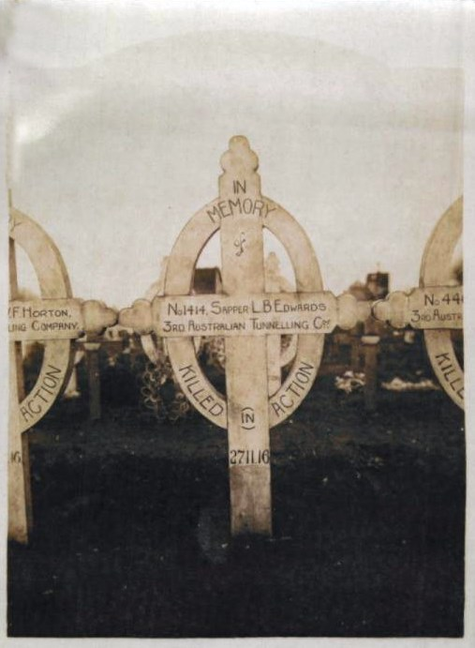
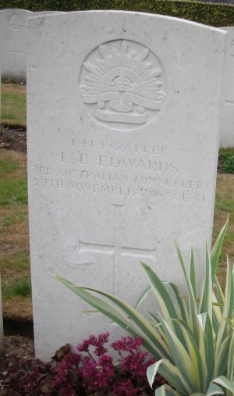
Above: Photograph of his original grave in Hersin Communal Cemetery Extension, France sent by Major Sanderson to his father in 1919.

Right: Photo of permanent headstone courtesy John Battersby, England.

“No. 1414 Sapper L.B. Edwards, killed in action by an enemy mine explosion on 27/11/16 and buried in the Communal Cemetery of Hersin, 2¼ miles south of Noeux-les-Mines, France.”

The grave is located in Plot 1 of Hersin Communal Cemetery Extension, Lens, Nord de Calais, France within Row C in grave no. 10.

In the After War Report of the 3rd Tunnelling Company his name was listed in the Roll of Honour as follows:

No. Rank Name Nature of Casualty Locality Date Buried at
1414 Spr Edwards, L.B. Enemy “Blow” at Hill 70 Hill 70 27/11/16 Hersin

The Circular re War Graves was despatched to Mr R. Edwards on December 22, 1919.

For his supreme sacrifice Sapper 1414 Lewis Brinley Edwards, 3rd Tunnelling Company was issued with the British War Medal (32151) and the Victory Medal (31928). The War Medal went to A.I.F. Headquarters in London to issue to his father and the Victory Medal was inscribed and issued from Australia House, London.

The Memorial Scroll (321299), the pamphlet “Where the Australians’ Rest” and the Memorial Plaque (321299) were sent to his father on August 8, 1922.
His name is commemorated on Panel 26 in the Commemorative Area of the Australian War Memorial in Canberra, ACT.

The Gelligaer district World War I Memorial was unveiled in 1927 to commemorate local people who died in the Great War. His name is etched on the Ystrad Mynach and Hengoed Cenotaph.
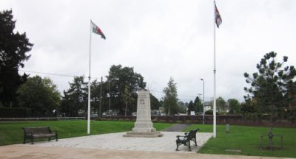
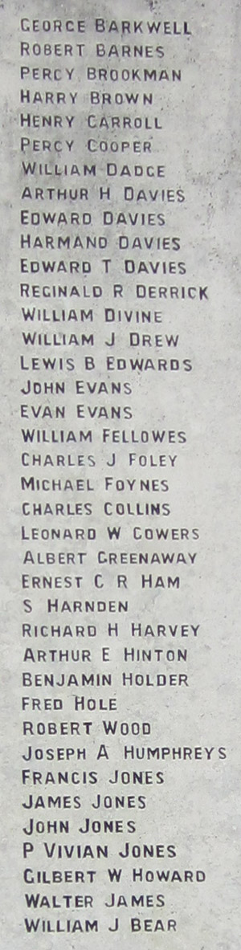
Ystrad Mynach & Hengoed Cenotaph, Wales
Photo sourced from Gelligaer Historical Society’s Website for the district’s World War I soldiers


The Sydney Morning Herald - Saturday 23 July 1921:

ENGINEERS' ROLL OF HONOUR
The Royal Engineer War Memorial Committee are arranging to deposit a roll of honour of all ranks of the Royal Engineers whose names were officially published as killed in action or died of wounds or disease in the war in the chapel of St. Paul's Cathedral, and the Engineer corps of the dominions, colonial, and Indian armies have been invited to deposit similar rolls of honour in St. Paul's, to be attached to that of the Royal Engineers. This invitation has been accepted in Australia. The roll will be inscribed on vellum and enclosed in a casket of Australian timbers to rest on a slab of Australian marble.

This extract from Tunnellers Roll of Honour included in profile with the kind permission of the Dean and Chapter of St Paul’s Cathedral, London
Photos courtesy of Robin Sanderson, Paris

LEST WE FORGET

© Donna Baldey 2016
www.tunnellers.net

