**Bibliography-**

<http://www.nationalanzaccentre.com.au/george-gordon-ryan->

<https://discoveringanzacs.naa.gov.au/browse/records/332876/2>

<http://catalogue.nla.gov.au/Search/Advanced>

<https://www.awm.gov.au/collection/awm4/>

[www.rslvirtualwarmemorial.org.au](http://www.rslvirtualwarmemorial.org.au)

**Sources-**

The Australian War Memorial has photographs related to World War One. <https://www.awm.gov.au/collections-> Use this if you are looking for a specific type of photo. If you want all photos related to your individual, leave this blank, this will help to make your search more relevant; e.g. First World War 1914-1918. You can also refine your search by the location of the photograph, e.g. Adelaide or Gallipoli.

The State Library website provides me with some fantastic photographs taken throughout South Australia’s past of certain individuals. <http://www.catalog.slsa.sa.gov.au/search/X>-

Pearson Text book (History year 9)- <https://reader-sin-prod.gls.pearson-intl.com/readBook-> Provides us some key information about World War 1.

The aif website helps Identify name, service number, location and regiment of your soldier.<https://www.aif.adfa.edu.au/search>

The Gallipoli Campaign (YouTube)

<https://www.youtube.com/watch?v=qW8O_sisf4I> -

A brief explanation of the Gallipoli War.

West Terrace AIF Cemetery - courtesy of Faith Jones, where **George Gordon Ryan** was berried.

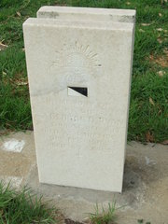

World War 1 (YouTube) <https://www.youtube.com/watch?v=dHSQAEam2yc->This video explains to us the basics of world war 1 (how it started, why it started, the teams and how long it lasted for).

The Anzac portal will be used for simple key information throughout my assignment. <http://www.gallipoli.gov.au/why-gallipoli/events-leading-up-to-the-landing.php>

The 3rd Light horse unit diary- <https://www.awm.gov.au/collection/C1350977?image=2>

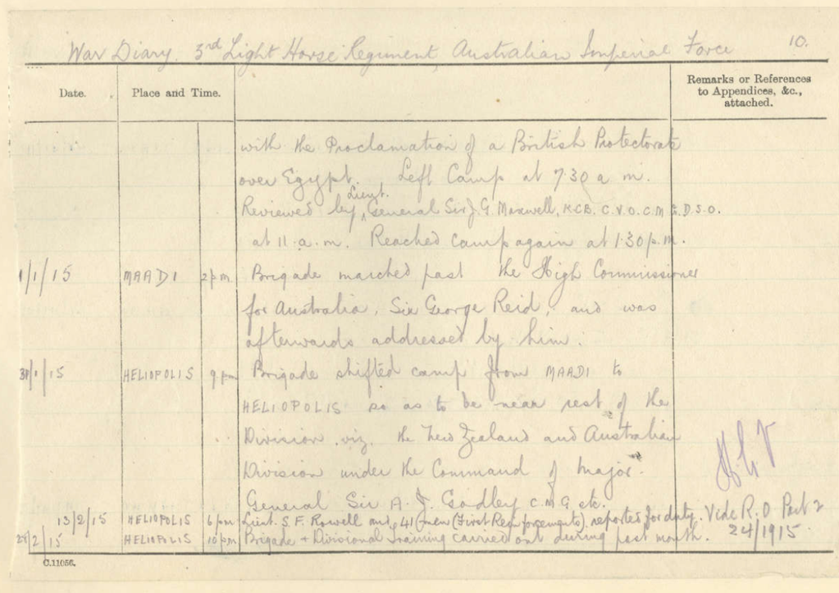

Map of team’s during World War 1. Gives me a visual understanding of how the countries were set out. (how far apart they were, how large the land was and their surroundings).

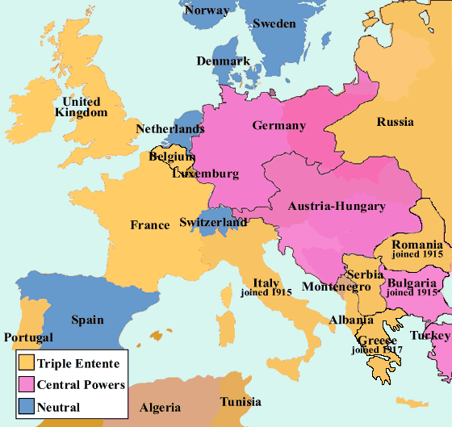

This was the ship George Gordon Ryan travelled on during World War 1.

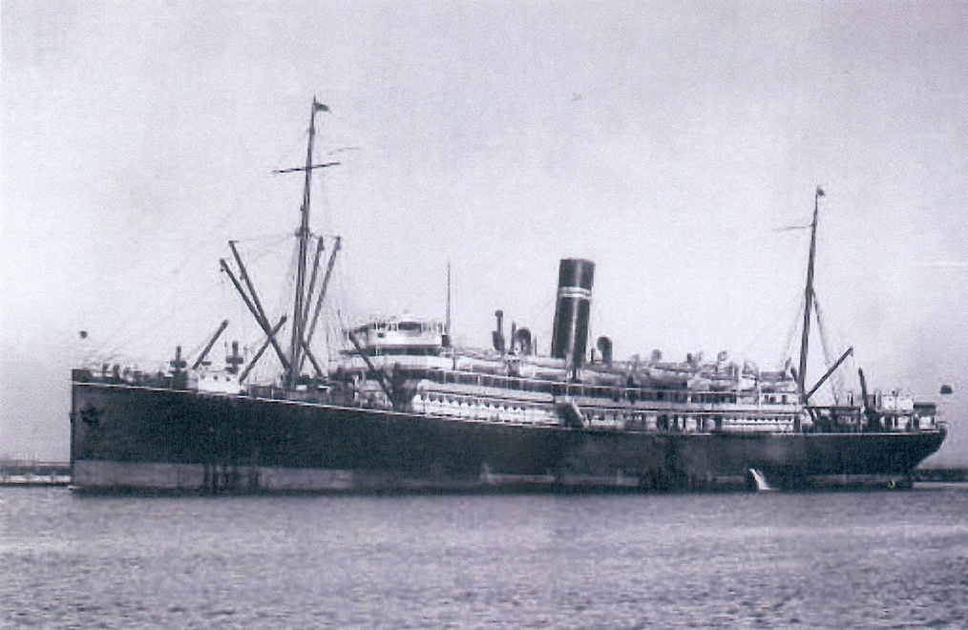

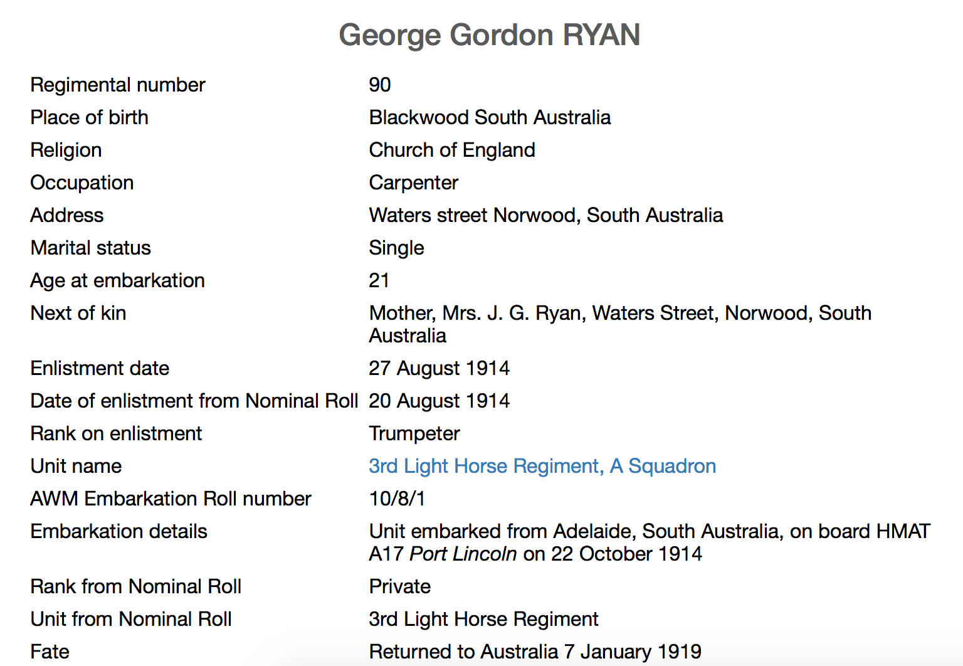

**Key information-**

George Gordon Ryan was service number 90.

His occupation was a carpenter.

He was raised and brought up in blackwood, South Australia.