ABBOTT and WILSON BROTHERS

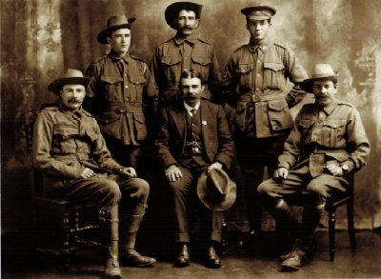

Rear L-R: Robert Leslie WILSON 4519 George WILSON 4514 William Henry WILSON 996

Front L-R: Charles Henry ABBOTT 4261 John Edward ABBOTT Edmond ABBOTT 4260

Photo courtesy of Kerri Earl, Kalgoorlie, WA

'John Edward, Edmund, and Charles Henry were three sons of James Thomas and Margaret (nee Thorp), Abbott. James Thomas Abbott died in 1875 and Margaret married George Michael Wilson; their children included George, Robert Leslie and William Henry.  All the children were born in the hospital at Adelaide Lead, Maryborough, Victoria.'

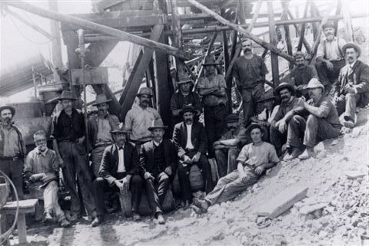

Workers at one of the Abbott/Wilson mines at Ora Banda – Photo Courtesy Jan McKinlay, Augusta, WA

The Abbott/Wilson family operated the “Victorious” and the “Gimlet South” mines at Ora Banda in Western Australia, a place they were involved in having gazetted as a Town. Abbott Street and Gimlet Street are so named in recognition of the family contribution to the Town. The family mines made full use of the local battery, and no other miners had access to it, so the government decided to build the state battery at Siberia, some 25 kilometres away.

Further information on Ora Banda is available at: http://www.geocities.com/lorraine_de_leuw/ora_banda.html

**SAPPER EDMUND ABBOTT**

**4260 – 3rd Tunnelling Company**

Born at Adelaide Lead, Maryborough, Victoria, the son of Margaret and James Thomas Abbott, Edmund was a 42-year-old labourer by trade working in Kalgoorlie when he signed the Attestation Paper of Persons Enlisted for Service Abroad on 28 January 1916. The Attesting Officer was the Area Officer for Area 84A, Goldfields Senior Cadets, Kalgoorlie. Edmund initially named his sister, Mrs Longwood, of Kalgoorlie, as his Next of Kin, this later being changed to his mother, Mrs. Margaret Wilson of Ora Banda, WA.

Edmund was 5ft 6in tall and of ruddy complexion with blue eyes and brown hair. He was medically examined and considered fit for active service on 28 January 1916 at Kalgoorlie and appointed to the No. 6 Tunnelling Company on 13 March 1916, the appointment being ratified on 29 March at Belmont by Capt Lawson, Officer Commanding that unit.

He embarked with his brothers and stepbrothers, Charlie Abbott and George and Robert Wilson, on HMAT A69 ‘Warilda’ from Fremantle in 1 June 1916, after a march through the streets of the city. On board were 375 members of the 4th Tunnelling Company who had embarked in Sydney, 371 members of the 5th Tunnelling Company from Melbourne, and 371 members of the 6th Tunnelling Company. Disembarking at Plymouth, England, on 18 July the men moved into the 2nd A.D.B.D. at Perham Downs.

The four brothers proceeded overseas to France on 28 August. All were attached to 1st Canadian Tunnelling Company from 26 October 1916 for a period of training following which the brothers joined the 3rd Australian Tunnelling Company where all except Robert were taken on strength on 31 January 1917.

Edmunds’ records show that he enjoyed some leave between the 3rd and 17th February 1918. He was admitted to hospital with debility on 11 October 1918 and sent to the 5th Army Rest Camp on 21 October, rejoining his unit on 4 December 1918.

After a second lot of leave from France between 4th and 18th January 1919, he again re-joined his unit in France on 21 January. Marching out for demobilisation, Edmund left France on 1 February 1919.

Leaving England on 31 March on board the ‘Khyber’, Edmund arrived back in Australia on 23 May 1919 and was discharged from the A.I.F. on 7 July 1919. He was entitled to wear the British War Medal and the Victory Medal.

Details of Edmunds’ military service were provided to the Repatriation Department, Perth, in December 1938.

Edmund Abbott died in 1940 and was buried in the Kalgoorlie Cemetery on 19 September 1940.

**SAPPER CHARLES HENRY ABBOTT**

**4261 – 3rd Tunnelling Company**

Charlie was a 40-year-old miner by trade working in Kalgoorlie when he signed the Attestation Paper of Persons Enlisted for Service Abroad on 10 March 1916. The Attesting Officer was the Area Officer for Area 84A, Goldfields Senior Cadets, Kalgoorlie. Edmund initially named his brother, John Abbott, of Kalgoorlie, as his Next of Kin, this later being changed to his mother, Mrs. Margaret Wilson of Ora Banda, WA.

Charlie was 5ft 9in tall and of fair complexion with blue eyes and brown hair. He was medically examined and considered fit for active service on 10 March 1916 at Kalgoorlie and appointed to the No. 6 Tunnelling Company on 21 March 1916, the appointment being ratified on 29 March at Belmont by Capt Lawson, Officer Commanding that unit.

On 26 May 1917, Charlie was wounded in action by an enemy shell and died later that day at the 1/1st North Midland Field Ambulance.

He was buried in Hersin Communal Cemetery Extension, 2¼ miles South of Nouex-les-Mines, France, at Plot 1, Row D.

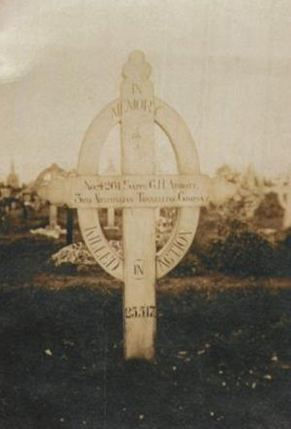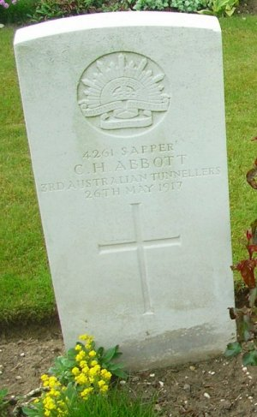

Charlies’ personal effects, consisting only of a notebook and Testament, were returned to his brother, John Edward Abbott on 3 March 1918.

Photographs of his grave were forwarded to his mother on 21 May 1919 by Major Alex Sanderson, who had been Charlies’ Commanding Officer and was still with the unit at Tournai, Belgium.

Photographs had previously been forward in October 1918, also by Major Sanderson.

Although his records show that the Memorial Scroll commemorating Charlies’ sacrifice, the Pamphlet “Where The Australians Rest” and the Memorial Plaque were all issued direct to his father, his brother John Edward Wilson signed for the items in March and September 1922. His mother, Margaret Wilson, signed for his British War Medal in January 1923. His brother, John Edward Wilson, signed for his Victory Medal in March 1923.

**SAPPER GEORGE WILSON**

**4514 – 3rd Tunnelling Company**

George was a 35-year-old miner by trade working in Kalgoorlie when he signed the Attestation Paper of Persons Enlisted for Service Abroad on 5 February 1916, and allotted 3/5ths of his pay for the support of his children. The Attesting Officer was the Area Officer for Area 84A, Goldfields Senior Cadets, Kalgoorlie. He named his son, Eddie Wilson of Ora Banda, as his Next of Kin. Eddie later advised the Army that he had changed his address to Kalgoorlie.

George was 5ft 8in tall and of dark complexion with blue eyes and brown hair. He was medically examined and considered fit for active service on 5 February 1916 at Kalgoorlie and appointed to the No. 6 Tunnelling Company on 10 March 1916, the appointment being ratified the same month at Belmont by Capt Lawson, Officer Commanding that unit.

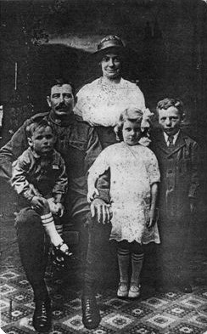

George Wilson with Gladys & children George, Phylis and Edward (standing)

Photo courtesy of Kerri Earl

George was wounded in action on 16 July 1917 suffering a gunshot wound to the left shoulder, rejoining his unit 5 September after treatment in the 8th General Hospital, Rouen.

George again reported sick and was admitted to 33rd Field Ambulance on 4 December, rejoining his unit on 27 January 1918.

He reported an injured hand on 24 June 1918 and was admitted to Military Hospital Endell St, London, with an accidentally fractured 5th metacarpal on 30 June 1918. He was discharged from the hospital to furlough on 17 July, to report back on 31 July. Subsequent examinations found some weakness in his hand and a note of 7 September records he was unable to close his hand.

It appears George did not return to France, and remained in England until he embarked at London 21 January 1919 for repatriation on board HT ‘Demosthene’ arriving back in Australia as an invalid.

After a final medical examination, which found he had a slight disability due to the hand injury, George was discharged on 5 April 1919 in 5th Military District entitled to wear the British War Medal and the Victory Medal.

**SAPPER ROBERT LESLIE WILSON**

**4519 – 3rd Tunnelling Company**

Robert, known as ‘Tug’, was a 22-year-old trucker/miner by trade working in Kalgoorlie when he signed the Attestation Paper of Persons Enlisted for Service Abroad on 11 February 1916. Robert named his father, George Wilson, of Ora Banda, as his Next of Kin.

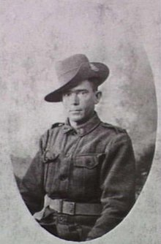

WILSON Robert 4519 - near Bethune, France, 1918. Portrait of Sapper "Tug" Wilson of the 3rd Australian Tunnelling Company, at Noeux les Mines. (Donor J. Hallinan)

Robert was 5ft 7in tall and of fresh complexion with blue eyes and brown hair. He was medically examined and considered fit for active service on 14 February 1916 at Kalgoorlie and appointed to the No. 6 Tunnelling Company on 10 March 1916, the appointment being ratified on 3 March at Belmont by Capt Lawson, Officer Commanding that unit.

Robert was wounded in action on 3 December 1916, suffering a gunshot wound to his left knee and received initial treatment at the 10th Casualty Clearing Station, before being admitted to the Stationary Hospital at Wimereux on 5 December. He was evacuated to England on 8 December and was admitted to the Military Hospital at Shornecliff. He was transferred to the 1st Auxillary Hospital on 26 June 1917 and from there to furlough between 28 June and 12 July, to report to Weymouth Depot on completion of furlough. Transferred on 18 July, he continued his recover at the No.1 Commonwealth Depot at Perham Downs.

Robert was admitted to the Sutton Veny Military Hospital with influenza on 13 March 1918, being discharged to the Training Depot on 23 March. He was then transferred to the Overseas Training Brigade at Longbridge Deverill, before he again proceeded overseas to France on 17 May 1918 from the Training Brigade at Longbridge Deverill camp where he had been recuperating and was finally taken on strength of the 3rd Australian Tunnelling Company on 22 May.

Robert took part in the Givenchy Raid and was not one of the casualties.

On the morning of 24/8/18, 2 officers and 40 O.R’s of No.1 Section of the 3rd Aust. Tnlg. Coy. took part in the raid on the enemy on the Givenchy Front, co-operating with the 164th Brigade of the 55th British Division.

In order to assist the operation, North of La Bassee Canal at Givenchy barrages for two dummy raids, and also smoke barrages were put down in the Hulluch Sector. M.G’s fired 24,750 rounds in connection with this dummy raid in addition to the normal harassing fire by artillery.

The Tunnellers part in the offensive operation at Givenchy was to examine dugouts and mine entrances and to mark them “safe” of “dangerous” according to the results of examination: to search for and render harmless any mines or booby traps found: to cut all enemy electric leads: to destroy any T.M’s founding the forward objectives and to collect any information such as documents, plans, or particulars of accommodation available for troops.

Cont. below

The whole party was suitably equipped with rifle and bayonet as well as tools of their particular necessity. Each patrol party of the Infantry was accompanied by two tunnellers.

The operation was kept very secret. No orders were issued until 8 p.m. on 23/8/18 when the men selected were assembled on the alarm post and finally instructed by the C.O. in what their part in the raid was to be.

The raid was successful and all objectives were gained, only three casualties (wounded) among the Tunnellers.

On the night of the 24th, a Signal message was received from General Jeudwine of the 55th Division by the C.O. which read:

“55th Division send hearty thanks for the able and keen co-operation of the 3rd Australian Tunnelling Company to-day”.

Lieut Colonel Commanding the 2/5 Lancs Fusiliers.

“Please accept on behalf of all ranks of my Battalion and myself our Sincere thanks for the assistance rendered by your men in the operations of the 24th inst.

Your officers, N.C.O’s and men were splendid and I cannot speak too well of them”.

Admitted sick 22 October 1918, apparently still suffering with the knee injury, and after treatment at Etaples and Rouelles, he rejoined his unit on 21 November 1918.

Robert enjoyed some leave from France between 5 and 19 February 1919 before leaving France on 9 March 1919.

He returned to Australia on board HT ‘Somali’, leaving London on 1 June and disembarking in Australia on 8 July 1919 and was discharged from the A.I.F. on 22 August 1919

In January 1939, a Mr. Leo J Walsh of Toronto, Ontario, contacted the Department of Defence stating that in 1916 he had been convalescing in a place known as “Isenhurst” Convelescent Home, Five Ashes, Sussex, England. He had served with the 14th Canadian Battalion and had recently been thumbing through his old war diary and came across the names of two Australians whose details he had recorded. He wrote seeking information on the possible whereabouts of the two men, referring to one as: Sapper R.L. Wilson (called “Tug”) #4519, no 6 Tunnelling Coy, A.I.F.

‘Tug’ Wilson was entitled to wear the British War Medal and the Victory Medal.

The Department of Defence replied in March, giving Roberts address in Kalgoorlie, W.A.

In December 1961, the Repatriation Department in Western Australia requested his documents from the Central Army Records Office.

*“From what I can gather most of the brothers suffered with bronchitis and TB during the war.*

*I remember Grandad Bob (Robert Leslie) having suffered with chest problems. Bob died when I was six years old, but I have a vivid recollection of his nature and look.*

*Fortunately he lived three houses down across the lane from us when I was a child, and I actively sort to spend time with him each day, and especially on Saturdays when my older siblings went of to sport with Mum. We used to sneak out to the Piccadilly Hotel beer garden (three blocks away) where he would have one beer, and me an orange polly bottle. I remember Nan saying ‘Bob your not taking that child in a hotel’, and he would reply ‘No Dolly, I certainly will not take her into a hotel’. We would laugh on the way because the beer garden wasn’t in the hotel.*

*He was such a gentle distinguished man, with quick wit and full of fun. He talked one time of getting gassed in the trenches, and that’s why he didn’t have much puff as he would put it.”*

Kerri Earl – 15 Sept. 2006.

AWM P00615.003: Near Bethune, France, 1917. Portrait of the 3rd Australian Tunnelling Company taken at Noeux Les Mines, Pas De Calais. Top Left to Right: Tom Burke, "Tug" Wilson, James Hallinan, F. Wheatley, S. Smith. Sitting, Left To Right: J. Pitt, W. Smith, Thomas Newton. (Donor J. Hallinan)

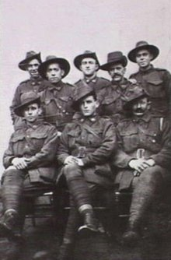

[**Private William Henry Wilson, 996 - Australian Army Medical Corps**

Born at Adelaide Lead, Maryborough, Victoria, the son of Margaret and George Wilson, William signed the Attestation Paper on 21 January 1916, naming his wife, Agnes (nee McKenna) as his Next of Kin. Agnes was living in Kalgoorlie with their two children at the time William enlisted, but moved to Ora Banda in March 1917. Agnes was the sister of 359 Trooper J. McKenna, 10th Light Horse, wounded at Walkers Ridge, Gallipoli, and later decorated with the Military Medal for gallantry on 15 October 1918.

William was a 23-year-old horse driver at the time of enlistment and was appointed to the 44th Battalion, Australian Infantry.



He embarked at Fremantle 6 June 1916, on board HMAT A29 ‘Suevic’, arriving at Plymouth, England, on 21 Jul 1916. William proceeded overseas to France on 25 November 1916 with 44th Battalion. He was transferred to 11th Field Ambulance on 22 December 1916, for duty with 44th Battalion.

William was wounded on 4 October 1917, suffering a gunshot wound to the cheek/jaw, which was assessed as severe in nature. He was transferred to England on 20 October and admitted to the Norfolk War Hospital. He was discharged to furlough on 5 November, returning on 19 November, and on 7 December was moved to the Australian camp at Deverill. He was transferred to the Training Brigades at Parkhouse on 10 May 1918 and proceeded overseas to France on 25 May, spending a few days at the A.G.B.D. before re joining his unit on 1 June.

William reported sick on 10 August and was admitted with tuberculosis to the 2nd Canadian Stationary Hospital. He was transferred to 1st Eastern General Hospital at Cambridge on 28 August with debilitating bronchitis, but was discharged on the same day to No.2 Commonwealth Depot where it was decided by 9 December that he be repatriated to Australia.

William left London on H.T ‘Argyllshire’ on 19 December 1918, disembarking in Australia on 19 January 1919, classified as an invalid. He was discharged from the Australian Imperial Force on 8 March 1919 in the 5th Military District, entitled to wear the British War Medal and the Victoria Medal.]

Prepared with the assistance of Kerri Earl, of Kalgoorlie, WA, granddaughter of Sapper Robert Leslie ‘Tug’ Wilson

& Jan McKinlay of Augusta, WA, great-niece of the Abbot and Wilson brothers.

© Donna Baldey 2008

www.tunnellers.net