The Aggressive Handcock’s of Myrrhee, Victoria

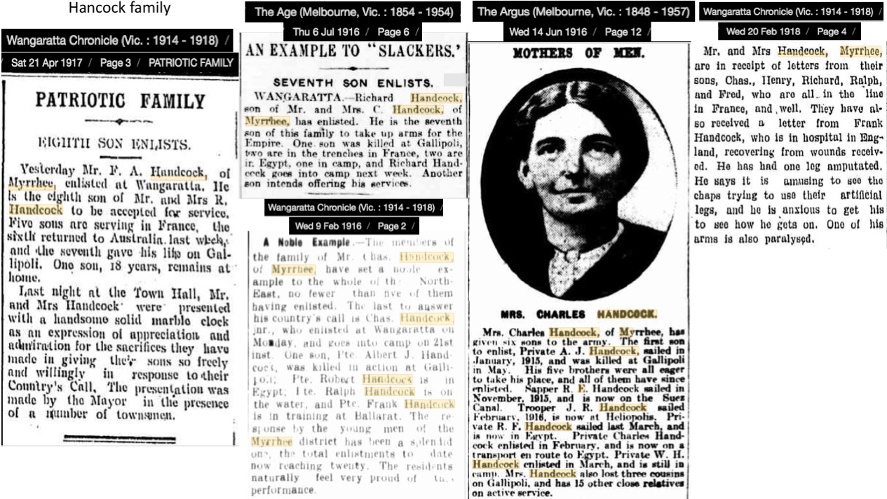
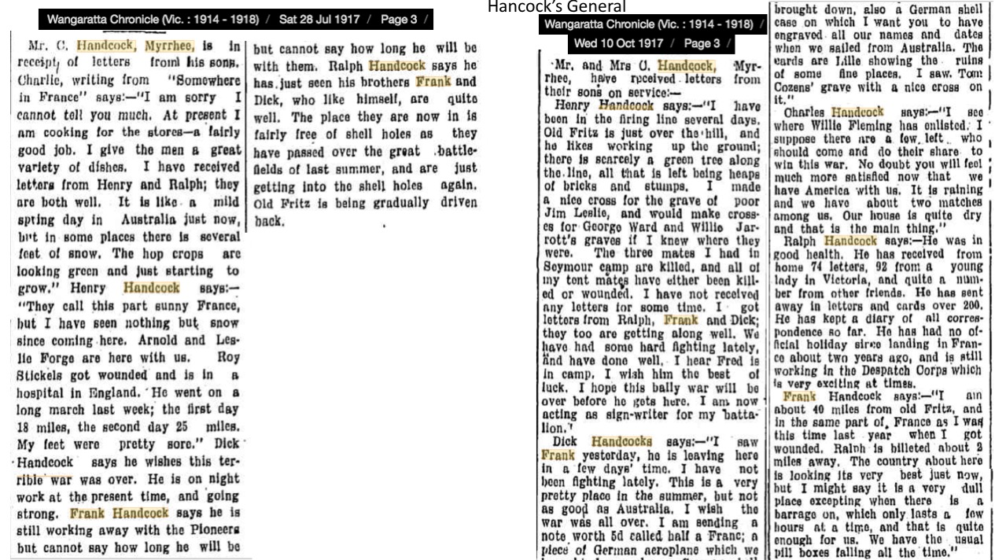

Eight Handcock sons in all enlisted for WWI
Pte Richard Merdic Row Handcock, (RN 2634), 2nd Pioneer Bn, b 1898, RTA 23/1/1919
https://rslvirtualwarmemorial.org.au/explore/people/161141
Pte William Henry Handcock, (RN 1846), 38th Bn, b 1889, RTA 30/4/1919
https://rslvirtualwarmemorial.org.au/explore/people/353929
Pte Reginald Francis Handcock, 21st Bn
https://rslvirtualwarmemorial.org.au/explore/people/259653
Sapper Robert Handcock (RN 3045), 5th Field Company Engineers
https://rslvirtualwarmemorial.org.au/explore/people/156340

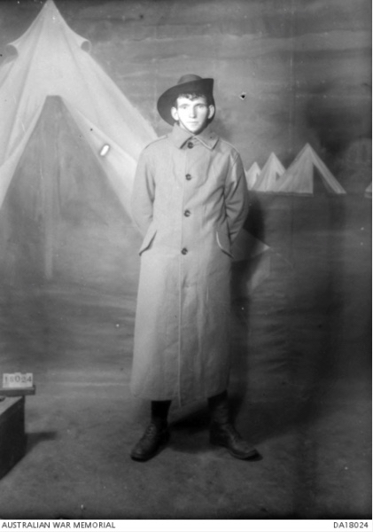  Sapper Frederick Ather Handcock, (RN 7568), 1st Tunneling Company, b 1893, d 1965  https://rslvirtualwarmemorial.org.au/explore/people/334486 | 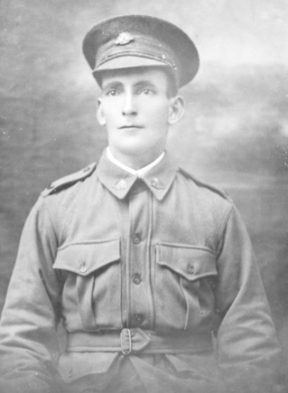  L/Cpl Charles Handcock (RN 39), 38th Bn – Headquarters, b1887 d 10/11/1918 (disease, France)  https://rslvirtualwarmemorial.org.au/explore/people/263084 | 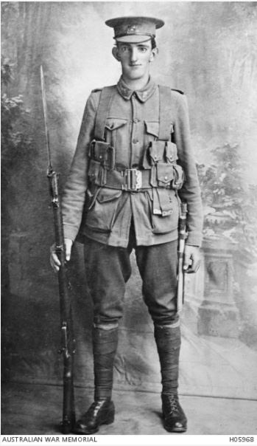  Pte Albert John Handcock, (RN 1350),  7th Bn, b 1891, KIA 2/5/1915 (Gallipoli) https://rslvirtualwarmemorial.org.au/explore/people/214389

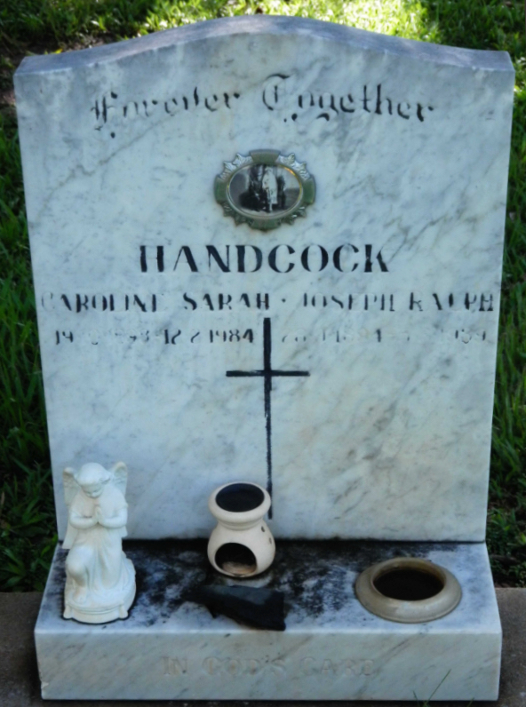  Grave of Pte Joseph Ralph Handcock and his wife Caroline in Darwin Cemetery  b 28/9/1894, d 5/3/1989 | 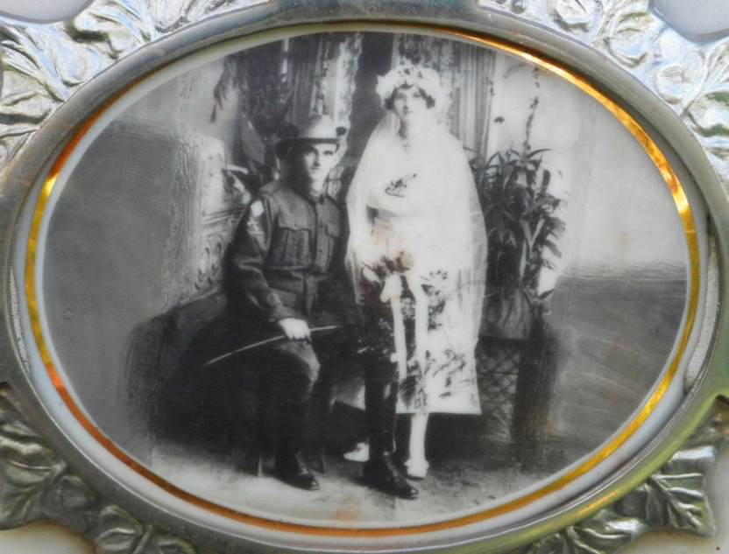  Pte Joseph Ralph Handcock on his wedding day with Caroline (nee Nolan) 1920 Pte Joseph Ralph Handcock, (RN 2021), 4th LH Regiment/2nd Pioneer Bn, b 28/9/1894, d 5/3/1989 https://rslvirtualwarmemorial.org.au/explore/people/200144

The ‘Aggressive’ Handcocks

Albert John Handcock was the first of eight brothers to sign up from the family of Charles and Harriet Handcock, from the Upper Fifteen Mile Creek area of Myrrhee in North East Victoria. It is said that the Handcock family had the world record for number of sons enlisting for WWI. Of the brothers Albert John was the only member to be killed in action (Gallipoli, May 1915). Another brother, Charles Handcock died of broncho pneumonia that followed on from influenza in November 1918. The other six brothers survived WWI, although Reginald had his right leg amputated below the knee due to a gunshot wound during Third Ypres otherwise shortened to just Passchendaele (around Zonnebeke?). He was earlier wounded at Pozieres in August 1916 (to the ankle) but recovered to rejoin his battalion. In an up-beat letter from England after the amputation he wrote that it was amusing to see the other fellows trying to use their artificial legs and that he was keen to have a go himself. He also has one of his arms paralysed.

Then as now the Handcock's are a well regarded and respected family of hop farmers whose Upper Fifteen Mile Creek hop gardens have seen continual production since the 1890's. That the family hop growing enterprise survived the boom – bust (mainly bust) hop growing profitability cycle of the 1970’s, 1980’s, 1990’s and 2000’s, when most independent growers went out of business, is testament to the family’s resilience and hardiness of the family.

“The Handcock's must be aggressive, six of them going!” (Capt Gerald Evans MC, 8th Bn, Myrrhee resident, letter to mother, 11/6/1916)

The ‘Aggressive’ Handcocks

Charles Handcock was one of eight brothers to sign up from the family of Charles and Harriet Handcock, from the Upper Fifteen Mile Creek area of Myrrhee in North East Victoria. He was married to Lilian Handcock and they lived in Wangaratta. It is said that the Handcock family had the world record for number of sons enlisting for WWI from any one family. Of the brothers Albert John was the only member to be killed in action (Gallipoli, May 1915). Charles Handcock was the other brother from the eight who did not make it home to Australia, dying of broncho pneumonia that followed on from influenza in November 1918. The other six brothers survived WWI, although Reginald had his right leg amputated below the knee due to a gunshot wound during Third Ypres otherwise shortened to just Passchendaele (around Zonnebeke?). He was earlier wounded at Pozieres in August 1916 (to the ankle) but recovered to rejoin his battalion. In an up-beat letter from England after the amputation he wrote that it was amusing to see the other fellows trying to use their artificial legs and that he was keen to have a go himself. He also has one of his arms paralysed.

Then as now the Handcock's are a well regarded and respected family of hop farmers whose Upper Fifteen Mile Creek hop gardens have seen continual production since the 1890's. That the family hop growing enterprise survived the boom – bust (mainly bust) hop growing profitability cycle of the 1970’s, 1980’s, 1990’s and 2000’s, when most independent growers went out of business, is testament to the family’s resilience and hardiness of the family.

“The Handcock's must be aggressive, six of them going!” (Capt Gerald Evans MC, 8th Bn, Myrrhee resident, letter to mother, 11/6/1916)

The ‘Aggressive’ Handcocks

Reginald Francis “Frank” Handcock was one of eight brothers to sign up from the family of Charles and Harriet Handcock, from the Upper Fifteen Mile Creek area of Myrrhee in North East Victoria. It is said that the Handcock family had the world record for number of sons enlisting for WWI from any one family. Of the brothers Albert John was the only member to be killed in action (Gallipoli, May 1915) while Charles Handcock was the other brother from the eight who did not make it home to Australia, dying of broncho pneumonia that followed on from influenza in November 1918. The other six brothers survived WWI, although Reginald had his right leg amputated below the knee due to a gunshot wound during Third Ypres otherwise shortened to just Passchendaele (around Zonnebeke?). He was earlier wounded at Pozieres in August 1916 (to the ankle) but recovered to rejoin his battalion. In an up-beat letter from England after the amputation he wrote that it was amusing to see the other fellows trying to use their artificial legs and that he was keen to have a go himself. He also has one of his arms paralysed.

Then as now the Handcock's are a well regarded and respected family of hop farmers whose Upper Fifteen Mile Creek hop gardens have seen continual production since the 1890's. That the family hop growing enterprise survived the boom – bust (mainly bust) hop growing profitability cycle of the 1970’s, 1980’s, 1990’s and 2000’s, when most independent growers went out of business, is testament to the family’s resilience and hardiness of the family.

“The Handcock's must be aggressive, six of them going!” (Capt Gerald Evans MC, 8th Bn, Myrrhee resident, letter to mother, 11/6/1916)

