Allen Richard Moffat
My Great Grandfather
31st of October 1944- 24th of April 1946
Service number: 153935
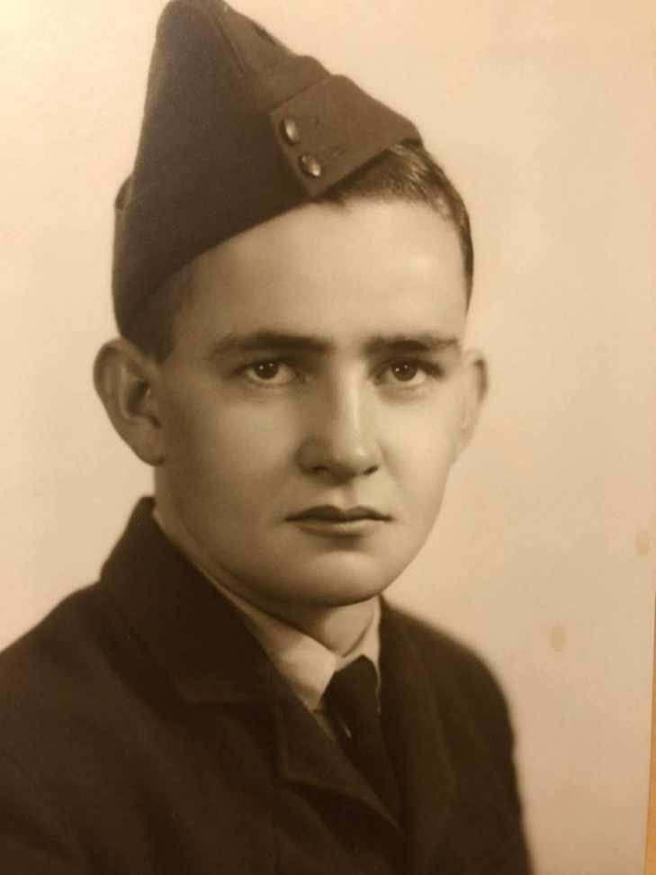

Figure 1: Allen Richard Moffat before heading of too WW2

Allen Richard Moffatt was born on 5 April 1926 in West Croydon, South Australia. He grew up in a hardworking family with his two sisters, Beryl and Maureen. His father worked as a carpenter, while his mother cared for the family at home. Like many Australian families during the 1930s and 1940s, the Moffatts faced many challenges in World War II.
Life Before the War
When Allen was in his teenage years, He began an apprenticeship in cabinet making. He enjoyed practical work and was learning skills that would help him build a future career. However, as the war continued overseas, many young Australians felt they should do their part to help defend their country. Allen felt the same way. Even though he still had about a year left to complete his apprenticeship, he chose to pause his plans and enlist in the Royal Australian Air Force on 31 October 1944 (Reference – Interview with Mavis Moffat). For an eighteen-year-old, this was a major decision. It meant leaving the safety of home and stepping into an uncertain future. Allen’s choice showed a strong sense of duty, which was shared by many Australians of his generation.

Context of the Battlefront
After joining the RAAF, Allen completed training at Singleton in New South Wales and later at Darwin in the Northern Territory. He was then sent to Papua New Guinea, where he served around the Madang area.
Madang was an important Allied base during the later years of World War II. After Allied forces regained control of the area in 1944, it became an important location for Australian and Allied air operations in the Pacific (Reference – Australian War Memorial).
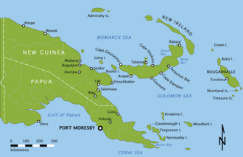
Life in Papua New Guinea was very different from life in South Australia. The tropical climate brought intense heat, high humidity, and heavy rainfall. Muddy conditions made everyday tasks more difficult, and mosquitoes spread diseases such as malaria. Accommodation was basic, with many servicemen living in tents and temporary camps. They often worked long hours and spent months away from their families.

The New Guinea campaign was one of Australia’s most important wartime operations. Earlie r in the war, Japanese forces had moved closer to Australia than ever before. Fighting in New Guinea helped stop this advance and protected Australia’s northern coastline. By the time Allen arrived, Allied forces were securing the region and using bases like Madang to support attacks on Japanese positions. Although Allen was not serving on the front line, he was still part of an operation that helped defend Australia and contribute to the defeat of Japan.

Service During the War
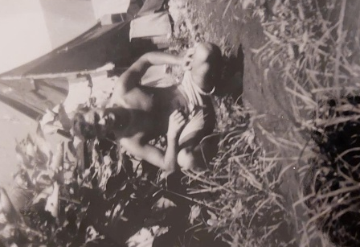
Allen Richard Moffatt enlisted in the Royal Australian Air Force on 31 October 1944 and reached the rank of Leading Aircraftman (LAC), a junior rank that involved helping with the day-to-day needs of the Air Force (Reference – National Archives of Australia). After completing his training, Allen was posted to Papua New Guinea, where he served around the Madang area.
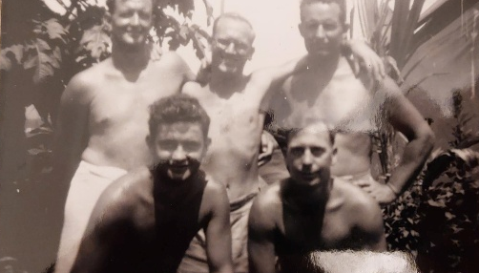
Figure 5- Allen Richard Moffat serving in Madang / New Guinea with a group of other soldiers (Who remained unnamed)

Figure 4- Allen Richard Moffat serving in Madang / New Guinea

The Moffat family states that Allen worked as a mess steward and helped transport food, supplies, and equipment needed by aircrew and other military personnel. His job involved making sure that pilots and support crews had the resources they needed to carry out their duties. These tasks may not have received as much attention as combat roles, but they were still very important to the success of military operations.

Aircraft crews depended on support workers to keep things running smoothly. Without people like Allen providing food, equipment, and supplies, air operations would have been much more difficult. Every role in the military was important, and support workers played a key part in helping frontline troops do their jobs.
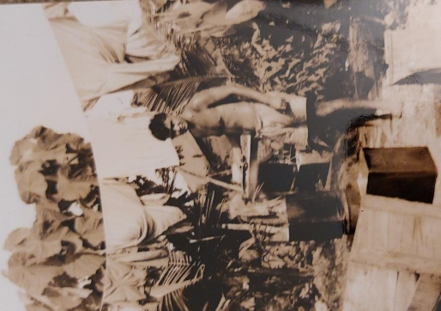
Life in Papua New Guinea was challenging. Allen was still a
teenager and was serving thousands of kilometres away from home in difficult conditions. The tropical climate, basic living arrangements, and long working hours required determination and hard work. Like many servicemen, he likely missed his family and friends and found it difficult being away from home for long periods of time.
Figure 6- Allen Richard Moffat serving in Madang / New Guinea

Allen’s service shows that bravery during wartime is not only shown on the battlefield. Support personnel also made valuable contributions to the war effort. Through his hard work and willingness to serve where he was needed, Allen helped support Australia’s war effort and played a small but important part in Allied success in the Pacific campaign.

Figure 7,8 and 9

Life After the War
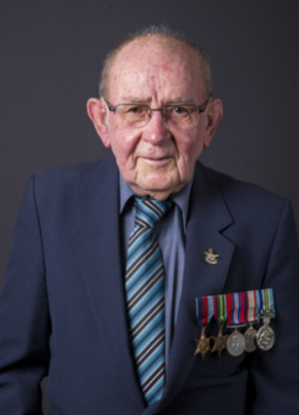
When World War II ended, Allen returned home to South Australia in 1946. Like many veterans, he had to adjust to normal life after serving in the military. He went back to his apprenticeship in cabinet making and continued working toward the future he had paused when he enlisted.
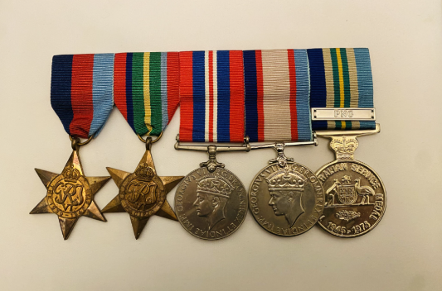
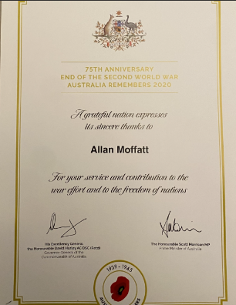
Allen later married Mavis and built a life focused on family, work, and community. He was proud of his wartime service and carried the experiences and lessons from the war with him throughout his life. Family members remembered him as a hardworking, reliable, and caring man who valued both his service and the people close to him. Allen Richard Moffat earned 5 medals through his time spent in WW2 such as (Left to Right) The 1939–45 Star, The Pacific Star The Pacific Star, The 1939–45 War Medal, Australian Service Medal 1939-1945 and the Australian Service Medal 1945-1975 and Allen also received the 75th anniversary of the ww2 Australia remembers certificate.
Figure 10- Photo of Allen Richard Moffatt (1926–2022), Leading Aircraftman, Royal Australian Air Force.

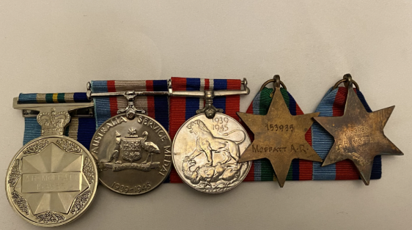

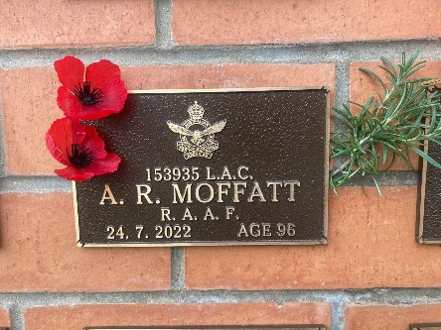
Allen passed away on 24 July 2022 in Westbourne Park, South Australia, at the age of 96. His funeral included military honours, with the Last Post played and the Australian flag placed over his coffin. These traditions recognised his service to Australia and showed the respect given to veterans who served during wartime (Reference – Mavis Moffat).
Figure 11- Allen R. Moffat’s Plack at the Australian war memorial.

Although Allen was not a famous military leader or a highly decorated war ‘hero’, his story is still important because it reflects the experiences of thousands of ordinary Australians who served. His dedication, sacrifice, and commitment to his country show that every contribution mattered. Remembering Allen Richard Moffatt helps us understand the human side of war and ensures that the service of Australians like him is not forgotten.

Reference List
- Australian War Memorial, Chapter 27 – The Pursuit to Madang, Australian War Memorial, https://www.awm.gov.au/collection/RCDIG1070064.

- Australian War Memorial, Researching Australian military service: Second World War, Royal Australian Air Force (RAAF), Australian War Memorial, https://www.awm.gov.au/research/guide/ww2-raaf.

- National Archives of Australia 2026, Royal Australian Air Force, National Archives of Australia, https://www.naa.gov.au/explore-collection/defence-and-war-service-records/royal-australian-air-force.
- Interview with Mavis Moffat wife of Allen Richard Moffatt

Figure list
Figure 1- Photo of Allen Richard Moffatt before heading of too WW2
Figure 2- Photo of Allen Richard Moffatts family
Figure 3- Map of where Allen Richard Moffat Served in WW2
Figure 4- Allen Richard Moffat serving in Madang / New Guinea
Figure 5- Allen Richard Moffat serving in Madang / New Guinea with a group of other soldiers (Who remained unnamed)
Figure 6- Allen Richard Moffat serving in Madang / New Guinea
Figure 7- Front of Allen R. Moffat War medals (Left to Right) The 1939–45 Star, The Pacific Star the Pacific Star, The 1939–45 War Medal, Australian Service Medal 1939-1945 and the Australian Service Medal 1945-1975.
Figure 8- Allen’s 75th anniversary of the WW2 Australia remembers certificate.
Figure 9- Back of Allen R. Moffat War medals (Left to Right) The 1939–45 Star, The Pacific Star the Pacific Star, The 1939–45 War Medal, Australian Service Medal 1939-1945 and the Australian Service Medal 1945-1975.
Figure 10- Photo of Allen Richard Moffatt (1926–2022), Leading Aircraftman, Royal Australian Air Force
Figure 11- Photo of Allen R. Moffat’s Plack at the Australian war memorial.

