Leslie Charles Shaddock RAAF WW2 – Australia
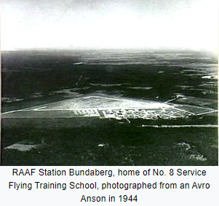
2
11May – 28Dec1942 Port Melbourne VIC
No. 1 Stores Depot
Carpenter General trade duties at 1SD? Or Inspection duties, aircraft production at Fishermans Bend?

17Apr – 21Sep1943 RAAF Bundaberg QLD
No. 8 Service Flying Training School
Avro Anson Mk I a/c
(one-piece spruce & plywood wing)
Leading Aircraftman 1Aug1943

1
3
5
4
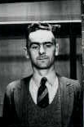
L C Shaddock 31672
b. 16Jan1909 Launceston TAS
Militia 1927 - 1929
Civil trade: Joiner
RAAF: Carpenter Rigger

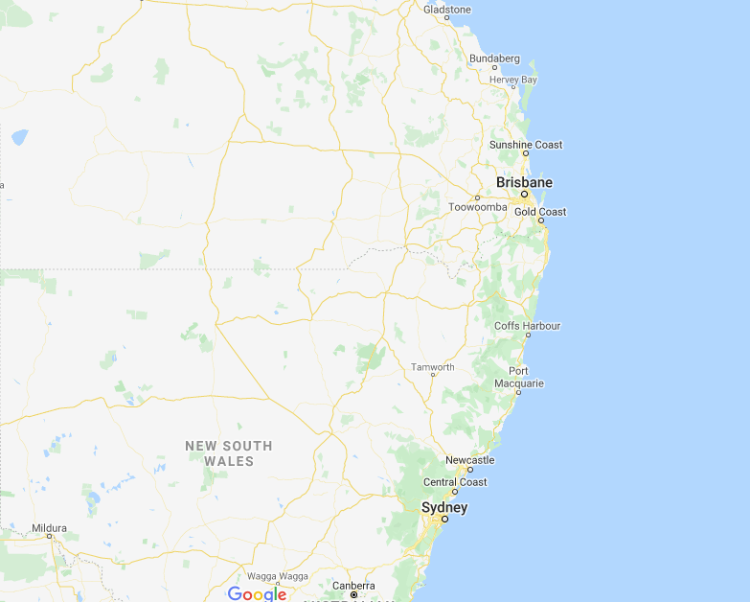
29Dec1942 – 16Apr1943 Ascot Vale VIC
No. 1 Engineering School
No. 32 Carpenter Riggers Course 4Jan-10Apr1943 76.5%
Remustered Carpenter Rigger 11Apr1943

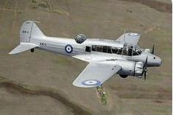
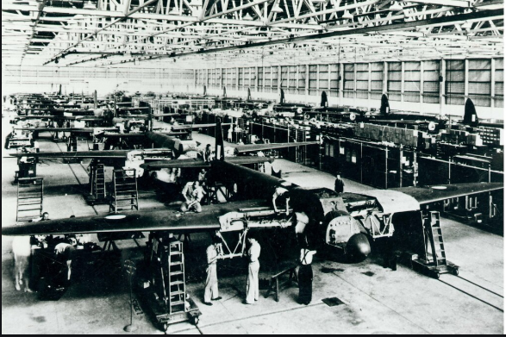
de Havilland Australia, Bankstown NSW
(Mascot until 1940)
DH.82 Tiger Moths 1940-Feb1945 1070 built
DH.84 Dragons 1942+ 87 built
DH.98 Mosquito 1942+ 212 built
Les in inspection/quality control role (AID) for DH.98 Mosquito (wooden) aircraft production
9Oct1943 – 1Jan1944 Sydney NSW
No. 1 Transport and Movements Office
Unit home while working at de Havilland, Bankstown

2Jan1944 – 27Oct1945 Waterloo NSW
No. 2 Stores Depot
Unit home while working at de Havilland, Bankstown

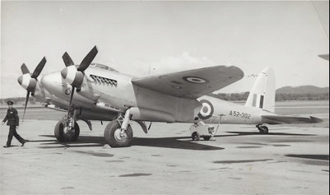
6
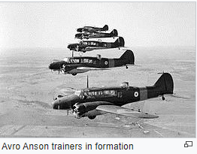
22Sep1943 – 27Oct1945 Melbourne VIC
Air Force Headquarters
Aeronautical Inspection Directorate

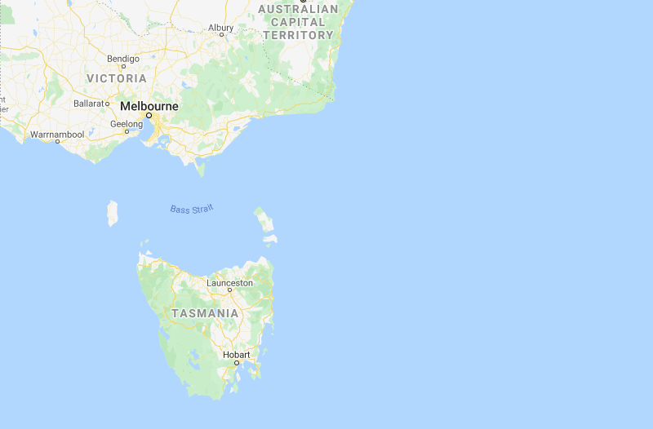
20Apr – 10May1942 Ascot Vale VIC
(Melbourne Showgrounds)
No. 1 Engineering School
Drill Training Course 22Apr-9May1942
28Oct1945 – 2Jan1946 RAAF Laverton VIC
No. 1 Aircraft Depot
Aircraft assembly, test & maintenance
Les - general modification bench work in Aircraft Repair Section

Commonwealth Aircraft Corporation
Fishermans Bend, Port Melbourne
Wirraway, Wackett, Boomerang production

3Jan – 17Feb1946 RAAF Western Junction TAS
Care & Maintenance Unit
Storage & maintenance of surplus aircraft prior to disposal via auction 18May1946
(54 Tiger Moth DH.82 a/c from 7 EFTS)

Dept of Aircraft Production
Fishermans Bend, Port Melbourne
Beaufort ~Aug1941 – Aug1944
Beaufighter ~1943 - 1946

7
18 – 21Feb1946 Hobart
No. 6 Personnel Depot
Discharge/Demobilization 21Feb1946
Leading Aircraftman

11Mar1942 Hobart
(178 Macquarie St)
No. 6 Recruiting Centre
Enlistment in RAAF Reserve, Class E5
Aircraftman 2
Active Service from 20Apr1942
Carpenter General

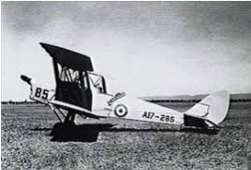
16Feb1942 Medical Exam at Launceston Technical College

9
8
Launceston to Hobart
via train warrant

