Arthur William Harding

Registered No 583
Australian Imperial Forces
World War I

Registered No S212671
Australian Army
World War II

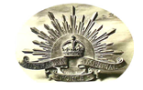
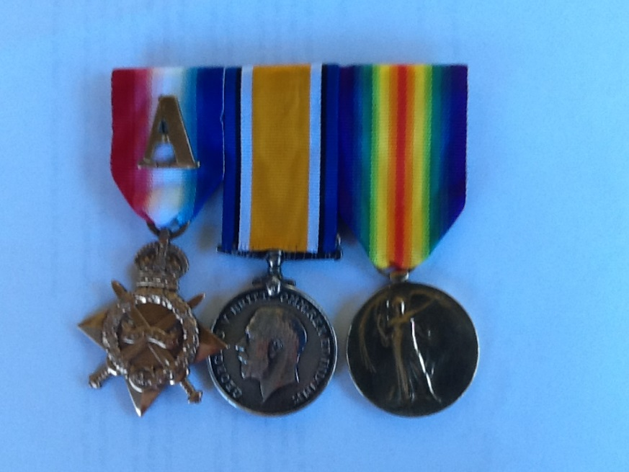
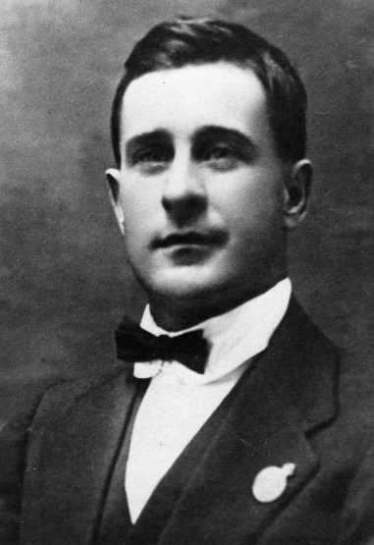

ARTHUR WILLIAM HARDING

(This story was written for the Descendants)
If you are reading this you are a direct descendant of Private Arthur William HARDING, Registered Number 583 a member of the Second Division, 27th Battalion in the Australian Imperial Force in World War I. He was your Grandfather, Great-Grandfather or Great-Great-Grandfather. We knew him as only Poppa Harding. He was also known by family and friends as ‘Sonny’.

He survived Gallipoli and the Western Front in France. He was not conscripted into the war. He volunteered. He was there because he believed it was the right thing to do.

Unlike many WWI soldiers there are no photographs of him in uniform, no letters to home from the front, no objects of memorabilia (apart from his medals). He never spoke about the war. He never spoke about what he did or what he saw. We can only imagine the horrors he witnessed. For us, his ancestors, he is a hero.
Note: A photo in uniform has been found)

THIS IS HIS STORY

Arthur William HARDING was born in Burke, New South Wales on 21st March 1888, the oldest of 13 Children. He grew up in the country near Burke in NSW and was the son of a saddler. We do not know how he ended up in South Australia in 1915, but we do know that on 22nd February 1915 he enlisted in the Imperial Forces at Keswick near Adelaide. He was assigned to the 27th Battalion 2nd Division and undertook some very basic training.

On 31st May1915 he embarked for the war in Turkey aboard the HMAT Geelong. By this time the Australians and New Zealanders (The ANZACS) had been fighting on Gallipoli for some months with massive losses of life and really no gains. They were still basically stuck on Anzac Beach.

What must had he been thinking on that journey? How much did he and his mates know about what was yet to come?

In September 1915 he, along with large numbers of re-enforcements, landed in darkness on Anzac Beach. (To get an idea of what this must have been like, watch the Australian Movie GALLIPOLI. It is based on a group of Western Australians who landed as re-enforcements at the same time.). We don’t know what happened to Poppa once he landed. We don’t know what he did although there is some record of him being in the Signal Corp. The job of a soldier in the Signal Company was to maintain communications between the men in the trenches and the front line with the decision makers at the rear. During WW1 this meant laying telephone cables directly from the front lines and at times Signal Company men ran messages back and forth. This occupation definitely put them in harm’s way and they sustained many causalities. On the occasions when ground was gained it would have been Poppa’s job to venture into ‘no man’s land’ to extend the phone cables. It would have been then that he would have witnessed the real horrors of the First World War.

He was there on Gallipoli for a few weeks when his records show that on 20th October 1915 he was wounded by shrapnel to the head and was taken off Gallipoli to a hospital ship then to the Greek Island of Lemnos where he would have cared for in an Australian Field Hospital with Australian nurses. There have been published accounts of the horrors on these ships. It was common for several hundred wounded and dying men to be evacuated on these ships with one or two doctors with very little equipment. Bear in mind these men’s wounds would have already been untreated for many days before they were put on these ships. Many hundreds died on the way to the relative safety of Lemnos Island.

Poppa made it to Lemnos and he was then transferred to Alexandria in Egypt to recover.

In December 1915 Gallipoli was finally evacuated. The Australian casualties were about 26,000. Of these nearly 8,000 were killed. Poppa Harding was one of the lucky ones to survive.

Poppa’s records show that on 8th January 1916 he re-joined his Battalion, now recovered from his wounds.

For us this would appear to be enough. He has done his bit. But no. Worse was to come.

Next comes the Western Front in France and Belgium.

Poppa’s army records line up with records of the 27th Battalion in that they left Egypt on 15th March 1916 for Marseilles then directly to the killing fields of northern France near the border of Belgium.

From careful examination of his army movements records it appears he was near some of the worst fighting on the Western Front from April 2016 to the end of the war. At some stage he moved from the 27th Battalion to the Signalling Company attached to the headquarters of the 2nd Division. The records show they fought in the Somme, Pozieres, Ypres and Gueudecourt.

Poppa is listed in France as being a driver within the Signalling Corp. This could explain how he managed to survive. Perhaps his job was to bring supplies from the rear to the soldiers on the front line. The job of the Signals remained the same however. That was to maintain communication from the front line to the Officers at the rear. We just don’t know exactly what Poppa did, but we do know that there was constant shelling and occasional changes to the position of the front line. It must have been terrifying to be in the middle of this.

The casualty rate of young Australians continued to rise. In an Official record of the 27th Battalion it is said that in area known as the ‘Windmill’ above Pozieres, the ground contains more South Australian DNA than anywhere in the world apart from Adelaide Metropolitan cemeteries.
27th Battalion Colours
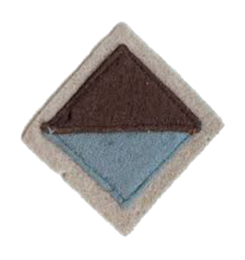
THE SECOND DIVISION

The official record of the 2nd Division show they were involved in many battles, well known now, such as Pozieres in July 1916, Mouquet in August 1916 and Ypres in September 1916. From January 1917 to April they were involved in the bitter fighting along the Hindenburg Line and in May 1917 the Battle of Bullecourt.

By October 1917 the Division had moved to Flanders and the fighting continued for month after month with little advantage being gained by either side. In April 1918 the Germans made a final desperate push and the Australians were involved in what is known as the Spring Offensive and fought at Villers Bretonneux.

In May 1918 they fought at Ville-sur-Ancre and in July 1918 at Hamel where they captured 1600 Germans.
In November 1918 the Second Division were the last of the Australians to see combat. It still took some time to end it all but by May 1919 all the Australians were safely back in England. Thousands of young Australians did not return and so many were simply listed as “MISSING”

Poppa’s personal record has gaps of months at a time when he would have been in the thick of the fighting. The only time entries were made by his Commanders was when he had some days or weeks of leave or bouts of sickness. It appears he suffered quite badly at different times from Dysentery. Thousands died from disease during this awful time on the Western Front.

There are records of a few times Poppa falling sick and being taken to hospital in England, mainly London, but each time he returned to the fighting. This went on from May 1916 to July 1918 when he was finally posted to London towards the end of the war. It is not known why he left the front when he did but it may well be that his ongoing illnesses may be the reason.

What did he see? Did he lose many of his mates? Did he witness the horrors on the Western Front? We just don’t know, but the answer more likely than not is YES. How did he manage to survive? Was he lucky or was he just clever?

So here he is: Arthur William Harding registered number 583. He has survived, he is still in the army and he is stuck in England. His records show that he disappeared a few times and was recorded as AWOL (Absent without leave). Can you blame him?

Poppa’s records when read carefully show there was a bit more happening than just the war. It seems that on one of his breaks from the fighting while in London he met a young girl named Louisa Barrett and on 3rd May 1917 he married her in London. He returned to the front after the wedding and would have only seen his new wife when he had some leave or was returned to England during his bouts of illness. Catching up with his young wife may well explain the few times Poppa was AWOL.

AFTER THE WAR

On the 9th July 1919 Poppa, along with his wife Louisa left for Australia on the Franz Ludwig and they arrived in Melbourne on about the 20th August 1919. Without much fan-fare he was discharged from the army and they travelled to the Riverland in South Australia to be re-united with his family.

There are no photographs of Louisa and not much is known about her. Spare a thought for her. She is in a strange country and knows no-one except her husband. The sad tale gets worse as records show that Louis died in Berri within three months of arriving. It is believed she died from Tuberculosis. She is buried in the Loxton Cemetery. We can only wonder how hard it must have been for Poppa who had been through so much, seen such terrible things and survived, only for him to lose his wife so soon after returning home.

NANNA HARDING

Well things just had to get better or none of us would be here.

In May 1917 Arthur (Poppa) Harding’s younger brother Willie who had been too young to join the war had married Caroline Maude Gower, a Riverland local. It turned out Caroline had a sister, Olive May Gower who was now known to the HARDING clan. Poppa married Olive in May 1920 when she was 23 years old. Olive became Nanna Harding and so here we all are. They eventually had seven children and moved to Adelaide where Poppa worked hard to bring up his family (here lies a whole new story.) There are now about 50 direct descendants of Arthur William Harding and obviously many more to come.

As mentioned earlier Poppa rarely spoke about the war except to his two eldest sons Colin and Jim who both served in the Second World War. Understandable really as at they at least had some concept of the realities of war. Sadly they are no longer with us so Poppa’s specific memories are gone. As time goes on and the 100 years anniversary of the day Arthur William Harding signed up for the AIF passes please help to keep his memory alive. He was a hero.
WW II

We believe Poppa had done his bit for the country but, despite having his two oldest sons serving overseas in the Second World War, he joined up again. Given his age and WWI Service he was not sent overseas again. He joined 4 Garrison Battalion (SA) and served in Adelaide guarding infrastructure and took part in guarding detainees at internment camps.

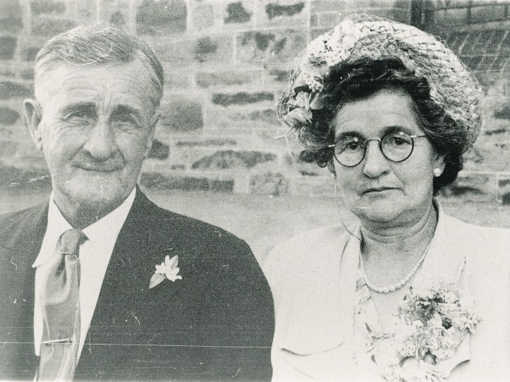
Poppa and Nanna Harding

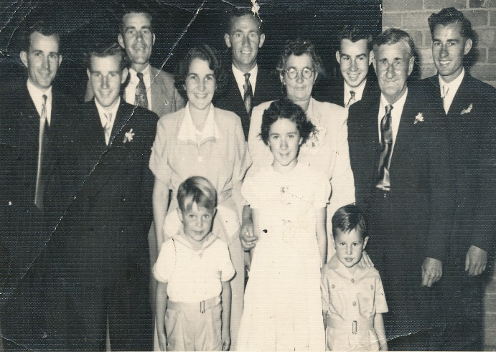
Nanna and Poppa with all 7 children and 3 grand-children

If you would like to know more about the Harding family history I have quite a bit of information put together by a relative John Harding who is the grandson of Willie Harding. He spent years putting it together and I can share it with you if you are interested.
To view his full army record visit the Website and search his name and registration number 583 at National Archives of Australia http://www.naa.gov.au/)
TERRY HARDING
Email: hardingtmpm@optusnet.com.au

