Shelled at Harbonnieres!
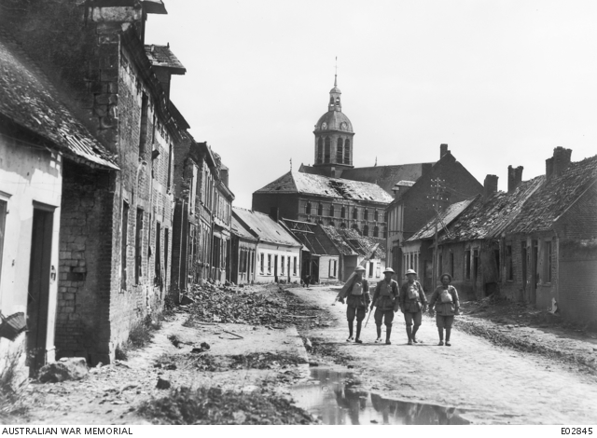
The village of Harbonnieres after its capture by the Australian troops.

The 8th August 1918 is acknowledged as the day the rot really set in amongst the German army; indeed it was the opening day of the offensives of one hundred days that would bring an end to the First World War. The Australians supported by the British to the north and the Canadians and French to their south had commenced the Battle of Amiens at 4.20 am that morning east of Amiens with a plan of attack involving three objectives. The final objective included the village of Harbonnieres, which was successfully captured around 11.00 am that morning by soldiers of the 5th Australian Division.
The attack was a success and the 1st Division AIF, which were held in reserve on the 8th August 1918, did not enter the attack until the following day when they went into support for the Canadians. The 1st Field Company Engineers (FCE) were in billets at Rivery, near Amiens, on the 8th August 1918. The following day they moved out towards Villers-Brettoneux, maintaining some distance behind the infantry of the 1st Australian Division.
The 1st FCE entered the village of Harbonnieres and established billets on the 10th August 1918. Although the Germans were well and truly in retreat they still maintained a level of artillery shelling and aerial bombardment to hold up the advancing allied forces. The War Diary of the 1st FCE for that day noted that- “Enemy dropping bombs in Bayonvillers and heavy shells around Harbonnieres”.
The sergeants of the 1st FCE appear to have set themselves up in a house of their own in the village of Harbonnieres and the following day it fell victim to the German shelling. The 1st FCE War Diary recording on the 12th August 1918- “At about 5 p.m. enemy shell burst near sergeants mess causing four casualties, one of whom, Sergeant G.W Taylor DCM, MM has since died of wounds”.

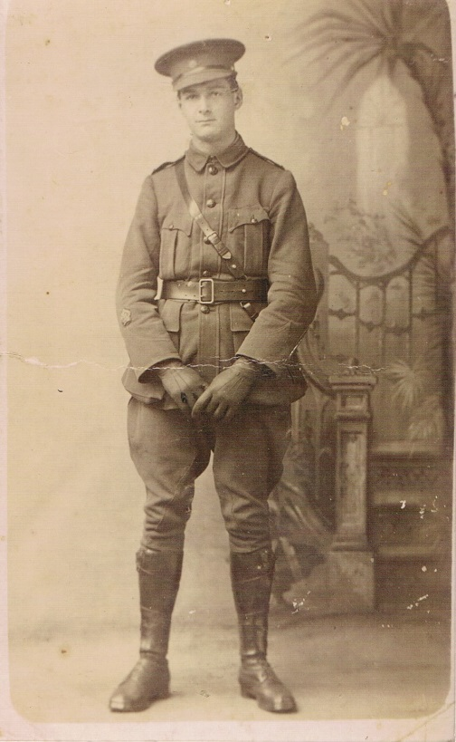
CSM James Pasfield in early 1917.
Sergeant James Pasfield of the 1st FCE, who had not suffered a wound during his four years of war, was in the billet that day. His luck ran out that afternoon, reportedly whilst conversing with Sergeant George Taylor on the doorstep of the billet. Taylor was killed by the shell which seriously injured Pasfield.
From witness statements tendered within the Red Cross Wounded and Missing file of Sergeant George William Taylor it is likely that Company Sergeant Major James Johnston and Sergeant Frederick Wicks were with Pasfield and Taylor at the time.

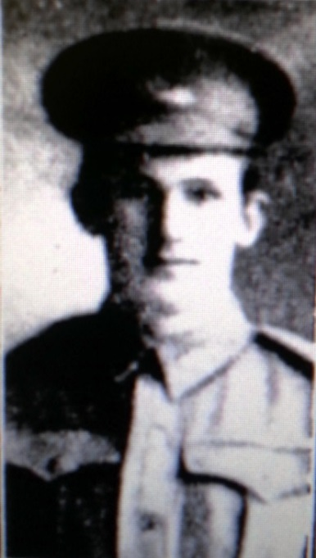
Sergeant Frederic Wicks.

Two other men of the 1st FCE who were witnesses to the shelling gave the following statements-
92 Sapper William Fahey
Informant states that on some date prior to 18/9/18 the company was working on the line near Harbonnieres and was billeted in that village. Taylor was sitting outside of his billet when a shell came over and hit three men including Taylor and Sergeant Pasfield. Informant was at the time right opposite him and saw the shell land about 100 yards away. He went over to Taylor and helped to bandage him up. He was conscious and said that he felt bad, but thought that he would get alright. The ambulance was sent for and Taylor was taken away at once in the presence of the informant, who never saw him again, but heard that he died a few days later.

68 Corporal Jack Lloyd McMahon
Informant states that on or about the 12/8/18 the company was in billets at Harbonnieres. About 5p.m Taylor and Sergeant Pasfield were on the doorstep of the house in that village in which they were billeted and informant was close by. They were yarning. A 5.9 shell burst outside on the hard road and wrecked the billet, wounding three men including Taylor. Pasfield was also one of those hit. Taylor was conscious and to encourage him, informant told him he was alright. They bandaged him on the spot, and he was taken to a dressing station at the other end of the village. Informant never saw him again but heard that he died at Le Treport.
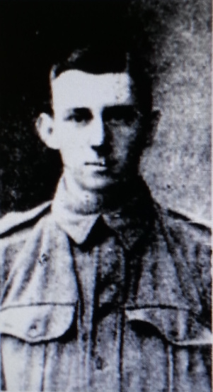
Corporal Jack Lloyd McMahon.

Taylor later succumbed to his wounds. According to the Officer in Charge of No.3 General Hospital, B.E.F, France-
“Sergeant Taylor was admitted to this Hospital from 55 Casualty Clearing Station on 16.8.18 suffering from G.S.W leg right, thigh right, head, chest and arm right. He was very ill on admission, extremely anaemic and weak. No progress was made and patient died at 11.35 pm on 19.8.18. He was buried at Mount Huon Cemetery near Le Treport by the Rev W Tod, his grave no. is 998b”.
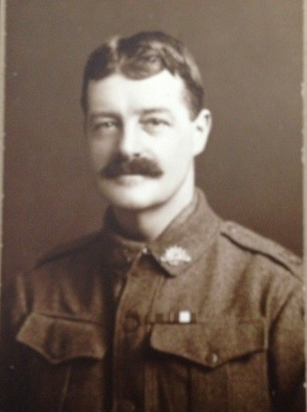

Sergeant George Taylor.
Taylor had enlisted amongst the 10th Reinforcements of the 1st FCE on the 27th July 1915. A bricklayer by trade and born in England, Taylor was nearing forty years of age when he left his employment with the Australian Gas Light Company at Mortlake to enlist.
Born in England in 1876, Taylor who had lost his wife migrated to Australia in 1911 with his only son and younger brother Frederick. Frederick would also later serve with the 1st FCE. Taylor was an old soldier having served for more than two years with the South Staffordshire Regiment during the Boer War.
Taylor embarked from Sydney aboard the HMAT Ballarat on the 6th September 1915. After a brief stay in Egypt he arrived at Gallipoli on the 3rd November 1915, catching the tail end of the campaign. He returned to Egypt in late December 1915 where the 1st FCE remained until the 21st March 1916 when they embarked for the Western Front.
In May 1916 he was appointed to the rank of Lance Corporal. Taylor was later promoted to the rank of 2nd Corporal on the 25th July 1916, the day the 1st FCE were relieved in the line at Pozieres. During late 1917 Taylor distinguished himself in the Third Ypres Campaign, commonly known as Passchendaele. Taylor was awarded the Military Medal for his work during the Battle of Menin Road on the 20th September 1917.
A little over a fortnight later on the 4th October 1917 the 1st FCE were in the thick of the action at Broodseinde. 2nd Corporal Taylor was constructing a strong point that morning when his section officer was wounded. He sent the officer to a dressing station and continued to construct the strong point and command the section; he was awarded the Distinguished Conduct Medal for his actions.
As 1917 came to an end 2nd Corporal Taylor returned to England serving at the AIF Engineer Training Depot at Brightlingsea in Essex. He would spend five months training the reinforcements arriving from Australia before they were sent to their units on the Western Front. On the 9th July 1918 he was promoted to the rank of sergeant and left for France on the 1st August 1918.
Sergeant Taylor re-joined the 1st FCE on the 5th August 1918 at Racquinghem, near Hazebrouck. As mentioned above, several days later they were involved in the Battle of Amiens where he received his mortal wounds. Sergeant Taylor was held in high regard by his comrades, indeed Sapper William Harvey would state to the Red Cross that “everybody liked Taylor, who was one of the finest soldiers going”.
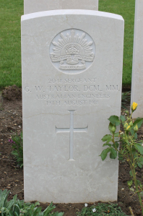
Sergeant George Taylor’s grave.
Sergeant Pasfield suffered shell wounds to the head, arm and leg and was picked up by men from the 3rd Field Ambulance and admitted to the 53rd Casualty Clearing Station on the following day. From the casualty clearing station he was sent to the 47th General hospital at Le Treport on the French coast. The serious nature of his injuries lead to him being sent back to England aboard the hospital ship ‘Aberdonian’ two weeks later.
Pasfield was hospitalized at the 1st Southern General Hospital in Birmingham from the 26th August 1918 until the 19th October 1918. The war was close to an end at this stage and on the day of the armistice James was serving at the No.1 Command depot at Weymouth. Less than a month later on the 9th December 1918 James embarked aboard the troop ship ‘Leicestershire’ bound for Australia on 1914 leave, his war was over.
Company Sergeant Major James Johnston, Sergeant Frederick Wicks, Sapper William Fahey and Corporal Jack McMahon all survived the war and returned to Australia.

Image of Sergeant George Taylor and grave courtesy of Greg Maunsell and Sergeant George Taylors family.

Written & researched by Scott Wilson (05/14). DRAFT.

