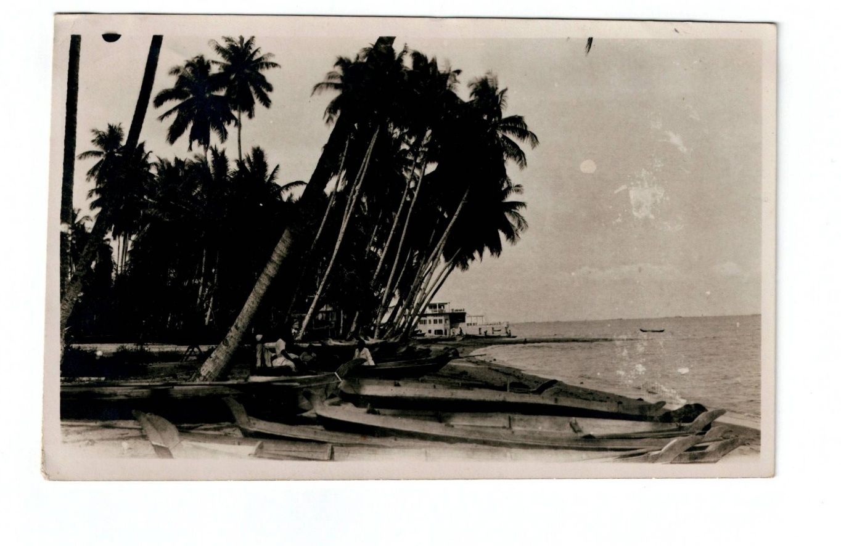
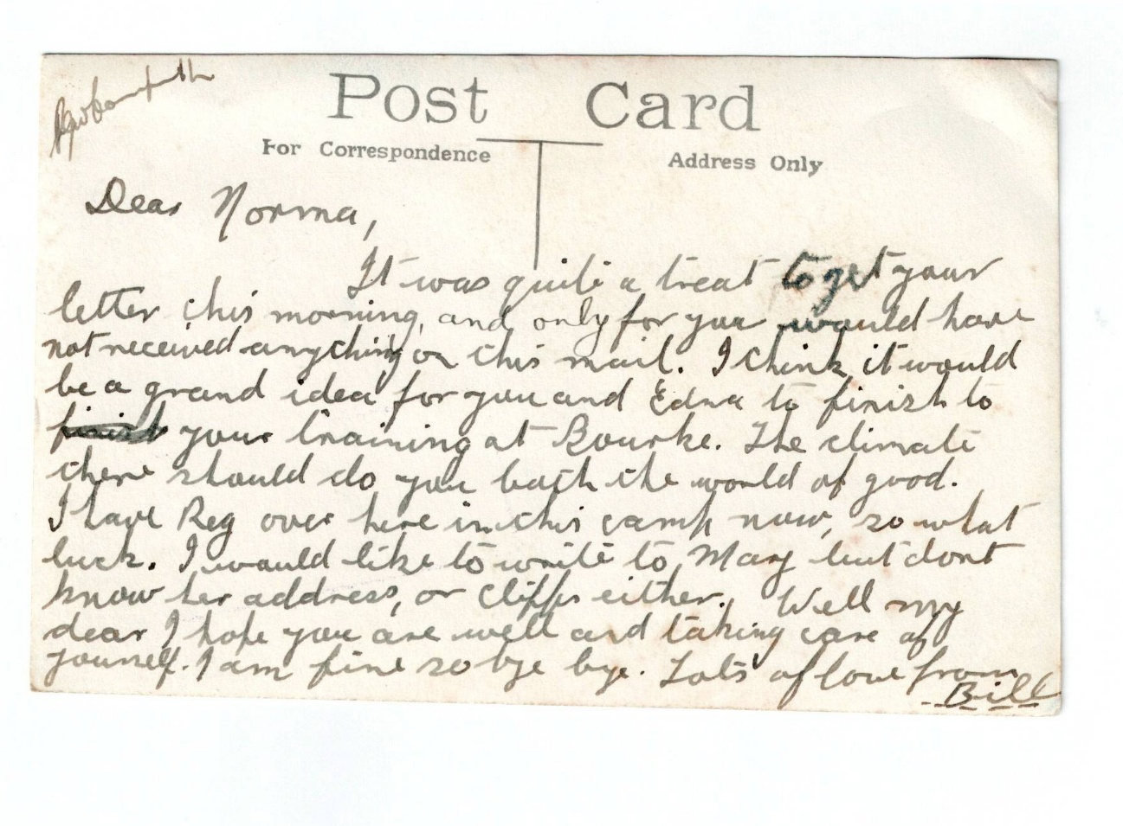
Sent from Singapore between September 1941 & February 1942
Dear Norma (sister)
It was quite a treat to get your letter this morning and only for you would have not received anything on this mail. I think it would be a grand idea for you and Edna (Norma’s twin sister) to finish your training (nurses) at Bourke. The climate there should do you both the world of good. I have Reg (brother) over here in this camp now so what luck. I would like to write to Marg (sister) but don’t know her address or Cliff (brother) either. Well my dear I hope you are well and taking care of yourself. I am fine so bye bye. Lots of love from Bill.

