The Following is an Excerpt from "A History of the Mudge Family 1300 to the present", compiled by Peter James Philip Mudge © November 2002.

The family of Horace Lyle Mudge (1897-1953) and Dulcie Margaret Coleman (1899-1985)
Did you know?
We are fortunate that quite a few of our forebears’ wills survived the air-raid on Exeter in May 1942, even though some 90% or more of Devon(shire) wills were destroyed during this raid. The Mudge family wills are in the keeping of the County Archivist at Exeter.

Horace Lyle Mudge was born on 12 March 1897 and died on 20 January 1953 aged 56. Horace married Dulcie Margaret Coleman at St Thomas’s Church, Murwillumbah, on 4th January 1921. Dulcie’s father was James Coleman (c. 1865–1914; died at about 49 years of age—his mother was an Ainsworth). Dulcie’s mother’s maiden name was Catherine Finn (also known as ‘Colo’, short for Coleman; she is pictured at Mary Mudge’s wedding and died 14 May 1955, aged 7913). Horace was converted and baptised before his marriage into the Catholic Church. Dulcie thinks that Horace may have been Presbyterian or Church of England through his family (he is listed as
C of E on his war records). He definitely had a high esteem for the Salvation Army, which makes sense given earlier family involvement as Salvationists.
Dulcie Margaret Coleman was born 2 December 1899 and died 5 September 1985 (aged 86)

Horace left school in about 1911 aged 14 years of age and chopped down trees for the North Coast Forestry commission around Mullumbimby and the surrounding area. He enlisted for World War I on 6 January 1917 when he was almost 19. This was the same year in which Dulcie’s father James Coleman died. Nana recalls that Horace did not serve for any length of time in a particular place but moved from one conflict zone to another (see his war records below).

Photo: Horace Lyle Mudge at about 18 years of age in 1915.

Horace Lyel [sic] Mudge—The World War One years (The Great War)

Introduction
Peter Mudge requested and received a copy of Horace Lyel14 [sic] Mudge’s war records on 15 May 1996. They were sent by the Australian Archives, Mitchell, ACT. This is the National Office that issues World War I (WWI) Personnel Records and other types of records.15 These records show that Horace Lyel Mudge was eventually appointed to the 5th Machine Gun Battalion (5 MG BN).¹⁶
Figures from this bundle of documentation indicate that he enlisted on 6 Jan 1917. After the war ended some two years later on 11 November 1918, he departed England via Suez on 28 June 1919. He arrived back in Melbourne Australia on 6 September 1919, his time away from Australian shores (21 June 1917—6 Sept 1919) totalling 2 years 2 1/2 months. His total enlistment service was 2 years 8 months exactly.
His only active service was in France but he was gassed and also afflicted by appendicitis for most of the time. Therefore his active service spanned between 30 December 1917 (marched out of Rouelles, France) and 29 June 1918 (Field Hospital near Rouen, France?) where he was admitted with appendicitis—thus making a total of 6 months active service.
Possibly he was disappointed in not seeing more active service at the Front or elsewhere, but perhaps also for our sakes, he was one of the lucky ones who came back alive from the Great War.

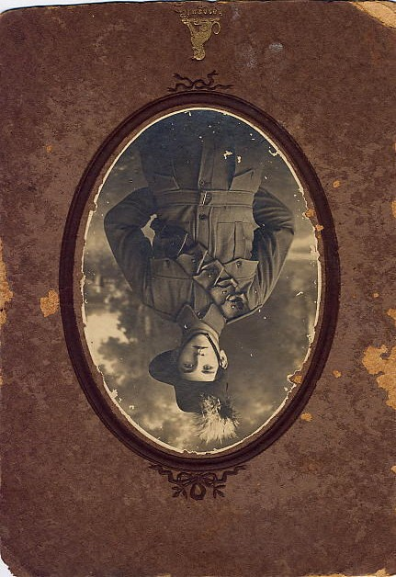
Photo: Horace Lyle Mudge around 1917 when he enlisted in the A.I.F. for World War One.

His ‘Attestation Paper of Persons Listed for Service Abroad’ shows (as already mentioned) that he enlisted relatively later in WWI (duration 1914-1919) on 6th January
1917. He was initially appointed to the
11/11th Machine Gun Company, 41st BN. This has been crossed out and underneath is written ‘5th M. Gun Bn’. Here are the abridged details of that same Attestation Paper (the original penned in Horace’s own handwriting).

Medical Report for H. L. Mudge on Enlistment—6 January 1917

Name: | 1. Horace Lyel Mudge
In the Parish of: | 2. [left blank]
Near the Town of: | Milton
In the County of: | New South Wales
 | 3. Natural born British [subject]
Age | 4. 18 10/12 years
Trade or calling | 5. Labourer
Ever been an apprentice? 6. No
Are you married? 7. No
Next of kin? (The answer to this question shall not be construed as in the nature of a will) 8. Mr. Robert Charles Mudge (Father) [of] Federal, Richmond River, New South Wales What is your permanent address in Australia?
9. Clunes, Richmond River, New South Wales
Ever been in Armed Forces? 10. No
Have you stated any previous service? 11. Yes
Ever been rejected as unfit for His Majesty’s Service? If so, on what grounds?
12. No
For married men. 13. [left blank]
Are you prepared to undergo inoculation against small pox and enteric fever?
14. Yes
Signed twice by H. L. Mudge at bottom.
Date: 6-1-1917

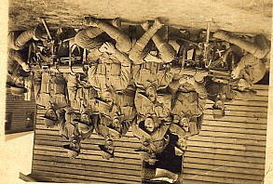

Photo: Horace Lyle Mudge behind machine gun at right. Possibly taken in 1917 in France? He moved between the 11th and 41st Machine Gun Battalion during his time in WW I.

Horace’s ‘Oath to be taken by Person being Enlisted’ was taken ‘SO HELP ME GOD’ in Lismore on the same date. His ‘Certificate of Medical Examination’, also completed at Lismore, contains the following valuable descriptions:
Description of Mudge H. L. on Enlistment
Age: 18 years 10 months
Height: 5 feet 7 inches
Weight: 11 st 13 lbs
Chest Measurement: 34/36 1/2 inches [latter upon expansion]
Complexion: Fair
Eyes: Grey
Hair: Dk Brown
Religious Denomination: C of E
Distinctive Marks: None
[other comments] 6/6 6/6 [referring to vision test for each eye].
Note: ‘Requires Minor Dental Treatment 14.2/17’ [referring to location of teeth requiring treatment?]

This Certificate was only signed by the Commanding Officer on 31.5.17, almost 6 months after the original medical exam was administered. However, he was serving in his first unit from the very day he joined. Here is his ‘Statement of Service No. 669A’ as best as I can reconstruct it with its varieties of handwriting and official stampwork, etc (essential details listed only). In doing so, I have combined four lots of war records to arrive at a cogent chronological record. Other records from which data has been taken are footnoted or otherwise marked with symbols.

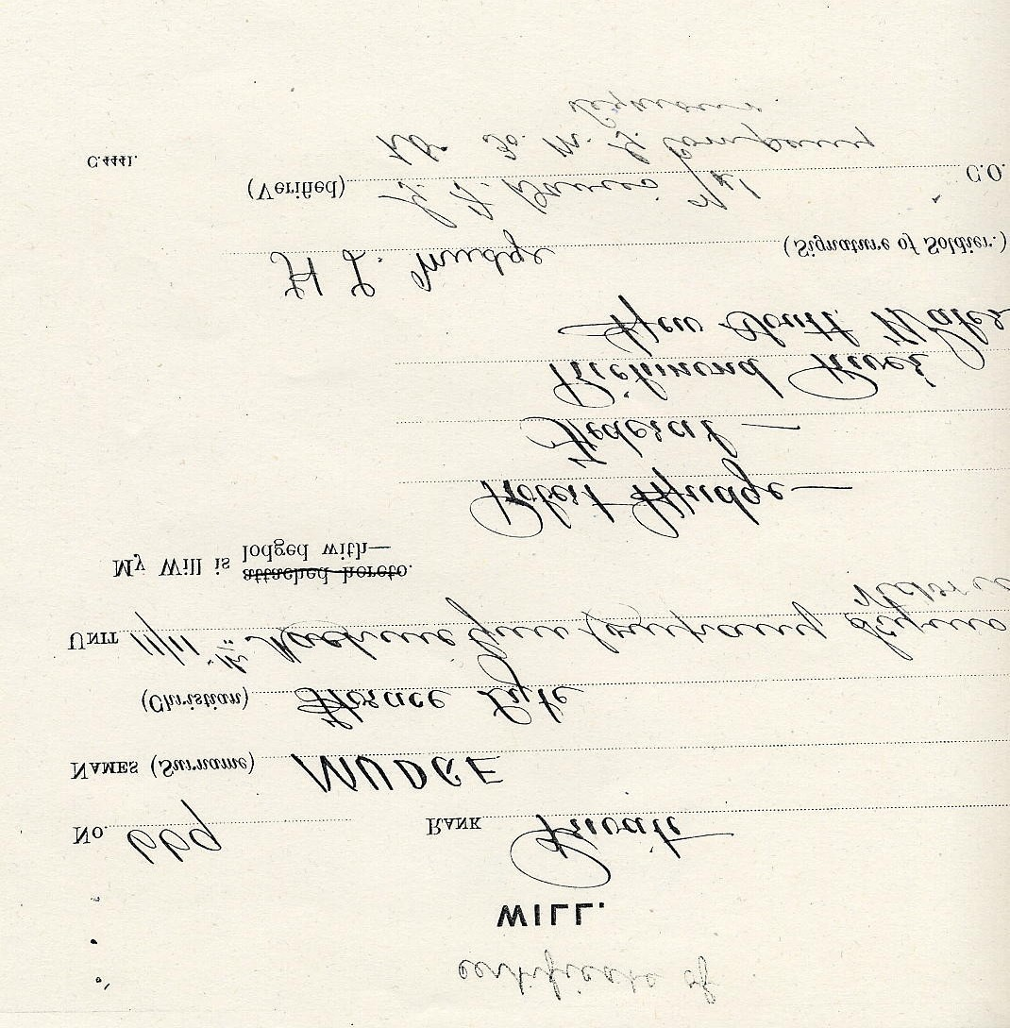

Chronological Service Record for H. L. Mudge

Unit in which served & Activity | Place | From | To | Total time spent at place & some historical notes
World War One (The Great War) breaks out with the assassination of Austria’s crown prince. It lasted from 1914-1918. The Allies of  France, Russia, Britain,  Italy after 1915, and the U.S. after 1917, defeated the Central Powers of Germany, AustriaHungary, and Turkey. | Fought mainly in  Europe and the  Middle East, after  June 28, 1914 |  |  | H. L. Mudge is to enlist on 6.1.17, some 2 yrs 6 mnths after outbreak of WW I
Horace Lyel Mudge enlists with the 11th Depot Btn as a Private.  Orientation & training? | Lismore | 6.1.17¹⁷ | 8.3.17 | 2 months
First vaccination¹⁸ takes place after enlistment | Still in Lismore? | 14.2.17 | 21.2.17 | Vaccination 1 mnth 1 wk after enlistment
14/31 Machine Guns | Lismore | 9.3.17 | 22.3.17 | 13 days
Records show that he is vaccinated successfully | Unknown, Australia | 13 or  14.3.17 |  | 1 day
Embarks on a ship Brisbane, Q, 28.3.17 Other details not sailing out of Brisbane¹⁹ Australia listed
Training to be part of Seymour, Victoria 23.3.17 29.3.17 6 days. His
the 14/31 or 11/11 ‘Certificate of
MGB? Will’ also
confirms these details.

Machine Gun Depot Moves from MAR 29, 21.6.17 3 months. One 11/11 MG. Coy [moved Seymour, Victoria 1917²⁰ other record has from Lismore to Sydney to Melbourne, (29.3.17) him departing on
to Melbourne?] Victoria H.M.A.T. (His
Embarked A29 at Majesty’s
Melbourne on Suevic. Australian
Transport) Suevic on the same date.²¹
Recorded as aboard the Departed 21.6.17 Was also to
ship Ulysses and Melbourne return aboard the embarking Melbourne²² Ulysses.
Did they change ships during the voyage over?
Disembarked Liverpool Arrived at 26.8.17 Sea voyage took 2
(LR 7365) Liverpool months 5 days
Pte from Australia in England 27.8.17 Given as the date
England of
Disembarkation.²³ Transferred from 11th England 27.8.17 Listed as arriving in
MGBtN to 41st BTN Darrington, England on this
date.²⁴
Marched into 11th Lark Hills,²⁶ 27.8.17
Training BTN from England
Australia²⁵
3rd Inoculation Lark Hills, 29.8.17 Finishing date given for administered to H. L. England inoculation is 7.9.17
Mudge
Listed as preparing for From Lark Hills, 11.10.17 Perhaps preparations for
embarkation from England? active service in France, but
England to France²⁷ details unknown.
Recorded as in No. 13 Fovant, France 5.11.17 to One week
Camp, Fovant, France. 11.11.17
Moved from 11th MG
BN to 9th Training BN²⁸

Private proceeded overseas to France ex  Fovant via  Southhampton²⁹ | England to  Fovant, France | 27.12.18 | Last Battalion movements transpire over 4 months
Had been transferred out of the 9th Training  BN to No. 13 Camp,  Fovant |  | Just after Christmas | The war quickly develops its major front in E. France where millions died in static trench warfare
Marched into Fovant, France after departing Rouelles, France. Stationed during this time at the A.I.B.D. (Australian Infantry  Base Depot).³⁰ | Moved from  Rouelles to  Fovant, both in  France | 28.12.17 to  30.12.17
Moved from 41st BN [back to] 11th MG Coy out of England | France | 4.1.18
Allotted new regimental No. 669A | France | 4.1.18?
Part of 41st Battalion, taken on strength, and placed back in the  field³¹ | Fovant, France? | 4.1.18 to  5.1.18
Recorded as in the field but no records of any troop movements³² | Fovant, France? | 27.2.18
T.O.S. (Taken On  Strength) of 41st BN from 11th MG Coy but gassed during active service | France | Gassed  March  1918
Moved [from field hospital?] to another hospital in France. Reported as recovering in the 5th C.C.S.  (Casualty Clearing  Station)³³ | France (near  Roüen perhaps?) | 25.6.18 to  27.6.18 | Took 3 months to recover from gassing?
With 41st BN. Thin in hospital sick (near or in a Field Hospital?)³⁴ Stated elsewhere that he was moved to Roüen in  France³⁵ | Near Fovant, France? | 25.6.18 to  29.6.18 | He is admitted to the 10th  A.S.H. (Australian Stationary Hospital) with appendicitis.³⁶

Admitted to L of C Hospital? Sick | France | 27.6.18 | Q: gassing and later appendicitis related?
Invalided to U.K.³⁷ | France to England | 1.7.18 | Had been in France c. 6 months
Admitted to  Northamptonshire War Hospital suffering from Appendicitis. Additional records show³⁸ that Horace’s condition was: ‘Intestinal adhesions. Reported sick with abdominal pains. Slight tenderness of right side of abdomen. No other  symptoms and no  rigidity. Xray of alimentary track shows nil abnormal. Site of tenderness well above right to left of iliocostalis region’ [ribs and intercostal muscle region]. | England  Northamptonshire  War Hospital,  Durrington??³⁹ | 2.7.18 | Discharge date given as 19.7.18. Therefore in hospital for duration of 17 days. Another form indicates a stay of 18-19 days.⁴⁰
Transferred to 3rd  Auxiliary Hospital with  Chronic Appendicitis | Dartford, England  (s-east of  London?) | 19.7.18 | Following initial appendicitis bout, was in hospital about 3 weeks before chronic attack
Record of: ‘Contusion of stomach. Seen by surgical specialist who considered treatment unnecessary.’⁴¹ | 3rd AAH  (Australian  Auxiliary  Hospital)  Dartford, England | 22.7.18 | Discharged 9.8.18. Total of 19 days.
Record of dental treatment | Dartford, England? | 6.8.18
Discharged to 3rd  Convalescent Depot  (CD) with Chronic Appendicitis, Reallocated to Regiment No. 669A. | Still Dartford,  England? Another record states location as Hurdcott,  England⁴² | 9.8.18 | Stays total of 1 month

Recorded as ‘In good condition’.⁴³ Later on, on 15.8.18, recorded as ‘No disability’ on same form. | No. 3  Convalescent  Depot (CD)  Classification Unit Dartford,  England? | 9.8.18 | Discharged 11.9.18. Total of 31 days.
Marched In (MI) from  3rd AAH (Australian Auxiliary Hospital) Dartford. | Dartford England | 9.8.18 to  10.8.18 | Stayed there about 1 month
Moved to an O.S.T.B. (OverSeas Training Brigade). | OSTB, preparing for move to Longbridge,  Deverill, England | 11.9.18 to  12.9.18 | 2 months from this time until the end of WW I.
Transferred to  (M.G.C.D.H.) Machine  Gunners Corps  Dermatological  Hospital, and thence to  Parkhouse, Longbridge,  Deverill⁴⁴ | Parkhouse,  Longbridge,  Deverill, England | 20.9.18 to  21.9.18
T.O.S. (Taken on  Strength) for MG  Detachment out of 41st  Battalion at Parkhouse,  England.⁴⁵ | Preparing to depart from Parkhouse,  England | 20.9.18 to  22.9.18 | There is a gap of over 2 months before his next move. Still recovering from appendicitis or undergoing further treatment?
Surrender of Central  Powers and agreement to an armistice with the Allies | England and Europe | 11 NOV  1918  (11.11.18)
Moves from MGTD  (Machine Gun Training  Depot).⁴⁶ | Preparing to move OS to France, out of Parkhouse, England and via  Folkstone,  England | 28.11.18
M/I (Marched In) to Machine Gun Details from MGCBD out of England | England | 29.11.18
Moves from A.G.C.B.D.  (Australian General Corps Base Depot) marching out to England (via ship) to Camiers, France. Now part of 5th MGBtn.⁴⁷ | From Folkstone,  England to  Camiers, France | 29.11.18 to 1.12.18

T.O.S. (Taken On  Strength) of 5th MG  BTN from M.G.C.B.D.  (Machine Gun  Company Barracks Depot). Previously had been in 41st BN. | Town or region unknown, England | 2.12.18 | Recorded elsewhere with same events as occurring between 8.12.18 and  22.12.18⁴⁸
Transferred to M. Guv. Corp District Hospital and to Parkhouse ex 41st BN. Transferred to  Machine Gun Details. Embarked at Suez Gulf for Australia | North’shire to  Parkhouse to  Suez Gulf | 22.12.18 | Total period of treatment for initial and severe appendicitis was almost 6 months. On location in Suez Gulf for c. 5 months before contracting scabies.
Marched out in Quota 47 in France⁴⁹ | Still in France,  between Camiers and Le Havre? | 3.5.19 to  10.5.19
Marched out from Le  Havre, France to  England, being from A.B.E.D.1 (guessing that this is Australian Base  Emergency Depot No.  1).⁵⁰ | Le Havre, France | 12.5.19 | Now moving from France to England as result of scabies condition
Marched in as part of  No. 5 Group to  Weymouth, England.⁵¹ | Weymouth, England | 13.5.19 to  17.6.19 | Stays there for 1 month and 4 days
Becomes sick and is admitted to 1st ADH  (Australian  Dermatological Hospital) Amended diagnosis from VD736  (is this what I think it is?) to Scabies⁵² ⁵³ | Bulford, England | 17.6.19 to 20.6.19, then extended to 29.6.19 | Total of 12 days treatment
Discharged from  Hospital to No. 2  Group, S. Veny (Sutton Veny). On this same day the Treaty of Versailles is signed.⁵⁴ | Sutton Veny, England (just north-east of Longbridge,  Deverill) | 28.6.19 or  29.6.19 | Had been in hospital with scabies for 11 days.
In No. 2 Group, marched in from Bulford, England⁵⁵ | Bulford, England | 1.7.19
Embarked [on Ulysses?] from England to return to Australia | Departed London? | 1.7.19
Arrived in Melbourne from overseas. Listed elsewhere as part of 25th Mach. Gun Corps but still in 5th MGBn.⁵⁶ | Melbourne, Australia | 6.9.19 | Return voyage took same time as journey over; i.e. about 2 mnths 5 days
Discharged from Forces | Melbourne | 6.10.19

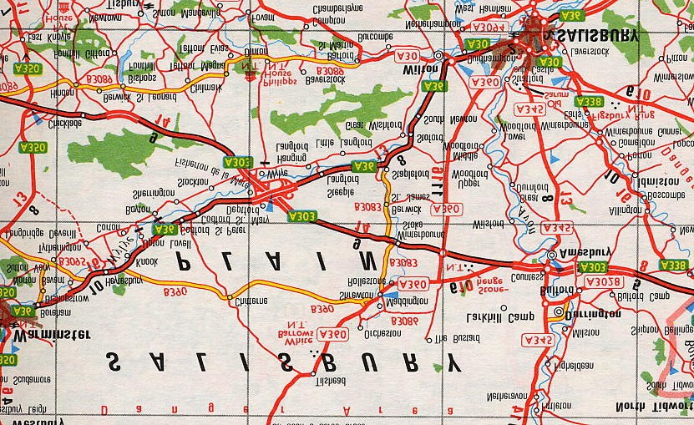

Map of the Salisbury Plain, where Horace Lyle Mudge served in 1917. the line in top right-hand quadrant shows the distance from the Larkhill Camp to Stonehenge, which Horace must have visited at some stage? (see double-headed arrow on map)

Medical History for H. L. Mudge upon Vaccination—14 March 1917
‘Army Form B. 178A’ contains the ‘Medical History’ of Horace Lyle [sic; spelled differently from previous forms, but could have been filled out by an army doctor] MUDGE. The information confirms, extends, and in some cases contradicts earlier information given above (e.g. spelling of second name, and occupation). The form was filled out 2 months and 1 week after his original enlistment date. Here are some edited details from same: Age: 18 10/12 years [same as elsewhere]
Trade or Occupation: Butcher [previously ‘Labourer’]
Height: 5 feet 7 inches [same]
Weight: 13 stone 7 lbs (c. 87 kilos) [previously 11st 13 lbs]
Chest: 34” and 37” expanded [latter previously 36 1/2”]
Vaccination Marks: None on Right Arm; Four on Left Arm When Vaccinated: 14 March 1917
Vision: Right Eye = D6? Left Eye = D6?
Approved by: J. Inglis Robertson, Captain, Medical Officer
[originally] Enlisted: 6th January 1917

Horace’s Medical Report after Gassing—March 1918

Recorded on: A. M. Form D2
Horace’s ‘Medical Report on an Invalid’ states that he was ‘Gassed March 1918’. Other details provided are: HW (Hospital Warship?) Ulysses Station: 6 A G H (Australian General Hospital)
Number: 669A Rank: Private
Age: 20
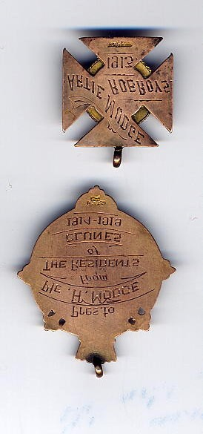
Date of arrival from overseas: 6/9/19
Present condition and progress?: No disability
Do you recommend discharge as permanently unfit [sic] for general service?: Confirmed
Signed by: H. L. Mudge and others

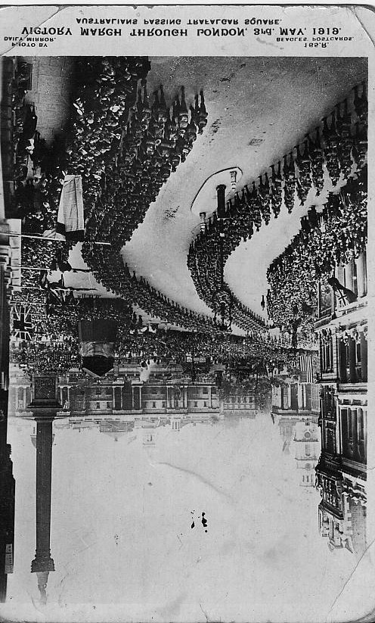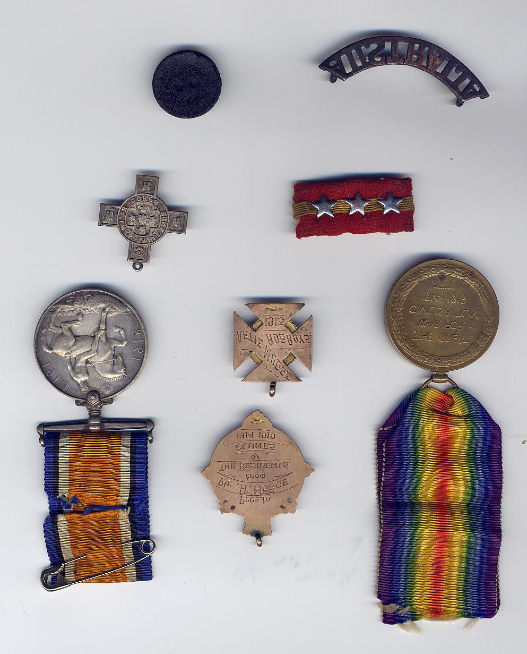

The Victory March through London on 3 May 1919,
after end of WW
I.

Service Medals awarded to
Horace Lyle Mudge
Refer to website listing all of Horace’s documents and military records at: National Archives of Australia at: https://recordsearch.naa.gov.au/SearchNRetrieve/Interface/ViewImage.aspx?B=7985514

