Private Howard Michael McCann was a roman catholic born in Redbanks, South Australia in September 1894 to Mrs Matilda Collins. He later moved to Salisbury as a baker. He was 5’ 5” (165 cm) weighed 125 pounds (56.7 Kg) with a medium complexion and brown hair and eyes.
On 25th September 1915 he enlisted in the 3rd light horse regiment, which was one of Australia’s mounted units, known for playing a part in Gallipoli and the Sinai Palestine campaign. The unit was formed in 1914 in Adelaide, consisting of mostly south Australian troops and some from Tasmania. The unit was initially commanded by Lieutenant Colonel Frank Milton Rowell. He joined the 14th reinforcement of this unit aged 21 and a half years.
Then on the 10th of February 1916 he embarked from Adelaide on the HMAT Marilda. The Marilda was ship designed for the East-west Australian coastal service. At the start of WW1, the vessel was taken by the Australian government as a troopship and assigned the prefix HMAT, which stands for His Majesties Australian Transport. During 1915-1916 the ship carried Australian troops from Australia to Egypt to England. Around June 1916 the ship was converted into a hospital ship for use of the British admiralty and was put to use in the Mediterranean and English Channel, making over 180 trips and carrying around 80 000 wounded soldiers. The ship was sunk on the 3rd of august 1918 while carrying wounded soldiers from Le Havre in France to Southampton in England 801 people were aboard and approximately 123 people died.
to France, taking on the strength of the first light horse regiment. He arrived in France on the 5th of January 1916. On the 17th of September he was appointed as a driver, a driver was a soldier who took part in some transport duties, such as transporting hospital and ambulance carts and ammunition in horse drawn carts. The drivers also took care of horses and their equipment. The role of a driver was a vital but often dangerous one, as they would have to transport goods under heavy fire in the front lines.
Later, on the 1st of February 1917 he was admitted to hospital sick then he rejoined his unit 10 days later the 12th. He did take some leave in the UK between the 20th of September and the 4th of October 1917. He was soon appointed as a driver on the 14th of January 1918. He was attached for duty on 31/8/18 but his attachment ceased on the 12th of October later that year. He took some leave to the UK again from the 13th of November to the 14th of December after his attachment, when he then rejoined at France again. He finally returned to his home in Australia after 1197 days of service on 22/5/19. McCann also had a brother in the military. Private James Thomas McCann was part of the 5th divisional ammunition column. James McCann returned to Australia on the 22nd of May 1919. Howard Michael McCann died due to natural courses on the 16th of December 1980 at the age of 87, he is now remembered on a plaque in the garden of remembrance in South Australia. His body was laid to rest at the centennial park cemetery.

Timeline of Private Howard Michael McCann
1890s – Early Life
- September 1894 – Born in Redbanks, South Australia to Mrs Matilda Collins.
- Raised Roman Catholic.
- Later moved to Salisbury, where he worked as a baker.

1915 – Enlistment
- 25 September 1915 (Age 21½) – Enlisted in the 3rd Light Horse Regiment (14th Reinforcement).
  - Regiment formed in 1914 in Adelaide.
  - Known for service in Gallipoli and the Sinai–Palestine campaign.
  - Originally commanded by Lt. Col. Frank Milton Rowell.

1916 – Departure & Early Service
- 10 February 1916 – Embarked from Adelaide on the HMAT Marilda (troop transport).
- 5 January 1916 – Arrived in France (noting that dates in records often overlap due to multiple movements; this one indicates his arrival for service in the European theatre).
- 17 September 1916 – Appointed Driver (responsible for horse-drawn transport of supplies, ammunition, and ambulances).

1917 – Illness and Leave
- 1 February 1917 – Admitted to hospital sick.
- 12 February 1917 – Rejoined his unit.
- 20 September – 4 October 1917 – Took leave in the United Kingdom.

1918 – Continued Service
- 14 January 1918 – Again appointed Driver.
- 31 August 1918 – Attached for special duty.
- 12 October 1918 – Attachment concluded.
- 13 November – 14 December 1918 – Took another period of UK leave.
- December 1918 – Rejoined unit in France.

1919 – Return to Australia
- 22 May 1919 – Returned home to Australia after 1197 days of service.
  - His brother, Private James Thomas McCann (5th Divisional Ammunition Column), also returned on the same date.

1980 – Death
- 16 December 1980 – Died of natural causes, aged 87.
- Buried at Centennial Park Cemetery, South Australia.
- Commemorated on a plaque in the Garden of Remembrance, South Australia.

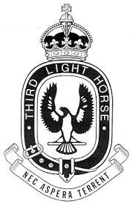 | 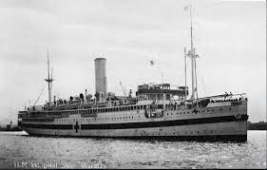
3rd light horse regiment Badge | HMAT Marilda as a hospital ship
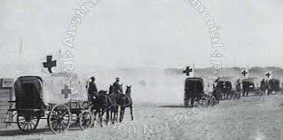 | 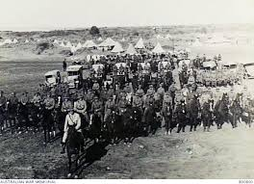
Light horse field ambulance | 3rd light horse regiment

Harvard references

Terrace, V. (2025). View digital copy. [online] Naa.gov.au. Available at: https://recordsearch.naa.gov.au/SearchNRetrieve/Interface/ViewImage.aspx?B=1938776 [Accessed 17 Nov. 2025].
‌Adfa.edu.au. (2025). Details. [online] Available at: https://aif.adfa.edu.au/showPerson?pid=193581 [Accessed 17 Nov. 2025].
Wikipedia. (2020). 3rd Light Horse Regiment (Australia). [online] Available at: https://en.wikipedia.org/wiki/3rd_Light_Horse_Regiment_(Australia).
Anon, (n.d.). Australian Light Regiments and Brigades – Australian Light Horse Association. [online] Available at: https://www.lighthorse.org.au/mounted-troops/.
Samrainc.org. (2025). History 3rd LH. [online] Available at: https://www.samrainc.org/history3lh.htm [Accessed 17 Nov. 2025].
‌

‌

