ROBINSON Norman Alexander 2LT
NZ Birth index
1896/84 | Robinson | Norman Alexander | Annie | Alexander | - | Order Product
1891/3610 | Robinson | Norman Lambert | Annie | Alexander | - | Order Product

NZ Death index

1891/828 Robinson Norman Lambert 3M

CAPT. A. ROBINSON. (His father)

MASTER MARINER'S DEATH.

The funeral of Captain Alexander Robinson took place on Friday. The body was interred in the Field of Mars Cemetery. The Rev. A. M Ogilvie conducted the service.

Captain Robinson, who was 6O years of age, was one of the best known master mariners in Australia. His first command was that of the barquentine Handa Isle, in which he had a part interest. In 1899 he joined the Howard Smith service (now Australian Steamship Pty., Ltd.), as master of the steamer Julia Percy. He remained with this company up to the time of his death, and commanded practically every vessel owned by it, including the Peregrine and the Canberra (flag-ship).

Captain Robinson during his career had some remarkable experiences. Whilst he was in the Handa Isle she was rammed by a whale, and the vessel, after being given up as lost, arrived at Bluff, New Zealand, six weeks overdue.

Though 34 years at sea he never lost a ship or had a serious accident. Born in Antrim, Ireland, he was a man of strong character, and he maintained the highest traditions of the mercantile marine. He leaves a widow and four children.

Family moved from NZ to Sydney when?????
THS board has N Robinson
1909 High School scholarship (from schools in classes III and IV), Norman A Robinson, Beecroft PS

6.7.1910 THS Junior scholarship, Tech Day School 2 years, ’Norman A Robinson’

29.1.1912 – 31.12.1914 Intermediate scholarship, ‘Norman A Robinson’

He states on his attestation signed April 1916, that he had been an apprentice civil engineer for 4 years with R Fisher Civil Engineering. dates??? – 1912 1913 1914 1915

On his application for a commission in the Expeditionary Forces 11.4.1916, Norman states that he held a Public Service pass, Senior pass and Honours Graduate STC Engineering. He was appointed 2LT 20 Jun 1916 and LT 6.9.1916

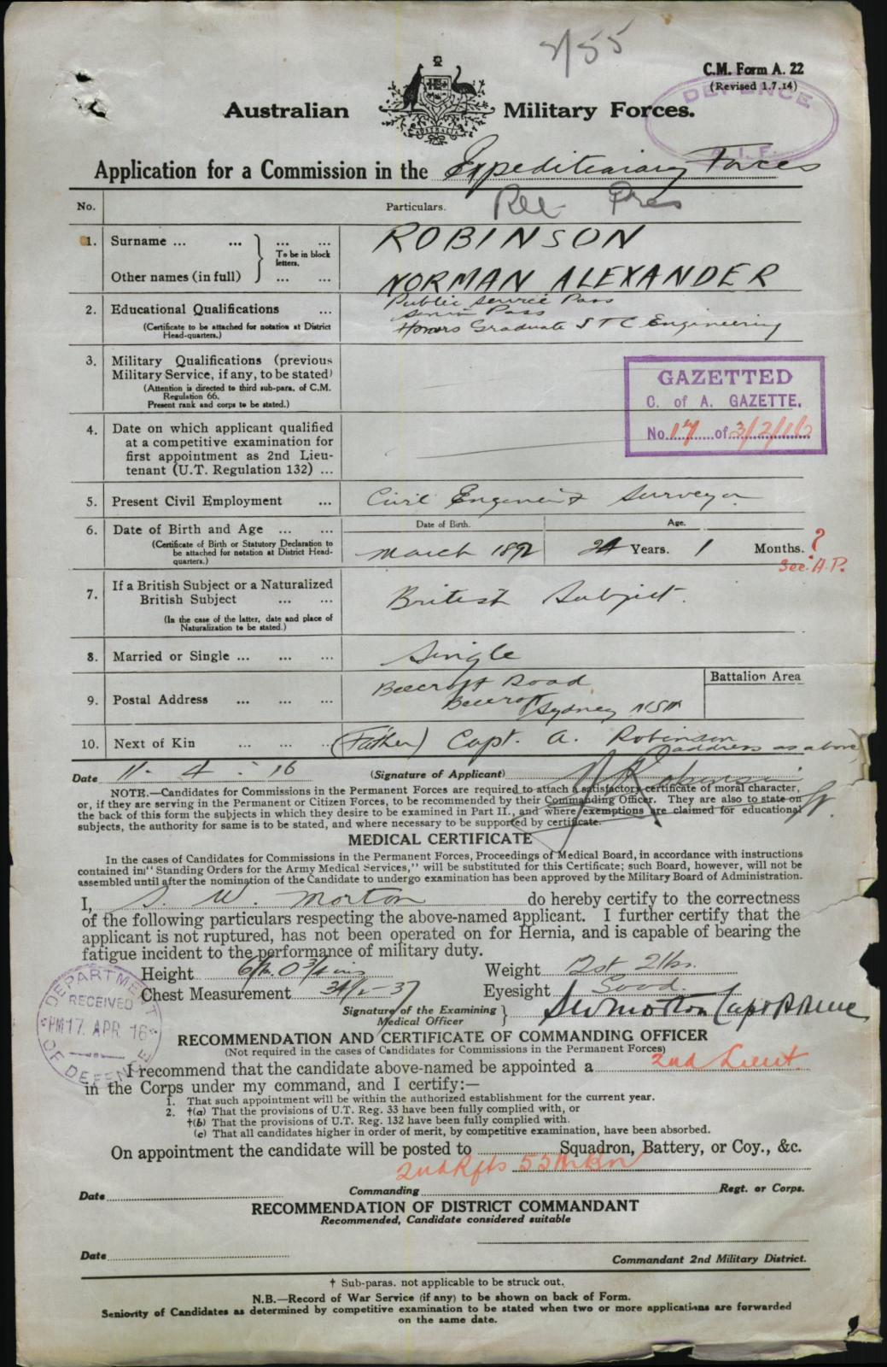

LT Norman Alexander ROBINSON
Place of birth | Auckland, New Zealand
Religion | Presbyterian
Occupation | Civil engineer
Address | Beecroft Road, Cheltenham, New South Wales
Marital status | Single
Age at embarkation | 23
Next of kin | Mother, Mrs Annie Robinson, Beecroft Road, Cheltenham, New South Wales
Enlistment date | 22 June 1915
Rank on enlistment | 2nd Lieutenant
Unit name | 55th Battalion, 2nd Reinforcement
AWM Embarkation Roll number | 23/72/3
Embarkation details | Unit embarked from Sydney, New South Wales, on board HMAT A40 Ceramic on 14 April 1916
Rank from Nominal Roll | Lieutenant
Unit from Nominal Roll | 55th Battalion
Fate | Returned to Australia 4 May 1917
Other details | War service: Western Front  Medals: British War Medal, Victory Medal

Norman ROBINSON
Regimental number | 642
Religion | Presbyterian
Occupation | Labourer
Marital status | Single
Age at embarkation | 21
Next of kin | Mother, Mrs Jean Robinson, 54A Manor Lane, Lee Kent, England
Enlistment date | 23 September 1914
Rank on enlistment | Private
Unit name | 15th Battalion, D Company
AWM Embarkation Roll number | 23/32/1
Embarkation details | Unit embarked from Melbourne, Victoria, on board Transport A40 Ceramic on 22 December 1914
Rank from Nominal Roll | Private
Unit from Nominal Roll | 15th Battalion
Fate | Returned to Australia 21 July 1917
Miscellaneous information from  cemetery records | Plaque in New South Wales Garden of Remembrance
Date of death | 24 April 1936

https:/www.bdmhistoricalrecords.dia.govt.nz
The Sydney Morning Herald (NSW : 1842 - 1954) Tue 24 May 1921 Page 10
The Star (Sydney, NSW: 1909 - 1910) Wed 7 Jul 1909 Page 14 STATE SCHOLARSHIPS.
SRNSW STHS Register of Scholarships and Bursaries

