

LT Claude Elliott FULLER MM

4806
Birth | 16 February 1897 at Nowra, NSW to Sidney Howarth FULLER (Public School Master 1869-1935) of Bridge Road and Alicia (née xxxx)
Religion | Church of England
Schooling | Technical High School
Occupation | University undergraduate Engineering
Address | Neville Street, Smithfield, New South Wales
Marital status | Single
Age at embarkation | 21
Height | 5' 8"
Weight | 119 lbs
Next of kin | Father, S H Fuller, Neville Street, Smithfield, NSW
Previous military service | Served for 5 years in the Cadets (18 months as 2LT).
Enlistment date | 9 September 1915
Place of enlistment | Holsworthy, NSW
Rank on enlistment | Private
Unit name | 3rd Battalion, 15th Reinforcement
AWM Embarkation Roll number | 23/20/3
Embarkation details | Unit embarked from Sydney, New South Wales, on board HMAT A15 Star Of England on 8 March 1916
Regimental number from Nominal Roll | Commissioned
Rank from Nominal Roll | Lieutenant
Unit from Nominal Roll | 55th Battalion
Recommendations (Medals and Awards) | Distinguished Conduct Medal (altered to Military Medal)  Recommendation date: 1 October 1917
Fate | Returned to Australia 15 January 1920
Medals | Military Medal  'This N.C.O. displayed great devotion to duty and courage during the attack on POLYGON WOOD on 26th September 1917. His platoon commander was wounded early in the attack and Sergeant Fuller took command and led the platoon forward. His coolness was a fine example to his men. On reaching the objective he rendered valuable service in connection with the work of consolidation. He worked untiringly throughout the period his company were in the line after the attack.'  Source: 'Commonwealth Gazette' No. 76  Date: 23 May 1918
Discharge date | 29 April 1920
Other details | War service: Egypt, Western Front  Medals: Military Medal, British War Medal, Victory Medal
Date of death | 23 November 1978
Place of burial | Levin Cemetery, New Zealand

Name: | Claude E Fuller
Birth Date: | 1897
Birth Place: | New South Wales
Registration Year: | 1897
Registration Place: | Nowra, New South Wales, Australia
Father: | Sidney H Fuller
Mother: | Alicia E
Registration Number: | 5708

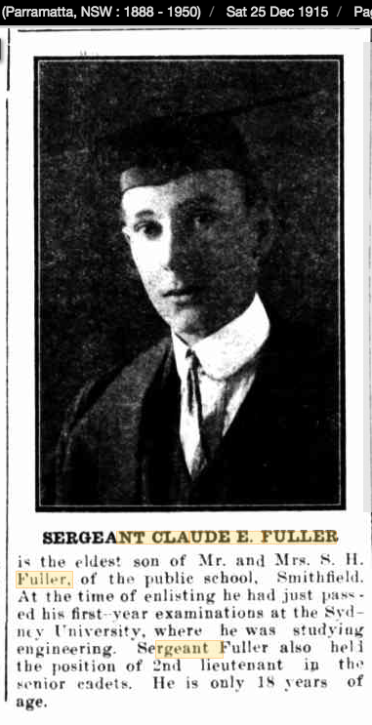
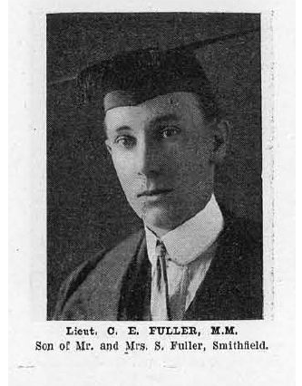

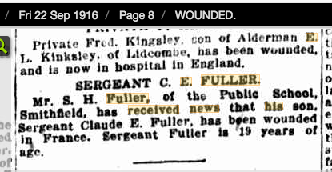

Claude Elliot Fuller
M.M., B.E. : Lieutenant, 55th Battn., A.I.F., France. Enlisting 8th September, 1915, and sailing 8th March, 1916, joined battn. in Egypt and, crossing to France in June, remained with it till wounded severely at Fleurbaix, 5th September. On recovery served with battn. until the end of the War, returning 29th February, 1920. Promoted sergeant, 31st May, 1916; company sergeant-major, 12th November, 1917; lieutenant, 18th December, 1918. Early education at Sydney High School.

Name: | Claude Elliott Fuller
Gender: | Male
Age: | 28
Birth Year: | abt 1891
Marriage or Bann Date: | 29 Mar 1919
Marriage Place: | Oxford, St Philip and St James, Oxfordshire, England
Parish as it Appears: | Ss Philip & James
Search Photos: | Search for 'Oxford, St Philip and St James' in the UK City, Town and Village Photos collection
Spouse: | Clarissa Emily Ernestina Shurman
Father: | Sidney Howarth Fuller

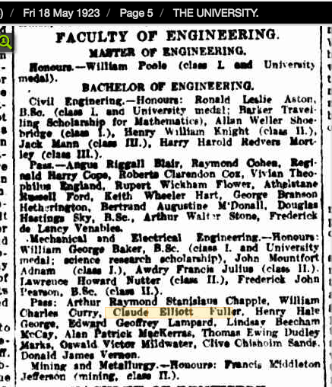

1930
42 Sutherland street Lane Cove engineer
Clarissa Emily hd

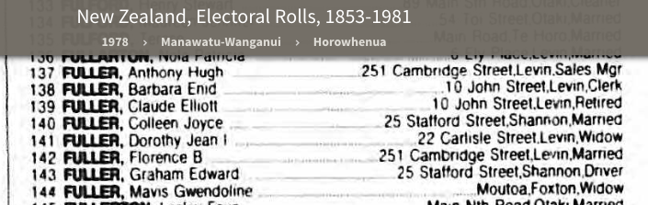

FATHER
Sidney Howarth FULLER
17 Jan 1869
First appointment 19 July 1883

1909 PSL Prospect Teacher
1914 PSL Smithfield Teacher (still there 1923)

18 February 1897 on passenger list arriving in UK, 1955
Some records have Howard (including Anglican baptismal record)
Intermediate Certificate 1912
AIF database has “University English student” but NAA dossier as above, and Sydney University Union War Record shows Engineering in 1915.

