ROCA EXTRA
NOTE 13/11/25: Article originally for the Roseworthy Old Collegians (now Roseworthy Campus Association), Winter 2012 edition of the ROCA Digest, by Richard Turnbull RDA 1969
Roseworthy Agricultural College - Tales from the Honour Roll

John Tassie RDA (1903 – 1906)
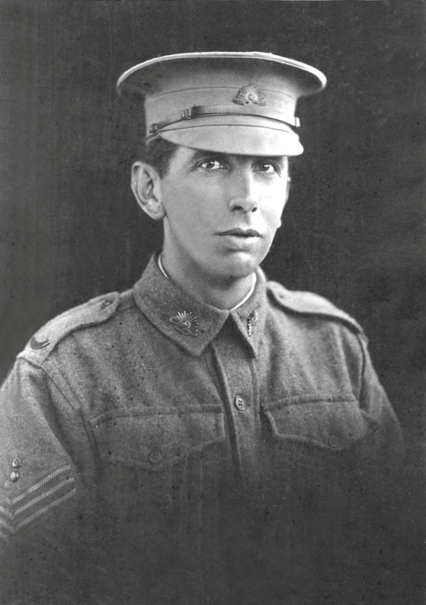
- Private John Tassie jnr
Killed in Action 25th April 1918, France.

John Tassie’s war was a short war. He arrived ‘in the field” at North Western France on 4th January 1918 in the last year of the war, and was killed on 25th April, 111 days later and became one of the 41 Roseworthians who gave their lives in that great and terrible war. He was one of the “deep thinkers”, a term use for those who enlisted latter, by those who enlisted early, in a haze of patriotism, sense of duty and a hunger for adventure. Perhaps many of those who did enlist early, later with the wisdom of hindsight, wished they had given it a little more thought. John’s attestation papers show him joining on 4th July 1916, at the age of 31 years, so he could not have thought all that deeply about it. He was appointed to the 7th Reinforcement detachment for the South Australian 43rd battalion, AIF. He had come to Adelaide from his farm at Keith and recorded his address as 10 Seawall, Glenelg, his parents’ home. Their home was an imposing residence right on the foreshore at Glenelg, on Moseley Square, where the Grand Hotel now stands. His father was the managing director of the Adelaide branch of D &W Murray, a large British Importing & Exporting Company. He had purchased his son John a farm at Keith, after he graduated from Roseworthy.

John’s family came to Adelaide from Perth not long before he entered Roseworthy Agricultural College (RAC) in 1903, aged 18. He had been student at Scotch College, Perth. It was there he gained the four years of cadet experience mentioned in his attestation papers … the forms where a recruit attests to his personal details as part of his application to join the Australian Imperial Force (AIF). At Roseworthy he appears to have been a quiet student, as he does not get many mentions in “The Student”, a magazine produced and edited by the students detailing College life and events. In those days there were only around 40 to 50 students at Roseworthy. The only committee he appeared to have served on is the library committee. He was not on the sport committee or the dance committee, and his name does not appear in any of the football, cricket or tennis team during the three years he was there. At the Annual Sports and Dance Day in July 1905 he won the 220 yards flat race. He did much better academically, coming second overall in his final year, also winning the Viticulture and Wine Making Prize that year and the Book-Keeping prize in his first year in 1903. In second year he won the prize for outside work. Not bad for a city boy!

The family called him Jack and his mother's letters are addressed “Dear Jack”, but he signed himself John Tassie jnr. and his father was known as John Tassie snr. It was, and still is a family tradition to name one of the sons John. His nephew, (another) John Tassie says the family knows very little about Jack’s life other than that his father purchased a farm at Keith for him some time after he left Roseworthy. In those days Keith was real frontier country, but they did at least have the Adelaide Melbourne railway line.
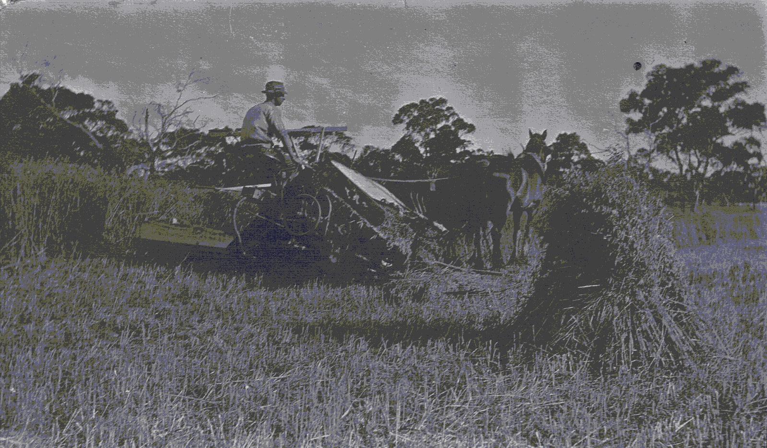
Jack’s Farm at Keith
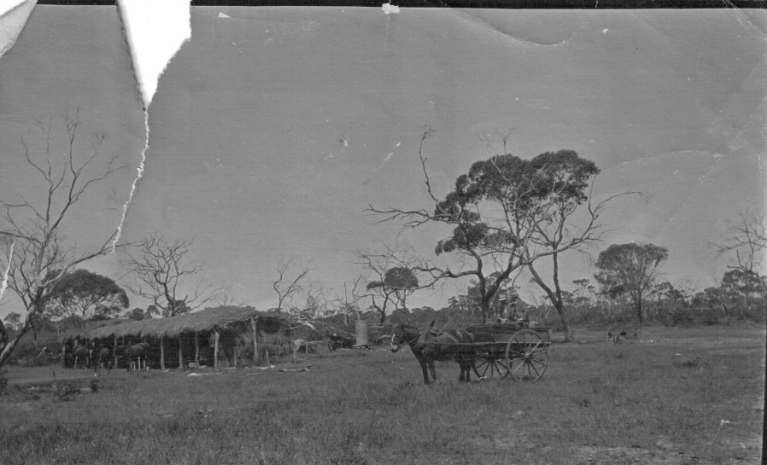
Upon enlisting in July 1916 Jack was marched into Mitcham army camp, which was the main AIF training establishment in South Australia from July 1915 to 1920. The suburb of Colonel Light Gardens is now located on the old camp site. His army records show that he qualified for the rank of Sergeant after attending an NCO course and the camp commandant noted on his certificate “Recommended to attend an Officer Training Course”. He qualified with certificate in Musketry and Trench Warfare and Grenade use and was promoted to Sergeant. Very few details are known of his time at the Mitcham camp, only that he stayed there for almost a year. He did not go on to officer training but probably became an instructor. No doubt his RDA, his general knowledge and leadership abilities persuaded the army to keep him back for this important role. Finally, he embarked for overseas service on 26th June 1917, on the HMAT (A30) Borda and arrived in Plymouth on 25th August 1917.
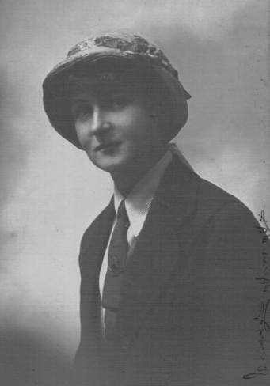 | 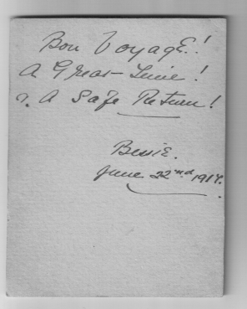  Bon Voyage!  A Great Time!  ? A Safe Return!  Bessie  June 22nd 1917
Photo of a young woman Bessie, unknown to the family
As far the family knew Jack was never romantically involved, but have speculated that he may have been in the early stages of a budding relationship with Bessie, who he could have met in Keith where he worked on his farm. The above photo is dated 22 June 1917, four days before Jack embarked for Europe. However they never heard from her after his death.

He arrived in England as a sergeant and immediately requested to be reverted to the lower ranks. Later after being promoted to acting Lance Corporal, he again requested to be reduced to a private just prior to going to France in late December 1917. This explains the photo of Jack over the fireplace in the Tassie Memorial Library, in which he is wearing sergeant’s stripes. Note that the letter notifying his family of his death, records his rank as “Private” Tassie. It was not uncommon for new NCO’s and even some officers with no battle experience to request they be reduced in rank as they did not wish to lead experienced front line men in battle. A very understandable sentiment. He underwent further infantry training in Southern England, at Larkhill military camp near Durrington village in Wiltshire, not far from Stonehenge. He was well trained by the time he embarked at South Hampton for France on 27th December 1917.

Private John Tassie arrived at Havre France and was marched into the 43rd Battalion AIF on 4th January 1918, the day the battalion was rotated out of the line. He was one of the 210 reinforcements that joined the battalion around that Christmas period. The battalion had just endured nine very hard and bitterly cold days in the trenches in the Armentieres – Bois Grenier sector of North Western France. Jack may have thought he was finally to see action, but the battalion moved to the rear and immediately commenced the normal regimental routine of training and drilling. According to the battalion’s story and official history written by E.J. Colliver and B.H. Richardson published in 1920 (Rigby Ltd), that was “where a thorough system of smartening drill and ceremonials was adopted and a strict discipline was maintained, both on and off parade”. He must have thought he was still in a training battalion. It seems incredible that a CO would subject his men to this seemingly unnecessary activity considering the battle-weary troops had just come out of the trenches in the middle of a bitter winter. Keeping strict discipline and not allowing the men to slack off, was a policy the Australian High Command had adopted to keep their battalions in a much better fighting condition, just as a football coach would refuse to relax his training regime in the middle of the season. The weather conditions frequently proved unfavorable for outdoor training, as numerous snowstorms and heavy falls of rain rendered the ground unsuitable for drill movements. Brigade courses in signaling and intelligence were arranged and numerous lectures were delivered on topics of military importance. The Australian Divisions were now very experienced and at full strength. At this stage of the war many of the experienced British battalions were severely depleted and war weary, while the new battalion contained a high proportion of enthusiastic 18 year olds fresh out of recruit training.

The 43rd battalion was formed in Adelaide in 1916 and was South Australia’s contribution to the new 3rd Division. Together with the 41st 42rd and 44th Battalions the 43rd formed the 11th Brigade of the Division. The battalion spent most of 1917 bogged down in bloody trench warfare in Flanders. In June of that year it participated in the battle of Messines and in October it fought in the Third Battle of Ypres. Thus Jack was joining a very experienced battalion and the 210 new arrivals of which he was one, brought the battalion to its full strength of around 960 men.

For most of January the battalion was in reserve, while in February it went in and out of the front line a week at a time. When not in the front line they were not far behind in support. Even as early a late January/February 1918, Allied command believed that the Germans were preparing for a general advance, as intelligence reported large numbers of German divisions were returning from Russia after the 1917 Revolution. In March the battalion went to the back area to billets at Selles, which was near the English Channel, not far from Calais. In his CO report for March 1918, Lt Col. John Farrell described their time at Selles thus: “The billets were very scattered and consisted mostly of barns which were very comfortable and were provided with straw – The weather was good during this period and the men greatly benefited by the change”. The spring weather prevailed, and the men were allowed to relax and play sport, which included inter-company and battalion football matches and other forms of entertainment. Training was not forgotten, with daily musketry and Lewis gun instruction, followed by range work, while a certain amount of ceremonial drill and marching was undertaken. On the evening of the 21st March a mounted staff officer arrived at the battalion HQ from Brigade bringing information that the long-awaited German offensive had started. The Division’s 14,000 men were ordered to be prepared to move forward within 48 hours. This was the beginning of Ludendorff’s Operation Michael, which had as its aim the capture of Amiens, a critical rail centre, 90 km north of Paris. The German plan was to drive a wedge between the British army to the West and the French army to the East. The Germans were hoping this offensive would give them greater bargaining power at any peace takes which they believed would be inevitable. By then they had given up on the idea of defeating the Allies

The Roseworthy Agricultural College magazine The Student of January 1920(Vol XIX – No 2) contains an article “When the Germans Attacked” written in the first person by a student or an old scholar identified only as “I.O.”. The article describes almost exactly the movements of the 43rd battalion from Selles, 100km towards the South East to an area in the Somme Valley a few kilometers north of Villers-Bretonneux. (See www.adelaide.edu.au/roca/ and click on Roseworthy Agricultural College, it is in the University Archives, Records and Collection page, then click on “The Student Magazine” and find Vol 19, No2 Jan 1920). It was here the Germans were to mount their greatest effort. Jack Tassie and his battalion arrived at Heilly, on River Ancre during the morning of 27th March 1918, with orders to hold the line. They had been on the move for five days with hardly any sleep. The article in “The Student” gives a much more personalized account of the move.

The battalion only lost 8 killed and 15 wounded during March. During the month of April, the battalion was employed on the line for the whole month in the Bonnay-Heilly area, 16 km northeast of Amiens and 8 km north of Villers-Bretonneux. They were covering 2500 yards of the front line during this vital period and lost 22 killed (including Jack) and 54 wounded during the month of April. These were considered light casualty numbers. On the 4th of April, from their positions on the northern side of the River Somme, Jack no doubt was able to hear and feel the ground rumble as 15 German Divisions comprising about 150,000 men launched a major attack East towards Amiens about 4-5 Km south of their defensive position. This was the start of the first Battle of Villers-Bretonneux in which the 18th British Division and the 9th Brigade of the Australian 3rd Division halted the German advance toward Amiens. An, heroic counterattack by the 36th Battalion of the 3rd AIF Division saved the day. The 9th Brigade sustained 660 casualties in this two-day battle. The 43rd battalion took no direct part in this action although it was only occurring a few kilometers south on the other side of the Somme river. On the next day another major German attack took place at Dernancourt, just south of Albert and 4 km Northeast of Jack’s position. This attack was blunted by the 12th and 14th Brigades of the 4th Australian Division.

Operation Michael was putting a lot of pressure on the Allies all along the front, particularly in the Somme valley across from the city of Amiens, pushing the front line further into France. The river Somme flows through the middle of Amiens. All five Australia Divisions had been sent to this vital sector. However, a major offensive in the North near the Belgium border forced the British commander Field Marshal Haig to order the 1st Australia Division North where it had just come from to assist in the defense of Hazebourck, a key rail centre for British supplies from the English Channel. The British high command knew that much of their army were on their last legs or were so inexperienced that they could not be relied upon, but all 5 Australia Divisions (about 75,000 soldiers) had proven themselves to be effective and reliable. On 24th April the Germans made a second attempt to capture Amiens, again by attacking though Villers-Bretonneux. This time they captured the town. The British were incapable of retaking the town, so it was left to the Australian 15th brigade attacking at night from the North and the 13th brigade attacking from South to re-take the village on 25th April 1918. At this time the 43rd battalion was at in the line at Bonnay 8 km north of Villers-Bretonneux. The Battalion’s war diary records that after five days of comparatively quiet enemy activity, heavy shelling, HE and gas erupted in the early morning of 24th April and did not finish until 4 p.m. The barrage was particularly heavy, with shells landing in the trenches and further behind to the artillery positions nearer the village of Bonnay. Most were Phosgene shells. That night the battalion was relieved by the 41st battalion and they moved to the support trenches a few hundred yards further back. In the battalion’s war Diary, the O.C. B Company recorded in his monthly report for April, the deaths of two members: T/Sgt Lilliecrap and Pte Grant occurring on the 24th April. These were the only deaths recorded in the battalion’s diary for that day and for the next day, Anzac Day 1918. The War Diary’s report for 25th April was very brief, stating “Day was spent mostly improving sleeping positions. Day quiet and visibility bad.”.

The official forms in Jack’s service record, (available on the National Archives website) all record his death occurring on 25th April. No other details of where and how he died are recorded in these documents. His family has no letters or other communication from his CO or comrades in arms regarding his death. A search of the 43th Battalion War Diary, does not mention his death and his name does not appear in any of the regimental documents. This is not unusual, as very few individual deaths are recorded in these documents. One can only speculate about the circumstances of his death, based on information in the battalion’s War Diary.

The Battalion had to move back to the support trenches by 01 00 hours on 25/4/12 after being relieved by the 41st Bn and enemy activity opposite their position that day is recorded as “quiet”, unlike the previous day. Even on quiet days, the odd shell may come over or snipers could have been active and support positions could well have been in their sights. These were very hazardous places in those days. Not more than a few kilometers to their South the second battle for Villers-Bretonneux was in full flight. It appears Jack was very unlucky on the 25th April 1918.

There is some indication that his father sought further information from the army regarding his son’s death and requested a picture for his grave site. Today the family have very few of Jack’s things. I was shown what appeared to be the contents of his personal kit sent to his father, by the AIF Kit Store, Hammersmith, London. The inventory of his kit read as follows: “disc, tobacco pouch, 3 certificates, letter, photos” I was shown all these items by Jack’s nephew John Tassie when I visited him at Eden Hills, Adelaide, May 2012. Not much to show for a life.

The death of Jack must have affected his family very much; especially his father. Jack had four siblings, Janet (b 1879), Jeffrey (b 1880, died 1906), Anne (b 1882) and Gemmel (b 1901). Gemmel was the father of Jack’s nephew John Tassie of Eden Hills. Jack was born 1885. Soon after the war John Tassie snr set about seeking permission to erect a memorial library at Roseworthy to Honour the memory of his son. The Governor opened the library in December 1920.
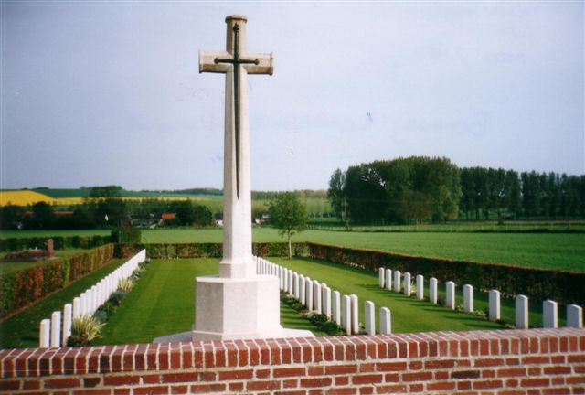
Private 3015 John Tassie is buried here at Bonnay Communal Cemetery Extension (grave reference B 28), near the village of Bonnay on the north west banks of the River Ancre, 3 km north of Corbie in Northern France. The date of death on his headstone is recorded as 25th April 1918, Australian Infantry AIF, 43rd Btn. The extension contains the remains of 106 soldiers; 34 British and 75 Australian.

Researched and written by Richard Turnbull (RDA 1968)

