Some Memories of War – Woods Family
Hi Janet,
I’m writing to you with some info & stories regarding my family that may be of interest to you. In retrospect probably easier to do this by email as they would take up too much air time and not do them justice.
A bit of family history included as well.
I hope they don’t bore you too much!!
My Grandfather – Francis Joseph Woods (1892-1964)
- 4th MGC (Machine Gun Company) fought at Gallipoli and France.
- Suffered disability from mustard gassing, survived and had 4 daughters and a son (thankfully).
My Great Uncle – John Thomas Woods (1890-1945)
- 9th Light Horse
- Wounded at Gallipoli – 24 June 1915 (Wounded whilst in trenches, with a bullet through his left forearm), survived but never married.
My Father – John Francis Woods (1924- 1999)
Joined the RAAF 20 August 1942 – 18 years & 2 mths old.
Trained in Shepperton and Cowra NSW with a friend Frank Petch (Author of the Book – “We Dood It Too”) in which my dad is mentioned numerous times. See below.
My dad was a qualified and efficient Pilot but was allocated to the RAF 12th Squadron (a combined RAAF & RAF squadron) as a Wireless Operator due to his superior Morse code abilities (35wpm+) and he said you never forget it!
He completed a tour of 33 operational missions over Germany where the average was 5 missions.
I met all his crew in Bungaree (5 miles East of Ballarat) in 1971 where my father was the local cop there for over 25 years. He never drank – but the stories at the local were amazing.
I have documented a number of the war stories they related. Quite funny especially those from his Irish Rear gunner. They were just a bunch of kids – my dad kept saying, “I was single at the time”. He only seldom spoke of theses time alone and only when prompted. He survived to raise 6 sons and a daughter – happily married for 50 years.

Myself
I was never in the services but spent 6 years on Bougainville Island (1975-80) with RTZ’s Bougainville Copper Limited. During which I learnt much about the Coast Watchers there and I explored the trenches that had been carved into the coastal cliff areas to observe, record and report on Japanese maritime traffic. There were many stories from the locals of how they helped the Australians and formed a very strong bond with them. I loved hearing some of the stories of these times from Terry Gallaway regarding his father. I can tell by the raw emotion in his voice, when he speaks of his dad, that he holds him in the same great esteem as I do my father.
I visited the crash site (still intact) of General Yamamoto’s G4M ‘Betty’ transport plane shot down by modified (long range fuel tanks) P-38 Lighting fighters from 400mls to the East. Yamamoto was heading to the Ballalae Island airfield. His absolute punctuality was his downfall. I also visited Ballalae airfield, a tiny Island some 300 acres in total which was later sold to a US consortium and stripped of its many tiny tanks, munitions and Japanese Zeros in the late 1970’s. The well-built air strip was still in prime condition these 35 years later.
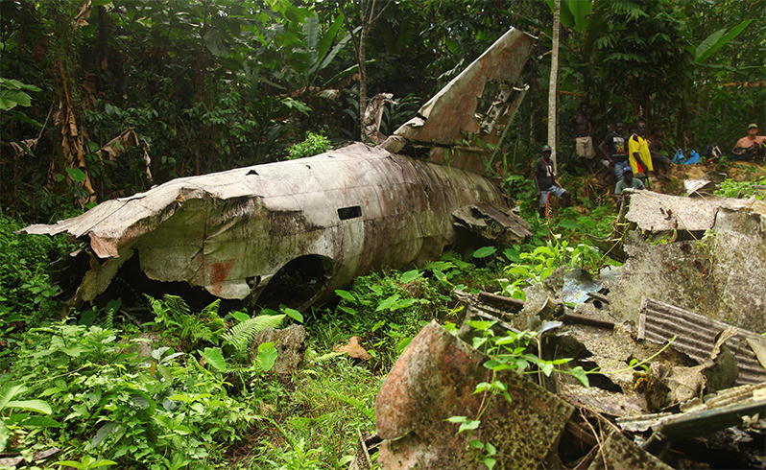
Admiral Yamamoto’s G4M Betty bomber that was shot down on April 18, 1943.
It is located 9 miles (14 km) from the town of Panguna, North Solomon Island.
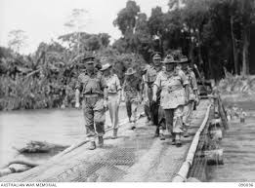
BOUGAINVILLE. 1945-03-26. GENERAL SIR THOMAS BLAMEY, COMMANDER-IN-CHIEF, ALLIED LAND FORCES, SOUTH WEST PACIFIC AREA (5), ACCOMPANIED BY SENIOR OFFICERS, CROSSING THE MCKINNA BRIDGE OVER THE PURIATA RIVER ON HIS WAY TO VISIT FORWARD TROOPS IN SOUTH BOUGAINVILLE. IDENTIFIED PERSONNEL ARE: - BRIGADIER J. FIELD, COMMANDER 7 INFANTRY BRIGADE (1); MAJOR J. SUMMERTON, BRIGADE MAJOR 7 INFANTRY BRIGADE (3); MAJOR-GEN W. BRIDGEFORD, GENERAL OFFICER COMMANDING 3 DIVISION (4); LIEUTENANT GENERAL S.G. SAVIGE, GENERAL OFFICER COMMANDING 2 CORPS (6). THE BRIDGE IS CONSTRUCTED OF WIRE MESH AND LOGS.
Bougainville island was also visited by my Wife’s Great Uncle – Sir General Thomas Albert Blamey in March 1945 during WW2. (see above)
My second youngest son (of 4 boys &1 girl) Jonathan Richard Blamey Woods, went to Osaka High School and Osaka University, fluent in Japanese and had a number of stories to tell his class mates who enquire of his Middle name Blamey. Blamey would have been amused. They googled this name and saw Blamey accepted the surrender of Lieutenant General Fusataro Teshima, Commander of Japanese second Army at Morotai Island and also signed the surrender (on behalf of Australia) on board the US Missouri. Their first question was always – Do you have the Katana (sword)?
My conversations with Tom Blamey (Thomas Blamey’s grandson) confirmed that a lot of these memorabilia many well have been kept with the family and lent to the War Museum as required – for many of Blamey’s personal items including his Field Marshall Baton etc, hardly ever see the light of day.

My Dad - Service No. 419548

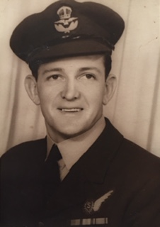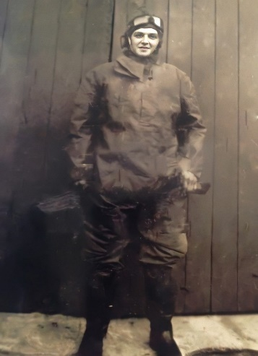
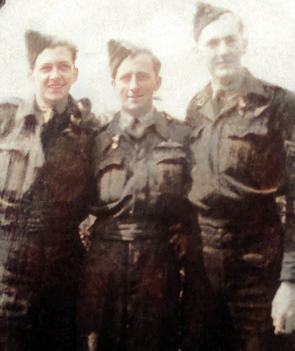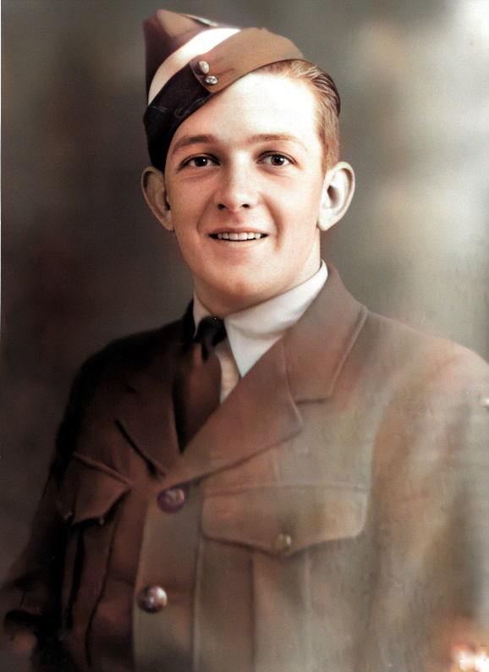
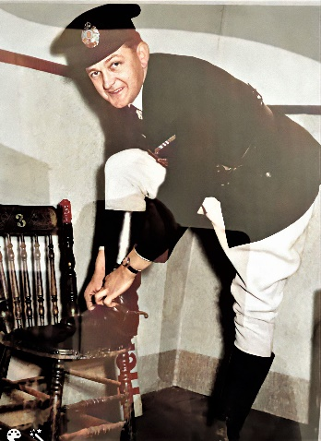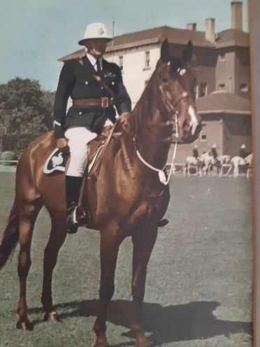
My Dad as a Mounted Policeman - Ballarat
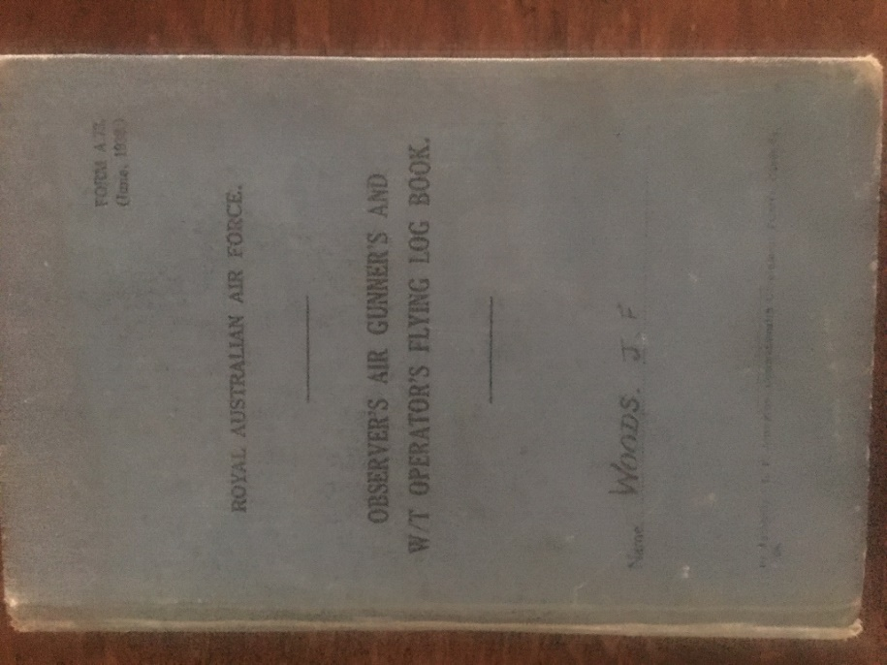
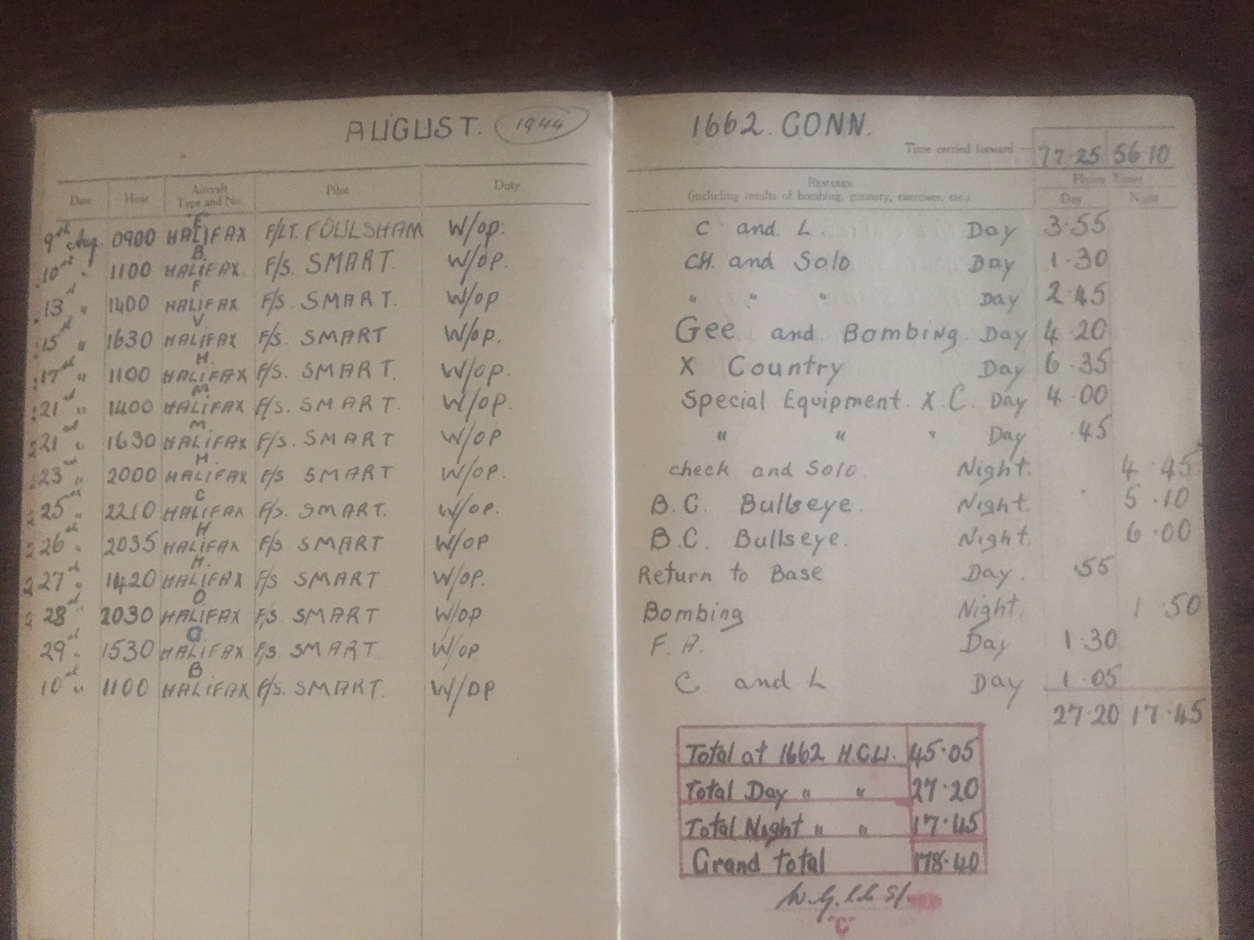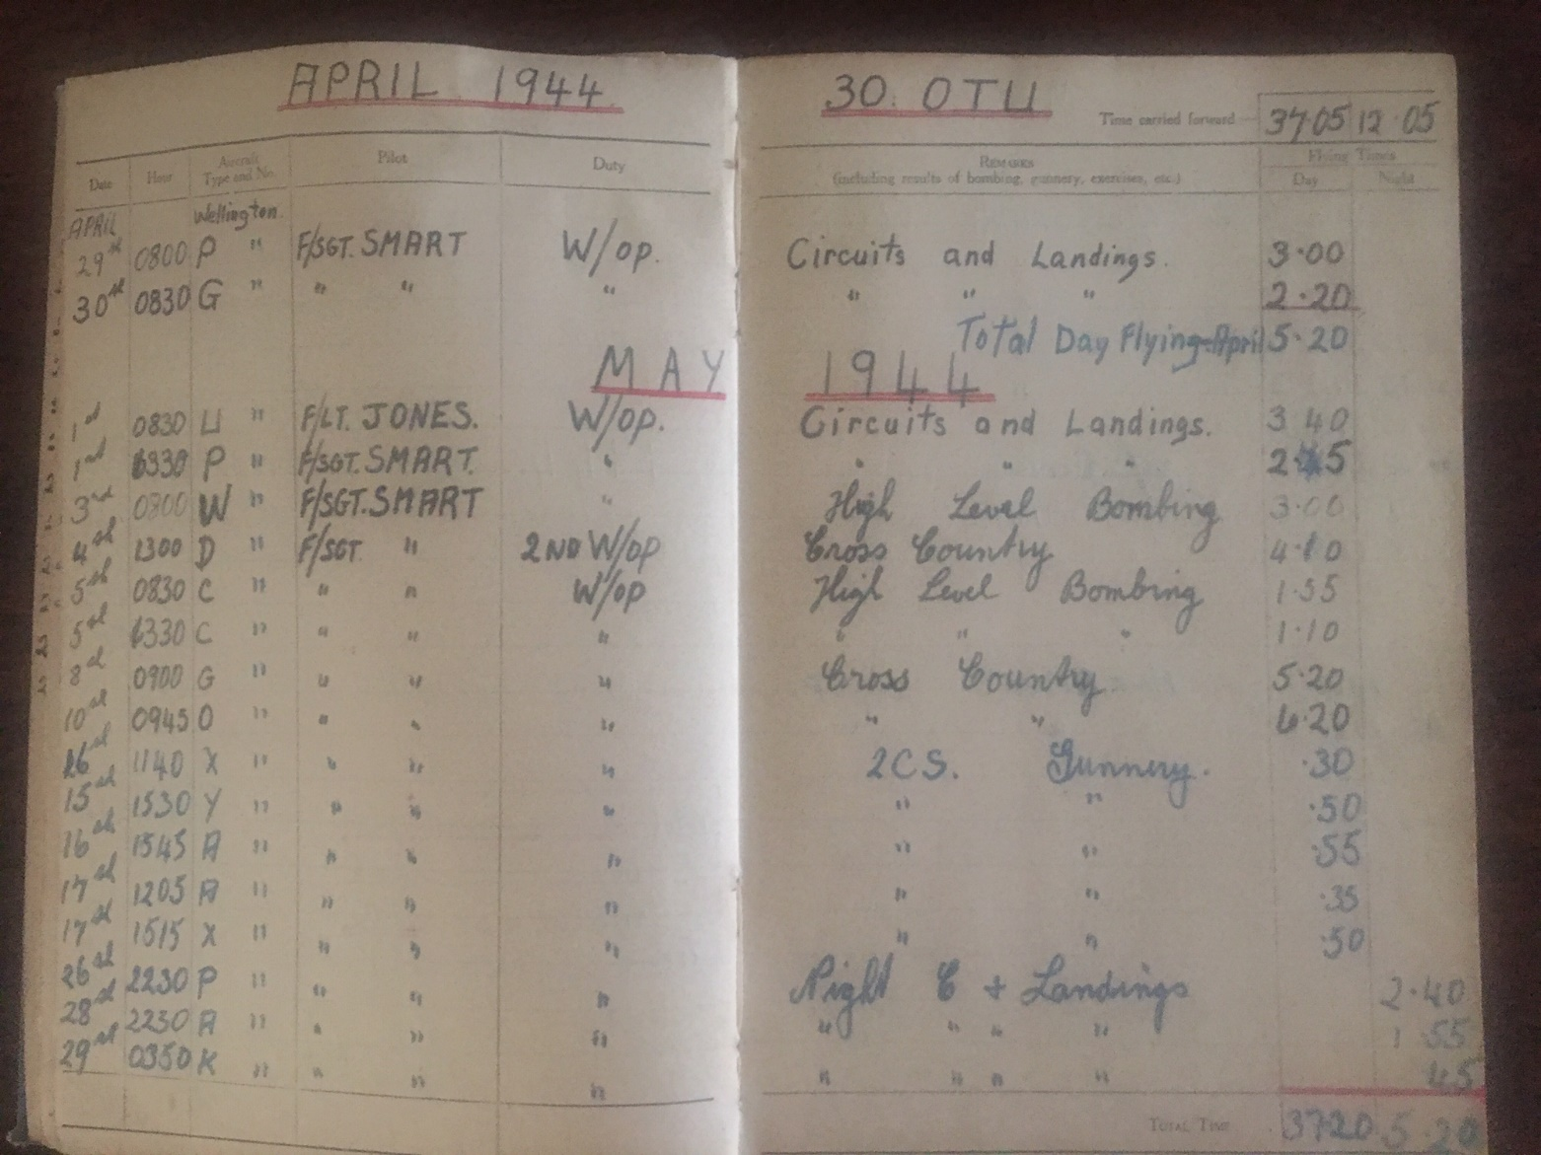
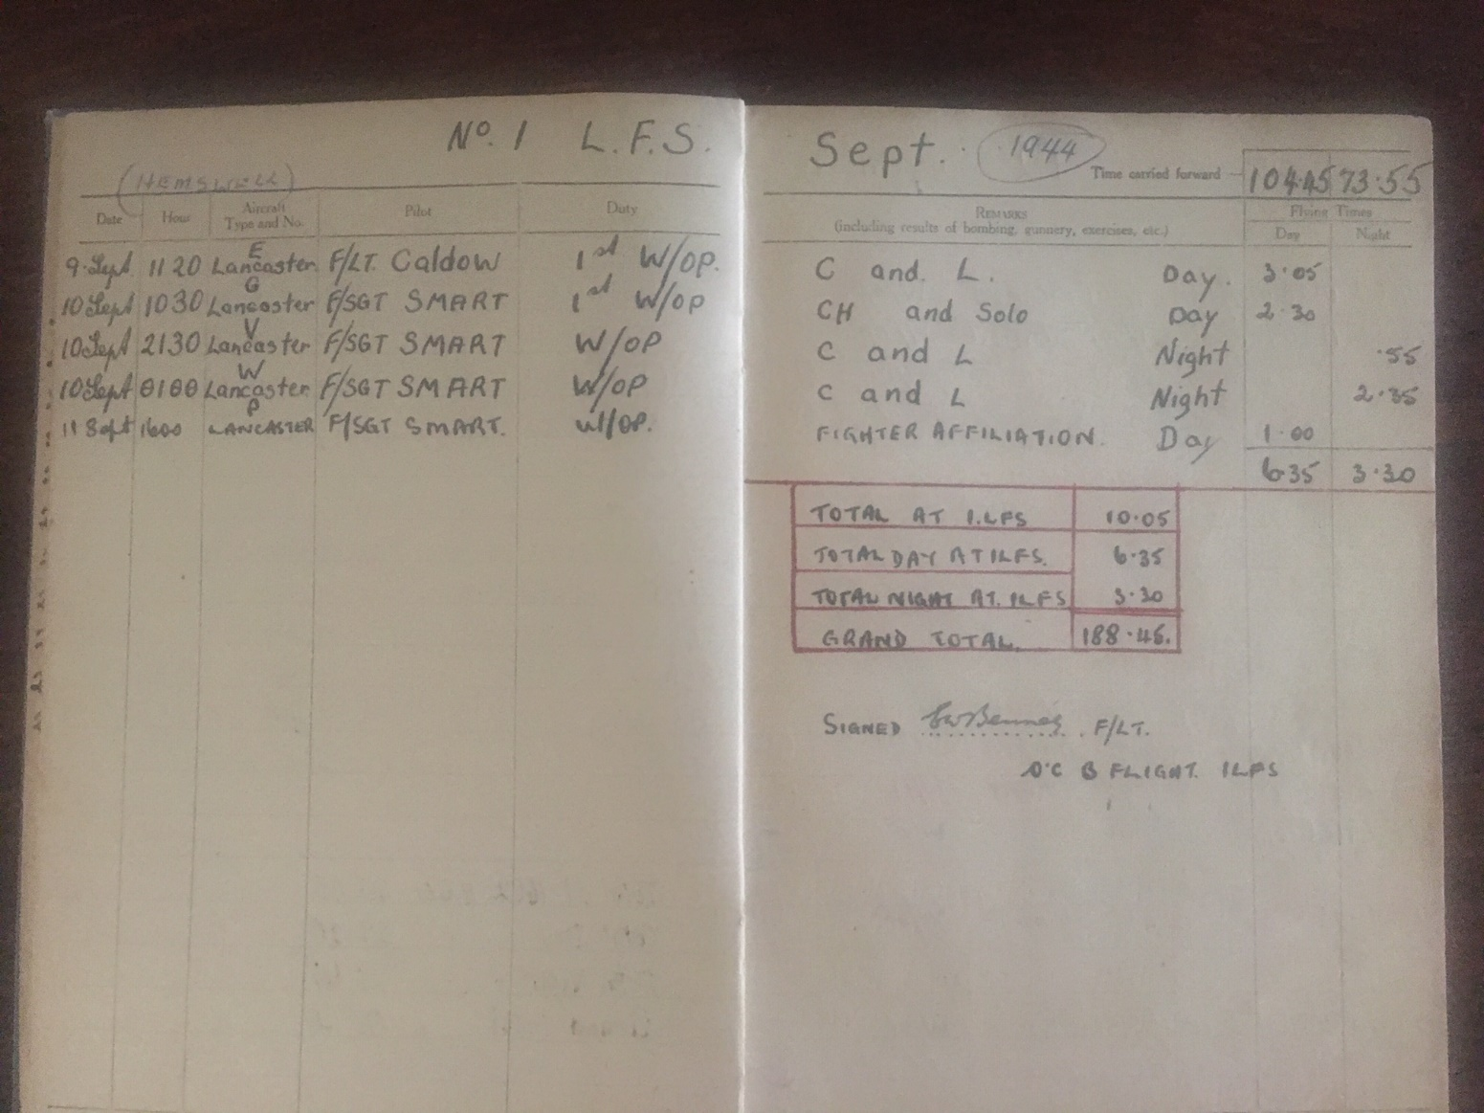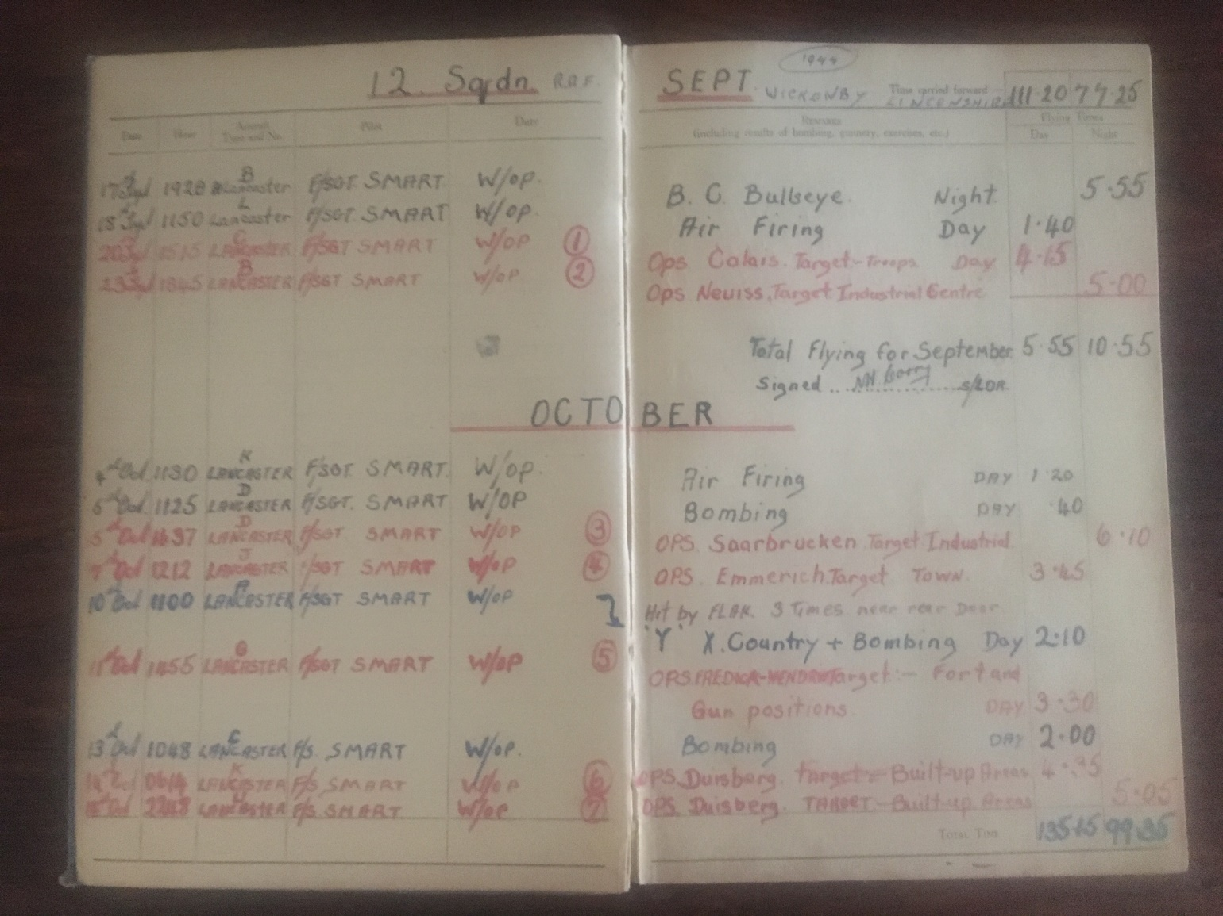
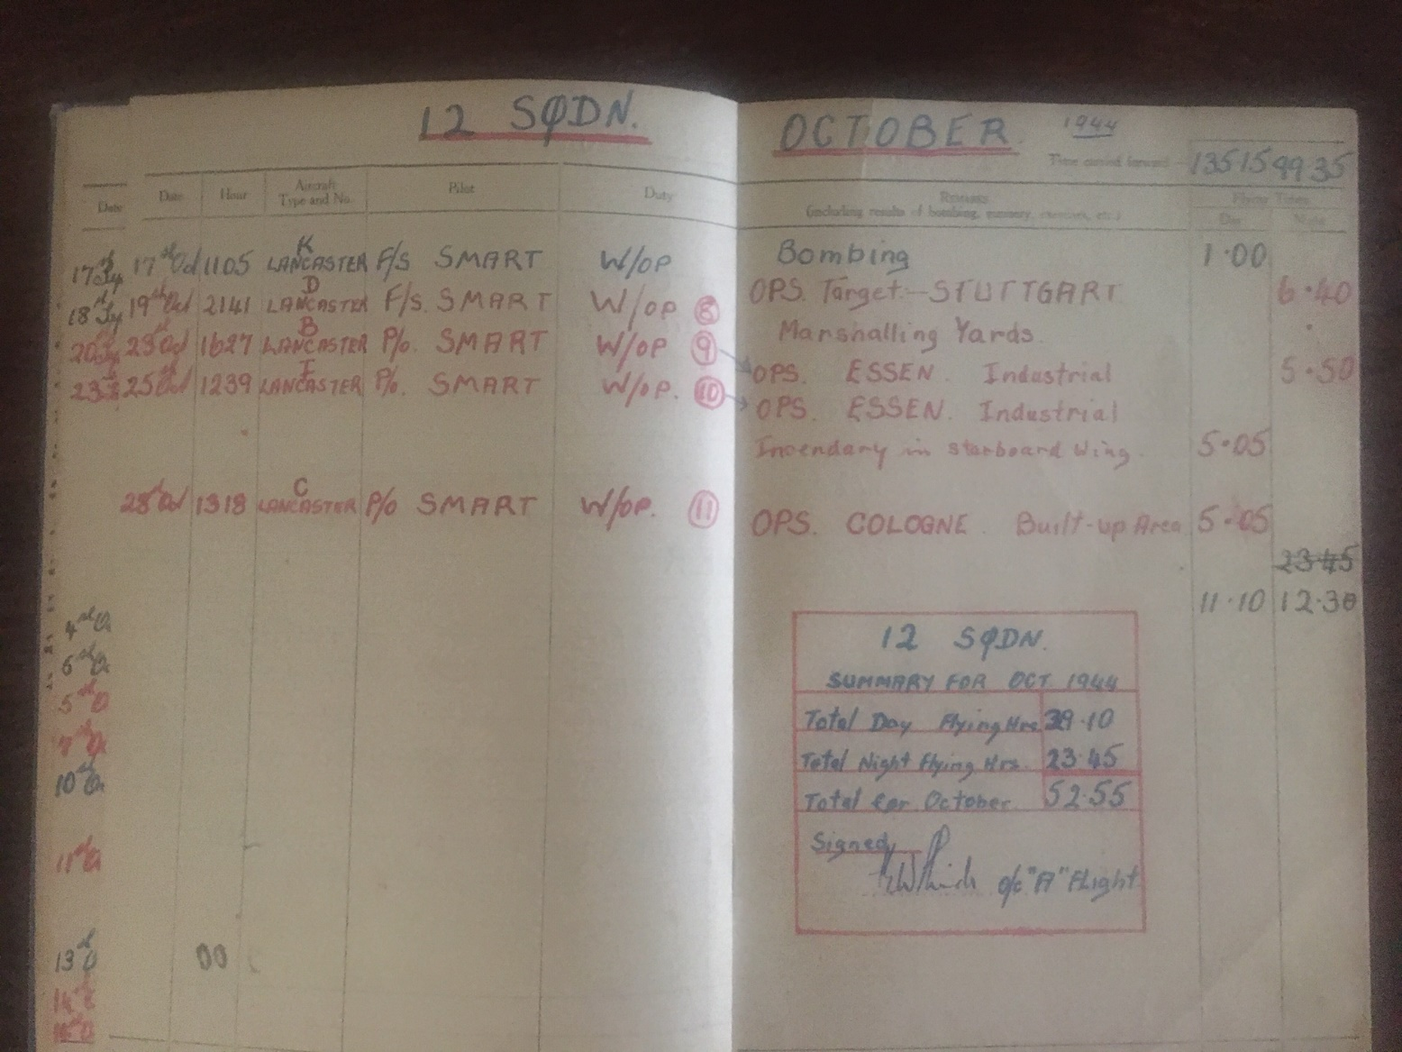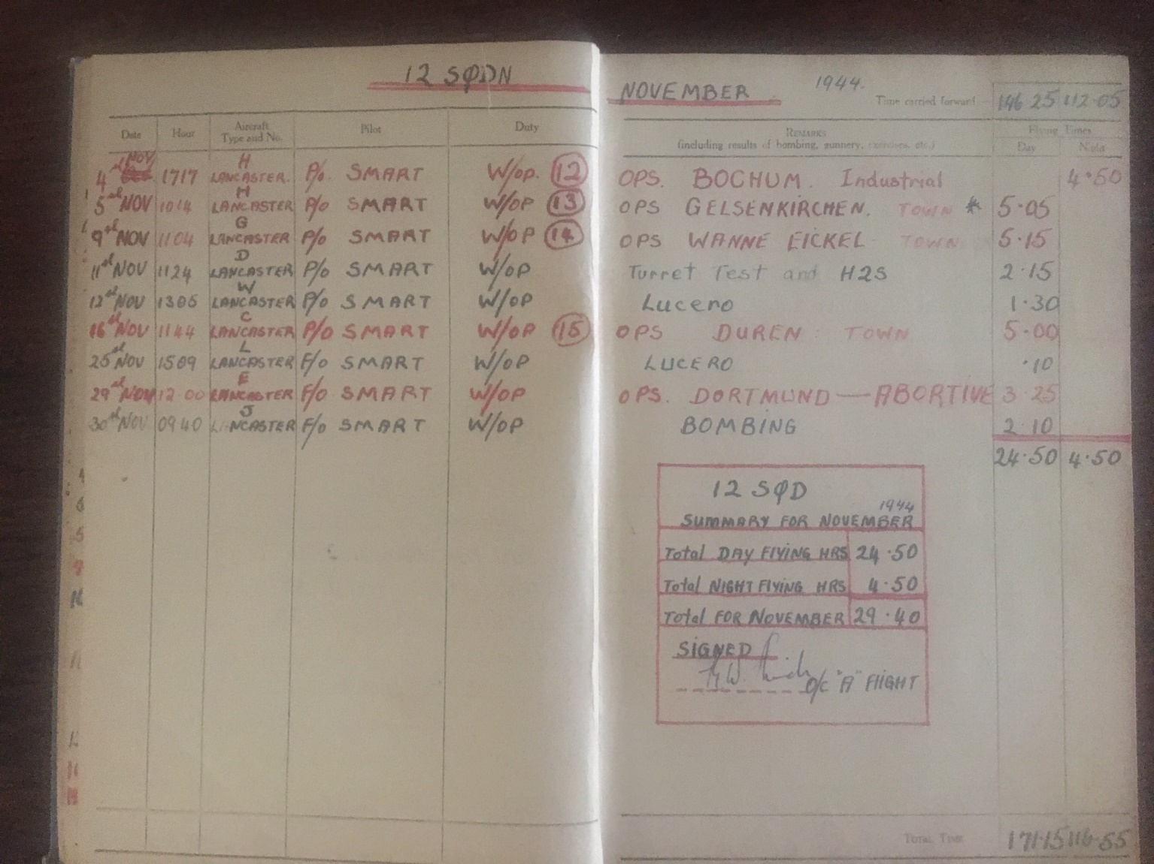
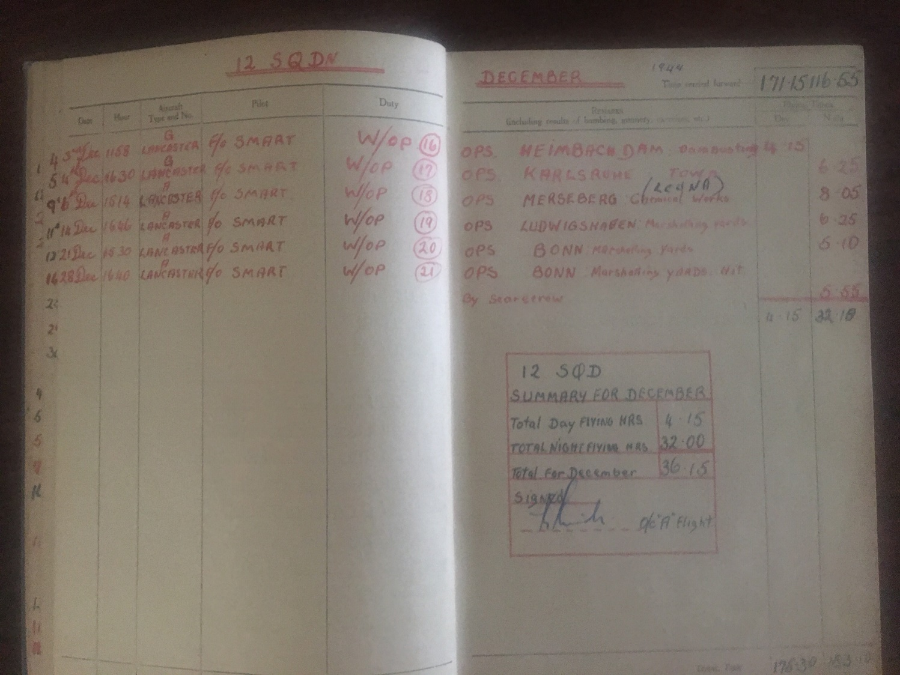
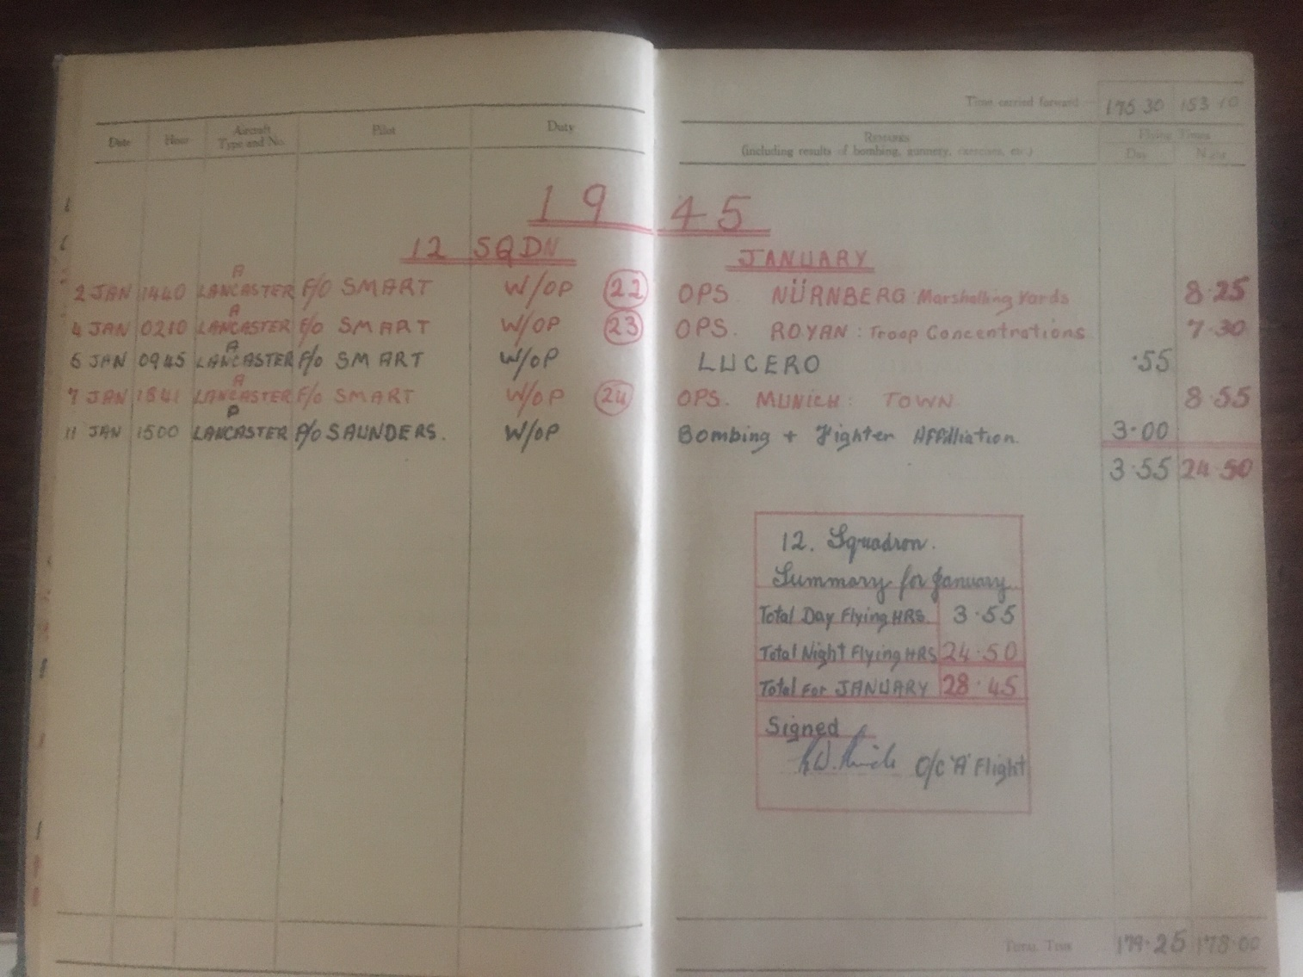
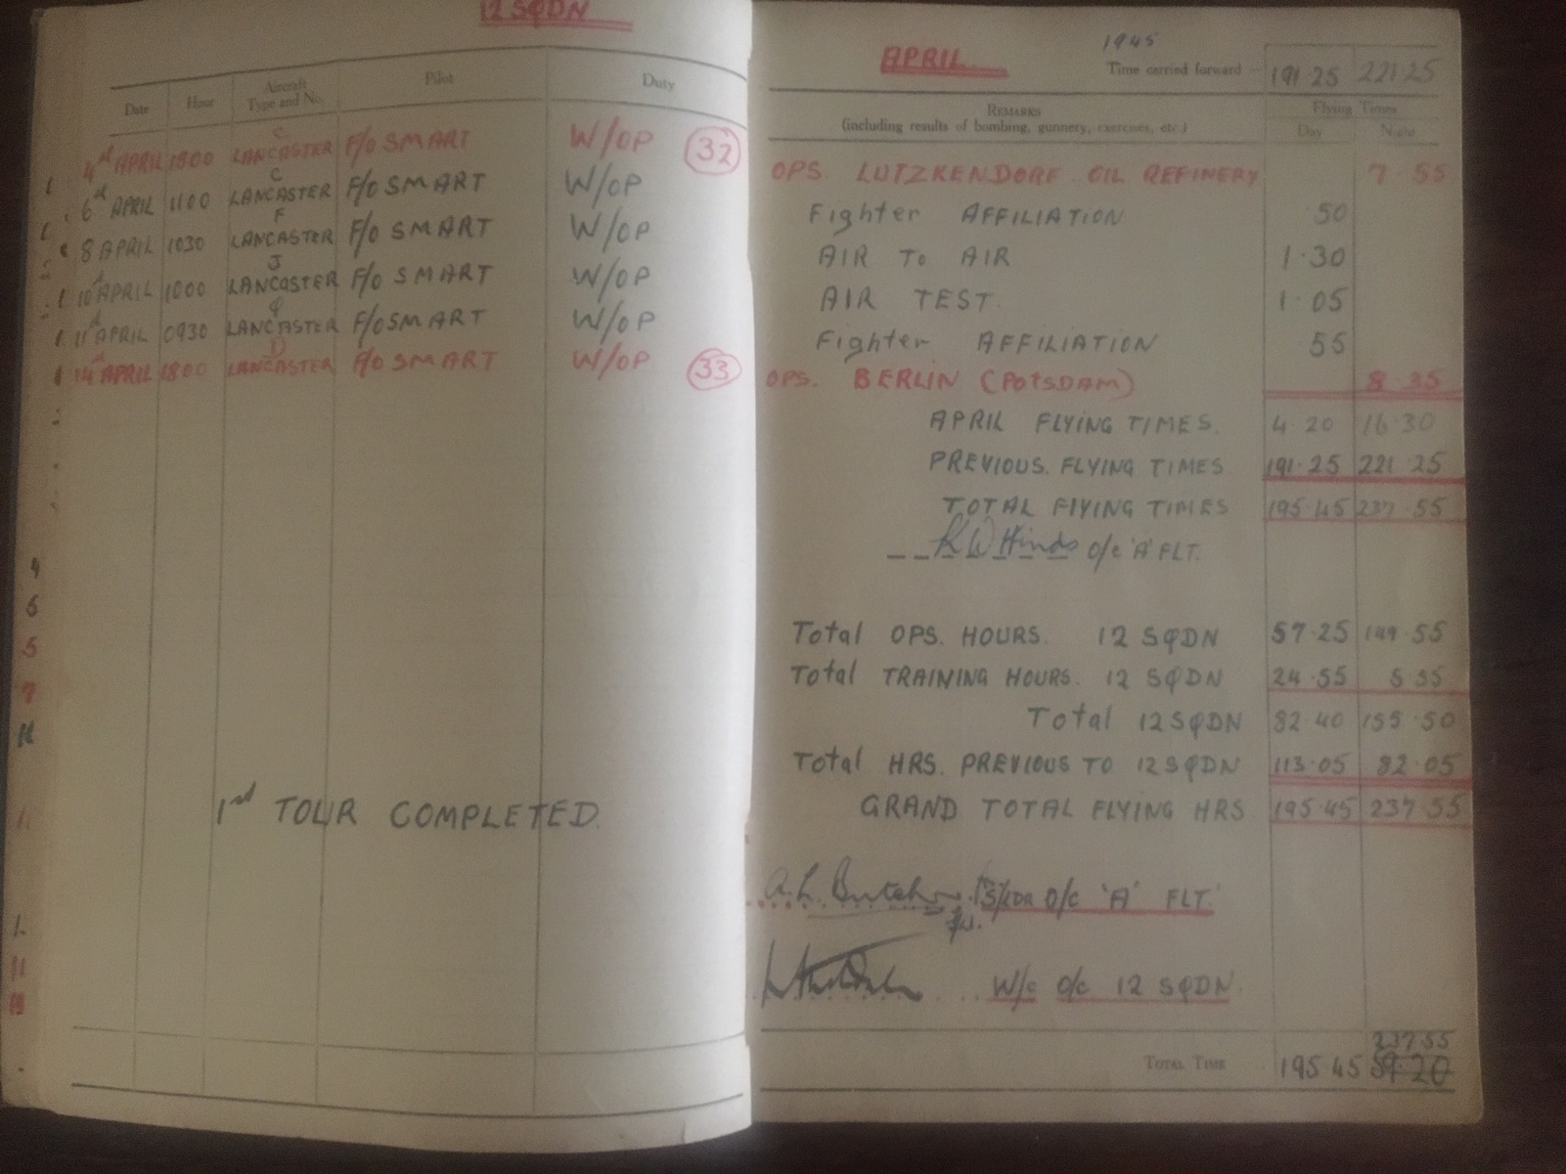

Frank Petch’s Book – a 354-page personal account of his WW2 Journey – A Great Read
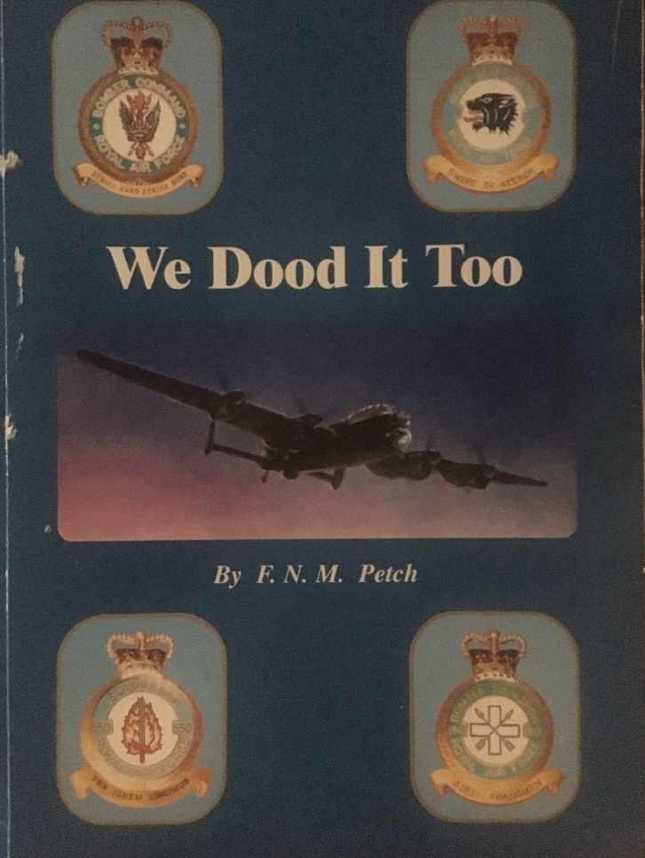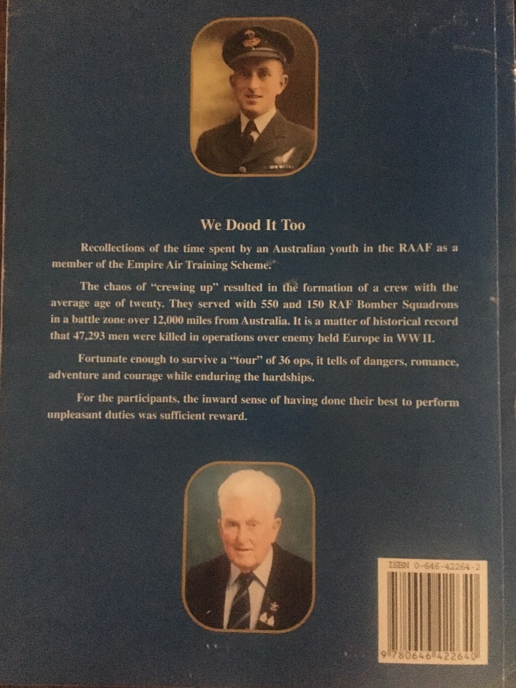
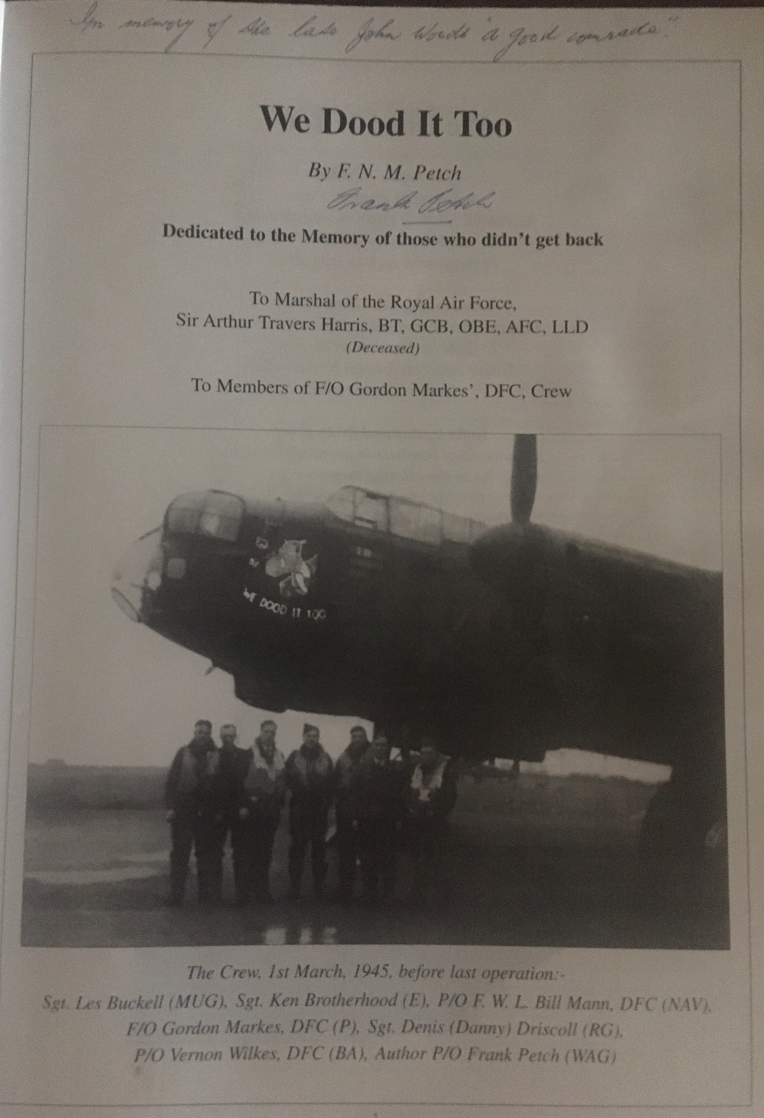
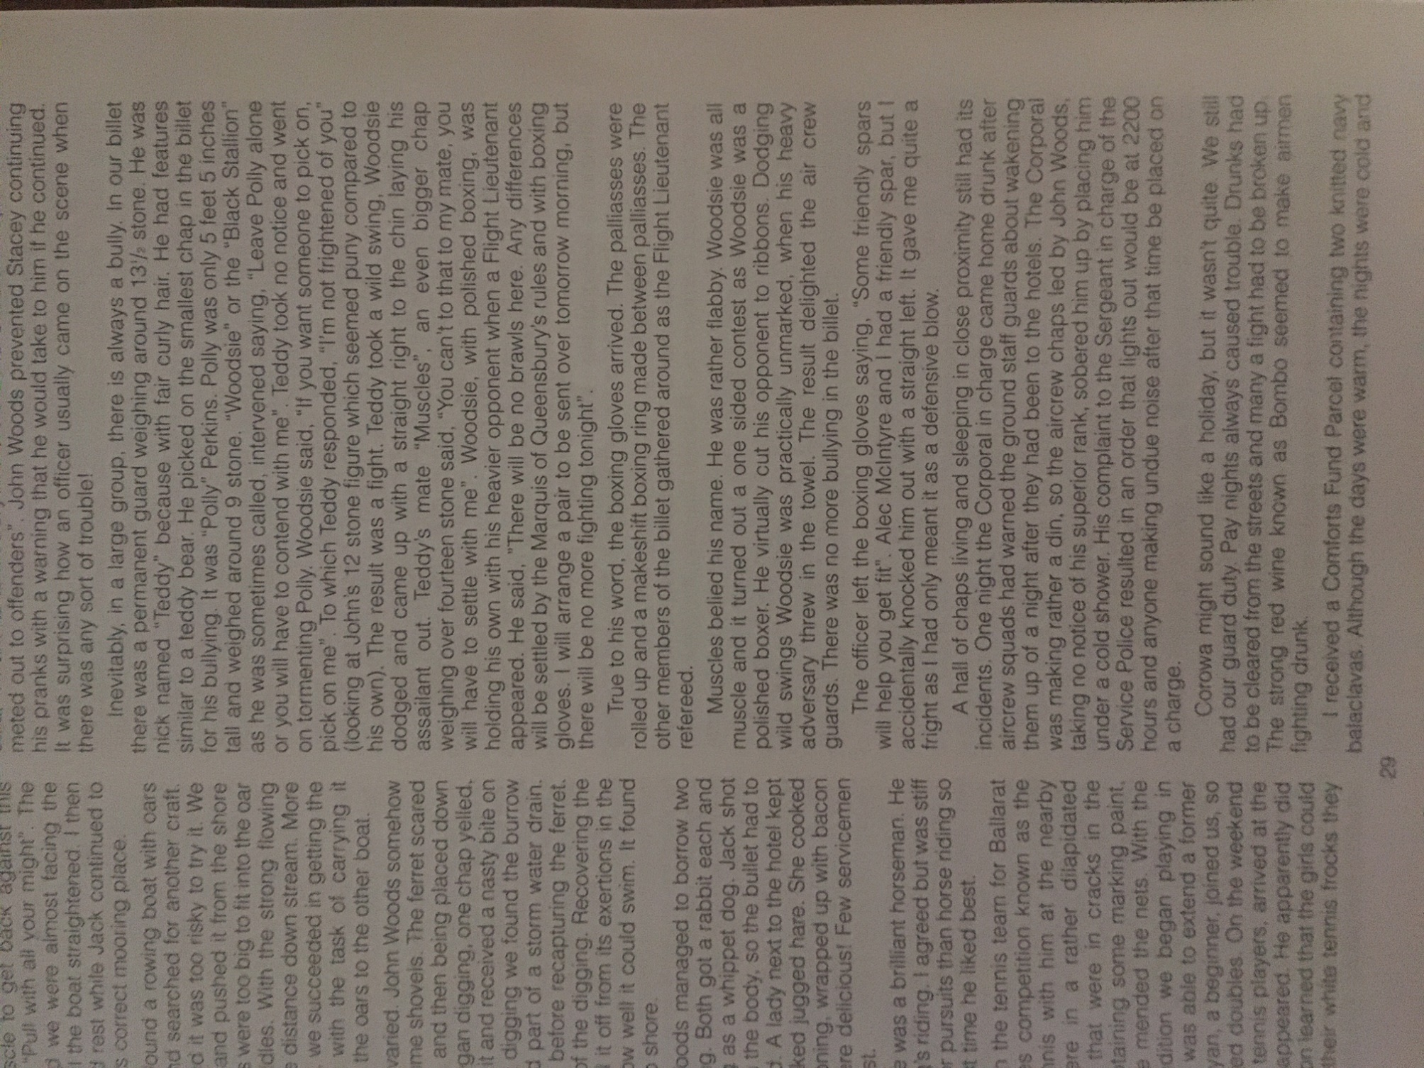

One of the great stories for from Frank Petch’s Book – We Dood It Too
And one of a few, in the book, regarding my father, John Woods – Petch’s close comrade.
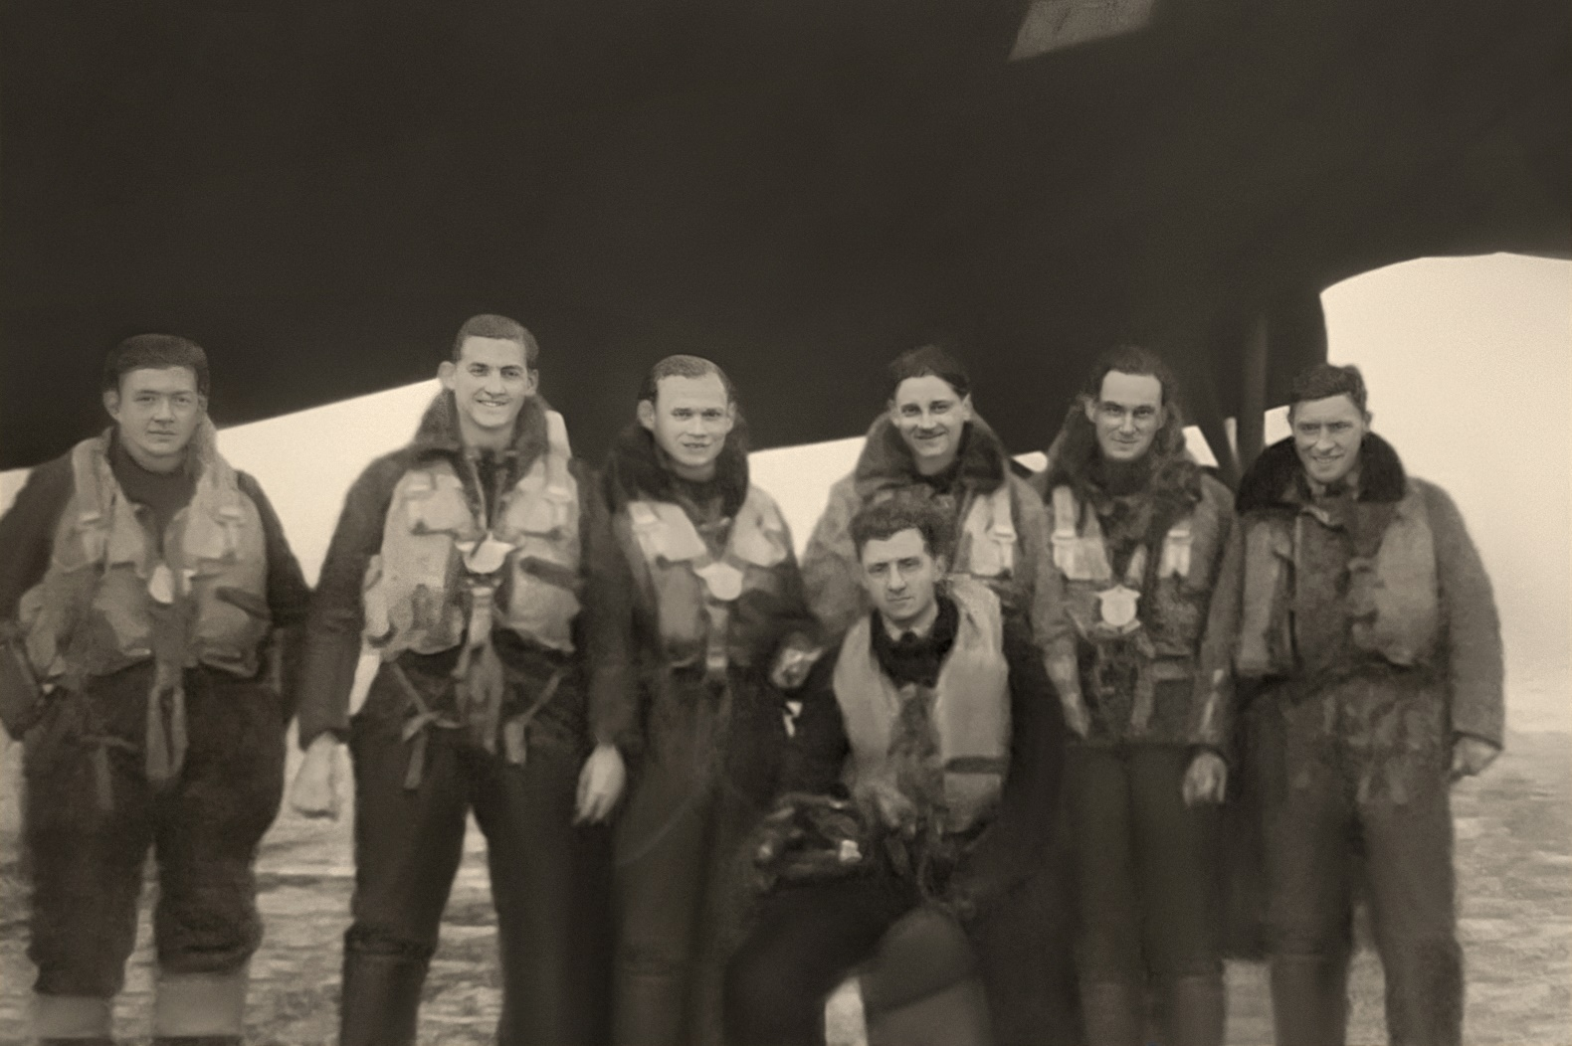
Back Row
Wireless Operator: John Francis Woods RAAF Flying Officer, Service No. 419548
Navigator: Douglas Alexander Herron RAAF Flying Officer DFC Service No. 432004
Bomb Aimer: Geoff Natrass RAF
Engineer: Thomas Grimsby RAF
Mid Upper Gunner: Michael Kirby RAF
Rear Gunner: Jock McNicol RAF (killed in action whilst flying with another crew to complete his tour.)
Front Row
Pilot: John (Jack) Edward Smart RAAF Flying Officer DFC Service No. 427158

