A SISTER AT WAR – Janet Annie McDonald
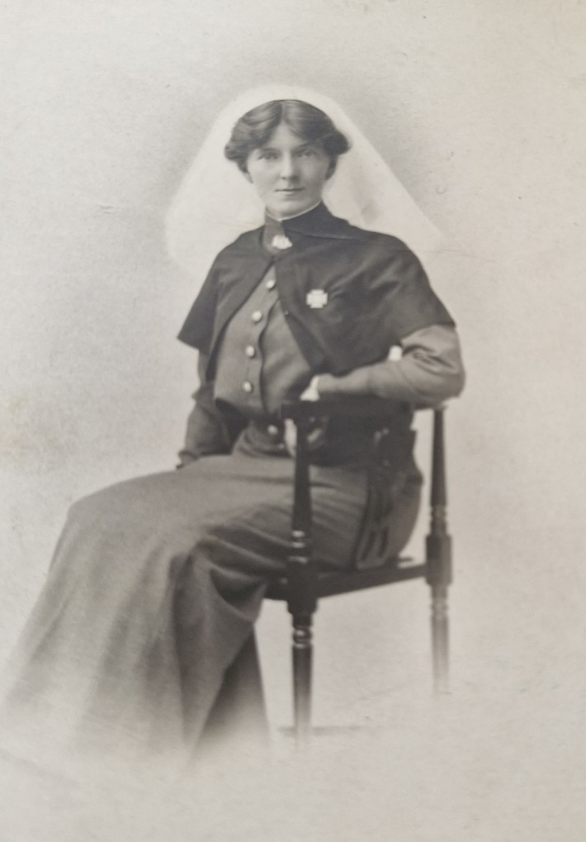

Janet Annie McDonald MBE (also spelt as “MacDonald”) was born in Adelaide, South Australia on the 24th of March 1885, to parents Alexander Norman McDonald (B.1859 – D.1922) and Margaret Jane Catherine Grant McDonald (B.1858 – D.1937).
Janet the eldest of four siblings Norman, Flora (fondly referred to as Buddie) John and Jean. Janet’s brother, John McDonald also served in WW1.

Not much is known about Janet’s early life but on her birth, her parents resided in Norwood, moving to the beachside suburb of Semaphore c1890. It is likely that Janet, along with her siblings, attended Le Fevre's Peninsula Public School – children from the ages of 7 to 13 were required to attend due to the Education Act of 1875.

Janet’s father worked as a public servant at the local post office (still in operation) making life in Semaphore comfortable but quiet.

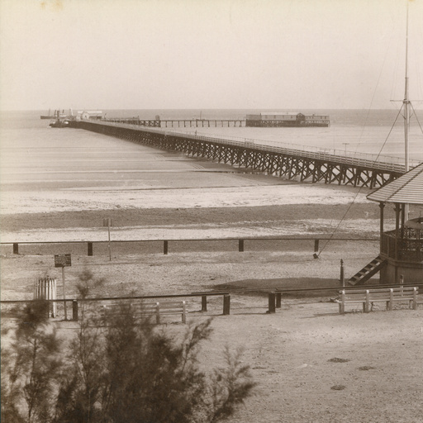
(Semaphore Foreshore, c1890)
(State Library, South Australia Semaphore Collection)

After leaving school Janet pursued a career in nursing at the Royal Adelaide Hospital, later gaining employment at the Broken Hill Hospital, New South Wales where she worked as a night superintendent. before enrolling in the Australian Army Nursing Service on the 13th of January 1915 at the age of 28.
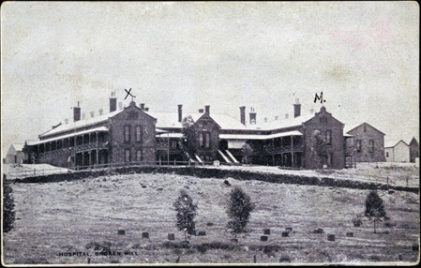
(Broken Hill Hospital c1913)

Janet enrolled in the Australian Army Nursing Service, signing her enlistment papers on the 13th of January 1915 - see enlistment papers below. Whilst enlisted, Janet served in Egypt, France and England until March 1919 as a nursing sister. She also assisted in the transportation of wounded soldiers from Egypt to New Zealand.

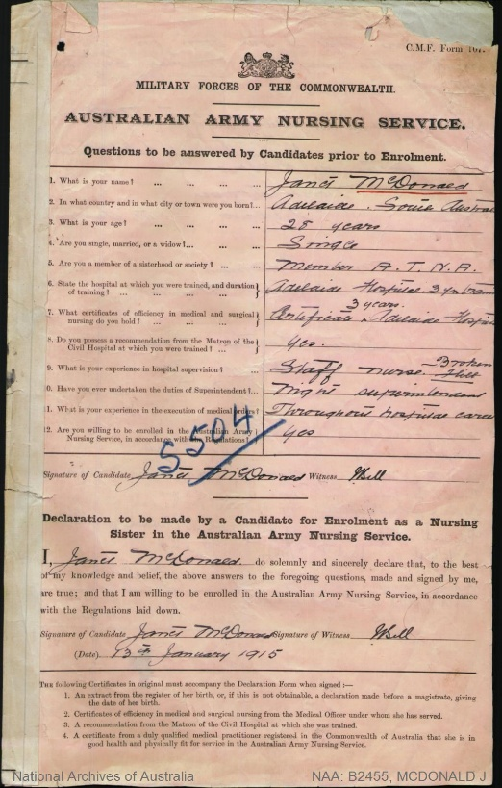

(Enlistment Paper, National Archives of Australia)

On November 11, 1918, when the Armistice was signed (the end of WW1), Janet returned to Australia and resided in Perth, Western Australia on the ship “Delta” at Fremantle dock. Her appointment as a sister enlisted AANS was terminated on 9 December 1919.

Once settled in Western Australia, Sister Janet McDonald took up a position as Matron at Kalamunda Hospital in 1920, convalescent home, also referred to as the “Kalamunda Convalescent Farm”.

The Kalamunda Convalescent Farm was established to provide care and recovery for "war-worn and weary soldiers" and civilians. It aimed to restore the health of returned soldiers through a farm environment.

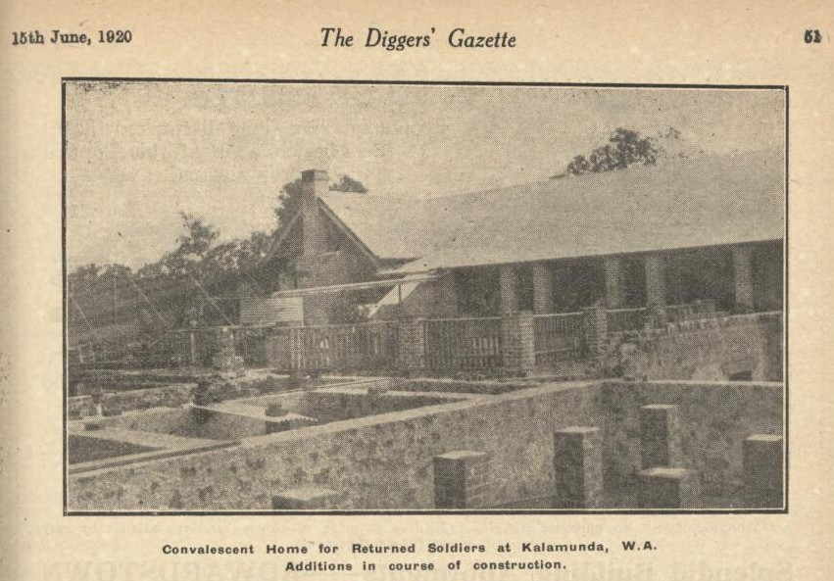

From 1930 to 1939 Janet worked at Lemnos Mental Hospital, Perth Western Australia as the Principal Matron of Western Command.

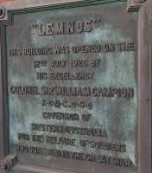
Lemnos Mental Hospital was specifically opened for the recovery of WW1 soldiers suffering from PTSD, opening in 1926. It was named after the Greek island relevant to the Gallipoli campaign, providing a home-like environment rather than a strict institution.

Sister Janet McDonald was chosen to attend the Coronation of King George VI on 12 May 1937, representing the returned army nurses of Western Australia (Australian Women’s Weekly 13 November 1937). She was also accorded the honour of representing the ‘Ladies of the Lamp’ at the coronation.

An interview prior to her departure to England (6 March 1937) at the “Army Nurse Social” Lieutenant General Sir J Talbot Hobbs comments, “I am sure that the selection of Matron Janet McDonald to represent the returned Sisters of Western Australia at the coronation is a most popular one”.

Below are articles that contain interviews about Janet and what one of her patients had to say about her after she was chosen to go to England to attend the coronation of King George.

The Mirror article dated 6 February 1937, some of the soldiers interviewed noted “...the Matron is a lovable person and has even allowed diggers to call her “ma” or “mother” ...”.

They also referred to being “a disciplinarian” and “her yes is her “yes”. A good story is told by a digger of her firm but kindly methods “I was in hospital she was sticking a needle in me telling me all the time that it was for my own good. Finally, I said to her it hurts, sister. Well, it doesn’t hurt me, she replied. I stood it for a while and then I said again, I tell you it hurts me, but she didn’t stop longer than to say, “well I can’t feel it Joe, now be a good boy and go to sleep”.

When interviewed for The Daily News Perth, 9 February 1937, Sister McDonald spoke of the spirit of adventure and the urge to practice her profession where it was need most. Commenting “we had men friends and relatives in the firing lines and wanted to perhaps meet and nurse them”. She stated, “we all had the experience of dreading to take off bandages for fear of what we would see” noting “the men, however, were so wonderfully brave...”.

Following the coronation, Janet spent 6 months travelling in England, Germany and the Hebrides. During this time, she completed a short postgraduate course in psychology and visited numerous hospitals treating patients with nervous disease (PTSD). She returned to Lemnos Mental Hospital in November of that year to resume her position as Head Matron continuing to devote her life to caring for soldiers suffering from nervous disease after the war.

Janet retired from nursing in January 1949 in Perth, Western Australia. It is unclear when she returned to Adelaide but somewhere between 1949 and 1958, possibly after the death of her brother John Malcolm McDonald (27th of May 1951), residing at the family home in Torrens Park with her sister Flora McDonald (Buddy).

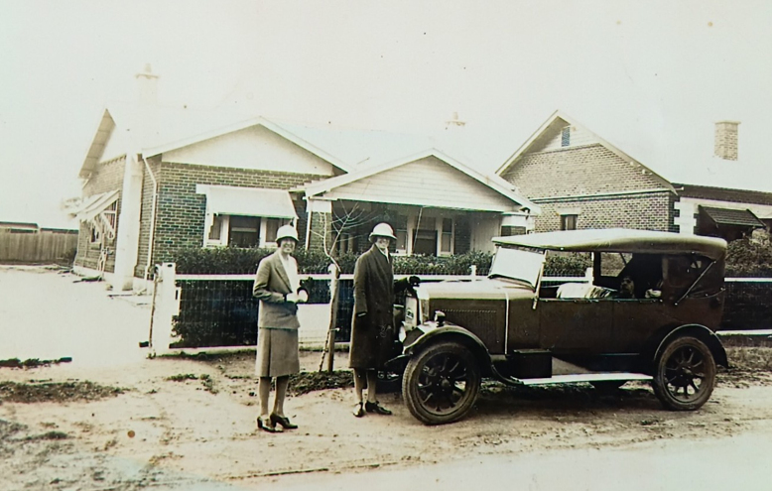

(Buddie and Margret in front of the family house Torrens Park 1930)
During her time in abroad Janet attained two seeds one of a Lone Pine and a Gallipoli Oak, two native trees from Turkey that became a symbol of the Gallipoli campaign after cones were retrieved and often brought back to Australia as a living memorial to those who served in the campaign. Both trees are now fully grown and planted in the descendants yard still serving as a living memorial to those who lost their lives.
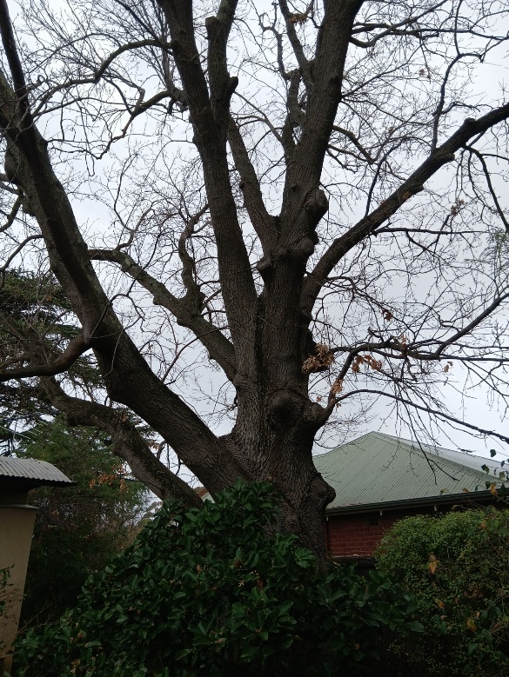
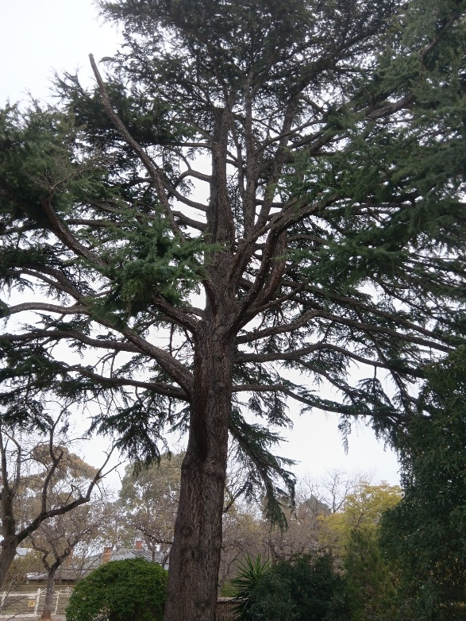

Janet died on the 17th of October 1958 in the Royal Adelaide Hospital due to cerebral haemorrhage. After her death Janet donated all her money to a retired greyhound facility.

Janet was a woman before her time who understood nervous disorders, which we currently known as PTSD and the traumas of war. She devoted her life to nursing and the recovery of others. Janet was described to me as a stern but kind woman who was no-nonsense, but she was also a kind, loving woman, allowing patients to call her Ma or Mum. I think Janet reflects the Anzac spirit, characteristic of discipline and perseverance, as she was away from home and her family for most of her life, practising what she loved and helping other in the process.

My visit to the McDonald family grave on the 2nd of August.
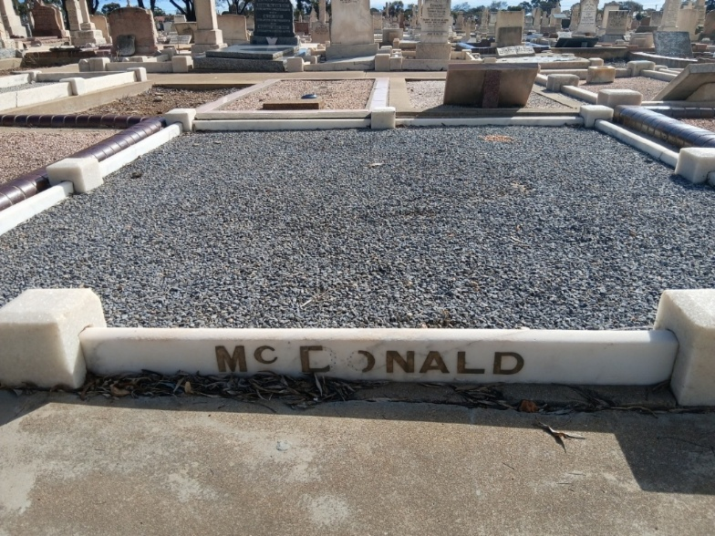

(McDonald family grave, Cheltenham Cemetery)
John Malcolm McDonald, Janet’s brother was in Gallipoli in May 1915 and in the Middle East. He served in the 9th Light Horse Brigade, returning to Australia due to a gunshot wound in left thigh, 1917. He then returned to the Middle East in December 1917, again with the 9th Light Horse Brigade. John died in Tilpa 1951 at the age of 61.
I wanted to include John McDonald in my submission as I believe the war brought Janet and him together. Even though they are the furthest apart between their siblings, Janet and John were the only two who enlisted and served in WW1. I think they might have also met during their time overseas.
When meeting with the descendants, Tony spoke fondly of his great uncle returning to Adelaide for every ANZAC Day, attending the march in Adelaide and taking Tony on the Popeye. Tony also said they weren’t sure where John learnt to ride a horse and assumed he must have learnt whilst in Egypt.
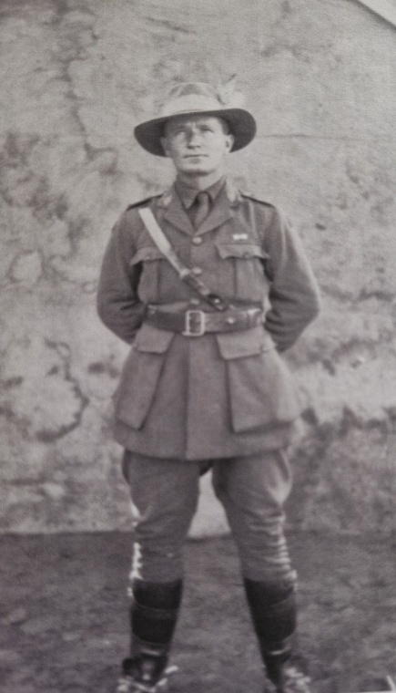
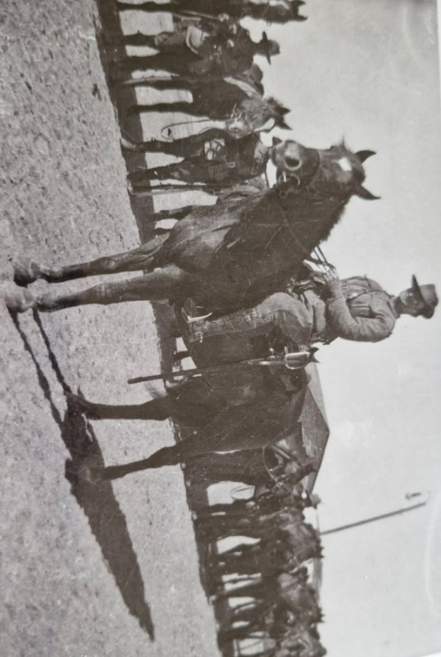
(John on his horse – 9th Light Horse Brigade, Gallipoli campaign)

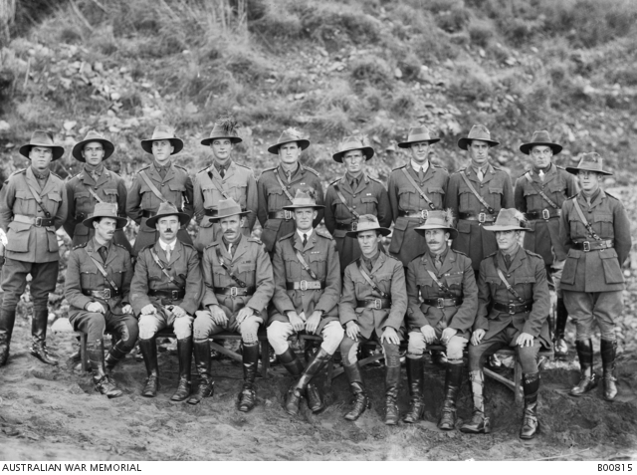

(9th light horse regiment John is fifth from the right-hand side backrow)

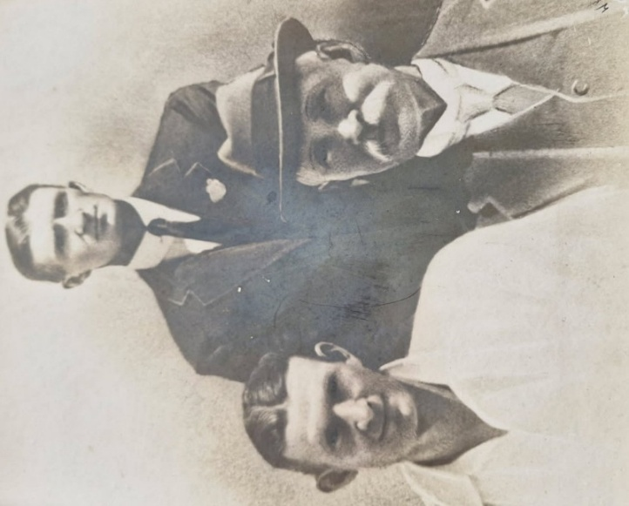
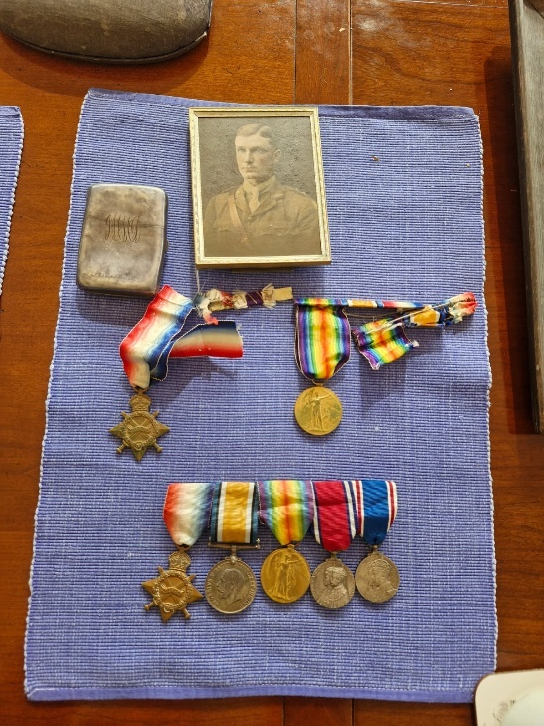
(Family medals) (Family photo John (back ) his father right corner and brother Norman on the left)

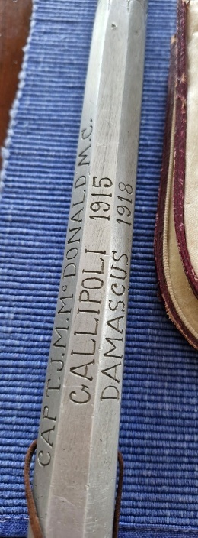
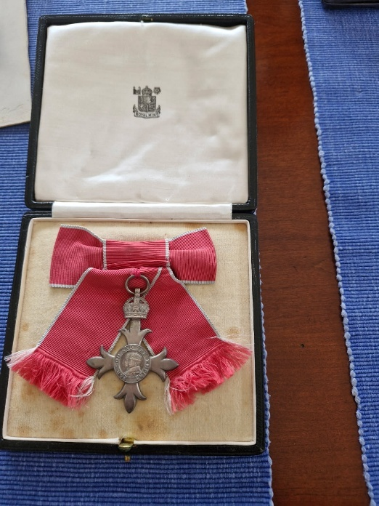
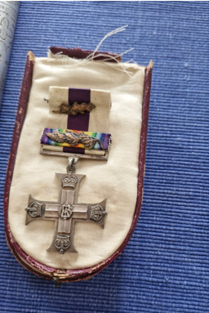
( Janet’s medal) ( Swagger stick used for killing enemies) (Janet’s MBE)

 | Timeline of Janet McDonald’s life
1885 | Birth of Janet Annie McDonald
1886 | Birth of brother Norman Alexander McDonald
1888 | Birth of sister Flora (Buddie) McDonald
1890 | Family moved to semaphore
1890 | Birth of brother John Malcolm McDonald
1892 | Birth of sister Jean McDonald
1900 | Janet left school
1915 | Enlisted in Australian army nursing service
1918 | World war I ended
1919 | Termination from Australian army service
1920 | Janet worked at Kalamunda hospital
1922 | Death of Father Alexander Norman McDonald
1930 | Janet started working at Lemnos mental hospital
1937 | Janet attended king George VI’s Coronation
1937 | Janet was awarded Ladies of the lamp
1937 | Janet travelled for six months in England
1937 | Janet completed a short postgraduate course in psychology
1937 | Janet returned to Lemnos mental hospital
1937 | Death of Mother Margaret Jane Catherine Grant McDonald
1951 | Death of Brother John Malcolm McDonald
1953 | Death of brother Norman Alaxander McDonald
1956 | Death of sister Flora (Buddie) McDonald
1958 | Death of Janet McDonald

Bibliography
Australian Nurses in World War 1 (n.d.), Australian Nurses in World War 1, accessed 10 March 2025. https://ausww1nurses.weebly.com/

‘Broken Hill Hospital’ (2025), in Wikipedia, accessed 15 March 2025. https://en.wikipedia.org/wiki/Broken_Hill

[Convalescent Home for Returned Solders at Kalamunda, W.A. Additions in course of construction] (1920) The Diggers' gazette : official organ of the Returned Sailors' and Soldiers' Imperial League of Australia (South Australian Branch), Vol. 1, no 15(June):51.

McDonald, John M (Captain, MC, 9th LH Regt) (n.d.), The Australian War Memorial, accessed 20 June 2025. https://www.awm.gov.au/collection/C89899

The Daily News (Perth, WA : 1882 - 1955) (9 February 1937) ‘Should there be another war’, The Daily News.
Thank you to all the wonderful people at the Headstone Project for your support and for helping me with my submission.

Part B
My information was sourced through articles, newspaper cuttings, and family records sourced through the descendants. An interview was also conducted on the 2nd of August to help me gain further insight into what type of people Janet and John might have been.
The descendants also kindly shared stories and memories of their relatives that I included in my report. I met with Tony and Pam at their home at Torrens Park, the same house Janet lived in after coming back to Adelaide. This proved to be a very special moment for me, as I felt a sense of connection getting to see the house Janet lived in.
Tony’s great-grandfather was Norma, Janet and John's brother, who was the only sibling to marry and have children.
The wonderful people at the Headstone Project also played a critical role in my report as they recommended, I research the McDonald siblings and helped me get in touch with the descendants. The Headstone Project is filled with passionate and dedicated volunteers that helped me uncover more about Janet’s story.
Interview questions:
- How are you related to Janet?
- What can you tell me about Janet schooling?
- What did life look like before World War I for Janet?
- How would you describe Janet?
- Are there any stories you’d like to share about John and Janet?
- What do you know about John’s experience and service in the war ?
- What do you know about Janet’s experience and service in the war?
- Why didn’t Janet marry after the war ended?
- Why did they enlist in world war I?
- What was Janet and Johns relationship like growing up?

