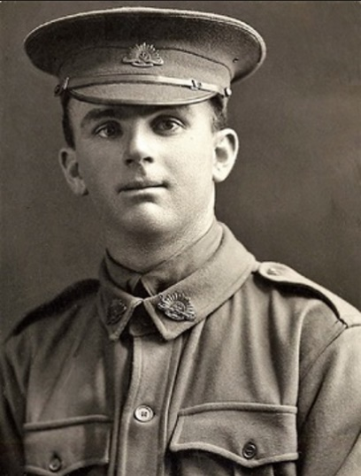
William James Codd Soldier Profile
William James Codd was born in Port Pirie on May 1894. There is not much information about his early life, except his parents, Jane Codd (his mother), and James Codd (his father), and where he lived, Mile End, city of West Torrens. He worked as a locomotive engine cleaner, and as per his later Attestation Papers, he stated his religious denomination as methodist. He was the age of 21 years and 4 months at the time of enlistment, which was 27th September 1915 in Adelaide, South Australia. His standing height was 5 foot 6 inches, chest width 2 foot 7.34 inches, and weight 141 lbs. His papers describe that he had brown eyes, dark brown hair, and a fair complexion. Once his application was accepted, he left his role as a locomotive engine cleaner to join the WWI efforts and placed into the initial role of private with prior military experience of 4 years in the citizen forces. The citizen forces was a home-defence army, part of the Australian Military forces created in 1903, it was part-time as it was mostly made up of volunteers. But from 1911, it became compulsory training for young men and was the time when William James Codd joined the citizen forces and served as a training ground for men who later for the AIF in WW1.

Codd embarked from Adelaide to Suez, Egypt on board HMAT A28 Miltiades alongside other A.I.F soldiers on 7 February 1916. His service number was 2003, he arrived at Zeitoun, Egypt to participate in training/conflict/battle, where he was a part of the 3rd Training Battalion. After completing his training, he marched out of the 3rd training battalion and taken on strength of 32nd battalion on 1st April 1916. He was deployed to France to join the British Expeditionary Force in the Battle of Somme, a conflict that lasted from July to November 1916. But he was shortly injured after 26 days of battle on 19 July 1916. He sustained a gunshot wound to the thigh and was transported to the No 1 Casualty Clearing station for treatment, spending a day there, before relocation to a number of other hospitals, including No 14 General Hospital, Wimereux the next day, then to No 1 War Hospital, Birmingham, where he was finally able to rest for about 1 month and a half. He was then transferred again to No 1 Australian Auxiliary Hospital, where he rested for another 3 days before he marched into No 2-command depot.

Private Codd then marched into No 1 command depot, 11 October 1916, then into No 3-command depot, 13 October 1916, where he stayed for a couple of months, and marched into No 4-command depot, 26 March 1917 and then back into No 3 command depot on 19th March 1917. He was then classified class B1A4 on 1st April 1917 and transferred to and taken on strength of 70th battalion, Wareham, 3 April 1917. After about 4 months, he was transferred to the 32nd battalion on 19th September 1917 and marched into 69th Draft battalion on the same day.

He then proceeded overseas back to France on 14th October 1917, and marched into 5th Australian Divisional Base Depot, Le Havre, 15th October 1917, and was soon taken on strength of 32nd battalion on 26th October 1917. He was accidentally injured two months later in a train accident on 16th December 1917, and admitted to No 3 Canadian General Hospital, Boulogne on the same day due to a fracture in the right tibia. After a week, he was transferred to England on 22nd December 1917, and then to Exeter War Hospital the day after. After about 3 weeks, he was moved to No 1 Australian Auxiliary Hospital on 12th January 2018, and then discharged, and marched into No 3 Command Depot, Hurdcott on the 1st of February 1918.

After about 4 months, Private Codd marched into No 1 Command Depot, Sutten Veny on 6th June 1918. He was then classified class A3 on 15th July 1918 and marched into Overseas Training Depot, Longbridge Deverill the next day. After completing his training, he proceeded overseas back to France on 8 August 1918, and marched into Australian Intermediate Base Depot, Le Havre, on 10th August 1918. He once again rejoined the 32nd Battalion on the 12th of August 1918. After a long battle, he proceeded to England for return to Australia on 5th March 1919, and marched into No 1 Command Depot on 15th March 1919. He commenced return to Australia on board HT 'Devanha', on 8th May 1919, disembarked Adelaide on 20th June 1919, and discharged Adelaide due to termination of period of enlistment, on the 12th of August 1919.

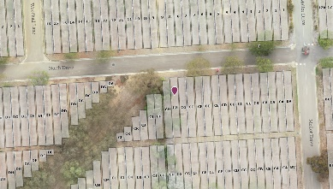
His last service record indicates he left after serving in the 32nd battalion, receiving no promotional changes during his war service. He was awarded British War Medal, given to soldiers for qualifying service during World War 1, and the Victory Medal, which marked the Allied victory in the war. Codd went on to live to the age of 68 and passed away on 25 June 1962. He was buried in Centennial Park SA, Aca C Path CG, 567.

Reference List
Adfa.edu.au. (2025). Details. [online] Available at: https://aif.adfa.edu.au/showPerson?pid=56783 [Accessed 22 Sep. 2025].
Austcemindex.com. (2025). Australian Cemeteries Index - Name/Cemetery Search. [online] Available at: https://austcemindex.com/?given_names=William+James&family_name=Codd&state=SA [Accessed 22 Sep. 2025].
Discovereverafter.com. (2025). Everafter. [online] Available at: https://centennialpark.discovereverafter.com/profile/27514303 [Accessed 22 Sep. 2025].
Terrace, V. (2025). View digital copy. [online] Naa.gov.au. Available at: https://recordsearch.naa.gov.au/SearchNRetrieve/Interface/ViewImage.aspx?B=3266254&S=1&R=0 [Accessed 22 Sep. 2025].
Vwma.org.au. (2025). William James CODD. [online] Available at: https://vwma.org.au/explore/people/267207 [Accessed 22 Sep. 2025].

