Eric Thornton Moore
NX3321
World War 2 Diary

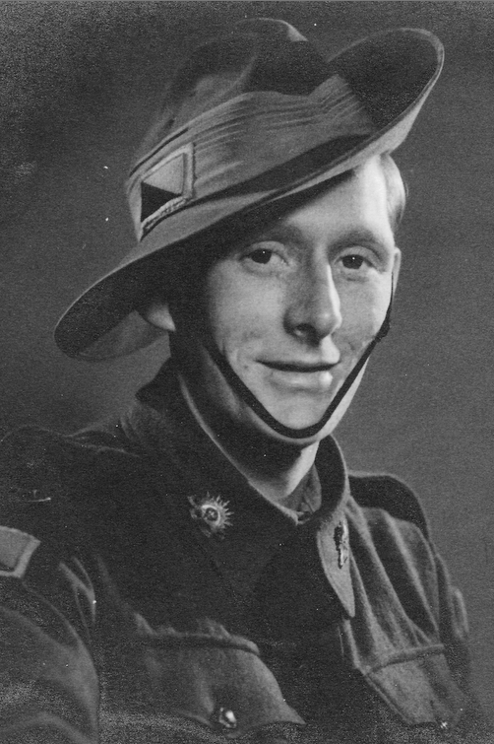

January 1941

Left Ikingi Sat 21 Dec
Mursa Matruh 22 Dec
Side Barabi 22 Dec
Fort Caputza 23 Dec

Action at Bardia on 23 Dec
Shelled for the first time Xmas Eve sent a few back. Plenty to do in way of laying lines and on the phone. Terrible experience first time under fire!

Jan 1
Still shelling Bardia getting ready for push.

Jan 2
None coming back but throwing plenty over. Moved up to forward possie going all night laying cable for barrage which started 0530 hrs and continued for 2 hrs. Very successful and very pretty to watch. At OP and had them lobbing close.

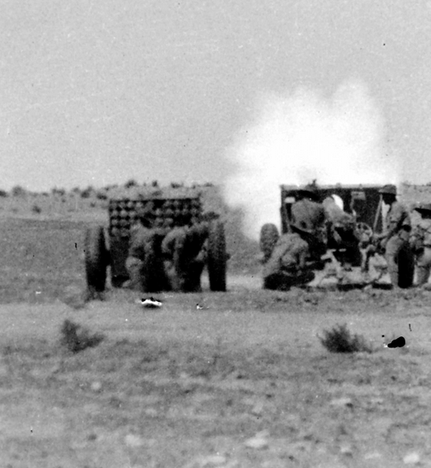

Jan 4
Prisoners start rolling in thousands of them. Very ill equipped no tin hats. One with a dog. Pitiful sight.
Wish I could get some mail away.

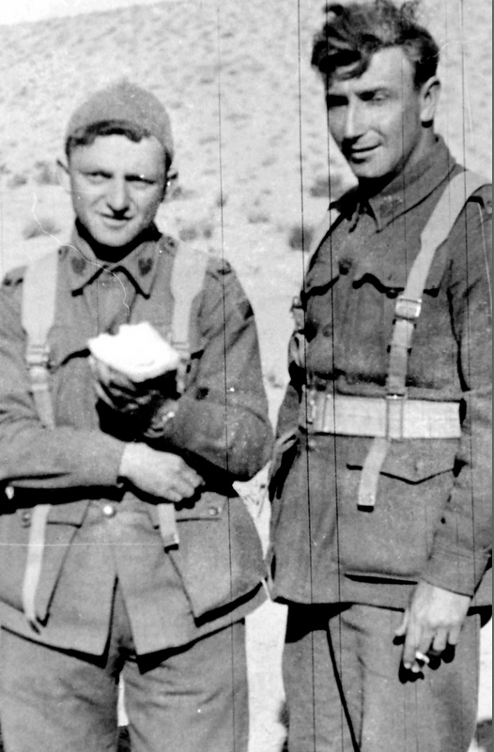
Eric’s photo of Italian POWs.

Jan 5
Another barrage in morning more prisoners. Good news Bardia ours very few casualties none in our Regt.

Jan 6
In search of Iti wire. Left Bardia for Tobruk. Drove all night. Had 2 ½ hours at wheel. Fair cow.

Jan 7
20 miles from Tobruk. Resting. Went into position. Slept all night. 2 letters Ray Mum. 2 yesterday too.

Jan 8
Up ay 0530 to maintain line. Iti rotten shot missed me by 100 yds. Going all night must be

Jan 9
my lucky day. Sniper missed me by 3 ins. Felt wind on my face. Had heaviest fire at me to date. Iti gave me the works.

Jan10
No time to sleep. Very tired went on phone at 1700 hrs. Couldn’t keep awake.

Jan 11
Phone all day very warm and very quiet. Moved up at night had a good sleep.
Been away 12 months doesn’t seem so long. Hope I’m home for next Xmas.

Jan 12
Usual maintenance job. Len Cull had a very lucky escape. Dud landed 10ft away covered him in dirt, wasn’t far from me.

Jan 13
Very quiet today. On phone morning to night. Wrote 2 letters. Ray and Betty.

Jan 14
Very hot today. Did practically nothing.

Jan 15
Bad windstorm today. Dust very thick otherwise quiet.

Jan 16
Very quiet again. Will continue to be so until the push starts. It won’t be long now.

Jan 17
Still nothing doing. If war was like this all the time no one would get hurt.

Jan 18
Navy has been giving them hell. 2 parcels today from Mum & Betty.
It won’t be long now. Biggest & best sight Iti plane coming down in flames.

Jan 19
Lazy day. Shifted at night to lay doggo for tomorrow.

Jan 20
Got to bed at 4 up at 1300 had bath. Shift again tonight & let them have it tomorrow.

Jan 21
The battle is on. Plenty of noise. Very successful advanced several miles, plenty fires.

Jan 22
Out early today along wire. The war is over at least at 7 o’clock. It didn’t take long this time. Went AWL into Tobruk.
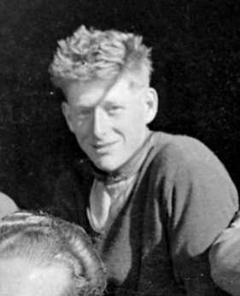
Jan 23
Westward Ho. Next stop Derna. Didn’t get far today acquired a .44. Good get too.

Jan 24
Travelled all day to 20 mile east of Derna. Good road. Saw some trees, first for some time.

Jan 25
Rec’d letter from Dad also one from Harry Jagoe. On the line today. Started belting Derna about. A few my way.
Libya. Lousy place.

Jan 26
Hardest day so far. Up at OP and got belted with everything. Lucky to be here.

Jan 27
On phone quiet after yesterday although air still busy. Heavy dust and rain storm at evening.

Jan 28
Rained all night most of the day. Rotten cold and poisoned finger. Lousy war. Wet thru.

Jan 29
Not much today. Had a bath and building was shelled whilst I was boolagi.*
*naked

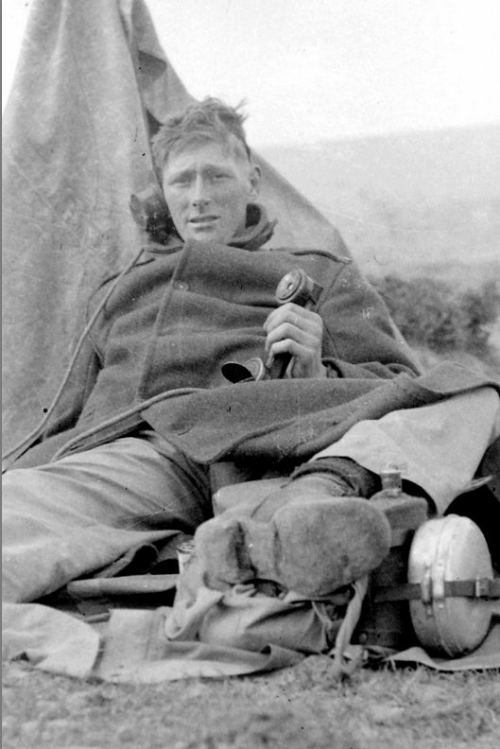
Jan 30
Shifted in afternoon. Derna taken. It is evacuated it overnight.

Jan 31
Went thru Derna pretty place. Stopped other side and belted tripe out of Dago btys. Was at O.P. and saw the fun.

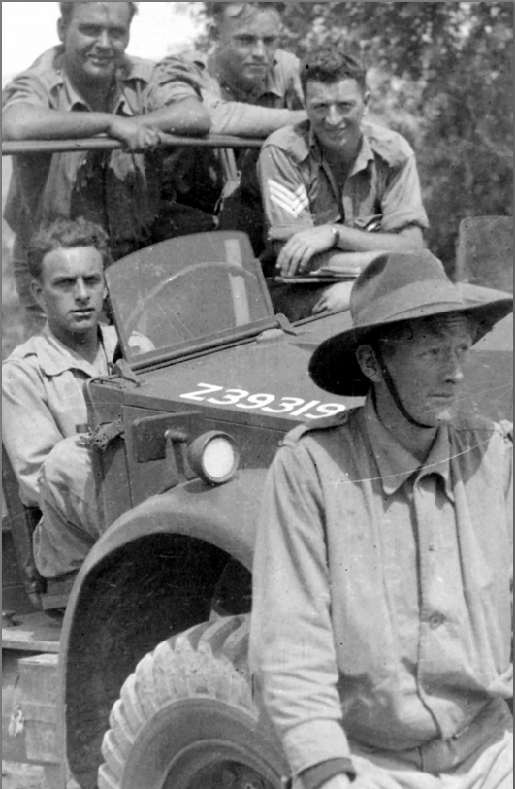

February 1941

Feb 1
Nothing much today, just kept going. Wrote home.
Friday 2 letters from Ray and 2 from Betty. Sent one to Jack ? and 1 to Betty.

Feb 2
Up onto the escarpment chasing Iti. Haven’t caught any yet.

Feb 3
Still chasing them, they must be a long way ahead.

Feb 4
Nothing doing, just waiting.

Feb 5
Green grass, beautiful country. Still chasing the Dagos westward.
Feb 6
Rotten day. Rain and Wind. Still going west. Farms have white flags flying.

Feb 7
Into Bengazi without a shot fired. Ever onward west trying to catch them up. MAFEE SH LIBYA

Feb 8
Having a rest & getting things ready trip, don’t know whether Tripoli or Alex.
Seven weeks in action. Libya fallen, at 1500 hrs 7-2-41 we heard the good news.

Feb 9
In barracks again. An Iti airdrome outside Bengasi.

Feb 10
Nothing doing except work.

Feb 11
Menzies paid us a visit today. Made a good speech. 6 letters,

Feb 12
An air raid this morning, nothing much. Nazi plane.

Feb 13
Terrific air raid this morning. Landed all round us. On leave to Bengasi. Not much to see.

Feb 14
On the phone. Shifted from airdrome yesterday. Rumour about returning to Mena Cairo.

Feb 15
Novel experience. On exchange for 24 hrs. Another air raid this morning.
Not a bad week. Joe Greenwood got a piece of ? in arm, first casualty in B.Tp.

Feb 16
Things very quiet now. Just routine work.
Nasties raiding Bengasi.

Feb 17
Same as usual. Light railway thru camp amusing us, go to meals on it.

Feb 18
My second birthday in army. 24 today. 2 Nasti raids on Bengasi.

Feb 19
Trying hard to keep away from work.

Feb 20
Still doing nothing, getting tired of it too.

Feb 21
Shifted guns and helped dig gun pits.
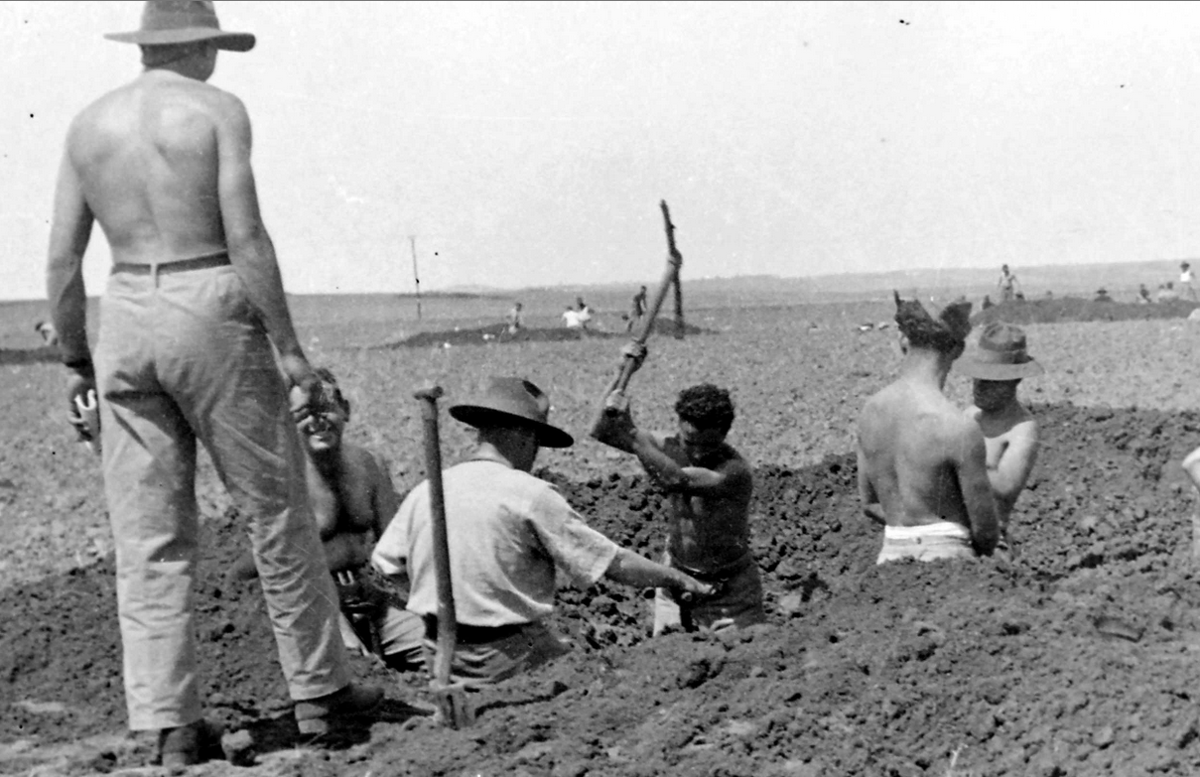

Feb 22
Had afternoon off so wrote letters and mucked around.
Letters from home 2 & 1 from Ray 18/2/41.

Feb 23
Wrote more letters and received some (5).

Feb 24
In kitchen all day, cow of a job.

Feb 25
Packed vehicle ready for move. Where to no one knows.

Feb 26
On the move. Drove all afternoon going south.

Feb 27
Still moving, getting into the desert again. Took up defensive position.

Feb 28
Dug in. Easy digging as it is all sand. Bit of a sand storm, very dirty.

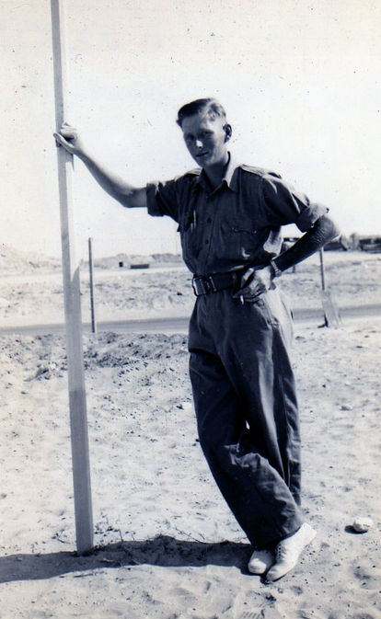

March 1941

Mar 1
Mooched around with nothing to do, dug us a house, pretty good.
Letters Betty 2, Mum 1, Ray 1, Mrs Parker 1.

Mar 2
At O.P. today. Hope to have a bath soon.

Mar 3
Fred Lamprill Bty NCO Sigs. Pazzi TP NCO. I go to RB temporarily.
Beautiful day, ears gone on me.

Mar 4
Coming back to get cars, attended to in ambulance. Long trip, travelled since 1800 hrs Monday. [ed: yesterday]

Mar 5
At Bengasi. Got ears attended to. Back to Barce for teeth.

Mar 6
In Barce. Have to be back here Tuesday 1100hrs. Might be staying here.

Mar 7
Lovely lazy day. Have to stay here till Tuesday.

Mar 8
Still staying.

Mar 9
Having nice time. Stroll into Barce in afternoon. Canteen and cooks after tea.

Mar 10
Same as usual. Wrote several letters home.

Mar 11
Went up to get teeth and found after waiting a week that I couldn’t get them. Dentist threw them away.

Mar 12
Trying to get out of the place. Might go today I hope.

Mar 13
Left this morning on truck, travelled all day and reached Derna airdrome where we stayed night.

Mar 14
Continued back today reached Tobruk early afternoon. Rotten sandstorm. Went out to staging camp to stop.

Mar 15
Had a quiet day at camp. Had to do a bit of work.

Mar 16
Left camp this morning. Going back to Derna. Have been told to look up there for unit. Arrived Derna 1800 after cold trip.

Mar 17
Made enquiries but cannot find rgt. Have been advised to return to Tobruk. Get lift back with Tommie.

Mar 18
Some more running around, am told rgt is on way to Alex. Catch YMCA truck and set out for Alex.

Mar 19
Left 1500 hrs yesterday, pull up at Mersah 0400. Arrive Alex 1400. Granted leave for 24 hrs.

Mar 20
Went to pictures last night then to bed. Arose 100 hrs. Mooched around Alex until train left for Amria. Air raid in morning. 1 plane crash(?)

Mar 21
At Amrea . Dirty weather. I played cards and read. Very quiet.

Mar 22
Left for Mersah by train arriving at 2000 hrs and taken out to barracks

Mar 23
Recd 2 parcels and five letters. Worked on truck all day.

Mar 24
Five more letters today. In kitchen all day. Still a rotten job.

Mar 25
Worked all morning. Swimming in afternoon cold in water.

Mar 26
Finished off truck. Wrote home at night Mum, Ray.
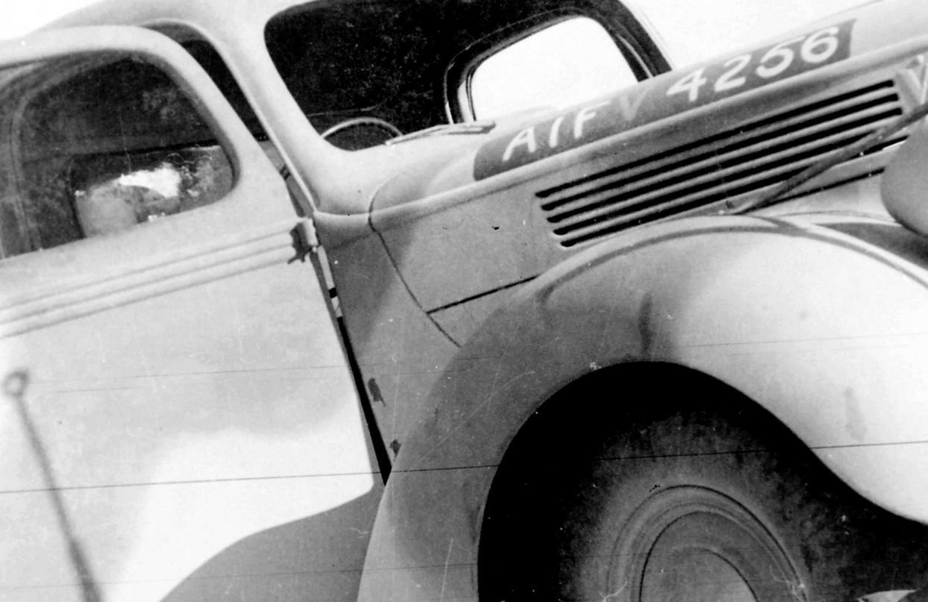

Mar 27
Still doing nothing. Have an awful face.

Mar 28
Still the same. Face and flu.

Mar 29
Face worse, skin very tight. Flu getting better.

Mar 30
Still in bed but am feeling well.

Mar 31
Up again today. Feel better. Leaving tomorrow.

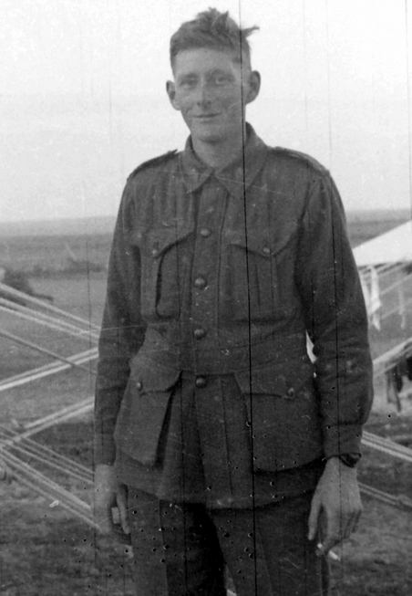

April 1941

Apr 1
Good trip to Amrea. No springs or brakes. Very hot.

Apr 2
A new M5. Packed it and made it ready for boat.

Apr 3
Boys on leave. I didn’t go. Will probably go to hospital tomorrow for teeth. Dust storm today.

Apr 4
Still nothing doing about teeth. No leave today.

Apr 5
On leave to Alex today. Not a bad day. Bought tablecloth, purse and cushion cover to send home.

Apr 6
Nothing doing except dust storm.

Apr 7
More dust and dirt.

Apr 8
Just routine work & dust.

Apr 9
Went to dentist and had impressions taken.

Apr 10
Boys sailed tonight. I go to 2 Bty until I catch up.

Apr 11
Mucked around all day.

Apr 12
Went and saw Arthur Stubbs. Had a yarn.

Apr 13
On leave to Alex today, had a quiet day.
Apr 14
Rotten dust storm today. At dentist again.

Apr 15
Had another visit to Arthur.

Apr 16
Anther dust storm.

Apr 17
More dust. The worst dust storm I have experienced.

Apr 18
Got my teeth today. Good fit. Makes me pretty again.

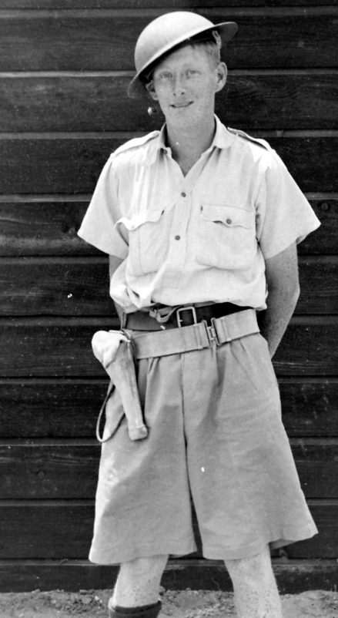

Apr 19
Lovely day today. Did nothing much.

Apr 20
Cold day with rain. Nothing to do or read. Cow of a day.

Apr 21
Wrote some letters and messed around.

Apr 22
Still getting treatment for ears.

Apr 23
Went to Alex to see specialist. One ear badly inflamed. Bought watch.

Apr 24
Sent cable to Athol. Ready to move but not by sea.

Apr 25
Anzac Day. A short service and then some more work.

Apr 26
Just mucking about.

Apr 27
Wrote some letters.

Apr 28
Nothing to write about.

Apr 29
Some of 1st Bty get back from Greece.

Apr 30
Ears still crook. Going to specialist tomorrow.

May 1941

May 1
Leave for Palestine to rejoin troop. All night in train.

May 2
After mucking about at Base and Arty training (?) arrived at Khassa and 1st Bty.

May 3
Mucked about and had most of the day off.

May 4
Received some mail today. Very hot.

May 5
Went to Tel Aviv had a good feed.

May 6
Went to Ascalon and had a swim.

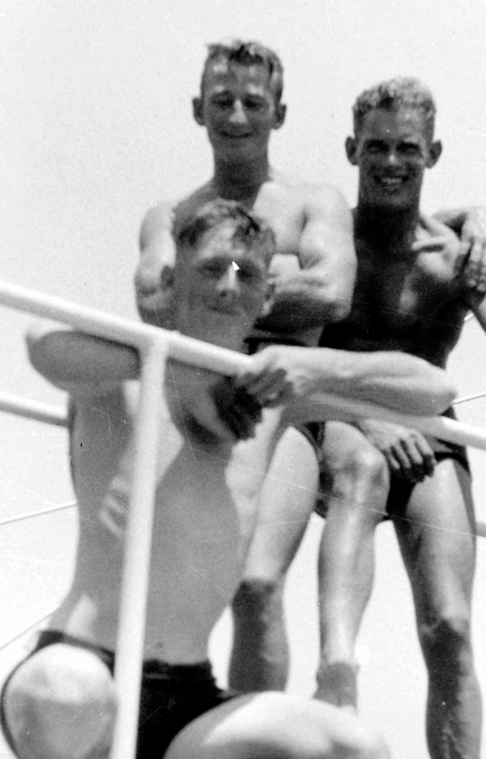
Eric (Front) and mates after a swim.

May 7
Battery runner today. Wore my legs off to the ankles.

May 8
Half hours drill and rest of day off. C.R.A. addressed us.

May 9
Messed around doing nothing.

May 10
Am knocking off until something happens.

……..
From May 11-28th , Eric uses these pages to record mail and parcels received and sent to his family and friends: Alison, Mum, Margaret, Betty, Athol, Frank, McDowels, Norma, Beryl, Ray, Auntie Vera.
He then continues writing, using the rest of the diary to record events of 1942.
……..

(May 29 )
(written in pencil)
9th March [ed:1942]
Leave Khassa for unknown place, the most popular rumour is Aussie. Road party left last Saturday.
Arrive Kantara 10th Mar and change trains for Suez. Arrived Suez and went to staging camp 10th Mar.

(Jun 1)
Up at 0430 am. March to boat at Pt Tewfik.
Boat turns out to be Westernland a Dutch vessel of 16000 tons. Go on board about 0800 in an Invasion barge. Leave Suez 12th March bound for Aden.

(Jun 5)
Arrive Aden 2100 Monday 16th Mar, load etc and leave Aden 0800 Wednesday 18th Mar. Where to we do not know as yet. Either Bombay, Ceylon or Durban. The Orontes is with us and are being convoyed by an armed auxiliary cruiser.
(Jun 9)
Wed Mar 26th arrive at Colombo, still as woggy as ever. The diving boys conspicuous by their absence. Were ready to go ashore as soon as we tied up but as usual had to sit slack for a few hours. Have not been told anything yet.

(Jun 14)
We did nothing until Sat 28th Mar. Disembarked at an early hour, came ashore, marched to station and finally arrived at some village where we got into busses and drove to Horana and are at present camped in a rubber plantation.
It rains every night and as there is not any tents issued the boys have built themselves little tents to serve until the trucks arrive.
The country is very beautiful and everywhere green trees and grass can be seen. The natives are very friendly and already I have been into a temple to see Buddha. Had to take the boots and hat off.
(Jun 22) Still using the 1941 diary, Eric rewrites in ink his previous account, adding more detail:
9 March 1942.
We leave Khassa after being in it for so long. Bus to Madjal and train to Kantara. This I hope is the last time I shall travel in one of those Palestinian. Arrive Kantara 10th March, cross the canal and then to Suez by train. Arrived about 1600 and go to staging camp. Went to cinema as piquet and saw Captain Fury. Bloody show.

(Jun 26)
Up at 0430 11th Mar and march four miles to Pt Tewfik where we embark on SS Westernland. Dutch vessel of 1600 tons. Get aboard at 0500 and have a feed. Vastly different to our trip over here on Orford. Ship is built to carry about 2000 but they put nearly 4000 on. Not much room to do anything. Bloody hot down stairs and crowded on deck.
Left Suez 12th Mar bound for Aden. Cleared harbour at 1700 and head down the Red Sea.
(Jun 29)
Arrive Aden 2100 16th Mar. The old tub is on its own and can only do about twelve knots per hour after coaling etc. We leave Aden at 0800 18th Mar in company with Orontes and Corfu the latter being an armed merchantman as our escort. Trip very boring. Do not know where we are going either, Bombay or Colombo. Turns out to be Colombo.
Arriving at 1000 hrs Wed 26th Mar no “I dive” boys to welcome us and still as smelly as ever.
All ready to go ashore as soon as we enter harbour but sit slack until 28th. Went ashore early . Marched to station and caught train out to some place Panadura where we got buses to Horana and set up abode in a rubber plantation.

(July 5)
It rains almost every night and as there are no tents available until the trucks arrive we have to get the wogs to build us little palm huts. Resembles a native village. The natives are very friendly and we went for a look around, were invited into a temple and saw Buddha. Had to take the boots off.

(July 7)
Had the religion explained to us by a priest.
An invasion scare had us digging but nothing came of it.
Sunday 5th April a big air raid on Colombo, we downed 29 planes and so the japs didn’t go too well.

(July 9)
9th April. Went out on night march and got lost. Soon found ourselves tho’. Don’t mention paddy fields.

(July 11)
24th April. Nothing much has happened since the last entry. The trucks have arrived and we are still digging. The latest rumour is that we are going to hand over all our gear to the Kippers and get some new stuff when we get home. Leaving in about 5 weeks according to rumour. Some mail also arrived. I rec’d three. The rain has set in and it has only stopped once in the last 15 hours.

(July 15)
May 10. Had a march past C.I.C. thoday. Admiral Layton.
Mucked about for a few days and then on Thursday 14th May went up to Diyatalawa for a shoot. Beautiful trip. Gorgeous country. Shot for two days and returned to Kalatura and took over from 51 Bty on 19th May.
24.6.42
Duke of Gloucester had a review of 10 Bge on Kaltura airdrome.

(July 20)
8th July [ed:1942] Left Horana outward bound via truck, train & boat for Aussie. The ship is Hellship Westernland . The boys curse plenty. Sail 1600 hrs 13th and run into weather. I get me a job on Bren gun as A/A gunner.

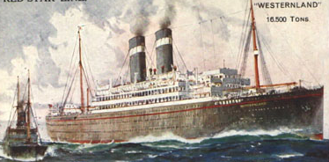

“Hellship” Westernland
In July 1942 she repatriated Australian troops from Ceylon (now Sri Lanka).

(July 24)
Plenty of fresh air and bludge. Only go below for mungaree* which is not upta.
19th. Sunday. Escort leaves us. Up till now we had one light cruiser of H.M.S. She left us today and now we have a Yank Battle Cruiser.
This is our first sight of America at war. Nuff said.

(July 28)
Fremantle Tuesday 20th July. Land looks good. Leave from 1400 hrs until 2359. Look out munga.

July 29 [Ed:1942]
Wed. Leave again. Pictures and food, Ate everything we have missed while away.

July 31
Sailed at 1530. I think that Adelaide will be next stop.

Aug 1
Aug 7
Melbourne. Arrived this morning, get off and go by train to Seymour. Bloody cold. Rain.

Aug 3
Aug 10
Left Seymour for Sydney and leave. Nuff said.
Ray married.** [Ed: Eric met Lorna/Kay Freeman at wedding]
Finish leave Walgrove. Greta & then Brisbane . Moresby.
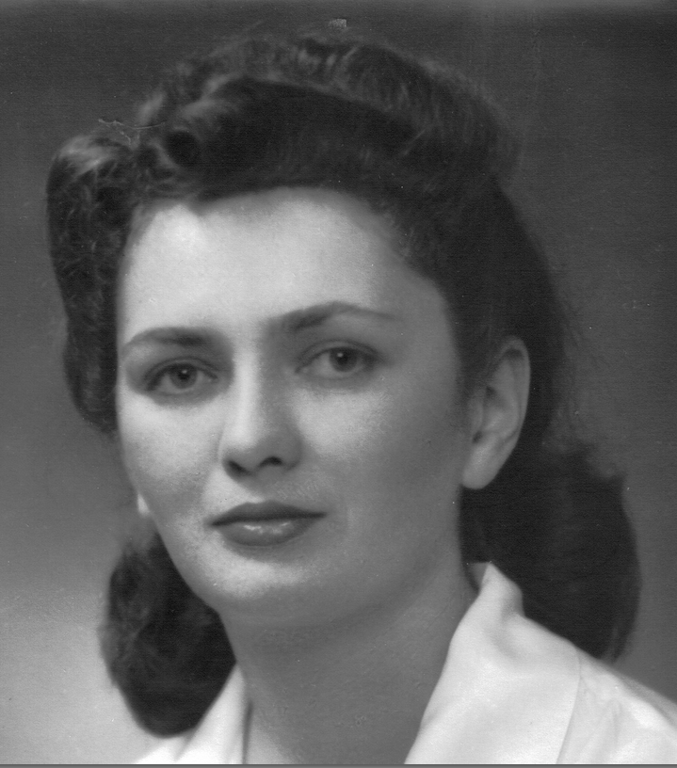

Lorna (Kay) Kathleen Freeman c1942

Aug 5
Saturday 12th Sept left Greta for Brisbane. Good trip up by train. Trucks are on flat cars.

Aug 6
Sunday 13/9 Arrive (?). Drive thru Brisbane to Ascot. English trucks. Attract attention. My jalopy hard to shift. Makes plenty noise.

*munga/mungaree = food, meals

**Raymond Judd m. Beryl Bryant Aug 1942 Beryl was a good friend of Lorna Freeman.

Aug 8
Mon 14. Loaded trucks on boat all day.
Aug 9
15 Tues. Still loading. Went aboard last night. Met Frank on wharf.
Wed 16. At sea again. Frank on same boat. He’s not too happy, sea slightly rough.

Aug 10
Sat 19 Sept. Off Townsville, trip very uneventful.

Aug 11
21 Sept. Left Townsville.
Friday 25. Arrive Moresby. Go to Murray barracks.
Tues 29th. Took up position covering beaches. Looks like another defensive roll.
Aug 14
21/10/42
Work (?) Parade for Blamey. John turns up, stays the night and we go out to see Frank the next day. What a day. [Ed: Frank, John are Eric’s younger brothers.]

Aug 16
Fri 20.11.42
Crack myself in shin with axe.
Monday 23.11.42 On the back because leg is poisoned.

Aug 17
Tues 24.11.42 To the RAP for a week. In bed, foot up a mile.

Aug 18
Thurs 26.11.42 Troop moves to drome on way to Buna. I miss out. Still on the back, can’t walk.

Aug 20
9.12.42 Troop returns, move cancelled.

Kay’s Birthday 18 October

[Ed: last diary entry. The rest of the diary is empty apart from addresses of letter writers and a list of all the places Eric & B Troop had been to since enlisting in 1939.
Eric was to spend until 1945 fighting the Japanese troops in New Guinea. In January 1944 he married his sweetheart Kay (Lorna). He discontinued his diary in November 1942 and we can only follow his activities and thoughts through the official B Troop Diary and letters home to his family.]

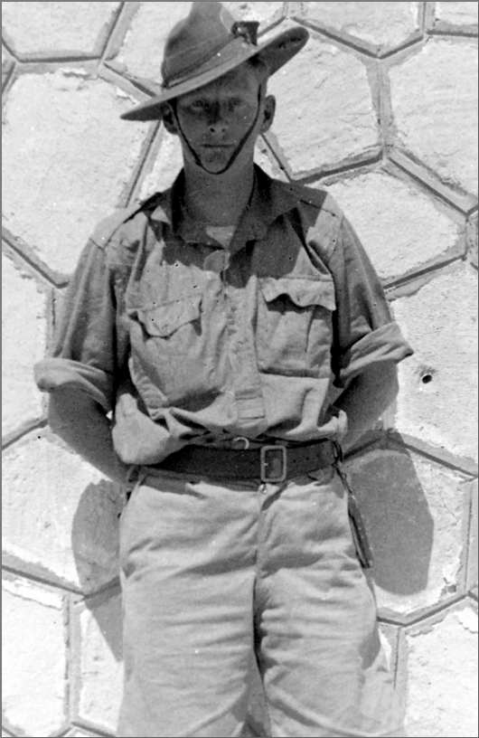
Eric Thornton Moore c1942

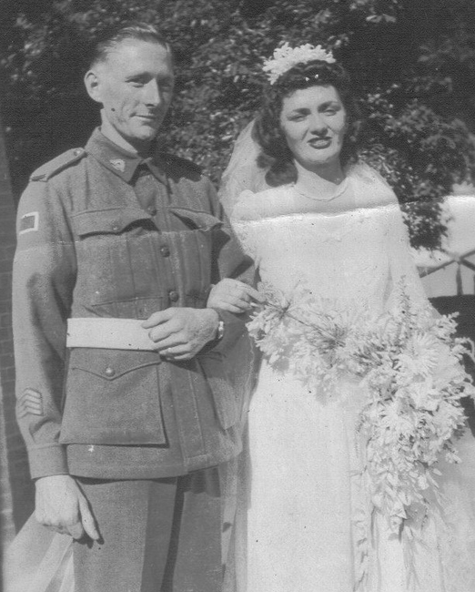
Lorna and Eric 8 Jan 1944, Chatswood

Places and troop ships recorded by Eric:

- Holdsworthy
- Ingleburn
- HMT OS Orford
- Qastina
- Beir Asluj
- Julis
- Deir Suneid
- Jaffa
- Deir Suneid
- Kilo 89 [Ed: Gaza Ridge]
- Haifa
- Acre
- Sidi Bisch
- Mex
- Seagull
- Heluan
- Ikingi Maryut
- Sidi Anish [Ed: Haneish]
- Mersa Matruh
- Sidi Barani, Sollum
- Fort Capuzzo
- Bardia
- Tobruk
- Derna
- Barce
- Baracca
- Tocra
- Bengazi
- Adjadabia
- Benina
- Er Regima
- Adjadabia
- El Agheila
- Adjadabia
- Bengazi
- Barce
- Derna
- Tobruk
- Derna
- Tobruk
- Bardia
- Capuzzo
- Sollum
- Sidi Barani
- Mersa Matruh
- Alexandria
- Amrea
- Mersa Matruh
- Amarea
- Khassa
- Pt. Tewfik, Suez
- Westernland
- Aden
- Columbo
- Horana
- Pembroke
- Diyatalawa
- Horana
- Westernland
- Perth
- Melbourne
- Seymour
- Walgrove
- Greta
- Ascot
- Moresby
- Wau
- Summit
- Skindewoi
- House Mango
- Napier
- Nassau Bay
- Morobe
- Buna
- Dobodura
- Moresby
- SS Katoomba
- Townsville
- Narellan
- Canterbury
- Loftus
- Yerongapilly
- Ravenshoe
- Rocky Creek
- Biboohra [QLD]

