William Percival Merten
William Percival Merten was born on the 15th of June, 1889 in Angaston, South Australia. He was the son of Julius Merten (occupation unknown), his next of kin on his enlistment form. Information for his early life, such as primary and secondary schools and starting employment could not be found. His job when enlisting was a relieving stationmaster. His appearance consisted of a fair complexion 5’8 in height and 140lbs, as well brown hair and brown eyes. He embarked to the war on the 2nd of December 1915 on RMS Malwa.
With no military experience prior to the war, he enlisted as a private in the 1st Stationary Hospital A.I.F on July the 25th, 1915 and began working in forward areas in Gallipoli. All nurses in stationary hospitals were required to be unmarried and between the ages of 25 and 40, allowing him to serve as one.
One month before the invasion, Merten was set up at the 1st Stationary Hospital in Mudros Harbour in Lemnos, 100km southwest of Gallipoli. After staying for 2 months, he then proceeded to join the war as a reinforcement for the 12th battalion, part of the 3rd Brigade. He then proceeded to fight in Gallipoli, securing areas in The Nek and Russell’s Top. He was then successfully evacuated and stationed in Egypt.
He then transferred to the 7th Light Horse Regiment as a private, moving to Dueidar, Cairo. Merten fought against a small attacking Ottoman force, then moved to , transferring once again to be a 2nd Signal Troop as a sapper (2 years), constructing communication lines and defenses at his camp.
During this time, he suffered from an abrasion in his right thigh as a result of a horse kick on the 9th of November 1917, causing hematoma. Shortly after in Egypt, 1918 he both contracted malaria, which he survived and was wounded slightly. After recovery, he resumed his duties as 2nd Signal Troop.
After, he became a Lance Corporal, followed by a Temporary Corporal, and ultimately a Corporal on the 28th of March 1919. William returned home on the 28th of June 1919.
William was awarded a 1914/15 Star, a British War Medal, as well as a Victory Medal. He had a total of three promotions and three transfers throughout his time of service. Four months after returning, he married (partner unknown). He passed away on the 31st of August 1959, cause unknown. William was mentioned in numerous memorials, such as the Adelaide Grand Masonic Lodge WW1 Honour Board, the Angaston Congregational Church WW1 Roll of Honour (due to his congregational religion) the Angaston War Memorial, the Angaston District WW1 Roll of Honour and the Truro and District Roll of Honour. His grave is located at Centennial Park in Pasadena, City of Mitcham SA. No photos of William could be found.

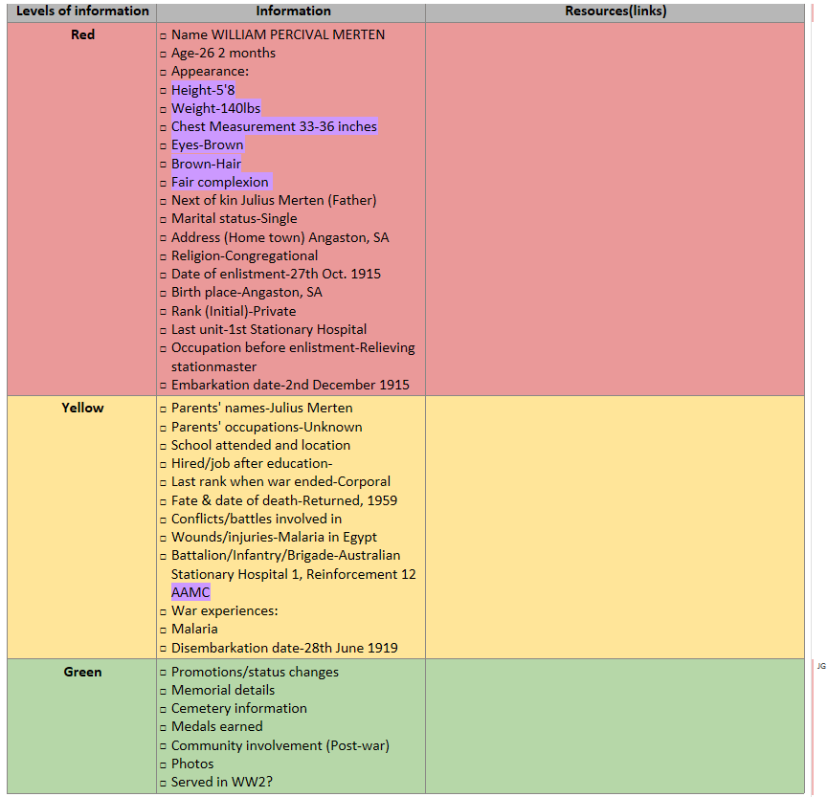

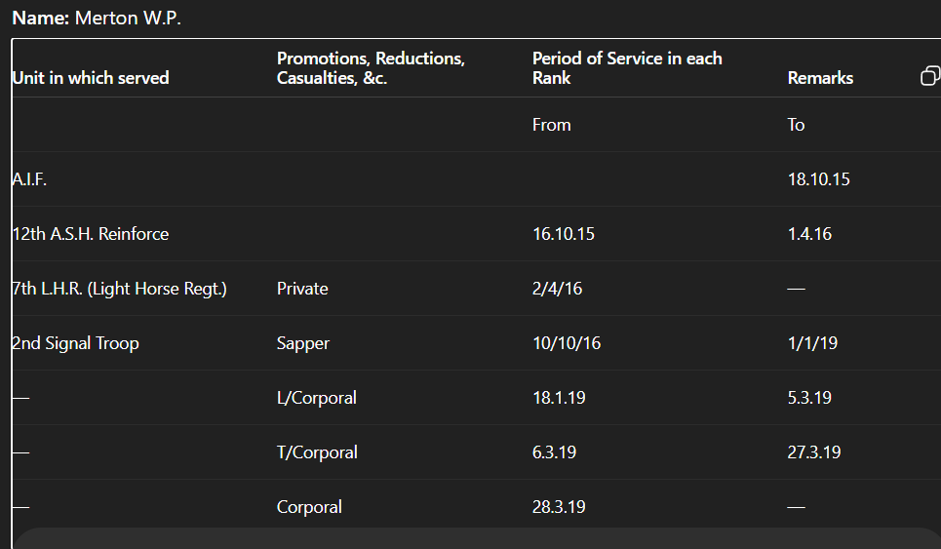
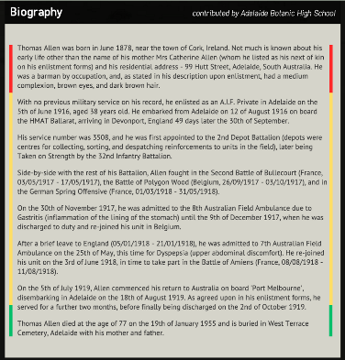

INFO:

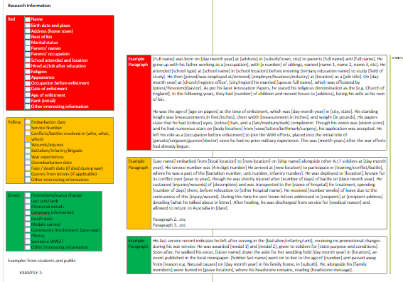
Examples

War Experience Research
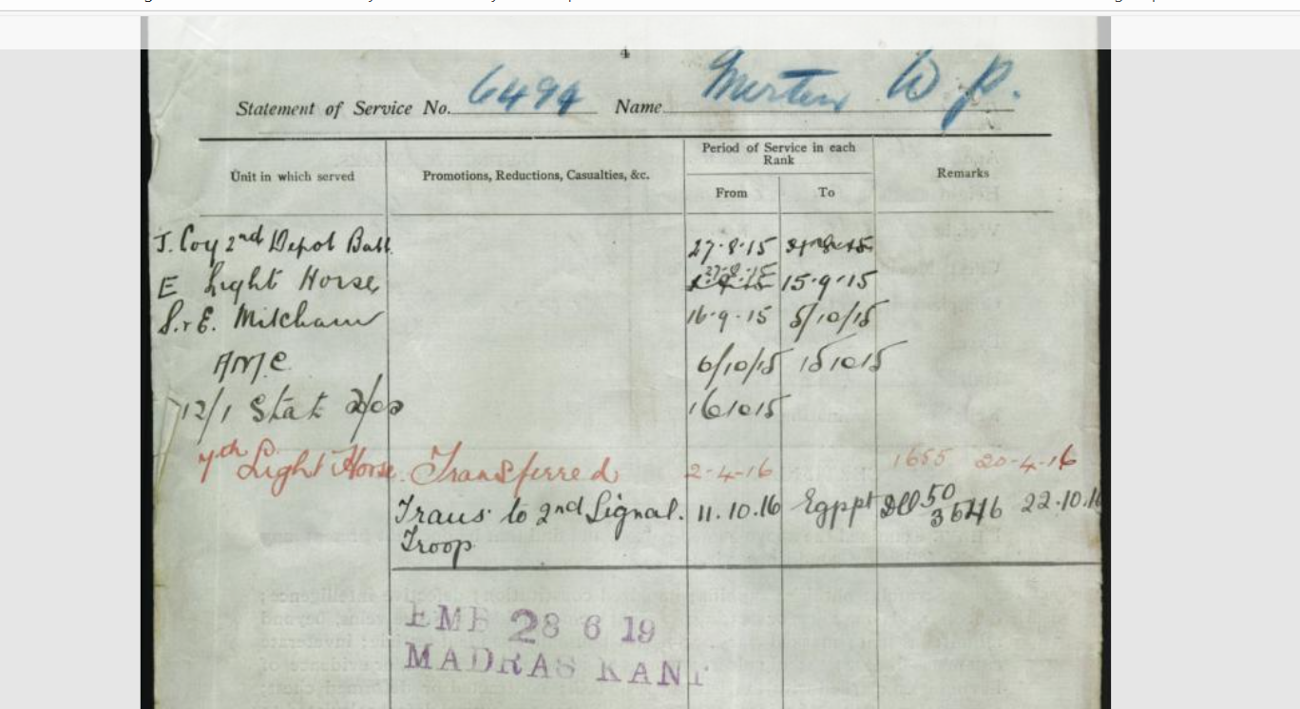

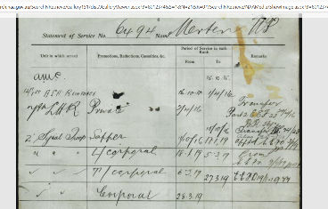

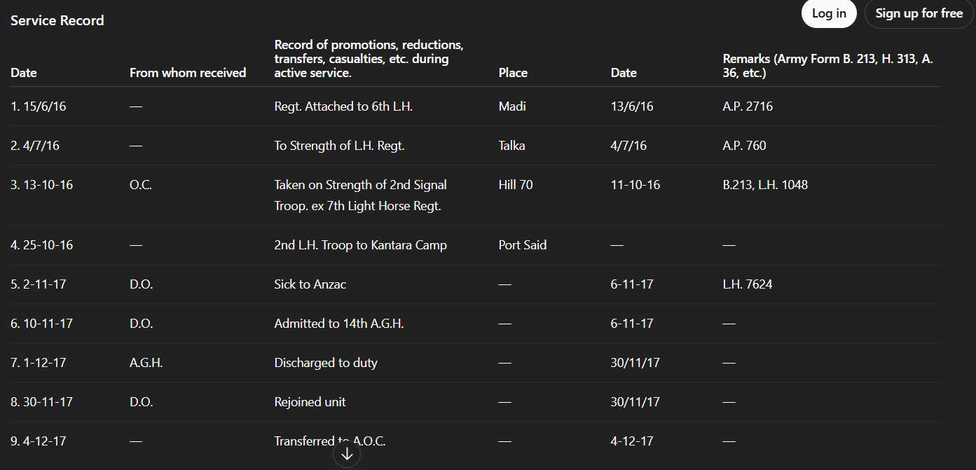

Casualty Form –Active Service
Regiment or Corps: 7th Light Horse Regt
Regimental No.: 6494
Rank: Pte
Name: Merton W.P.
Enlisted: —
Terms of Service: —
Service reckons from: —
Date of promotion to present rank: —
Date of appointment to lance rank: —
Numerical position on roll of N.C.O.s: —
Extended: —
Re-engaged: —
Qualification: P.B. 236624
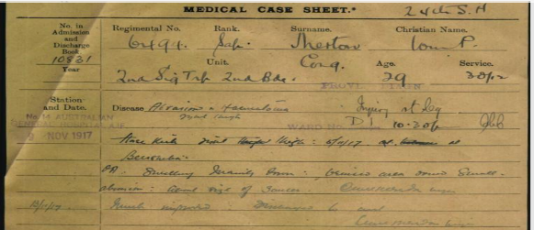
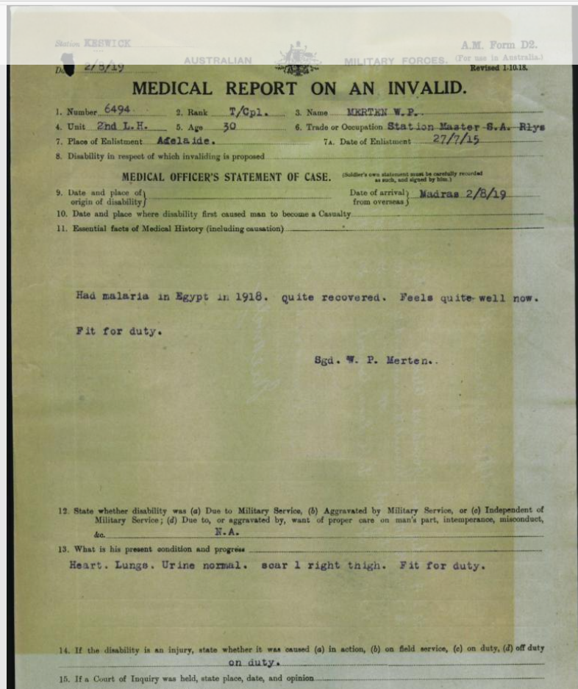v

MEDICAL CASE SHEET
24th A.S.H
No. in Admission and Discharge Book: 10881
Year: —
Regimental No.: 6494
Rank: Pte.
Surname: Merton
Christian Name: Tom P.
Unit: 2nd Sig. Tpt. 2nd Bde.
Age: 29
Service: 3 Yrs. 2
Station and Date:
No. 14 AUSTRALIAN GENERAL HOSPITAL, CAIRO
8 NOV 1917
Disease: Abrasion & Haematoma
Right Thigh
Injury rt. leg
Ward No.: D1
Bed No.: 10.30 F
Duty: DH
History:
Horse kicked right thigh. 6/11/17 at base.
Observation:
P.P. swelling, densely brown bruised area about 5 inches.
Abrasion – lateral side of femur. Quadriceps ? injury.
13/11/17 – Much improved. Discoloration less. Clean abrasion healing.
\

