The Herald (Melbourne, Vic. : 1861 - 1954) Sat 4 Jan 1936, Page 6

|  |  |
| --- | --- |
| **TWENTY YEARS AFTER—Dernancourt—And A Grave**  **By Basil Burdett** | Figure 1 - Basil Burdett (1897-1942) |

AT AMIENS I asked for a ticket to Dernancourt. The man in the booking office had never heard of it. Never heard of Dernancourt! I know a number of Australians who could have given him almost the exact map location of the little Somme village.

A porter came to the rescue and told me there was no station at Dernancourt. I have to go to Buire and walk. Buire-sur-Ancre— well, that was a name to excite memories in an Australian, too.

Meanwhile, the man at the ticket window was explaining that he was new in Amiens. An exile, he said wistfully, thinking no doubt of some white town in the Midi, so different from this grey northern city.

So I took a ticket to Buire. But Dernancourt continued to be enveloped in vagueness, or, rather, the war cemetery I sought, did. Several people I asked on the train could tell me nothing about it, nor how far I should have to walk from the station, although I could make a pretty fair guess at that. I could still remember marching from that frozen camp on the Albert Road, down through Buire to Dernancourt and on to Mametz, in the winter of 1916.

But, in the end, I found the local postman in a neighboring carriage. Tho cemetery was only a couple of kilometres from Buire station, he told me, and an old woman in the same carriage confirmed his estimate.

**Woods of the Somme**

The train started at last. A slow. We puffed leisurely through the autumn woods bordering the Somme. The fields were bright green about the lagoons which star the shallow valley.

Here were remembered names on little stations— Heilly, where Monash once had his headquarters; Ribemont, Mericourt, and Corbie, with its imposing Gothic church presiding over a brand new village. I could remember rummaging in the dusty cellars of its battered houses looking for wine. And through the regular lines of poplars bordering the canal I could see the shadowy shapes of hundreds of nude Australians, splashing in summer contentment in the cool waters during one of those brief and rare intervals of rest before and after the storm of war.

Buire! The old woman in the postman's carriage got out too. I told her I was an Australian seeking the grave of a fallen relative. "Ah!" she said, "there were many Australians in Dernancourt."

"You still remember us. then?"

"How should we ever forget?" she asked simply.

This little encounter warmed me; it is nice to be remembered, even anonymously. The day, too. It was a warm autumn afternoon. Light clouds flecked the blue sky above the yellow stubble on the gently rolling hillsides. Hunters were abroad. The season had just opened. Men picked their way through the stubble, their dogs nosing the ground for scent of the elusive hare. From a distant copse came the vague echo of a shot. Twenty years ago, that echo would have startled me.

**Where 500 Sleep**

The Anglo-Australian cemetery at Dernancourt is just outside the village. It adjoins the God's Acre where the good folk of Dernancourt bury their own departed.

The sextant told me to jump the low wall behind the iron calvary. He stopped cutting grass to ask me if I had been here during the war. "You must have been very young," he said, eyeing me closely.

"Very," I agreed, with feeling. "You would be what now?" I suggested.

"You are still young. Me, I am just on 60. C'etait pas bonne cette guerre, eh?"

No. that war had been no good at all I had no difficulty in agreeing.

About five hundred Australians are buried in Dernancourt. Each grave has a neat headstone, inscribed with name and unit beneath the Rising Sun. British and Australians lie together there, mingling in the last sleep. Many, alas, are Unknown Soldiers. But there is glory in their namelessness.

The cemetery is a model, a veritable pleasaunce of Eternity. The headstones are planted amid roses, lavender and rosemary, and other sweet-smelling things, which mingle in distilling a fragrant incense to the dead. Lawns, tended with English skill and care, surround them.

**Cornflowers And Poppies**

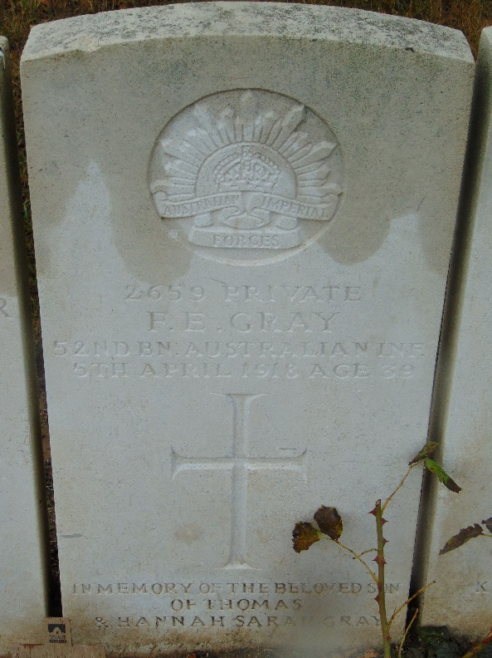I found my grave eventually, it was almost the last, at the end of a row, nestling in the shade of a shrub. I stood looking at it awhile, thinking of the last time I met the man who lay beneath, on a duckboard track in the Ypres sector, in the midst of a sea of mud, one forlorn day in 1917. Even on that wretched afternoon, in that welter of winter foulness, his blue eyes had been alight with enthusiasm. For the first time in his life he felt he was doing something real. He had not been afraid, I knew.

Figure 2 - The grave of Frank Ernest Gray (1879-1918), Basil Burdett's uncle

I walked on into the village afterwards. The baker in his hooded cart was doing the rounds up the straggling main street. His little bell tinkled clearly in the somnolent afternoon.

I had a Vichy in the little fly-spitten café and then started out to walk to Albert, five kilometres away. I would catch the later train back to Amiens.

It was hot walking, but pleasant enough. A poppy, culled from a wayside stubble field, flared at my buttonhole. The white road, the blue, sunny sky, the poppies and the cornflowers in the fields, all reminded me of that first serious route march, four days long, from Doullens to Vadencourt Wood, which was the prelude to our debut on the Somme in the summer of 1916.

The dusty road was something more than merely the highway to Albert. It was also the highway back to my youth, to my military, but unbelligerent, youth.

**The Eve of Pozieres**

AFTER half an hour's walking the brickfields appeared over the crest of a rise, those famous brickfields, where we spent the uncanny and frightening eve of the first Battle of Pozieres. The greatest concentration of artillery then known in military history thundered up the narrow valley and over to the ridges beyond which lay Pozieres and Contalmaison. Very lights, in a mad, incessant will o' the wisp dance above the front line made a ghastly daylight in the nocturnal inferno.

That was 20 years ago, or nearly. Today the Virgin of Albert no longer hangs perilously, head downward, above a wartime shambles, but keeps gilded guard, from the summit of the new basilica, over a countryside which smiles as though it had never known the agonies of war. It has known war so often this land, that not even Armageddon could daunt its citizens.

New streets and new houses—Albert has risen from its ashes, literally. But there is nothing in its newness which speaks necessarily, of war. Only out in the countryside there is a massive and shining reminder of conflict. It is the great British war memorial at Theipval.

It was dark when I got back to Amiens. Neon signs, I decided, made a more cheerful illumination than Very lights.

And, looking out of the window of my attic room in the Hotel du Rhin, where I had gone to stay because I drank my first bottle of Burgundy there, nearly 20 years ago, I could reflect that no hostile aircraft, droning in the night sky, would threaten the lovely pile which Ruskin called the Bible of Amiens and whose shadowed bulk I could see across the square, and that I should sleep, for the first time in this ancient city, in peace.