**Farrier Sergeant John Edward Quill**

**Rod Martin**

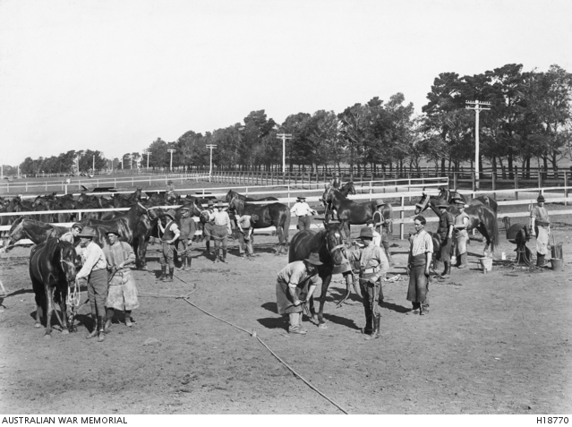

Farriers at the Maribyrnong Staff Remount Depot (AWM H18770)

According to the Oxford Dictionary, a farrier is a smith who shoes horses. Up to and including the First World War, horses had been the primary means of military transport throughout history. Indeed, even in the Second World War the German Army still used horses to pull most of its limbers and field guns. Wherever horses are used, of course, a supporting infrastructure is required: the provision of feed and other supplies, of veterinarians and of smiths. One member of the latter group was John Quill, a thirty-five year-old married man from 70 Argyle Street, Moonee Ponds. When he joined 4 Squadron of 1 Remount Unit AIF on 1 November 1915, he had already been in the Army Service Corps for almost four years. Presumably, that is where he learned his smithing skills. Because of this experience, he was named a farrier sergeant straight away, attached to the remount unit at Maribyrnong and transported overseas only eleven days later on A67 HMAT *Orsova.*

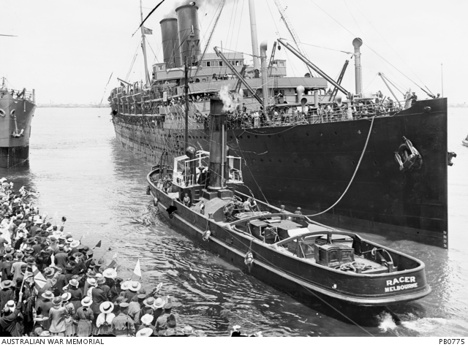

*Orsova* leaving Port Melbourne, December 1916 (AWM PB 0775)

Tall at 181 centimetres, and reasonably lean, John obviously possessed the stamina required to be a smith. The unit’s war diary informs us that the men were selected initially for their knowledge of horses and a requisite skill such as smithing, saddle-making or wagon driving. The unit was first formed in September 1915 to go to Egypt and take charge of the horses belonging to the Light Horsemen who were fighting as infantry at Gallipoli. Taking charge of the animals would release for combat the men of the Light Horse who had been left behind to look after the animals. This was hard work, and the diary records it as such. It was initially felt that men up to the age of fifty could be gainfully employed in the unit. However, it was discovered that, in many cases, that age limit was too high because the work was very severe, and a number of the older men could not stand the work and climate. John obviously could because, having arrived in Egypt in later December, he remained in the Middle East until July 1919.

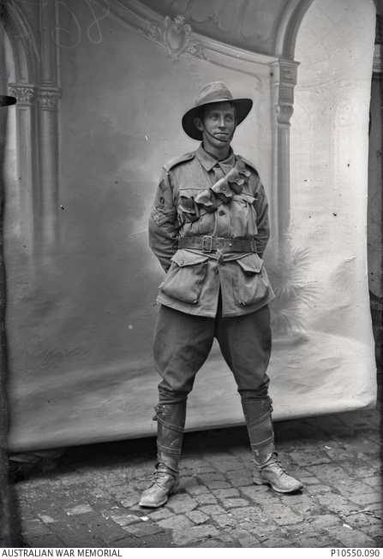

A farrier sergeant of 2 Division. Note the horseshoe emblem on

His sleeve (AWM P10550.090)

However, by the time the unit arrived At Suez on 8 December, the evacuation from Gallipoli was well underway. As a result, 1 Remount Unit moved to Zeitoun (now part of Cairo) to take charge of 198 horses intended to pull mobile batteries that would soon be arriving from Australia. John was one of four farrier sergeants in the unit, and they were in charge of nine farrier corporals. Therefore, the work caring for 198 horses would fully occupy them and the privates under their charge. If that was not enough, the unit was ordered in late December to move further south to Maadi, there, along with other remount units, to take charge of 356 horses at a new depot. Furthermore, just before new year, 716 mules arrived, driven from Abbassia further north (and causing some ‘unavoidable’ annoyance to the local people by getting into graveyards and enclosures!).

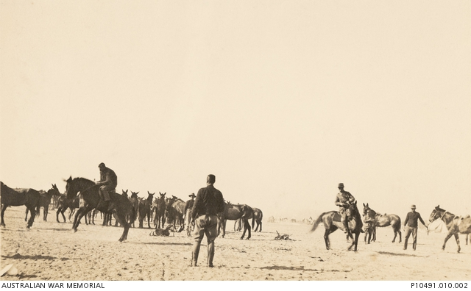Breaking the mules in (from an album of 1 Remount Unit in Egypt) (AWM P10491.010.002)

Tony James tells us that both donkeys and mules had been used at Gallipoli, the five most famous of the former being used by John Simpson Kirkpatrick to ferry wounded soldiers down to the medical centre on the beach. They were used for this purpose by other stretcher-bearers as well. Mules, on the other hand, were in constant demand to carry supplies to the front line. They were particularly suited for this role because of their resistance to drought and temperature extremes.

Despite what was surely a heavy workload for the men, the authorities in March 1916 decided to reduce the enlarged organisation to just one remount unit again. Half of the men remained as 1 Remount Unit while others were encouraged to join other corps if medically fit. John remained with the remount unit and, along with his comrades and the horses and mules, they were ‘marched out’ to a new base at Heliopolis, located in Cairo. It would have been interesting to see the horses and mules being ‘marched out’! However, the diary informs us that the move was effected without difficulty or delay, so the horses and mules obviously behaved themselves.

Over the next few months, a number of shiploads of horses arrived from Australia. They were taken to Abbassia and inspected by the veterinarians in the unit. Of concern was the fact that sizeable number were found to be unfit

. . . many being small and weedy, several as low as 14..1 and light besides, quite a number were too old.

Three shipments of horses arrived in June. After inspection, it was found that the percentage of inferior horses in these shipments was twelve, twenty and twenty-five per cent. These figures must have caused concern as the animals were expected to do very heavy work in many instances.

As far as we know, John and the other men in the unit never saw action during the war. However, the dangers of handling horses and mules were ever-present. On 21 July 1916, the unit’s first fatal casualty occurred. A trooper was kicked over the heart by a horse and died almost immediately. No blame was attached to anyone except the trooper himself.

On 23 August 1916, John, a captain and fifty-nine other men were sent to Salonika, Greece, with 600 mules. This was the first time any conducting party from 1 Remount Unit was sent overseas.

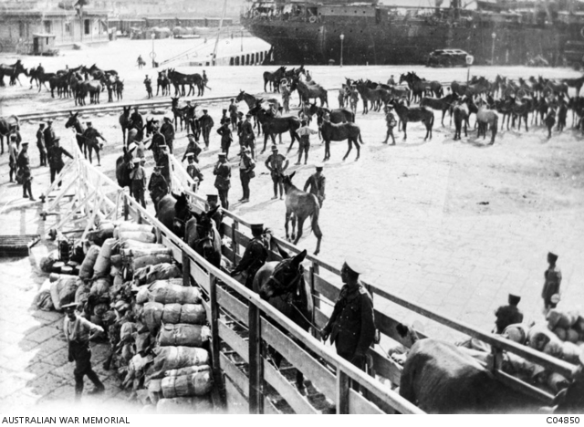

Mules being embarked at Alexandria (AWM C04850)

However, it was only a short trip. The men were back in Heliopolis by 4 September.

Over the next three months, work at the depot was quiet and consistent – but probably harder as the unit had been reduced, again, by two squadrons. John stayed with the unit throughout this time. There was an incident just before Christmas when an officer committed suicide by shooting himself. The war diary records that no reason could be provided for his act, apart from insomnia, from which he had evidently suffered for some time. He was buried with full military honours in the Old Cairo

Cemetery.

In late January, 1917, it was discovered that cases of glanders were originating from the remount depot. Glanders is a rare contagious disease affecting horses, donkeys and mules. It is characterised by swellings below the jaw and mucous discharges from the nostrils. The general in charge immediately order a quarantine of the depot and the biological testing (‘mallein’) of all the stock. This took place over six days, 500 animals being tested on the first day alone. As it was, only one light draught horse showed signs of a reaction, and it was immediately isolated. A week later, two more cases were reported from the nearby veterinary hospital, but that seems to have been the last of them.

However, if it is not one problem with animals it is another. In April, catarrh broke out among the horses and mules, causing the cancellation of a delivery to the battle zone. The war diary records that catarrh spreads very rapidly, but rarely causes death. However, pneumonia is quite common in serious cases. The men were certainly being kept on their toes.

In June 1917, all men in the unit were tested for fitness. 263 were passed fit for combat, and 178 volunteered for fighting service. The Third Battle of Ypres, in Belgium, was about to begin and the army probably encouraged these men to consider a change of occupation and scenery. John did not volunteer for this move. Instead, he assisted with a shift to a new depot at Moascar, on the Suez Canal, in July. The relocation brought them closer to the battle front in the Sinai Peninsula, and put them nearby the Light Horse training centre. The men were also able to transfer eighty mules to a recently established remount depot at Kantara, on the western side of the canal, north of Ismailia.

The routine at the Light Horse centre was well-organised, the troopers exercising the horses in the relative cool of the early morning then returning them to the centre and watering and feeding them. The men of the remount unit then took over, performing various tasks during the day. In September 1917, the commanding officer noted in the war diary that

The work done by the Farriers during the period under review has been uniformily [sic] good, the shoeing of often very vicicous [sic] and wild horses being carried out without injury to the animals in any one case, though not without injury to the men themselves.

He also noted that, besides shoeing animals, a lot of useful work was done regarding cutting and welding tyres on to transport wagons, repairs to those wagons ‘and other things too numerous to mention.’

On 9 October, the commanding officer received orders to send all fit mules and draught horse east, across the canal, to the recently captured settlement of Rafa. Accordingly, on 12 and 13 October 192 men, including John, set off for Rafa with 600 horses and mules. By this time, the Light Horse Brigade was chasing the Turks out of Sinai. On the last day of that month, the horsemen would mount their famous charge and capture the important communications base at Beersheba in Palestine. A ‘shuttle service’ of horses and mules was set up between Kantar and Rafa to keep the fast-moving Light Horse adequately supplied as it moved into the Holy Land.

After several fierce battles across Palestine, Jordon and Gaza, the war in the Middle Est finally ended when the forces of British General Sir Edmund Allenby entered Damascus on 1 October 1918 and drove the Turks out. During the previous year, the troops from the remount depot spent a lot of time delivering fit horses and mules to Rafa and then further on as the front moved north.

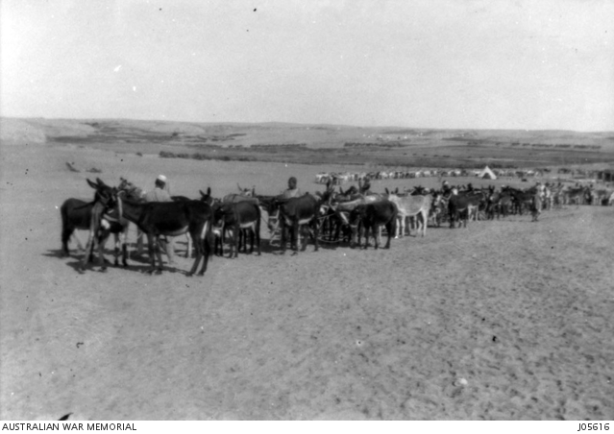

Watering transport mules at Rafa (AWM J05616)

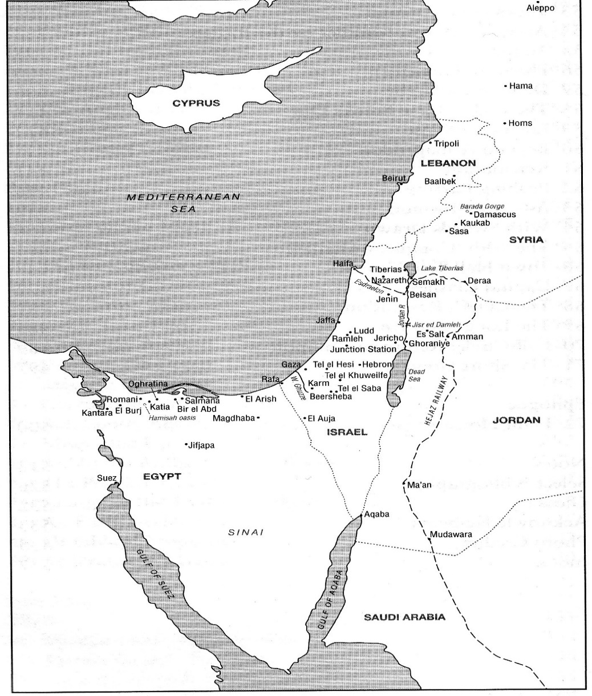

The Middle East 1917-1918 (Perry: *The Australian Light Horse*)

After the war in the Middle East ended, the remount depot acted as a transit station for the most part. It would receive horses and mules from various war zone locations and pass them on to other areas that needed them. There is a record of quite many being given to the local populace. The King of Hedjaz (now a region of western Saudi Arabia) was the receiver of many donations. As the year wore on and moved into 1919, this activity slowly wound down and more men moved out, most heading home on ships. There was still work to do at the depot for the men remaining (one of whom was John) and there was still danger involved. In one month, for example, four men were sent to hospital with broken legs. There are no prizes for guessing how they happened!

Finally. On 3 July 1919, an order from the director of remounts arrived, notifying the commanding officer that all animals had to be out of the depot by the eighteenth of the month. The next fifteen days saw animals transferred, most of them to other remount depots. On 26 July, six officers and 232 other ranks moved to Kantara for embarkation on HMT *Burma.* 1 334 horses, 505 mules and three donkeys had been moved out in that last fortnight. There is no mention in the war diary of any animals being deliberately destroyed, so either the commanding officer was sanitising his reports, or the sad tale of destruction only applied to other depots and Perry, Roland: *The Australian Light Horse,* Sydney, Hachette Australia, 2009

the mounts of the Light Horse Brigade. We’ll probably never know.

After arriving back in Australia, John was finally discharged on 21 October 1919.

**Sources**

Australian War Memorial

Bean, C. E. W.: *The official history of Australia in the war of 1914-1918*:

Sydney, Angus and Robertson, 12 volumes, 1941 (Chapter VII,

written by Henry Gullett)

<http://www.bing.com>

<http://www.tonyjamesnoteworld.biz>

<http://www.tonyjamesnoteworld.biz>

National Archives of Australia

Perry, Roland: *The Australian Light Horse,* Sydney, Hachette Australia, 2009