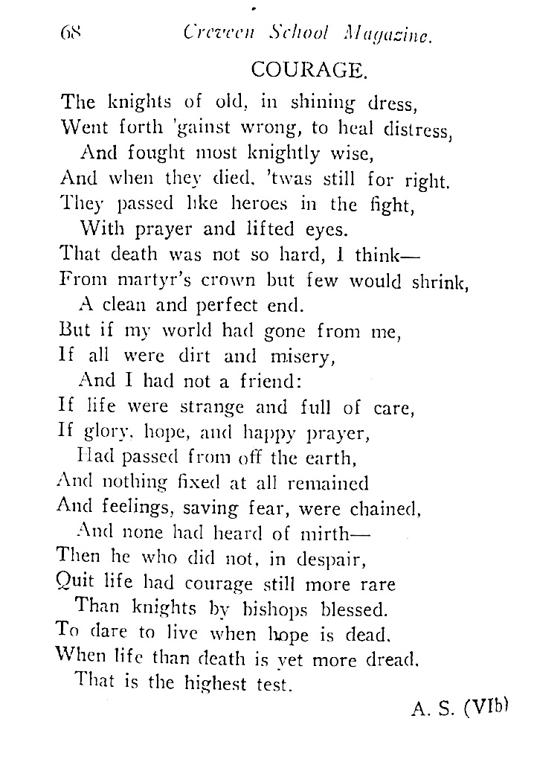
‘Courage’ by 16 year old Audrey Simpson
Creveen School Magazine, Vol XI, December 1933 (SLSA)
Published in Chronicle, 28 December 1933, p45

Audrey Simpson: Introduction
Audrey Katherine Allen Simpson (1917–2014) was a physiotherapist from South Australia who served in WW2. Her service took her to Malaya and Singapore, Alice Springs and Katherine in the Northern Territory, Redbank and Brisbane in Queensland and finally to the islands of Morotai and Labuan in present day Indonesia.
Such a list does not do justice to the very varied contexts in which Audrey worked and to her experiences. She worked in hospitals in the tropical city of Singapore, on the edge of jungles in Malaya and on Labuan, in remote towns in the Northern Territory, and on a large army base near Brisbane. She had days that were frantic and terrifying, and others that were quiet and monotonous.
Audrey came from a well known, wealthy and well connected South Australian family. Her forebears on both her paternal and maternal sides had played significant roles in the development of the state, in its economy, political life and education. The women of her maternal side included pioneering educators and a medical practitioner. The family’s wealth and connections gave Audrey a privileged upbringing, in particular a Grand Tour of England and Europe in 1936–37. She had a seat in Westminster Abbey at the coronation of George VI.
After the war Audrey continued in the physiotherapy profession as an expert on thoracic (chest) physiotherapy. She travelled extensively, maintained her wartime friendships, continued to be active in the Unitarian Church and, oddly perhaps, took up fly-fishing. When she was 50 she married widower Professor Andrew Abbie, a noted anatomist and anthropologist at the University of Adelaide. She was a generous benefactor to the university.
This brief biography touches the surface of Audrey’s full and rich life. She awaits a biographer who will explore her extensive collective of private papers, including hundreds of letters, held in the archives at the University of Adelaide.
Before the war
Audrey Simpson was a fourth generation South Australian on both sides of her family. Her paternal great grandfather Alfred Simpson, an almost penniless tinsmith, arrived in Adelaide from England in 1849. He set up a successful tin and iron manufacturing business which his son Alfred Muller Simpson expanded. The company A Simpson and Co passed to his sons, Audrey’s father Alfred Allen Simpson and her uncle Frederick Neighbour Simpson.
The Simpson men were prominent in business and civic affairs as well as being successful industrialists. Audrey’s father, for example, was Lord Mayor of Adelaide in 1913 and 1914, active in the Adelaide Chamber of Commerce and a director of the Bank of Adelaide. He initiated the South Australian Soldiers Fund in 1915 and, with Lady Galway the state governor’s popular wife, the Belgian Relief Fund. A German speaker whose wife was of German heritage Alfred opposed anglicising the names of South Australia’s German towns in WW1.
Among his interests outside business, Alfred Simpson was president of the state branch of the Royal Geographical Society from 1925 to 1930. He provided financial assistance to his friend, Douglas Mawson, for Mawson’s Antarctic expeditions. He funded the first aerial survey of central Australia by Mawson’s university colleague (Cecil) Thomas Madigan. Each explorer named a geographical feature in honour of their benefactor: Mawson, Cape Simpson in Antarctica and Madigan, the Simpson Desert. Mawson’s wife Paquita and Simpson’s wife Doris became close lifelong friends.
Audrey’s maternal side was German in origin and pioneering like the Simpsons. Her great grandfather, Ulrich Hübbe, arrived in South Australia in 1842 having assisted German immigrants fleeing religious persecution. A polymath, he was a ‘journalist, farmer, teacher, interpreter, land agent and legal scholar’. Ulrich’s son Samuel, an explorer and surveyor, married Edith Cook, Adelaide University’s first female student (1876) and the second principal of the Advanced School for Girls in Adelaide. Left with five young children when Samuel was killed in the South African war, Edith opened and ran a very successful school for girls – known as ‘Mrs Hübbe’s school’ and a ‘school for ladies’) – in the Adelaide suburb of Knightsbridge. Three of her daughters, (Edith) Ulrica, Marjorie and (Janet) Doris attended the school and then taught there. Ulrica (‘Rica’) graduated in arts (1908) and medicine (1922) and Marjorie became a kindergarten teacher. Doris married Alfred Allen Simpson in 1910.
Education
Audrey was born in 1917, the second daughter and fourth child of six born to Alfred and Doris. In 1919 the family moved to the Adelaide suburb of Burnside, to ‘Undelcarra’, a large house on nine hectares. It was a comfortable, even privileged life with a staff that included two housemaids, a cook, children’s nurse and two gardeners.
Audrey’s parents set great store on education for their sons and daughters. The four boys attended St Peter’s College, Adelaide’s prestigious Anglican private school, notwithstanding the family’s strong adherence to Unitarianism. Their two daughters, Janet and Audrey, briefly attended the Knightsbridge school then Creveen, a well known private establishment for girls in North Adelaide since 1910, run by its founder Miss Rita Cussen.
Audrey spent most of her school years at Creveen (1926–34). It was non-denominational (Christian) but with a strong Anglican influence. The students attended regular services at Christ Church North Adelaide, the nearby Anglican parish, and the rector there taught the girls scripture. Notwithstanding this influence Audrey remained staunchly Unitarian throughout her life.
Despite her later protestations of shyness as a child and teenager, Audrey crammed a good deal into her school days. She was a brownie, girl guide and cadet in the Creveen patrol and a prefect. She was a member of various committees, contributor to and editor of the Creveen magazine, actor in plays and competition debater. She was no fan of sport but sat on the swimming committee as the school swimming carnival took place in the large tank on Undelcarra that served as a pool. In 1934 she passed Leaving examination subjects, several with honours.
Failure at mathematics prevented Audrey from formally enrolling in a degree course but undaunted she followed her older siblings to the University of Adelaide. Her sister Janet had taken English and history but Audrey chose science subjects. She had excelled in botany and physiology in the Leaving examination. Her eldest brother Moxon had graduated in science and his wife (Elizabeth née Cleland) held a master’s degree in science. Her aunt Rica Hübbe had studied medicine. Her parents’ close friends included eminent scientist Professor Sir Douglas Mawson.
It is not clear if Audrey did well academically in 1935 – it seems unlikely – but the social notes in the local papers showed she had a busy life as a member of the ‘younger set’ from ‘good’ Adelaide families. She organised entertainments for the University Union and debated competitively. She attended balls including her own ‘coming out’ into Adelaide society. She felt the need for several visits to the country to ‘rest from the gaities of town’.
Grand Tour 1936–37
In 1936 Audrey and Janet gave up their university studies and embarked on Grand Tour of Britain and Continental Europe with their mother Doris. This was a carefully planned trip designed to provide an extended ‘finishing school’ experience. They left in February 1936 and returned to Adelaide in September 1937. Over the 19 months abroad they enjoyed shipboard life, participated in London society, and motored through the British Isles and nine European countries including the Dalmatian coast (modern day Croatia) and Scandinavia. On some trips they had the services of a chauffeur, on others Doris drove. They met their Hübbe relatives in Hamburg. Germany was popular with English visitors, many of whom were impressed with the country’s apparent economic progress since Hitler became chancellor in 1933. Janet spent five weeks there in 1937 based with her mother’s family while she perfected her language skills and travelled.
The Simpsons were among leading families from South Australia in England for the ‘London season’, spring and summer in 1936 and/or 1937. They attended parties hosted by Sir Charles McCann, South Australia’s Agent-General in London, and Lady McCann. They were at the South Australian Centenary Reception at Australia House in June 1936; it was ‘like a party in Adelaide as so many well known people were present’.
The Simpson women were caught up in the excitement and celebrations surrounding the coronation of George VI on 12 May 1937. Two traditional ‘Court Presentations’ were held in the week prior to the main event. Young women from aristocratic and upper-class families curtseyed to King George and Queen Elizabeth and so formally made their entrance (‘debut’) into London society. Janet and Audrey had already ‘come out’ in Adelaide but they were among the South Australian debutantes at the second occasion; a Lady of the Queen’s Bedchamber presented them to the royal couple. Finding the right dresses in the style dictated by strict protocols took them considerable time. The Reverend Harry Simpson, a cousin, secured them coveted tickets inside Westminster Abbey for the coronation service.
After hectic weeks in London, the Simpson family went touring in Scotland, ‘glad to get into a more restful atmosphere.’
The time was not all parties and sightseeing. Doris Simpson made contact with charitable organisations with which she was involved in South Australia: the Junior Red Cross, St John Ambulance and infant welfare bodies. Janet and Audrey took various classes including dancing and Italian.
After 19 months away, the three travelling Simpsons arrived back in Adelaide on 11 September 1937. Janet and Audrey attended the first of many welcome home parties the same afternoon. From then until the end of summer, Audrey and usually Janet often appeared in the newspaper social notes, attending bridge parties, afternoon teas, symphony concerts and a (large) private viewing of Hans Heysen’s paintings. They enjoyed a spectacular night flight over Adelaide courtesy of Radio 5AD then flew to Sydney for the nation’s sesqui-centennial celebrations.
Physiotherapist in training
Audrey spent several holidays that summer with her aunt Rica Hübbe. Their conversations very likely contributed to Audrey’s decision to train as a physiotherapist in 1938. Rica’s private medical practice in the city was in rooms she shared with prominent women doctors Helen Mayo and Constance Finlayson. The three were active in promoting maternal and infant health and welfare and greatly concerned about the serious outbreak of infantile paralysis in the state in 1937–38. Demand grew for qualified physiotherapists (masseuses) to treat affected children and adults, so much so that the 1938 graduating group had their examinations brought forward. A second possible factor in Audrey’s decision was the ill-health of her father Alfred. From late 1937 at least until his death in late 1939, he was stricken with ‘strokes that left his active mind trapped in a ruined body’. Perhaps the most pragmatic reason for Audrey’s decision was that without mathematics for a degree program, physiotherapy was one of the few courses at the university open to her.
Audrey returned to the University of Adelaide in 1938 as one of three women beginning the physiotherapy course. Over the next two and a half years she studied physiology and anatomy, attended lectures arranged by the Australian Massage Association, and undertook practical work at the Children’s Hospital and Royal Adelaide Hospital. She received her Diploma in Massage, Medical Electricity and Medical Gymnastics in late 1940. By then she was working at the Children’s Hospital and delivering lectures to school teachers.
Just as she had in 1935 Audrey enjoyed many social opportunities with her friends in Adelaide’s ‘younger set’ during her study from 1938 to 1940: competitive debating (she defeated [later Chief Justice] Roma Mitchell on the topic ‘that the way of the transgressor is hard’), dances and balls, symphony concerts and the weddings of family and contemporaries. She was often accompanied by her mother and sister Janet. During winter term breaks she skied in Victoria, ‘a welcome relaxation, for she is leading a very busy life just now learning to be a masseuse.’ She also hosted cocktail and small dinner parties for her friends.
Three major events affected Audrey’s life while she was studying. The first came in July 1939 when her sister Janet married Lieutenant Eric Mayo, eldest son of prominent Adelaide lawyer Herbert Mayo and his wife Clarice. Eric (‘Rick’) was a serving member of the Royal Australian Navy and about to be posted to HMAS Sydney as torpedo officer. Janet gave birth to their son John in August 1940 while Eric was aboard Sydney in the Mediterranean Sea. Secondly, after months of anxious anticipation, on 3 September the war between Britain and Germany broke out and Australia immediately joined Britain. Finally, in November 1939, her father Alfred Simpson died after several years of illness.
Each of these had a major impact on Audrey’s life but none more so than the outbreak of war.

Much of the information in this and other chapters has been taken from ‘Audrey’s Story as told to Elizabeth Bleby 2005–2007’, not published, in the family collection. Marjorie Findlay, 'Simpson, Alfred (1805–1891)', Australian Dictionary of Biography, National Centre of Biography, Australian National University, https://adb.anu.edu.au/biography/simpson-alfred-4581/text7523, published first in hardcopy 1976, accessed online 22 July 2025; Antony Simpson, Revolution in the Home: The Simpsons of Adelaide 1853–1986, 133 years of manufacturing, Antony Simpson, 2021.
Alfred Allen Simpson, https://en.wikipedia.org/wiki/Alfred_Allen_Simpson, accessed 22 July 2025.
Alfred Allen Simpson, https://en.wikipedia.org/wiki/Alfred_Allen_Simpson, accessed 22 July 2025.
David St Leger Kelly, 'Hübbe, Ulrich (1805–1892)', Australian Dictionary of Biography, National Centre of Biography, Australian National University, https://adb.anu.edu.au/biography/hubbe-ulrich-3808/text6041, published first in hardcopy 1972, accessed online 22 July 2025. He has been credited with devising the famous land title system attributed to Robert Torrens.
https://adelaideaz.com/articles/edith-cook-h-bbe-first-adelaide-university-female-students--heads-advanced-school-fo-girls-and-knightsbridge-school-with-sister-harriet-, accessed online 22 July 2025.
Lee Clark, HerStory Project, ‘Mrs Janet Simpson’, SA History Hub, History Trust of South Australia, https://sahistoryhub.history.sa.gov.au/people/mrs-janet-simpson/, accessed online 22 July 1925. Knightsbridge became Leabrook.
‘Audrey’s Story’.
‘Been to Bethany’, Advertiser, 4 September 1935, p16.
‘South Australians in London’, Advertiser, 22 June 1936, p10.
‘Notes from London’, Advertiser, 25 May 1937, p21.
‘Touring in Scotland’, Advertiser, 2 July 1937, p9.
Sands and McDougall Directory, 1938, p43.
For example, ‘Bright Colourings In Hospital’, Advertiser, 6 May 1938, p9.
Honor C Wilson, Physiotherapists in War: the Story of South Australian Physiotherapists during Word Wars I and II, Japan-Korea and Vietnam, Adelaide, p71.
Simpson, Revolution in the Home, p39.
‘Careers For Girls’, Advertiser, 5 January 1937, p7. The article was written before the infantile paralysis epidemic. The Australian Massage Association became the Australian Physiotherapy Association in 1939, the same year as the prefix ‘Royal’ was added to the Adelaide Hospital. ‘Women Freshers At University’, Advertiser, 2 March 1938, p8.
Advertiser, 27 November 1940, p17; ‘Medical Examinations At Child Centre’, Advertiser, 22 November 1940, p13.
‘Diana’s Notebook’, Mail, 29 July 1939, p12.

