**HEDLEY Private Davidson 1640**

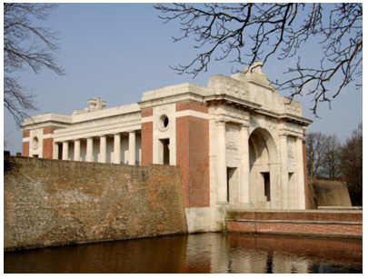Private Davidson Hedley was born in Scotland and his next of kin was his father, John Hedley of Jedburgh, Scotland. He was a 25 year old labourer of Coonamble when he enlisted on 12 January 1916 at Tooraweenah and marched to Bathurst with the Tooraweenah Kookaburras. He passed the medical examination and he was described as 6’ tall, 168 lbs (76kgs), chest 36”-39”, fair complexion, blue eyes, brown hair and no distinctive marks noted. He was Presbyterian.

After training in Bathurst NSW, Davidson embarked from Sydney on board the HMAT ‘Ceramic’ on 14 April, 1916, with the 45th Battalion. After further training in Egypt and England, he joined his unit in France in August 1916, in time to fight in the Battle of the Somme at Pozieres and Mouquet Farm. In September he spent a short time in hospital with an abscess in his tear ducts and then endured a freezing winter in the trenches. He would have fought at Guedecourt and Bullecourt, and on the first day of the Battle at Messines in June 1917 he was wounded in action with a gunshot wound to his hand. He was sent back to England for treatment and convalescence and rejoined the unit on 2 September 1917.

Davidson was promoted to Lance Corporal on 7 October 1917 and was killed in action near Passchendaele in Belgium. He has no known grave and is commemorated on the Menin Gate Memorial Panel 27, Australian War Memorial Panel 139 and the Coonamble War Memorial.

His father received his effects, the Memorial Plaque, the British War Medal and the Victory Medal.

His brother, Lance Corporal Ralph Hedley MM 2613 was from Warren NSW

Photo Menin Gate Ypres Belguim