Private William Young

Rod Martin

Young William Young - and he was young, only eighteen and a half years old when he enlisted - was among the record 36 575 men who volunteered for the army in July 1915. He was a slight lad, 174 centimetres tall and sixty-eight kilos in weight, with dark brown hair and grey eyes. He stated his occupation as an engineer, but what that meant in reality is hard to guess. At such a young age, it is unlikely that he had many if any qualifications or much experience. However, coming from Moonee Ponds, he had spent four years in senior cadets, attached to the Essendon-based 58 Infantry Brigade, so his knowledge of military matters would have been quite considerable. His attestation details indicate that he was initially assigned to the Signals Corps. However, and perhaps at his own request, he was transferred to 9 Reinforcements of 21 Infantry Battalion soon after.

After training at Williamstown and Broadmeadows, William and his comrades sailed for the Middle East on A69 HMAT Warilda on 8 February 1916.

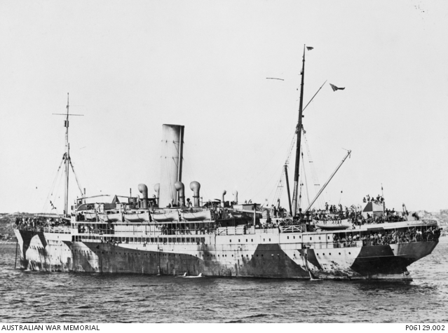

The Warilda in 1917, after being converted to a hospital ship. The camouflage
was painted on the ship after the Germans announced that they would
attack any allied ship in the English Channel. Warilda was torpedoed off Le
Havre in August 1918 while fully loaded with patients and medical personnel.
(AWM P06129.002)

When William arrived in Egypt, the Australian Imperial Force was in the process of post-Gallipoli reorganisation, reinforcement and enlargement. Like the other existing battalions, the twenty-first was divided in two, one half remaining and the other assigned to a newly created battalion. Reinforcements were then added to the still existing half, William among them. As part of 4 Brigade and then 2 Australian Division, 21 Battalion was among the first to leave for the Western Front, sailing for Marseilles on 20 March 1916. Arriving in that port on 24 March, the men then entrained for the so-called nursery sector near Armentières, in the northern section of France. This relatively quiet part of the front was selected so that the men could acclimatise themselves to the conditions on the Western Front without being in too much danger.

By 7 April, however, the battalion was in the front line at Fleurbaix, close to the small town of Fromelles. There the men spent time facing off against the Germans, being sniped at and bombarded by 77mm. field guns, before going into reserve for a short while. Soon after returning to the front line, the battalion lost its first man, killed by a sniper on 22 April.
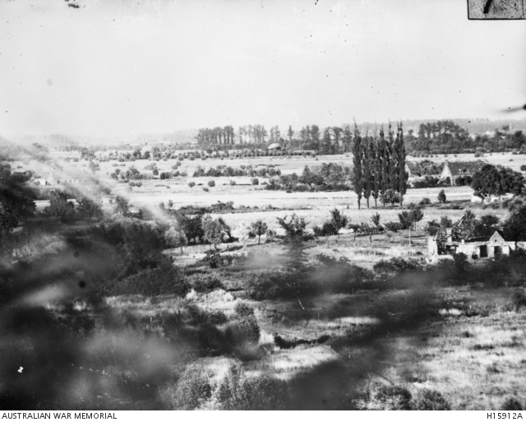

Fleurbaix 1915: looking towards Fromelles (AWM H15912A)

21 Battalion went into reserve at the beginning of May and stayed in that role until 11 June, when it returned to the front line at Rue Marle. It remained there until the twenty-second, when it was relieved by 24 Battalion. It was still in danger, however. On 1 July, the commander reported that the Germans 'dropped' a three-inch shell in front of the battalion headquarters, slightly wounding three men.

In early July, the men started to move south-east, towards the Somme Valley. The greatest battle of the war had started there on the first of the month, and 2 Australian Division had been ordered to move to the area near the village of Pozières in anticipation of going into action there later in the month. They finally reached Sausage Gully, close to Pozières, on the twenty-sixth of the month. A week earlier, 5 Australian Division suffered 5 533 casualties in a poorly planned attack at Fromelles to the north, the first major blooding of Australian troops on the Western Front. If the men of 2 Division had heard any rumours of the disaster, they may well have been nervous when they reached Pozières. If they were not, the news that greeted them once they arrived there surely would have frightened them. On 23 July, 1 Division attacked across the line at Pozières, intending to take the ruins of the village and the ridge behind it. By the twenty-fifth, after losing 5 285 casualties, the men had seized a foothold amidst the rubble. Now it was 2 Division's turn, its target being the high point of the ridge, where once a windmill stood. The attack began on 29 July, and 21 Battalion was acting as a support to the troops in the front line, taking food and water to them. On 31 July, it relieved 23 Battalion and was in action on 1 August.

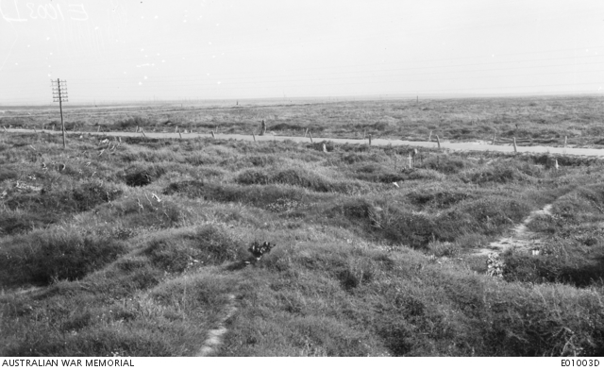

The Pozières battlefield in 1917 (AWM E01003D)

It would appear from the battalion's war diary that it basically performed support duties (such as carrying equipment to the front line) while other battalions were actively involved in seizing Pozières Ridge on 4 August. Two days later, the division was relieved and moved to bivouac at nearby Tara Hill. 2 Division suffered 6 846 casualties during its first stint at Pozières. 21 Battalion's contribution to this lamentable figure was twenty-nine killed, 2 503 wounded and seven missing.

The men stayed in reserve, moving around the area, until 22 August, when they moved back to the front line near Sausage Gully. By this time, the military's targets were the German stronghold at Mouquet Farm and then the fortified village of Thiepval beyond it.

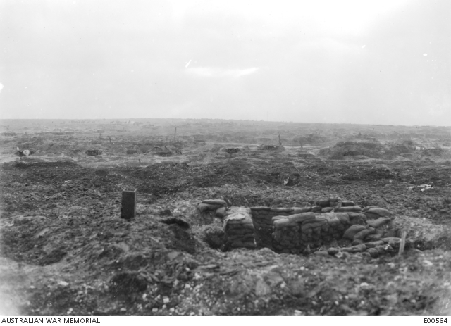

Mouquet Farm, December 1916. The Germans were entrenched in a
catacomb-like system of tunnels under the farm. (AWM E00564)

4 Division made the first assaults on the farm, attacking several times and losing
4 649 casualties by 15 August, when it was replaced by 1 Division. By the twenty-second of the month, that division had lost 2 650 casualties
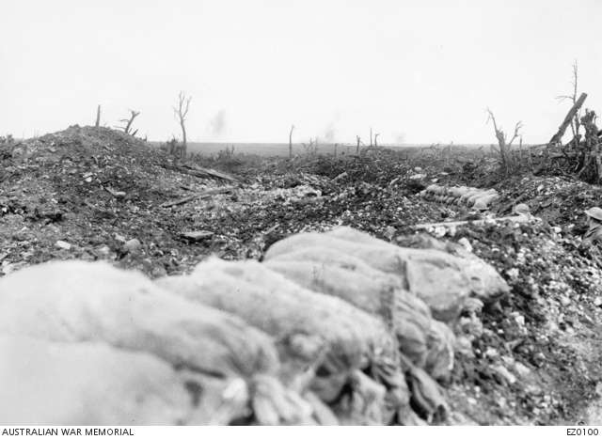

.

Looking towards Mouquet Farm from Pozières Ridge, 28 August 1916
(AWM E0100)

2 Division then took over the task and finally reached Mouquet Farm on 26 August. However, it could not hold on to it. It suffered 1 268 casualties before it was relieved by 4 Division.

4 Division was finally relieved on 15 September, having driven the salient to its furthest extent. The capture of Thiepval was unachievable. As Richard Travers comments, the total number of Australian casualties in forty-five days on the Somme was 24 139. The gain was small: Pozières Ridge and the ridge behind it.

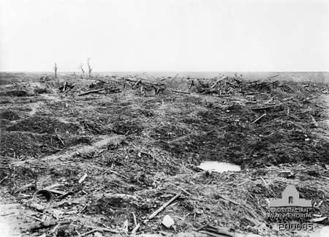

Mouquet Farm, looking south towards Pozières. This position was the
scene of severe trench warfare, neither side holding it for more than a few
hours. (AWM E 00005)

When 2 Division finally reached Mouquet Farm on 26 August, William was amongst the men attacking the position. By the end of the day, however, he had gone, disappeared like so many, probably obliterated or buried by a shell. After the war, in reply to a query from William's family as to what happened to him, the war department sent the following message, provided to it by the Red Cross:

Private J. Parker of 21 Battalion reported that William was wounded at Mouquet Farm on 26 August - one bullet in the shoulder and two in the leg - but he was still able to walk. He was taken prisoner when the unit was cut off during a German counter-attack. When the men retook the spot later, William and another wounded soldier were gone.

Evidently, the Germans did not report William as a prisoner, so the military had to assume that he had been killed in action. It is possible that the Germans marched the two men away and then executed them. Such things happened on both sides during the First World War. The question arises, however: why take the trouble to transport them elsewhere if the intention was to shoot them? We shall never know the truth of what happened.

Because William has no known grave, his name was inscribed on the Villers Bretonneux Memorial after the war.

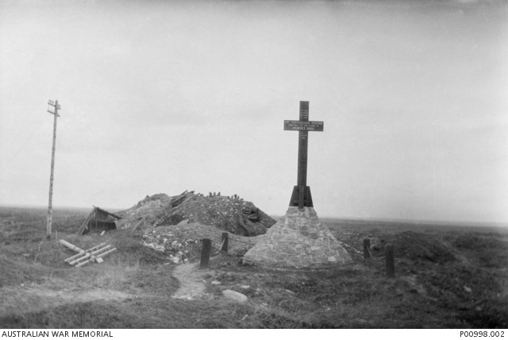

Memorial to 2 Division soldiers who died at Pozières in 1916.
( Photographed in 1918) (AWM P0098.002)

Sources

Australian War Memorial
Google Earth
National Archives of Australia
Travers, Richard: Diggers in France: Australian soldiers on the Western Front,
Sydney, ABC Books, 2008

