Private William Henry Yeates

Rod Martin

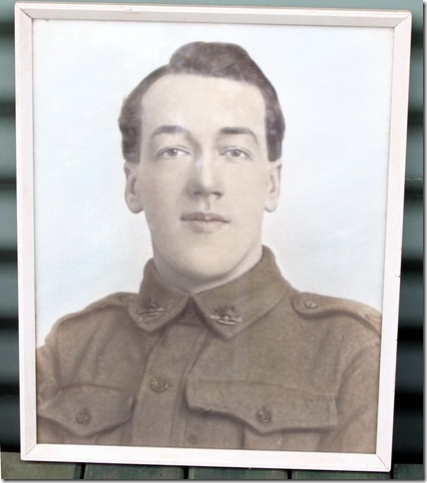

Bill Yeates was nineteen years old when he enlisted in July 1915, one of a record 36 575 men to sign up during that month. Numbers began declining rapidly after that time as awareness of the dangers of Gallipoli began to seep into the minds of the Australian public.
Bill was three years younger than his brother Joe, but was able to enlist earlier than him because Joe had problems with his eyesight, and was initially rejected when he tried to enlist in 1914. Bill’s successful application may have inspired Joe to have another go, for he applied again in September 1915 and was finally accepted.

Like Joe, Bill was a mechanic/engine driver, a job that was classified as ‘exempt’ in army terminology. He also had a stint in the country, assisting in the construction of the Mt. Buffalo Chalet in 1910. It is obvious that Bill was keen to do his bit, for he could have stayed at home and claimed (legally) that he was needed there. Instead, the 165 centimetre-tall lad, fair-haired and with blue eyes, was allocated to 6 Reinforcements of 22 Infantry Battalion and sent to Broadmeadows to undergo his training. He duly sailed for the Middle East on A38 HMAT Ulysses, leaving Port Melbourne on 27 October 1915.

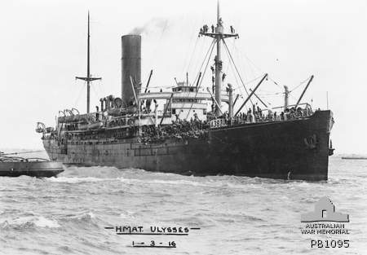

(AWM PB1095)

Arriving in Egypt in early December 1915, Bill was not sent to Gallipoli as the Allied high command had decided to admit to failure and leave the peninsula by the end of the month. Instead, the British and Anzacs (as they were now called) decided to concentrate on the Western Front in France. With all the recruits from July and other months available, the Australians were able to expand their forces. This required reorganisation. New battalions were formed and, in February, Bill was assigned to the new 57 Battalion, and then to 58 Battalion in March. That unit sailed for Marseilles in France on 17 June, destined to take part in the upcoming major assault in the area near the Somme River.

The men of 58 Battalion spent a little time in the so-called ‘nursery sector’ near Armentières in order to acclimatise themselves to conditions on the Western Front before moving towards the small town of Fromelles in July. As part of 5 Australian Division, the battalion was ordered to participate in a feint attack on 19 July, designed to draw German forces away from the main battlefront further south on the Somme. The Fromelles strategy was an unmitigated disaster due to unrealistic expectations, poor planning and inadequate resources. The men were sent out in the early evening, being expected to cross almost 400 yards of flat, open land in the face of German machine guns, shells and barbed wire and take a fortified position called the ‘Sugar Loaf’. Australia’s baptism of fire on the Western Front cost 5 553 casualties in one night for no gain.

58 Battalion was officially in reserve during this assault but nevertheless became involved when called upon to attack at 10 pm. The battalion diary informs us that one company actually made it to the enemy trenches (against all the odds), but could not stay as it would have become isolated, and the remnants then crawled back to their own trenches throughout the night. Losses were recorded as being heavy. 15 Brigade commander ‘Pompey’ Elliott cried as the survivors staggered back during the night and early morning. He had never believed in the plan and had said so – but to no avail. Heavy German shelling throughout the night prevented the Australians from evacuating the dead and wounded. A reckoning determined that twenty-seven men of 58 Battalion had been killed, 167 were wounded and fifty-three were missing. Many of those missing were probably killed and then collected by
the Germans and buried in mass graves just behind their lines. It was those graves that were recently discovered and excavated.
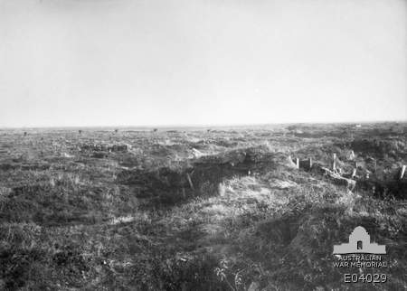

The old Fromelles battlefield, photographed in November 1918. Note the
remains of German fortifications on the ‘Sugar Loaf’ to the right.
(AWM E04029)

We must assume that Bill was involved in this debacle, and was lucky to survive. What impact it had on him is unknown, but it interesting that he transferred to 15 Brigade Machine Gun Company only four days later. It may well be that he had put in his request for transfer before the attack at Fromelles. It may also be the case that a vacancy became available as a result of the battle, and he seized the opportunity. Whatever the reason, Bill became a machine gunner from that time on, and followed 15 Brigade (of which 58 Battalion was a part) as it moved around the battlefields.

The machine gun company was made up of approximately 150 men, using sixteen Vickers machine guns.
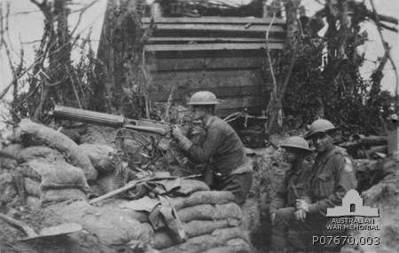

A Vickers machine gun in action at Pozières, July 1916
(AWM P07670.003)
The dangers that machine gunners faced were no different to those experienced by the infantry or any other type of unit at the front. During the attack at Fromelles, for example, 15 Company had lost two guns by 6.30 pm (the troops went over the top at 6 pm) and suffered seventeen casualties. By 9.35 pm, nine men had been killed and seventeen wounded. The final tally at 9.45 the next morning was thirty-four casualties.

15 MG Company stayed in the area of Fromelles during August and September, taking regular action against the German trenches in support of the four rotating battalions of 15 Brigade. On 20 August one man was killed during a raid on the enemy trenches. Later in the month, on the twenty-ninth, a drama occurred among the ranks when one man shot and wounded another. While the injured man was evacuated to a field hospital, the perpetrator was arrested and taken away. The reason for the conflict was not reported, but the company’s almost constant involvement in action may well have exacerbated tensions among the tired, often shell-shocked troops.

Bill attended an artificers’ school in Calais between 15 September and 4 October. Army artificers are trained mechanics, and it is likely that Bill gained skills and experience in servicing and repairing Vickers machine guns. When in the field, the company would have to have done much of its own maintenance, and it required men who had such skills.

The company finally moved out of the front line on 17 October and travelled towards Montauban. The next day, it took time out to allow the men to vote for the first of Australia’s two plebiscites (often referred to incorrectly as referenda) on the issue of the conscription of men for front line duty.

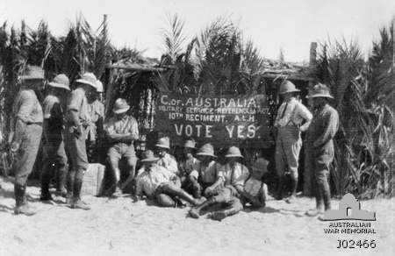

Australian troops voting in the first plebiscite, the Sinai Desert 1916
(AWM J02466)

At the end of the month the unit was back in action again, and the diary recorded the fact that it was raining heavily. In fact, it had been raining heavily for some time and, on 2 November, Bill succumbed to one of the soldiers’ greatest enemies on the Western Front:

trench foot. This affliction was a widespread and debilitating complaint that affected men on both sides of the lines. When in the trenches, the men were often standing up to their ankles or even calves in cold mud for hours on end. As a result, their feet would swell and turn red, and blood blisters would develop. If their boots were tight-fitting, the damage would be exacerbated. The pain was severe until the sensory nerves were damaged. Their feet would then go numb, and gangrene was a possibility. Some men died as a result of trench foot.

The treatment involved elevation of the limbs and the application of modest warmth. The more severe the case, the more likely the chance of nerve damage and/or gangrene, and the longer the need for treatment. Bill’s case must have been quite bad for he was evacuated to hospital in England on 7 November and was not discharged until the twelfth of the next month. He then stayed in England, recuperating for some time. It was while he was there that his brother Joe died after being wounded in France in February. One of Joe’s last hopes was that he would be evacuated to hospital in England and be able to catch up with Bill. It wasn’t to be.

In March 1917, new battalions were formed in England, designed to be part of the future 16 Infantry Brigade and 6 Division. It would appear that Australian soldiers who were currently recuperating in England were assigned automatically to the new units, regardless of any previous affiliations. Bill found himself appointed to 65 Battalion on the twenty-fifth of the month. How he and the others affected felt about this is not known, but they were probably not happy to be separated from their mates.

Bill was not in his new unit very long before he ended up in hospital again, this time with the highly infectious disease called Scabies. Scabies are small mites that burrow under the skin. They are passed on by close human contact in dirty, often crowded conditions. Bill may have caught these in the barracks where the men were housed. It is interesting in this regard that the entry in his record concerning this infection stipulates that he did not have venereal disease. There was obviously a strong connection between the two infections, considering the likely unhygienic conditions of French estaminets and brothels.

65 Battalion – in fact, the whole 6 Division – never made it to France. Instead, it was disbanded and the men distributed among other, already existing units when they returned to action. When Bill returned on 22 October 1917, he rejoined his old company. By that time, it was located in Belgian Flanders and supporting 15 Brigade in the Third Battle of Ypres. Success had come for 5 Division at Polygon Wood the previous month. By late October, however, in the face of terrible weather and the thick, glutinous mud for which Flanders is infamous, the battle was literally bogged down. 15 MG Company was in reserve when Bill arrived back, but spent the next two months alternately training and spending time in the front line before moving back into France just before Christmas.

In March 1918, the Germans made a last-ditch effort to win the war before American troops could arrive on the Western Front in large numbers (The United States had entered the war in April 1917). Bolstered by troops from the Eastern Front now that the newly Bolshevik Russia was out of the war, the Germans staged a massive offensive in France that pushed the Allies back. 5 Division men and their supporting artillery and machine gun companies
were involved in such defensive actions as the battle for Villers-Bretonneux in late April.

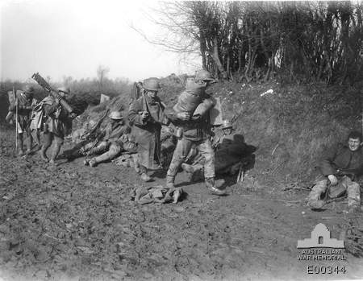

Machine gunners near Bapaume, France, 1917 (AWM E00344)

Victory in those battles helped them to consolidate their positions and slowly push the Germans back. By 29 July, 15 MG Company was in action in the vicinity of the Ancre River near the Somme and Bill was one of three men wounded that day. He was struck in the face, both arms and his right leg by an exploding shell, receiving compound fractures of his femur and left forearm. Initially, he was reported as having died of his wounds on the twenty-ninth, but this was later altered to ‘dangerously ill’. A premature telegram would have caused incredible grief at home before a revised, more hopeful version followed it a few days later.
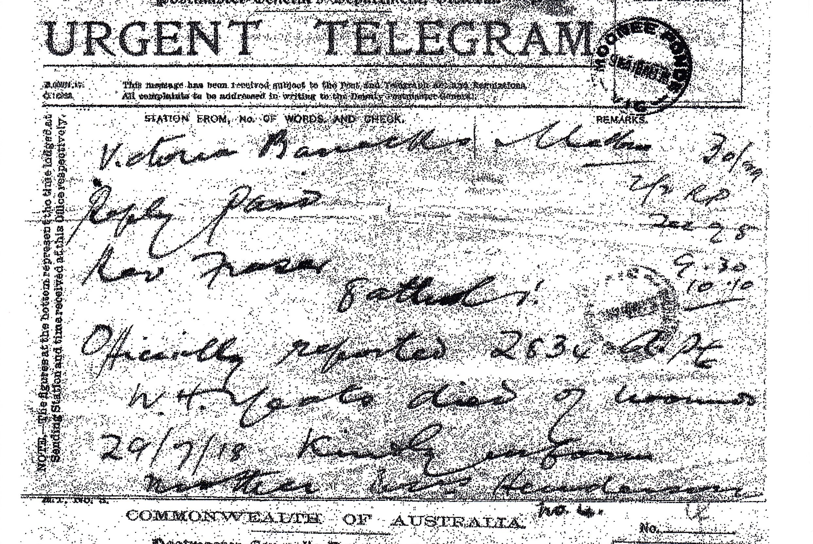

(Lorilee Yeates)

The fact was that the shell killed a number of men, and their bodies lay in the subsequent crater. Presumably, they were reported as killed, Bill included. He was underneath them and remained there for three days until discovered by Salvation Army officers. Had they not noticed the flicker of his eyelid they may well have buried him along with the others. It is also interesting to note, as his granddaughter Lorilee has reported, that he had an emergency blood transfusion in the field, something quite new in those days. With the knowledge of blood types being scant, and with no idea of Bill’s type, the medics and Bill were just lucky that the blood taken from an Irish soldier was compatible with his. The result could have been quite catastrophic!

Bill was cared for in a field hospital until he was transferred to a permanent one on 7 August. He remained there until he was evacuated to London in October, presumably when he was well enough to travel. By that time his left forearm may have been amputated. It is rather difficult to interpret his file at this point, but it does contain a reference to ‘amp.’ in regard to his wound and later indicates that he was classified ‘MD’ (medical disability – or discharge?).

Bill’s war was over. He spent the next six months in 8 General Hospital. In addition to the loss of his left forearm, he could not turn his right one. Part of his right leg had been blown away. It was not amputated, but it was very stiff for the rest of his life. His face, badly injured, also had to be rebuilt. As if this was not enough, he had been gassed at some time during the conflict, and he suffered from the effects of that for the remainder of his days.

Bill spent some time in convalescence before being granted a furlough on 23 April. He sailed for Australia on 28 August 1919. When he was finally demobilised, he obtained a job at the head office of the Commonwealth Bank in Bourke Street, operating one of the lifts. He married and had one son, also named Bill.

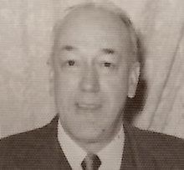

Bill in later years (Lorilee Yeates)

Bill’s story, sad as it is in many ways, is able to finish with a little piece of levity. Lorilee reports that, at one stage during the war, Bill was captured by the Germans. However, he

managed to escape and was hidden by some French farmers in, of all places, their privy – under the contents! The Germans failed to find him (not surprisingly!) and he was able to return to his unit. Just what state he was in when he arrived there is open to speculation. He may have been given a very wide berth by his comrades!

Sources

Australian War Memorial
Lorilee Yeates
en.wikipedia.org
http://www.aif.adfa.edu.au
Martin, Rod: John Frederick Keith Comb, Melbourne, unpublished, 2008
National Archives of Australia
Travers, Richard: Diggers in France: Australian soldiers on the Western Front,
Sydney, ABC Books, 2008

