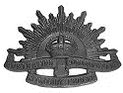

**Gnr. Elford Renner Smythe**

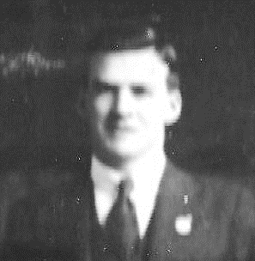

**Played with Adelaide University**

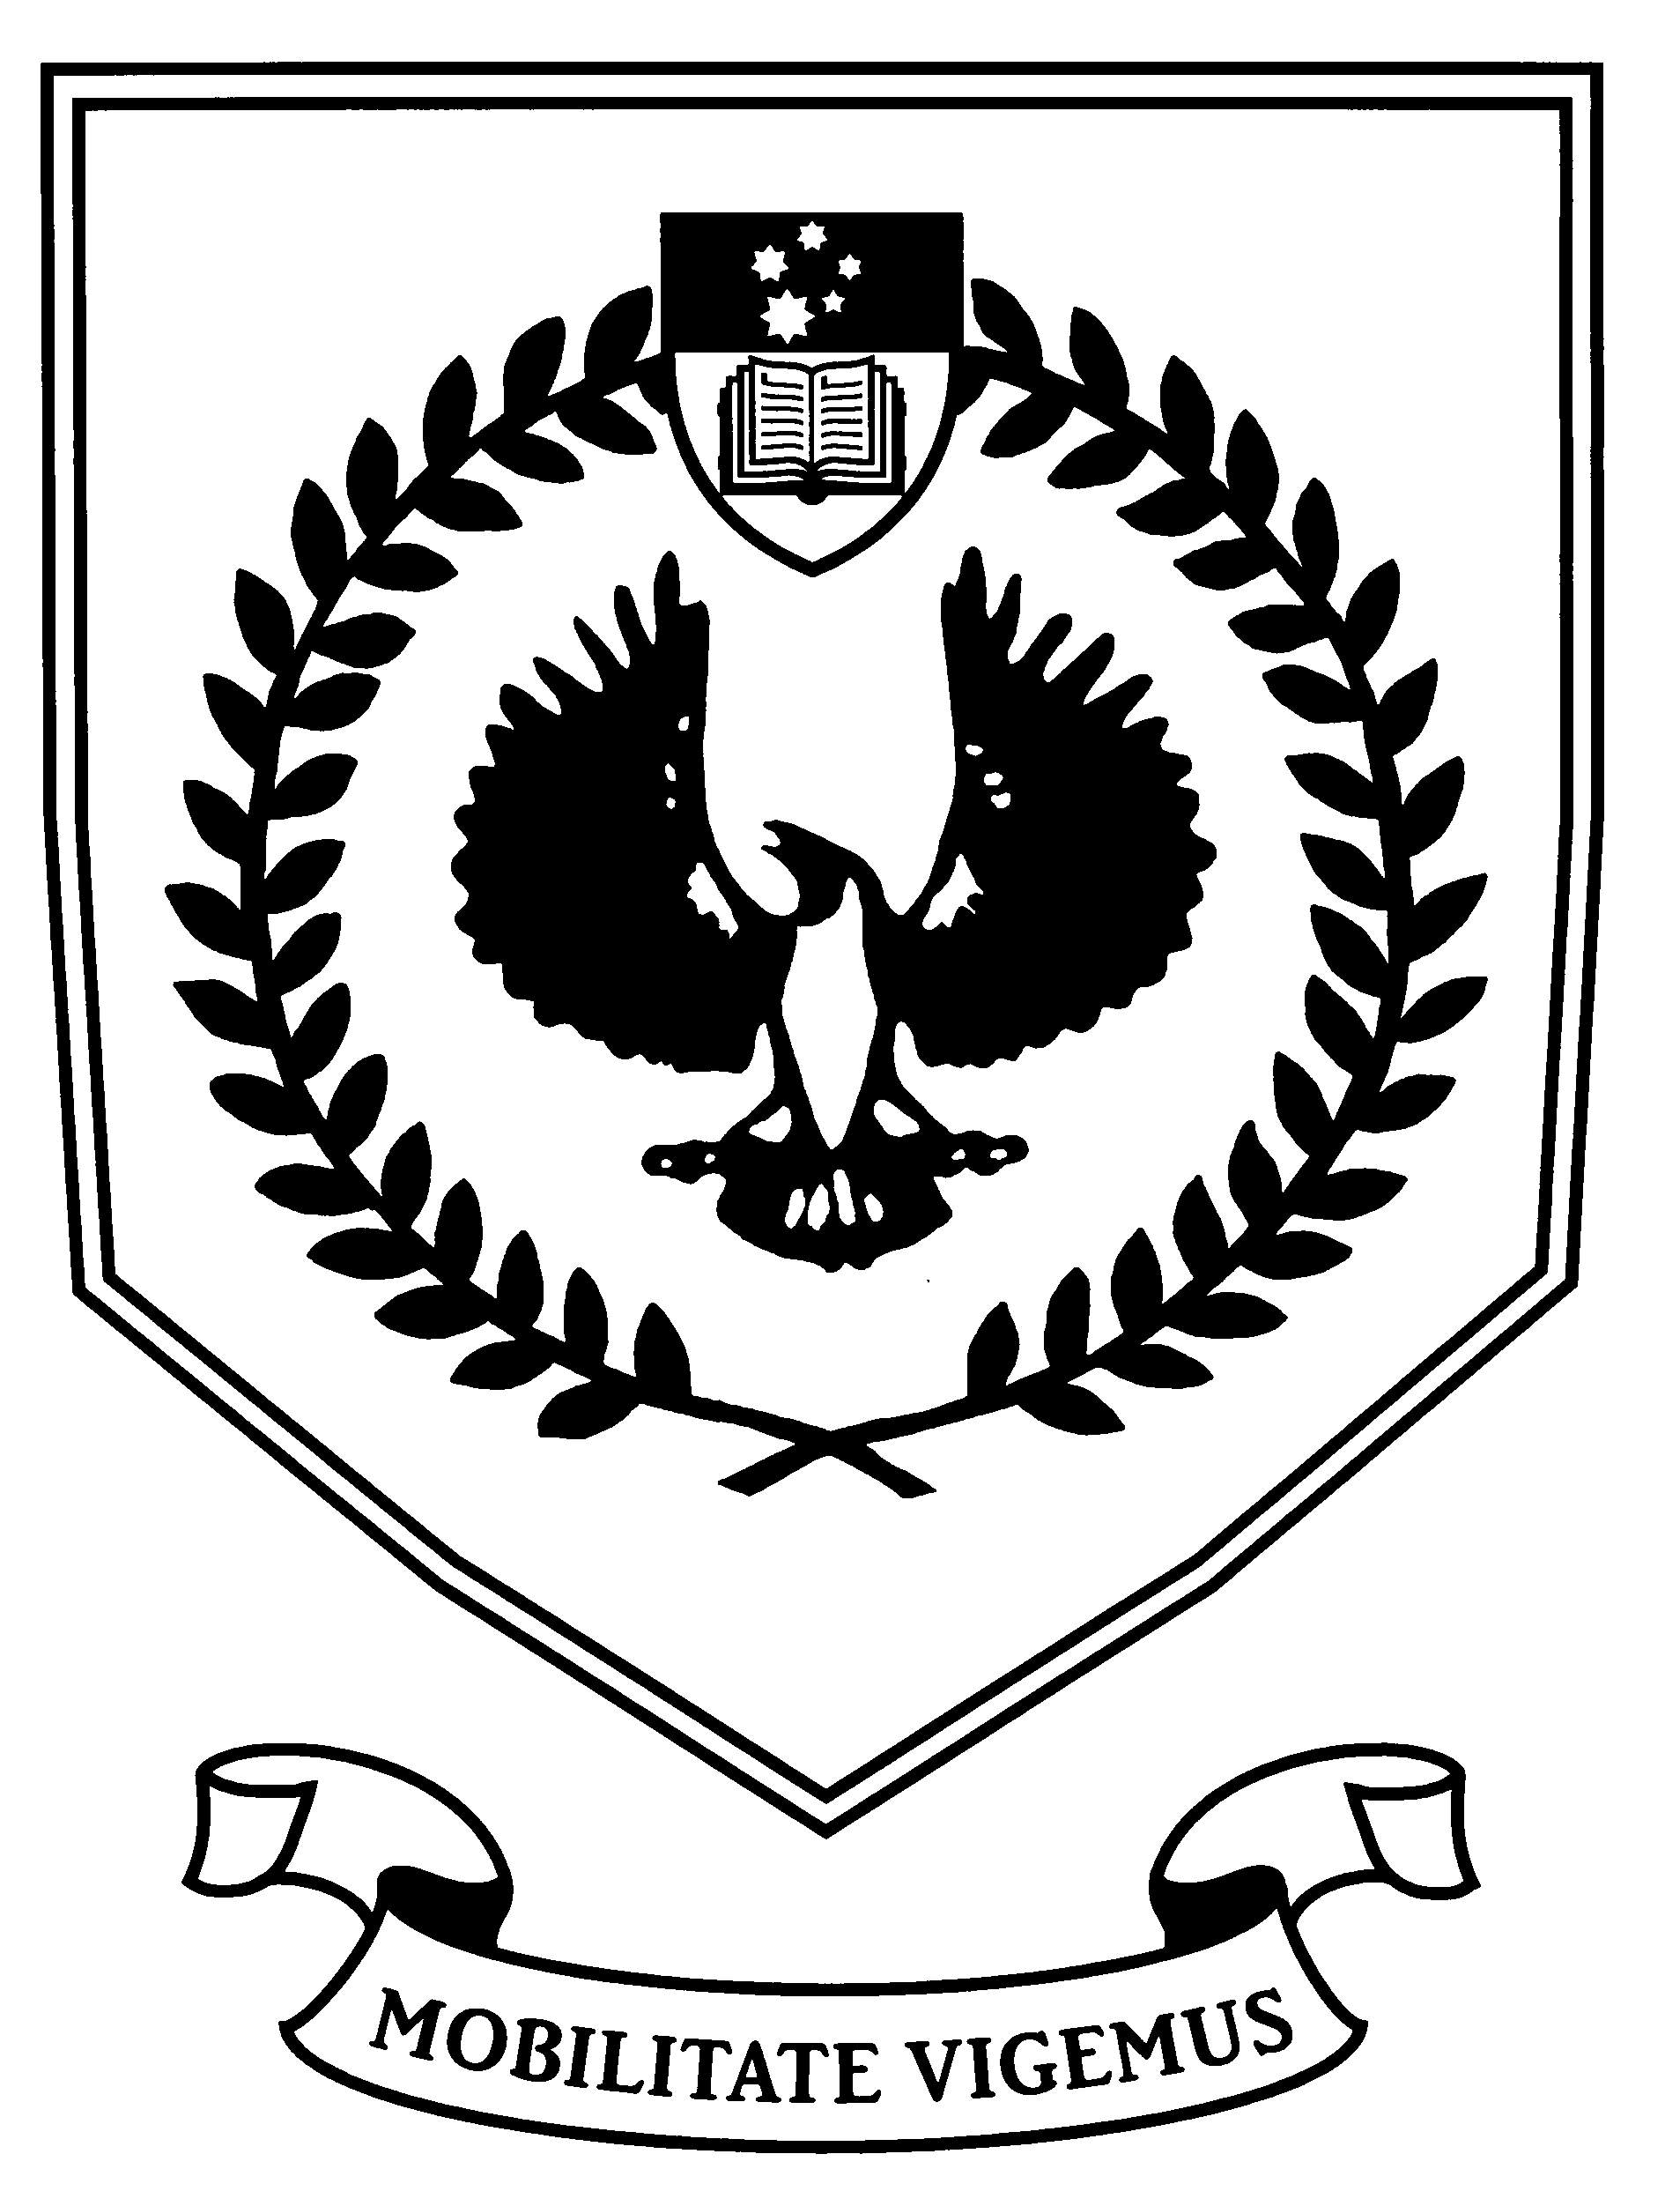

**Football Club: B Grade (1920 & 1921)**

**Student of Arts and Applied Science**

***Background***

***Coinciding with the Centenary of Anzacs our incentive behind the series of biographical publications is the Adelaide University Football and Cricket Club's desire to honour our players who served in the Great War (1914 - 1918). These brave men put on hold their academic, professional and sporting careers for King and Country in the name of peace and freedom. The AUFC/AUCC WW1 Memorial Committee is endeavouring to identify every one of our players who served and prepare life stories on all. This is to ensure their sacrifices and further contributions to society will be recognised by future generations.***

***On Anzac Day 2015, the Centenary of the Gallipoli landing, a memorial plaque was unveiled on the Adelaide University Oval Pavilion and this was followed by the erection of a picket fence between the pavilion and the scoreboard with each picket bearing a plaque with the name of an AUFC/AUCC player who served.***

***The following documentation relates to the life of Elford Renner Smythe. It is compilation of information and photographs collected from a variety of historical sources.***

AUFC/AUCC WW1 MEMORIAL COMMITTEE

**The AIF Project**

<https://aif.adfa.edu.au/showPerson?pid=282611>

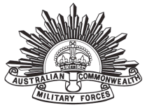

### Elford Renner SMYTHE

|  |  |
| --- | --- |
| Regimental number | 31600 |
| Place of birth | Adelaide, South Australia |
| Religion | Church of England |
| Occupation | Draughtsman |
| Address | Murray Bridge, South Australia |
| Marital status | Single |
| Age at embarkation | 19 |
| Height | 5' 11" |
| Weight | 150 lbs |
| Next of kin | Father, F.E. Smythe, Murray Bridge, South Australia |
| Previous military service | Senior Cadets (4 years); 80th Infantry (still serving) |
| Enlistment date | 16 September 1916 |
| Place of enlistment | Adelaide, South Australia |
| Rank on enlistment | Gunner |
| Unit name | Field Artillery Brigade 6, Reinforcement 12 |
| AWM Embarkation Roll number | 13/34/3 |
| Embarkation details | Unit embarked from Melbourne, Victoria, on board RMS *Orontes* on 23 December 1916 |
| Rank from Nominal Roll | Gunner |
| Unit from Nominal Roll | 5th Field Artillery Brigade |
| Fate | Returned to Australia 9 March 1919 |
| Discharge date | 3 June 1919 |

|  |  |
| --- | --- |
| Other details | War service: Western Front  Embarked Melbourne, 23 December 1916; disembarked Plymouth, England, 17 February 1917; marched into No 3 Camp, Parkhouse, 18 February 1917.  Marched into Reserve Bde Australian Artillery, Bulford, 26 March 1917.  Proceeded overseas to France, 19 June 1917; marched into Australian General Base Depot, Rouelles, 20 June 1917.  Proceeded to unit, 25 June 1917; taken on strength of 2nd Australian Divisional Artillery Column, 27 June 1917.  Transferred to 5th Field Artillery Bde, 11 August 1917 and taken on strength of 13th Battery the same day.  Wounded in action, Belgium, 17 October 1917, and admitted to No 10 Casualty Clearing Station the same day (gas shell); transferred to No 16 Ambulance Train, 18 October 1917; to No 22 General Hospital, Camiers, 19 October 1917 (gassed, mustard); to England, 29 October 1917; to General Military Hospital, Colchester, 30 October 1917 (gassed, severe); to No 3 Australian Auxiliary Hospital, Dartford, 16 November 1917; discharged and marched into No 3 Command Depot, Hurdcott, 19 November 1917.  Classified B1A1, 20 November 1917.  Classified B1A2, 30 November 1917.  Marched into No 4 Command Depot, Worgret Hill, 10 December 1917.  Marched into Overseas Training Bde, 19 March 1918 and then marched into Reserve Bde Australian Artillery, Heytesbury, the same day.  Proceeded overseas to France, 8 April 1918; marched into Australian General Base Depot, Rouelles, 9 April 1918.  Proceeded to unit, 12 April 1918; taken on strength of 2nd Australian Divisional Artillery Column, 25 April 1918.  Transferred to 5th Field Artillery Bde, 28 April 1918, and taken on strength of 13th Battery the same day.  Proceeded to England for return to Australia, 26 January 1919; marched into Administrative Headquarters, no date stated, and granted leave until 6 February 1919; marched into 1st Training Bde Concentration Camp, 6 February 1919.  Commenced return to Australia on board HT 'Kashmir', 1 April 1919; admitted to Ship's Hospital, 1 April 1919 (pyrexia of unknown origin); disembarked Adelaide, 25 April 1919; discharged (termination of period of enlistment), Adelaide, 3 June 1919.  Total war service: 2 years 261 days (of which 2 years 124 days were abroad).  Medals: British War Medal, Victory Medal |
| Date of death | 12 December 1923 |
| Age at death | 26 |
| Place of burial  Sources | AIF Cemetery (5 West 14), West Terrace, Adelaide, South Australia  NAA: B2455, SMYTHE Elford Renner |

**Service Record**

<https://recordsearch.naa.gov.au/SearchNRetrieve/Interface/ViewImage.aspx?B=8087496>

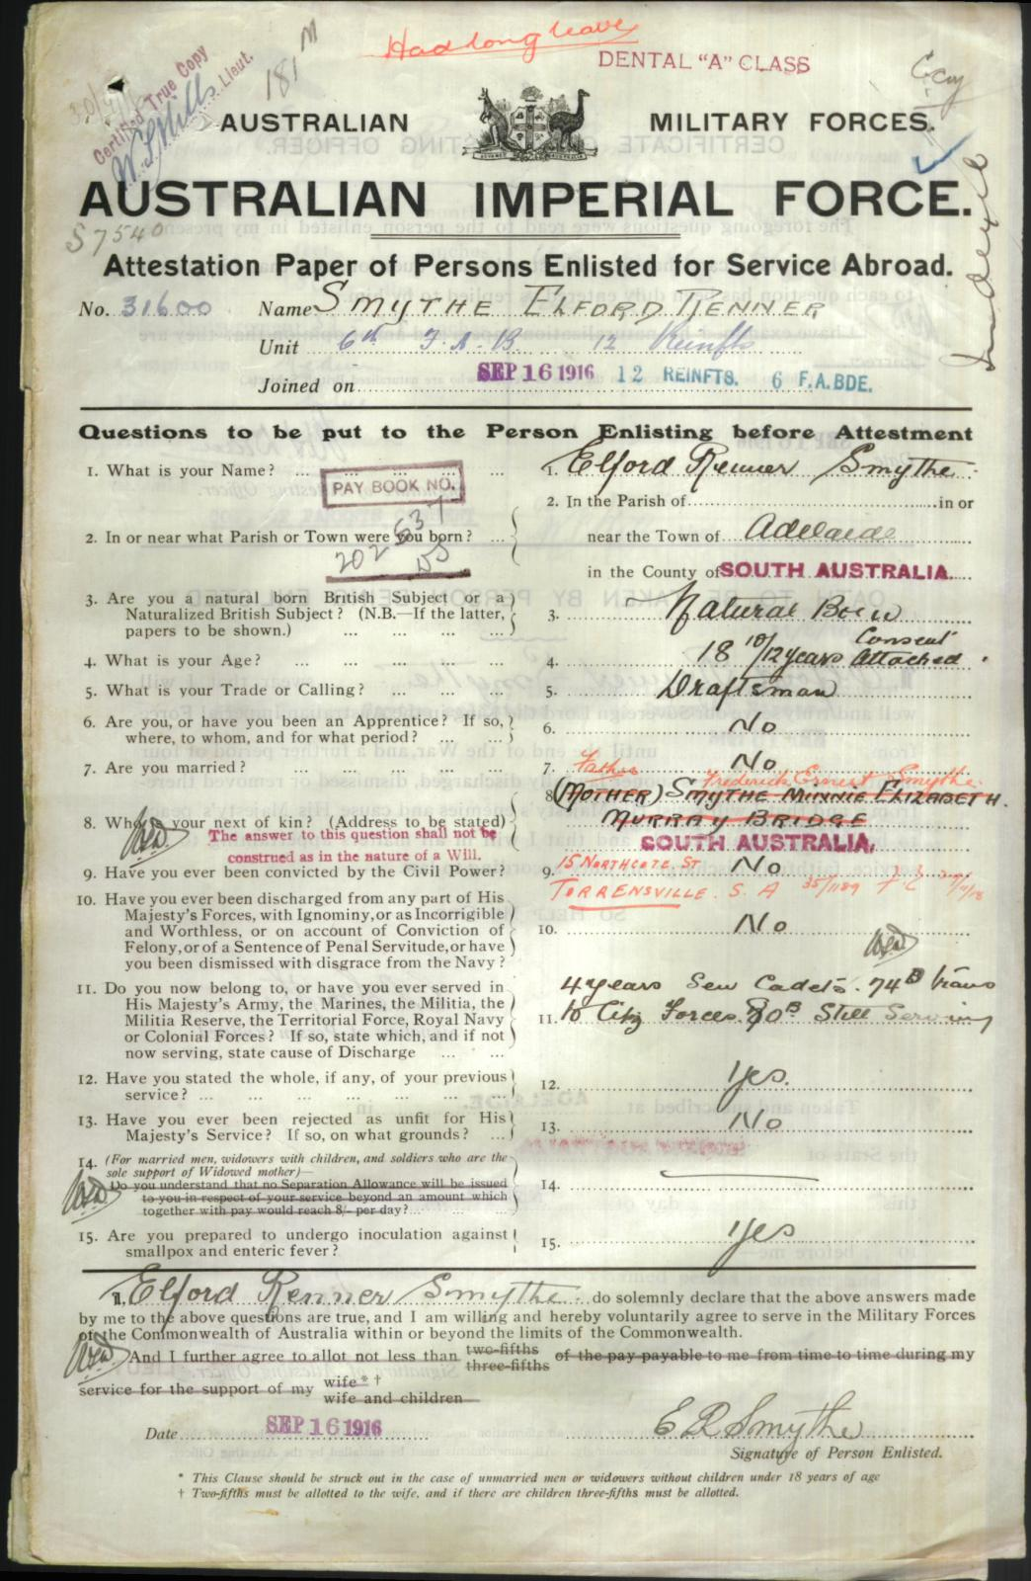

**Biography**

**Early Life**

Elford Renner Smythe was born on the 3rd of November 1897 at Mackinnon Parade, North Adelaide, the son of Frederick Ernst "Ernie" Smythe and Minnie Elizabeth Renner of Petersburg (Peterborough), SA. Elford’s father was employed in the Resident Engineers’ Office of the South Australian Railways.

Snapshot(17).png

**Schooling**

Elford’s early schooling would have been undertaken at Peterborough where the Smythe family were living. Elford’s younger brother, Alan Cresswell Smythe, was born there on the 18th of September 1908.

Ernie Smythe and his family moved from Peterborough to Murray Bridge in April 1909. Elford passed the Education Department examinations in First Grade Model Drawing in December 1913. He attended Murray Bridge District High School, coming 19th in the Junior Examinations in 1913 and then Mt Barker High Schools,. Elford’s father had been a fine cricketer at Peterborough and Elford played cricket at Murray Bridge in 1914.

**Pre-War Career**

In June 1916, Elford was accepted for appointment to the professional staff of the South Australian Railways. He passed Intermediate Freehand and 2nd Grade Solid Geometry at the Adelaide School of Arts examinations in August and September 1916.

**World War I**

On the 16th of September 1916, Elford enlisted. He was 18 years and 10 months old with his occupation stated as a draftsman. His mother was named as his next-of-kin, but this was later changed to his father after the family had moved to Torrensville. Elford had been a Senior Cadet for four years and was a serving member of the Citizens Forces. Elford was 5’11”, 150 lbs, with a medium complexion, blue eyes and brown hair. Being under 21 years of age, Elford had required his parent’s permission to enlist.

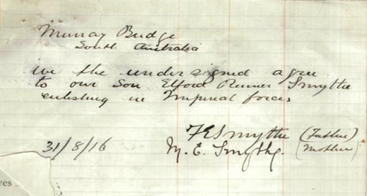

He was given a farewell by the staff of the Resident Engineer’s Office at Murray Bridge in November 1917.

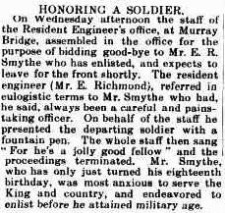

Elford went to Maribyrnong in Victoria and trained as a Gunner. He embarked from Melbourne, Victoria, on board *RMS Orontes* on 23rd of December 1916 and arrived in Plymouth, England on the 17th of February 1917.

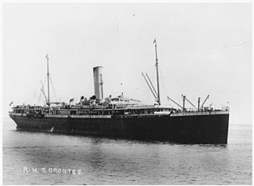 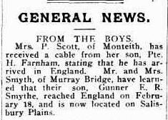

Elford served on the Western Front and his movements during WWI are detailed in the AIF Project profile above. In November 1917, news arrived in South Australia that Elford had been gassed and was convalescing in London. Elford was at the Colchester General Military Hospital then the Australian Auxiliary Hospital, Dartford.

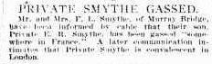

Elford returned to Australia onboard the troopship *HMS Kashmir* on the 30th of April 1919 and was discharged from the AIF on the 3rd of June 1919.

**Adelaide University**

Elford could have been enrolled as a student in the Faculty of Arts at Adelaide University, when he enlisted in September 1916. Although his name does not appear in the University Calendar’s list of students for 1916, his name does appear on the Adelaide University Honour Roll for the Faculty of Arts students.

On his return to civilian life after WWI Elford changed his focus and studied Engineering and Applied Science at Adelaide University and at the School of Mines, passing examinations in Compulsory Mathematics and Fitting and Turning in November/December 1919. Elford passed further subjects toward his degree in 1920 and 1921 and was still at University in 1922, however his name does not appear in the 1922 examinations pass lists.

**University Sport**

*Football*

Elford played football for the Adelaide University B Grade in 1920 and 1921; he was a member of the B Grade Premiership winning side in 1920.

**1920 - Adelaide University – B grade - Premiers**

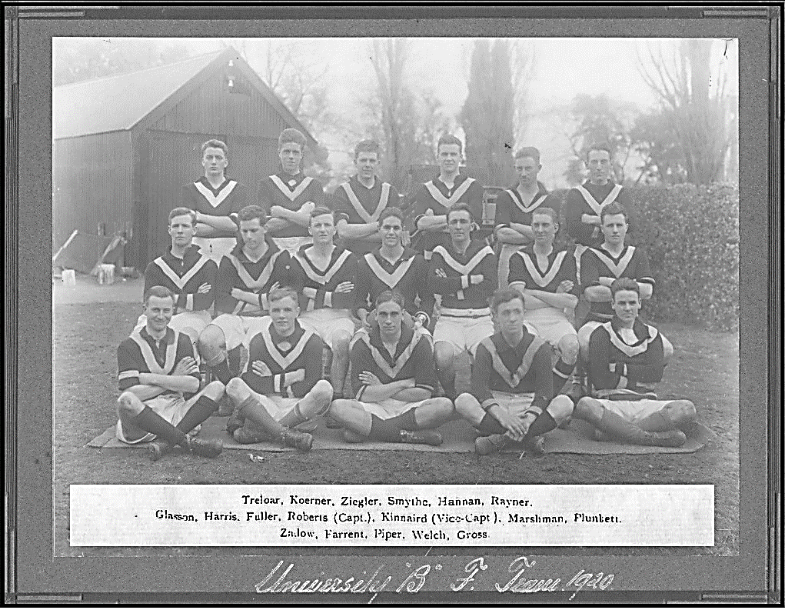

***E.R. Smythe – Back Row – Third from Right***

*Tennis*

Elford played lawn tennis for the University D team in the Class III grade in the 1920/21 season and in the Adelaide University team in the Metropolitan Association in 1921/22.

*Athletics*

Elford competed in the Adelaide University Athletic Club Annual Sports in 1920-1922.In 1920 he won the 880-yds Handicap and the Mile Handicap, in 1921 he again won the 880 Yards Handicap and in 1922 he won the 880 Yards Championship.

**1920 Adelaide University Athletic Club Annual Sports**

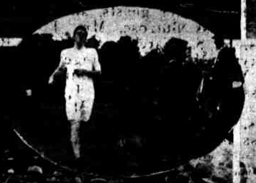

***E.R. Smythe – Winner - 880 Yards Handicap***

In 1921 Elford represented the University at the South Australian Amateur Athletics Association competition in the 880 yards and the mile races. He was on the committee which ran the Intervarsity Athletics competition in Adelaide in 1922 and was a member of the competing side.

**1922 – Adelaide University Intervarsity Athletics**

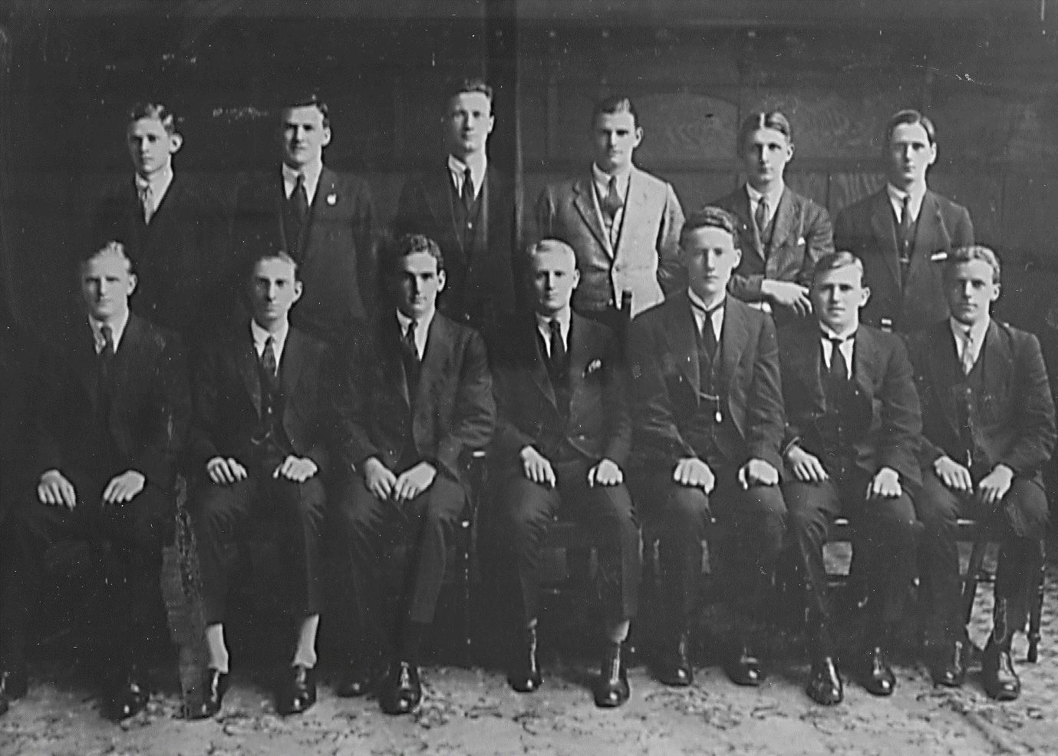

***Back: M.A.Brookes, E.R.Smythe, F.W.Hoopman, G.J.Gregerson, G.H.Howard, W.R.Ashton.***

***Front: R.T.Kleeman, W.M.Marshman, E.J.Harbison, L.V.Pellew(capt), J.Harris, J.S.Kessell, C.E.Willing. Won by Melbourne, Adelaide 3rd.***

*Rowing*

Elford was a member of the Adelaide University Eight who rowed in the Intervarsity competition in June 1921. He weighed 11 stone 6 pounds at the time and rowed in seat 5.

**May 1921 - Adelaide University Eight**

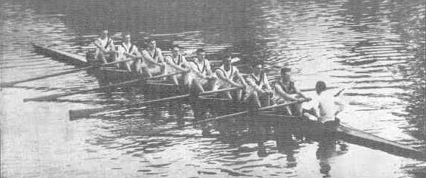

***E.R. Smythe – Fifth from Left***

***Left to Right: 1, W. Ferguson, 2, L. P., Johncock, 3, E. P.Northey, 4, L. Thyer, 5,***

***E. Smythe, 6, F.Morphett; 7, J. S. Lord; stroke, R. L.Naylor***

(the newspaper photograph above was not named and

the naming assumes the crew were rowing in their advertised seat numbers)

Elford had been selected to row in seat 7 for the 1922 Intervarsity but had to retire owing to severe lumbago.

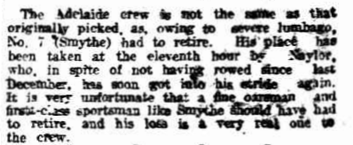

After the newspaper report above which states that ‘It is very unfortunate that a fine oarsman and first-class sportsman like Smythe should have to retire”, Elford ceases to appear in newspaper articles, except for an article relating to the Murray Bridge Roll of Honour until his untimely death in December 1923.

**Death**

Elford Renner Smythe passed away on the 12th of December 1923, aged 26 years, he was buried at the AIF Cemetery (5 West 14), West Terrace, Adelaide, South Australia on the 13th of December 1923.

Elford’s cause of death is not known however, his death does not appear to have been unexpected or the result of an accident as no details of a coroner’s case have been located and Elford was laid to rest the day following his death.

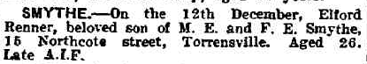

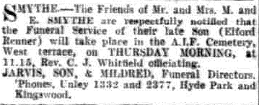

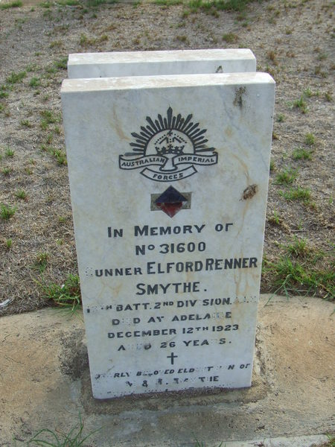

***Profile Compiled by: Beth Filmer AUFC/AUCC WW1 Memorial Group***

**Sources:**

The AIF Project <https://www.aif.adfa.edu.au/>

RSL Virtual War Memorial <https://rslvirtualwarmemorial.org.au/explore/>

The National Archives of Australia <http://recordsearch.naa.gov.au/>

Australian War Memorial <https://www.awm.gov.au/collection/>

The Adelaide University <http://www.adelaide.edu.au/records/archives/>

<http://hdl.handle.net/2440/50135>

<http://hdl.handle.net/2440/62461>

<https://digital.library.adelaide.edu.au/dspace/handle/2440/63849>

The National Library of Australia <http://trove.nla.gov.au/newspaper/>

(Trove Newspaper articles tagged – Elford Renner Smythe)

SA Genealogy <https://www.genealogysa.org.au/resources/online-databases.html>

Ancestry.com.au

Adelaide Cemeteries Authority <http://www.aca.sa.gov.au/Records>

Smythe, Elford Renner v.1