***Howard Champion NIELD WW1 1914-1918)***

**PERSONAL INFORMATION**

|  |  |
| --- | --- |
| Name | Howard Champion Nield |
| D.O.B | |  | | --- | |  |   1891 November 3 |
| D.O.D | 19 August 1969 at Daw Park, SA |
| P.O.B | Strathalbyn S. Aust |
| Aged | 77 |
| Religion | |  | | --- | | Methodist | |  | |
| Occupation (prior enlistment) | Farm Labourer |
| Address | Tarlee, S. Aust |
| Parent(s) | Henry NIELD and Fanny nee CHAMPION |
| Sibling(s) | 1. [Doris Mary Nield (F)](https://www.familysearch.org/en/tree/person/GZFH-9H4) 2. [Arthur Patrick Nield (M)](https://www.familysearch.org/en/tree/person/GC3J-2B2) 3. [Hugh Kingsley Nield (M)](https://www.familysearch.org/en/tree/person/L5XL-KNT) 4. [Olive Marjorie Nield (F)](https://www.familysearch.org/en/tree/person/GC3J-G9S) 5. [Ernest Wilfred Nield (M)](https://www.familysearch.org/en/tree/person/GC3V-MJX) 6. [Winifred Bessie Nield (M)](https://www.familysearch.org/en/tree/person/GC3J-LXQ) 7. [Frederick Boden Nield (M)](https://www.familysearch.org/en/tree/person/GC3J-J76) 8. [Mabel Annie Nield(F)](https://www.familysearch.org/en/tree/person/GD3R-M9G) 9. [Eleanor Fanny Nield (F)](https://www.familysearch.org/en/tree/person/GC3V-M3X) 10. Florence May Nield (F) 11. [Kenneth Charles Nield (F)](https://www.familysearch.org/en/tree/person/GC3J-LFK) |
| Spouse | [Marjorie Elizabeth Day](https://www.wikitree.com/wiki/Day-15697) |
| Date married | 18 Aug 1923, Methodist Church, Malvern, S. Aust |
| Children | Eleanor Margaret (Nield) Hatcher –  b. 28 Jul 1924, d. 4 Jan 1992, m. 5 Apr 1952  Graham Arthur Nield –  b. 22 Sep 1926, d. 23 Jun 2004, m. 19 Apr 1952 |
| Place buried | Buried Enfield Memorial Park Second Crescent 523 |
| ? | Cremated Centennial Park Cemetery |
| Next of kin | Mother, Mrs. Fanny Nield, Salisbury, South Australia |
| Place buried | Buried Enfield Memorial Park Second Crescent 523 |
| Image: | Picture |

‘

**SERVICE INFORMATION**

|  |  |
| --- | --- |
| Regimental number | 1629 |
| Conflict | First World War (1914-1918) |
| Enlistment date | 27th July, 1915 |
| Place of Enlistment | Keswick S. Aust |
| Rank | Private |
| Unit | [3rd Light Horse Regiment, 12th Reinforcement](https://aif.adfa.edu.au/showUnit?unitCode=LH3REIN12) |
| Age at embarkation | 23 |
| AWM Embarkation Roll number | 10/8/3 |
| Embarkation details | Unit embarked from Adelaide, South Australia, on board HMAT A2 *Geelong* on 18 November 1915 |
| Return details | Returned to Australia 9 December 1918 per 'Argyllshire' |
| Rank (Nominal Roll) | Driver |
| Unit (Nominal Roll) | 4th Division Ammunition Column |
| Served in | Egypt |
| Medals | Military Medal  Meritorious Service Medal (?) ( |
| Record number(s) | State Records of SA GRG 26/5/4/1730 |

**SIBLING’S SERVICE INFORMATION**

|  |  |
| --- | --- |
| Name | Arthur Restarick Nield |
| Parents | Charles Henry NEILD and Fanny nee CHAMPION |
| Rank | Lieutenant |
| Regimental number | N/A |
| Unit | Imperial Camel Corps. |
| D.O.B | Born 11 August 1890 |
| P.O.B | Crystal Brook, SA |
| D.O.D | Killed in Action 11 April 1918 at Mussellabeh, Palestine |
| Address | William Street, Hawthorn, SA |
| Aged | 28 |
| Occupation (prior enlistment) | Mercantile Clerk |
| Date of Enlistment | 11 September 1914 |
| Place of Enlistment | Morphettville S. Aust |
| Served in | Egypt and Palestine |
| Returned to Australia | N/A |
| ??? |  |
| Place buried | Buried Jerusalem War Cemetery, Palestine |
| Record number | State Records of SA GRG 26/5/4/1729 |
| Image | Picture |

|  |  |
| --- | --- |
| Name | Ernest Wilfred Nield |
| Parents | Charles Henry NEILD and Fanny nee CHAMPION |
| Rank | Corporal |
| Regimental number | 1548 |
| Unit | 27th Battalion |
| D.O.B | 05 December 1895 |
| P.O.B | Gumeracha S. Aust |
| D.O.D | 19 July 1987 |
| Address | William Street, Hawthorn, SA |
| Aged | 91 years |
| Occupation (prior enlistment) | Clerk |
| Date of Enlistment | 15 March 1915 |
| Place of Enlistment | Keswick, S. Aust |
| Served in | Gallipoli and France |
| Returned to Australia | 12 February 1918 per 'Kanowna' |
| Place buried | Buried Centennial Park RSL Walls 121 E008 |
| Record number | State Records of SA GRG26/5/4/1732 |
| Image | Picture |

|  |  |
| --- | --- |
| Name | Frederick Baden Nield |
| Parents | Charles Henry NEILD and Fanny nee CHAMPION |
| Rank | Corporal |
| Regimental number | 2162 |
| Unit | 27th Battalion |
| D.O.B | 08 March 1898 |
| P.O.B | Yorketown S. Aust |
| D.O.D | 19 July 1987 |
| Address | William Street, Hawthorn, SA |
| Aged | 89 |
| Occupation (prior enlistment) | Clerk |
| Date of Enlistment | 15 March 1915 |
| Place of Enlistment | Keswick, S. Aust |
| Served in | Gallipoli and France |
| Returned to Australia | 12 February 1918 per 'Kanowna' |
| Place buried | N/A |
| Record number | State Records of SA GRG 26/5/4/1733 |
| Image | Picture |

|  |  |
| --- | --- |
| Name | Hugh Kingsley MC Nield |
| Parents | Charles Henry NEILD and Fanny nee CHAMPION |
| Rank | Lieutenant |
| Regimental number | 2206 |
| Unit | 32nd Battalion |
| D.O.B | 12 March 1893 |
| P.O.B | Born at Stepney S. Aust |
| D.O.D | 22 March 1975 |
| Address | William Street, Hawthorn, SA |
| Aged | 82 |
| Occupation (prior enlistment) | Clerk |
| Date of Enlistment | 01 June 1915 |
| Place of Enlistment | Keswick, S. Aust |
| Served in | France |
| Returned to Australia | 05 August 1919 per 'Port Lyttleton' |
| Place buried | Cremated at Centennial Park Cemetery |
| Record number | State Records of SA GRG 26/5/4/1731 |
| Image | Picture |
| EXTRA | * Husband of Leonie Bray NIELD of North Terrace, Highgate, SA * *'During the operations covering the advance on the Somme on 27th -29th August, 1918 near Fontaine-les-Cappy, he was indefatigable in patrolling his section and reconnoitring under heavy fire with successful results.  During one of his reconnaissances he was shot through the shoulder, but made a most accurate report, which was of great service to head-quarters, before handing over his company.  His gallantry under heavy fire and his good leadership were conspicuous and worthy of high praise'* * Awarded the Military Cross Supplement 31158 London Gazette dated 31st January 1919 |

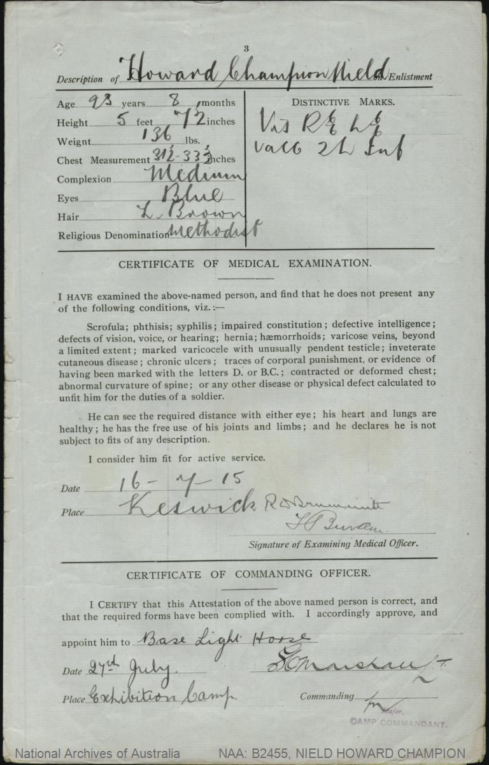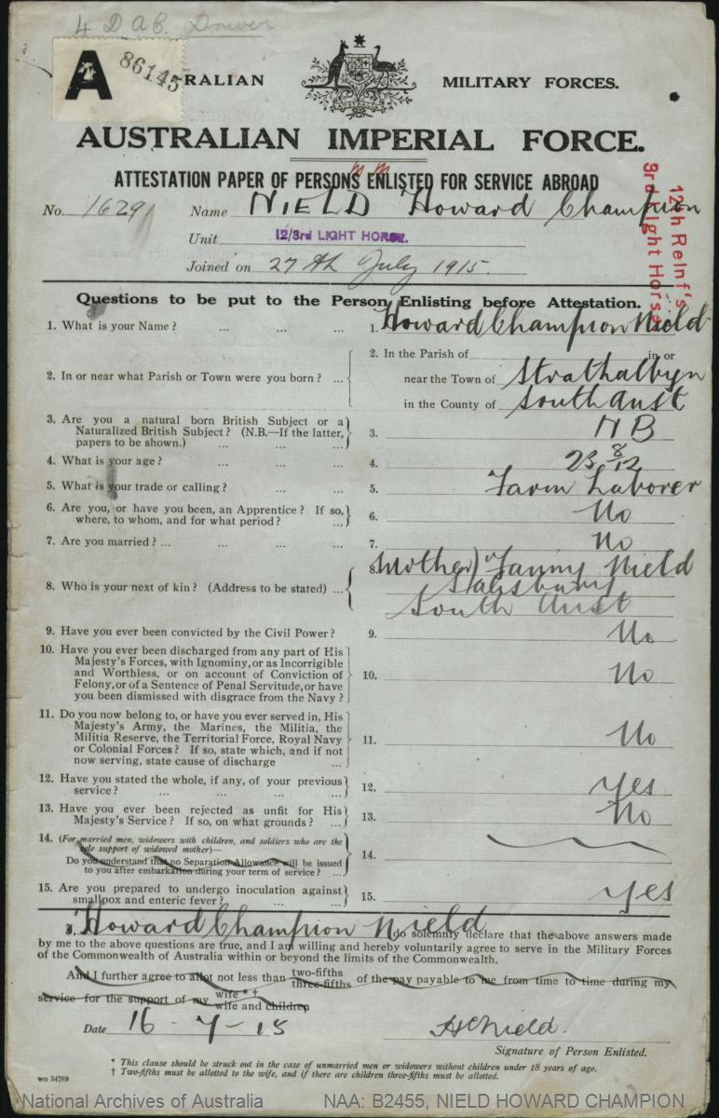**IMAGES**

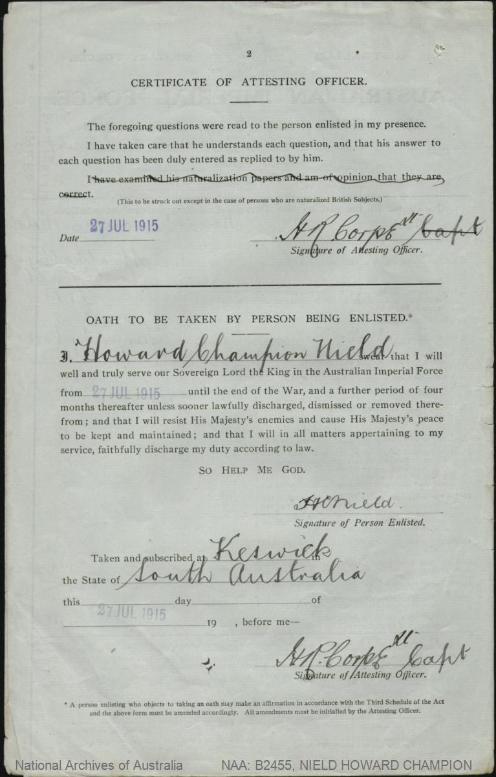

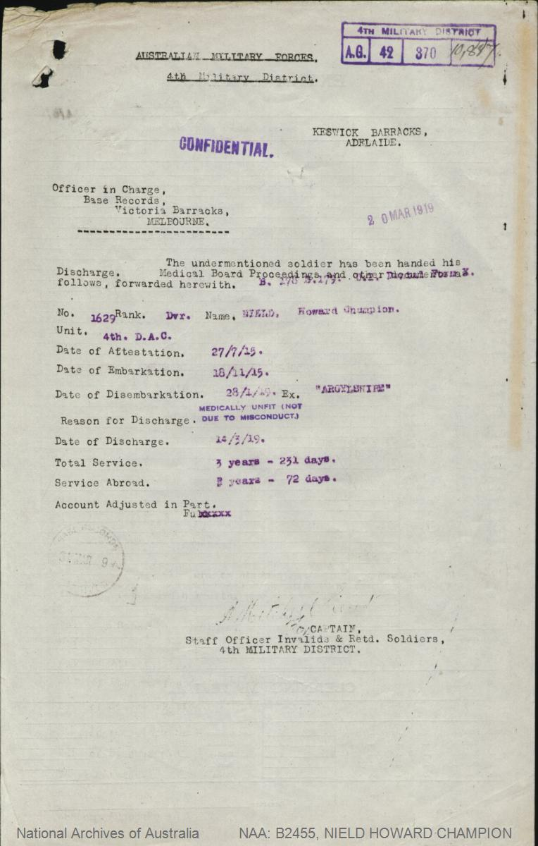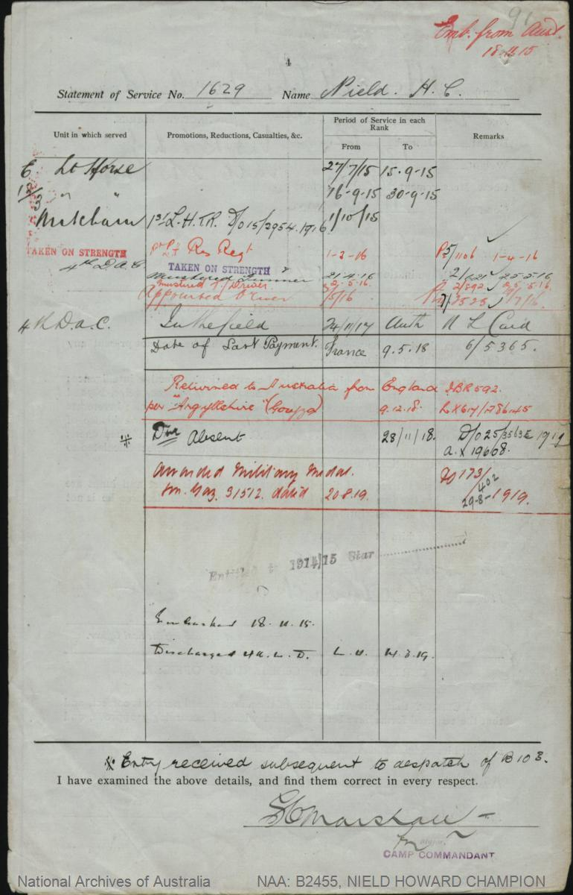

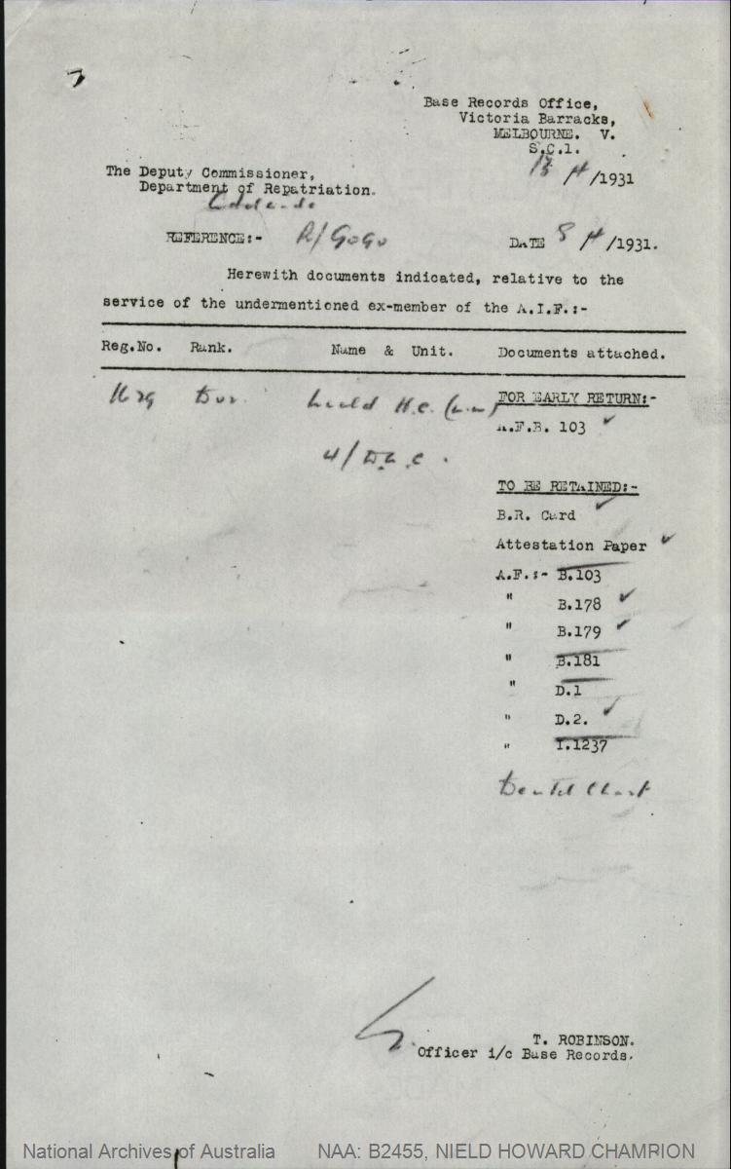

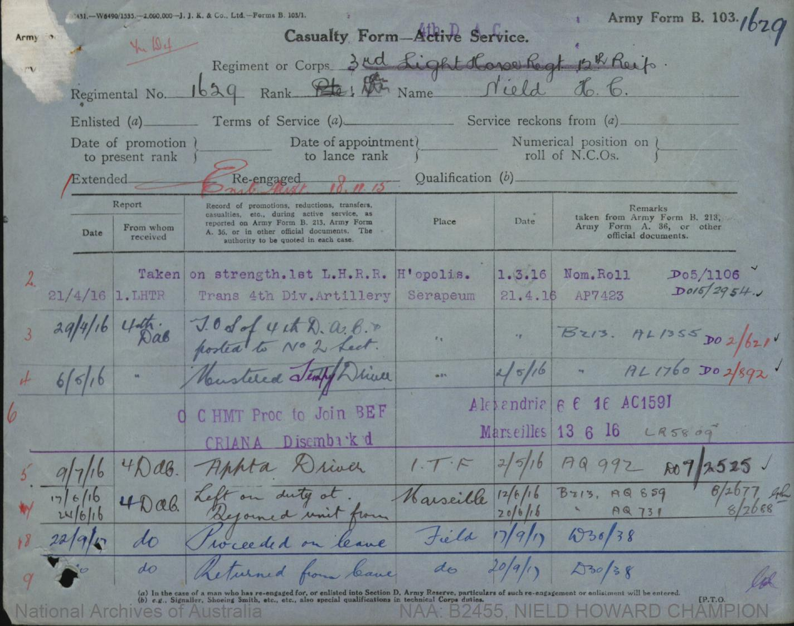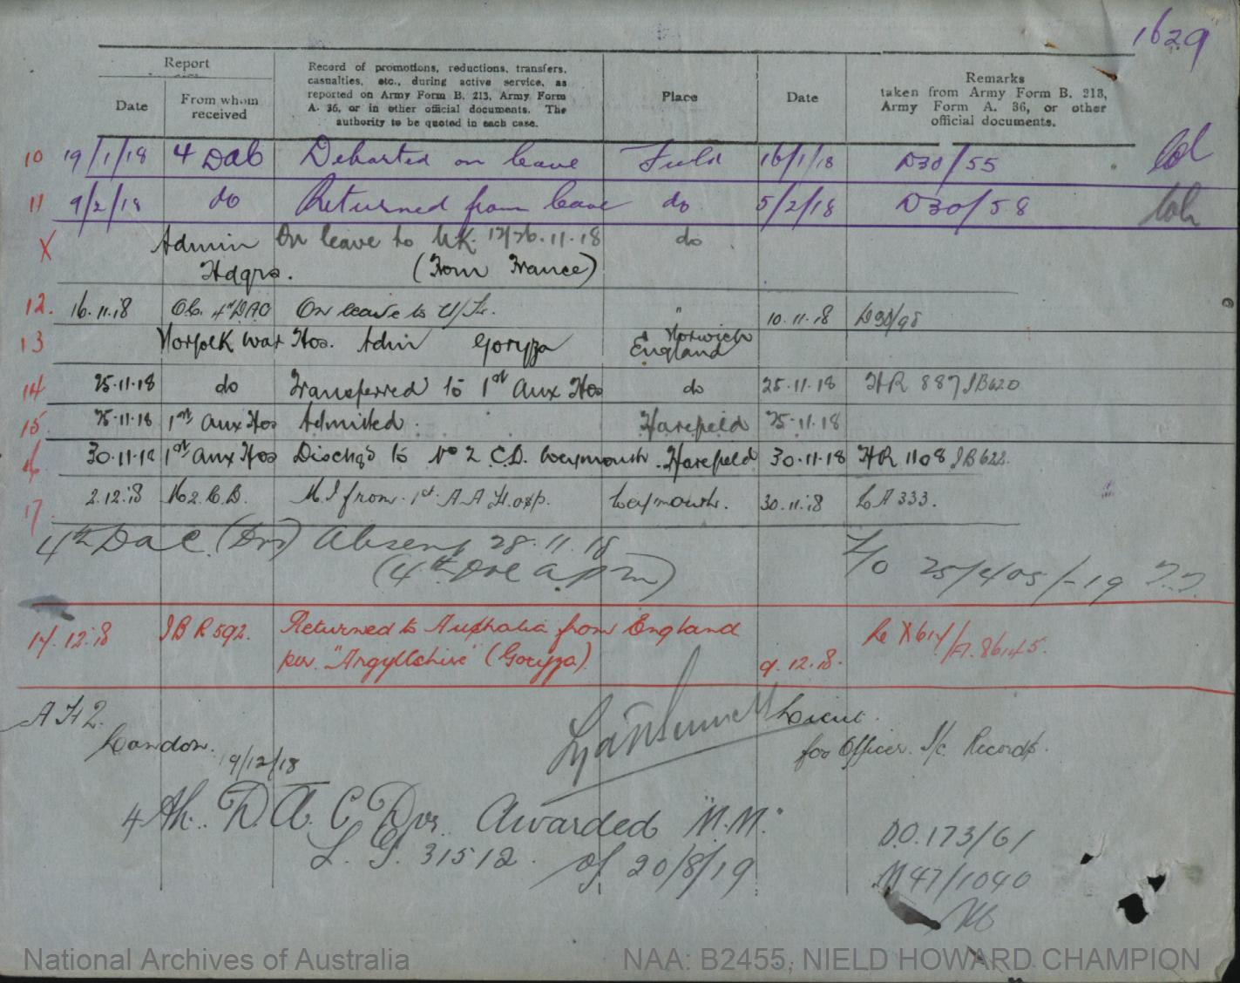

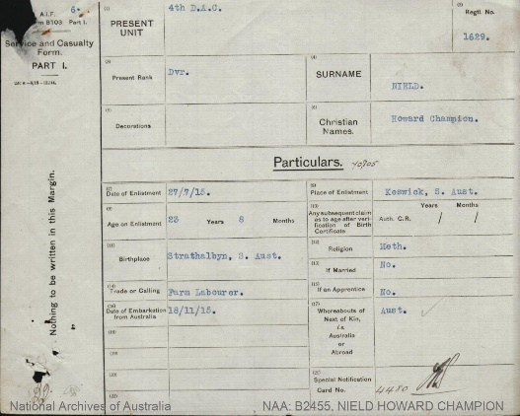

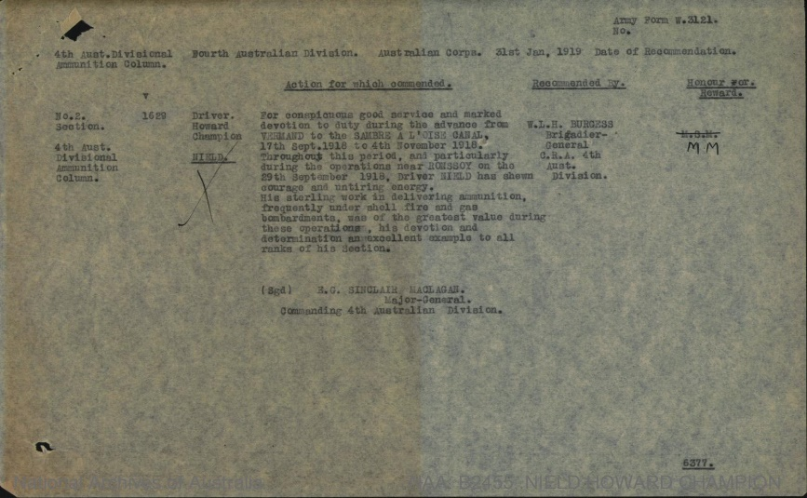

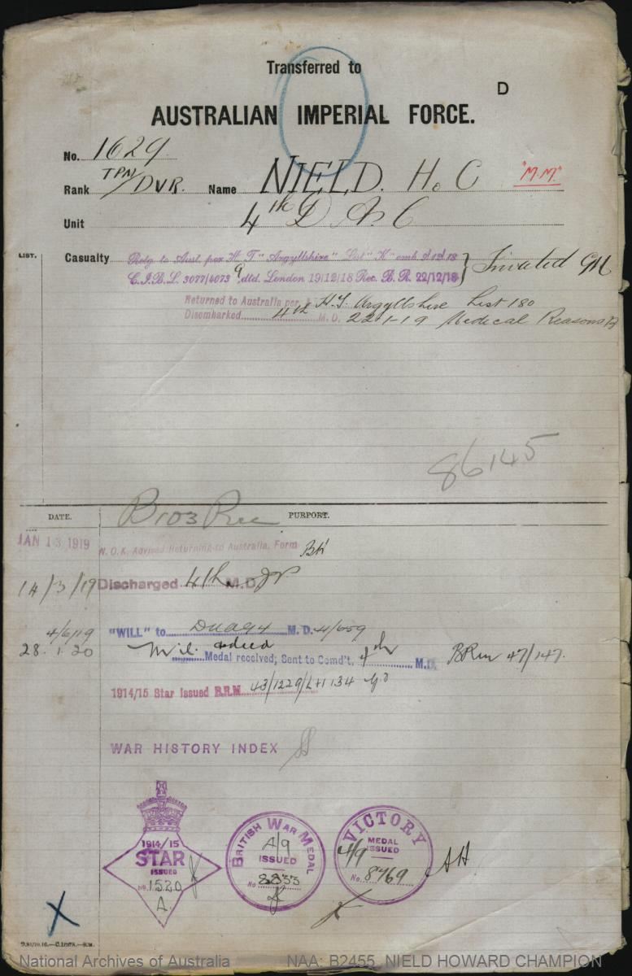

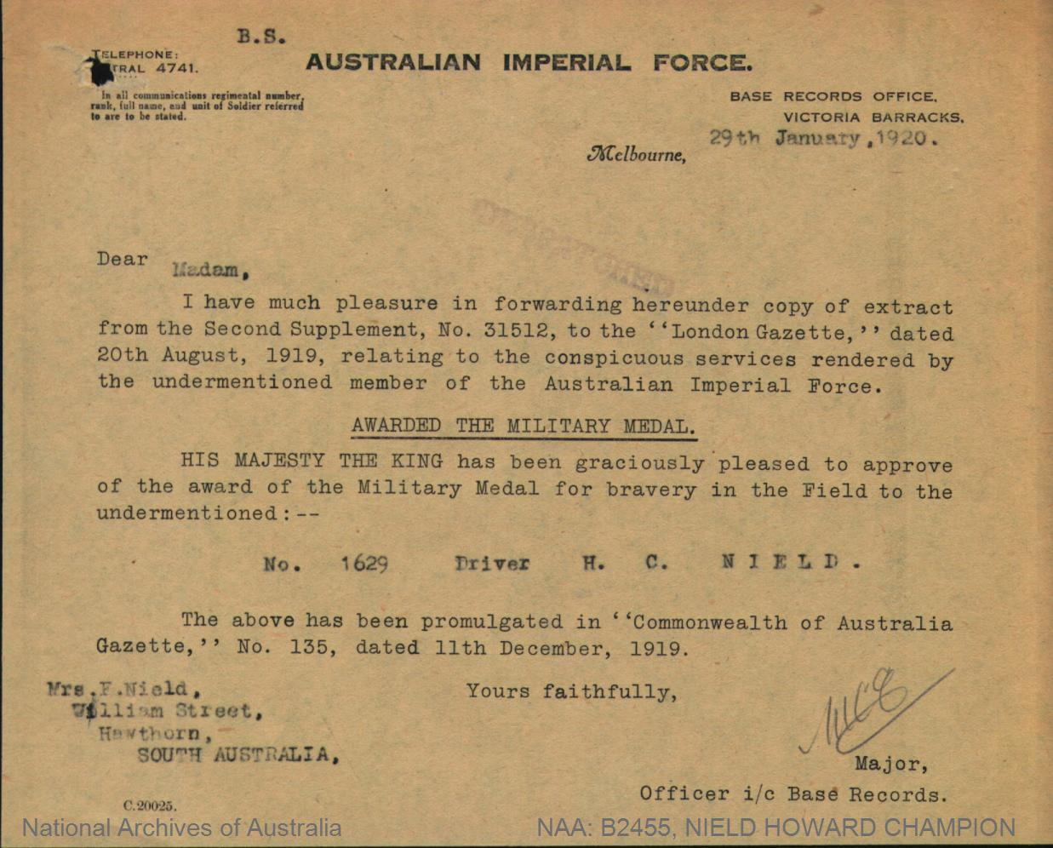

**BIBLIOGRAPHY –**

* <https://unleyww1.weebly.com/n.html>
* <https://www.awm.gov.au/collection/E84346>
* <https://www.awm.gov.au/collection/U51219>
* <https://www.awm.gov.au/collection/R1506197>
* [https://www.naa.gov.au/explore-collection/defence-and-war-service-records/army-first-world-war-1914-18#](https://www.naa.gov.au/explore-collection/defence-and-war-service-records/army-first-world-war-1914-18)
* <https://www.awm.gov.au/advanced-search?units=true>
* <https://abs.gov.au/census/find-census-data/quickstats/2021/303021055>
* <https://livesofthefirstworldwar.iwm.org.uk/community/1681>
* <https://en.wikipedia.org/wiki/3rd_Light_Horse_Regiment_(Australia)>
* <https://sarcib.ww1.collections.slsa.sa.gov.au/enquirer/charles-henry-nield>
* <https://aif.adfa.edu.au/showPerson?pid=223932>
* <https://aif.adfa.edu.au/showPerson?pid=223931>
* : <https://www.findagrave.com/memorial/157752138/howard_champion-nield>
* <https://recordsearch.naa.gov.au/SearchNRetrieve/Interface/ViewImage.aspx?B=8001023&S=1>
* <https://trove.nla.gov.au/newspaper/article/43779323>