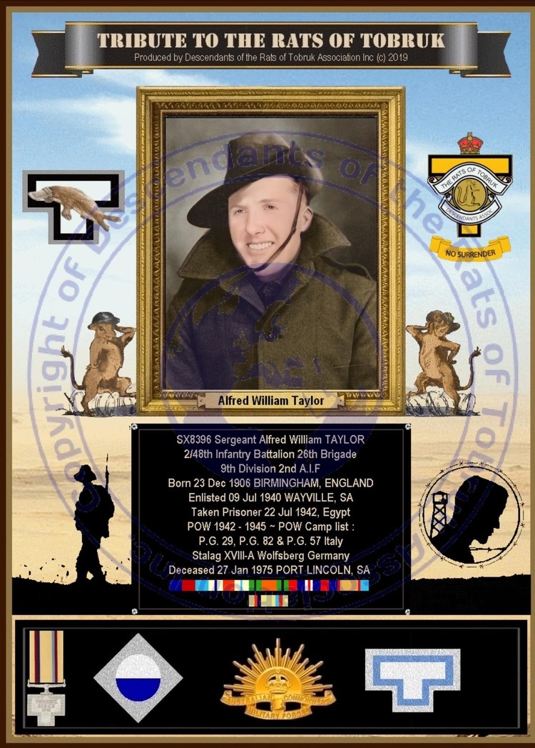

ALFRED WILLIAM TAYLOR

BARWELL BOY AND WORLD WAR 2 SOLDIER

Alfred William Taylor was born in Kings Norton, Birmingham, England on 6th December, 1906 an only child of Alfred and Matilda Taylor and on August 23rd, 1922, along with many other boys, he sailed to South Australia on board SS Benalla as part of the Barwell Boy Scheme. The total of 1440, mostly teenage boys, immigrated as South Australian Farm Apprentices who were assigned employment on farms for 3 years. The idea was that they replace in some measure the 6000 South Australian men who died in WW1. On completion of his Apprenticeship he worked mostly around the Cungena/Chandada area and leased a property before signing up in the AIF. He married Gwendoline Marlow on 22nd June, 1940.

In 1939 World War 2 broke out and Alf then aged 33 volunteered to join up and enlisted for service in the Australian Forces at Streaky Bay on the West Coast, in June,1940. His Medical Examination took place at Wayville in Adelaide where he also made his Oath of Enlistment on 9th July, 1940. Enlisting as a Private Alfred William Taylor, SX8396, 2/48th Battalion, 9th Division, AIF, he was later promoted first to Acting Corporal then to Sergeant while serving overseas in the Middle East.

The soldiers embarked on HMT “Stratheden” at Port Adelaide on 17th November, 1940 and disembarked in “The Middle East” on 3rd January,1941and life on the battle field commenced. The forces faced daunting desert conditions with extreme heat and flies during the day and bitterly cold conditions at night, sandstorms, constant artillery shelling and strafing and bombardment by enemy planes. The men suffered from a shortage of supplies and illnesses. Alf and his army mates became one of the famed “Rats of Tobruk”, they were the allied soldiers, mainly Australian, who were besieged by the German and Italian forces at Tobruk, Libya 1941.

After completing training in early July,1942 Alf became the head of a three man Bren Gun Carrier which later hit a mine behind the German lines and he was captured. He was reported as missing believed a Prisoner of War on 10th August, 1942. Many allied soldiers were handed over to the Italian Army and were eventually loaded onto an unmarked Italian freighter “Nino Bixio”, to cross the Mediterranean Sea to face incarceration in various infamous POW Camps. Nino Bixio” was torpedoed off Navarino by the British submarine HM Turbulent. The ship was carrying nearly 3,000 Allied POW’s. Later descriptions written by men who survived that event are dreadful and there were many casualties. Some stayed with the ship till it washed up on the Italian coast and other survivors, some who floated for days in the sea, were recaptured by the Italians and sent to their POW camps. They were captured with only the clothes they were wearing. Not a good start to their internment. My father was in three different camps till the Italians signed an armistice with the Allies, however the Germans quickly stepped in and evacuated over 25,000 Allied prisoners from Italian POW Camps. My father was put with others in train cattle trucks and transported all the way to Germany, Austria or Poland. My father’s destination was Stalag 18A in Carinthia, south of Wolfsberg in Austria.

The conditions in the German Army (Wermacht) POW camps in some instances were an improvement on the Italian ones, but not all. The inmates were put in work parties under guard with various jobs to do and I have photos taken of some of these men cutting timber, carting hay (fodder) and looking after cattle. I was told by a Polish witness that some men escaped from this camp with the help of, for example, Polish internees who had been transported to Austria to form a Polish Forced Labour Camp not far from Stalag 18A. They came with their own stories of sorrow and hardship, whole villages were captured, and trucked out, less their old people who were dumped on the road many miles from their homes. One of these men who befriended my father was Tedeus Krupka (Ted) a clever man who remained a friend of our family after he emigrated to South Australia after the war. He could speak many languages and was an amazing, intelligent and articulate man whom I still maintained a friendship with in Adelaide when he was in in his 90’s.

At the end of the war my father was repatriated on board the “Odessa” to the UK for recovery. He stayed in England with family and saw his father for the last time before he embarked for Australia on board “Mauritania”. He was discharged at Wayville in September, 1945 into the welcoming arms of his young wife who had also battled, losing their baby shortly after Alf left for overseas and working to keep their lease viable through drought and hardships of her own. They picked up where they had left off and led a busy but productive life.