SERGEANT MICHAEL JOHN MORRISON D.C.M.
4779 – 2nd Tunnelling Company / 2nd Pioneers

Michael John Morrison was born at Arthur’s Point, Queenstown-Lakes Otago, New Zealand the son of John and Catherine (nee Hayes) Morrison. He married in 1898 to Ethel Maud Louisa Senior and they had three children John James (b: 1899 Coromandel); Laurence Norman (b: Arthur’s Pt 1900); and Michael John (b: 1901 Coromandel). He was a miner at Coromandel, Waikato. His wife died in 1905 and son John in 1909 while there.

He brought his family to the goldfields of Western Australia where in 1913 he is listed as a miner at Ora Banda. He married in 1914 to Julia Bunsell and they went to the Tullah district of Tasmania and three sons were born to the couple, Frederick Charles, Milton James and Edward Benson Morrison.

Military experience stated was three years with Kauraka Rifles, Thames, N.Z., 12 months Victoria Rifles, Auckland Mounted Infantry and 9 years with Coromandel Rifles. He was also an active member of the Tullah Rifle Club, Tas.

At the recruiting depot in Ross, Tas on 19 November, 1915 the married forty-three-year-old miner applied to enlist for active service abroad and passed the medical examination. Attestation forms describe him as 171cms (5ft 7½ins) tall, weighing 70kgs (154lbs) with a chest expansion of 92-97cms (35-38ins) and had a fair complexion with blue eyes and fair hair. Distinctive marks were a scar on the bridge of his nose, transverse scar inner curfew left forearm just below elbow and a right-side hernia scar. Religion was Roman Catholic. Next-of-kin nominated was his wife Julia Morrison of Tullah, Tas and later changed to 20 Nott Street, Port Melbourne, Victoria and allotted three-fifths of his pay in support of her and their children. He signed and took the Oath of Allegiance the same day.

Acknowledgement to the new recruits was published in the:
Mercury (Hobart) Wednesday December 1, 1915:
RECRUITING – THE ROSS CAMP
During the month recruits have been steadily entering the Ross camp, and the number of men now there totals nearly 300. The following are the names of the men (63) who entered the camp on November 14, 15, 18, 22, and 25. M. Morrison, Article abridged

On 27 November, 1915 the men were transferred to Claremont camp and a list of men recruited for the Mining Corps was published in the:
Examiner Thursday December 9, 1915
THE CLAREMONT CAMP
On November 27, 208 men, belonging partly to the Mining Corps and partly to Infantry reinforcements, were transferred from Ross to Claremont. The following are the names of the men:
Mining Corps: Captain T.H. Vincent, G.A. Anderson, W. Berry, M. Berkeley, W. Blaney, W. Bayes, F. Bidulph, A.D. Black, C. Breaden, W.M. Bateson, W. Birch, D. Brennan, C.W. Burris, A.T. Coulson, W.J. Crosswell, F.A. Cashman, B. Cahill, F.E. Cooper, R. Carter, E.A. Crawford, C.N. Clarke, G. Dewhurst, P. Dunn, L.M. Forsyth, W.A. Fraser, W.J. Ferguson, H. Gatehouse, E. Green, W.S. Geard, H.R. Homan, G. Holloway, E.L. Hubbard, W.H. Horsberg, V.J.R. Hubbard, G.H. Johnston, H.V. Jackson, E.A. Jupp, A.R. Little, E.R. Monks, P.T. Moseley, W.M. Moran, M.J. Morrison, A.W.J. Maggs, A. McDermott, L.R. Morgan, M.P. O’Toole, W. Painter, E.D. Price, J.R. Peterson, T.T. Rocter, J. Reynolds, R. Smith, L.J. Shearing, W. Stewart, W. Searle, C. Seen, H. Stevens, L.A. Street, H.C. Simpson, J.G. Turnbull, O.N.W. Taylor, J. Taylor, J. Thomas, T.J. Travis, C.D. Wardle, L.J. Wolfe, W. Walls, C. Chaplain, P. J. Barrett, F. Claxton, O.L. McArdell, M. Ryan, J. Brennan, W. Fordham, -- Jupp.
Article Abridged

On 5 January, 1916 he was allotted to the No. 3 Company of the Miners Corps at Claremont camp then on 1 March re-allotted to the No. 5 Tunnelling Company (6th Military District).
On 24 April 3 officers and 76 Other Ranks plus 8 Reinforcements were transferred to Broadmeadows Camp, near Melbourne, Vic (3rd M.D.) to join the No. 5 Tunnelling Company recruited from Victoria made up of Headquarters and 2 Sections (8 officers & 173 men) (3 M.D.) and also 1st Reinforcements for No. 5 Company (17 men from Vic.)

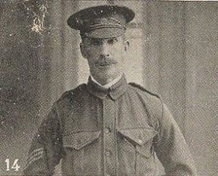
On 29 April, 1916 was promoted to be Sergeant.
Sergeant Michael John Morrison
Photo sourced from Virtual Anzacs website

Meanwhile the recruits forming part of the No. 4 Tunnelling Company embarked from Brisbane, Qld early in May, 1916 aboard HMAT A69 Warilda for Sydney, NSW. Six officers and 152 other ranks together with the 1st Reinforcements of fifteen other ranks made up the two sections.

At Rosebery Park, Sydney, NSW they joined their Headquarters and two sections (8 officers & 153 O.Rs.) plus 1st Reinforcements consisting of one officer and seventeen other ranks for final training. The rank of Sapper and the Regimental number 4779 in No. 4 Company was assigned to him.

The 7713-ton transport departed Sydney, NSW on May 22, 1916 and collected in Melbourne, Victoria the No. 5 Company recruited from Victoria, South Aust. & Tasmania made up of Headquarters and 2 Sections (8 officers & 173 men) (3 M.D.). 1 Section from Tasmania (3 officers & 76 O.Rs.); also 1st Reinforcements for No. 5 Company (17 men from Vic. & 8 men Tas.)

The ship departed on May 25, 1916 for Adelaide, S.A. to collect one Section of 3 officers & 76 O.Rs. with 1st Reinforcements of 8 O.Rs.

In Perth the No. 6 Tunnelling Company was in their final stages of preparation for departure giving a regimental show of their strength in parades.

Docking at Fremantle, W.A. on June 1, 1916 added No. 6 Company recruited from W.A. of 14 officers and 325 O.Rs. along with 1st Reinforcements of 1 Officer & 32 O.Rs. departing the same day.

Durban, South Africa was reached on June 16, 1916 and Cape Town on June 21, 1916 while St Vincent completed the African ports of call on July 7, 1916. Discipline was fairly good except at intermediate ports where Away without Leave caused concern.

The fifty-eight-day voyage experienced remarkable pleasant weather terminating at Plymouth, England on July 18, 1916. Four, Five and Six Companies comprising of 1064 officers and other ranks were detrained to Amesbury and Tidworth to begin training for the front.

The Reinforcement proceeded to France on 28 August, 1916 arriving at the 2nd Divisional Base Depot two days later then moved to the 1st Anzac Reinforcements Camp on 12 October. Four days later joined the 1st Anzac Entrenching Battalion which was an advanced section of the Base Depot that organised works near the lines and through duties, usually of ten days duration, would accustom the reinforcements to war conditions before being assigned to a company in the field.

On 26 October, 1916 was attached to the 1st Canadian Tunnelling Company until taken on strength with the 2nd Tunnelling Company.

His was among those soldiers mentioned in a letter home concerning the Catholic Soldiers’ Guild and published in the:
W.A. Record (Perth) Saturday November 4, 1916:
CATHOLIC SOLDIERS’ GUILD
Writing from France, Corporal J.J. Purtell says the Soldiers’ Guild has so far given excellent results, and has been the means of restoring the Faith to the careless ones, and bringing back to God those who have forgotten Him for years.
He sends the following budget of names to be added to the membership of the Guild, and begs the prayers of our devout readers for their spiritual and temporal welfare: Sergt. M.J. Morrison, Article abridged
He was recommended for a Distinguished Conduct Medal for his devotion to duty with the citation recorded as follows:

No. 4779 Sergeant Michael John MORRISON.
2nd Tunnelling Coy, Aust. Engrs
At the BLUFF of the night of 24/25th March, 1917, during an intense enemy minenwerfer and artillery bombardment preliminary to a raid, he organised a party of tunnellers and in a very exposed position defended the main entrance to the underground workings.
After two hours the mine entrance was crumpled in and further entrance to the workings became impossible. He then led his men to a place of safety through several hundred feet of collapsed gallery.

Sergeant was transferred to the 2nd Pioneer Battalion being taken on strength on 29 March and carried supernumerary to the establishment of a Non-Commissioned Officer. His Unit wrote for the date transferred to the Pioneers. It is marked on his card as 14 April, 1917.

On 2 May, 1917 went sick to the 5th Aust Field Ambulance with a swollen testicle and admitted to the Casualty Clearing Station. On 5 May sent to the 3rd Stationary Hospital in Rouelles diagnosed with hydrocele (collection of watery fluid in sac-like body cavity usually scrotum) and to recuperate a day later at the 2nd Convalescent Depot. Two days later was to report to the 2nd Aust General Base Depot at Etaples marching in on May 11 and left the Reinforcements Camp as a “permanent base” duty soldier on May 18 for England arriving a day later at the No. 2 Command Depot at Weymouth.

News arrived that he had been awarded the Distinguished Conduct Medal on 25 May, 1917 with announcement in the London Gazette as:
Sergeant awarded the D.C.M. for conspicuous gallantry and devotion to duty. He organised a party of Tunnellers and in a very exposed position, defended the main entrance to the underground working of a mine.

His wife was cabled the news of his award and shared in the:
West Australian Tuesday June 26, 1917:
PERSONAL
Mrs M.J. Morrison, Rathay-street, Victoria Park, has been notified by cable that her husband, Sergeant M.J. Morrison, has been awarded the D.C.M. while on active service in France.

Sergeant Morrison embarked for Home Service in Australia due to sub-acute orchitis (inflammation of testicles – a complication after mumps or infection) on 22 July, 1917 on board H.T. Nestor. Base Records wound have advised his wife he was returning home.

News of his award was announced locally in the:
Zeehan and Dundas Herald Tuesday July 24, 1917:
TULLAH – SERGEANT M.J. MORRISON, D.C.M.
The pleasing information reached Tullah on Saturday last that one of her contributors to the Empire’s forces Sergeant M.J. Morrison, had gained the coveted D.C.M. for conspicuous gallantry in action. Writing to Mr W.K. Whelan from France, the subject of this paragraph mentioned that he had, at a big parade, been decorated with the medal, and that although they were having a hard fight, hoped to come out alright. Contd.
Continues
Sergeant Morrison spent a number of years in the New Zealand military forces, where he gained distinction as a crack rifle shot, also a color-sergeant’s stripes. He was employed by the North Farrell Company for some years, and clearly associated himself with the Tullah Rifle Club, of which he was captain and held the senior aggregate medal for the whole of the period he was connected with [line blurred] proving himself the best shot, and as a [blurred] was unequalled, the persons “leading scorers” of the club being a tribute to his early advice and guidance. Enlisting some 18 months ago, he has seen a lot of active service. Tullah feels justly proud of her contribution of 50 men, and the distinction gained by the “winner” of them, and congratulates Mrs Morrison and family, and his sister, Ms J. Bisset, of Round Hill, former residents.
In his regular articles for the Sydney newspaper Willie Wombat also mentioned the circumstances that Sergeant Morrison experienced to gain his D.C.M.
Sydney Morning Herald Saturday August 4, 1917:
THE MINERS
(BY WILLIE WOMBAT)
The latest awards have been to No. 2 Company, the D.C.M. having been awarded to Sergt. M.J. Morrison for gallant work on a night when one of our tunnels was crumpled as the result of “minnie” fire. He rallied a squad of tunnellers, and successfully defended the position against raiders.
Article abridged

The transport docked in Melbourne (3rd Military District) on 24 September, 1917 with a brief mention in the:
Bendigo Independent Monday September 24, 1917:
SICK AND WOUNDED
At 10 o’clock this morning 1343 sick and wounded soldiers will disembark at Port Melbourne. There are 492 for Victoria, 225 for Queensland, 577 for New South Wales and 49 for Tasmania. Some men disembarked at Fremantle.

News of his arrival in Tasmania was reported in the:
Daily Telegraph (Launceston) Thursday September 27, 1917:
FROM THE FRONT
Sergeant Michael John Morrison, 2nd Pioneers, sick
Article abridged

The 6th Military District Headquarters on 9 November, 1917 forwarded medical board proceedings for the returned soldier to Base Records advising of his return and upcoming discharge.

Base Records Office forwarded to his wife at Nott Street, Port Melbourne on 16 November, 1917 the copy of the extract from the Fourth supplement No. 30095 to the London Gazette dated 27 May, 1917 relating to the conspicuous services rendered by her husband.

AWARDED THE DISTINGUISHED CONDUCT MEDAL
HIS MAJESTY THE KING has been graciously pleased to approve of the award of the Distinguished Conduct Medal to the undermentioned non-commissioned officer, for acts of gallantry and devotion to duty in the Field:
No. 4779 Sergeant M.J. MORRISON
For conspicuous gallantry and devotion to duty. He organised a party of tunnellers, and in a
very exposed position defended the position defended the main entrance to the underground mine.

They also advised the above had been promulgated in the Commonwealth of Australia Gazette No. 174 of 11th October, 1917.

Further news from Military Orders was published in the:
North Western Advocate and the Emu Bay Times Friday November 16, 1917:
MILITARY ORDERS
Military Orders of October 26 contained formal notification of the following distinctions:
The Distinguished Conduct Medal for act of gallantry and devotion to duty in the field to Sergeant M.J. Morrison, Pioneers, late Engineers;
Article abridged
Military Discharge was issued in Hobart (6th M.D.) as medically unfit on 21 November, 1917.

The 6th Military District wrote to the Department of Defence on 28 November, 1917 as an application had been received from Sergeant Morrison, 2nd Pioneer Company for the Distinguished Conduct Medal granted to him in April, 1917 to be presented to him.

This man originally enlisted in the 6th M.D. but on being attached to the 2nd Pioneer Battalion was shown on records belonging to the 2nd M.D. May I be informed when this Decoration is likely to be available.
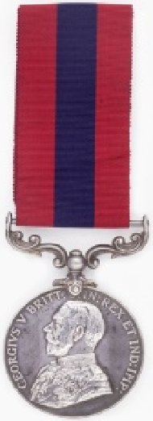
Base Records, Melbourne replied on 7 December, 1917 that the D.C.M. in question was forwarded to the 6th M.D. on the 4th inst. The Minister directed that an early opportunity be taken to present this medal with as much publicity as possible. Please acknowledge receipt to the Officer at Base Records.

The following is an extract from a newspaper clipping reproduced from the Daily Mail issue of 9th January, 1918 in the Unit Diary of the 2nd Tunnelling Company in Appendix VIII of the January 1918 Report. It refers to the Bluff area where Sergeant Morrison and his men defended the mine entrance.

UNDERGROUND RACE WITH THE HUNS
EXCITING MINE BATTLE
CUT OFF FOR THREE MONTHS
At the Bluff, also underground lighting went on incessantly. After February 1, 1917, the enemy showed signs of great uneasiness, and blew several heavy mines and camouflets in the endeavour to interfere with our working. One of these blows destroyed our gallery to the Spanbroekmolen mine.
For three months this mine was cut off, and only recovered by strenuous efforts on the day preceding the Messines attack.
The Spanbroekmolen mine formed the largest crater of any of those blown, the area of complete obliteration having a diameter of over 110 yards.
A total of 8,000 yards of gallery were driven in the construction of these mines, and over one million pounds of explosives were used in them. The simultaneous discharge of such an enormous aggregate of explosive is without parallel in land mining, and no actual experience existed of the effects which would be produced. In these circumstances, that fact that no hitch of any kind occurred in the operation, and the effects of the discharges were precisely such as had been foretold, reflects the very highest credit upon those responsible for the planning and construction of the mines.

Further mention on his award of the D.C.M. appeared in the:
Western Mail W.A. Friday April 26, 1918:
WAR HEROES
Presentation of Honours - DISTINGUISHED CONDUCT MEDAL
No 4779 Sergeant M.J. Morrison, 2nd Tunnelling Co. for conspicuous gallantry and devotion to duty. He organised a party of tunnellers, and in a very exposed position defended the main entrance to the underground workings of a mine.

He is listed in 1919 as residing at Tullah, Tas with the occupation of miner.

His assistance to the reception committee with a welcome home reception was reported in the:

Examiner (Launceston) Monday May 26, 1919:
TULLAH
At the Academy on Tuesday night a social was held by the reception committee of welcome home Private Waters (Anzac). Mr J. Geddes president and Sergeant M.J. Morrison D.C.M. was also up on the platform. Article abridged
To go with his D.C.M. Medal Sergeant 4779 Michael John Morrison was also awarded the British War Medal (4106) and the Victory Medal (4095) in service for his country.

In 1922 they were residents at South Street, Bellerive.

The death of his youngest son was announced in the:
Mercury (Hobart) Saturday April 19, 1926:
DEATHS
MORRISON—On April 16th, 1926, at Children’s Hospital, Hobart, Edward Benson (Little Teddy), dearly beloved youngest son of Julia and Michael John Morrison, of 285 Liverpool-street, aged 7 years and 4 months.

The Hobart branch of the Repatriation Commission requested copies of his service documents from Base Records which were duly forwarded on 2 October, 1926 and again on 11 June, 1936.

From 1928 onward they were residents at 40 St George’s Terrace, Battery Point, Hobart.

He was one of the many prominent soldiers mentioned at the funeral for the late Colonel Chisholm and reported in the:
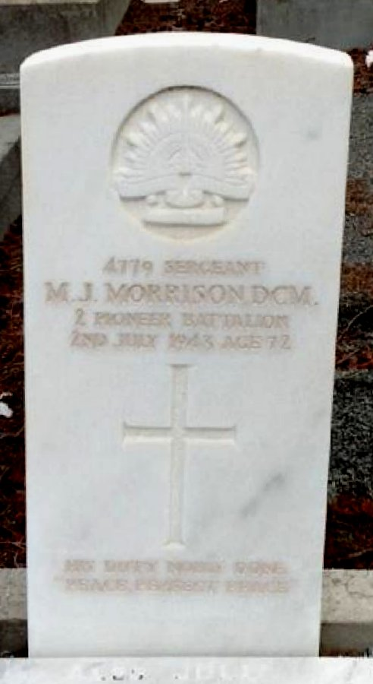
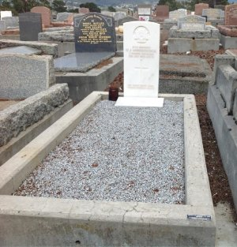
Mercury (Hobart) Thursday November 19, 1936:
MILITARY FUNERAL FOR FORMER PROMINENT SOLDIER
The remains of Col. J.D.W. Chisholm were buried with military honours at Cornelian Bay.
REPRESENTATIVE MOURNERS: Among those at the Cathedral and at the graveside were:
M.J. Morrison (2nd Tunnelling Co. A.I.F.)Article abridged
His Commonwealth War Grave in Cornelian Bay Cemetery, Hobart, Tas
Photo supplied by Dept. of Veterans’ Affairs and used with permission
Voice (Hobart) Saturday July 3, 1943:
FAMILY CIRCLE – DEATHS
MORRISON—Passed peacefully away on July 2, 1943, at Repatriation Hospital, Hobart, Michael john Morrison, D.C.M., Sgt 2nd Pioneers, beloved husband of Julia Morrison, of 40 St George’s Terrace, Battery Point, and loving father of Laurie, John, Fred and Milton. Aged 72 years. A patient sufferer at rest.
FUNERAL NOTICE
MORRISON—Friends are respectfully invited to attend the funeral of the late Mr Michael John Morrison, which will move from his late residence, 40 St George’s Terrace, Battery Point, on Sunday (to-morrow), at 3.15 p.m., arriving at Cornelian Bay Cemetery at 3.40 p.m.
H.C. MILLINGTON & Co.

Interment took place in the Church of England portion of Cornelian Bay Cemetery within section FF in grave no. 110. He has a Commonwealth War Grave.
Michael John Morrison passed away on 2 July, 1943 aged 72 years. Family arrangements were placed in the:
Mrs Julia Morrison was also interred in the same grave on 23 July, 1951 aged 66 years.
Their son served in World War II.

Milton James Morrison (born Perth, W.A. 20 February, 1917) enlisted for active service from Hobart, Tasmania on 20 October, 1939 with the Aust. Army nominating M. Morrison as next-of-kin. His rank was Sapper TX18 Morrison was with the 2 /3 Field Engineers and discharged on 14 November, 1945.
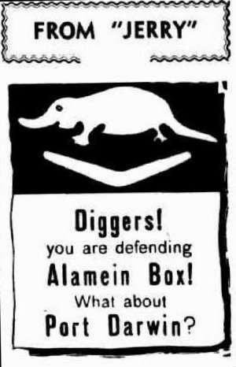
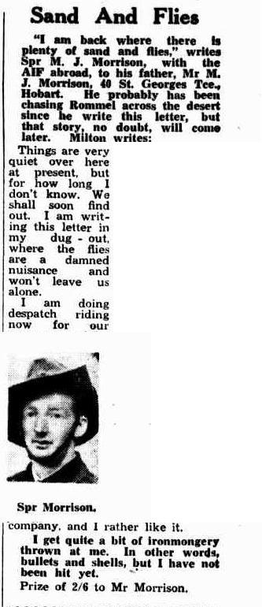
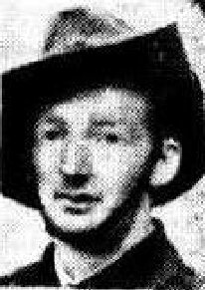
“This is what ‘Jerry’ dropped on us in the front line—put it in “The Mercury.” Well, here it is, Spr. Milton Morrison, and the latest news from the Western Desert suggests that you ignored its message. Too bad—for Rommel. “This pamphlet was sent in by Mr M.J. Morrison of St George’s Tce, Hobart, father of Spr. Morrison.)
Mercury (Hobart) Wednesday November 11, 1942:
SAND AND FLIES
“I am back where there is plenty of sand and flies,” writes Spr. M.J. Morrison, with the AIR abroad, to his father, Mr M.J. Morrison, 40 St Georges Tce, Hobart. He probably has been chasing Rommel across the desert since he wrote this letter, but that story no doubt, will come later writes:
Things are very quiet here at present, but for how long I don’t know. We shall soon find out. I am writing this letter in my dug-out where the flies are a damned nuisance and won’t leave us alone. I am doing despatch riding now for our company, and I rather like it. I get quite a bit of iron monger thrown at me. In other words, bullets and shells, but I have not been hit yet.”
Prize of 2/6 to Mr Morrison.
Same newspaper:

© Donna Baldey 2022
www.tunnellers.net

Footnote: All articles by Willie Wombat on The Miners are available on this website

