# **SERVICE HISTORY - RAYMOND FRANCIS DEMPSEY**

## **Enlisted 2nd August, 1915, Newcastle.**

### **Service Number 1471**

### **Age 18 years**

### **Born: 15 December, 1897 registered Waratah, Newcastle N.S.W.**

### **First Unit: 7th Light Horse Regimen NSW ANZAC.**

### **Last Unit: 10th Field Artillery Brigade 39th Battery – Rank Driver**

### **Killed in Action 5th April, 1918 Aged 20 years, France.**

**FAMILY STORY**

**Raymond Francis Dempsey** was the youngest child of Joseph and Catherine Dempsey. He was one of 14 children the youngest of their 10 sons. He had convict ancestry as his grandfather Richard Dempsey from Kilkenny Ireland was on one of the last convict transport ships to arrive in Sydney the 1840’s

Raymond was the first of his family to enlist. He followed his cousin Charles (Dutch) Croese who had enlisted the previous month and was mentioned in dispatches, and awarded the *French Croix de Guerre* in 1917 for valour. His family never discovered why he received such an award as when asked, he would reply, that he did nothing more than anyone else.

Raymond was followed five months later on 16th January, 1916 by his brother Henry Dempsey and his cousin Cornelius Croese (brother to Charles). His brother, Donald Peter Dempsey joined two days later on the 18th January, 1916. Thomas Croese also enlisted on 2nd July 1916.

Tragically, Raymond’s parents would lose 4 of their sons, Alphonsus and Vincent to sudden illness as young teenagers in 1899 and 1900, then Raymond and Henry killed on the battle fields of France in 1917 and 1918. Henry returned to Australia at the end of the war discharged with injuries.

**ISLAND LIFE**

The family lived on Moscheto Island. They were a very musical family; all could play a musical instrument well. It was also known as Mosquito Is. possibly in relation to the plentiful supply of biting insects. They shared the island with many migratory birds.

It was one of a group of islands near the mouth of the Hunter River at Newcastle, the main islands being **Ash, Moscheto**, and **Dempsey**, formed by the delta of the Hunter Rive. It was separated from Ash Island and Dempsey Island by Moscheto creek. The islands were situated within 3 miles (4.8 km) from the heart of Newcastle.

As a young child Raymond would have lived out Huckleberry Fin adventures fishing, collecting shells, swimming in the sandy bottom creeks, canoeing, enjoying an imaginative freedom by the river, in the fields and with the animals. He enjoyed playing football and cricket within the closeknit island community of twenty-five farming families. As well there was always menial work to be done to help on the farm. His occupation at the time of enlistment was Dairyman/Labourer.

Raymond went to the only school on the island, a one teacher school with one classroom and a carpentry room for the boys. The children wrote on slates with a slate pencil. During the war years from 1914 the Commonwealth and Union Jack flags would be unfurled, many patriotic songs were sung and fund raising for the war effort was a regular occurrence.

To attend the higher classes the children rowed themselves back and forth to Newcastle each day.

It was mixed farming with dairy being the main source of income. Their rich fertile lands yielded a bountiful harvest of fruit and vegetable and feed crops. Nearly all the milk consumed in the city, a large portion of poultry, eggs, dairy produce seen at the market came from these three islands.

Newcastle had poor soils so during Raymond’s lifetime (and for over fifty years), the islands were the principal and important source of this produce to the city. In fact, the islands and the farmers were the pioneers of the Newcastle dairy industry.

There was no electricity. The dark moonless nights were pierced by the twinkling lights of the city beyond. Oil and kerosene-fuelled lamps provided lighting and the big open fire and wood stove was the main source of heating and cooking with pots and kettles hanging on chains. Raymond’s mother Catherine with such a large family had a woman come in during meal time just to cut bread. Water was drawn from wells built by convicts and the only communication with the mainland was by small wooden open rowing boats. This was how they and their produce was transported to Newcastle.

It was hard physical work and created tough and physically strong young men. Raymond would rise at 3 a.m. and assist his father with milking the cows.

“*It was usually 4 a.m. when the small vessel pushed off. If it were choppy the task of man-handling the boat downstream was a real job. Many a day when the wind blew strong it took four hours to pull the milk to land at Market Wharf, Newcastle.*

*There were no guiding lights in the harbour in those days and the men had to depend on their sense of direction when the river was wrapped in fog to find their landing place. At times the task was almost impossible.” Newcastle Morning Herald & Miners Advocate 2nd September 1939.)*

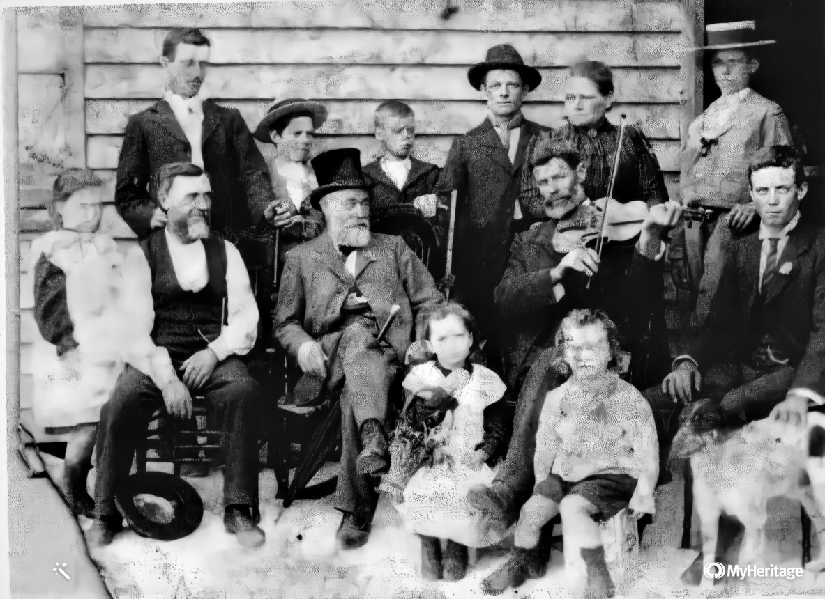

Figure 1 Raymond seated in front on stool with some of his siblings, father Joseph with violin. Photo taken with visiting politician in top hat.

**ENLISTMENT.**

The islanders were full of patriotic endeavours and men, women and children of the island worked hard to raise funds to help the war effort, attested by local newspaper articles.

A young man by the name of Jordan was the first from Moscheto Island to enlist. He left with the first contingent in 1914 and it seems died on the battlefields of Gallipoli.

Due to the great losses happening in Gallipoli the three Dempsey brothers responded to the call. Out of twenty-five families on the island, nineteen young men enlisted and fought in various campaigns in France. Almost fifty percent of them became casualties of the war and would never return.

on 2nd August, 1915Raymond enlisted in the Australian Imperial Force in the7th Light Horse Regimen NSW ANZAC mounted division 11th to 13th reinforcements.

His enlistment form describes him as 18 years and 7 months, a Labourer/Dairyman His height as 5ft. 8 inches, weight 150 pounds, chest measurement 37 inches fully extended. Complexion dark, eyes grey, hair brown. He had a small scar on the back of his knees.

He had been exempted from participating in the government’s compulsory military training scheme of the time due to the difficulties of travelling to the nearest depot.

**FAREWELLS**

Before embarking their ships for the front, the men were usually given two weeks leave to say goodbye to loved ones and have a final rest after training before joining the war effort.

There were many social gatherings to farewell the soldiers. Moscheto Island was no exception and farewells included food, music, songs, speeches and gifts.

“In late September, 1915 at the school hall on the island, five young men who had all grown up together (3 *related*), **Raymond Francis Dempsey**, Charles Croese No 2379, Richard Jordon No 2424, Private Tarrant and Private Hughes who had volunteered for active service at the front were given a social evening and presented with a wristlet watch and a sheepskin vest. The President of the P&C Committee spoke of their sacrifice in leaving pleasant surroundings to face an unknown danger. They were the next group to enlist since young Jordon. They said in reply that they were determined to uphold, if possible, the fair name already attained in the war by Australia.”

It was said that they were a fine example of Australian youth, of a robust constitution, full of life and energy, born and reared in the country and splendid rifle shots. (Newcastle Morning Herald and Miners’ Advocate 29th Sept. 1915 P. 31)

More farewells would follow as more young men of the island families joined the war effort. Almost every family had a representative.

**CAIRO, EGYPT.**

**2nd November, 1915.**

After a period of training Raymond embarked on the ship *‘Euripides’* for Egypt and arrived in January 1916.

**11th December, 1915**.

He was in the Australian Camp in Egypt at *Tel-el-kebir.* It was located about 40km west of Ismailia and was a training centre for the First Australian Imperial Force reinforcements. It was also the site of the No 2 Australian Stationary Hospital, and of a large prisoner of war camp.

**28th December 1915.**

Raymond was taken to casualty for Gallipoli Mediterranean Expeditionary Force at Maadi with an injury to this thumb.

Some 40,000 Australians were camped in a tent city at **Tel-el-Kebir** which was six miles in length.  The Light Horse Brigade settled on the edge of the desert south of Cairo at Maadi Camp, south of Maadi's Road 84.

With them were many lines of beautiful and much-loved horses and they had practically constant attention night and day. Raymond must have found it hard to leave his horse behind.

It is hard to imagine the huge cultural and environmental shock Raymond and his follow soldiers must have experienced on landing. It was the first time that most of the men would have left their own townships, let alone Australia, to be exposed to the desert landscape, populated by people of completely different ethnicity and customs.

As troop ships with Australian soldiers pasted through the Suez Canal to England they witnessed in amazement the long lines of tents. Charles Croese, cousin to Raymond in writing home to his parents mentions his passage through the area. “*It was a lovely sight with camps all along it and as far across the desert as the eye could see dotted with camps.”*

It was the hottest place he had ever experienced and he pitied his brother Cornelius his friends and cousins camped there as he said all the soldiers were burnt black.

**REST AND RELAXATION**

Every day two per cent in each unit were given two days leave in Cairo. Overstaying one’s leave was fairly common. The men accepted the fine or punishment and the officers knew their men’s willingness to fight had not been affected. This meant that this situation was pretty much tolerated.

Raymond was one of many guilty of overstaying leave and was punished for being absent from duty from Serapeum from 10.55am to 12.21am

**TRAINING IN THE DESERT**

The training was fairly rudimentary and was simply the old British Army training. There was little advice from the Western Front as to the tactics being used in this new form of modern trench warfare. The Australian and New Zealand officers had to rely almost on themselves. They had not seen a bomb (grenade); they had scarcely heard of a periscope, so it could be argued that they were not prepared for what was to come.

According to Charles Bean despite the rudimentary training it was of exceptional intensity. All day long, in every valley of the Sahara for miles around the Pyramids of Giza were groups or lines of men advancing, retiring, drilling or squatted near their piled arms listening to their officer. For many of the battalions many miles of desert had to be covered in the morning and evening to and from their allotted training areas. At first, to harden the troops, they wore full kit with heavy packs. Their backs became drenched with perspiration, and the bitter desert wind blew on them as they camped for their midday meal and many deaths from pneumonia were attributed to this cause.

Raymond soon succumbed to illness on **31st December 1915** only five weeks after he left Sydney. he was admitted to the Australian Stationary Hospital in Maadi for five weeks with bronchitis.

On **22nd January, 1916**, he was back in hospital with Mumps and pneumonia and remained there for 18 days.

Despite the hardships and illness, all this hard training in the desert served them well. A newly arrived Officer from England remarked that the view of the Australian soldiers at the time was positive saying that the Australian Division was at least well trained as any regular division before the war. The performance on the battlefield of Australians and New Zealanders were known as among the most fearsome and willing troops of the Allied forces.

**CHANGE OF UNIT**.

**In early February,1916** now recovered from pneumonia, Raymond rejoined his unit at Maadi.

With the evacuation of Gallipoli in December1915, the 7th Light Horse Regiment had been brought up to strength after Gallipoli. Raymond was with a holding regiment for fresh reinforcements. The AIF had doubled in size in preparation for the fighting on the Western Front.

**1st June, 1916** Raymond was transferred to the artillery and formed the nucleus of the newly formed **10th Field Artillery Brigade to** support the newly raised 4th Division**.**

**A Brigade** is comprised of three to five battalions, approximately 1,500 to 4,000 soldiers. A brigade was a unit of artillery support attached to an infantry division and provided crucial fire support for infantry attacks and also targeted enemy positions.

Raymond was mustered as a Driver with the **39th Battery.** ABattery was an artillery unit equivalent in size and structure to an infantry company equipped with cannons and other artillery pieces, responsible for providing fire support to the infantry and engaging enemy targets from a distance.

He was responsible for at least two horses pulling an artillery wagon which had the battery’s 18-pounder field gun and ammunition. He was most probably given this position due to his experience with horses. It was extremely dangerous work as the enemy force prioritised counter-battery fire to neutralize the artillery position.

**FRANCE AND WESTERN FRONT**.

Raymond proceeded to join the British Expeditionary Force (Belgium, France, England) from Alexandria, Egypt to be transported to the western front.

A military railway had been constructed to take troops from the camp to their vessels in Alexandria and elsewhere including for embarkation to the Gallipoli landings and later to France.

He left Alexandria and sailed for France in **June 1916**. The route taken was through the Mediterranean Sea, around the coast of Spain and then north on to the coast of France. Moving troops on mass like this over the sea was an extremely risky business as the Germans would target their ships, endeavouring to stop troops from reaching the front.

On the **13 June, 1916** he disembarked at Marseilles, France on the Mediterranean coast.

Raymond would now go on to help provide fire support for the Australians at **Fromelles, Pozieres**, and **Mouquet Farm**

Early **December, 1916**, He was taken to the field ambulance.

The 10th Field Artillery Brigade spent several weeks in Belgium as the AIF recovered from its heavy losses on the Somme.

**The battle of Fromelles** **19th to 20th July, 1916** was the first major battle fought by Australians Soldiers on the western front. The battle was designed, essentially, as a decoy, to take attention from the Somme Offensive.

Australians suffered over 5,500 casualties in a night. They lost more soldiers during this one campaign, than the entire loses Australia faced during the Boer War, the Korean War and the Vietnam War put together. The utter chaos, bloodshed and hell experienced here cannot be overstated.

**The Battle of Pozieres 23rd July to 3rd September, 1916** has reverberated throughout Australia's military history, long regarded as a costly battle that produced little meaningful gain. Pozieres was characterised by the most intense artillery bombardment the Australians had experienced in the war thus far.

**Mouquet Farm** **8th August to 3rd September, 1916** became a well-known name in many Australian families. The farm was near the high ground of Pozieres ridge. Three Australian Divisions made nine attacks on the Germans here between 8 August and 3 September 1916. Most of the farm buildings were reduced to rubble. Stone cellars remained below ground, and the Germans made them into defences. The Battle of Mouquet Farm cost the Australian Divisions over 11,000 casualties.

The harsh winter of 1916 and 1917 took a severe toll on the troops. During those winters Raymond spent time in and out of hospital in France and England with bronchitis.

**10th December, 1916**, Taken to the general hospital at Camiers, Étables, France.

**5th January, 1917**, He was sick with influenza taken to the general hospital, Camiers, Étables, France.

**20th January, 1917** Raymond was back on the battlefield where he was temporarily attached to the 4th Division Ammunition Column, which maintained a constant supply of shells between ammunition dumps and the gun batteries. As a driver, Raymond would have been vulnerable to hostile artillery and small arms fire as he delivered high-explosive and shrapnel shells up to the guns.

**31th January, 1917** Admitted to the 2nd Australian General Hospital, Rouen France with Bronchitis.

**6th February, 1917** Transferred to Edmonton Military Hospital, England with Bronchitis until 24th February.

**26th February, 1917 - 13th March 1917** He was at Furlough, Perham Downs, Salisbury Plains. It was one of four Australian command depots in the UK dealing with soldiers who had been discharged from hospital and needing training before being sent back to France. It was capable of accommodating 4,000 men.

**11th April 1917** he proceeded with the Reserve Brigade Australian Artillery to Folkstone and France.

**12th – 21st April, 1917** Marched to Australian General Base Division at **Etaples, France** where he was to rejoin his unit.

**11th May 1917** Raymond returned to the 10TH Field Artillery Brigade and was later involved in the **Battle of Messines** and in the **Third Battle of Ypres.** Although the gun batteries were heavily shelled by the German army, Raymond survived unscathed.

**The battle of Messines** fought on 7 June 1917 was the first large-scale action involving Australian troops in Belgium. Messines was an important success for the British Army leading up to the beginning of the **Third Battle of Ypres several weeks later.**

**The Third Battle of Ypres (Passchendaele).** In the countryside near the Belgian town of Ypres, Australians fought in one of the most costly and horrific campaigns of World War I. Many of them died or were wounded in the epic struggle. In the 1917 offensive, British and French forces tried to roll back the German positions along the low-lying ridges south of Ypres and break through the German lines towards the Channel coast. The Allies suffered some 310,000 casualties, of whom some 38,000 were Australian, and the Germans lost about 270,000 men.

It was during this battle on **8th October, 1917** that Raymond’s older brother Donald was killed in action during the Third Battle of Ypres. He body likely lost in the mud near Passchendaele in the battle of Broodside Ridge.

It is questionable as to his suitability for service. Before he joined, he had been diagnosed with a concerning health issue. After being re-examined on his third attempt to enlist he was found medically fit.

His body was never recovered and his name is written on the Menin Gate, Belgium with over 54,000 others who died on the Ypres Salient and have no known grave.

His Service No. 1113. He joined as part of the 18th Battalion and his group was known as ‘Newcastle’s Own’. It is unknown if Raymond knew of his brother’s death.

**12th January, 1918** Raymond spent 12 days at the Causality Clearing Station with bronchitis and was discharged to duty on **24th January** rejoining his unit the next day.

**11th February, 1918** He proceeded to the United Kingdom on 14 days leave rejoining his unit on **26th February.**

**THE BATTLE OF DERNANCOURT**

In March the 10th Field Artillery Brigade was amongst the Australian units rushed south to defend the city of Amiens. If the German reached Amiens they would have easy reach to Paris.

Along with two brigades of the 4th Division, Raymond’s brigade took up positions near the town of Dernancourt in preparation for the German assault.

In April, 1918 the German Army launched an offensive intended to split the British and Franch armies in northern France

On the 5th April, 1918 four German divisions made an all-out assault on the Australian positions at Dernancourt in a concerted effort to drive west toward Amiens.

They began the action with a heavy bombardment of Australian gun positions and the 10th and 11th Brigades were badly hit. They were strung along the railway siding. The Germans made some important gains, and for a time the Australians were in a precarious position. Some of the lost positions were regained by Australian counter-attacks, but the Germans failed to fully break through the Australian defences. (*AWM records.)*

Supporting the beleaguered infantry the gunners of the 10th Field Artillery Brigade shelled the German positions and responded to the infantry’s calls for emergency barrages. The brigade’s war diary recalls the severe German counter-battery fire, with the guns firing no fewer than 12,300 rounds that day*.(AWM records.)*

The Australians eventually repulsed the German attack, but victory came at a heavy price. German counter-battery fire had claimed the lives of 20 gunners.

**KILLED IN ACTION.**

Raymond Francis Dempsey was one of those killed in action at ***Melincourt*** during this battle of ***Dernancourt*** on 5th April 1918. He was 20 years old.

**From the 10th Field Artillery Brigade War Diary for the day**

*“5/4/18 Dull but fine day – temp 60 degrees – wind westerly 5m.p.h. A deep and heavy barrage put down by enemy at 7.30 a.m. on all battalions and headquarters. At 9.10 a.m. enemy attacked and the day was one long fight – Major Garling O.C. 37th and Lt. Harrison, Signals Officer were killed and Lts. Mossman, Linsley and Stubbin were wounded…the battle swayed backwards and forwards and ended up with a slight loss of ground by us… - our two Brigades had three German divisions against the, and did great slaughter.”.*

Lieutenant John Harrison killed was mentioned in dispatches.

Raymond’s sister Dorothy his youngest sister (*who he was very close to*) received a letter from Driver W.J. Harrison of the Battery to which Raymond was attached. “The letter which was dated April 6, states that Raymond met his death on the previous day. He was at the time carting ammunition and with the two horses he was driving, he was killed by a shell. He was hit in the head, and death was instantaneous. He spoke of Raymond as a loyal and faithful comrade, who was liked by every man in his battery and who’s death was mourned by all. “Newcastle Herald & Miners Advocate Saturday 27 April 1918 Page 7 District casualties.

Raymond was buried at **Frechencourt Communal Cemetery**, **France** Row A Grave 14

It is the military section of the Frechencourt village cemetery and located 3 kilometres north of Querrieu on the Amiens-Albert Road.

Of the 57 graves 49 are Australian and of those all but one are artillery-men. Most fell close to where they lie, for the village is on a wooded hill at one end of the settlement. Ten of the gunners were killed on 5 April, 1918. *.(Guide to Australian Battlefields on the Western Front 1916-1918 by John Laffin.)*

The following is a report what happened to those killed from the 39th Battery on that day*.(Guide to Australian Battlefields on the Western Front 1916-1918 by John Laffin.)*

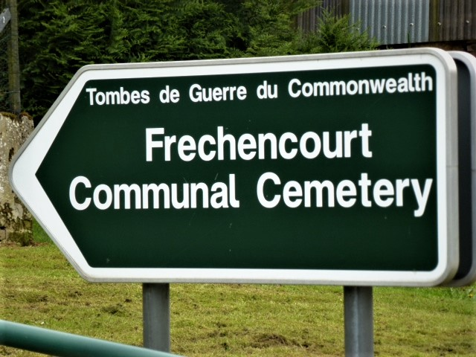

“*The whole of the above were killed in action on April 5th at Melincourt, on the day when the 4th Div. 10th and 11th Bdes. Held back 4 Div. of Germans. They were buried by Padre Shaw, 11th Bde. I made one Cross and put a 41/2 inch railing round the grave, one surround for the 14 graves. They are buried in the above order, in one row in Frechencourt Civilian Cemetery. Lt. Harrison being on the left, and the rest downwards to the right. The name of each is on the railing at the head of each grave respectively. There are no names on the Cross, which bears the inscription – ‘In Loving Memory of Officers, N.C.O’s and Men of 4th Aust. Div. A.F.A., K/A 5.4.18. R.I.P.’ Informant. Rice H.G. 141 42nd Bty. Hut 72, Westham.” (From Australian Red Cross Wounded & Missing Files).*

A few older villagers at Frechencourt have fond memories of the Australians and they frequently tend the graves in the war section of the cemetery. *.(Guide to Australian Battlefields on the Western Front 1916-1918 by John Laffin.)*

**NEWS TO FAMILY**

Raymond death was published in the local paper. “Mr Joseph Dempsey had been informed that his youngest son, Driver Raymond Dempsey was killed in action in France on April 5th. This is the second son Mr. Dempsey has lost. Private Donald Dempsey having been killed some months ago. He has another son still at the front, Private Harry Dempsey. Driver Raymond Dempsey who was 20 years, enlisted from Moscheto Island and left in November 1915. He saw service in Egypt before going to England and then to France. *(Newcastle Herald & Miners Advocate Saturday 27 April, 1918. Page 7 District casualties).*

His father also received a letter from the Chaplin who buried his son. **“MAYFIELD – LATE DRIVER DEMPSEY**. Mr. Joseph Dempsey of Mayfield formerly of Moscheto Island has received a letter from Chaplin G.E. Shaw referring to his son, the late Driver Dempsey, who was killed in action in France. The Chaplain offered his sympathy, and states that Driver Dempsey had a most excellent record among his associates. He was buried alongside several of his comrades who fell, and arrangements were being made for a cross to be erected over his grave. *(Newcastle Morning Herald and Miners’ Advocate Saturday 6 July, 1918 P.2)*

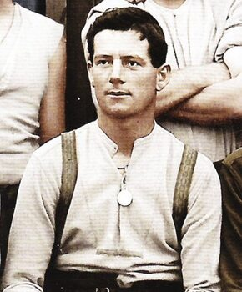 Raymond’s other brother **Henry** Dempsey (known as Harry) Service No 407 34th Battalion dubbed “Maitland’s Own”. The 34th Batt. Became part of the 9th Brigade of the 3rd Australian Division. He fought in all the major battles including Villers-Bretonneux and returned home after the end of the war with a disability after being wounded twice in action from shrapnel and gun fire. He was invalided to England in 1918 and returned to Australia on 17th April 1919.

Figure Henry Dempsey

**WELCOME HOME TO RETURNED SOLDIERS**

Raymond would never live to marry and have a family, his young life lost forever. Like his brother Donald he would not be welcomed home to live his life in the freedom they had won. Donald would leave behind a wife and small daughter named Delma. Henry would return home with a disability.

A Moscheto Island Roll of honour Board was unveiled for those young men left behind and Raymond’s father had the honour (as seen below) to unveil the honour roll. His father said it was painful for him as on that board were the names of two of his sons who would never return.

This Memorial Honour Board was eventually sent to Christ Church Cathedral, Newcastle when the islands were reclaimed and cemented together to became Koorangang Island. It has sadly since gone missing.

***NEWS. MOSQUITO ISLAND. ROLL OF HONOUR UNVEILED****. Empire Day was celebrated at Mosquito Is land on Saturday, the function being attended by the unveiling of the roll of honour erected by the parents and citizens' committee, in connection with the school. The roll includes the names of all the young men enlisted from the islands, most of whom had passed through the school. Of the eighteen named, seven are those of men who have paid the supreme penalty. The board is a splendid piece of work, made and presented to the committee by Mr. George Towns, senior…. the toll of the war had fallen heavily on the residents of the island; some parents having lost two out of three who enlisted. To them he extended his deepest sympathy. He called on Mr Joseph Dempsey* *to unveil the honour roll. Mr. Dempsey said it was painful for him as on that board were the names of two of his sons who would never return. He was also related to several other brave lads whose names were also there, and some of them had also been killed…Before the outbreak of this struggle Australian lads were looked upon as altogether given up to sport, but when the call came, and their country was in danger, they proved that they could be both a sport and a soldier. The following names appear on the roll, those who have fallen being indicated by x: xS. J. Moore, Chas. Croese, R. Jordan,* ***xR. F. Dempsey****, J. Tarrant. xJ. Hughes, xR. M'Queen, H. Dempsey, Con. Croese, C. Ross, xG. Glover, xD. P. Dempsey, J. Williams, A. Morris, C. O. Harrison, T. Jordan, xR S. Naylor, S. E. Turner. .(*Newcastle Morning Herald and Miners' Advocate (NSW : 1876 - 1954), Tuesday 28 May 1918.)

Raymond’s father would receive Raymond’s medals – The Victory Medal, the British War Medal and the Star Medal.

As mentioned, eventually the powers that be decided to turn all the island into one, naming it Koorangang Island. The eastern portion was developed and industrialised and the western section, Ash Island rehabilitated. It has undergone a revegetation program and is a pleasant place to visit.

**VISIT TO RAYMOND’S GRAVE**

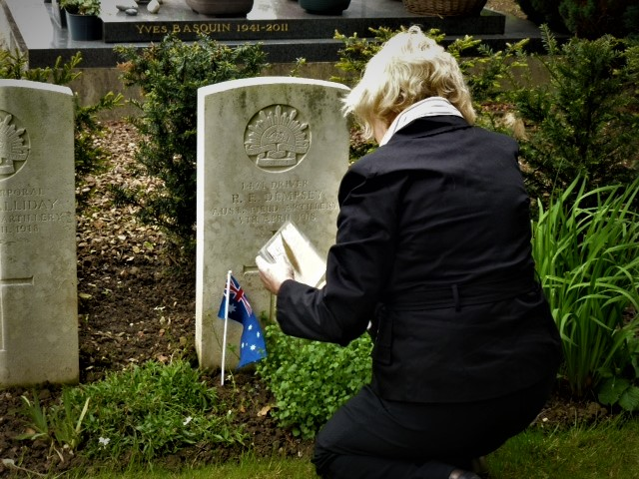The family of Raymond and his brother Donald were never able to visit the grave or the memorial to their sons. The writer in 2012 visited the grave of her great uncle Raymond and left Australian flags and a poem she had written in honour of her uncle. Fréchencourt Communal Cemetery 11th May, 2012

TO HONOUR RAYMOND FRANCIS DEMPSEY

You left as a lad the Dempsey Farm

and the endless blue of Australian skies

To answer the call from the motherland,

with the horrors of war yet unrealised.

the Light horse, then artillery, you were sent

to the roar of guns and the endless mud

and you fell that day where the poppies rise,

to lose your life and spill your blood.

In the battle of Dernancourt you died

close to the place where I now stand

to honour you this memorable day

in this distant village on French farm land.

the first of your kin, one you never knew

I come as your parents would have ached to do,

To know the place to be present here

with the collective love of the yester years.

A love that continues gifted as mine

So, we never forget with the passing of time

The sacrifice of so many young men

you did not return when war found its end.

To ferry the milk to the Newcastle shore

With the toil of your back and the splash on the ore

No love, no wedding, no life on the farm

No children to raise to hold safe in your arms.

This sacrifice you and your brother Don gave

In the heart of our family I commune with you now

As I stand at your grave.

. 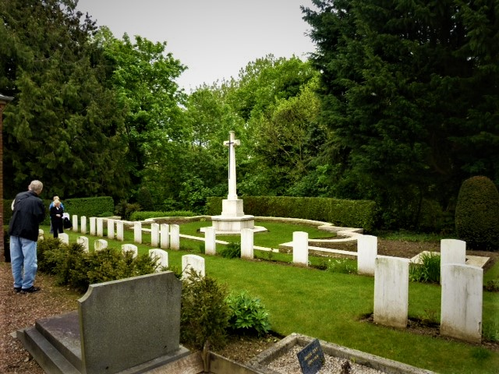

May they rest in peace.

Kathleen White.