***THE VIETNAM WAR Tahlia Andolos***

The Vietnam War was the longest major conflict in which Australians have been involved; it lasted ten years, from 1962 to 1972, and involved around 60,000 people. A limited initial commitment of just 30 military advisers grew to include a battalion in 1965 and finally, in 1966, a task force *(war.commemoration.gov.au/vietnam-war/index.ph*p). Each of the three services was involved, but the major role was played by the army. Australia’s involvement in the war cost the lives of more than 500 servicemen, many of whom were conscripted; and around 3,000 men were wounded or were victims of illnesses during their time there (Some still suffer). This essay primarily includes:

**‘A Soldier’s Reflection, Interview with a Vietnam Veteran’**

Mr Philip Henderson (Phid) was a Regular Serviceman. He joined the army straight out of high school at the age of 17.

On enlistment into the army all recruits were given 3 months training. This was referred to as basic training. Training took place at Kapooka, which is just outside of Wagga Wagga in NSW. After recruit training Phid was sent to the infantry training centre (ITC) at Ingleburn NSW for another further 3 months corps training. Most soldiers were then posted to an infantry Battalion or in some cases sent straight to Vietnam (after a period in the Jungle Training Centre at Canungra QLD) as reinforcements to a unit already in Vietnam *(Henderson 2011).*

In Phid’s case he was still too young to be sent overseas as the minimum age for overseas postings was 19. As a result he had to undertake further training in various areas of combat training including, assault pioneer training. His next posting was to the jungle training centre and then after Phid had turned 19 he was posted to 1 Army Reinforcement Unit (1ARU) Vietnam on the 26th of August 1968. Then after about 3 weeks at 1ARU he was posted to 4RAR/NZ support company, assault pioneer platoon based in Nui Dat *(Henderson 2011).*

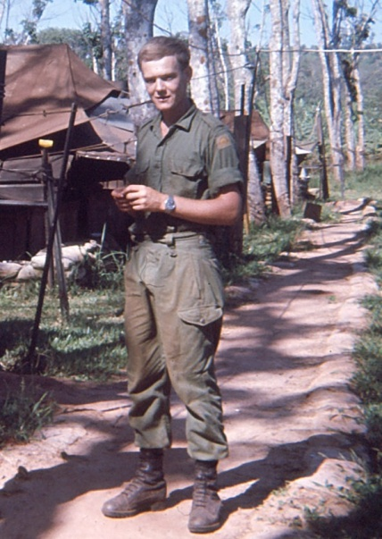 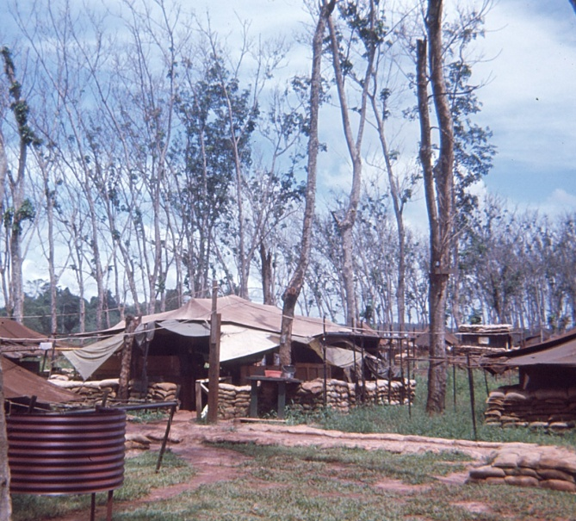

P. Henderson Dui Dat 1968 “My Home” Nui Dat 1968-1969

When Phid arrived in Vietnam his first impressions were that it was hot, humid, noisy, tense and smelly.

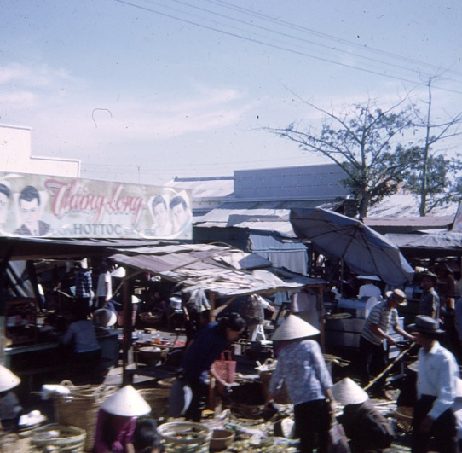

Market Place Vietnam1998

Phid had flown from Sydney on a cool wet day, and after a stopover in Singapore, arrived at Tan Son Nhut Airport Saigon. This was the busiest airport in the world at the time due to the Vietnam War and straight after he got off; it was all go. Plus on top of that they could feel the tension all around them *(Henderson 2011).*

Phid’s role in Vietnam was to carry out numerous tasks. These varied from constructing perimeter wire fencing around fire support bases; locating and destroying enemy bunker systems and patrolling independently as a platoon or with a rifle company. On several occasions the men would be flown into a designed area of operation (AO) to secure the area and lay the perimeter for a fire support base (FSPB).

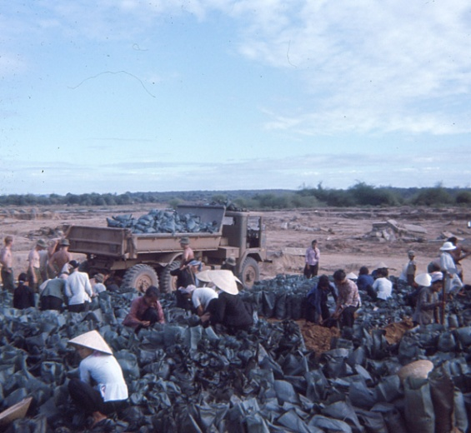

Sandbags being filled for FSPB (Note the local help,)

A FSPB was an area from which a company or the Battalion would operate from over the duration of the operation.

One of these operations (Operation Goodwood*) lasted from the 3rd of December 1968 to the 19th of February 1969. It was during this operation that Phid worked with other members of pioneer platoon and B Company to establish FSPB dyke *(Henderson 2011). *Refer N01*

It was fairly hairy as the helicopter pilots wouldn’t land their aircraft for fear of landing on a mine. So, they had to jump! Phid said he finished up on his face covered in mud, with mud jammed in the barrel of his rifle. Not a very good start for him on that operation. However the men finished the task on time for the Battalion to fly in once the area was all secure. Another one of the tasks was to spend time on a feature known as the Horseshoe. Called Horseshoe because of its shape. This area was in fact a permanent FSPB and every company, including V and W Company did a stretch at the Horseshoe. V and W company were New Zealand troops therefore the designation of 4RAR/NZ (Anzac) Battalion *(Henderson 2011).*

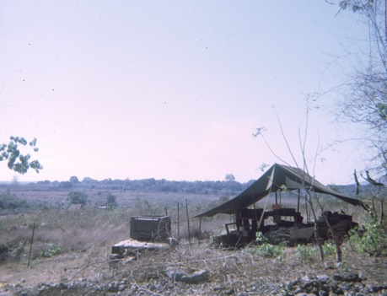 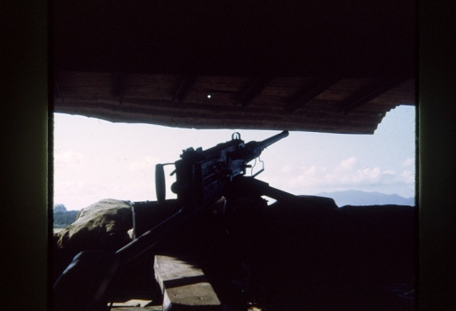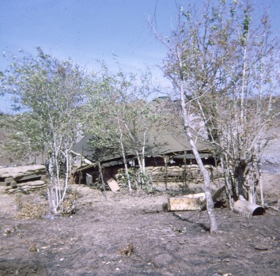

Living conditions Horseshoe March 1969. 50 Cal Gun Placement. Horseshoe 1969 Luxury accommodation

Phid’s rest and recreation (R&R) was spent in Taipei, Taiwan. Allegedly 5 days of rest. However the men spent the 5 days partying and after the 5 days the people of the Crux Hotel were more than likely glad to see them leave. Also soldier’s had another 5 days of rest in the country ‘RIC’. These 5 days was spent in Vung Tau at the Peter Badcoe Club. Phid and his team had 10 days off in a year *(Henderson 2011).*

Overall the conditions were pretty awful. Always humid and hot even during the so called ‘dry season’. Throughout the wet season it was exceptionally wet with torrential rain causing everything to turn into mud. Their living conditions were very basic and nothing exciting. Open tents with sand bags around the edges, when in Nui Dat.

In the field while on operations they slept in holes they had dug out themselves with a small tent like cover referred to as a hoochie *(Henderson 2011).*

The Viet Cong was a tough adversary as they had been fighting in the jungles for a longer period of time. First against the French occupation then the war Australia was involved in. When patrolling they were tense all the time, and always had to be on the lookout for something to happen. Even when the soldier’s stopped for a smoke and brew you were still all on edge.

When contact is made with the enemy, the adrenalin starts to kick in, training takes over and you do the job. Only after the contact is over with and the area is swept and all secure, you do think about what could have happened. Then you start all over again *(Henderson 2011).*

Phid was in Vietnam fighting for 277 days. He arrived on the 26th August 1968 and left on the 30th May 1969, going home with the Battalion on the HMAS Sydney. An old aircraft carrier converted into a troop ship, affectionately known as the VUNG TAU FERRY *(Henderson 2011).*

Once Phid had left Vietnam he took leave on his return and flew straight to the UK where he met up with and married his girlfriend Annette. She also returned to the UK with her family before they reunited with each other *(Henderson 2011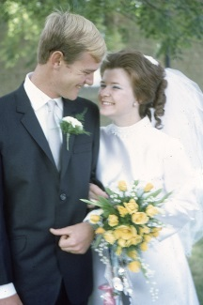).*

On release from the army Phid found getting work was difficult. It seemed that because he served in Vietnam he couldn’t get passed the first interview, so Phid had to take on anything he could to get, even if it meant not telling anyone had had served in the army.

Phid had many jobs over a long period, as he couldn’t seem to settle down, until he was given an opportunity to work with a large multi-national company (3M), where he stayed for 26 years. This is because the company kept changing his role and sent him all over the place. This had suited Phid as he became somewhat of a workaholic, even though at the time he didn’t know it was a sign of underlying health issues *(Henderson 2011).*

As mentioned Phid married in 1969 and still is married to the same young girl. Phid and Annette have two children and one grandchild,(Now two **Edit 23**) who are the apple of their eyes. Their grandchild has given them both a new lease on life

*(Henderson 2011).*

Since the war ended Phid has many acquaintances but only a few close friends. This is because he moved around so much over the years but most likely because he became a grumpy person. Phid and his wife have become really close friends with other veteran families who have also shared many post-traumatic stress disorder (PTSD) training sessions with him. These training sessions have helped many veterans and families cope with life much better and have bonded in only a way close friendships can *(Henderson 2011).*

In total Phid has had many homes (eleven in all), in three states around Australia. Hopefully he is now settled, but who knows what will happen. *(Henderson 2011).* (4 Moves since 2011. **Edit 23**)

Phid’s experience over in the war has affected him long term. He has been diagnosed with PTSD which is linked back to his time Vietnam and may explain his somewhat erratic behaviour, at times, over the years, leading up to his first break down. Phid had denied this for such a long time until his wife forced him into getting assessed through the DVA and he is currently still receiving treatment and learning to cope with it *(Henderson 2011).*

***References:***

"The Vietnam War." *Australia and the Vietnam War*. Departments of Veterans' Affairs, 2011. Web. 4 Apr. 2011. <http://vietnam-war.commemoration.gov.au/vietnam-war/index.php. ***(secondary Source)***

Henderson, P., 2011, Interview conducted via email 27th March 2011. ***(Primary Source)***

***\*N01 OPERATION GOODWOOD • The Battle of Hat Dich (3 December 1968 − 19 February 1969) was a series of military actions fought between the 1st Australian Task Force (1 ATF) and the North Vietnamese Army and Viet Cong during the Vietnam War. Under the codename Operation Goodwood, two battalions from 1 ATF,1RAR and 4RAR/NZ(Anzac), deployed away from their base in Phouc Tuy province, operating against suspected communist bases in the Hat Dich area, in western Phuoc Tuy, south-eastern Bien Hoa and south-western Long Khan provinces as part of a large allied sweep known as Operation Toan Thang II. The Australians conducted sustained patrolling throughout the Hat Dich and extensively ambushed tracks and river systems in the Rung Sat, occupying a series of fire support bases as operations expanded. Meanwhile American, South Vietnamese and Thai forces also operated in direct support of the Australians as part of the division-sized action. • On 6 February 1969, two additional battalions from the Thu Duc VC Regiment were reported to have entered the Hat Dich area and 4 RAR/NZ was subsequently redeployed with tanks and APCs in support, resulting in the heaviest contacts of the operation. The fighting lasted 78 days and was one of the longest out of province operations mounted by the Australians during the war. Although there were few major actions, the fighting resulted in heavy Viet Cong and North Vietnamese casualties and forced them to abandon their permanent bases in the Hat Dich, as well as disrupting their preparations for an upcoming offensive during Tet. Immediately following the operation the Australians were redeployed to block the approaches towards key US and South Vietnamese bases in Bien Hoa, Long Binh and Saigon in anticipation of the 1969 Tet offensive, during Operation Federal***