Documents from Capt Gerald Evans MC’s file that relate to RSM Harris, both 8th Battalion

France
Oct 10th 1916
My dear Mother -
It is a good while since I have written to anyone at home but I missed the last mail - hope you will not be imagining all sorts of things about me.

There was a little matter of a raid that I happened to be in charge of, and I did not feel inclined to write till it was over; however it went off very successfully, and now can tell you all about it, it was very well done, & they have all said very nice things about me, and what you will probably like much better, I will not feel it is my turn to take part in a raid for a long time to come.

I have had lots of letters from everybody saying how pleased they were I was wounded because I would be away from the firing line for a while, the funny part is I have not been away from the Battalion for a day.

You cannot imagine what hard luck I had the day before yesterday, I had the warrant in my pocket to go on leave in England for ten days when I got sick, a bad bilious attack. I think, any how it stopped me, I am just about right again now, and as soon as I am well the pass will be forthcoming, it is the first time I have been ill like that since I can remember, I think it may have been a touch of ptomaine poisoning, however I am going to get properly well before I go as I want to do the leave full justice. What a bad fall father must have had, you must have got a fright. Alan and Pearlie are a strange pair as they must have taken all the dogs from Killingworth with them -

You will be sorry to hear that my batman Tullett has gone, he is 56 years & sleeping on the wet ground & so on was playing up with him so I got the Doc to send him back to Australia. He was a fine old chap as honest as the sun, & did not like leaving me, I have had him with me for 15 months and kept him out of all the rough business.

Captain Hurrey who was in the same Company as I for a long time has gone to England sick, he was always very decent to me - Dickson is now a Captain, all the fellows who went to new battalions got their promotion quickly, I was just due for mine but lately five original officers of this battalion have come back, so suppose I will be in the cold, these officers have been away 16 months, & most of them have seen practically no fighting, I will have to wait for another Pozieres, they are the stunts to make promotion. However I am quite content to bump? along as I am - Hope the next time I write will be from London.

I do not understand how you could have had a cable from Bill Usherwood, is he still alive? The paper says he cabled from England. He may have been picked up & got over there without his Battalion knowing of it -

Must stop now, with love to all
Your loving son
Gerald

Also included in envelope

92 London
10 words
Evans Redcamp Wangaratta
Leave England very well
Love Evans 6-30 PM 17th Oct
At this time the 8th Battalion was in the line in front of Ypres at the Glasgow post which is Sth of Zilebeke – D Coy at Battersea Farm in reserve. From Battalion diaries: Raiding party trained for this for around 10 days befere 30/9/1916, Raid a complete success with one German prisoner (later died) and two Germans killed. Lieut Joynt and one OR slightly wounded and Pt Smith (later DoW? Badly wounded. Indentifications and information gained. Many congratulations from Army Corps, Division, Brigade command. Gerald led the raid.

Note: See “Cobbers in Khaki” page 132-133. It would appear that this raid occurred near Ypes in an area “north east of the bluff”. On the 26th of September, the whole unit moved into billets at Scottish lines, and on the last night of the month (30th Sept) the raiding party, with faces blackened and wearing balaclavas, crawled into No Man’s Land at 10pm and after covering the 50 yards at the agonizingly slow rate of only two yards a minute, attacked a sector of the enemy trenches north east of the Bluff, held by the 73rd Landwehr Regiment. The raiders scrambled across extensive entanglements using ladders and mats, and totally surprised the enemy. The raid resulted in several Germans being killed or wounded in their dugouts. A solitary wounded prisoner brought back by the raiders later died from his wounds at a casualty cleaing station before he had divulged his unit identity. This was ascertained from his id discs.
The raid leaders, namely Lieutenants Evans, Goodwin, Joynt, Maguire and CSM Harris, were delighted to receive congratulatory messages on the success of the raid from their commanders at Corps, Division and Brigade level. Colonel Gordon Bennett (CO of 6th Battalion) was on “loan” to 8th Battalion for the training for the raid, “spoke highly of Evans’ leadership during the raid “He trained his men so well they did the work with calm regularity and precision in very great danger. He controlled his party with great coolness” Assume this is one of Gerald’s Mentioned in Dispatches.

Lieutenants Francis W. Goodwin [MC+bar, MID, KIA 4/10/1917], W.Donovan. Joynt [later VC, MID], John T. Maguire [3945, later MC, MID, KIA 4/10/1917] and CSM George Harris [DCM, MID].

Recommendation for a Military Cross, ended up being a Mentioned in Dispatches.
Lieutenant DG Evans, 8th Battalion, 2nd October, 1916
Running a raid on the German trenches near Hollebeke on the night of 30th Sept/1st Oct, Lt Evans was in command of the left raiding party. He trained his men so well that they do the work with calm regularity and precision in very great danger. He took his post on the enemy parapet and controlled his party with great coolness. The party killed one German and brought to our lines one wounded German from whom the necessary identification was established. His fine leadership was to a very great extent responsible for the success of his party.
Major General Gordon Bennett, Commanding Officer

Order of Service, 8/7/1917, for the unvieling of the Poziers memorial for the 1st Division.
Eight men were selected to represent each company. Gearld was selected to represent A Coy. Found in Gerald’s wallet.

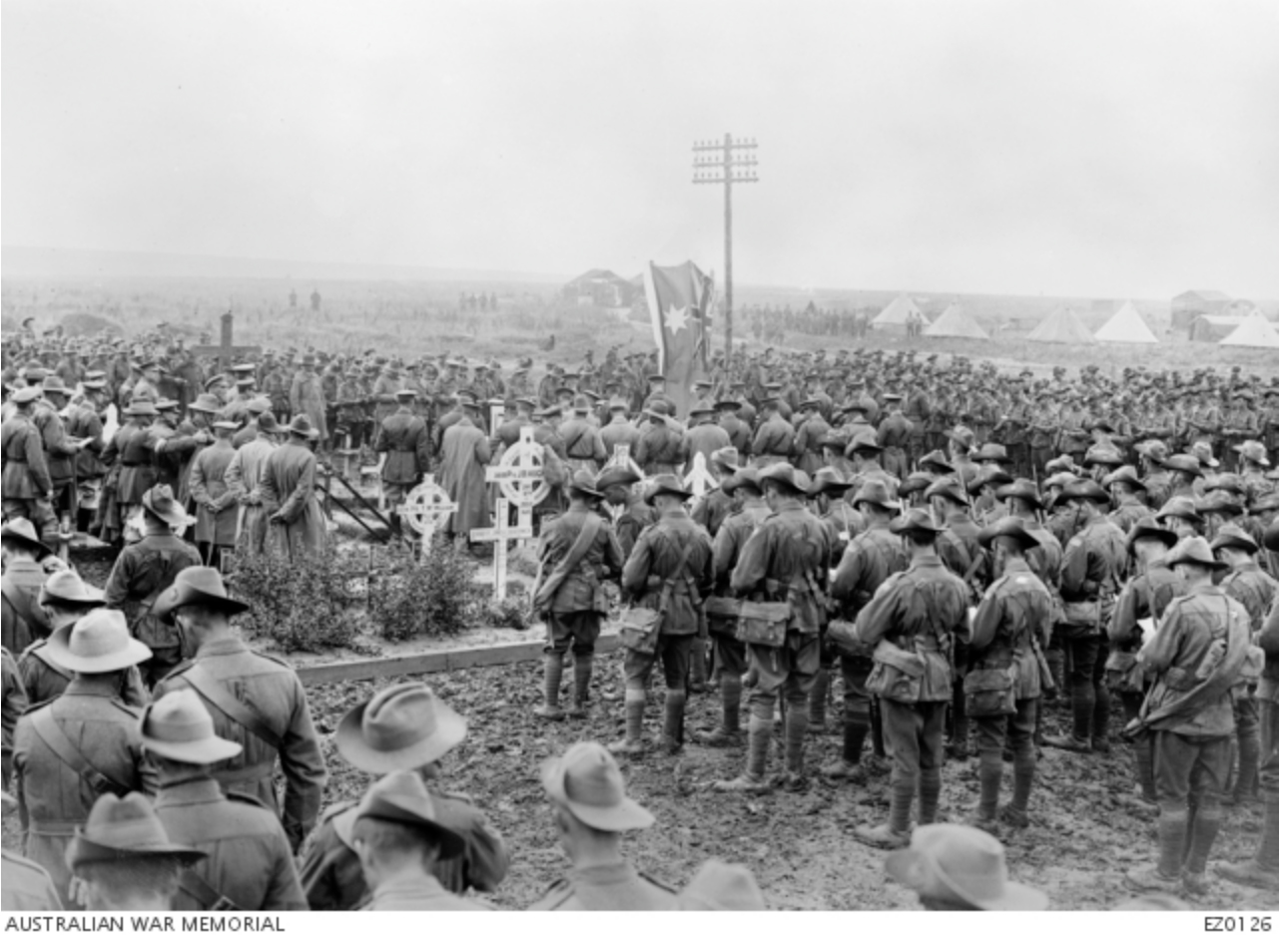
Picture of Pozieres Memorial Service, 8th July, 1917, AWM E20126

