**Robert Aschman: A man who served his country**

Robert Aschman was one of the many Australians who risked their life and served in World War I. Born in Glasgow, Scotland, in 1883, he later migrated to South Africa, where he served 18 months with the Oudtshoorn VolunteerRifles in South Africa before his service ended when peace was declared (likely related to the Second Boer War). Then he moved to South Australia, where he worked as a canvasser and lived with his cousin. Robert was a Jewish man, standing at 168 cm tall and weighed 63 kg. He was single at the time of enlistment, so his cousin (who he lived with) was listed as his next of kin.

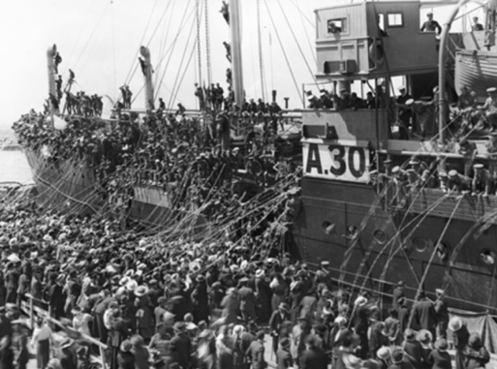

Robert began the enlistment process on the 17th of August 1915 and officially enlisted on the 10th of September 1915 into the 10th Battalion of the AIF. From the very beginning, Robert demonstrated commitment and service, and after undergoing initial preparations, he embarked from Australia on the 11th of January 1916 aboard the HMAT A30 *Borda*.

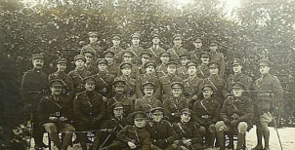After arriving in Suez, Egypt, on the 11th of March 1916, Robert continued his training. Then on the 20th of May 1916, as part of a reorganization in the Australian forces, he was transferred to the 50th Battalion. The 50th battalion was formed from experienced members of the 10th Battalion and new recruits. Just one day after the transfer, Robert was promoted to sergeant, a sign of his strong performance and leadership qualities.

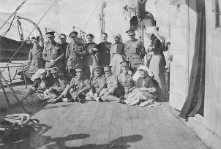

He was sent from Alexandria, Egypt, to Plymouth, England, on the 6th of June 1916 for further training. From there, he was deployed to the Western Front in France. He disembarked in Étaples on 30 November 1916 and was assigned to the 4th Australian Division Base Depot before eventually joining his unit on the front lines on the 28th of June 1918.

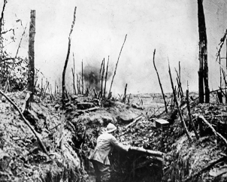During his service, Robert took part in many major battles, including the Battle of Fromelles (July 1916), the Retreat to the Hindenburg Line (February 1917), the Second Battle of Bullecourt (May 1917), the Battle of Polygon Wood (September 1917), the Battle of Villers-Bretonneux (April 1918), the Second Battle of Morlancourt (May 1918), the Battle of Amiens (August 1918), and the Capture of Peronne and the Hindenburg Line (September 1918).

Despite his promotions from Private to Lance Corporal on the 31st of March 1916, and eventually to Sergeant by the 7th of December 1916, Robert also experienced setbacks. On the 5th of September 1916, he was disciplined after allowing six prisoners to escape. He was severely reprimanded and demoted back to Private. However, once again he rose in the ranks until he was a Seargent. Later, he was marked as AWL on the 30th of November 1916 while at Étaples, France. His punishment was a deduction in pay, which was standard.

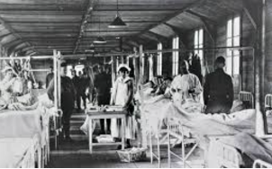Robert also faced many health issues during his service. On the 11th of December 1916, he was hospitalized in Étaples with piles and was transferred to England the following day and in March 1918, he was admitted to Sutton Veny Hospital with conjunctivitis. However, his most serious wound occurred on the 23rd of August 1918 during the Second Battle of Somme. He suffered a gunshot wound to the right thigh and was treated at the 41st Casualty Clearing Station before being evacuated to England.

Robert arrived in England on the 26th of August 1918 and was admitted to Northamptonshire War Hospital in Duston. After further recovery at the Daventry VAD Hospital, he was placed on furlough. Then on the 26th of November 1918, he returned to the No. 1 Command Depot at Sutton Veny but was declared medically unfit for further service.

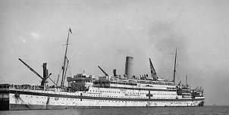On the 12th of December 1918, Robert boarded the HT *Nestor* at Liverpool to return home. He disembarked in Melbourne on the 1st of February 1919 and was officially discharged in Adelaide on the 31st of March 1919 due to his medical condition. His final rank was reverted back to private since he was declared medically unfit. In total, Robert served for 3 years and 222 days, with over three years spent overseas.

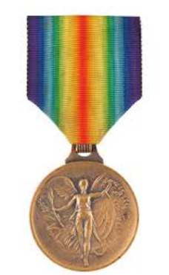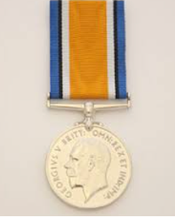

For his service, Robert Aschman was awarded the British War Medal and the Victory Medal, both were awarded to those who served in operational theatres of war. However, since Robert passed away in 1928, the medals were given to his brother.

After the war, Robert lived for another decade before passing away of unknown causes. He was buried in the AIF Cemetery at West Terrace in Adelaide, South Australia.

Robert Aschman’s story reflects the journey of many soldiers who served during World War One. Even through battles, wounds, illnesses, and setbacks, he endured it all. His commitment and sacrifice towards Australia were truly commendable. Hopefully with this biography spreading his story, Robert Aschman will not be just another name on a record, but a man who gave his all for his country, and whose legacy continues after his death.

