**Mary Catherine Green Vowles born on 21 July 1891 in South Australia,**

**died on 5 July 1979 in South Africa at the age of 87.**

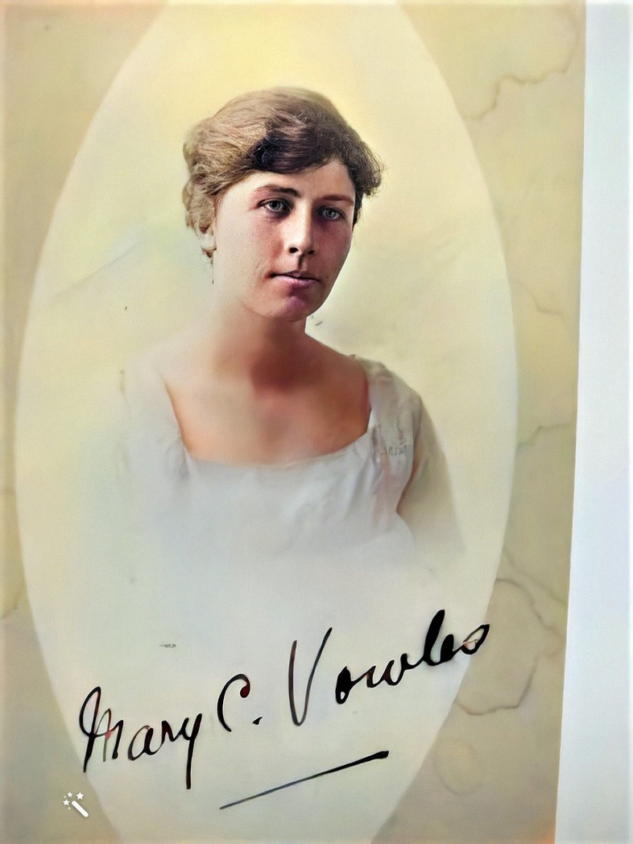

When Mary Catherine Green Vowles was born on 21 July 1891 in South Australia, her father, William, was 33, and her mother, Annie, was 34. She had three brothers. She died on 5 July 1979 in South Africa at the age of 87.

Mary Catherine Vowles (Aunty Polly) as she was affectionately known was born at Bowden. On the 10th April 1933 she returned to South Africa and worked as a nurse but I'm not sure exactly where. She remained in South Africa until her death on the 5th July 1979. At that time she was residing in the Clareinch Nurses War Memorial Home, Cape Town. Mary never married. Polly is a feminine name of Latin origin that means "star of the sea." Once used as an endearing pet name for "Molly" and "Mary," Polly has since matured into a timeless name in its own right. Polly is a diminutive of Mary.

Trained at North Adelaide Private Hospital  
Enlisted 17 August 1916 at the age of 24.   
Served in Bombay, India  
Embarked for Salonika 24 August 1917 per 'Manitou'  
Served in Salonika Contracted Malaria  
Returned to Australia per 'Wiltshire' 3rd October 1918 to Sydney  
Proceeded to 5th MD for duty East West Rail 28 December 1918 to nurse Influenza  
Returned 04 September 1919 per 'Takada'  
Appointment terminated 19 October 1919

Volunteered 22nd May 1915

Enlisted on the 17th August 1915 staff nurse

Member of the Armed Forces Nursing Academy  
24th August 1916 Embarked from Adelaide per RMS 'Mooltan' as part of the Australian Army Nursing Service

17th August 1915 Promoted temporary sister and transferred to No 6th District.

1st July 1916 temp sister Active Duty List (ADL?)

17th August 1916 appointed to Rank of Sister Letter issues by the Department of Defence Melbourne, signed Brigadier-General 4th District.

13th September 1916 Arrived in Bombay

13th September 1916 Posted to Colaborar Hospital Bombay for duty.

14th December 1916 Transferred to Station Hospital

11th July 1917 Bombay India

24th July 1917 From Bombay to Salonika

4th August 1917 Alexandria

18th August 1917 AIF( Australian Imperial forces ) HQ Cairo from Bombay ex “Malwa”

22nd August 1917 Received from N/R “Manitou” embarked for Salonika

29th August 1917 Disembarked ex “Manitou”

1st September 1917 Arrived for duty. “66 Gen Hosp”

18th September 1917 Admitted for Malaria

30th September 1917 Admitted for Malaria Sisters Convalescent Camp

13th October 1917 Discharged to duty

20th October 1917 Re-joined from Convalescent Hospital “66 Gen Hosp”

14th November 1917 To 42 Gen Hosp for duty

15th November 1917 Doing duty

29th December 1917 Appointed A/Sister with effect from 1st September –Authority AANS Salonika Order No1.

25th May 1918 Admitted to Red Cross Convalescent Home

8th June 1918 Discharged to duty

29th June 1918 Re-joined on discharge 42 Gen Hosp

3rd July 1918 Admitted Malaria 43 Gen Hosp

23rd July 1918 Medical board held Salonika at “43” Gen Hospital notes prepared by Australian Headquarters Egypt.

Disability was found to have had Malaria on three occasions in August 1917, September 1917 & the 3rd July 1918.

Unfit for General Service for 6 months.

Unfit for Home Services or light duties at Home for 3 months.

Does not require Hospital or convalescent treatment.

Disability contracted in the service and under circumstances over which she had no control.

Caused by military service – Infection in Macedonia. Recommended to be invalided to Aust.

26th July 1918 Discharge to “52” Gen Hospital awaiting Evacuation ( Mal )

22nd August 1918 Embarked for Egypt en-route to Australia.

28th August 1918 Disembarked ex “Girgon” from Salonika Alexandrina

30th August 1918 Embarked per “Wiltshire” for Australia – Invalided, via Suez (assumed Suez canal).

5th October1918 Transferred from Salonika and returned to Australia on Sick leave with Malaria. From the Wiltshire (assumed Hospital ship) disembarked via Sydney.

WW1 Ended on 11 November 1918.

6th December 1918 Returned after being abroad for 2 months. Also had 2 weeks leave. Required to report at 15.00 at Australian General Hospital ( doesn’t say where )

28th December 1918 Volunteered to nurse Influenza A, left for WA ( assumed Western Australia) another reference referring to “East West Rail” ?

4th September 1919 returned to 4th Military District ex Takada 29th August 1919 Embarked Fremantle to Takada (assumed Hospital ship)

19th October 1919 this sister be terminated owing to “cessation of Hostilities”. Letter issues by the Department of Defence Melbourne, signed Brigadier-General 4th District.

At Sea. 17 April 1915. British ship HMT Manitou, and other transports, collecting men and material from the water after having been stopped by a Turkish Navy destroyer during the ship's voyage from Alexandria to Lemnos.

Mary Catherine served as a Staff nurse from the 17th August 1915 until the 30th August 1918 in active service. Mary was discharged from service due to the “cessation of Hostilities” on the 19th October 1919.

