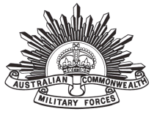

**John Joseph SAVAGE**

|  |  |
| --- | --- |
| Regimental number | 5404 |
| Place of birth | Penshurst New South Wales |
| Religion | Roman Catholic |
| Occupation | Farm hand |
| Address | Darra, Queensland |
| Marital status | Single |
| Age at embarkation | 18 |
| Next of kin | Sister, Miss Isabella Savage, c/o Mrs E Arnold, 'Lynton',Sackville Street, Bexley, sydney, New South Wales |
| Enlistment date | 4 March 1916 |
| Rank on enlistment | Private |
| Unit name | [26th Battalion, 14th Reinforcement](https://www.aif.adfa.edu.au/showUnit?unitCode=INF26REIN14) |
| AWM Embarkation Roll number | 23/43/4 |
| Embarkation details | Unit embarked from Brisbane, Queensland, on board HMAT A50 *Itonus* on 8 August 1916 |
| Rank from Nominal Roll | Private |
| Unit from Nominal Roll | 26th Battalion |
| Fate | Returned to Australia 9 February 1919 |