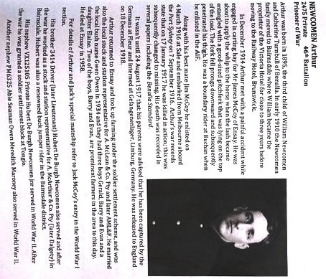

**Source**:

Wayne George...*they wouldn’t talk about it. The Service Men and Women Of Ensay District.(Wayne George, 2023) p.81. Permission given by author.* waynegeorge500@hotmail.com