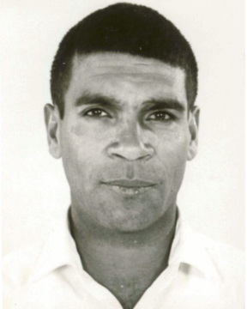**Private Andrew Drummond**

*Service number: 55537*

Andrew ‘Andy’ Drummond was born on the 2nd of May 1942 in Carnarvon Western Australia, a small town 900km north of Perth. He worked as a farmhand on several outback stations and at Mullewa before joining the army.

He became a member in the 5th Battalion for the Australian Army in the Vietnam War after enlisting on the 7th of November 1967. As a part of his platoon, he was positioned as a scout, his job to gather information about the enemy’s position and movement.

Within this job, Andy was seen as a professional, and capable to carry out many jobs that other soldiers could not, due to his wonderful awareness of surrounds and his strong eyesight. A fellow solider, A J Hinchey mentioned that “*In size he was short, but he was able to carry out all tasks as well as other soldiers who were much larger than he was*.” In this position of forward scout, Andy clearly displayed his courageous spirit.

Bruce Mitchell remembers Andy as “*a much loved and highly respected solider.*” Being slightly older than the other members of his platoon, many remember Andy as a ‘father figure’ for the group. Battalion member, Robert Smith recalls “*We looked up to Andy and yet he was a humble and likeable bloke*.” John Chambers also saying, “[Andy was a] *friendly sort of bloke, with a cheeky grin that he was always willing to share with anyone*.”

His battalion members called him ‘Little Andy’ due to his short stature. Yet, fellow soldier, Lofty Bond described Andy as someone who stood tall and held pride in his culture, his mates, his battalion, his country and himself.

*Andy, (right)*

As one of the only First Nations Australians in his battalion, Andy’s hat puzzled many of his platoon members, written on it, the word ULURU. Platoon commander, Moose Dunlop OAM, AIMM (my neighbour) once asked him what it meant. He recalls Andy answering, “*we know what it means, and it is up to your mob to find out*.” If only Andy could see Uluru now.

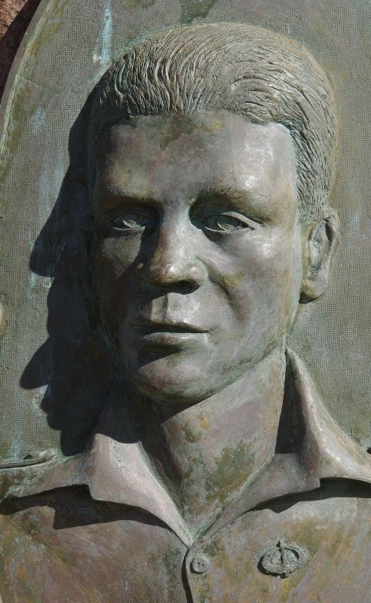On the 30th of May 1969, Andy was accidently killed. As a part of Operation Twinkenham 2, the battalion was in the Nui Thi Vai hills, surrounded by dense jungle, an area with extremely low visibility. The platoon was given the job of clearing one side of a large hill. In the events that followed, Andy was accidently shot and killed, his death a huge sadness for the platoon and all who knew him.

Many recounts of his life were collated after the war. Rod Hawkins fondly remembering Andy as “*truly one of nature’s gentlemen.”* Chas Exindaris said, “*He was a much loved man amongst all and his memory never fades, nor does our love for him*.” Another recounting, “*I know that I wasn’t the only one upset and that other comrades still feel the pain*.”

After arriving home following the Vietnam war, Andy’s platoon members paid for a bust to be placed in his hometown to commemorate and remember the amazing person that Andy was.

“Today Andy’s spirit radiates through his friends and into the broader society breaking down barriers of racism by highlighting love.” -Garry Forster, company member.

Lest we forget.