Alexander Roy MATSCHOSS was born on 18th May 1908 to Mr. Johann and Mrs Bertha MATSCHOSS at Truro. Known as “Jim”, he was the younger brother to Hugo and John.
Jim was 33 years of age and lived with his parents at Moculta. A single man who worked as a labourer, he was working in Waikerie before enlisting at Waikerie, attesting on the 9th of May 1941 and joining the 2nd Australian Infantry Forces.
After his enlistment and training, Jim left for the fighting overseas, just one month later, in October 1941. Jim was posted with the 2/27th battalion, in the Middle East. In January 1942 the 2/27th were recalled to Australia in preparation for meeting the Japanese fighting forces that were making their way across and towards Australia. They arrived in Adelaide in March 1942.
The men took leave and visited Waikerie. On April 1st, 1942, the paper reported that Sergeant Hugh Dalby, Privates Geo. Mather, “Jim” Matschoss, John Burns, Les Curtis, Glen Parish, "Barney" Webber and D. Eyre, all came back to Waikerie on leave visiting the RSL where they were feted. In mid April they were transferred to Caloundra, Queensland for intense jungle training.
In mid-August the 2/27th battalion was deployed to Australian New Guinea, which the Japanese were threatening to capture by crossing the Owen Stanley Ranges. The 2/27th joined the intense fighting on the Kokoda Track, at Isurava. They fought a withdrawal, stemming the Japanese advance. On 6th September the 2/27th, took a defensive position at Mission Ridge, on the northern face of Brigade Hill.
For two days, the battalion held off a frontal attack by the Japanese, but as a result of flanking moves a withdrawal to Menari was ordered and the 2/14th and 2/16th Battalions withdrew, leaving their wounded with the 2/27th, who formed the brigade rearguard. The 2/27th were cut off and fought through the thick jungle, carrying their wounded with them. They regained contact with supporting units, eventually linking up with them at Jawarere on 22 September.
During this heavy contact and fighting, Jim was killed in action. Alexander MATSCHOSS is interred in the Bomona War Memorial Cemetery, Port Moresby and is commemorated on the Australian War Memorial on the Roll of Honour.
Jim is also commemorated with a tree and plaque here in the WAIKERIE War Memorial Gardens.

Private Alexander Roy MATSCHOSS
18-5-1908 – 17-9-1942

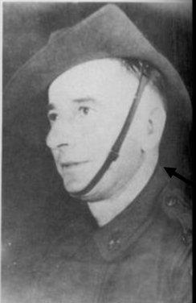

LEST WE FORGET
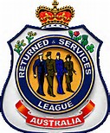
Waikerie RSL Sub branch

